
This Photo by Unknown Author is licensed under CC BY-SA

REFLECTIVE REPORT

University of Wales Trinity Saint David

Module: Academic and Employability Skills

BMSW4001_BIRM

Module Lecturer: Mr. Jonathan Wyatt

Student: Borimir Atanasov Petkov (2118523)

Table of contents

Contents
Table of contents 2
1.INTRODUCTION. 3
2.Reflective Writing. 4
3.Model of reflection. 4
4.Reflective review of task 1 6
4.1 Description. 6
4.2 Feelings. 6
4.3 Evaluation. 6
4.4 Analysis. 6
4.5 Conclusion. 7
4.6 Action Plan 7
5. Reflective report on presentation in week 7/8. 8
5.1 Description. 8
5.2 Feelings. 8
5.3 Evaluation. 8
5.4 Analysis. 8
5.5 Conclusion. 9
5.6 Action plan. 9
6. Personal Development Plan. 10
7. Conclusion 11
8. Reference list 12

1.INTRODUCTION.
Reflection is a look back in the past to analyze and explore what has happened and why, to find out how our own experience has provoked us to behave in a certain way and to explain what has influenced our response. All of this will help us to understand ourselves better and will contribute to prevent some mistakes of happening in the future, in other words will lead us to a better performance and a better final result. Academic reflection will help us develop our professional skills, will improve our critical thinking via analyzing our past experience and therefore will be beneficial for us in our future career. Moreover, reflective writing will establish the connection between what we are taught in theory and what we need to do in practice, will lead us to review our progress and use deep thinking to determine the root of the problem so we can be more productive and react more appropriately in different situations.

2.Reflective Writing.

Williams, K., (2012) “Reflective Writing” provides concise and practical guidance on how students can improve their academic writing through self-reflective thinking, reading and writing”. Reflection allows as to look back in time on something and thing about it. What we did wrong, and how we can improve that in the future. Reflective writing allows us to write about our feelings and experiences in first person.

3.Model of reflection.
There are four models of reflection such as: ERA Model, Driscoll’s What Model, Kolb’s Experiential Learning Cycle and Gibbs Reflective Cycle. In the following report I am going to use Gibbs reflective Cycle. “Gibbs model of reflection (1988) is focused on the ability to self-reflect on one’s actions with the need to engage in the process of continual learning” (Wilding, 2008). According to Gibbs, (1988) “It is not sufficient simply to have an experience in order to learn. Without reflecting upon this experience, it may quickly be forgotten, or its learning potential lost”. The Gibbs reflective cycle represents self-repeating stages in order to help us identify our previous mistakes and how to prevent them from happening in the future.

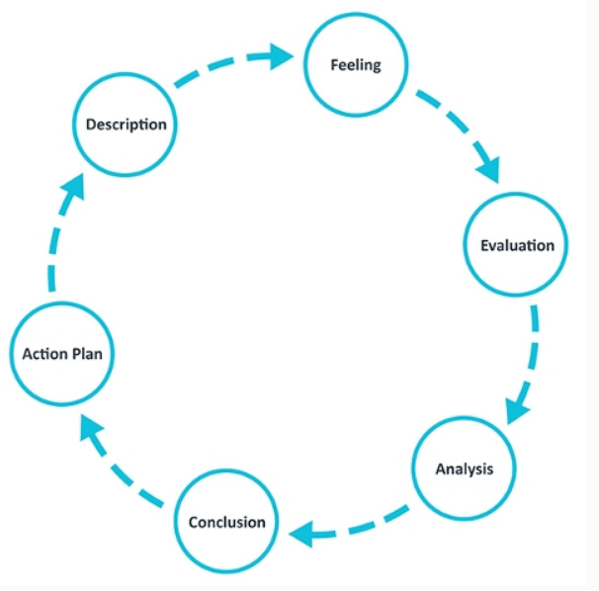Source: University of Edinburgh (2019:1)

4.Reflective review of task 1

4.1 Description.
In my first week at university, I was introduced to Academic and Employability Skills. During the first half of a term my lecturer showed me how to develop new skills such as: note taking, time management, finding and understanding information, Harvard referencing and academic writing.

4.2 Feelings.
In the beginning everything was looking extremely difficult to me. I had no idea what Harvard referencing was, or what exactly meant academic writing. When I was searching for credible literature, I felt very frustrated. I thought I will never be going to make this happen. At that time, I was looking at my colleagues, how they are progressing with the assignment and how happy they were. I knew I needed to try harder because that was the only way to take advantage from the situation. Once I started to write the report, I was very surprised, because it was not that difficult, I thought it is going to be. After I did more then the half of the academic report, I started feeling much more confident than before.

4.3 Evaluation.
I had the chance to meet and study together with new people. Last time I did that, was a very long time ago. I am happy that I started that course because, I had the chance to improve my time management and academic writing. On the other hand, when I was practicing how to find credible information and Harvard referencing, it did not go as well as I expected. Attending the campus was very beneficial because the lecturer was always around if help was needed. Joining the meetings online felt almost like loss of time.

4.4 Analysis.
The experience from task one was positive, because I have improved my academic writing and, in the future, when I need to do a report once again, I will feel much more confident. Improving time management helped me to organize my time in an acceptable way. “Time Management is the method which used to organize our time, so each decision we make regarding that is useful, constructive and the most beneficial to our life's structures” (Hashemzadeh et al., 2011, p. 2536). Understanding how to reference did not go so well, because I did not invest enough time.

4.5 Conclusion.
Next time I could join all the lessons in the campus and the lecturer can help me much more than if I am online. I will try to do more active listening in order to memorize and perform better. I will try to start my assignments as soon as possible, in order to have feedback from my lecturer, or if I get stuck, I can always ask the tutor for help, or I can ask for additional support from the university. When I have free time at home, I will try to practice my academic writing.

4.6 Action Plan.
I believe good time management is a key factor to perform my task on time. Next time I will need to organize much better, prior to starting my assignments. I can always delegate some not so important tasks to other family members and try to concentrate on my course work. I can make sure I attend all of my lecturers in the campus in person, rather than having them online. I can also try to complete my work in advance so I can get some feedback from my lecturer and do some adjustments.

5. Reflective report on presentation in week 7/8.

5.1 Description.
In a week 7/8 at the university, I have been given a task in class- to do a job advertisement together with a group of my colleagues. We had the opportunity to choose how exactly to present it -to make a flayer, presentation or to create a document. We decided to make a presentation so we can visualize our thoughts and give a better explanation to the other participants. We were divided into groups and each group had to give feedback to the others at the end. The maximum score points were 20.

5.2 Feelings.
Initially, I felt a bit more confident as this was not my first presentation and I already had a clue of how to create one. Although I had a bad experience from my first presentation, I decided to trust and give a chance to the others in the group, and I strongly believed that we could make a good team. I saw that another girl in the group was very willing to complete the task correctly and together with her we united our thoughts and led the team to accomplish the task successfully.

5.3 Evaluation.
Group work can always be beneficial if you share common ideas and have a mutual goal. If you have other people in the group who are cooperating and giving their best to make the task completed, it is much easier to work, than to do it alone. Difficulties may occur in case you do not have the same vision of the things, but sometimes even that can be useful so you can see the task from different perspectives. Good communication is essential to make you combine your thoughts and show the best of your group performance.

5.4 Analysis.
We managed to design a really good presentation and as a result we got great feedback from our peers and scored 18 of 20 with our work. The only thing we were told we needed to improve was our public speaking, but I think that it was normal for us to be not that confident while talking, because we do not have that much of experience. We need to learn how exactly to present so that we can engage the public with our speech, make it more interesting and easier to understand the topic as well as using more eye contact and specific gestures that can help us to attract and hold people’s attention while talking.

5.5 Conclusion.
With that presentation I learned that I could rely on my colleagues and believe in their abilities in order to create a common goal. I also learned that I am capable of completing my tasks if I trust in myself more. Although we had good communication in our team, I think that the more you communicate, the more positive results you will obtain. The skills we need to develop are our presentation skills, which we can achieve if we practice more and pay more attention to the small details-dress code, smile, pose and specific gestures.

5.6 Action plan.
I am strongly willing try to develop my communications skills so I can understand and be understood better.
I will try to practice my presentation skills at home and when possible-in public, so I can gain more confidence while talking and get better results at the end.
I can try to be more active in class and help my group with whatever I could instead of just thinking that we cannot manage.

6. Personal Development Plan.

Personal Target | How will I achieve this | How will this improve my academic or employability prospects? | How will I know that I have achieved this? | When will I achieve this by?
Learn how to do a Harvard referencing | I am planning to read carefully the Harvard referencing book | I will learn to reference properly | My tutor will give me feedback | Hopefully by the end of my current course
Learn how to find and understand information | Via practicing my research skills and with the help of Google Scholar and the university library | I will be able to use credible literature for my future projects | My lecturer and Turnitin will provide me with feedback | By the end of the year
Improve my presentation skills | By practicing my speech in front of the camera and in front of public as well | I will have better marks at the university and bigger chance of finding a good job | By getting feedback from the audience | I am planning to get better and better, before each presentation
Improve my communication skills | I am planning to achieve this by communicating with my peers and communicating with my tutor during my sessions | Good communication makes a big different in our every day’s life’s | By improving my results at school or from the feedback in general | Hopefully as soon as possible

7. Conclusion

Academic skills are really important not only during our studies but in our future professional lives as well. When I started that module, I had just basic and irrelevant information of how to proceed in order to be successful at the university. My current course “ Academic and Employability skills” taught me how to manage my time properly and more professionally, how to do the right note taking, helped me develop my research and referencing skills, improved my communication with my peers and showed me how to write in academic style.
Additionally, that course made me understand that teamwork is significantly important and essential when you want to pursue a mutual cause and achieve a common goal.

8. Reference list

Joan Woodhouse, Phil Wood. (2022) Creating dialogic spaces: developing doctoral students’ critical writing skills through peer assessment and review. Studies in Higher Education 47:3, pages 643-655.
University of Edinburgh. (2019) [online]. Gibbs’ reflective cycle, Available at https://www.ed.ac.uk/reflection/reflectors-toolkit/reflecting-on-experience/gibbs-reflective-cycle, Accessed 16.07.2020.
Wilding, P. M. (2008). Reflective practice: a learning tool for student nurses. British Journal of Nursing, 17(11), 720-724.
Hashemzadeh, G.R., Ranjbar, V., ... Eidi, F., 2011. The role of organizational culture in the establishment of time management (a case study: Mines and mineral industries). Australian Journal of Basic and Applied Sciences 5, 2536–2543.
Williams, K. (2012). Reflective Writing. Palgrave Macmillan.https://search.ebscohost.com/login.aspx?direct=true&scope=site&db=nlebk&db=nlabk&AN=1524142.
Hargie, O., Dickson, D. and Tourish, D., 2017. Communication skills for effective management. Macmillan International Higher Education.
Damarell, R.A., Miller, R. and Badcock, J.M., 2005. Author-date (Harvard) referencing guide. Flinders University of South Australia, School of Nursing & Midwifery.
Hartley, J. and Davies, I.K., 1978. Note‐taking: A critical review. Programmed learning and educational technology, 15(3), pp.207-224.
Thomas, A.B., 2004. Research skills for management studies. Routledge.
McCarthy, P. and Hatcher, C., 2002. Presentation skills: The essential guide for students. Sage.

