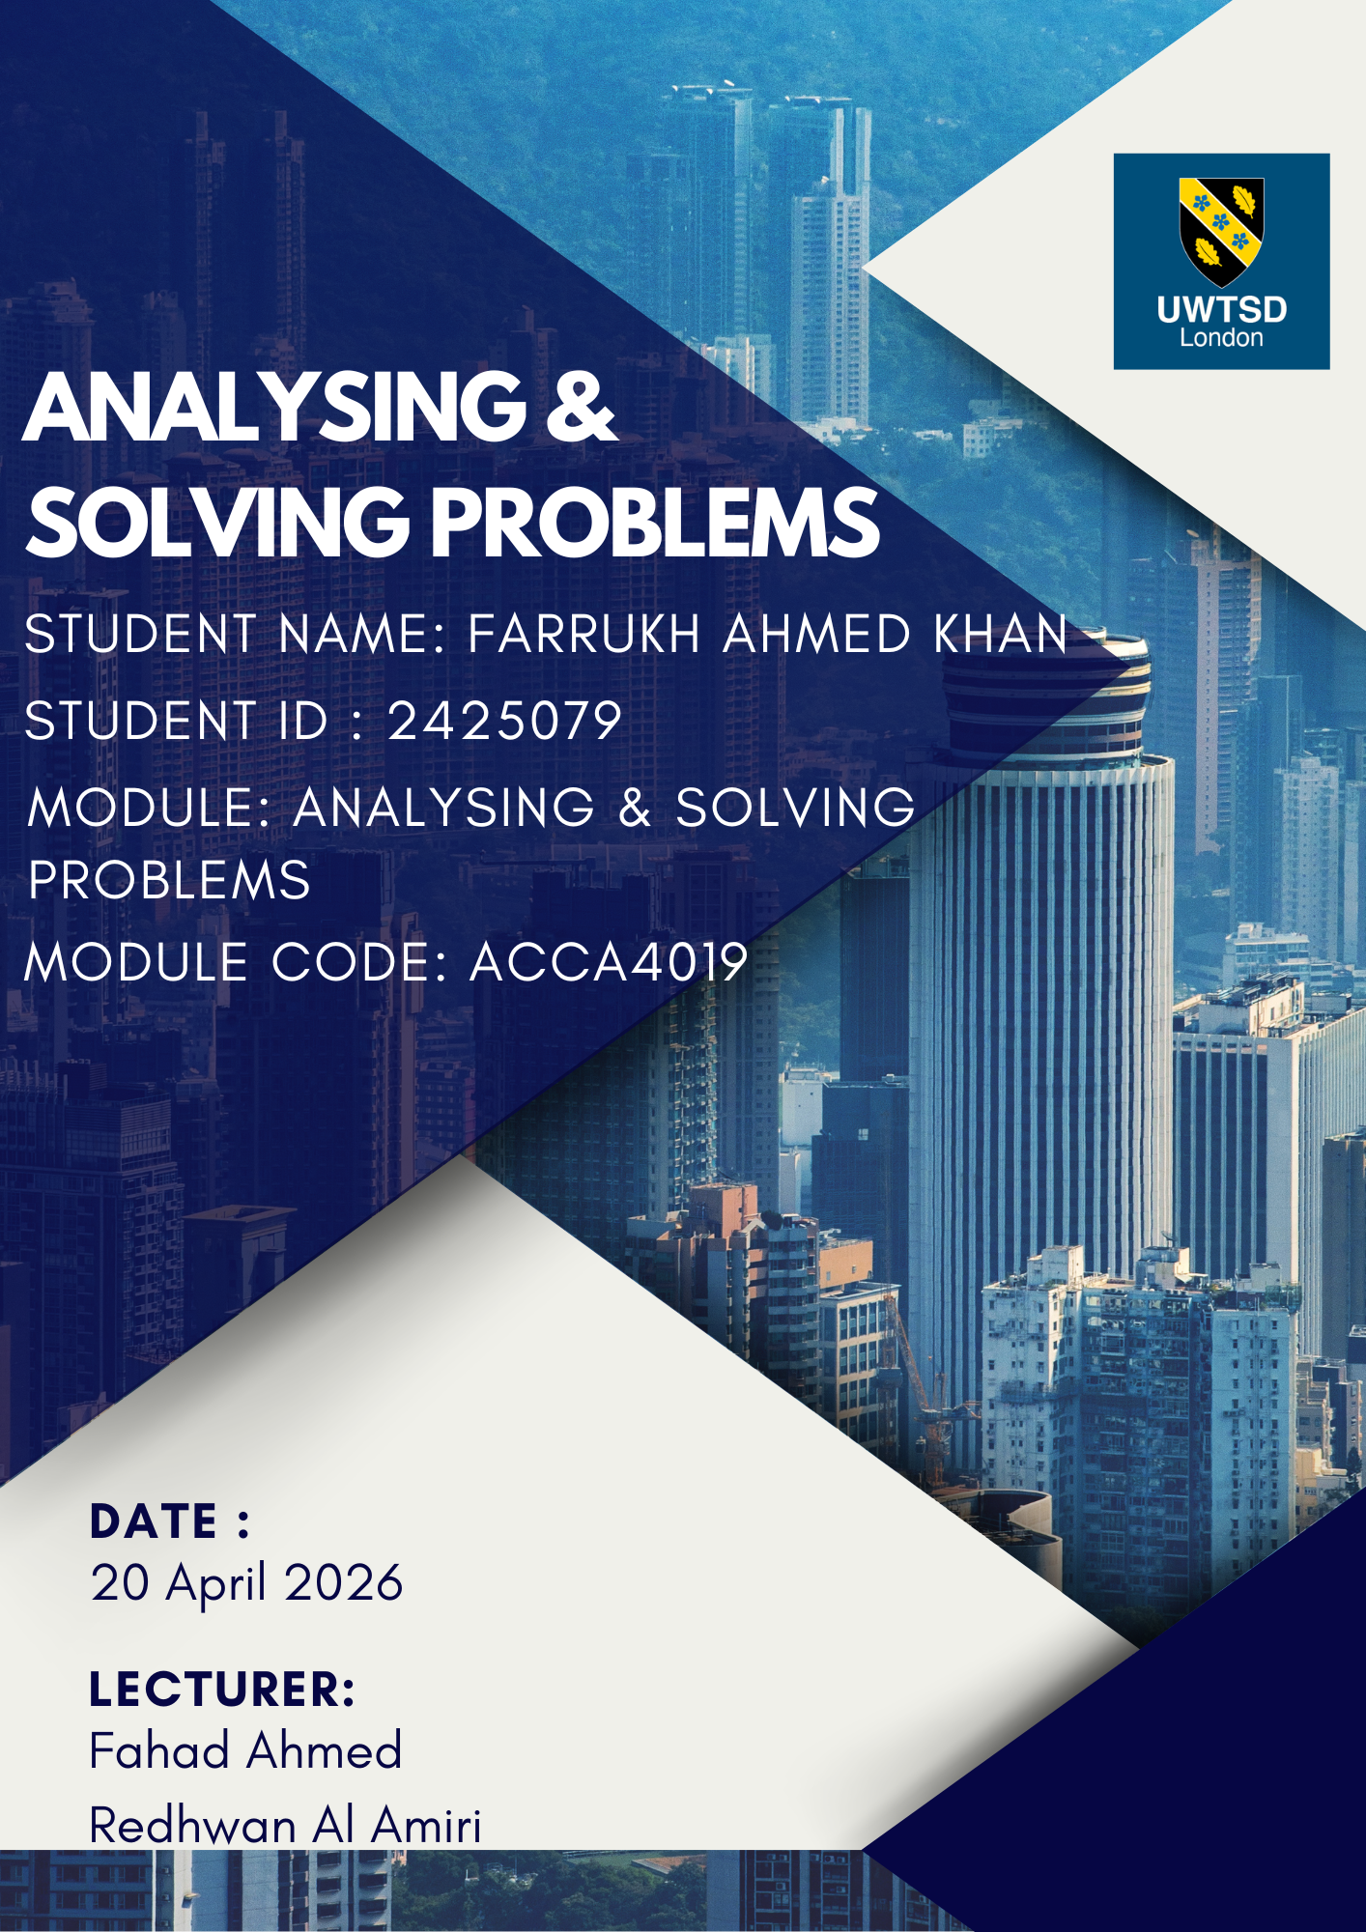
Contents
1. Introduction 2
2. Deconstruction of the Problem 2
2.1 Key Variables 2
2.2 Requirements Analysis (MoSCoW Technique) 3
2.3 Constraints 3
3. Proposed Solution 3
3.1 The Flowchart Logic 4
3.2 Written Explanation of the Process 4
4. Reflection and Justification 5
4.1 Problem-Solving Techniques Used 5
4.2 Justification 5
4.3 Limitations and Assumptions 5
5. Conclusion 5
6. REFERENCES 6

1. Introduction
Efficient resource management is a cornerstone of operational success in educational institutions. A local college currently faces significant logistical challenges: classroom overcrowding, underutilisation of space, and excessive transit times for staff and students. These issues culminate in "scheduling conflicts and diminished pedagogical quality" [1]. This report aims to deconstruct these challenges and propose a structured, algorithmic solution grounded in systems thinking and abstract problem-solving.

2. Deconstruction of the Problem
To solve a complex problem, one must first break it down into manageable components—a process known as functional decomposition or subdividing [2].

2.1 Key Variables
The efficiency of classroom allocation depends on the interaction of several discrete variables:
- C (Classroom Capacity): The maximum number of students a room can legally and comfortably hold.
- S (Student Enrolment): The number of students registered for a specific module.
- T (Time Slots): The temporal availability (e.g., 09:00–11:00).
- L (Location/Proximity): The physical distance between Building A and Building B.
- F (Facilities): Specific requirements such as laboratories, projectors, or specialized software.

2.2 Requirements Analysis (MoSCoW Technique)
The MoSCoW method is utilized here to prioritize the requirements of the new allocation system, ensuring that the most critical needs are met first [3].

Category | Requirements
Must have | Clash-free scheduling (no two classes in one room); (class size must not exceed capacity); Room assignments for every scheduled module.
Should have | Proximity-based allocation (successive classes for a cohort should be in the same or adjacent buildings); 10-minute "buffer" between sessions.
Could have | Preferences for specific rooms based on tutor requests; Automated notification system for room changes.
Won't have | Real-time tracking of student movement; Physical expansion of the college buildings in this phase.

2.3 Constraints
The primary constraints include a finite number of rooms, fixed academic hours, and the geographical layout of the campus which dictates the minimum "commute time" between classes.

3. Proposed Solution
The proposed solution adopts a Heuristic Allocation Algorithm. Rather than a random assignment, this approach uses logic to optimize room usage based on the variables identified in Section 2.

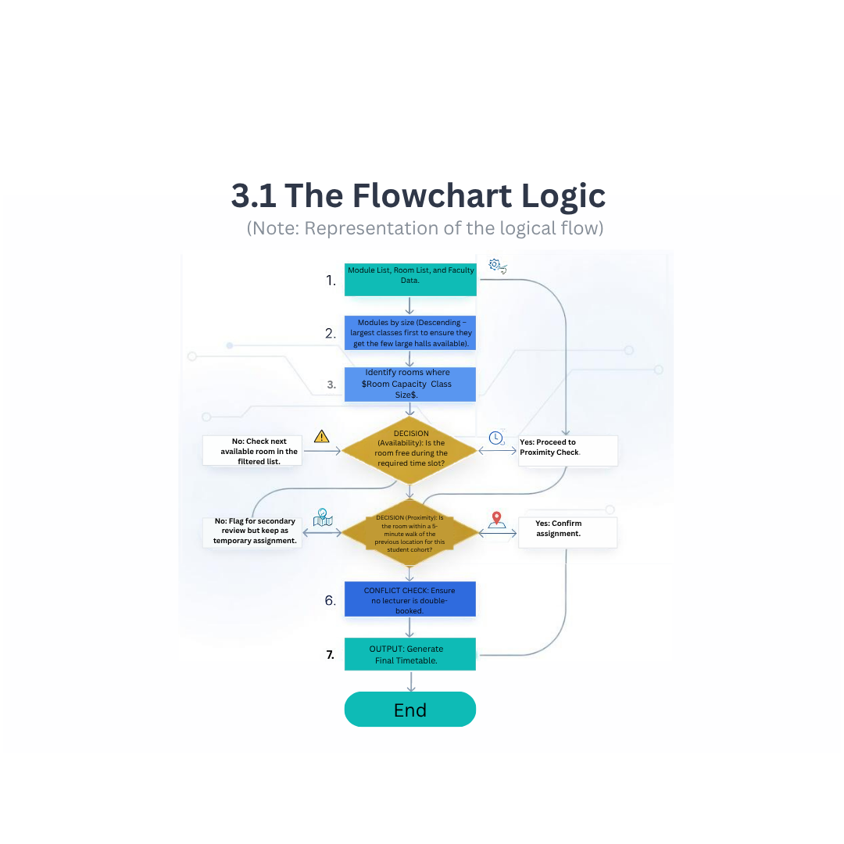
3.1 The Flowchart Logic

3.2 Written Explanation of the Process
The solution employs Abstract Thinking by viewing the college not as a collection of bricks and mortar, but as a mathematical set of capacities and time-windows [4].
- Optimising Usage: By sorting modules by size before allocation (Step 2), we prevent a 20-person seminar from occupying a 100-person lecture hall, which is a primary cause of overcrowding elsewhere. This is known as the "Best-Fit" approach in bin-packing theory [5].
- Minimising Movement: The algorithm prioritises "Building Clusters." If a group of students has a 9:00 AM class in Building Alpha, the algorithm searches for a 11:00 AM room within the same building or its immediate neighbour.
- Avoiding Conflicts: The centralized database ensures that once a time-room variable (T, R) is assigned, it is locked, preventing scheduling overlaps.

4. Reflection and Justification

4.1 Problem-Solving Techniques Used
The primary technique utilized was Computational Thinking, specifically Abstraction and Pattern Recognition [6]. By ignoring the specific subjects being taught and focusing on the "data" of class sizes and room numbers, a generic solution was created that can be applied to any department.
Subdividing (or decomposition) was also critical. Managing a whole college's schedule is overwhelming; however, by breaking it into individual "constraints" (Capacity, Time, Location), the problem became a series of logic gates.

4.2 Justification
This approach is appropriate because it moves from a "reactive" model (solving clashes as they happen) to a "proactive" systems-thinking model [7]. According to Senge’s Systems Thinking theory, small changes in the rules of a system—such as the order in which we assign rooms—can lead to significant improvements in overall institutional efficiency [8].

4.3 Limitations and Assumptions
- Assumptions: It is assumed that all rooms are "general purpose." If a class requires a specific Chemistry Lab, the algorithm’s flexibility is reduced.
- Limitations: The solution does not account for sudden changes, such as a room being out of order due to maintenance. Furthermore, the "proximity" check requires accurate mapping of the campus, which may be data-intensive to implement initially.

5. Conclusion
The difficulties faced by the college are not inherent to the space available, but rather to the logic of how that space is distributed. By deconstructing the problem into quantifiable variables and applying a structured MoSCoW-based requirement set, a solution was developed that prioritizes both spatial efficiency and human transit time. Implementing this logical framework will result in a more streamlined, clash-free environment that enhances the educational experience for both staff and students.

6. REFERENCES

References
[1] J. Hill and K. Smith, "Visions of blended learning: Identifying the challenges and opportunities in shaping institutional approaches to blended learning in higher education," vol. 32, no. 3, pp.289–303, 2023,
[2] R. K. Yin, Case study research and applications, Sage Thousand Oaks, CA, 2018.
[3] D. Clegg and R. Barker,Case method fast-track: a RAD approach, Addison-Wesley Longman Publishing Co., Inc., 1994.
[4] J. M. Wing, "Computational thinking," Commun ACM. vol. 49, no. 3, pp.33–35, 2006,
[5] T. H. Cormen, C. E. Leiserson, R. L. Rivest and C. Stein, "Introduction to algorithms. Cambridge, MA: MIT Press," 2009,
[6] K. Brennan and M. Resnick, "New frameworks for studying and assessing the development of computational thinking", Proceedings of the 2012 annual meeting of the American educational research association, Vancouver, Canada, pp. 25.
[7] D. Meadows, Thinking in systems: International bestseller, chelsea green publishing, 2008.
[8] P. M. Senge, The fifth discipline: The art and practice of the learning organization, Broadway Business, 2006.

