
15-4-2020

STUDENT NAME | YAZMIN VEGA RODRIGUEZ
STUDENT NUMBER | 1917100
MODULE No | BMSK4003
MODULE TITLE | DIDGITAL SKILL AND RESEARCH METHODS
LECTURER | ANUPAM MAZUMDAR

IKEA

INTRODUCCION
IKEA is an internationally known as the largest home furnishing retailer around the world for its remarkable Scandinavian style. Most of IKEA furniture is flat-packed, ready to be ensembled by the consumers using their catalogue with visual instructions, IKEA vision was to create affordable and practical designs with low prices ready for the consumers.

BACKGROUND

It has developed and grown rapidly since it was founded in 1943 by 17-year-old Ingvar Kamprad in Smaland in Southern Sweden.
However, until 1948 developed the concept of furniture design. Previously Ikea was focused on selling accessories such as wallets, pens, and cosmetic products. It is when they began with marketing furniture. As a result, their profits increased, and over the years IKEA launched the first catalogue in 1951.
In 1953 the company was part of a furniture exhibition that was the beginning of the furniture as we know today. Approximately 550 million people visit IKEA in more than 341 stores, distributed in 50 countries, every year, attracted by it is famous catalogue positioning itself in the market.

AIM
IKEA is an international home furnishing retailer, that sells good quality design at low prices with sustainable sourcing of materials around the world.

OBJETIVES
The objective is to produce affordable items for the consumers. This will ensure the customer gets value for money.

MISSION
The goal of IKEA is to Offer a wide range of well-designed and functional home furnishing.
They mark their prices to be accessible for all.

VISION

IKEA has a vision to create a better everyday life for many people. The business idea is to offer a wide range of well-designed, functional home furnishing. The products come flat packed in order for the customer to ensemble at home.

SERVICES OF IKEA
IKEA has an extensive range of products approximately 2000 including home furniture and accessories all available in store. The Internet expands Online shopping increasing profits and excellent customer service such as.

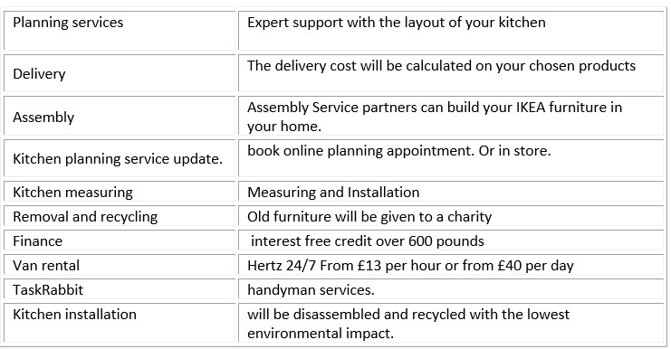

PURPOSES
It is to offer an immense variety of home furnished products of excellent design and function, hight quality and durability. The company targets the consumer who is looking for value and is willing to do the assembly at home. All products come with visual instruction for easy home construction

TECHNOLOGY
1945-2020

- In 1945 Ingvar was using a local newspaper to advertise his products and using a
makeshift mail-order service.
- In 1951 IKEA published the first catalogue that we know today.
- IKEA wanted to show the customer that their products, prices and innovation were better than competitor. Therefore, they opened a showroom in Almhult, Sweden
- The Internet expands the market increasing profits for more costumers Including online shopping.
- IKEAS 2020 digital Offerings and APPS allow customers to visit virtual and design and customise what they want.
- Interior design supported by the special marketing department had a huge impact to consumer sales.
- Augmented Realty, using 3D technology the customer can view from different angles and see the products that are available to preview in the App.
- Environmental resources, using old shipping containers made of steel as a symbol of recycling. Having a second life being used in such places as restaurants, cafes, art galleries pop up stores and hotels.

LIST OF REFERENCES
IKEA official website https: 16 -04 -2020
https://www.ikea.com/gb/en/customer-service/services/van-rental-pubfae74391
Wikipedia 20-04-2020
https://en.wikipedia.org/wiki/IKEA#References no vale
heritage Ikea 21-04-2020
https://www.ikea.com/gb/en/this-is-ikea/about-us/our-heritage-
Jennifer Nini Aka Eco warrior princes 2018 national sustainability in business conference.
https://sustainability.asn.au/blog/how-sustainable-is-ikea-really/
Technology IKEA 2020
https://digiday.com/marketing/ikea-using-augmented-reality/
IKEA 1940
https://www.ikea.com/ms/ar_QA/about_ikea/the_ikea_way/history/1940_1950.htm
https://www.dictionary.com/browse/target?s=t sinonimos

