MSc Applied Computing

Managing Information Systems Projects

Assignment Two: Managing a Project

Sue Maw

Lauren Paige Collins – P134209

Contents
Table of Figures 3
1.0 Introduction 4
2.0 Explanation of the Project Plan 5
2.1 Evaluation of the Suitability of the Project Management Software 8
3.0 Explanation of assignment within the Group 9
3.1 Evaluation of Group Working with regards to assigned Project Roles 10
3.2 Management of Change 11
3.3 Evaluation of Recommendations from the Literature 11
4.0 Risk Management 12
4.1 Risk Factors 12
4.1.1 Project Risks 12
4.1.2 Technical Risks 13
4.1.3 Business Risks 14
4.2 Causal Map 15
4.3 Analysis of PERT tools 16
5.0 Sustainability Issues 18
5.1 Lami’s Green IT framework 20
5.2 Well-being of Future Generations (Wales) Act 2015 21
6.0 Ethical Issues 22
6.1 BCS Code of Conduct 22
6.1.1 Public Interest 22
6.1.2 Professional Competence and Integrity 23
6.1.3 Duty to Relevant Authority 24
6.1.4 Duty to the Profession 25
7.0 Legal Issues 27
7.0.1 Data Protection Act 2018 27
7.0.2 Intellectual Property 27
7.0.3 Computer Misuse 28
7.1 General Data Protection Regulation 28
7.2 Potential Overseas Sales 29
7.3 Issues arising from Brexit 32
8.0 References 33
9.0 Bibliography 35

Table of Figures

Figure 1 Task List Part 1 5
Figure 2 Gantt Chart Part 1 5
Figure 3 Task List Part 2 6
Figure 4 Gantt Chart Part 2 6
Figure 5 Causal Map 15
Figure 6 Network Diagram Pt.1 16
Figure 7 Network Diagram Pt.2 16
Figure 8 Network Diagram Pt.3 17
Figure 9 Network Diagram Pt.3 17
Figure 10 The Sustainable Project Management Circle [5] 18
Figure 11 Seven Well-being Goals [10] 21
Figure 12 Country Comparison 29
Figure 13 Brexit Strategy 32

Introduction

Following on from the previous report, where the team members whom are working for ‘GetitrIT’ produced a Project Initiation Document (PID). The next step within the process is to now Manage the Project. The software resource requested by Student Services at University of Wales Trinity Saint David, Swansea, is within the initial stage of development and the team will be presenting a prototype of the system to representatives of the department. Accompanying this, will be PERT analysis project plan, representing the milestones the team have overcome and also the progress.
Throughout this report, an evaluation of the groups work will be discussed, including team work, responsibilities within project roles and finally how the team managed change.
Within this, further issues will also be discussed, including Risk Management, Sustainability Issues, Ethical Issues, and finally Legal Issues. Many frameworks and guidelines will be used to evaluate these four points in detail, ensuring all necessary information has been analysed thoroughly.

Explanation of the Project Plan
Due to size of this particular project, the team created a project plan producing a Gantt Chart. Below are the print screens of the project plan and the Gantt chart that was produced from creating the plan.
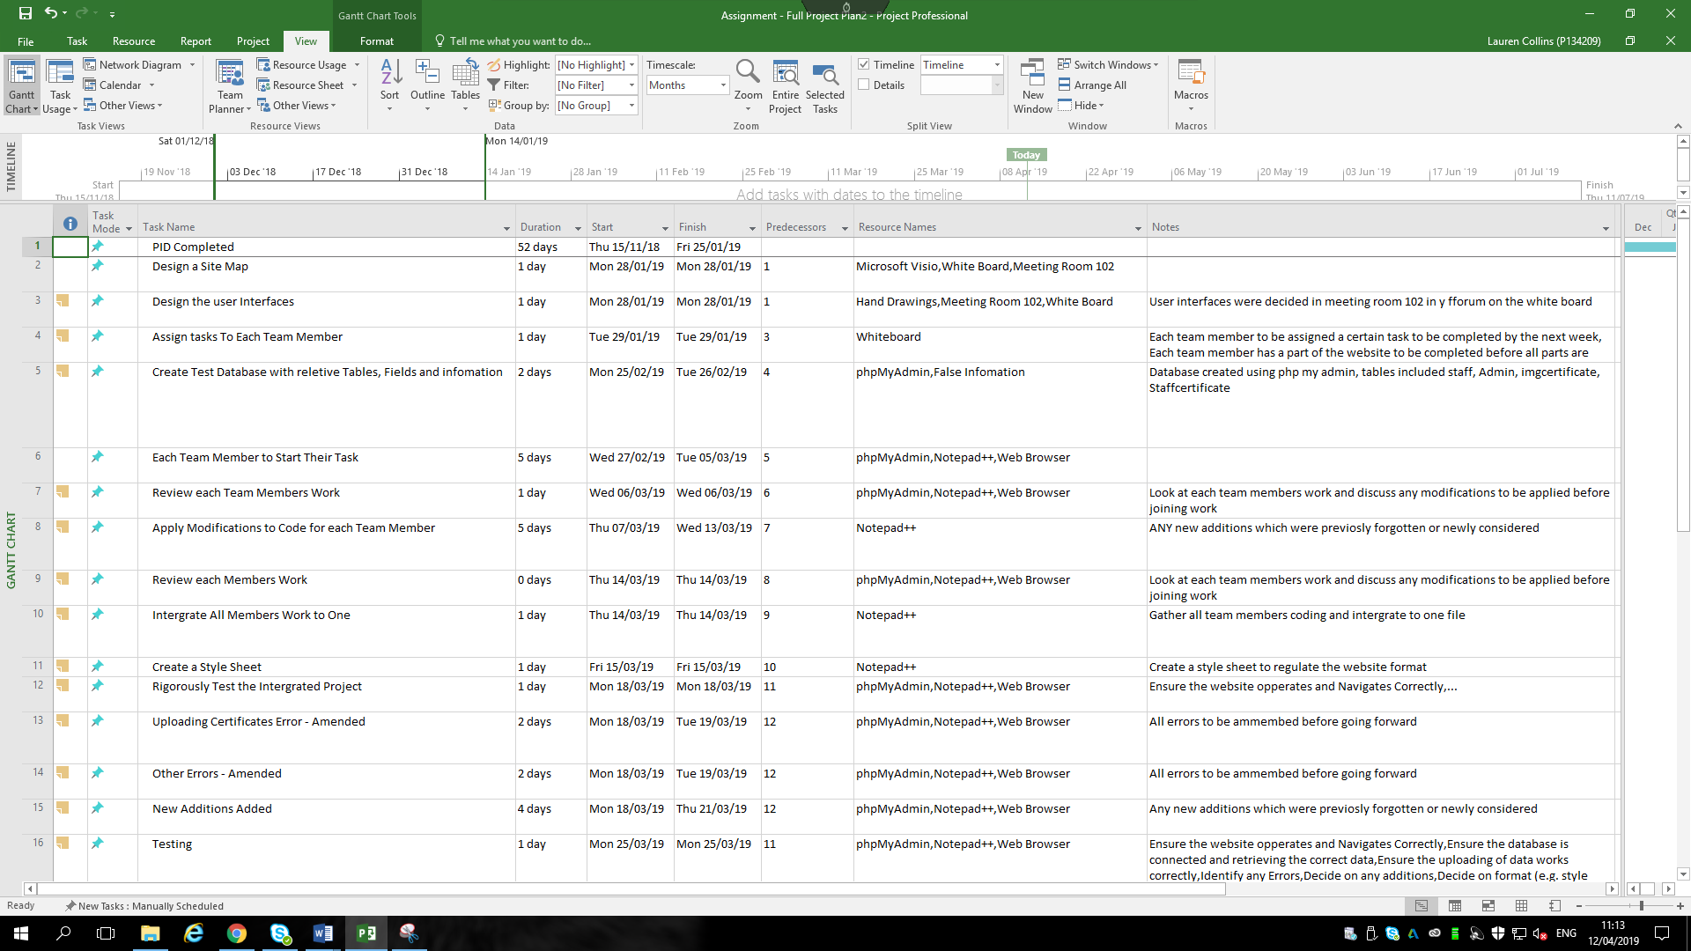

Figure 1 Task List Part 1

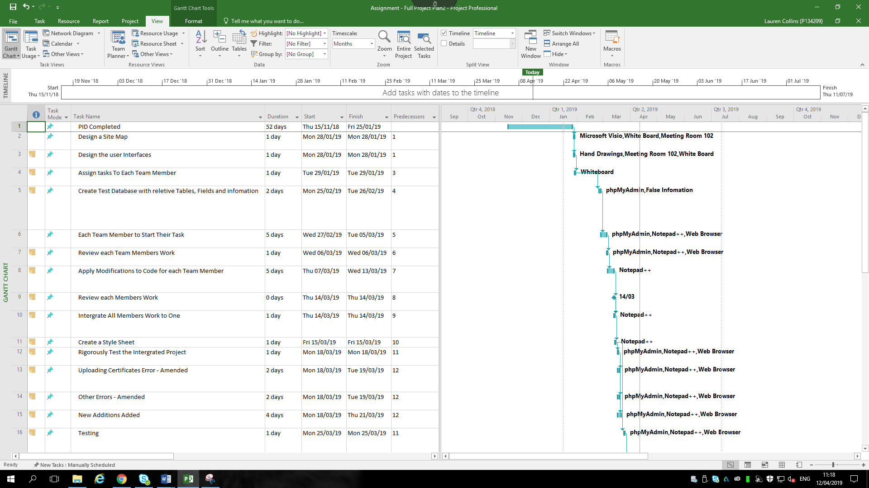

Figure 2 Gantt Chart Part 1

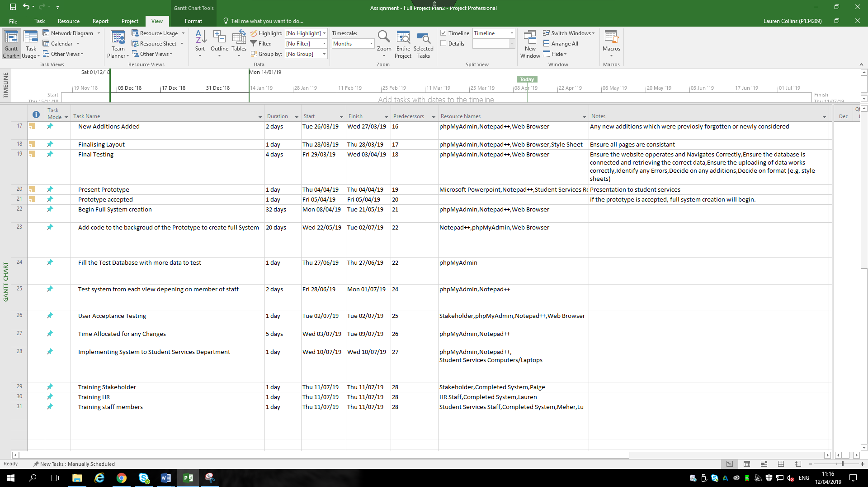
Figure 3 Task List Part 2

Figure 3 - Tasks Part 2

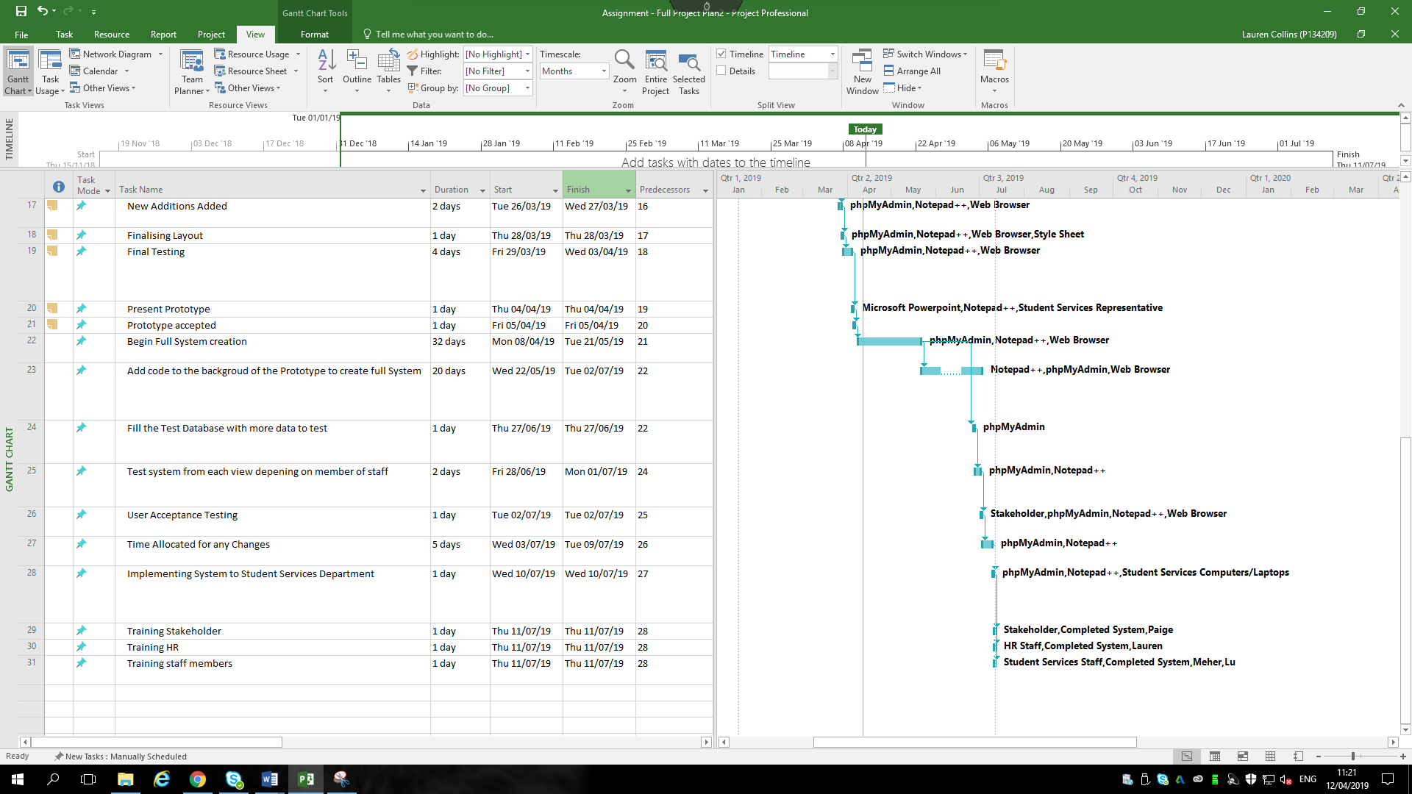

Figure 4 Gantt Chart Part 2

Within this project plan, each task that was completed by the team was included in the plan. Doing this throughout the process of creating the system prototype aided in tracking the production of the system and tracking the tasks that had been allocated to the team members.
A blank simple template was used to create this plan. The fields that were used within the plan were task name, duration, start and end date, predecessors and resource names. Using these fields enabled the team to create a detailed plan of what would be conducted, the time duration to completion and the resources that would be required to complete the tasks. A very useful tool for the team was the predecessor field as it allowed the group to see which of the tasks preceded another activity within the list, allowing for a clear view of what tasks would needed to be completed before continuing with the next. The resources field was also incredibly useful regarding the planning element of this project. For each task that was required to be completed, the team were able to view exactly what resources were required, along with the type of environment which aided in the completion of the tasks.

Evaluation of the Suitability of the Project Management Software

Within this report and the PID previously created, Microsoft Project was used to produce the Project Plans. This tool was particularly useful for the planning of this project, especially as it was an overall group task. When there are a number of members within a team, it can sometimes be difficult to track who was assigned certain tasks, how long was taken to complete them and if the tasks have been completed or not. Using this solid scheduling tool aided the team greatly with this aspect of the project.
Microsoft Project is very flexible and allows for efficient scheduling as a result of the features it contains. It allows for clear inputting of tasks with the users required time frame, producing a Gantt Chart which can be great visual aid for users when tracking the time that is remaining. It also helps teams to stay productive when working on an extensive project. The team would be able to have a clear indication of what tasks need to be achieved, the time frame available to complete tasks and what tasks have already successfully been conducted.
Regarding the training element to use this software, Microsoft Project have aided within this area, due to the acquainted scheduling elements and prepopulated pull down menus, allowing for a required feature to be found and used promptly. This reduces any training time that needs to be given to new or existing employees, which overall saves the organisation money and time. Reports and plans created on the software can be easily shared across the organisation to all the required individuals who need access, which aids in ensuring every person involved is viewing the same information, avoiding any unnecessary confusion.

Explanation of assignment within the Group

Working within a team, can sometimes be difficult. This often depends on, the project that the team are working on, the amount of people within the group, educational backgrounds and work ethic.
Within the first phase of this project, a PID (Project Initiation Document) was completed. During the PID, the work was split equally between the four team members. This was completed successfully resulting in a presentation to the lectures and a representative from student services.
Due to the team member’s previous experiences with coding, it was decided that HTML and PHP would be used to produce the prototype of the system.
Notepad++ was used to create the code for the website and PHP My Admin was then used for creating the database and the storing of the data. As a result of this, the team made the decision that each member would participate in the writing of the code, as each member had previous experiences of using the software previously stated.
The team met regular to discuss the creation and the development of the prototype. Within the meetings, the team decided on which pages would be created, who would produce the code for those pages and also created a site map, showing what pages would be required for each login requested by student services. Although an agreement was made between the group for which pages were to be created and by whom, it unfortunately didn’t go to plan. Reasons for this can be viewed in section 3.1.
The team has a whole worked very well together in the creation of the PID, but as for the development of the prototype the team could have operated better. This is a result of some members within the team not listening to the tasks given and not participating within the development process.

Evaluation of Group Working with regards to assigned Project Roles

When creating the PID, job roles were created and assigned to members of the team for the development stages of the student services prototype system. These roles can be viewed below: -
- Project Manager – Lauren Collins
- Website Programmer – Paige Harris
- Website Designer – Meher Arasada
- Database Analysist – Lu Han
Although each member was assigned a role, it was agreed before the building of the prototype began that the team as a whole would participate in the writing of the code. But when the development began only three out of the four team members ensured that there was participation in each area of the creation of the prototype.
Lauren, Paige and Meher produced and modified code for the system, all contributing to the build of the system requested by student services.
When the site map was produced by the team, the team manager asked the team what pages each member would like to work on. A fair decision was made, ensuring no one member had more to do than the rest. When the team met the following week to join the pages produced, this was when a few issues arose.
Paige created the CSS Style Sheet that was used for the design and format of the webpages. The style sheet was shown to the other members in the team where the team agreed on the design. Other features for the design were then added to the webpages when created, e.g. adding the contact information of the other universities within UWTSD, to the home page.
Lauren and Paige had both created the pages that had been assigned to them, along with the database that Paige had volunteered to create, which was agreed by the team. Meher had also began the build of the database on PHP My Admin and created a number of the pages that the other team members were supposed to produce also. This had created an unnecessary amount of work as both databases and website pages had been created twice.
This issue was resolved by the team agreeing to use Meher’s database and some pages of his code, as these had already been linked. Lauren and Paige then modified the original code and entered relevant test data within the database to ensure the correct data was presented appropriately to meet the requirements of the prototype. The three team members then proceeded to work together to work on different aspects of the prototype, to ensure all the necessary pages and features were included. Unfortunately, Lu did not create the pages requested and did not participate in the creation of the prototype.

Management of Change

As a result of the team originally working on the PID separately as each member had a section of the PID to complete, conducting the creation of the prototype was a change for the team as each member had gone from working separately to working as a team on one single machine. The prototype needed to be created on one machine as there was a restriction of one person who was able work on the system at one time. This proved to a challenge for the team, as each member had to take turns working on one machine when attending the meetings.
One change which the team had to manage, was that the team was reduced from four members to three. As the team had originally planned to divide the work between the four members, the three members then had to re-evaluate who would work on the different elements within the code. This is a result of the team recognising halfway through the development of the prototype, that one team member was not participating, as the pages that were requested by this person were not prepared.

Evaluation of Recommendations from the Literature
When conducting any type of project, there are always recommendations available to aid in the process of developing a project. Regarding IT projects, there are few different elements that must be considered when managing one. One key point that should be established, is that “technology only serves to complicate matters further because today’s computing environments tend to become obsolete with ever-increasing speed. Thus, a good project manager must not only be proficient at managing, but he or she must retain that proficiency as the technology changes.” [1] This should almost be a requirement that change within technology has got to accepted, due to the rate of technology advancing, not slowing down any time soon.
Although there are many roles that are required to be fulfilled by the project manager there are some which are vital within an IT project. The project manager should ensure that integrated business is supported, manage IT aspect and set project manager initiatives, as well as:-
- “Define company’s PM objectives and strategies.
- Establish company’s PM priorities and direction.
- Approve PM policies, procedures, and standards for the program delivery.
- Recommend appropriate budget levels and program budget allocations for PM investments to IT and executive business management.
- Obtain approval from IT and executive business management on recommend PM budgets based on approved programs.
- Release funds based on business objectives, strategies, and program alignment with IT and PM objectives, strategies, priorities and direction.
- Perform role of executive PM sponsor to champion the project management methodology, including accountability for project management integration.” [2]

Risk Management

When creating a project, there are always going to be issues that could arise throughout the development. The key is to have a plan in place of how these issues could be resolved if they were to become an issue. “Project risk management is the process of identifying, analysing and then responding to any risk that arises over the life cycle of a project to help the project remain on track and meet its goal.” [3]

Risk Factors
Within the PID a number of risks were identified which could arise from the student services project. Those risks were split into three separate categories, Project Risks, Technical Risks and Business Risks. These risks are now going to be updated and analysed for how these were monitored throughout the development of the prototype.

Project Risks
- Scheduling and Timekeeping
This can often become an issue if the project is not planned correctly. As a result of this, the team created a project plan using Microsoft Project to ensure the time that the team had been given was managed correctly. The team kept within the timeframe given and confirmed that all the required features of the prototype were included.
- Becoming over Budget
When the PID was completed by the team, a presentation was then presented to student services. Within the presentation the team provided an estimated total for overall team and initial input costs. This was calculated as 80 days *4 members*£12.30 per person per hour *8 hours per day = £31,488. Adding the initial input costs of £6,700 to this amount, totalled the estimated figure to £38,188.
After revaluating this figure, it has shown that the cost of the project would go over the budget originally stated. The team’s project plan revealed that the team worked for 102 days rounding the figure for the team cost, to a higher total of £40,147.20. With the initial input costs, the final estimated figure was totalled at £46,847. This would result in the team going £8,659.20 over budget.
- Personal Matters
Throughout the development of the prototype, there was one incident which resulted in the team having to reschedule a meeting. This was a result of one the team members being ill and having to miss the meeting. Although this affected the time frame set by the team, the meeting was then rescheduled for two days later, allowing the team to catch up on the time that was previously missed.
- Customer changes the Specifications
After the initial meeting with the stakeholder from student services, there was no change in the requirements or the specifications that were requested by the department.
- Work Ethic within Team
During the development of the system, one team member did not complete the work that was requested and there was no motivation to participate in the creation of the prototype. As a result of this, Lauren, Paige and Meher ensured that any of the work that was missed was completed to ensure a successful prototype was produced.
During the group meetings, there was occasions where Lu was not listening to the team discussion. For instance, she had her earphones in connected to her phone, where she then proceeded to make a phone call whilst the team were discussing the development.

Technical Risks

- Design Changes
During the first meeting for the creation of the prototype, a site map was produced by the team. Alongside this, designs and system layout were also discussed to allow the team to make a decision on how the overall system should be presented. As a result of the stakeholder not providing details on how the system should look, this then allowed the team to make changes to the design and layout as the system was produced. Although there was a CSS (Cascading Style Sheet) format in place for the overall design and layout, some pages were later modified to meet the requirements of those pages. This was based on the type of information the page was presenting.
- Implementation Issues
As a result of only a prototype being produced by the team, there has not yet been any implementation issues.
- Maintenance
Due to the system not being fully produced and finalised, maintenance is not yet required on the system.
- Security
It was requested by the department manager that every member of staff within student services had an individual log in with a password, as different members of staff are only authorised to view certain data within the system. This request was implemented into the prototype as it was a feature that was in demand by the department, due to the sensitive information that will be stored within the database. The database will only be accessed by the department manager which will also be protected with a username and password.

Business Risks

- The Market Changes
As a result of the stakeholder having a variety of personalised requests, there is very low likelihood of a new software being released within the market which would affect the team developing the project. Due to the stakeholder having minimal IT skills, the need for the system to be built by the team is still going to be required.
- The need becomes out of date
For the need of this system to go out of date, the student services department will either have to be instructed to store the data in another way or the department is taken over within the university, making the system redundant.
- Competitor
As a result of another team being hired to produce a prototype to choose from, there was competition between the two teams. When the prototype presentation was presented to the stakeholder by the two teams, the stakeholder was then required to select a team to develop the prototype to a fully developed system. The end result for this was that team containing the members Lauren, Paige, Meher and Lu had acquired the contract to develop the system.
- Financial Risk
Due to the estimated costs for the overall project being £8,659.20 over the initial cost, there is risk that the department not being able to afford the final costings. This could result in the team getting under payed if the new amount is not agreed upon with the department or the project not going ahead, resulting in the team losing the contract.

Causal Map

The team created a Causal Map for the student services system. “A causal map is a word-and-arrow diagram in which ideas and actions are causally linked with one another through the use of arrows. The arrows indicate how once idea or action leads to another.” [4] When working in a group, this can be very useful for addressing the various situations and directions a project can go in.
This can be an extremely useful technique to aid in figuring out possible issues that could arise throughout the development of the project. When working in a group it is also useful for communicating the problems so that a team are able to help one another resolve the potential issues.
There are number of situations where creating a causal map can benefit, especially when [4]: -
- Effective strategies are required to be established.
- Convincing arguments are required.
- Effective and logical communication is necessary.
- There is the need for understanding and management of conflict.
- It is vital for a situation to be understood better as a prelude to any action.

The Causal Map that was produced by the team, was created on Microsoft Visio. This can be viewed below. Producing this causal map was particularly useful as it allowed for the team to view the different positive and negative events that could have occurred. As a result of the system produced by the team being a success, the team mainly listed the negative events that could have arose throughout the project.

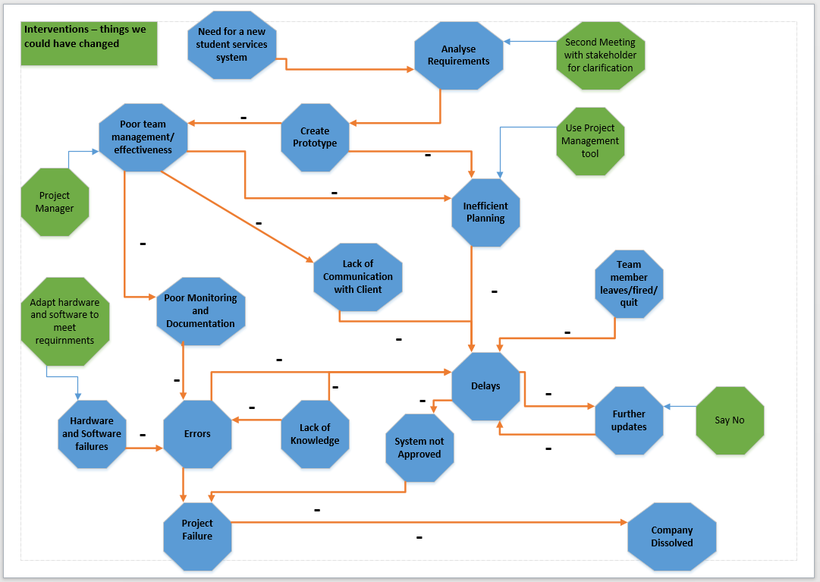
Figure 5 Causal Map

Analysis of PERT tools

As a result of the project plan being created in Microsoft Project, this then allowed for a variety of different diagrams to be created from the existing information. A PERT (Program Evaluation Review Technique) chart was also able to be produced. This technique allowed the team to view another chart which could be used for scheduling, organising and coordinating the team’s tasks.
By clicking on the view tab in Microsoft program, the option for Network Diagram could then be chosen. This is the PERT tool that was chosen by the team. Below are the print screens of the network diagram that was produced from this.

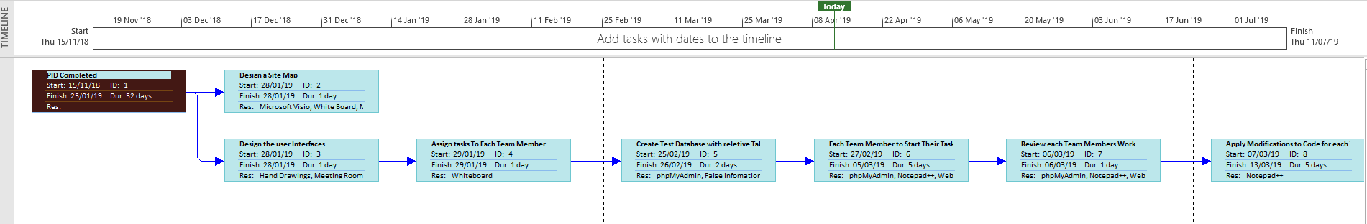
Figure 6 Network Diagram Pt.1

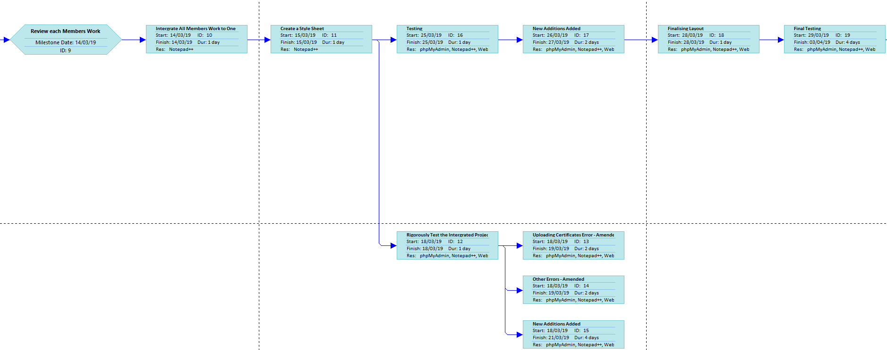
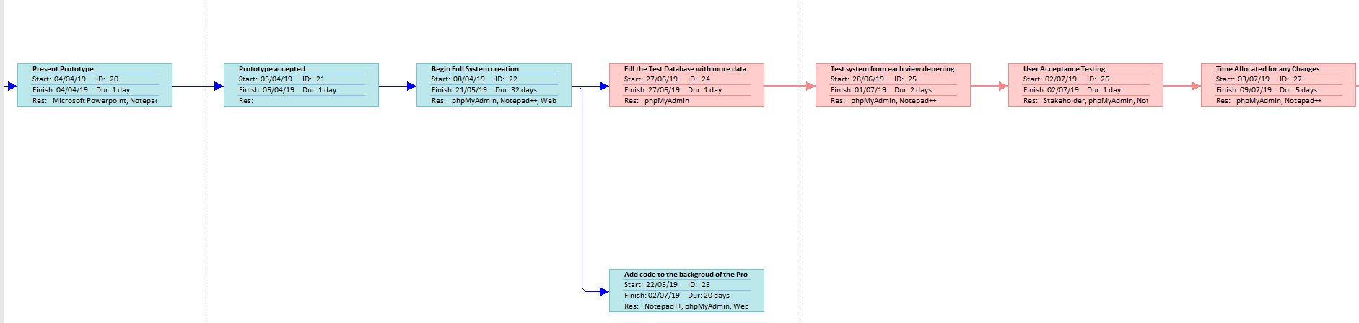
Figure 7 Network Diagram Pt.2
Figure 8 Network Diagram Pt.3

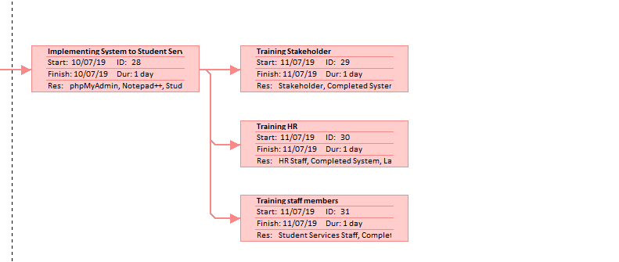

Figure 9 Network Diagram Pt.3

Although this tool was particularly useful, it did not make a difference on the planning process of the team. Due to the project plan already being created producing the Gantt chart, this is the plan that the team followed as it was overall easier to read.
This is a good visualisation tool for this particular project as it enables the user to see what procedure comes after each task. The team were aware that the project involved tasks that the needed to be completed one after another due to this being a development of a prototype. It was required to complete the tasks in order, to ensure full successful completion.

Sustainability Issues

Within today’s industry, Sustainability is becoming an issue, especially within IT Project Management and “is defined by the “green project management”, part of the PMI (Project Management Institute)”. [5]
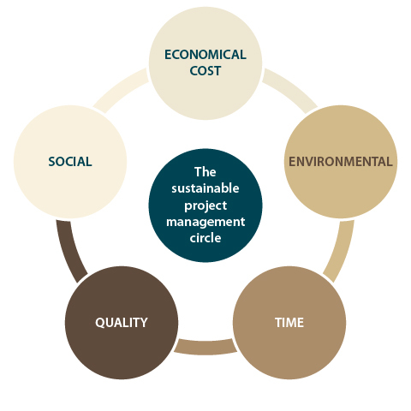
What is fundamental within sustainability in project management, is that there is a balance between social, environmental and financial interests within any project. The main points that should be considered within this particular area, can be viewed in the figure below.

Figure 10 The Sustainable Project Management Circle [5]

Integrating sustainability practices within an organisation can be very important, but when doing so the organisation is then accountable for the effect that it has on the customers, employees, stakeholders, the surrounding community and also the environment. To have a sustainable focus within the business, it needs to recognise alliance between the organisation and association with society. The following aspects are recommended implement to achieve a sustainable focus.
- “Human Rights
- Labour Practices
- The Environment
- Fair Operating Practices
- Consumer Issues
- Community involvement and Engagement” [6]
The sustainability issues within an organisation are becoming vital and fortunately there are many different industries who have set standards to implement and apply to an organisation. With relation to the student services project, there are many sustainability matters which need to be analysed.

Due to the department requiring an overall online based system, this will aid them greatly in relation to the paper-based documentation system that is currently in place. As a result of this, the department could implement the ISO 14001 Environmental Management System. This “is a systematic and process driven approach to controlling those aspects of your business that have a significant impact on the environment. The system is proven to make business owners and managers be more aware of their environmental responsibilities.” [7] Implementing an environmental management system aids the organisation sufficiently as it can help with reducing the departments waste and carbon cost.
Alongside this, as a result of the student services department executing an online based system, more computers and other forms of technology are going to be required for the office and staff members. To ensure that the department purchase sustainable products, it is recommended that the department manager uses the EPEAT online registry. The EPEAT (Electronic Product Environmental Assessment Tool) is the leading worldwide ecolabel for the IT division. It provides an online registry list which contains “sustainable products from a broader range of manufacturers than any comparable ecolabel. Purchasers can search for electronics based on product category, manufacturer, geography or EPEAT rating.” [8]

Lami’s Green IT framework
Lami’s Green IT framework “aims at identifying those characteristics of the software development project (called Green Drivers) able to influence its environmental impact.” [9] The below framework has been applied to the student services project, highlighting the characteristics which affect the environment.
Green Drivers | Power | Effort/Time | Materials | Paper | Fuel
People
Customers |  | More time can be dedicated to helping students
Staff Members | New hardware | Training of software  Easier system for uploading certificates, timesheets etc. |  | Reduction in paper used | Remote working so less fuel used
Managers | New hardware | Improved database system of staff details |  | Reduction in paper used | Remote working so less fuel used
Developers |  | Prototype developed to agree requirements first |  |  | Travel to produce project
Project Content
Resources | New hardware (improved and ecological) |  |  | Paper less system
Technology | More computers required | Relying on the online system
Development
Project Methodology |  | Sufficient planning through plan and Gantt chart

Well-being of Future Generations (Wales) Act 2015

In the below figure, the Well-being of Future Generations Act can be viewed. The act contains seven well-being goals which are unique to Wales, “it offers a huge opportunity to make a long-lasting, positive change to current and future generations”. [10]
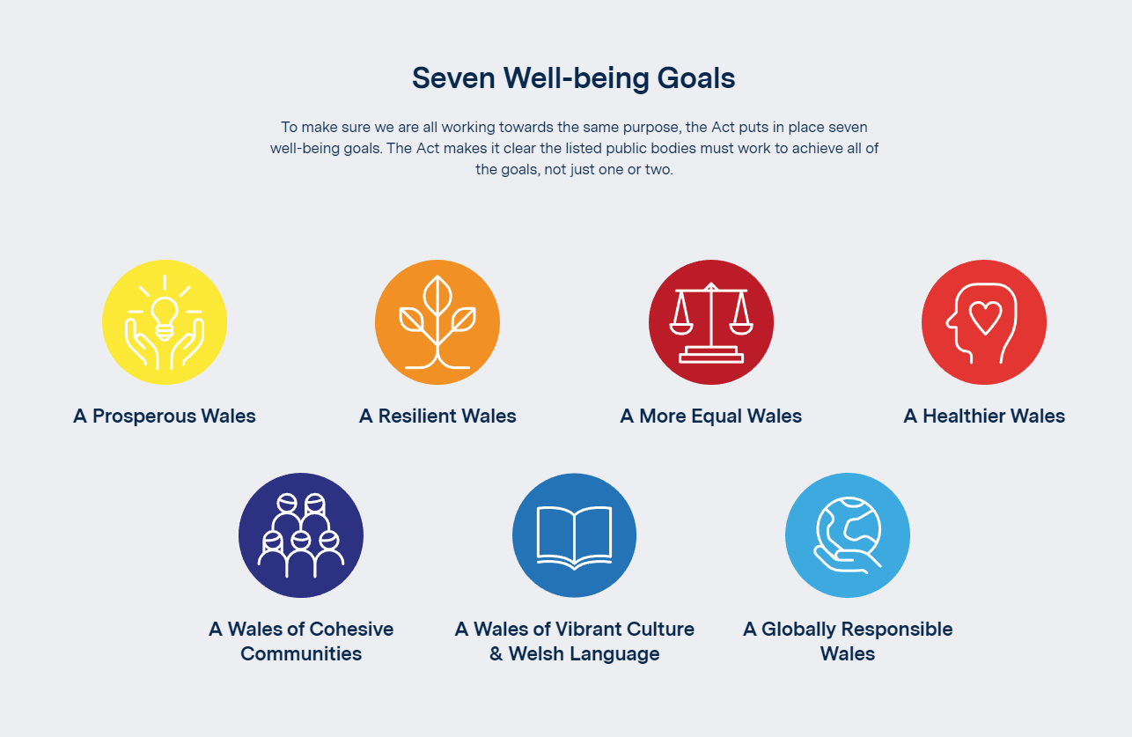
Figure 11 Seven Well-being Goals [10]
Lami’s Green Drivers framework does support compliance with the Well Being of Future Generations Act. Both the framework and act have the same goals in mind and want to ensure that steps are taken by organisations to improve both the environment and carbon footprint. Many of the goals within the well-being act can be applied to aspects of the green driver framework.

Ethical Issues

Ethical issues are important within any situation, but especially in project management. The bigger the project and the more people involved can often result in sometimes the ethics of the company/organisation being compromised, just to meet required deadlines. “However, when project managers and other stakeholders turn a blind eye to questionable activities, the results are often disastrous—blown budgets, legal trouble and even criminal charges are all too common in today’s business environment”. [11]
Within Student Services project, ethical issues are very important and should be acknowledged on a daily basis due to the kind of work that is conducted within the department. To analyse the key ethical issues which should be implemented within the department, the BCS (British Computing Society) Code of Conduct is going to be applied.

BCS Code of Conduct
“The British Computer Society (BCS) are a professional body that ensures that the legal, ethical and social issues within the IT industry are followed to ensure that the correct practices are being followed within the UK.” [12] The people who are members of the society are obliged to follow the code of conduct to meet the rules are regulations. “The BCS sets the professional standards of competence, conduct and ethical practice for computing in the United Kingdom. The Royal Charter incorporated the Society in July 1984.” [13] The code of conduct includes four regulations, which include Public Interest, Professional Competence and Integrity, Duty to Relevant Authority and finally, Duty to the Profession. These regulations are going to be analysed in relation to the student services project where relevant.

Public Interest

“Have due regard for public health, privacy, security and wellbeing of others and the environment.” [14]
The overall department should apply this regulation, due to the work that student services do. For the system, these have all been considered as result of the information that the system is going to hold on all the members of staff within student services and others. The privacy and security of the project has been met as separate login accounts and passwords were requested for the manager and staff members and also for the database where the data is contained.
“Have due regard for the legitimate rights of third parties.” [14]
The requested system by student services is going to have an impact on all involved. As a result any data collected on staff, colleagues and students should be respected and kept secure to ensure that the data is not unlawfully used.
“Conduct your professional activities without discrimination on the grounds of sex, sexual orientation, marital status, nationality, colour, race, ethnic origin, religion, age or disability, or of any other condition or requirement.” [14]
Any activity conducted within the department should ensure this regulation in place, due to the number of people who work and are involved within the department e.g. staff and students. Alongside this, the team who are developing the project have also certified that this would not be an issue with the creation of the system. A persons personal details can be set as preferred with any other requirements requested to ensure every individual involved is treated with dignity and respect.
“Promote equal access to the benefits of IT and seek to promote the inclusion of all sectors in society wherever opportunities arise.” [14]
Within the department, it should be ensured that all members have access to computer systems and the produced system. There are many different functions of the system and it is important for staff members to access it where required to add, modify or upload any information related to that member when required.

Professional Competence and Integrity
“Only undertake to do work or provide a service that is within your professional competence.” [14]
When the stakeholder met with the team and listed the requirements of the system, the team were then able to use that information and then explain to the stakeholder what the team could build based on the knowledge capacity of the team members. The team created the system through a programme and code that all were familiar with which allowed them to provide the best system possible based on all the team members capabilities.
“NOT claim any level of competence that you do not possess.” [14]
When building a requested system, it was important to not falsely inform the client of the capabilities of the team. Doing so would of cause issues for the development of the system and the communication between the team and the stakeholder. To do this could result in the team losing the contract or taking a considerable longer amount of time to complete the project.
“Develop your professional knowledge, skills and competence on a continuing basis, maintaining awareness of technological developments, procedures, and standards that are relevant to your field.” [14]
As a result of technology constantly growing and changing, it is vital for individuals within the industry to keep up to date with any updates or modifications. The development team are sure to monitor this as it is important in develop skills and knowledge within the specialised fields.
“Ensure that you have the knowledge and understanding of legislation and that you comply with such legislation, in carrying out your professional responsibilities.” [14]
In every job role there are certain legislations that should be followed by individuals, set by the organisations that those individuals work for. As a result of this the employees of student services and the members of ’Getitr IT’ should ensure that those regulations are learnt and followed.
“Respect and value alternative viewpoints and seek, accept and offer honest criticisms of work.” [14]
As a result of both the development team and student services working together and also with others, it needs to be ensured that every member involved respects one another. Every member should be able to express viewpoints and all aid each other when required if help is pursued.
“Avoid injuring others, their property, reputation, or employment by false or malicious or negligent action or inaction.” [14]
No malicious attack should be committed within the team or by the department. Every person involved is working together to complete the project and student services are in place to help and advice where required. It is important for no injury to be purposely inflicted in the work place.
“Reject and will not make any offer of bribery or unethical inducement.” [14]
Within a department like student services, this can be vital. The staff members are in place to help students where necessary, so it is important that the department never do this. Also the team can guarantee that this would never happen in the case of building the system. It would be completed per to the agreement with the stakeholder and would be delivered at the estimated agreed time also.

Duty to Relevant Authority
“Carry out your professional responsibilities with due care and diligence in accordance with the relevant authority’s requirements while exercising your professional judgement at all times.” [14]
Employees have many different responsibilities that have to fulfilled within a job role. As a result of this, what is asked of employees by employers must be completed to the best of that person’s ability. This applies to the development team and student services.
“Seek to avoid any situation that may give rise to a conflict of interest between you and your relevant authority. Accept professional responsibility for your work and for the work of colleagues who are defined in a given context as working under your supervision.” [14]
It is important when in a work place to avoid any confrontation where possible. If a disagreement was to arise within the development team, it would be resolved professionally and promptly. This would also be the case if a disagreement was to happen with the team and student services department. Every member would take responsibility for work conducted and respect the applicable authority when doing so.
“NOT disclose or authorise to be disclosed, or use for personal gain or to benefit a third party, confidential information except with the permission of your relevant authority, or as required by legislation.” [14]
When handling personal data, it is important for this to be followed. The development team are going to have access to the staff members personal details when the final system is produced. As a result of this, all team members should ensure information is confidential and also apply with the Data Protection Act 2018. This also applies to the stakeholder within student services, due to that individual having access to all personal data regarding other staff members.
“NOT misrepresent or withhold information on the performance of products, systems or services (unless lawfully bound by a duty of confidentiality not to disclose such information), or take advantage of the lack of relevant knowledge or inexperience of others.” [14]
When creating a product for client, it is vital that it any information regarding the system is disclosed to the client. If there in a performance issues or a bug within the system, the development team would ensure the relevant people were told and the issue would be resolved. The team are working together to complete the system so it can be presumed that neither of the members would take advantage and not disclose relevant information relating to the build of the system.

Duty to the Profession
“Accept your personal duty to uphold the reputation of the profession and not take any action which could bring the profession into disrepute.” [14]
The team should ensure that precautions are taken to certify that no damage is done to the overall team, its individual members and the work being undertaken.
“Seek to improve professional standards through participation in their development, use and enforcement.” [14]
The overall team are always looking to improve individual capabilities which aid the professional standards of the overall team. Alongside this, the student services staff members are continually completing new courses to improve certification levels. E.g. key skills.

“Uphold the reputation and good standing of BCS, The Chartered Institute for IT.” [14]
All work completed by both the team and the student services department is completed to the best of the individual’s abilities and ensures if any issues arise with the IT system, the team would resolve them promptly.
“Act with integrity and respect in your professional relationships with all members of BCS and with members of other professions with whom you work in a professional capacity.” [14]
A good communication level was required between the project management team and the student services department due to the system that was required. If any issues arose, the team could speak with the stakeholder and the staff easily to resolve the issue. It is vital to respect colleagues within a work place to aid in a successful completion of the system.
“Notify BCS if convicted of a criminal offence or upon becoming bankrupt or disqualified as a company director and in each case give details of the relevant jurisdiction.” [14]
If this was to occur to one of the individuals in the team or one of the staff members within student services, it is vital that if a person was to commit or being convicted, that it is reported to the necessary authority. As result of the department being an advising service for students within university it is important for the staff to disclose any relative information. If not, it could cause an unnecessary amount of problems for the people involved and the company. This stands for the development team also.
“Encourage and support fellow members in their professional development.” [14]
The team members all supported one another in the development of student services project. The team worked well together where required and aided one another when requested. This assisted the development process of the project to ensure a successful prototype was built.

Legal Issues

There are many different elements within legal issues that are required to be analysed within project management. The points that are applicable should be analysed so that if any legal issues were to arise, there is a plan in place to resolve them. Within computer law, there are three different aspects, which should be considered regarding legal issues. These consist of: -

- Data Protection / Privacy
- Intellectual Property - Copyright vs. Patents
- Computer Misuse [15]

7.0.1 Data Protection Act 2018
As a result of the growing rate of digital technology and how it affects people in nearly every aspect of everyday life, data protection was required to be updated due to the last Data Protection Act passing in 1998. The new Data Protection Act now includes the following elements: -
- “Makes our data protection laws fit for the digital age in which an ever-increasing amount of data is being processed.
- Empowers people to take control of their data.
- Supports UK businesses and organisations through the change.
- Ensures that the UK is prepared for the future after we have left the EU.” [16]
In relation to the student services project, every person involved are required to apply by the Data Protection Act regulations. A great amount of personal data is going to be handled by the department manager and the development team when creating the databased of all the necessary information.

7.0.2 Intellectual Property

“Intellectual property (or IP) refers to creative work which can be treated as an asset or physical property.” [17] There are four different aspects of intellectual property, Copyright, Trademarks, Design rights and Patents.
The development team creating the requested system will need to ensure that this is complied with, as the system is bespoke and has been created solely by the team. Because of this, intellectual property has not arisen an issue. The university details and logo have been included per request. If the system was to be developed further for another organisation, if a Patent was granted, these details would be eliminated, and the system would then be modified to meet the new requirements of the client.

7.0.3 Computer Misuse
To avoid any computer misuse issues, logins and passwords would be produced for every member involved within the department, which would hopefully aid in any computer misuse occurring. “The Computer Misuse Act is designed to protect computer users against wilful attacks and theft of information.” [18] Ensuring that those login credentials are put in place by the development team, should avoid hacking or unauthorised access occurring within the department.

General Data Protection Regulation
The General Data Protection Regulation (GDPR) was approved by the European Union (EU) Parliament on the 14th April 2016 and was then enforced on 25th May 2018 which replaced the Data Protection Directive 95/46/ec. The new regulation is now the new law to regulate how organisations protect EU citizens personal data. It was a requirement for companies who were already in compliance with the Data Protection Directive to ensure that the regulations of the GDPR were met before it came into force. If the regulations were not met, this resulted in the organisations receiving penalties and fines. The GDPR has been designed to: -
- “Harmonize data privacy laws across Europe,
- Protect and empower all EU citizens data privacy,
- Reshape the way organizations across the region approach data privacy.” [19]
The GDPR are aiming to produce a more consistent approach for the protection of both consumer and personal data within the EU nations. As result of the United Kingdom still being within the EU, it should be ensured that the requirements of the GDRP are met within the student’s union department. Below are the some of the main privacy and data protection requirements set by the GDPR that student unions should ensure are complied with.
- “Requiring the consent of subjects for data processing
- Anonymizing collected data to protect privacy
- Providing data breach notifications
- Safely handling the transfer of data across borders
- Requiring certain companies to appoint a data protection officer to oversee GDPR compliance.” [20]

Potential Overseas Sales

As a result of the student services department not requiring any oversea sales to be arranged, this is not a department legal issue. However, if an overseas organisation contacted “Getitr IT” to build a similar system or put an offer in to purchase the overall system, this could result in possible issues arising.
As a result of this being a possibility, a country has been chosen to compare with the United Kingdom based on culture dimensions. To do this Hofstede Insights Country Comparison is going to be applied, where the comparison of the six dimensions can be analysed on both India and the United Kingdom. The six dimensions include: -
- Uncertainty Avoidance
- Long Term Orientation
- Indulgence [21]

- Power Distance
- Individualism
- Masculinity
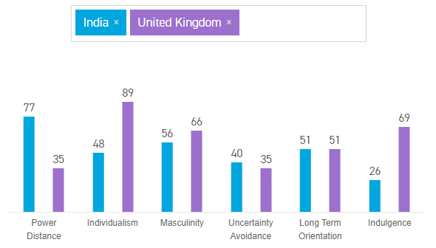

Figure 12 Country Comparison

The above figure was produced using the Hofstede Insights Country Comparison tool. Using this tool allows for a comparison to be conducted for these two countries based on the previously stated six dimensions.

- Power Distance
This particular dimension evaluates the countries attitudes towards individuals within society not being equals. There is quite a considerable difference between India and the United Kingdom (UK) for this dimension. With India having a ranking of 77, this shows that there is an appreciation for hierarchy in the organisation sense and society. The UK though have a lower ranking of 35 as the overall society believes that individuals should be treated as equals and that imbalances should be reduced.

- Individualism
This dimension indicates the level of independence individuals have within society and whether care is given to just family and friends or the people within the country. India and Britain ranked very differently in this dimension, with India scoring 48 and the UK scoring 89, which is “amongst the highest of the Individualist scores, beaten only by some of the commonwealth countries it spawned i.e. Australia and the USA.” [21] The individuals within the UK have been deemed as private people and children are taught from young that a purpose needs to be identified for the future and to look after no.1. India on the other hand is very different due to individuals wanting to be involved with a large social group and act in harmony with the group. Often an individual’s actions will be subjective to opinions of family and others, due to individuals fulfilling actions to please others and avoid being rejected.

- Masculinity
With regards to masculinity, this often results in that if a country has a high score that its society is pushed towards competing and accomplishing, and the need to be defined as the winner. Both India and the UK are scored as Masculine. With regards to India, it’s a result of the visual display that individuals show, clothes worn, jewellery showing ones success and control. In relation to the UK, people in its society live to work and aim to progress in performance and ambitions.

- Uncertainty Avoidance
Within this particular dimension, an analysation is based on how society is able to cope that the future cannot be predicted and that there is always going to be change. For this dimension, the scores are very close together with India scoring 40 and the UK scoring 35, situating the two at the lower end of the scale. There is an understanding with these countries that the future cannot be controlled and that sometimes plans required to be changed to new information arising.

- Long Term Orientation
This dimension analyses how the two societies preserve links with the countries past but also look to future and focuses on how challenges in the countries are handled at the time. Both India and the UK have the same ranking of 51 for this dimension, showing that society is very much in the middle regarding this issue, resulting in an uncertainty on how these two countries feel regarding this.

- Indulgence
Indulgence has often been an issue in the past and is very much a focus for the present and future. Socialisation is big part of human life and as a result, this dimension evaluates the amount to which individuals regulate both desires and impulses. Britain scored very high in this dimension with a score of 69, compared to India’s which is ranked at 26. The UK tend do what they like to do, regardless of money and have a very positive outlook on life, whereas India is much more restrained regarding this. Individuals are controlled and tend to not give in to desires and do not indulge, as it is viewed that is wrong to do so.

In relation to doing business with India and a potential for a sale to be completed on the student’s services system, the benefits of exporting to India have been analysed. These benefits include: -
- “English is widely spoken
- A common legal and administrative history
- Rising personal incomes creating a new middle-class consumer market
- Fast-growing economy with one of the world’s largest youth populations
- Expanding emerging cities with more than 50 cities now over a million people.” [22]
India is a particularly large company, due it currently having 29 states which is also an advantage due the market varying within those states. “India is one of the fastest growing economies in the world. The UK exported goods worth £6.35 billion to India and services valued at £2.24 billion in 2014, and the UK is the third largest investor in India.” [22] The risks of conducting with India, is that it can be price competitive and negotiation will be required to meet an agreed price. Alongside this, the import duty will should be considered, as it most likely a minimum of 35% after further taxes. Exchange controls are in place and any foreign money that is transferred from India must comply with the limitations inputted by the FEMA (Foreign Exchange Management Act).

Issues arising from Brexit
Britain voted in the UK referendum to leave the European Union on the 23rd June 2016. “There are essentially four phases to Brexit, namely 1) withdrawal, 2) future relations, 3) transition period and 4) approval. We are currently in Phase 1.” [23]
As a result of this, there are many different issues which project managers need to consider, in regards to Brexit. Below are some of the key considerations, specific to project managers.
- “Impact Assessments” [24]
A project manager must ensure that at this critical time, that the individual supervises any created scenario plans, impact assessments, strategies to deal with brexit and possibility strategies. Future decisions also need to be made and either be set in motion, postponed or integrated with the plans surround brexit.

- “Holistic Brexit Planning” [24]
Like every phase within management, planning is always required but must be thorough. For brexit planning, the customer, supply chains and the requirements for the ecosystem must be considered. There are some elements that are not within the manager’s control, but preparation should be conducted regarding third party willingness just as much as the elements which are internal.

- “Specific Brexit Tools” [24]
“Project managers also need to be aware of proprietary Brexit methodologies and tools.” [24] An organisation should ensure that tools or resources are developed which meet the requirements of the full life cycle of brexit. These should be based on principles of risk, ensure flexibility is a given element and a plan in place to react promptly to any change within the ecosystem of the organisation.
- “Portfolio Scenarios based on different Risk Profiles” [24]
Risks are always an element which need to be identified within any business, but especially for risks that brexit may arise within the organisation and also if the risks effect the individuals involved within the organisation. Alongside risks, the upside of brexit should be established, including prospects, competitive edge. Ensuring a clear indication is provided of both the good and bad points, this will allow the management to prepare and ensure scenarios are in place for when required.
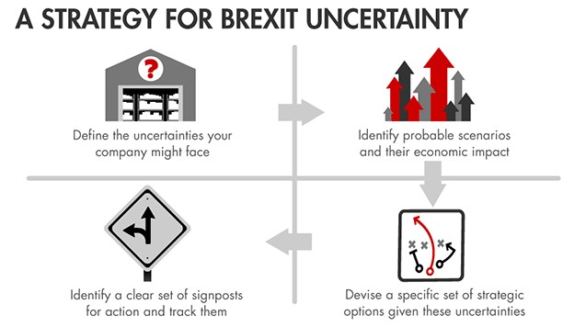
Figure 13 Brexit Strategy

References

[1] | R. Murch, Project Management: Best Practices for IT Professionals, 2001: Prentice Hall.
[2] | K. R. Bainey, Integrated IT Project Management: A Model-centric Approach, Norwood: Artech House, INC., 2004.
[3] | S. Ray, “The Risk Management Process in Project Management,” 19 October 2017. [Online]. Available: https://www.projectmanager.com/blog/risk-management-process-steps. [Accessed 23 April 2019].
[4] | J.M.Bryson, Visible Thinking: Unlocking Causal Mapping for Practical Business Results, John Wiley & Sons, Ltd, 2004.
[5] | “Project Management and Sustainability,” [Online]. Available: http://bricks.univ-lille1.fr/M08/cours/co/chap3_1.html. [Accessed 14 March 2019].
[6] | J. Tharp, “Project management and global sustainability,” 9 May 2012. [Online]. Available: Project management and global sustainability. [Accessed 25 April 2019].
[7] | “ISO 14001 ENVIRONMENTAL MANAGEMENT SYSTEM,” 2019. [Online]. Available: https://www.isoqsltd.com/iso-certification/iso-14001-environmental-management-certification/. [Accessed 11 April 2019].
[8] | “EPEAT Overview,” 2019. [Online]. Available: https://greenelectronicscouncil.org/epeat/epeat-overview/. [Accessed 11 April 2019].
[9] | “A Methodology to Derive Sustainability Indicators for Software Development Projects,” [Online]. Available: https://moodle.uwtsd.ac.uk/mod/folder/view.php?id=15071. [Accessed 29 April 2019].
[10] | “Well-being of Future Generations (Wales) Act 2015,” 2015. [Online]. Available: http://futuregenerations.wales/about-us/future-generations-act/. [Accessed 11 April 2019].
[11] | A. Catambay, “Ethical Issues in Project Management (& How to Deal with Them),” 13 June 2017. [Online]. Available: https://www.clarizen.com/ethical-issues-project-management-deal/. [Accessed 14 March 2019].
[12] | D. Adu, “The British Computer Society (BCS) and the Code of Conduct,” 13 November 2016. [Online]. Available: https://medium.com/@dadu_64294/the-british-computer-society-bcs-and-the-code-of-conduct-4efa47105a16. [Accessed 25 April 2019].
[13] | “BCS Codes of Conduct and Practice,” June 2010. [Online]. Available: https://www.cs.uct.ac.za/mit_notes/ethics/htmls/ch04s04.html. [Accessed 25 April 2019].
[14] | B. C. Society, “BCS Code of Conduct,” 2011. [Online]. Available: https://www.bcs.org/membership/become-a-member/bcs-code-of-conduct/. [Accessed 25 April 2019].
[15] | S. Maw, “Moodle UWTSD Legal and Ethical Issues Powerpoint,” 2018. [Online]. [Accessed 29 April 2019].
[16] | “Data Protection Act 2018,” 23 May 2018. [Online]. Available: https://www.gov.uk/government/collections/data-protection-act-2018. [Accessed 29 April 2019].
[17] | “Summary of intellectual property rights,” 2019. [Online]. Available: https://www.copyrightservice.co.uk/copyright/intellectual_property. [Accessed 29 April 2019].
[18] | “What is Computer Misuse?,” 2008. [Online]. Available: https://www.sqa.org.uk/e-learning/ITLaw01CD/page_03.htm. [Accessed 29 April 2019].
[19] | GDPR, “The EU General Data Protection Regulation,” 2019. [Online]. Available: https://eugdpr.org/. [Accessed 30 April 2019].
[20] | J. Groot, “What is the General Data Protection Regulation? Understanding & Complying with GDPR Requirements in 2019,” 26 April 2019. [Online]. Available: https://digitalguardian.com/blog/what-gdpr-general-data-protection-regulation-understanding-and-complying-gdpr-data-protection. [Accessed 30 April 2019].
[21] | “Country Comparison,” 2019. [Online]. Available: https://www.hofstede-insights.com/country-comparison/india,the-uk/. [Accessed 07 May 2019].
[22] | “Exporting to India,” 18 November 2016. [Online]. Available: https://www.gov.uk/guidance/exporting-to-india. [Accessed 07 May 2019].
[23] | D. Carson, “Planning for Brexit – a practical approach to project management,” 07 November 2017. [Online]. Available: http://www.engineersjournal.ie/2017/11/07/planning-for-brexit-ireland-practical-approach-project-management/. [Accessed 03 May 2019].
[24] | Ripley, A. Nulty, R., “HOW PROJECT MANAGEMENT CAN OVERCOME BREXIT UNCERTAINTY,” 11 January 2018. [Online]. Available: https://www.pmtoday.co.uk/articles/how-project-management-can-overcome-brexit-uncertainty/. [Accessed 03 May 2019].

9.0 Bibliography

- https://www.softwareadvice.com/resources/microsoft-project-pros-and-cons-for-smbs/
[Accessed 30/04/19]

- http://books.publishing.monash.edu/apps/bookworm/view/The+Project+as+a+Social+System%3A+Asia-Pacific+Perspectives+on+Project+Management
/171/OEBPS/c11.htm
[Accessed 01/05/19]
- https://www.sciencedirect.com/science/article/pii/S0959652614000250
[Accessed 03/05/19]
- http://www.big-dada.co.uk/2018/10/23/brexit-iod-event/
[Accessed 03/05/19]
- https://uk.practicallaw.thomsonreuters.com/4-500-8980?transitionType=Default&contextData=(sc.Default)&firstPage=true&comp=pluk&bhcp=1
[Accessed 06/05/19]
- http://www.doingbusiness.org/en/rankings
[Accessed 06/05/19]
- https://www.projectsmart.co.uk/project-management-success-with-the-top-7-best-practices.php
[Accessed 03/05/19]

