

University of Wales Trinity Saint David
School of Engineering

BSc AUTOMOTIVE ENGINEERING

Group Project & CAE

Gareth England

1702839

Group Project & CAE
M5X02204

Table of Contents
Introduction. 3
Research 4
Methodology 7
Analysis 8
Conclusion. 11
References. 12

Introduction.
My aim in this group project was to determine if and where aerodynamics would be a useful addition to the standard vehicle. By working as a team and taking into consideration other aspects of the vehicle it was determined that a full aerodynamic body wouldn’t be substantial enough due to the low top end speeds of the vehicle, therefore my focus was using aerodynamics to redirect as much airflow as possible over the batteries and motor for cooling purposes.
In order to achieve this data was collected from the Green power vehicle using measuring equipment such as a measuring tape, a rule, Vernier callipers and an engineer’s square. Then with the collected data a 3D model was created using Solidworks computer aided design software. This software can be used to model and create designs, but the software also features the ability to view flow dynamics across the model.

Research
Regulations.
T1.3. Motor cooling is only permissible using passive or forced air, without any prior energy input or power from batteries other than the main vehicle batteries.
T5.3. No part of the vehicle may extend more than 800 mm behind the centre point of the rear wheels.
T7.3. The skin of the driver’s cell in T7.2 must be constructed of rigid sheet material such as aluminium; rigid plastics; carbon fibre; glass reinforced plastic or other composites of at least 1.5 mm thickness. Plywood products must be at least 3 mm thick. The skin must form a continuous protective layer and be securely attached directly to the driver’s cell so as to be unlikely to fail as a result of an impact.
T10.5. Non-structural bodywork along with front and rear wheels must not be regarded as part of the roll protection. The top 150 mm of the roll bar must not have any fairing or other aerodynamic aid. See Fig 2.
T15.3. Battery retaining posts and sheet metal forming the battery tray may be removed/relocated/modified.
Note: Notwithstanding T1 & T2, any items other than the main Kit Car chassis may be modified/replaced/discarded.
(green power, 2019)
Batteries
Produced by Yuasa (Yuasa REC36)
Batteries are 12v AGM (Absorbent Glass Mat Batteries)
Discharge Temperature range -15°C to +40°C
3% Capacity loss per month
Float charge voltage at 20°C (V)/Block 13.65 (±1%)
Maximum Discharge Current 140 Amps per minute (Yuasa, 2014)
Batteries are standardized and cannot be changed for the competition.
 | VRLA Lead Acid | Lithium-ion
Energy Density (Wh/L) | 100 | 250
Cycle Life | 1,000 @ 50% Depth of Discharge | 1,900 @ 50% Depth of Discharge
Temperature Sensitivity | Degrades significantly above 25°C | Degrades significantly above 45°C
Efficiency | 60% @1-hr rate | 92% @1-hr rate
The optimum range for most general batteries requires operating near room temperature (15–35 ◦C). By keeping the temperature within a narrow optimum level, it helps to lengthen the battery pack lifetime.
Tayna Batteries, n.d
Altenergymag, 2012
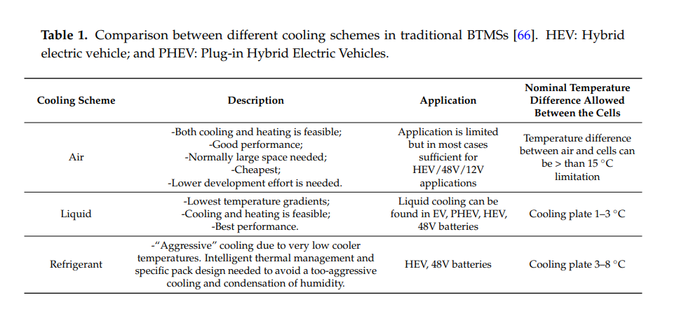 Mohammad Rezwan Khan (2017)

Abs Plastic
- High rigidity
- Good impact resistance, even at low temperatures
- Good insulating properties
- Good abrasion and strain resistance
- High dimensional stability (Mechanically strong and stable over time)
[ABS and its Features (2019)]
Properties of aluminium
- Light Weight
- Corrosion Resistance
- Electrical and Thermal Conductivity
- Reflectivity
- Ductility
- [Venkateshwarlu, Gudipati. (2014)]
Carbon fibre
- high tensile strength (3–7 GPa)
- high tensile modulus (200–935 GPa)
- compressive strength (1–3 GPa)
- compressive modulus (100–300 GPa)
- low density (1.75–2.20 g/cm3).
Bradley A. Newcomb,Han G. Chae (2018)]
Air Velocity is the measurement of the rate of displacement of air or gas at a specific location.
Air velocity (distance travelled per unit of time) is usually expressed in Linear Feet per Minute (LFM). By multiplying air velocity by the cross-section area of a duct, you can determine the air volume flowing past a point in the duct per unit of time. Volume flow is usually measured in Cubic feet per Minute (CFM).
[Air Flow Conversion Calculator (n.d)]
Aerodynamic drag equation: D = ½ρCAv²
Where:
D = Drag.
Ρ =Density of fluid (Air)
C = Coefficient of drag.
A = Area
v = Speed.
Glenn Elert (2019)]
First racing cars were primarily designed to achieve high top speeds and the main goal was to minimize the air drag. But at high speeds, cars developed lift forces, which affected their stability. In order to improve their stability and handling, engineers mounted inverted wings profiles1 generating negative lift. First such cars were Opel’s rocket powered RAK1 and RAK2 in 1928[1]. However, in Formula, wings were not used for another 30 years. Racing in this era occured on tracks where the maximum speed could be attained over significant distance, so development aimed on reducing drag and potencial of downforce had not been discovered until the late 1960’s[2]. But since then, Formula 1 has led the way in innovative methods of generating downforce within ever more restrictive regulations.
Air foil can be defined as a shape of wing, as seen in cross-section. In order to describe an air foil, we must define the following terms -
The mean camber line is a line drawn midway between the upper and lower surfaces.
The leading and trailing edge are the most forward a rearward of the mean camber line. 1Compared to an aircraft 2
The chord line is a line connecting leading a trailing edge.
The chord length is the distance from the leading to the trailing edge, measured along the chord line.
The camber is the maximum distance between mean camber line and chord line.
The thickness is the distance between the upper and lower surfaces. Figure 2: Air foil nomenclature The amount of lift L produced by the air foil, can be expressed in term of lift coefficient CL L = 1 2 ρ∞V 2 ∞SCL (1) where V∞ denotes the freestream velocity, ρ∞ fluid density and S the air foil area.
Gregor Seljak May 13, 2008

Methodology
In order to complete this assignment groups first needed to be allocated, this was completed by the course tutor. The first task of the group was to distribute the different responsibilities each participant would be undertaking. My chosen title was aerodynamics. Next the decision for team leader was made, this would be the person in the group who’s ideally the most organised and out going as the role involves arranging a lot of meetings and engaging with all team members.
The different tasks allocated were various aspects of a given green powered vehicle that could be upgraded or enhanced to improve the overall performance of the given vehicle. There were 5 members in the group at the beginning, one member took chassis design a second member took gear train a third member took wheels and a fifth member who ultimately dropped out took energy recovery systems and lastly, I investigated aerodynamics.
Once the tasks were given the next order of business was to have a team meeting with our course tutor and team leader so that the tasks were expressed correctly and that we had information about our subjects to be able to research them and begin our investigation.
Next was the introduction to the provided vehicle, this was a standard base model chassis provided by the university and supplied by green power. Then the vehicle had to be inspected and due to people previously using the vehicle it was damaged and had to be repaired, to which we found the vehicle was utilising parts that were not designed for it.
Now the green power vehicle had been repaired the vehicle was ready to be measured. measurements of the vehicle included the dimensions of the frame, suspension components, the tracking, rim diameter, material width, the motor and the batteries etc. The whole vehicle was measured so that mock designs could be made of the vehicle in Solidworks computer aided design.
After the vehicle had been measured a session was booked in the workshop to put the green power vehicle on the rolling road so that some working data could be recorded, the data that was most prominently recorded was the battery voltage and the rate of its discharge. This was achieved by measuring the voltage drop at select intervals and taking averages for a smooth graph.
Now with the relative collated data the models in CAD can be made and the vehicle can be adapted and upgraded with relation to the appropriate research and information to make the vehicle proficient.
To stay in contact in university the group arranged team meetings where the progress and information found was up to date. To touch base outside of university the team set up a group chat on Facebook where we could all chat and post updates, we also converged via email to transfer information and work. The scheduled meetings were at regular set intervals.

Analysis
Using the regulations as a guide a 3D model was created using Solid works, it was heavily influenced by the regulations as some designs would be against the regulations and would render the vehicle illegal to race. Such as the regulation that states no body panels can be added to the top 150mm of the roll bar, this influenced the design as one idea was to have tubing attached above the drivers head and directed down at the batteries and motor like the air intake ducting in F1 cars. Such as the image bellow.
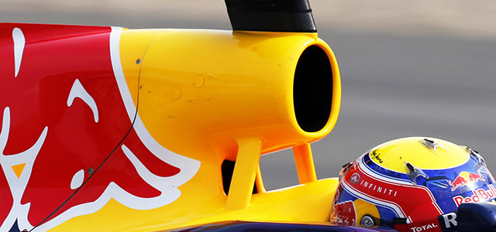
But due to regulations and safety concerns this design would be illegal and potentially dangerous.
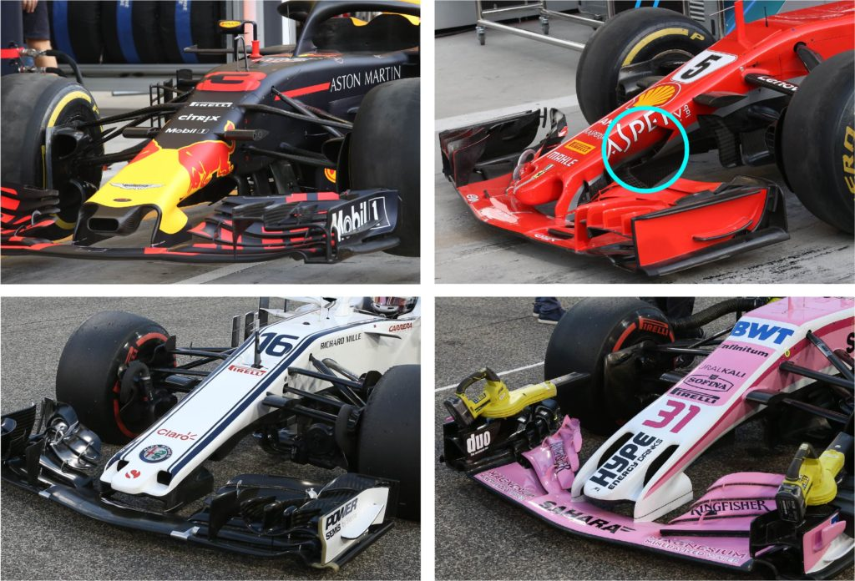
Due to formula one being the pinnacle of automotive engineering I researched further into their aerodynamic body and tried to design side vents on the rear half of the chassis that were similar to the cooling vents on the side of Formula one cars. Such as the image bellow.

The CAD designs produced are preliminary designs to show the idea that was planned, the back quarter of the chassis has an added sheet material vent that extrudes out to scoop air and redirect it towards the batteries and motor.
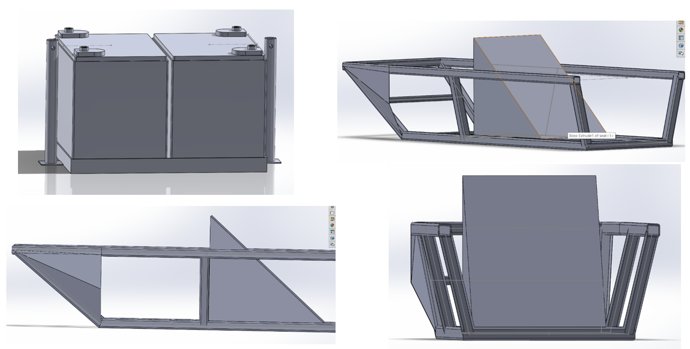
Later designs consisted of a more shapely model that would utilise the rear axel brackets by sitting right behind them and using the space and air flow behind them already. The designs below are the intended designs but due to complications using solidworks software I was unable to complete the designs for flow testing.

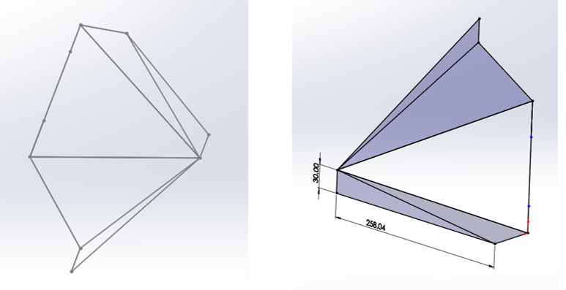
Further testing was planned for information to validate the reasons for adding these modifications. These tests would have included a flow dynamics simulation and real-life testing, such as running the vehicle on the rolling road with the fans on. This would allow the batteries and motor to run as they would in a race and temperature readings could be taken to prove that the modification is needed, this test was carried out, but the data was unusable and insufficient. Other tests could have consisted of creating a scale model and placing it into the wind tunnel.
Experimenting with using fans to force air across the batteries could also be done but as this is a university project the time and materials needed to test were unavailable. But tests such as fan placement and speeds could be tested.
With the added fans the batteries would have to be retested for the ability to be able to run the fan sufficiently. And how much quicker the batteries would discharge due to the added parasitic loads on them.
Once the design is finalized a real life model can be made. First a scale model should be made for testing purposes this would be made of materials such as card and blu tac just to test the designs effectiveness.
The real body design would be made of ideally aluminium. From the research aluminium is the best material its light weight strong enough for body panels but mailable enough to be reshaped if damaged during race conditions on a track test. Other materials considered were ABS plastic which was a strong light weight material but too brittle which makes it a potential danger due to it possibly shattering on collision. And another was carbon fibre which is a great material with amazing properties but is very costly and not mailable at all.

Conclusion.
The intentions for the assignment was to take a standard green power vehicle given to us by the university via green power and make different physical changes to improve the vehicles performance whether that relates to power, handling, longevity or cooling. These modifications were controlled by the stated regulations received by green power.
The improvements made to the vehicle would be developed using research, design, testing and modifying for the best final results. Throughout this investigation different designs have been discussed during meetings and conversations. These meetings entailed different opinions on the presented designs by other teammates and the team leader.
The vehicle was a base model provided by the University and even before the project started there were issues with the vehicle. Being a bare chassis there is lots of room for improvement and most modification designs could improve the vehicle regardless of initial testing.
Ultimately the modification made to the vehicle are theoretical due to final testing issues because of the covid-19 epidemic, not to mention that designing real life modification models are costly, timely and sometimes not possible.
Possible outcomes for this assignment would have been to run flow diagnostics on the CAD model designed to investigate the effectiveness and to modify it accordingly until the desired effect was reached, at this stage the next test would have been to make a scale model and to test in real life conditions using the wind tunnel.

References.
Dimic, Aleksandar & Miskovic, Zarko & Jelovac, Drago & Mitrovic, Radivoje & Ristivojevic, Mileta. (2016). Application of rapid prototyping in maxillofacial surgery. P. 4 https://www.researchgate.net/figure/Physical-and-mechanical-properties-of-ABS-plastic-ABS-plastic_tbl1_313240833
SpecialChem (2019) Acrylonitrile Butadiene Styrene (ABS) and its Features.
Available at: https://omnexus.specialchem.com/selection-guide/acrylonitrile-butadiene-styrene-abs-plastic#properties
(accessed: 26th November 2019)
Venkateshwarlu, Gudipati. (2014) “Evaluation of Mechanical Properties of Aluminium Alloy AA 6061(HE-20).”
Available at: https://www.semanticscholar.org/paper/Evaluation-of-Mechanical-Properties-of-Aluminium-AA-Venkateshwarlu/87a931fbbf096908bc6447ce772d0a743fd60561/figure/0
(accessed: 26th November 2019)
Bradley A. Newcomb,Han G. Chae (2018) “Handbook of Properties of Textile and Technical Fibres”
Available at: https://www.sciencedirect.com/science/article/pii/B9780081012727000213
(accessed: 26th November 2019)
N.A (n.d) “Air Flow Conversion Calculator”
Available at: https://www.engineering.com/calculators/airflow.htm
(accessed: 26th November 2019)
Glenn Elert (2019) “The Physics Hypertextbook”
Available at: https://physics.info/drag/
(accessed: 26th November 2019)
Mohammad Rezwan Khan, Maciej Jozef Swierczynski and Søren Knudsen Kær, Published: 16 March 2017, Towards an Ultimate Battery Thermal Management System: A Review. Department of Energy Technology, Aalborg University
Green power. (2019) technical and sporting regulations 2019. Available at: https://www.greenpower.co.uk/sites/default/files/uploads/Technical%20and%20Sporting%20Regulations%202019%20V1.2.pdf
(accessed: 5st November 2019)

