UNIVERSITY OF WALES
Trinity saint David
PROFESSIONAL CAREER DEVELOPMENT

BMSW4005_LON
Potential Career as a Registered Nurse

by
Olaniyi Taofeek Oladimeji
(2009509)
Course Lecturer: DR GULNAR ALI
2000 WORDS
AUGUST 2021
Table of Contents
1.0 Introduction…………………………………………………………………………………………………………………………………………...3
2.0The Johari window model……….………………………………………….……………….......4
3.0Personal SWOT Analysis…………………….….…………………………………………........5
4.0 Potential Professional Placement……………….……………………………………………….6
5.0Aim of My Career…………………………………………………….………………………….7
6.0Action Plan for Professional Development ……………………………………….…………….8
7.0Conclusion………………………………………………………………………………………....9
8.0References……………………………………………………………………………………...10
9.0Appendix1……………………………………………………………………………………...11
10.0Appendix2…………………………………………………………………………………….12
11.0Appendix3………………………………………………………………………………13

Introduction
To demonstrate the importance of employability within the context of development as far as the British Higher Education is concerned, universities in the country are being made to show what measures they take to ensure that the employability of their students are improved through the knowledge and skills imparted on the students (Knight et al, 2006). At the same time, the prevailing economic situation makes it increasingly crucial for graduates themselves to demonstrate in real terms the extent to which they are employable (Fitzgerald, 2010).
Knight et al (2006) speak of employability as a set of accomplishments comprising personal qualities, understanding and skills with which a graduate stands a very high chance of gaining employment and making a success of their chosen career, thereby benefiting not only themselves and the organisation they serve but also their communities and countries. Organisational awareness, technical capability and acumen, and cognitive skills are some of the prominent competencies that employers of labour have identified as being instrumental for improving employability (Kubler et al, 2006). Meanwhile, speaking in subject-specific terms, such skills as information technology, oral and written communication, collating and analysing information, problem-solving and decision-making, negotiation, team-based work, recognition of equal opportunities, and independent working, among others, are skills that have been identified as being in line with the student employability-related profile for Health Studies.
Be that as it may, the capacity to acquire and put the above skills into practice can be challenging for the many international students studying in the UK both at the undergraduate and postgraduate levels. Most of the students in question are not familiar with the accents of several of their lecturers nor are they able to adapt easily to the approaches through which teaching, and learning are conducted and the methods of assessing examinations (Burns, 1999). To mitigate these challenges and enhance the concerned students' employability, many UK universities organise post-study induction programmes for the students. However, the induction programmes are not usually reflective in nature, thereby necessitating that the individual students should evaluate themselves properly to determine how capable they are in the prospective career they want to undertake, their goals as well as how they should continue to improve on their capabilities and defeat both existing and potential career-related challenges (Treloar et al, 2010). The fact of the matter is that self-awareness is a very important factor as far as employability is concerned as it enables a person to have their skills and motivations reflected on and articulated. According to Rees et al (2007), an important approach for improving one's employability is using self-assessment grid mapping development against competencies as a prelude to stepping into the labour market.
Given my intention to become a registered nurse (RN), I hereby undertake a self-assessment of my competencies for the career by using the Johari Window Model and the SWOT analysis approach. I equally endeavour to come up with a potential professional development plan in anticipation of being employed as a registered nurse.

The Johari Window Model
The Johari Window is model of self-assessment that was developed in the 1950s by Joseph Luft and Harry Ingham, two disguised American psychologists who creatively coined the term Johari by putting together their first names. The use of this model as a self-assessment tool is suitable for the workplace where an individual takes advantage of the model in comprehending and influencing his self-awareness and personal development while, at the same time, enhancing interpersonal relationships and intergroup relations and team development. Therefore, the model is, in simple terms, about a particular worker's "self" and the "others" (colleagues) within the same organisation (Long, 2017).
The model is made up of four perspectives known as "quadrants", "areas" or "regions". Each perspective has and represents certain information that is known or known by the self-assessing subject or known or unknown by the subject's teammates. The four perspectives or regions are:
- Open area, open self, free area, free self, or "the arena": What is simultaneously known by the subject and his teammate about him (the subject)
- Blind area, blind self, or "blind spot": What the subject does not know about himself but is known by his teammates
- Hidden area, hidden self, avoided area or "façade": What the subject knows about himself but that is unknown by his teammates
- Unknown area or unknown self: What is simultaneously unknown by both the subject and his teammates
In my own case, however, I cannot yet use the Johari Window Model to assess myself as a nurse given the fact that such an assessment is based on the relationship a worker has with his co-employees. I am yet to become a nurse professionally so it is impossible to correctly ascertain what my potential colleagues will perceive about me. Be that as it may, I have used the Johari Window model to present below an assessment of myself in a former employment. The information in the assessment may be important in throwing light on how I could be perceived professionally in the future. It should be noted that the adjectives used in describing myself in the Johari Window are taken from the already state 55 adjectives associated with the model.

Arena  Amicable  Caring  Clever  Energetic  Responsive | Blind Spot  Adaptable  Bold  Cheerful  Confident  Dependable  Intelligent  Kind  Nervous  Organised  Spontaneous  Trustworthy
Facade  Accepting | Unknown  Calm, dignified, giving, independent, knowledgeable, logical mature, self-conscious, witty

Personal SWOT Analysis
SWOT analysis has to do with an approach commonly applied by organisation during their strategic planning. The acronym SWOT represents Strengths, Weaknesses, Opportunities, and Threats (Martins, 2019). While assessing myself in the context of my desire to become a registered nurse, I have used the SWOT analysis on a personal perspective to assess my strength and weaknesses in fitting into the nursing profession as well as possible opportunities and threats that I must profit from or contend with in the process of becoming a nurse. I should perhaps point out that my use of the SWOT analysis approach is not only to assess my capacity of becoming a registered nurse; it is equally for setting and planning my personal and professional goals in nursing. So, besides ascertaining my prospects of becoming a registered nurse based on my identified strengths and weaknesses, I will be able to identify potential nursing opportunities and threats that I must effectively manage to be able to have a successful entry into the nursing profession.
In the following table I have stated the outcome of the personal SWOT analysis as it concerns my chances of becoming a registered nurse. The qualities I have ascribed to myself are based on honest self-assessment.

Strengths  - I have communication and pro-people Skills that will facilitate my interactions with both professional colleagues and, particularly, patients.  - I am empathetic and compassionate; qualities that will enable me treat patients with diverse physical or psychological challenges.  - I am reliable and flexible, always being there whenever I am needed and ready to adjust to changes at short notice, especially as it concerns carrying out impromptu assignments.  - I am honest and trustworthy, always ready to accept my mistakes and not shielding any mistakes I notice others make.  - I have time management skills that will enable me attend to medical necessities according to the level of priorities. | Weaknesses  - I am easily emotionally attached as I may particularly break down at the sight of a critically wounded patient or a dead patient.  - I am incapable of working with body fluids. This means that I may feel uncomfortable handling such patients' body fluids as saliva and urine.  - If I encounter problems before talking too much work and cannot deliver high quality products on time, if I am too stressed in too many areas due to work overload
Opportunities  - There is a training workshop for enhancing the capacities of potential nurses.  - I want to focus on becoming an expert in my field once I have done it, I want to prepare myself for future promotional opportunities  - Nationwide employment of Registered Nurses is projected to grow 12 percent from 2018 to 2028 (Jividen, 2020). | Threats.  - Priority for job recruitment is not accorded registered nurses for now  - Competitors have innovative products or services, new competitors in the national market Adverse changes in reimbursements or regulations Changes in insurance plans and / or employer contracts in the main regions Competitors have better distribution channels

Potential Professional Placement
Professional placement has to do with the undertaking of a workplace placement by a student with a host organization as an obligatory requirement of the University's course being studied by the said student (Young, 2020). During the placement, I look forward to obtaining skills in various practical areas of nursing especially in clinical practice, one that is a major component and requirement to becoming a registered nurse. In addition, the time to be spent at the placement will boost my employability at the nursing sector as the opportunity will enable me to have a practical idea of what it would look like working within the context of modern healthcare system. Moreover, I will equally develop in me a combination of clinically oriented knowledge, confidence and skills that will help me truly become a part of the professional healthcare community.

Aim of My Career
Coming to the UK has exposed me to people from diverse cultural backgrounds as several peoples from disparate nationalities and cultures converge on the UK either to study or to work. I naturally like interacting with various categories of people. That is why I have chosen the nursing profession as it will provide me the chances of not only interacting but helping many persons irrespective of ethnicity, gender, or age. My aim of studying nursing is to have my knowledge increased and to involve myself in the practice of professional nursing. Indeed, my goal of eventually becoming a registered nurse has been motivated and inspired by both my previous education, and personal interests and experiences. In the long run, I hope to use the professionalism gained from the study to pursue a career where I will truly render services to diverse groups of persons. And from what I have been learned so far form the inception of this course health and social care , I gained a lot and this facilitate make it easy to progress with my ambition in the future and it will reflect on my career and make me more easy to achieve my goal.

Action plan for professional development
A professional development plan is a process whereby an employee collaborates with working closely with him in documenting the goals and skills that the employee needs to achieve uninterrupted career growth and development (DHR, 2021). In my own case, I have, as a potential nurse, come up with a standard professional development plan whose goals are specific, measurable, achievable, relevant, and timely (SMART). It should be noted that I am still looking forward to becoming a registered nurse and so the professional development plan is still work-in-progress. This means that I may still have to brush it up after being employed, in collaboration with my line manager.

My long-term goal | My Specific Career Goals | Vital Skills required for each Goal | Skills I must work on | Actions that I will take | Timelines for completing my Training
PROMOTION TO A DOCTOR OF NURSING (DNP) | Become part of nursing placement | Enhanced nursing capacities | Practical nursing | BSc in nursing | 6 months
 | Become a nurse practitioner (NP) | Advanced practice in nursing skills | Advanced nursing skills | MSc in Nursing (MSN) | 2 years
 | Become Certified Registered Nurse Anaesthetist | Advanced practice in nursing skills | Specialisation-related skills | Online training in advanced nursing practice | 1 year
 | Become a Doctor of Nursing | Advanced nursing skills  Organisational leadership skills  Nurse management skills | Capstone DNP project skills | Doctor of Philosophy (PhD) | 4 years

Conclusion
I have in this article stated my career intention to become a registered nurse (RN). To assess my competencies and skills for the career, I have undertaken a personal assessment of myself using the Johari Window Model and a Personal SWOT Analysis approach. I have equally endeavoured to generate a potential professional development plan. In reflection, I can say that most of the information I have provided are speculative since I am yet to be employed as a registered nurse, but they are based on integrity as they reflect qualities that I possess and that I have manifested in my previous experiences both as a student and as a casual worker. I am therefore confident that I can go into the nursing career as a registered nurse.

8.0 References
Duke Homan Resources (DHR, 2021), Professional Development Plan, https://hr.duke.edu/managers/performance-management/professional-development-plan Accessed 18 Aug 2021
Fitzgerald, P. (2010). Enhancing employability in a final-year undergraduate module using group work and peer assessment. Assessment, Learning and Teaching Journal, 10, 3-5
Jividen, S. (2020), Nursing Ranks & Levels Explained, https://nurse.org/education/nursing-hierarchy-guide/ Accessed 18 Aug 2021
Knight, P. & Yorke, M. (2006), Employability: Judging and Communicating Achievements. Learning and Employability Series, York: Higher Education Academy.
Kubler, B. & Forbes, P. (2006), Student Employability Profiles: A Guide for Employers. London: The Council for Industry and Higher Education
Long, C.E (2017), Reflection on the Johari Window, https://eloysiuschiang.wordpress.com/2017/08/06/reflection-on-the-johari-window/ Accessed 18 Aug 2021
Martin M. (2019), How to do a personal SWOT analysis, Business News Daily businessnewsdaily.com/5543-personal-swot-analysis.html Accessed 18 Aug 2021
Rees, C., Forbes, P. & Kubler, B. (2007), Student employability profiles: A guide for higher education practitioners. Accessed 18 Aug 2021, from http://www.heacademy.ac.uk/ourwork/teachingandlearning/employability
Burns, R.B. (1999). Study and stress among first year overseas students in an Australian University. Higher Education Research and Development, 10(1), 61 77

Strickland, K. (2019), SMART Goals in Nursing: 5 Examples, https://www.peoplegoal.com/blog/smart-goals-in-nursing-examples Accessed 18 Aug 2021
Treloar, C., McCall, N., Rolfe, I., Pearson, S.A., Garvey, G. & Heathcote A. (2010) Factors affecting progress of Australian and international students in problem-based learning medical course. Medical Education, 34, 708 715
Young, L. (2020), What to expect from your placement during nurse training, https://www.nurses.co.uk/blog/what-to-expect-from-your-placement-during-nurse-training/

APPENDICES

Appendix 1
Diagram of Johari Window Model

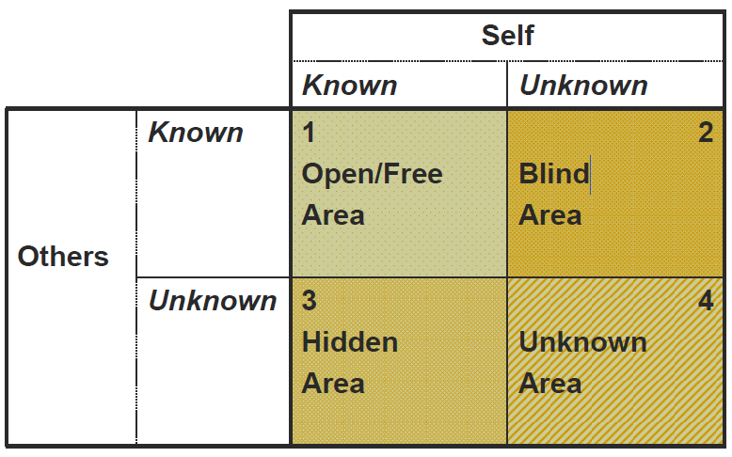

It is to be noted that initially the sizes of the regions or quadrants are the same, but they can change progressively to reflect changing proportion of knowledge of the subject available to him about himself or to his teammates about him.

Appendix 2
The 55 Johari Adjectives

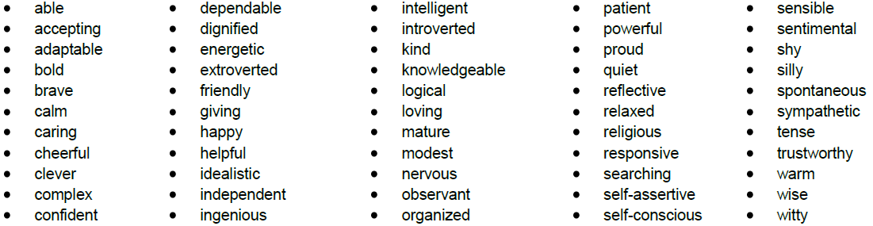
The following are the constant 55 so-called Johari Adjectives (written in alphabetical order) from which the subject is described based on any of the four suitable quadrants:

Appendix 3
Further Explanation on the SWOT analysis

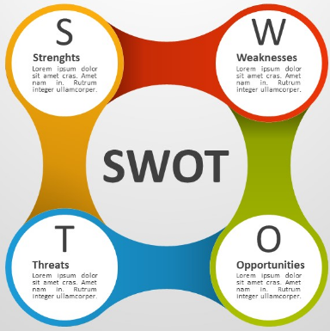

Strengths
In assessing himself, one should begin by broadly considering his strengths both about the organisation he may be engaged in and concerning other achievements he must have made in the past. The following questions have been recommended by Martin (2019) to be considered by the person assessing himself:
- What is he naturally good at?
- What could possibly distinguish him from others within his rank?
- What skills has he worked to develop?
- What are his talents or inborn gifts?
Weaknesses
Examining his weaknesses will enable a self-assessor to consider areas within himself that he has to improve on to better his career or to enhance his employability to a novel job. Again, the questions he may ask himself within this context are:
- What constitute his negative work habits and traits?
- Does any aspect of his education or training require being enhanced?
- What would others perceive as his weaknesses?
Opportunities
In this aspect of the SWOT analysis, a person assessing himself reflects on opportunities especially as they concern potential areas of growth and self-enhancement. Relevant questions for the self-evaluation within this context may include:
- What is the state of the economy?
- Is the industry the self-assessor belongs to experiencing growth?
- Is there new technology in your industry?

Threats
Threats usually come from external sources; that they are external factors that may negatively affects the goals of an individual or an organisation. For someone assessing himself the following questions are crucial to reflect on:
- Is the industry of the self-assessor changing direction or contracting?
- Is there strong competition for the types of jobs for which he is best qualified?
- What is the biggest external danger to his goals?

