Mercy Tshikombwe
Student number 24242792
Module code: LCHS4003
Title: introduction to Health and social care
Lecture: Azida Zainol
Assignment title Portfolio
Task one -Poster
Tasks two-Essay

Contents
Task 1 3
Task 2 Essay 4
NATIONAL HEALTH SERVICE 4
The National Health Service (NHS): Origins, Principles, and Contemporary Functioning 4
References 7

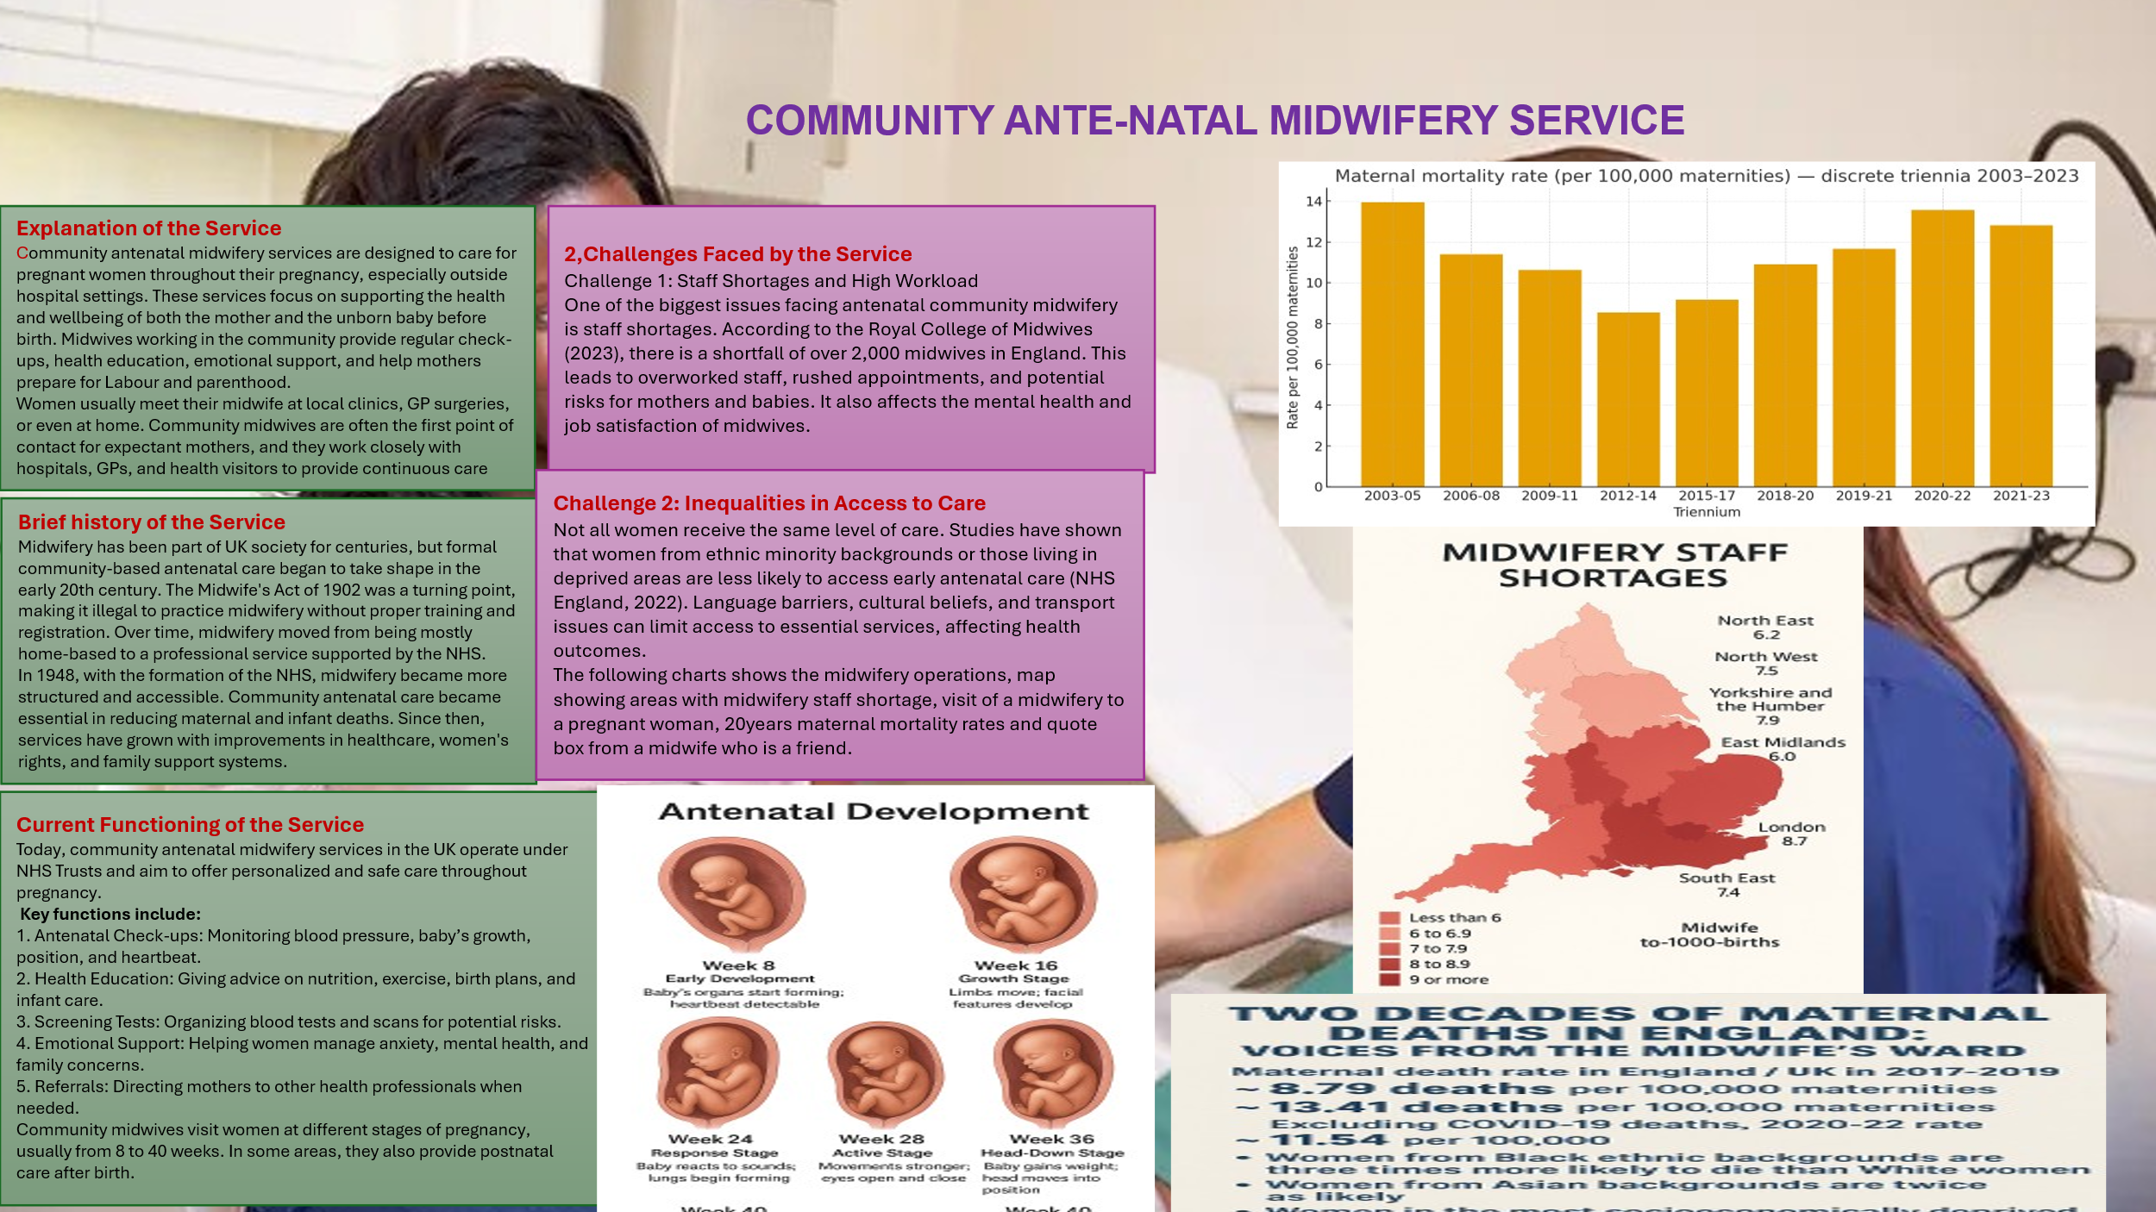
Task 1

Task 2 Essay

NATIONAL HEALTH SERVICE

The National Health Service (NHS): Origins, Principles, and Contemporary Functioning
The National Health Service (NHS) was established in 1948 as one of the most significant social reforms in British history. It aimed to provide comprehensive healthcare to all citizens, free at the point of use, regardless of income. Its development was rooted in the socio-political context of post-World War II Britain, where the population demanded greater social welfare and equity. This essay will discuss the origins and key principles of the NHS and critically examine its current structure and functioning, supported by credible sources.
Historical Context and Founding of the NHS
The NHS emerged in the aftermath of World War II, during a period when the British public was heavily impacted by economic hardship, health inequalities, and inadequate access to medical services. The Beveridge Report (1942), authored by economist William Beveridge, laid the ideological foundation for the NHS by identifying “five giants” on the road to post-war reconstruction: want, disease, ignorance, squalor, and idleness (Timmins, 2001). Beveridge proposed a welfare state where the government would take responsibility for citizens' health, education, and well-being.
The Labour government, elected in 1945 under Clement Attlee, took significant steps to implement these recommendations. Aneurin Bevan, the Minister of Health, led the creation of the NHS in 1948, nationalizing hospitals and integrating general practitioners, dentists, and opticians into one system (Webster, 2002). Bevan famously stated that the NHS would be “free at the point of use, based on clinical need and not the ability to pay” (NHS England, 2019).
Key Principles of the NHS
The NHS was founded on three core principles: it should meet the needs of everyone, be free at the point of delivery, and be based on clinical need, not the ability to pay (NHS Constitution, 2023). These principles are enshrined in the NHS Constitution and guide the service to this day.
Over time, additional principles have been added to reflect changing priorities, including respect for patients' rights, commitment to quality care, and value for taxpayers' money (Department of Health and Social Care, 2021). The emphasis on equity and universal access continues to distinguish the NHS from many healthcare systems worldwide.
Current Structure and Functioning of the NHS
The modern NHS operates across four devolved nations—England, Scotland, Wales, and Northern Ireland—each with its own administrative structure. In England, the NHS is overseen by the Department of Health and Social Care and operated through NHS England, which manages funding, sets strategic direction, and commissions services via Integrated Care Systems (ICSs) (Kings Fund, 2023).
While the NHS remains a symbol of national pride, it faces numerous challenges. Increasing demand from an ageing population, chronic underfunding, workforce shortages, and long waiting times have raised concerns about sustainability (Appleby et al., 2022). The COVID-19 pandemic further exposed structural weaknesses, including poor integration between health and social care (British Medical Association, 2023).
Reforms such as the Health and Care Act 2022 aimed to improve collaboration across services, but critics argue that marketisation and outsourcing threaten the NHS’s founding values (Pollock et al., 2022). There is an ongoing debate about balancing public funding with efficiency and modernization, especially amid budget constraints.
Conclusion
The NHS, born out of a vision for social equality and universal care, remains a cornerstone of British society. Founded in 1948, it was rooted in a commitment to free, accessible healthcare for all. Although the NHS continues to adhere to its core principles, it faces complex challenges in the 21st century. Sustainable funding, structural reform, and political commitment will be essential to ensure its longevity and integrity.

References
(UWTSD Harvard Style)
Borsay, A. and Hunter, B. (2012) Nursing and Midwifery in Britain Since 1700. London: Palgrave Macmillan.
Department of Health and Social Care. (2023) Women’s Health Strategy for England. London: GOV.UK. Available at: https://www.gov.uk/government/publications [Accessed 12 Oct. 2025].
National Institute for Health and Care Excellence (NICE). (2021) Antenatal care for uncomplicated pregnancies. Available at: https://www.nice.org.uk/guidance [Accessed 12 Oct. 2025].
(NHS England, 2022)
NHS England. (2022) Equity and equality: Guidance for local maternity systems. London: NHS. Available at: https://www.england.nhs.uk [Accessed 12 Oct. 2025].
NHS. (2024) Antenatal care - NHS. Available at: https://www.nhs.uk/pregnancy [Accessed 12 Oct. 2025].
(Royal College of Midwives, 2023)
Royal College of Midwives. (2023) State of Maternity Services Report 2023. London: RCM. Available at: https://www.rcm.org.uk [Accessed 12 Oct. 2025].

References
Appleby, J., Dayan, M. and Thompson, J., 2022. NHS pressures and performance. The King's Fund. [online] Available at: https://www.kingsfund.org.uk/publications/nhs-pressures-performance [Accessed 12 Oct. 2025].
British Medical Association (BMA), 2023. COVID-19 and NHS: Learning from the pandemic. [online] Available at: https://www.bma.org.uk/media/6216/bma-covid-19-review-report.pdf [Accessed 12 Oct. 2025].
Department of Health and Social Care, 2021. The NHS Constitution for England. [online] Available at: https://www.gov.uk/government/publications/the-nhs-constitution-for-england [Accessed 12 Oct. 2025].
Kings Fund, 2023. How is the NHS structured?. [online] Available at: https://www.kingsfund.org.uk/publications/how-is-nhs-structured [Accessed 12 Oct. 2025].
NHS England, 2019. The NHS Long Term Plan. [online] Available at: https://www.longtermplan.nhs.uk/ [Accessed 12 Oct. 2025].
Pollock, A., Roderick, P. and Godlee, F., 2022. The NHS and the Health and Care Act 2022: A step toward fragmentation. BMJ, [online] 377, p.o1245. Available at: https://www.bmj.com/content/377/bmj.o1245 [Accessed 12 Oct. 2025].
Timmins, N., 2001. The Five Giants: A Biography of the Welfare State. London: HarperCollins.
Webster, C., 2002. The National Health Service: A Political History. Oxford: Oxford University Press.

