  Component One:  What are the key skills required when working in the housekeeping team? 750 words (+/-10%)  Contribution to Overall Module Assessment: 25% | Student No: | 2131514
 | Module Title: | Operating Hotel  Facilities
 | Module Code: | BMIH4006
 | Lecturer: | Tristan Hawkins
A hotel needs regular cleaning and maintenance, which is referred to as "housekeeping." Cleaning services should always prioritise the health and comfort of its visitors and residents. Cleaning and sanitising guest rooms and bathrooms, making beds, dusting surfaces, vacuuming carpets, wiping floors, and arranging storage spaces are all part of housekeeping's broad purview. Housekeepers ensure that the hotel's common facilities, such as the lobby, dining halls, swimming pools, and elevators, are always clean and presentable for guests. Furthermore, they may be responsible for doing deep cleanings of the building as necessary, handling the laundry and linens, and restocking the supplies (Jones, 2017).
Housekeepers should follow all health and safety procedures to reduce the risk of illness and injury. All day, every day, employees in the cleaning department need to be able to talk to customers and one another. The housekeeper's role includes responding to guest complaints and helping to resolve them. They also need to be able to effectively manage their time and responsibilities, and they must be able to contribute effectively as a team player.
Due to the long periods of standing, walking, bending, reaching, and lifting involved in keeping a clean house, good physical fitness is essential (Hayes, Ninemeier and Miller, 2017). Housekeepers are held to a very high degree of quality and efficiency, even in the busiest of settings. Employees that work in housekeeping are essential to any hotel or other hospitality establishment. They play a crucial role in guaranteeing that visitors have a nice time and making the space they spend time in comfortable and enjoyable.
Attention to detail
When cleaning guest rooms, common areas, and communal spaces, housekeepers are expected to pay close attention to every little detail (Hayes, Ninemeier and Miller, 2017). They need to be able to see even the smallest issues and resolve them efficiently.
Time management
Housekeepers must be efficient with their time if they want to keep up appearances. The items on the to-do list should be prioritised, and this should be a skill they possess.
Physical fitness
Housekeepers have to be on their feet alot, crouch, reach, and lift things when cleaning, it might be considered strenuous. Housekeepers are expected to be in good health and able to carry out their responsibilities without any problems.
Communication skills
A good housekeeper's communication skills are essential not just while interacting with guests, but also with management and other staff members (Gray and Liguori, 2016). Excellent communication skills are essential for providing first-rate customer service and resolving any difficulties that may occur.
Organisation
Cleaners are expected to adhere to a certain routine and work quickly and precisely. They must be able to clean following predetermined protocols and procedures, as well as maintain an inventory of cleaning materials and equipment.
Problem-solving
Housekeepers that excel at their jobs can think critically and creatively to find solutions to any issues that may occur. They must be able to think outside the box when faced with a cleaning problem.

Team player
Being able to collaborate with others and identify areas of agreement is crucial in the position of a housekeeper (G Raghubalan and Smritee Raghubalan, 2015). They are responsible for the day to day performance of housekeeping team members.
Customer service
Those who work in housekeeping need strong people skills to handle the inquiries and concerns of guests. Always maintain an air of professionalism while being kind and accessible.
Flexibility
Housekeepers need to be adaptable, quick learners, and able to perform well under pressure and in a high-volume setting. They need to be able to adjust to varying shift lengths and be available for work at various times.
Dependability
Housekeepers are required to be dependable workers who consistently up for shifts on time and are prepared to do their jobs (Chakravarti, 2018). To top it all off, they need to be reliable and capable of fulfilling their obligations and responsibilities.
Honesty and integrity
Housekeepers should be reliable people who can protect the privacy of their guests. Consistently and professionally, they should carry themselves.
Basic cleaning skills
Any competent housekeeper must have solid proficiency with a variety of cleaning supplies and equipment, as well as a solid familiarity with basic cleaning practices. They must also be able to adhere to all regulations about health and safety (Brody, 2016).
In conclusion, cleaning is an essential aspect of the hospitality industry because it helps provide an environment that is neat, comfortable, and welcoming to guests. Members of the cleaning crew require a range of skills, from technical knowledge to physical prowess, to be successful in their roles. These include, but are not limited to, the capacity to pay careful attention to detail, efficiently manage their time and give outstanding customer service.
Word Count | 794

Component Two

Contribution to Overall Module Assessment: 25%
In this scenario – You have just been promoted to team leader for a floor within the hotel. A guest complains that on their arrival, their room had not been properly cleaned. Create an action plan and answer the following questions.

Problem | Why did it happen? | What are you going to do? | How will you prevent this from happening in the future? | What measures would you introduce to improve team effectiveness?
One of the visitors expressed their displeasure to the other guests that the room they first booked into was not adequately cleaned when they arrived. | To get to the bottom of what's causing the problem, it will be required to carry out a comprehensive investigation of the cleaning procedures and practices that are currently being used. Because of this, it will be easy to ascertain whether there are any prospective areas of concern (Wood, 2017).  It is possible that the cleaning crew does not have enough supervision, and it is also possible that they do not have adequate training. Both possibilities are plausible.  It is also possible that there are not enough personnel, which would force the cleaning staff to go more quickly through their jobs (Singh, 2016). If this were the case, the situation would be quite urgent. If there is not sufficient time, the cleaning crew will be required to do their tasks more expediently. | Apologise to the guest for the problem that has been caused and provide a solution to make up for the trouble that has occurred caused, such as an upgrade in their room or a meal on the house, as appropriate, to make up for the trouble that has been caused.  Visit the problematic room and do a thorough examination there to validate the guest's allegation and address any issues or concerns that may discover there.  It is critical to offer the cleaning staff additional training and guidance to raise their awareness of the necessity of thorough cleaning and ensure that they have a clear understanding of the level of performance that is expected of them (S Medlik and Hadyn Ingram, 2017). | If visitors want to be sure that the cleaning staff is providing the kind of service they want, visitors need to put in place a system of checks and balances to make sure they are.  Consistent training and teaching for the cleaning staff are critical for instilling the importance of thorough cleaning in their minds and keeping them abreast of developments in cleaning practices and standards (Srivastava, 2017).  One may reduce the possibility of employees rushing through their tasks by increasing the number of persons involved in the cleaning process or by giving them more time. | It would be beneficial for the cleaning crew to get coaching and feedback regularly since this would help them realise their full potential as workers (SUFI, 2019).  It is essential to cultivate an atmosphere that encourages open communication and respect for one another if one wants to guarantee that every member of the team is doing their weight.  .
The carpet exhibits several different indicators of wear and strain. | Finding the source of the issue and developing a remedy will be made easier if visitors investigate the foot traffic patterns on the floor and identify any areas that have a larger amount of people walking through them (Rai, 2020).  There might be several causes for this, including high-traffic areas, inadequate upkeep, or improper cleaning procedures. | Investigate the area that was affected to ascertain the entire extent of the damage that was done.  If necessary, either the damaged carpet should be repaired or replaced altogether.  To get to the bottom of the problem and ensure that the carpet will continue to get the necessary level of care in the years to come, visitors will need to develop a maintenance contract and put it into place (O’fallon and Rutherford, 2019). | To guarantee that the carpet is properly cleaned and maintained at all times, you should devise and adhere to a regular cleaning and maintenance program.  Develop a strategy for managing traffic to lessen the strain that is imposed on areas that have a lot of foot traffic.  The personnel responsible for cleaning the carpet should get training to reduce the possibility of harming the carpet while preserving its quality. | Providing the cleaning staff with regular feedback and coaching would help them reach their full potential as employees.  To make sure everyone on the team is doing their weight, it's crucial to foster an environment of open dialogue and mutual respect (Rutherford, 2016).  Provide the cleaning staff with opportunities for training and advancement so that they may grow professionally.  Establishing a system of recognition and awards is necessary to motivate and involve the cleaning staff.
Various Stained Areas Throughout the Upholstery | Figure out what's wrong by taking note of how the pieces are used and noting any spots which appear to be more deteriorated than others (Nitschke and Frye, 2013).  The possibility that accidents, lax cleaning, or neglect are to blame for the problem. | The full amount of the damage can only be known after a thorough examination of the region.  The need to clean or repair upholstery often arises in response to the presence of stains or damage.  Plan regular care of the upholstered furniture to identify the cause of the issue and ensure it is fixed permanently (Mary Elizabeth Palmer, 2019). | Create a routine of cleaning and upkeep to guarantee the upholstery is properly cared for.  Make sure visitors get a cleaning service that knows how to clean without harming the furniture.  Utilisation management strategies may help reduce congestion in busy places. | Maintaining a steady program of coaching and review may help the cleaning staff reach their full potential.  Regular team meetings help keep everyone on the same page and provide their best efforts for the project at hand (Mary Elizabeth Palmer, 2019).

Component Three
Contribution to Overall Module Assessment: 50%
Your task is to create and prepare a presentation following the detailed scenario provided below.

As the floor housekeeping manager and given the recent guest complaints you need to put together a basic training presentation for your colleagues within the housekeeping team to get the best out of them, ensure that brand standard is being achieved and that Health and Safety procedures are also being followed.
Housekeepers should follow all health and safety procedures to reduce the risk of illness and injury. All day, every day, employees in the cleaning department need to be able to talk to customers and one another. The housekeeper's role includes responding to guest complaints and helping to resolve them. They also need to be able to effectively manage their time and responsibilities, and they must be able to contribute effectively as a team player.

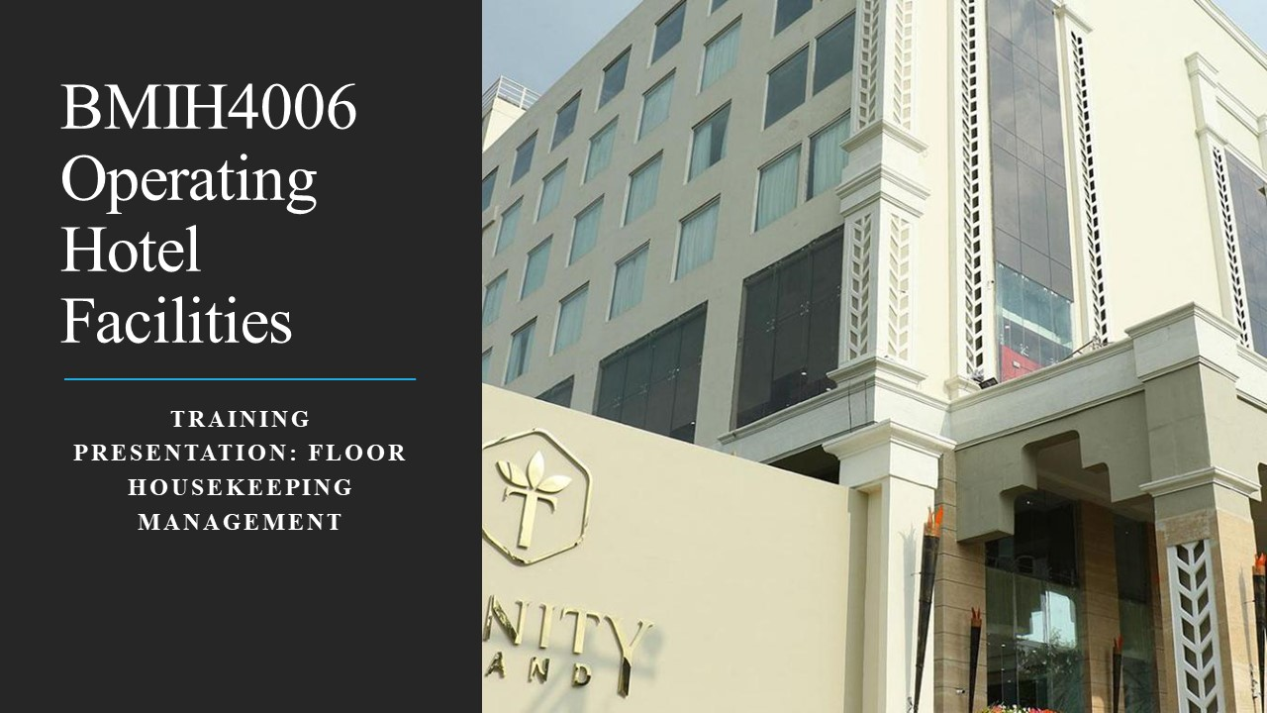

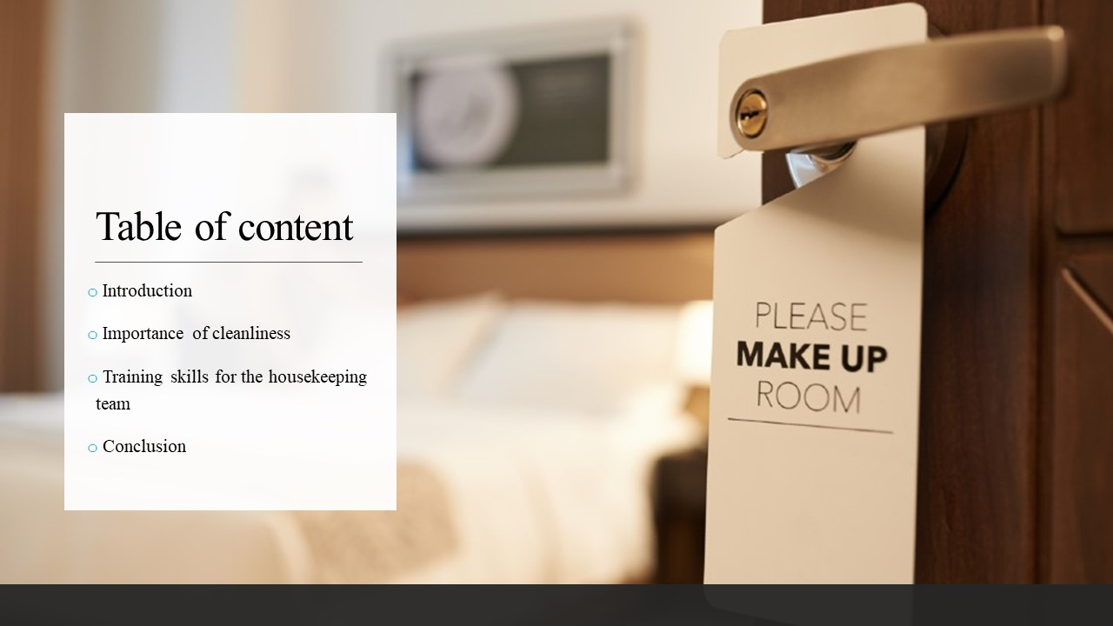

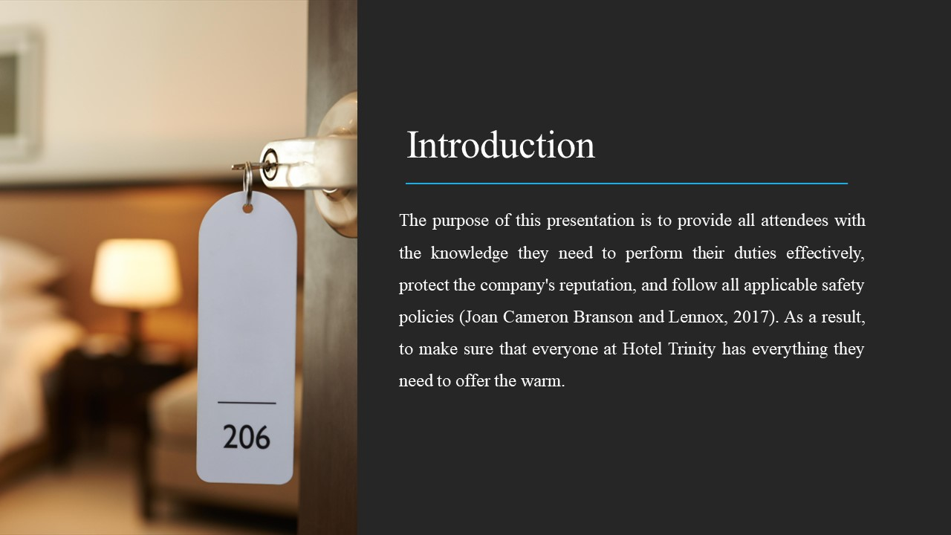

Training Notes: Welcome to join me in a training and skill development presentation for Hotel Trinity's housekeeping team. The purpose of this presentation is to provide all attendees with the knowledge they need to perform their duties effectively, protect the company's reputation, and follow all applicable safety policies (Joan Cameron Branson and Lennox, 2017). As a result, to make sure that everyone at Hotel Trinity has everything they need to offer the warm, friendly service that the regulars have come to expect and to maintain the hotel appearance and feel as great as it does.
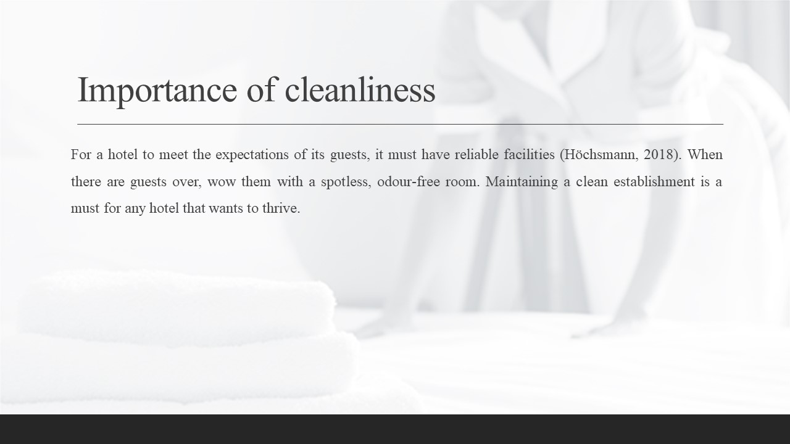

Training Notes: In a nutshell, a venue's cleanliness level has a direct impact on the level of satisfaction and loyalty it receives from its clientele. For a hotel to meet the expectations of its guests, it must have reliable facilities (Höchsmann, 2018). When there are guests over, wow them with a spotless, odour-free room. Maintaining a clean establishment is a must for any hotel that wants to thrive. The hotel's reputation may be affected by how well it maintains its cleanliness and sanitation standards, which will have a greater influence on guests than ever before.
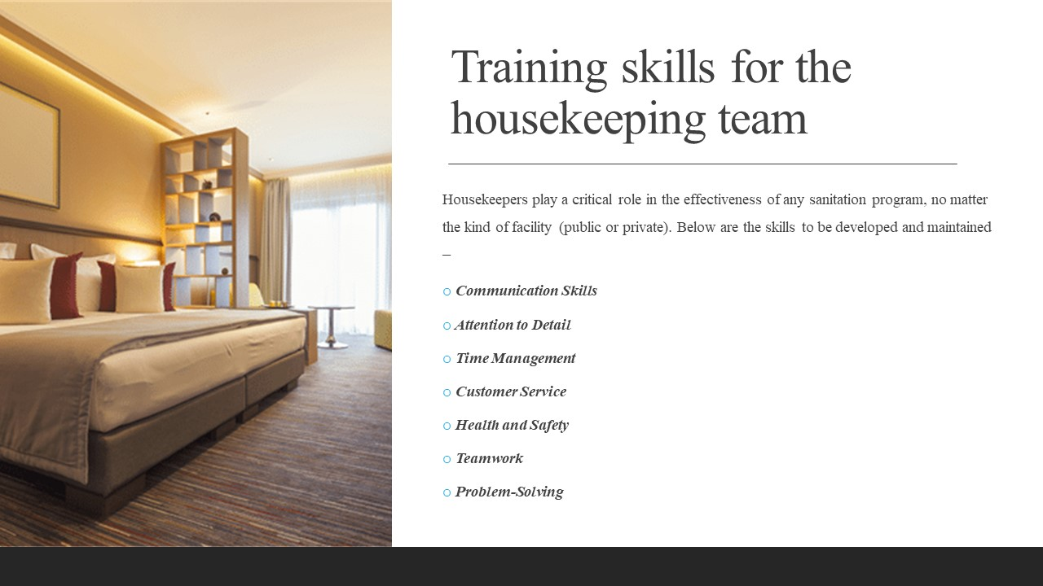

Training Notes: Housekeepers play a critical role in the effectiveness of any sanitation program, no matter the kind of facility (public or private). An excellent housekeeper has several qualities, such as attention to detail and the capacity for orderliness (Hayes, Ninemeier and Miller, 2017). A hospital, for example, may have strict cleaning requirements that a housekeeper must follow to guarantee that patients are cared for in a clean and hygienic atmosphere. As the floor housekeeping manager and given the recent guest complaints there need to put together a basic training presentation for their colleagues within the housekeeping team to get the best out of them, ensure that brand standard is being achieved and that Health and Safety procedures are also being followed. feeling of ownership over the space might be improved with a rewards system.

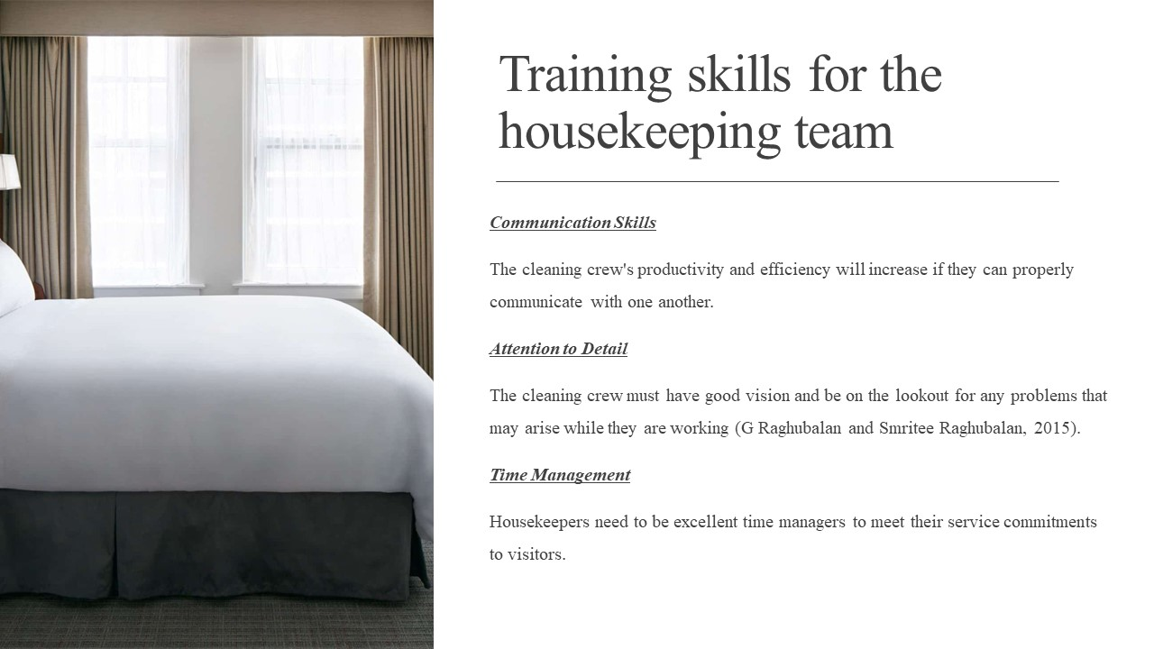

Training Notes:
Communication Skills
The cleaning crew's productivity and efficiency will increase if they can properly communicate with one another. The team, its guests, and the other teams must always have open lines of communication. The team members must be educated in the art of interacting with others and the art of serving customers well.
Attention to Detail
The cleaning crew must have good vision and be on the lookout for any problems that may arise while they are working. This includes instructing on how to make beds, clean bathrooms, and vacuum carpets, as well as the appropriate use of cleaning tools, equipment, and supplies.
Time Management
Housekeepers need to be excellent time managers to meet their service commitments to visitors. Team members should be taught to work effectively, with little wasted time.

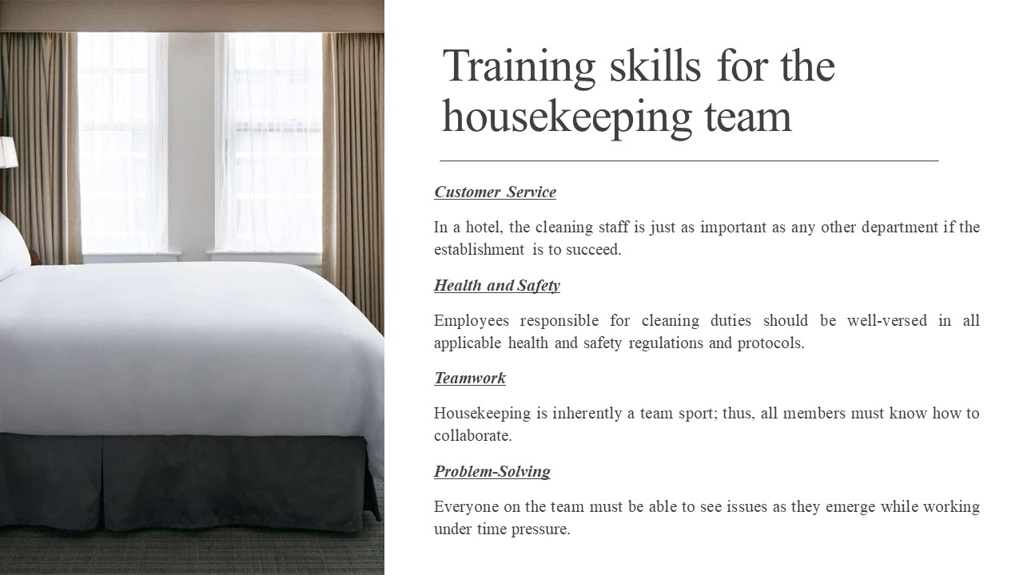

Training Notes:
Customer Service
In a hotel, the cleaning staff is just as important as any other department if the establishment is to succeed. Employees need instruction on the value of customer service, how to deal with visitors professionally, and how to address complaints from customers (Chibili et al., 2019).
Health and Safety
Employees responsible for cleaning duties should be well-versed in all applicable health and safety regulations and protocols. Those in charge of maintaining a clean environment in the facility should have no question in their minds about the critical nature of adhering to all safety regulations and utilising all cleaning chemicals, equipment, and supplies in the ways that have been specified.
Teamwork
Housekeeping is inherently a team sport, thus all members must know how to collaborate. In this course, students learn the value of cooperation as they work together to solve problems and divide and conquer (Chakravarti, 2018).

Problem-Solving
Everyone on the team must be able to see issues as they emerge while working under time pressure. To help customers pinpoint issues, brainstorm potential solutions, and put those ideas into action, a plan will be laid out.

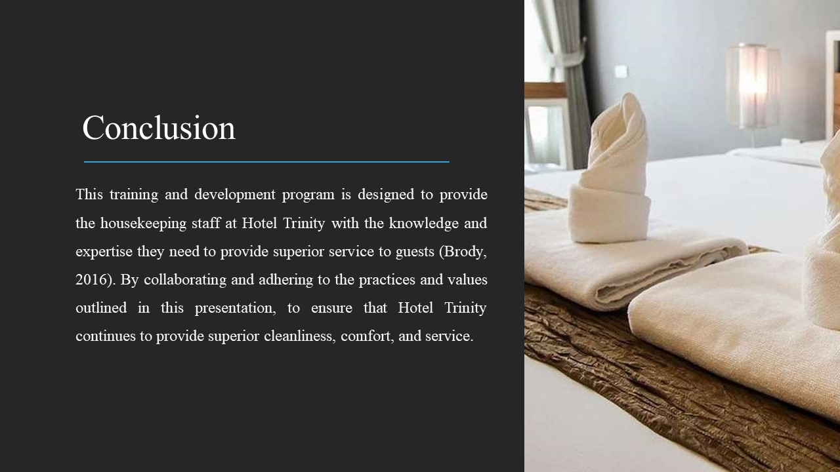

Training Notes: This training and development program is designed to provide the housekeeping staff at Hotel Trinity with the knowledge and expertise they need to provide superior service to guests (Brody, 2016). By collaborating and adhering to the practices and values outlined in this presentation, to ensure that Hotel Trinity continues to provide superior cleanliness, comfort, and service. Those in charge of maintaining a clean environment in the facility should have no question in their minds about the critical nature of adhering to all safety regulations and utilising all cleaning chemicals, equipment, and supplies in the ways that have been specified. The housekeeping workers should benefit from being provided training and other educational possibilities. Make sure that the people in charge of cleaning have access to chances for training and promotion so that they may develop professionally. To encourage and engage the members of the cleaning team, it is important to devise a system of prices and recognition.

References

Brody, D. (2016). Housekeeping by Design. University of Chicago Press.
Chakravarti, B.K. (2018). Hotel management. New Delhi: A.P.H. Pub. Corp.
Chibili, M.N., de Bruyn, S., Benhadda, L., Lashley, C., Penninga, S. and Rowson, B. (2019). Modern hotel operations management. London: Routledge.
G Raghubalan and Smritee Raghubalan (2015). Hotel housekeeping: operations and management. New Delhi, India: Oxford University Press.
Golden-Romero, P. (2017). Hotel Convention Sales, Services and Operations. Routledge.
Gray, W.S. and Liguori, S.C. (2016). Hotel and motel management and operations. Upper Saddle River, N.J.: Ph/Ptr.
Hayes, D.K., Ninemeier, J.D. and Miller, A.A. (2017). Hotel operations management. 3rd ed. Boston: Pearson.
Höchsmann, F. (2018). Housekeeping Management. BoD – Books on Demand.
Joan Cameron Branson and Lennox, M. (2017). Hotel, hostel and hospital housekeeping. Edward Arnold.
Jones, T.J.A. (2017). Professional management of housekeeping operations. Hoboken, N.J.: John Wiley & Sons.
Mary Elizabeth Palmer (2019). Guide to Hotel Housekeeping.
Nitschke, A.A. and Frye, W.D. (2013). Managing Housekeeping Operations (AHLEI). Pearson Higher Ed.
Nitschke, A.D., Frye, W.D. and Lodging Educational Institute And American Hotel (2012). Managing Housekeeping Operations. Pearson College Div.
O’fallon, M.J. and Rutherford, D.G. (2019). Hotel management and operations. Hoboken, N.J.: Wiley.
Rai, S. (2020). Hotel Housekeeping Operations. Orangebooks Publication.
Rutherford, D.G. (2016). Hotel Management and Operations. Wiley.
S Medlik and Hadyn Ingram (2017). The business of hotels. Oxford: Butterworth-Heinemann.
Sheppardson, C. and Gibson, H. (2015). Leadership and Entrepreneurship in the Hospitality Industry. Oxford: Goodfellow Publishers.
Singh, G.P. (2016). Accommodation management and tourism. New Delhi, India: Random Publications.
Srivastava, V.K. (2017). Hotel accommodation : operation & management. New Delhi: Aman Publications ; Delhi.
SUFI, Dr.T. (2019). PRINCIPLES OF HOTEL STAR RATINGS. Notion Press.
Szende, P., Dalton, A.N. and Michelle (Myongjee) Yoo (2021). Operations Management in the Hospitality Industry. Emerald Group Publishing.
Wood, R.C. (2017). Hotel Accommodation Management. Milton Taylor And Francis.

