Welsh Lesson ARC Reflection
Video Link: https://uowtsd-my.sharepoint.com/:v:/g/personal/1800795_student_uwtsd_ac_uk/EdLe7A0bNsxJnBREaz1L6u0BPRHf7zkXx4irxgMgYLQ8EA?e=OEciQo
As my Year 6 students had just chosen to centre their work around the topic of food, I introduced them to the sentence pattern ‘Dw i eisiau’ (I want) and ‘Dydw I ddim yn eisiau’ (I don’t want). They were already familiar with sentence patterns like ‘Dw i'n hoffi’ (I like) and ‘Dydw I ddim yn hoffi’ (I do not like). The lesson aimed to get students to develop their Welsh oracy and writing skills. Key Stage 2 and particularly year 6 students are known to work with increasing accuracy and continue to become more reflective and evaluative in relation to their own and others’ achievements (Welsh Government, 2015, p. 9). However, to keep the students from being stressed I decided that the lesson (Appendix 1) should be kept simple so that students could feel more comfortable when doing more challenging activities in the future.
The lesson started with students being shown familiar sentence patterns and then the new sentence pattern (Appendix 2), getting them to repeat the pronunciation several times. Students were then encouraged to create their sentences using the new language pattern and the language mats provided. This process was repeated when being shown sentence extensions, connectives, and descriptive vocabulary. An extract of this introduction is shown in the video. For the main activity (Appendix 3) students were tasked with completing and creating and translating sentences by using the sentence pattern and food vocabulary available. The task was differentiated, and the children could choose which would be within their zone of proximal development. To finish students played the game ‘I went to the shops’ but with ‘Dw I eisiau’, adding more objects/food as they can remember.
I very much enjoyed the lesson and the students responded well to the language pattern. As a class, they were already well versed with activating their prior knowledge which helped them with familiarising themselves with the new language pattern. I am glad I decided to keep it simple for the introductory lesson as it gave me the ability to see what students needed to work on. It can be said that “The chief moral is that the students often know best” (Cook, 2008, p. 117). This is to say that I wanted to let the students explain or indicate what they needed to work on or build confidence in before pushing them into more challenging activities. When observing previous Welsh lessons in this class and other schools, students could easily become frustrated with learning a second language even if it is familiar. “Some students see learning the second language as extending the repertoire of what they can do; others see it as a threat” (Cook, 2008, p. 8). By working on a careful developmental basis rather than students being pressured or rushed they should be more likely to appreciate and enjoy the language learning.
I felt the lesson was very well integrated into the welsh curriculum as seen in the lesson plan (Appendix 1). I made sure to follow the philosophy of the students building on the skills, knowledge and understanding acquired during the Foundation Phase (Welsh Government, 2015, p. 9). I used familiar language patterns to point out that, like with English, there are commonalities within the sentence structures of different language patterns i.e. dw i.
I made sure to practice my Welsh pronunciations before the lesson and to continue using the integrated incidental Welsh.

I am glad I integrated at least some aspect of oracy, reading and writing practice into the lesson as it emphasised the appropriate inter-relationship between them (Estyn, 2018, p. 4). I will admit that with the lesson was predominantly focused on oracy and writing but I felt this was appropriate due to their lack of familiarity with the language pattern. With the oracy, I encouraged and emphasised the idea of using the language pattern around the school i.e. when ordering lunch and doing the dinner register. This was emphasised using food vocabulary. Additionally, the writing aspect of the lesson allowed students to think about how the sentence should be set out, how sentences translated, how they could extend their sentences etc. By writing using the new language pattern both I and the student could more easily see their mistakes, what they struggled on, and what they were confident in. “Writing could be described as speaking in slow motion because you have more time to think about the words to use” (Day Translations, 2018).
During the rest of my placement, students did use the new sentence pattern when doing the dinner register. I did not observe them using it at lunchtime. To encourage more everyday Welsh, I could have implemented a points system for students where if they were observed using Welsh, they could earn points. This is an integrated part of some schools, but my year 6 class did not currently have that system. However, it would not hurt to test it next time even if it is a temporary fixture. Displaying the sentence pattern as soon as it is introduced may have also encouraged students to familiarise themselves with it.
The lesson did bring up some aspects of my lesson preparation that needed improvement. Unfortunately, one of the language mats (Appendix 4) was missing a word that was needed for the main worksheet and some of the questions on the worksheet could have been worded better. My Welsh language ability was not a factor in this situation. The issue was more with my process of creating and checking both my resources and my lesson plan. Previously I had prioritised the completion of the week’s lesson plans before the resources. However, as suggested by my class mentor if I completed the resources alongside the lesson plans, I would allow her and myself to properly check the lesson plan and resources needed for the class. For the rest of the placement, I used this system and it benefited me greatly not only improving my planning and preparation but reducing the stress of potentially completing resources last minute. Moving forward I will continue to use this system for preparation and organisation.
In addition to this improved system of lesson preparation, next time I perform a Welsh lesson I would prepare for the possibility for questions that did not directly relate to the lesson focus. For example, one student during the introduction asked about why in Welsh was ‘yn’ and y used in some sentences and not in others. I tried my best to answer simply explaining how the Welsh language just evolved that way just as the English language has its quirks. However, looking back I should have properly given the definitions of the two Welsh words with ‘y’ meaning ‘the’ and yn meaning ‘in’. Along with this, I should have given an example of when these words are used and explained that they do not need to use these words within this new language pattern. The evolution of language was better off being reserved for a Welsh history lesson or language investigation. Interesting topics like that would be a lesson I would like to address in the future.
Another area for improvement could be making my lessons more interactive rather than complying to the traditional lesson set-up i.e. introduction, main activity, plenary. However, I must not forget that the lesson I performed did go well and was planned within the confines of what the students were used to. However, this is still an area of my teaching which needs to be adapted. A lesson idea I could implement in the future is ’conversation bingo’. The basic idea for this main activity is that students would be given a selection of answers to the question of ‘Beth wyt ti’n eisiau?’ and their own personal answer. Students would need to make conversation with classmates and write down the name of the person who was given one of their bingo answers. The student who fills in their whole bingo card wins. This would require students to use their oracy skills and use their prior knowledge of the sentence pattern. If I were to do a lesson like this in the future, I would have to better prepare in case I have to adjust the classroom set up. In my Year 6 class, the room was quite small, and students were sat in rows facing the board. To do this type of walkabout lesson effectively and comfortably the tables would have to be adjusted or another room would have to be booked i.e. the hall, the computer room etc.
By using the school and classroom space more effectively, engagement would improve, and student participation should increase. By making the initial learning engaging students would be more likely to practice skills such as Welsh oracy, reading and writing independently outside the classroom. Engagement can also be improved by giving students free choice. Next time if I am unsure whether I am pushing students too hard I should ask for their opinions before planning and performing the lesson.
Finally, although the focus on Oracy and writing benefited students, I could have integrated some reading practice into the lesson. I would probably swap the plenary activity with reading an extract out of a book or a conversation about what someone is getting from the shops.
Overall, although the lesson went well, I still need to continue building my confidence in teaching Welsh. This can apply to both my Welsh language skills and my lesson planning in general. Perhaps if I were more confident in my Welsh language skills, I would have felt more confident to push students and challenge them more. However, by having these experiences and using a recording to analyse and reflect on how I introduced the language pattern, I feel inspired to explore more innovative and fun ways to teach Welsh. I look forward to my next Welsh lesson.
References:
- Cook, V. (2008) Second Language Learning and Language Teaching. Online PDF: Hodder Education
- Day Translations (2018) How writing can Improve your Second Language Acquisition. [Blog] Available at: https://www.daytranslations.com/blog/writing-learn-language/ (Accessed: 24/04/2020)
- Estyn (2018) Welsh in Key Stage 2 and Key Stage 3 in Welsh-medium or bilingual schools. Cardiff: Crown. Available at: https://www.estyn.gov.wales/sites/www.estyn.gov.wales/files/documents/Welsh%20in%20key%20stage%202%20and%20key%20stage%203%20in%20Welsh-medium%20or%20bilingual%20schools%20En.pdf
- Welsh Government (2015) Welsh Second Language in the National Curriculum for Wales: Key Stage 2-4. Cardiff: Crown Available at: https://hwb.gov.wales/storage/535c1f8f-5b2f-4243-a232-e669a3ec6a0b/welsh-second-language-in-the-national-curriculum.pdf

Appendices:
- Lesson Plan
- Introductory Paragraph
- Differentiated worksheet
- Frills Word Mat

(Appendix 1)
Student-teacher | Harriet Doek | Class | Key Stage 2 – Year 6 (Class 10)
Subject | Welsh | Date | 21/01/20
Lesson Focus | Dw I eisiau – I want (University Welsh Assignment)
Meaningful links to Curriculum | (Oracy)  Elements: Developing and Presenting Information and Ideas  Aspects: Speaking  - express issues and ideas clearly, using specialist vocabulary and examples  - use language that is appropriate for formal and informal situations  - mutate correctly after prepositions and pronouns, becoming aware that not every letter follows the usual order, e.g. y llinell  (Writing)  Elements: Organising ideas and information  Aspects: Meaning, purposes, readers  - proofread their own work and that of others, assess and evaluate it and make clear recommendations for improvement; edit/redraft work to show progression  Elements: Writing accurately  Aspects: Language  - use language appropriate to writing, including standard forms of Welsh  - use varied and appropriate vocabulary, including subject-specific words and phrases  Aspects: Grammar, Punctuation, Spelling, Handwriting  - use the standard form of a variety of verbs, e.g. present, past and negative forms  - mutate correctly after prepositions and pronouns, becoming aware that not every letter follows the usual order, e.g. y llinell  - produce fluent and legible handwriting.
Meaningful links to  Cross-Curricular Responsibilities | Thinking:  - Asking questions  - Activating prior skills, knowledge and understanding  - Determining success criteria  - Monitoring progress  - Reviewing outcomes and success criteria  - Evaluate own learning and thinking  Yr Curriculum Cymraeg:  - Recognising that there are many different levels of fluency in Welsh.  - Teaching through the medium of Welsh and using incidental Welsh in the life of the school.
Personal Targets (Linked to QTS and identified in weekly review)
Pedagogy: Refining – Managing the learning environment (Timing and Behaviour Management)

Learning Objectives (The pupils will learn to:)
Use a new welsh language pattern.

Success Criteria | Assessment of Pupils’ Learning (Evidence)
- To demonstrate an understanding of the language pattern ‘Dw I eisiau’.  - To demonstrate the ability to use familiar or relevant vocabulary to create complete coherent welsh sentences.  - To demonstrate the ability to extend sentences with familiar vocabulary and assistance. | - Ask the audience  - Basketball not ping-pong  - Closing the gap comments  - Exploring wrong answers  - Feedback using comments only  - Instant feedback  - More knowledgeable other  - Think-pair-share

Key Vocabulary/Welsh Vocabulary
Pawb yn dawel / pawb yn barod / Bant a ni / Tacluswch / Mae hi’n amser gwasanaeth / mae’n amser tacluso / mae’n amser mynd adre / Barod / Bobl bach / Eisiau / Beth wyt ti eisiau? / Dw i eisiau ...

Time | Activities/Methodology/Key Concepts | Pupil Tasks | Resources/Questions
Opening Phase (10 minutes) | Students are to be introduced to the language pattern ‘Dw I eisiau’ firstly through being shown the new language pattern and repeating it several times. Students can then create their own sentences with the help of the language mats provided I.e. ‘Dw I eisiau cacen’. Students are shown how to extend their sentences through welsh connectives and ‘Dw I ddim yn eisiau’. One again students are tasked with creating their own sentences using the language mats provided. When relevant students are reminded of welsh mutations. The practice segments are to be performed as if students are ordering from a shop. | Students will be expected to use their prior knowledge of vocabulary, mutations and how sentences patterns are usually structured. They are also expected to contribute to the oracy part of the introduction in order to practice the pronunciation and help with memorising the welsh they are learning. | - Language presentation  - Language mats  - Shop keeper lanyard  Does anyone recognise this language pattern?  Beth wyt ti’n eisiau?  How/why do we mutate this word?
Teaching and Core Learning (30-40 minutes) | Mild:  Students are to complete the sentences by looking at the pictures and vocabulary available.  Spicy:  Students are tasked with translating sentences and completing sentences using the pictures and vocabulary available.  Hot:  Students are tasked with translating sentences using the pictures and vocabulary available.  Extension:  Students can complete the welsh conversation between shopper and shopkeeper using the pictures and vocabulary available. If another person has got to the extension, they can practice their oracy by roleplaying. | When completing these tasks students are expected to use their prior knowledge as well as the prompts available. | - Differentiated worksheets  - Language mats  What does the picture show?  What language could you use in this sentence?  How could you extend this sentence?
Plenary (10 minutes) | Students are allowed time to express and explore any confusion or misconceptions they discovered during the lesson. If students like, they can have a go at playing the game ‘I went to the shops..’ but with ‘Dw I eisiau’, adding more objects/food as they can remember. | Students are expected to contribute any confusion they had during the lesson as well as help other students overcome their own misconceptions. | - Language pattern  - Language mats  Beth wyt ti eisiau?  What did people struggle with today?

(Appendix 2)
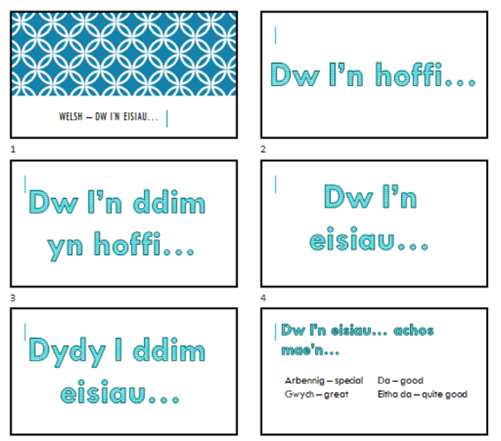

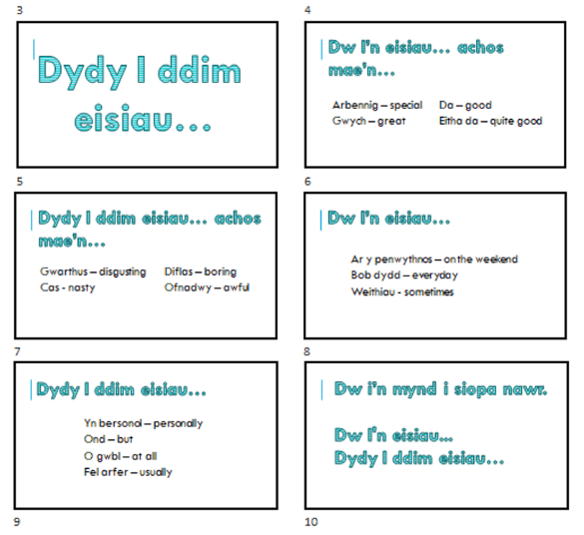

(Appendix 3)

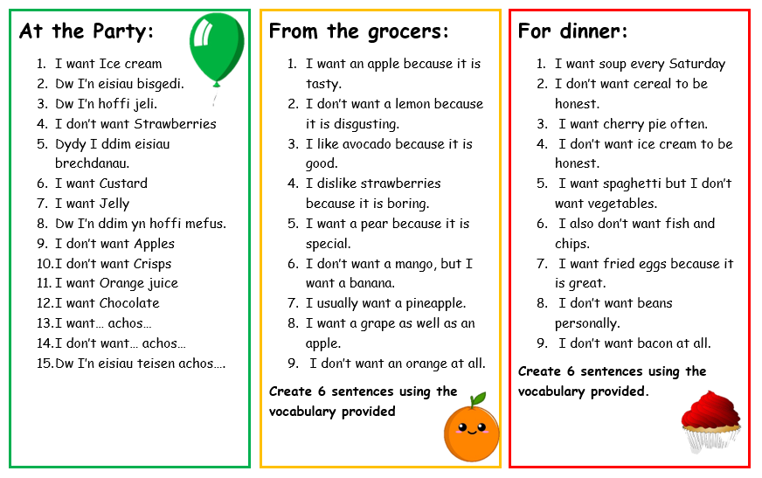

(Appendix 4)


