Assessment Two

Discussion Paper

Container or Content: Is Social Media a Tool for Transmission or a Form of Intangible Heritage?

Alyson Greening
1450605

Unravelling Heritage: History, Theory Methods (HPHE7002)

Introduction

According to Statistica 6.04 billion people use the internet and there are 5.66 billion social media accounts worldwide as of October 2025 (Statista, 2025). This accounts for sixty eight percent of the world’s population. It is clear therefore that social media has become a primary driver for human collaboration including practice of ritual and the transmission of storytelling. This paper questions whether social media is a form of Intangible Cultural Heritage (ICH) in its own right or whether it is a tool for the transmission of ICH. To do this the UNESCO definition of ICH will be considered along with notions of identity and cultural memory. If one considers that social media is indeed a form of digital ICH, further questions not within the scope of this paper could then be asked. For example, ‘How does social media fit within the UNESCO digital preservation program’ (UNESCO, 2023b)? Or, ‘How do the algorithms embedded within social media platforms influence the way in which ideas of heritage are disseminated to its users’? Or, ‘Have Assmann’s theories of Cultural Identity been subverted by the onset of digital technology and in particular, Social Media’? Perhaps the most interesting questions arising from this paper are those regarding the function of AI and Heritage.

UNESCO defines Intangible Cultural Heritage as ‘oral traditions, performing arts, social practices, rituals, festive events, knowledge and practices concerning nature and the universe or the knowledge and skills to produce traditional crafts’ . Central to this definition is the notion that practices and rituals, along with knowledge and abilities are passed down through the generations. Crucially for this paper UNESCO set the following framework:

Intangible Heritage must be
- Traditional, contemporary and living at the same time
- Inclusive
- Representative
- Community based (UNESCO, 2025)

Alongside this UNESCO recognises that digital heritage is an ever more important aspect of heritage as resources are increasingly being created digitally and require careful preservation in ways that are different from other forms of heritage (UNESCO, 2023a). From this perspective the question of whether social media is ICH or merely a digital receptacle is an important one.

Using this framework provided by UNESCO, this paper asks the following question: Does social media act as a form of Intangible Cultural Heritage or is it merely a tool for its transmission?

According to Trillo, Hallinan and Shifman social media can be typified by diverse rituals, creäted by the users as ‘communicative practices that formalize and express shared values, […]’(Trillò, Hallinan and Shifman, 2022). They argue that social media provides ‘culturally situated practices’ which have ‘deep rooted patterns of communication [referred to] as social media rituals’ (Trillò, Hallinan and Shifman, 2022). These rituals are created in the physical world via cultural and personal memories as part of ‘a transmitted culture from generation to generation’ and memories that are supplemented with strong visual cues are commonly retained for longer (Benton, 2010). In a social media setting, these rituals can be seen in commemorative posts such as birthday greetings and remembrance posts. Trillo, Hallinan and Shifman’s typography of social media rituals reflect many seen in the physical world. In addition to those discussed above, other rituals can include those based on behaviour and socially accepted norms, rituals based on philanthropy as well as games and craft videos. These rituals include storytelling, transmission of memes and folklore along with folklorism. These include folklore ‘belief’ practices on Facebook, such as ones in which users believe they can override terms and conditions by posting a statement, much like a written incantation which says they do not give Facebook permission to share content, along with storytelling content of urban myths both of which are designed to be shared from user to user and group to group.

One of the elements of the UNESCO definition is that ICH is formed of ‘traditions or living expressions inherited from our ancestors and passed on to our descendants’ (UNESCO, 2025). The concept of the need for longevity is supported by the likes of Assmann and Apaydin who argue that cultural memory is formed over generations and that this is vital for cultural identity and heritage.

Assmann (1995) agrees with Halbwachs that memory is socially mediated and relates to a group and in this sense Assmann may agree that there are elements here which are integral to social media. However, he terms this ‘collective’ or ‘communicative’ memory and argues that this is temporal in nature, limited to at most one hundred years. Cultural memory leading to cultural identity, he states, are not lost with time and memory here is preserved through festivals, rites, rituals, written stories etc. This is what UNESCO designates as ICH. In addition, Apaydin notes that ‘cultural heritage and the memory it embodies is vital for individuals, groups and communities in forming collective identities’ (Apaydin, 2020, p. 1) and argues that cultural memory and heritage are inextricably bound, primarily because heritage is an active form of cultural production—one that continually constructs and refines meaning for both individuals and communities. Heritage is a living thing which, through its practices, brings the past into the present. ICH is about the preservation of the past and by use of this argument social media cannot be seen as Intangible Cultural Heritage; it is too ‘quick’ and ephemeral. Indeed, snaps on the platform ‘snapchat’ can disappear almost immediately with the content (video, meme, song etc) being lost which invites the question of how the past is preserved in this context. However,

Assmann rejects Halbwachs’s notion of communicative memory as being too temporal in nature to be able to form cultural memories or identities which in turn provide the foundations for traditional practices. However, Eric Hobsbawm argues that traditions do not necessarily require the deep passage of time to be accepted as part of our cultural identity and heritage, and he argues that traditions can be invented:
‘Invented Tradition’ is taken to mean a set of practices, normally governed by overtly or tacitly accepted rules and of a ritual or symbolic nature, which seek to inculcate certain values and norms of behaviour by repetition, which automatically implies continuity with the past. Hobsbawm (2012, p. 1)

Hobsbawm states that traditions are invented by a process of reinforcement and ritualisation which references the past, even if only by the imposition of repetitive practice. Further, Hobsbawm goes on to describe a typography of invented traditions which includes those which create or signify group membership, those which create or validate status and those who exist to facilitate social interaction, including the establishment of belief systems and behavioural convention (Hobsbawm, 2012, p. 9). Critically however, this does not need to conform to the temporal requirements for these traditions to pass into cultural identity as can be exemplified by the case of the Scottish Clan Kilt which came about as the result of the writing of a fraudulent history of Scotland in 1760 by James Macpherson. This work was debunked in 1805 by Sir Walter Scott, who went on to introduce the notion that the kilt was worn as early as the third century A.D. In fact, the kilt was invented in 1707 and the clan tartans came into being even later. The kilt became the official national dress of Scotland when King George IV visited Edinburgh in 1822. Having been convinced to wear the tartan he then encouraged others to follow and when the false catalogue of clan tartan was developed in 1842, the wearing of the Scottish Kilt became a practice of both national and personal identity and heritage (Trevor-Roper, 2012). This case study demonstrates that practices can become heritage in much less time than Assmann’s theory of cultural memory would suggest. Indeed, the time the kilt was popularised until it became a symbol of personal and national identity was thirty seven years. This speed can be seen in the way in which social media has also become part of an individual and group identity. From the first post in 1997, Social Media has become a ubiquitous vehicle of participatory practices including rituals, group identification and value transformation.

institutions can be said to foster the participation of individuals groups and communities and to facilitate collected identities via such things as individual and group pages, along with other organisational presences designed to either encourage or transform the Authorised Heritage Discourse as well as pages designed for information exchange. For example, Facebook groups that facilitate nostalgia such as those dedicated to the history of a particular geographic area, those which foster collective identity based on hobbies and pastimes, such as photographic groups and neighbourhood pages which transmit information about community activities and help to keep the Intangible Cultural Heritage of the area alive. Fig. 1 shows an example of the group page ‘Talog News’ giving information about a 2025 Carol Service. These posts are vital for the members of the group, not only for information exchange but also to preserve the intangible practice of Carol singing. In this way participants are able to utilize a digital platform to encourage physical exchanges for the purpose of a festive event and oral tradition. Further, posts that are designed to elicit nostalgic responses, facilitate collective identities thereby strengthening the cultural memories of the group. Fig. 2 shows a post from ‘Swansea and its History’ Facebook page showing an urban street, probably from the 1970’s which elicited many nostalgic responses.

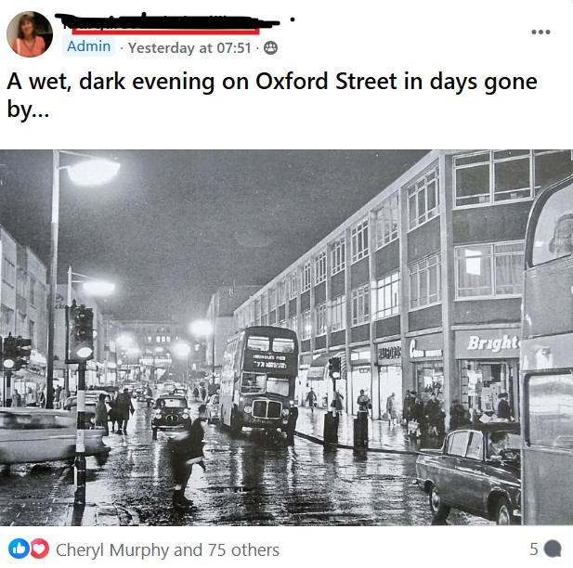

Fig 2. Swansea city centre in the 1970s
Fig. 1 Facebook post for a Carol singing service

It can be argued therefore that on this evidence, Social Media is a form of ICH as it contains social practices, rituals, festive events and knowledge transmission about the Universe and Nature. This is particularly present in the recent emergence of Facebook and Instagram reels by recognised media personalities and scientists such as Professor Brian Cox (profbriancox (instagram), 2024).
Assman
Harrison

For the argument

In their article discussing heritage sites and climate change, Ginzarly and Teller argue that social media and other digital tools help to embed Cultural heritage via knowledge distribution and inclusionary practices. Quoting Choi et. al, they argue that that; […] digital platforms empower communities, enhance participation, and contribute to the resilience of both the heritage itself and the communities that safeguard it’.(Ginzarly and Teller, 2025) They further suggest that social media can be used to transform and build heritage values in populations by fostering engagement

Def to go in as a thing of ICH
Assmann – cultural memory
BUT Hobsbawn points out that traditions etc.

Bibliography

