

Methods and Search Strategy Academic Poster

The Impact of Postpartum Depression on Maternal–Infant Bonding at 12 to 15 Months after Delivery
01 Introduction and Research Aim  This poster provides the methodology for a secondary research project that investigates the influence of postpartum depression (PPD) on maternal infant bonding throughout the later postpartum period (12–15 months after birth).  Aim:  To measure the effects of postpartum depression on the excellence of maternal infant attachment at 12–15 months postpartum and to recognise arbitrating risk and protective aspects that influence long-term maternal bonding consequences | 02 Search Strategy  A search strategy is a systematic plan utilised to recognise, locate, and retrieve applicable literature using specific databases, keywords, and filters (Grewal, Kataria & Dhawan, 2016). For this project, I produced a structured search plan using Boolean operators and distinct terms such as:  - “Postpartum depression” AND “maternal-infant bonding”  - “Attachment after 12 months” AND “postnatal mental health”  - “PPD impact on attachment” OR “infant bonding outcomes”  Filters encompassed peer-reviewed, English-language, and articles available inside the last 15 years.  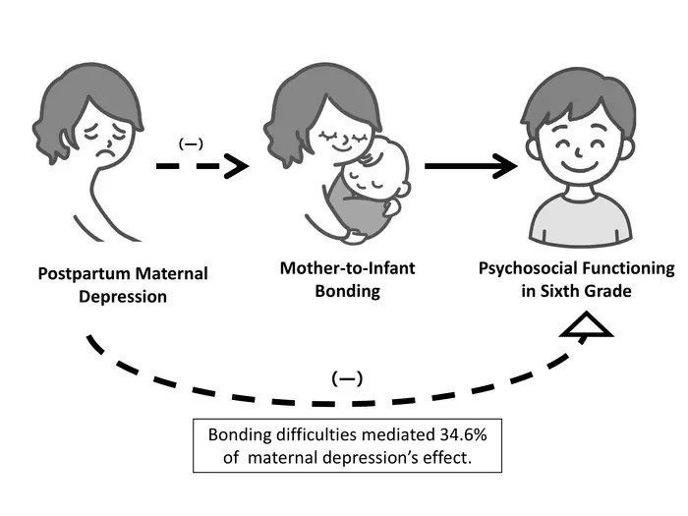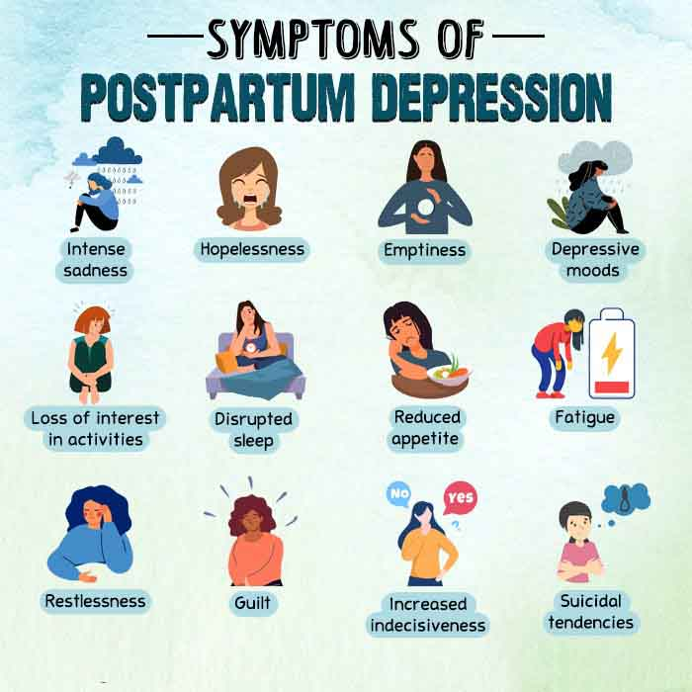
03 Searching for Information  The search process included the following steps:  - Database Selection: I used PubMed, PsycINFO, and CINAHL due to their focus on medical, psychological, and health-related research.  - Keyword Mapping: Initial keyword lists were refined with MeSH (Medical Subject Headings) and synonym mapping.  - Boolean Logic Application:  - “PPD AND maternal bonding”  - “Postpartum attachment AND infant development”  - “Social support AND maternal depression AND 12 months”  - Screening Process: Titles and extracts were screened for relevance to postpartum mental health outside the first year.  - Selection of Sources: I prioritised empirical studies expending authorised bonding measures (e.g., MPAS, PBQ) and policy papers lecturing intervention outlines.  - Reference Management: EndNote was used for citation management; NVivo will be used for thematic examination.  This structured method guaranteed the inclusion of relevant and credible foundations that support the investigation emphasis | 04 Picture / Graph / Visual Aid / Statistics  Globally, PPD affects 10–20% of mothers and often remains underdiagnosed in low-resource settings (lana , 2025)  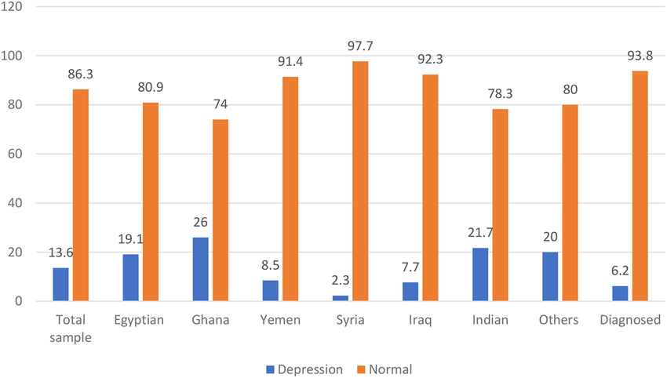  Source: (lana , 2025)
05 Research Validation and Analysis
Validation in secondary research involves selecting high-quality, credible, and peer-reviewed sources that support the research purpose (Saunders et al., 2019).
To ensure validity:
- Only peer-reviewed journal articles, systematic reviews, and clinical guidelines were selected.
- Studies were appraised using critical evaluation tools such as the CASP checklist.
- Grey literature was excluded to ensure academic rigour.
Thematic Analysis Process:
Using NVivo, the selected studies will be coded to identify major summaries such as:
- Effects of PPD on maternal responsiveness
- Mediating influences like income, support networks, and coping
- Quality of attachment beyond the first postpartum year
These subjects will inform the examination in Chapter 4 of the dissertation (Diane El Hadathy et al., 2024). This rigorous validation process ensures that only high-quality, evidence-based materials inform the findings of the dissertation. Using thematic analysis allows for the identification of patterns across diverse studies, making it possible to synthesise results even when methodologies differ. NVivo will enhance the consistency and transparency of coding, allowing categories such as risk factors, coping mechanisms, and bonding quality to emerge clearly. By critically analysing the literature, the research aims to build a nuanced understanding of how postpartum depression influences bonding outcomes in the second postpartum year, offering valuable insights for health and social care policy and intervention design
06 Inclusion Criteria  - Published within the last 15 years (2009–2024)  - Written in English  - Focused on maternal bonding at 12–15 months postpartum  - Included validated measurement tools (e.g., MPAS, PBQ)  - Sourced from peer-reviewed journals, government guidelines, or policy reports  - Empirical data or systematic reviews relevant to PPD and attachment. | 07 Exclusion Criteria  - Articles older than 15 years  - Studies only focused on bonding within the first 6 months postpartum  - Non-English sources  - Non-peer-reviewed blogs or opinion pieces  - Studies not using standardised tools or lacking methodological transparency
08 Ethical Considerations
Ethics in secondary research involves the ethical use of published literature, proper citation, and avoidance of plagiarism (Wilson, 2022).
Key ethical practices included:
- Use of licensed, publicly available academic databases
- Accurate attribution using Harvard referencing (Diane El Hadathy et al., 2024)
- No primary data collection (no direct participant contact)
- Observance of UWTSD’s academic integrity policy
- All data interpretation will remain objective, and sources will be critically appraised rather than accepted at face value

References:
Diane El Hadathy, Malaeb, D., Souheil Hallit & Barakat, H. (2024). The relationship between maternal-infant bonding & postpartum depression/anxiety: moderating effect of childhood psychological abuse & validation of the Mother-to-Infant Bonding scale (MIBS-8) in Arabic. BMC psychiatry, 24(1). doi:https://doi.org/10.1186/s12888-024-05745-9.
lana , R. (2025). Redirect Notice. [online] Google.com. Available at: https://www.google.com/url?sa=i&url=https%3A%2F%2Fwww.researchgate.net%2Ffigure%2FThe-frequency-of-PPD-among-the-studied-mothers_fig1_380571860&psig=AOvVaw0mTj_oxToJckpUU7ySZQpb&ust=1752211521613000&source=images&cd=vfe&opi=89978449&ved=0CBQQjRxqFwoTCIj--N_GsY4DFQAAAAAdAAAAABAE [Accessed 10 Jul. 2025].

