Current Perspectives for Entrepreneurs and Small Businesses

Student Name: Ionela Madalina Saiz
Student Number: 1605699
Module: Entrepreneurship (LCMB 7004)
Lecturer: Prof. Dr. Nandish Patel

Table of Contents
Part 1 3
Introduction 3
Effects of motivation on entrepreneurship skills 3
Internal factors 4
Impact of economy on business start-ups 5
• Innovation 5
• Job Creation 5
• Increased Competition 5
• Increased Productivity 6
• New Markets 6
Business starts up influenced by the cultural environment 6
• Uncertainty avoidance 6
Part 2 8
Introduction 8
• Recommendations for New Business Start-Ups 8
Business Incubator 8
Direct and Zero Interest Loan 10
Reach out to further entrepreneurs 11
Part of a Community 11
Learning Way to success 11
Embed growth and development process within the enterprise 11
Process of Start-ups 12
Conclusion: 12
References: 13

Part 1

Introduction
An individual who maintains a business and have all its benefit and furthermore bears every one of the misfortunes is essentially a business visionary (Amway, 2018). The interaction through which a business is arrangement is known as business. This is the real meaning of an entrepreneurship (Aziz, 2017). Therefore, a business visionary is additionally a wayfarer, a generator of ground-breaking thoughts, administrations products, and business/or methodology. They have a significant part in any economy, utilizing the abilities and imagination important to expect needs and offering great novel thoughts for sale to the public. Whenever demonstrated fruitful, business is remunerated with benefits, distinction, and proceeded with development openings. Whenever fizzled, Entrepreneurship, brings about misfortunes and less inescapability in the business sectors for those included. On contrast, Motivation means desires, needs, wants or drives that arouse within an individual (Bhidé, 2018). It is the process of encouraging or stimulating people to actions to accomplish the goals (Verheul, 2019) .Endeavor and business are the fundamental mainstays of any nation's economy (Block, 2018). The business venture is critical not exclusively to the economy, that is from elevating social change to driving development (Chell, 2020, pp. 17-19). Professional help to make work by implication the monetary turn of events. Entrepreneurial activities assistance makes innovative bounty. Current associations may continue bound to current business parts and might success a cut-off in regards to wage (Langroodi, 2017).

Effects of motivation on entrepreneurship skills
The way toward changing a conventional individual to an incredible finance manager, who can set out open doors and helps in amplifying riches and monetary improvement is called pioneering inspiration It is identified with different variables invigorate wants and initiates eagerness in business visionaries which cause them to accomplish a specific objective (Chell, 2020). Entrepreneurial inspiration is a mental interaction wherein every one of the intentions are liable for invigorating various objectives in an individual, these thought processes can be inside or outer (Birley, 2016).

Figure1: Motivation in Entrepreneurship
Source: (Aziz, 2017).
Internal factors involve need for self-actualization, positive attitude, empathy, optimism, self-motivation, enthusiasm, courage, commitment etc. (Reynolds, 2020).
External factors influencing social groups, availability of resources, government policies, products demand and supply, technology advancement, availability of information etc. (Reynolds, 2020).

Impact of economy on business start-ups
Many economic factors impact the new and existing business start-ups, which are as following:

Figure 2- Economy and Business
Source: (Amway, 2018).

Innovation
Individuals often resort to entrepreneurship for one of the following reasons; they found a solution to a market problem, make employment, generate income for themselves, use creativity to retain their work by using new technology and having financial resources which serves the contemporary need and wants of market place (Reynolds, 2020). Therefore, it is clear that innovation and creativity is the driving economic factor of an entrepreneurs that leads to starting up or retaining existing business.

Job Creation
As stated, entrepreneurs do look for new opportunities to sustain their employments, this leads to them employing other individuals to complete tasks timely. So, to be counted utmost positive impacts that entrepreneurs mark on a budget while starting a new business is job formation and the less of unemployment (Verheul, 2019).
For example, Africa a worthy example of modest businesspersons assisting to reduce poverty and serving many toward evade poverty.

Increased Competition
As new business centres in the market, competition is increased as new entrepreneurs join the fray in current local circumstances. It causes businesses in the market to re-evaluate their operational capabilities, upsurge value addition, lower costs and develop more effectual, however, it can lead to market saturation. (Wadhwa, 2018).
For example, for example; The application introduced for pet match up, food and breed has increased competition for the applications that were limited to food.

Increased Productivity
Increased competition in an economy leads the firm to that can help development and highly reduce prices while increasing worth resulting in increase in GDP. Therefore, national productivity is increased by new business start-ups (Acs, 2016).
For example, this new business start-up of cake popsicles, increased the overall production in baking industry that leads to overall increased productivity of the country.

New Markets
As increased competition causes market saturation, many entrepreneurs are having to attracted towards new market as a strategy of business (Manalel, 2018). Therefore, new business start-ups are useful for economy. Moreover, as globalization causing integration, business person looks into and out of the market as whole (Birley, 2016).
For example, Apple making iPads and entering in a new market in order to sustain their existing marketing position.

Business starts up influenced by the cultural environment
Cultural values are defined as the common ideals and long-term goals of individual and group of people that develop certain personality traits and motives, which influences people’s desire for achievement (Amway, 2018). Cultural values are broad and general concept that define entrepreneurship which impact new and existing business start-ups.

Uncertainty avoidance
Uncertainty Avoidance is called individuals’ intolerance of ambiguity. Doubt evasion causes entrepreneurship rates to increase as people see these activities as a way of dissatisfaction However, it should be noted that entrepreneurs are daredevils who do not avoid doubt which also effects business start-ups (Reynolds, 2020).
For example: the western culture is risk taker making immune to avoid uncertainty avoidance
- Future orientation
Future orientation societies consist of people are highly up in motivation and contains longer strategic orientation which causes higher innovativeness, pro-activeness, and autonomy of family businesses. Future-oriented societies value the efforts of successful entrepreneurs and encourage new start-up businesses as hard work, planning, and delayed gratification are promoted in such societies (Manalel, 2018).
For example: The American society is very future oriented therefore they excel in being possessing a lot of entrepreneurial skills.
- Power distance
Power Distance reproduces the grade to which a civilization receives power changes and freedoms. Societies where people except power distance exceed in entrepreneurial skills and promote business start-ups (Block, 2018).
For example, societies with individualist cultures e.g., the west are not much understanding to give into the authorities.
- Humanitarian location
Humanitarian Location takes observation and count how the community treats them and kindness to others. Societies enriched with human orientation are more welcoming to business start-ups and entrepreneurial skills as they are open to innovation and promote risk takers (Langroodi, 2017.)
For example, collectivist culture who are prone to group need e.g., the culture of the east is more human oriented encourage people within group with new idea.
- Performance orientation
High performance orientation societies measure improvements and results performance in groups or individual. People are more disposed to take creativity than to focus on dealings and status in such societies (Aziz, 2017).
For example, the Western individualist are more performance-oriented societies.

Part 2

Introduction
A start-up business is an entrepreneurial endeavour that undertakings to substantiate a marketplace requirement by formulating an attainable significance suggestion around a producer’s creative development, duty, or processor setting (Amorós, 2019). The current pandemic has put new businesses and start-up biological systems wherever in human peril. They are running out of money and watching investment dry out. Groups dealing with front line innovation are being disbanded, and client request is winding down, to some degree on the grounds that COVID-19 has delivered whole businesses inoperable (Amway, 2018). In the pandemic, entrepreneurs have taken sudden flexible actions and made their businesses online. The present situation made them do so, providing ease and running business. They must adapt to the present situation as they did in a perfect manner.
So, considering this pandemic and in usual way start-ups and entrepreneurs need support system. For this, there must be some steps to cater this. Such as:

Recommendations for New Business Start-Ups

Business Incubator
A Business Incubator is a communitarian course that helps to assist new start-ups and entrepreneurs with succeeding. Incubators assist business people with tackling the issues usually that counts area, finance and training the motivation behind a business incubator is to assist business people with developing their business (Acs, 2016).
The program helps the business to make entrepreneurs train, how they work and the ways. This is not only for the employees but for the owners too.
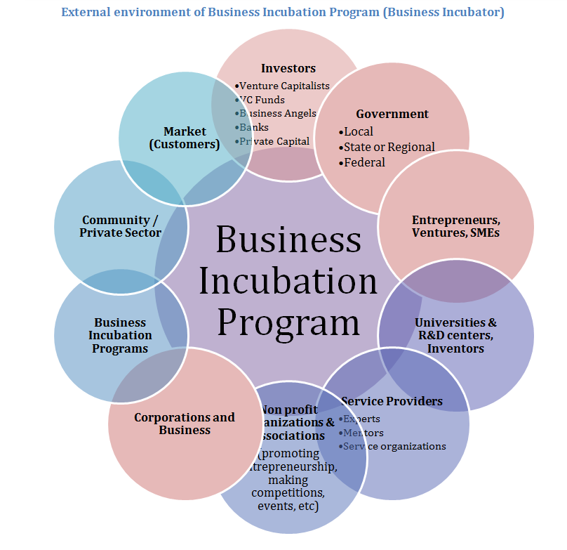
Figure 3- Business Incubator
Source: (Lumpkin, 2015).
- The incubators help in the basics of business, what mostly the owners of start-up do not concern. Incubators can help them to work for understanding the basics and new challenges of the business in market place and further provides opportunities (Birley, 2016).
- They also provide network opportunities, that made them connect to one and other as sponsors, as collaborator and even as promotes, start-up business doesn’t understand this way of making business known and profitable. This also counts the marketing services, such as social media marketing and promotions at every level and all the related sector (Birley, 2016).
- In addition to this, they will provide the financial assistance, in the way by providing financial assistance and most importantly, the planning’s to consume finance. Moreover, these, will help them to make their business to go in a flow and such things will affect the start up in the best possible way. They make it easy to access bank loans. As a surety it helps us to make the start-up more in capital and strong financial step in this way (Bhidé, 2018).

Direct and Zero Interest Loan
A no-premium credit implies that you are just repaying the head or the cash you acquired from the bank without premium. Be that as it may, you will actually need to be careful if your credit incorporates any extra expenses, similar to a start charge (Amway, 2018).

Figure 4- Business Loans
Source: (Block, 2018).
It helps the entrepreneurs and start-up in the best possible manner. In this way it is easy to take loans and return them back on time. The loans will help but have a negative effect on the economy. This is the most important problem that the start-ups are facing do for this purpose the bank must offer Zero interest loan. Zero interest loans help them return is easily. In addition to this, there are very difficult ways to approve a loan (Acs, 2016). The banks must make some plans and put it on board for the Business. There are a number of formalities that make it really hard for them to go for this (Amway, 2018).
This will have a good impact on the business community but it has a number of losses that;
- It will be difficult for the banks to make sure the return of loan.
- The people might make it easy to loss it all, as most of them but not be professional in what they do (Williams, 2020).
- The economy will be badly affected by this as no income will be coming by this way.
There are many drawbacks and obstacles related to beginning a new business and others that appear with profitability. Start-ups are one of the greatly reasonable paths to understand the critical difficulties humanity is encountering because they can respond much quicker to crises that arise and can innovate explanations more voluntarily than traditional businesses (Manalel, 2018). The start-up, in turn, facilitates the prototyping and demand testing of a large amount of new probable inventions, stimulating the growth through which squeezing global problems can be understood (Aziz, 2017).

Reach out to further entrepreneurs
Start-ups often have related problems no matter what business they subside under. Therefore, discover people around you who are business holders and foster connections with them. It expects putting up with time to have coffee and lunches and Assure that it is a mutually constructive connection where they understand they can surely reach out to you for information (Birley, 2016).

Part of a Community
Another area you can give the support to entrepreneurs is through require is through networking. That can either be online or offline. It prepares enlisting a population even more favourable is the evidence that you have tremendous mentalities providing indications, enabling with problem-solving, or praising you on (Lucy, 2017). Existing with a like-minded population within and outside your enterprise will be eye-opening knowledge as great as it is beneficial (Block, 2018).

Learning Way to success
Mentors are useful. These are populations who have experimented before and are ready to give understanding and reasoning from their excursions. It does expect to be accessible and practically impossible at periods but puts up with courage; they have all existed there (Bardi, 2018). The great aspect about existing an entrepreneur today is some areas relate with educators, and can be one yourself. It enables to understand assistance (Emden, 2019).

Embed growth and development process within the enterprise
Enterprise must have some major things in order to make the path of their success, growth and development. The growth and development in the enterprise go side by side. Internal and external factors also play important role in this regard.
The major component that makes it well is their employees. If the employees have Satisfaction, Job involvement and citizen ship, they put efforts in the success and betterment of the company. For employee’s motivation the company must care for them, their competitive pays, their motivation, their increment. The more an employee is satisfied the more he is in to organization work (Emden, 2019).
In addition to this, Innovation is all of it. If an enterprise never fails to bring innovation the more it feels smother to go on the track. The consumer of any enterprise loves innovation, as soon as the firms bring innovative approach for the consumers (Kwabena, 2019).

Process of Start-ups
The process starts from the idea or any need that is to be fulfilled. Then there’s a need to make a plan and work on the basis that is customers, segmentation, target and marketing channel. In addition to this, finance is the basics of this. If it goes well, it is at hype and smooth, there is a need to introduce deals and other trends to make the business go smooth.

Conclusion:
Motivation is the most important part in the Entrepreneurship and enterprise. For start-ups, there are many support systems such as, learning way, business incubators, relations with the community and thinking of as a community member, zero interest loans and easy ways by banks to consider start up, although there are limitations to and work must be done on it. Moreover, these things can be a strong support system for them. Financial problems, learning ways and knowledge. The growth and development on an enterprise values the employee’s performance and the innovation they bring to the market. Internal and external factors also have affected on it such an economic behaviour of country etc.
The examples used above gives an easy and accessible way to see the motivation for any business man or company. A person should focus for this and go ahead. If an enterprise wants to be successful, they should go for this and most importantly the support system should come forward.

References:

- Acs, Z. B. M. &. M. C., 2016. The social value of productive entrepreneurship.. Small Business Economics, p. 785–796.
- Amorós, J. C. O. &. M. M., 2019. Differences in entrepreneurship rate level and its volatility across countries. Driving forces behind entrepreneurship, pp. 1-50.
- Amway, 2018. Global Entrepreneurship. [Online]
Available at: www.amway entrepreneurship report.tum.de. [Accessed 2nd April 2021]
- Aziz, N., 2017. Entrepreneurial Motives and Perceived Problems:An Empirical Study of Entrepreneurs in Kyrgyzstan. International Journal of Business Research.
- Bardi, A. &. S. S., 2018. Values and behavior: strength and structure of relations. Personality and Social Psychology Bulletin, p. 1207–1220.
- Bhidé, A., 2018. The Origin and Evolution of New Businesses, New york: Oxford University.
- Birley, S. &. W. P., 2016. A taxonomy of business start-up reasons and their impact on firm growth and size. Journal of Business Venturing, pp. 7-31.
- Block, J. &. S. P., 2018. Necessity and opportunity entrepreneurs and their duration. Journal of Industry, Competition and Trade, pp. 117-137.
- Chell, E., 2020. Entrepreneurship: Globalisation, London: Innovation and Development.
- Emden, C., 2019. Conducting a Narrative Analysis. Collegian Analysis, pp. 34-39.
- Kwabena, N., 2019. Entrepreneurship theories and Empirical research. Entrepreneurship, pp. 60-78.
- Langroodi, F. E., 2017. Schumpeter's theory of economic development: A study of the creative destruction and entrepreneurship effcets on the economic growth. Historical and Normative Foundations of Economics, pp. 79-100.
- Langroodi, F. E., 2017. Schumpeter's theory of economic development:A study of the creative destruction and entrepreneurship effcets on the economic growth. Historical and Normative Foundations of Economics, 2(1), p. 70 89.
- Lucy, T., 2017. Entrepreneur ; how to start small business. England: Capstone Publishing Ltd.
- Lumpkin, G. a. G. G. D., 2015. . Clarifying the Entrepreneurial Orientation Construct and linking it to performance, UK: Academy of Management Review.
- Manalel, J., 2018. Evolution of Entrepreneurship. Theories from different groups , pp. 1-10.
- Reynolds, P. D. S. M. C. D. B. E. A. a. M. H., 2020. Global Entrepreneural Monitor,. Centre for Entrepreneural Leadership., pp. 10-79.
- Shane, S. E. L. a. C. J. C., 2019. Entrepreneurial Motivation. Human Resource managment Review, pp. 1-119.
- Timmons, J. A., 2020. 2015. A Guide to Entrepreneurship. Venture Area, pp. 89-90.
- Verheul, I. e. a., 2019. Factors influencing the entrepreneurial engagement of opportunity and necessity entrepreneurs. EIM , pp. 1-24.
- Wadhwa, V. A. R. &. S. A., 2018. The Anatomy of an Entrepreneur. Family Background and Motivation. The Kauffman Foundation.
- Williams, N. &. W. C., 2020. Evaluating the socio-spatial contingency of entrepreneurial motivations. Entrepreneurship & Regional Development, p. 661–684.

