 APPENDIX GA36a

LEVEL 4 ASSESSMENT SPECIFICATION

Student name: | Max Aaron | Student ID number: | 2014490
Programme:
Module: | Digital Surveying
Module code: | ACBA4002 | Contribution to Overall Module Assessment (%): | 50%
Lecturer: | Dr Jamiu A. Dauda | Internal Verifier: | Gavin Traylor
Assignment Title: | Practical – Levelling & Computation | Word count (or equivalent): | 2000 words
Submission deadline: | 9th May 2022 | Return date of provisional marks & written feedback: | 18th June 2022

A report focussing on:

Digital Surveying

Prepared for:

Jamiu Dauda

Created by:

Max Aaron

Introduction
This paper aims to provide the reader with a basic understanding of digital surveying using various methods such as research, my own knowledge, and a practical survey. Definitions of key words and equipment will be presented develop explanations and inform the reader of industry relevant terminology. Calculations of the survey conducted such as the height of collimation, reduced levels, and volume of earthwork, along with diagrams and photographs showing how equipment was used and how the survey was carried out. Also, this report will include the use of references to digital surveying and techniques.

General Overview of levelling surveying
Levelling surveying is understood as the computation of a height given a level relative to another. Therefore, surveyors use this process to determine the elevation of a point relative to a datum level (Anon., 2020).
Digital Surveying can be used and presented in many different ways within the industry. For example, a surveying company may carry out a full digital survey and provide the client with such information as the location, size and dimensions of; the land contour, utility information, ordinance survey grid and data. Furthermore, the information may be presented to the client in the form of volumetric surveys, which feature cross and longitudinal sections, 3D contours, and 3D triangulation models (dtsurveys, 2022).
In the survey conducted below the use of a dumpy level was in place to collect the data. However, there are many other instruments that can be used to carry out a levelling survey. Others include the Wye-Level, Cushings Level, Titling Level, Cookes Reversible Level, laser level, water level, Automatic Level (Anon., n.d.).
Furthermore, the most common survey tool used in today’s construction industry would be the dumpy level, or the use of Theodolite and GPS.
Levelling instruments use a reticule diaphragm where the horizontal cross-hair is used to determine the level of a point, and the lines above and below are stadia marks used to estimate distance using a simple calculation (Anon., n.d.).
A staff is used above the point being recorded, where a reading taken using the telescope of the dumpy level can be used to calculate a reduced level. There are two methods of recording this data; height of collimation method and rise & fall method.

Figure 1 shows staff being used

Useful terminology used in levelling surveying that of which some terms have been used in the report; elevation which is the vertical distance from a reference called a datum, Level surface is when multiple points are all at the same distance from the earths surface, Line of sight is the line which joins the optical centre of the lens to the cross hairs. Backsight is the reading taken from the staff above a known elevation, whereas a foresight is a reading taken from the staff above a point of unknown elevation which is yet to be determined. Thus the intermediate is a reading taken from the staff above a point of unknown elevation between the backsight and foresight (CivilJungle, 2022).
There are often errors in levelling that lead to incorrect data. These would include instrumental errors such as imperfect adjustments, a sluggish bubble, defective staff, defective tripod (CivilJungle, 2022). Errors such as these can be managed by servicing and re-calibrating the equipment regularly. Personal errors could be misread data due to carelessness when sighting or recording, incorrect setting up of instruments such as bubble out of centre, imperfect focussing. Factors like the wind or temperature can also take an effect on the data recorded by the surveyor.

Equipment used in levelling
To obtain the levelling of the points recorded in the survey, a dumpy level was used. A dumpy level is a telescope fixed to a position where it is able to be rotated only on a horizontal plane (Merriam-Webster, 2022).

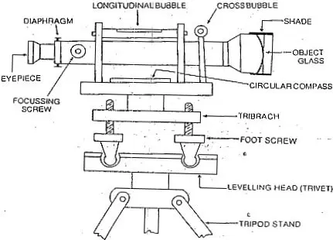

Figure 2 (Anon., 2022).

Figure 2 shows a diagram of the components of the dumpy level. The main components include the telescope, bubble, focusing screw, foot screws, and tripod. Levels were recorded using the telescope, taking readings from a measuring staff, which was at 20 metre intervals measured using a surveyors measuring roll tape.

Another piece of equipment used was the measuring staff. The measuring staff is a levelling rod used in land surveying to calculate the height of points, slopes and changes in elevation. Measurements are taken by sighting the rod through a telescopic lens, which can be as accurate as 2.5mm. There are two types of rods, a target rod and a self reading rod (Higa, 2022).

Levelling Procedure
The beginning of the levelling procedure starts with the set-up of the instruments. The tripod is placed with all three legs evenly spaced apart so that the levelling head is relatively level to the eye before placing the dumpy on top. The dumpy telescope is placed and screwed onto the tripod. The foot screws are then manually adjusted by the surveyor whilst looking at the bubble trying to make it centred, so that the instrument is level. A check is made to ensure the instrument is level by turning it 90 degrees checking the bubble remains central, before continuing with the survey.

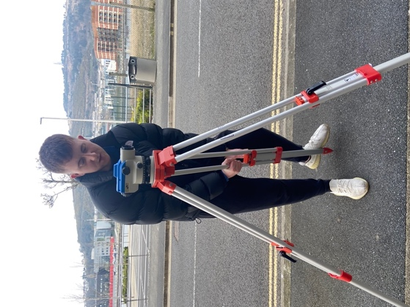

Figure 3 shows the setting up of the instrument.

Firstly, a backsight measurement Is taken from a known point so that whenever a survey is carried out, all recorded data can be linked back to the known point. The surveyor looks through the eye piece of the dumpy level and takes the reading of the middle cross-hair.
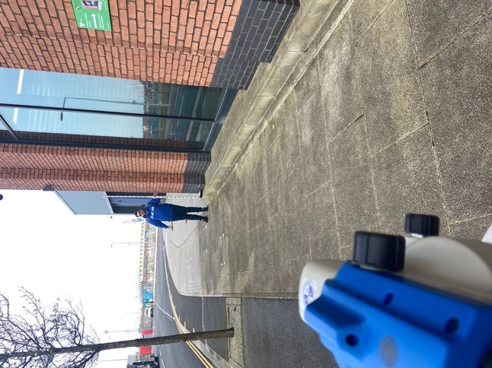

Figure 4 showing datum point surveyed.

Next, an intermediate point is recorded 20 metres away from the last recorded point.
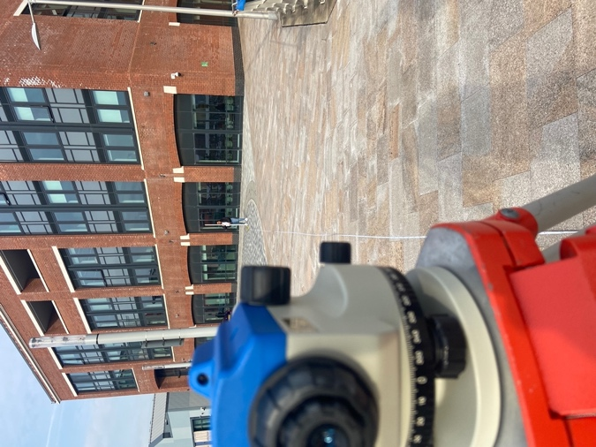

Figure 5 shows 20 metres spacing between points.

Once all intermediate points have been recorded, a final point called the foresight is recorded. Next, the dumpy level and tripod is moved to a different location whilst the person holding the staff remains on the foresight point. The person operating the dumpy level looks through the telescope and takes the level reading and notes it as a backsight, in the same column was the foresight.

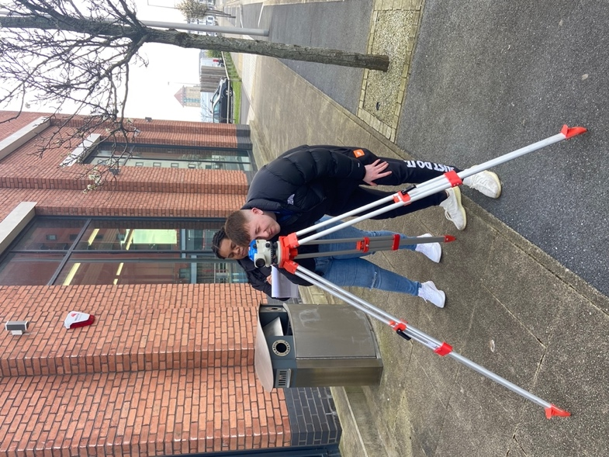
Figure shows data being recorded.

This procedure continues until all data has been recorded. To check if all levels are correct, the Backsight minus the Foresight should be equal to the Final Reduced Level minus the Initial Reduced Level.

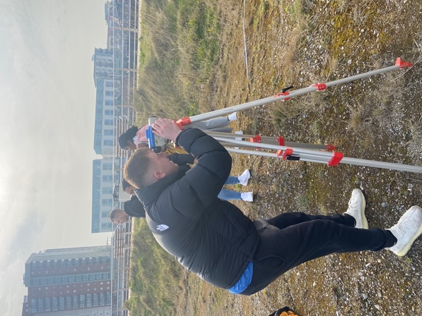
Figure 6 shows obtaining last point as foresight.

After the data is collected in the practical survey the information should be processed and presentable to the client. The data is transferred from the paper copy of a survey book such as the Chartwell Survey Book 2426, onto an excel spreadsheet where calculations can be carried out and programmed into the sheet. The data is presented into a suitable standard where it is easy for the client to read and understand and has all the information required to progress further with the project. The below figures show how the information would be presented with a visual representation of the survey.

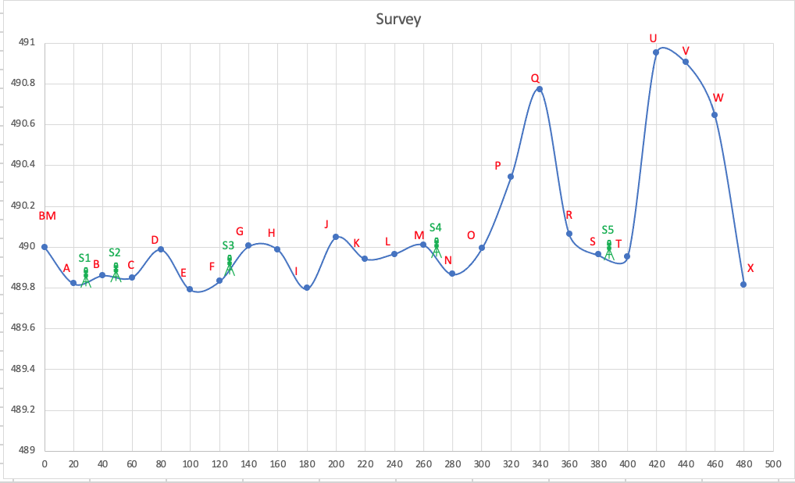
Figure 7

The figure above shows a visual representation of how the survey is conducted, where points B, F, M, S, have both a backsight and foresight due to the levelling instrument taking readings of the point from two different positions. BM is the benchmark point, point A the first data point of the survey, and point X the last point of the survey therefore a foresight.

Computation and plotting of levels

Figure 8

Using the data recorded from the survey, and the datum level of 490m, a reduced level for each point surveyed was computed at 20 metre intervals, reflecting the current ground state. The first column is a number column to represent a standard format to all data within the row. The second column is the letter associated with the point taken in the survey in alphabetical order. This makes it easy to read as well as easy to visualise on the diagram without confusing with elevation numbers. The third row is the backsight column. All backsights collected in the survey are recorded in this column. The backsight illustrates a benchmark of where the instrument is in relation to previously recorded levels. The intermediate column is where all other level points are recorded in the survey which are later used to calculate the reduced level. The foresight column shows all points where the final level was recorded at each station point before moving the instrument. The reduced level is calculated by taking the foresight point and subtracting it from the last known reduced level. A new height of collimation is then calculated from that point by adding the reduced level to the backsight reading, which is therefore the level plane of the dumpy level instrument. The last column shows the distance at which each point was taken from the first point to the last point of 480 metres.

Figure 9

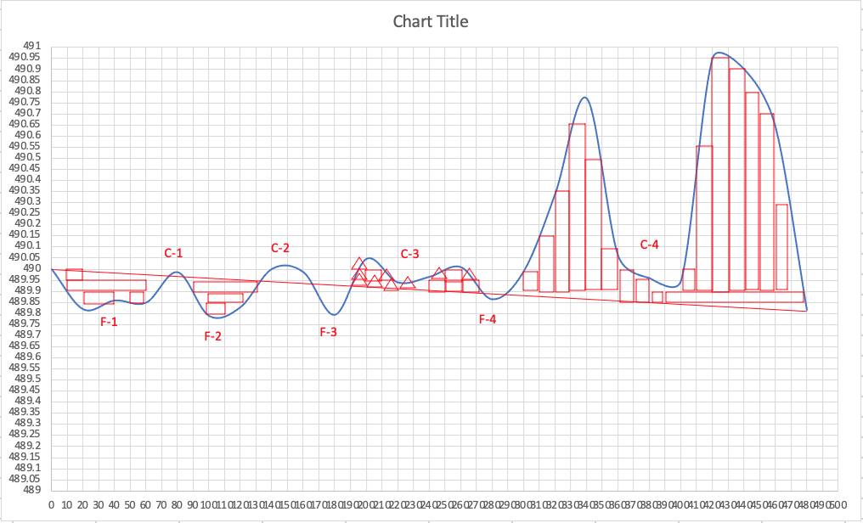
Figure 10

The figures above show how I obtained the values in Figure (9) for the cut and fill of the land survey. The snapshot above from the excel spreadsheet shows the calculations of the cut and fill needed from the land survey. These figures were calculated using squares, rectangles, and triangles to calculate whole blocks of cubic metres, triangles halves, and eye-estimation for quarters. This allowed me to get a fairly accurate estimation for the total cut and fill needed to level the land surveyed. I then multiplied these figures by the unit volume of 1 for cut and -1 for fill, and then calculated the total volume for each. Continuing on, I then added the cut and fill totals together to compute a total volume earthworks estimate.

Conclusion
The computation shows a clear and obvious need for the removal of land to level the plane of the site. The arisings of the excavations may be used to fill the land which is below the required plane, if the arisings are suitable however if not then materials will have to be brought in. Evaluating my survey, it was conducted thoroughly using the correct procedure of setting up the instruments and taking level readings at 20 metre intervals. However, to make the data more reliable as a group I would have everyone carrying out a specific role instead of changing, to therefore have the same person taking readings so that all of the data has been recorded in the same way.
Within this report the definitions of digital and land surveying have been explained, as well as my further explanations and understanding of levelling and surveying. A detailed explanation and understanding of instruments and equipment has been demonstrated, which has furthermore been used to conduct a thorough land survey to evaluate the condition of the land plane and conclude that a large amount of the land will need to be cut to level off the plane.

References
Anon., 2020. Levelling in Surveying. [Online]
Available at: https://www.designingbuildings.co.uk/wiki/Levelling_in_surveying
Anon., 2022. Dumpy Level Surveying – Components, Procedure, Advantages. [Online]
Available at: https://theconstructor.org/surveying/dumpy-level-surveying-components-procedure-advantages/20456/
Anon., n.d. [Online]
Available at: http://www.levelling.uhi.ac.uk/tutorial1_8.html
Anon., n.d. Different types of Levels used for Levelling in Surveying. [Online]
Available at: https://theconstructor.org/surveying/types-of-levels-leveling-surveying/14690/
CivilJungle, 2022. What Is Survey Levelling. [Online]
Available at: https://civiljungle.com/survey-levelling/
dtsurveys, 2022. digital survey. [Online]
Available at: https://www.dtsurveys.co.uk/digital-survey/
Higa, M., 2022. What is a Level Staff. [Online]
Available at: https://www.aboutmechanics.com/what-is-a-level-staff.htm
Merriam-Webster, 2022. Dumpy Level. [Online]
Available at: https://www.merriam-webster.com/dictionary/dumpy%20level

