

University of Wales Trinity Saint David
Level 5 Electromagnetic Radiation

Ordnance, Munitions and Explosives Bachelor of Engineering Programme (BEng)

Academic Year: 2021 - 2026

Craig Maclellan

Analysis of Electromagnetic Wave Propagation

Supervisor: Stalin Jacob
April 2025

This thesis is submitted in partial fulfilment of the requirements for the degree of Ordnance, Munitions and Explosives (Safety)

© UWTSD 2025. All rights reserved. No part of this publication may be reproduced without the written permission of the copyright owner.


Academic integrity declaration
I declare that:
- the thesis submitted has been written by me alone.
- the thesis submitted has not been previously submitted to this university or any other.
- that all content, including primary and/or secondary data, is true to the best of my knowledge.
- that all quotations and references have been duly acknowledged according to the requirements of academic research.
I understand that knowingly submitting work in violation of the above statement will be considered by examiners as academic misconduct.

Abstract
This report investigates the electromagnetic behaviour of a rectangular waveguide and a printed antenna using both theoretical analysis and simulation techniques. In Task 1, the dominant TE₁₀ mode was identified, and cut-off frequencies were calculated and simulated for waveguides filled with vacuum and Teflon. The results showed close agreement between theoretical and simulated values, demonstrating the effect of dielectric materials on wave propagation. Task 2 focused on the design and analysis of a printed antenna operating at 1.35 GHz. The simulated resonant frequency was 1.22 GHz, and the radiation pattern displayed omnidirectional characteristics in the azimuthal plane, as expected.

Abbreviations
dB | Decibel
dBi | Decibel Isotropic
GHz | Gigahertz
Hz | Hertz
MHz | Megahertz
HFSS | High-Frequency Structure Simulator
$$Z_{o}$$ | Impedance
$$S_{11}$$ | Reflection Coefficient
RL | Return Loss
$${TE}_{10}$$ | Transverse Electric Mode 10
PEC | Perfect Electric Conductor

Figures
Figure 1 - Electromagnetic Wave 1
Figure 2 - Flann Series 441/445 Waveguide 2
Figure 3 - Transverse Electric Mode 3
Figure 4 - Transverse Magnetic Mode 3
Figure 5 - Omnidirectional Radiation Pattern 4
Figure 6 - Omnidirectional Radiation Pattern vertical cross-section 4
Figure 7 - Rectangular Waveguide Dimensions 5
Figure 8 - Task 1A - Port 1 Mode 1 (n=0, m=1) 8
Figure 9 - Rectangular Waveguide TE Modes 8
Figure 10 - Task 1A - Port 1 Mode 2 (n=0, m=2) 9
Figure 11 - Task 1A - Port 1 Mode 3 (n=0, m=3) 9
Figure 12 - Task 1A - Electric field magnitude 10
Figure 13 - Task 1A - Electric field vectors 10
Figure 14 - Task 1A - Magnetic field magnitude 11
Figure 15 - Task 1A - Magnetic field vectors 11
Figure 16 – Task 1a Gamma Plot 13
Figure 17 - Task 1b - Port 1 Mode 1 (n=0, m=1) 14
Figure 18 - Task 1b - Port 1 Mode 2 (n=0, m=2) 15
Figure 19 - Task 1b - Port 1 Mode 3 (n=0, m=3) 15
Figure 20 - Task 1b - Electric field magnitude 16
Figure 21 - Task 1b - Electric field vectors 16
Figure 22 - Task 1b - Magnetic field magnitude 17
Figure 23 - Task 1b - Magnetic field vectors 17
Figure 24 - Task 1b Gamma Plot 18
Figure 25 - Task 2 - Antenna radiation pattern 20
Figure 26 - Task 2 - S-parameter plot 20

Tables
Table 1 - Task 1a - Ansys vs Calculation table 22
Table 2 - Task 1b - Ansys vs Calculation table 22

Equations
Equation 1 - Cut-off frequency 13
Equation 2 - Velocity of light for different materials 19
Equation 3 - Dipole antenna length 21
Equation 4 - Antenna operating frequency 21

Table of Contents
1. Introduction 1
1.1. What is Electromagnetic Radiation 1
1.2. What is a waveguide 2
1.2.1. Types of Waveguides 2
1.2.2. Cut Off Frequencies 3
1.2.3. Transverse modes 3
1.3. What is an Antenna 4
2. Method 5
2.1 Task 1a & 1b 5
2.2 Task 2 6
3. Results 7
3.1 Task 1a Data 7
3.1.1 Task 1a Port Field Displays 8
3.1.2 Task 1a Electric and Magnetic Field Vectors and Magnitude 10
3.1.3 Task 1a Cut-off Frequency 13
3.1.4 Task 1a Cut-off Frequency Calculation 13
3.2 Task 1b 14
3.2.1 Task 1b Port Field Display 14
3.2.2 Task 1b Electric and Magnetic Field Vectors and Magnitude 16
3.2.3 Task 1b Cut-off Frequency 18
3.2.4 Task 1b Cut-off Frequency Calculation 19
3.3 Task 2 Data 20
3.3.1 Task 2 Calculations 21
4. Discussion 22
4.1 Task 1A & 1B 22
4.2 Task 2 22
5. Conclusion 23
6. References 24
7. Appendix 1 25

Introduction

What is Electromagnetic Radiation
Electromagnetic radiation is a form of energy made up of oscillating electric and magnetic fields that propagate through space at the speed of light. These fields are perpendicular to each other and the direction of wave travel, forming a transverse wave. The electric field is a region around a charged particle where it exerts a force on other charges, attracting opposite charges and repelling like ones. It is defined as the force per unit positive test charge and is measured in volts per meter (V/m).
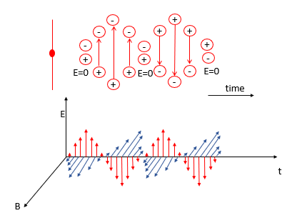
Figure 1 - Electromagnetic Wave
The magnetic field, on the other hand, arises around magnets or moving charges and exerts a force on moving charged particles. Its strength depends on the charge, velocity, and angle of motion. The interaction between electric and magnetic fields is fundamental to electromagnetic radiation as a changing magnetic field induces an electric field (Faraday’s Law), and a changing electric field produces a magnetic field (Ampère-Maxwell Law). These interactions allow electromagnetic waves (e.g. radio waves, microwaves, visible light) to be generated and transmitted through both vacuum and matter.

What is a waveguide
A waveguide is a structure that directs electromagnetic waves with minimal energy loss by confining the transmission to a single direction. It enables efficient propagation of high-frequency waves such as microwaves, radio waves, and infrared radiation. In contrast, low-frequency waves (>1 MHz) typically use parallel transmission lines or coaxial cables. Dielectric waveguides are employed for higher radio frequencies and optical guidance. A typical waveguide consists of a pipe made from a Perfect Electric Conductor (PEC) and filled with a perfect insulator. Waveguides are commonly used to transmit power between components in systems such as radios, radars, and optical devices. In simulations, the waveguide is assumed to be infinitely long, oriented along the z-axis, and uniform throughout its length.
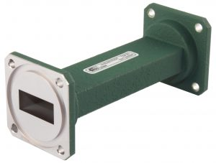
Figure 2 - Flann Series 441/445 Waveguide

Types of Waveguides
Waveguides come in various types, each suited to different frequency ranges and applications. Metal waveguides, typically made from a PEC, are commonly used for microwave transmission. These can be rectangular or cylindrical, with rectangular waveguides being the most widely used due to their simpler mode structure. Dielectric waveguides, made from non-conductive materials like Teflon, are used for higher-frequency applications such as optical communication. These include dielectric slabs and optical fibres, which are widely used in telecommunications for their low loss and high bandwidth.

Cut Off Frequencies
Waveguides have a specific cut-off frequency, which determines the minimum frequency at which signals can propagate through them. Signals with frequencies above this cut-off are allowed to propagate efficiently, while those below it experiences high reflection and are effectively blocked. This characteristic makes waveguides act as high-pass filters. They guide electromagnetic waves by reflecting them within a confined structure, such as a hollow metallic pipe or a dielectric medium, ensuring controlled and efficient transmission.

Transverse modes
Transverse modes describe the distribution of electromagnetic fields (electric and magnetic) in the cross-sectional plane perpendicular to the wave propagation direction. These modes are essential for the behaviour of radio, microwave, and optical signals confined within waveguides or optical fibres. The main types of transverse modes include Transverse Electromagnetic (TEM), Transverse Electric (TE), Transverse Magnetic (TM), and Hybrid modes [1].
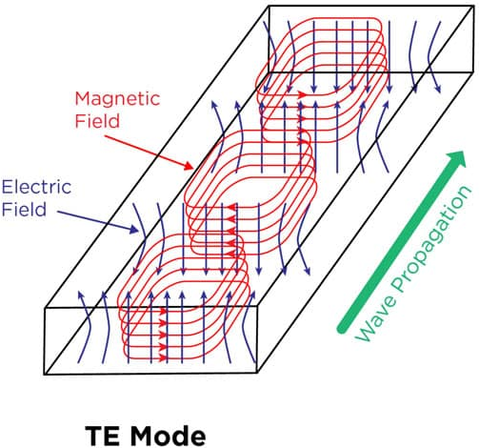  Figure 3 - Transverse Electric Mode | 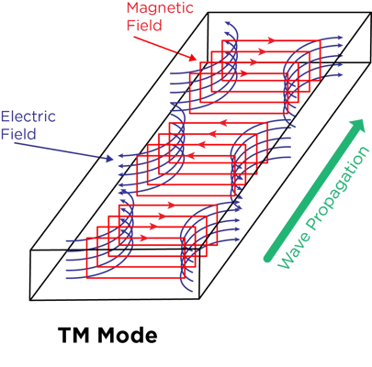  Figure 4 - Transverse Magnetic Mode
TEM modes have both electric and magnetic fields entirely transverse to the propagation direction, typically seen in coaxial cables. TE modes, common in rectangular waveguides, have no electric field along the propagation axis, while TM modes lack a magnetic field in that direction. Hybrid modes combine features of both, with electric and magnetic components along the wave path. These modes are essential for efficient wave guidance in waveguides and optical fibres.

What is an Antenna
An antenna converts electric current into electromagnetic waves for transmission and vice versa for reception. It can serve as a transmitter, receiver, or both, depending on the setup. Antenna design varies based on its use and operating frequency, with common applications in broadcasting, wireless communication, radar, and satellites. Signal loss can occur due to transmission line properties, reflection mismatches, and inefficient design, leading to interference and power loss. Proper impedance matching reduces these issues and enhances performance. Antennas are classified by structure, frequency, directionality, polarisation, and application, with performance illustrated through radiation patterns such as isotropic, omnidirectional, and directional [1].
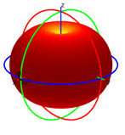  Figure 5 - Omnidirectional Radiation Pattern | 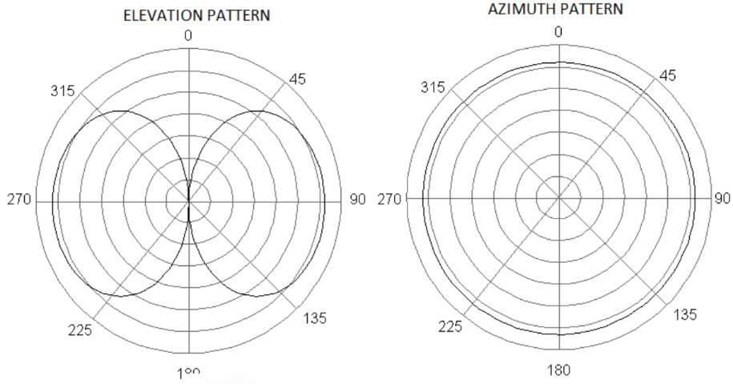  Figure 6 - Omnidirectional Radiation Pattern vertical cross-section
An isotropic radiation pattern radiates evenly in all directions but is theoretical, as real antennas have some directivity. Omnidirectional antennas approximate this by providing 360° coverage in one plane, with low gain and directivity. They're ideal for applications like FM radio and TV broadcasting, often used in monopole and dipole designs.

Method

Task 1a & 1b
The waveguide dimensions are defined as width (a), height (b), and a fixed length of 50 mm along the Z-axis. Dimensions “a” and “b“ were obtained using the student identification number, as shown below:
2114212
$$a = first two numbers of the student ID (2114212)$$  $$a =21$$  $b=$ $\frac{3rd and 4th number of the student ID}{2}$  $b =\frac{14}{2}$ $b =7$ | Length: 50mm  Width (a): 21mm  Height (b): 7mm
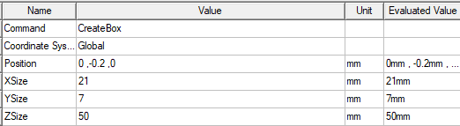
Figure 7 - Rectangular Waveguide Dimensions
Once the dimensions are known, the waveguide can be modelled using Ansys Electronics with the High-Frequency Structure Simulator (HFSS) software plug-in [2] [3].
Before modelling, the solution type must be configured. Network analysis was chosen for its simplicity and flexibility in adjusting excitation values post-simulation. Secondly, select model, not terminal. “Model” refers to the entire 3D structure being simulated, while “Terminal” defines the electrical connection points or ports.
Next, plot a rectangle with the previously calculated dimensions. The material properties of this rectangle is a vacuum which must be applied. The material properties are set to vacuum, and the transparency is set to 0.8 for improved internal visibility. A PEC boundary is applied to represent the conducting walls of the waveguide. Excitations are then assigned at the ports, providing fields and S-parameters that describe how radio frequency signals are transmitted and reflected [4] [5].
Wave ports are configured for three modes, with the characteristic impedance set to “Zpi” for efficiency and accuracy. The Full Port Impedance is set to 50 ohms. The wave ports are verified by expanding the excitations section, where patterns will be displayed. The adjacent excitation is configured similarly [6].
In the analysis section, a solution setup is added with the operating frequency set to 7 GHz, and the maximum number of passes set to 60 for accurate results. A frequency sweep is configured with a range from 2 GHz to 30 GHz and 401 points, using interpolating distribution for faster, accurate simulation. "Save Fields" is selected at Basis Frequencies to store the data.
After validating the model, a solution data report is generated to observe the cutoff frequencies. A gamma plot is created to mark the cutoff frequency. For further analysis, a Port Field Display is generated to visualise the electric fields at each port, and the Magnitude of Electric Field (Mag_E) and Magnetic Field (Mag_H) distributions are plotted to understand the waveguide’s behaviour.

Task 2
A new project was initiated in Ansys HFSS using the modal solution type, with units set to millimetres. A cylinder was created and its properties adjusted: radius set to 1 mm, height to 50 mm, and cantered at (0, 0, -25). The material was changed to PEC and its transparency adjusted to 0.8 for better visibility.
To form a gap in the cylinder, the original geometry was duplicated. The duplicate retained the 1 mm radius, but its height was reduced to 1 mm, with the centre positioned at (0, 0, -0.5). This smaller cylinder was assigned the material 'vacuum' and the same transparency. Using the Boolean subtraction tool, the smaller cylinder was subtracted from the larger one, resulting in two PEC sections separated by a 1 mm gap.
A lumped port was then added across this gap. The YZ plane was selected at the gap location, and the port was defined as a modal lumped port with an impedance of 50 ohms. An integration line was drawn vertically across the port surface to complete the port setup.
An open region was added to simulate free space for radiation. The solution setup was configured with a frequency near the operating point and up to 99 adaptive passes. A frequency sweep from 1 GHz to 7.5 GHz was then defined.
After validating the setup, the project was run. The S-parameter results were plotted and recorded, followed by the 3D polar plot of the radiation pattern to visualize the antenna's performance [7].

Results

Task 1a Data
In this section, a rectangular waveguide with PEC walls and a vacuum core is modelled. The simulation involved analysing the waveguide at both wave ports, evaluating its performance across three distinct modes. Field magnitudes and vectors for both electric and magnetic components were extracted, and the cutoff frequency was determined using a gamma plot for visualisation.

Task 1a Port Field Displays
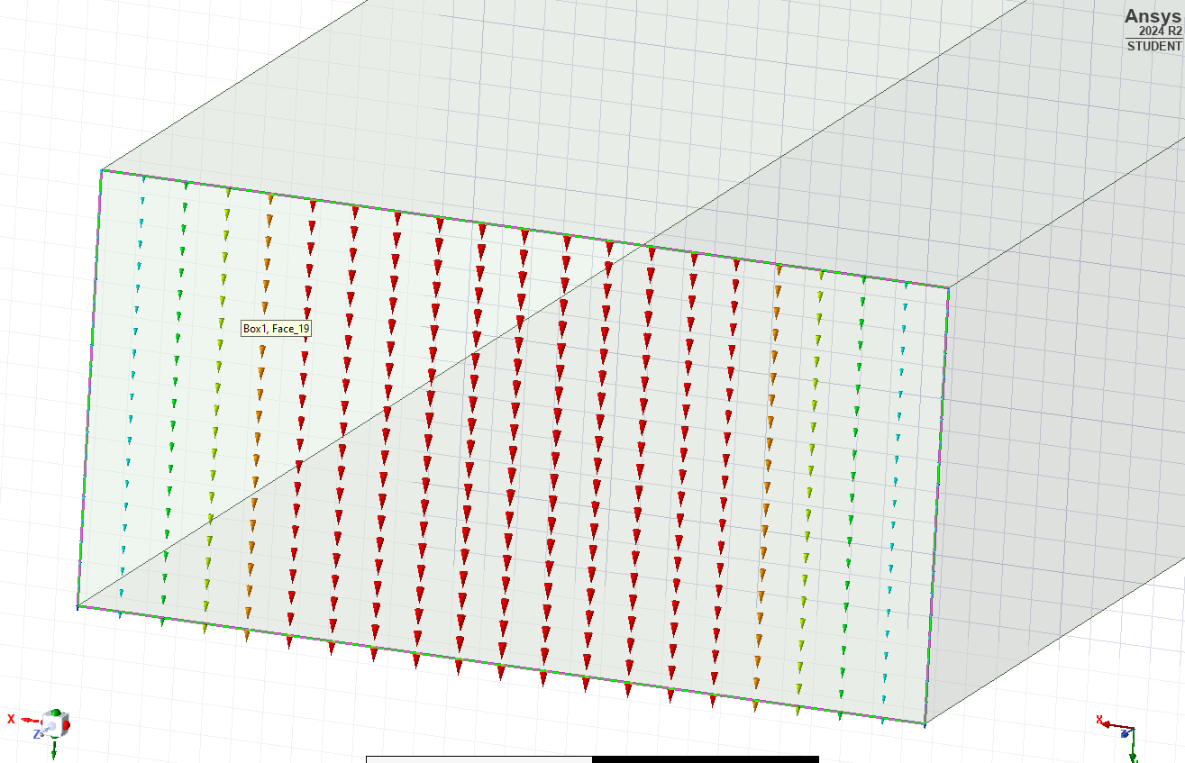
Figure 8 - Task 1a - Port 1 Mode 1 (n=0, m=1)
As shown in Figure 8, the electric field lines displayed in the port field visualisation indicate that Mode 1 corresponds to the ${TE}_{10}$ mode, meaning the electric field lines are perpendicular to the direction of propagation, while the magnetic field lies along the direction of propagation.
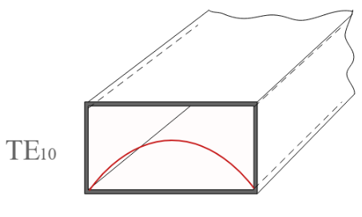 | 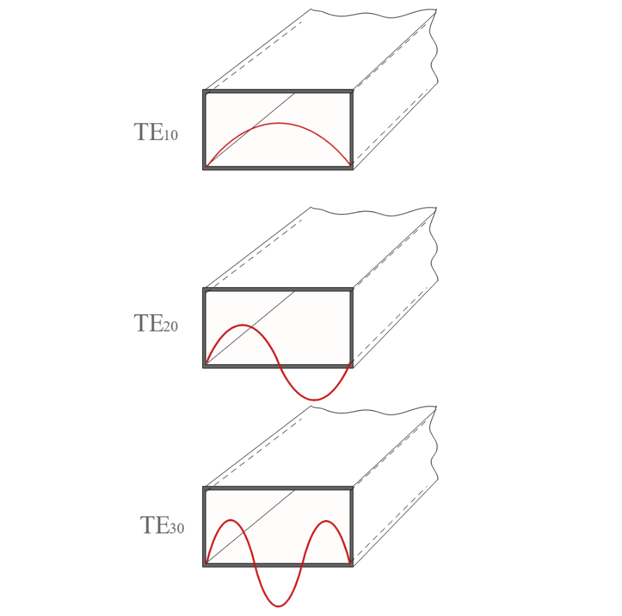
Figure 9 - Rectangular Waveguide TE Modes
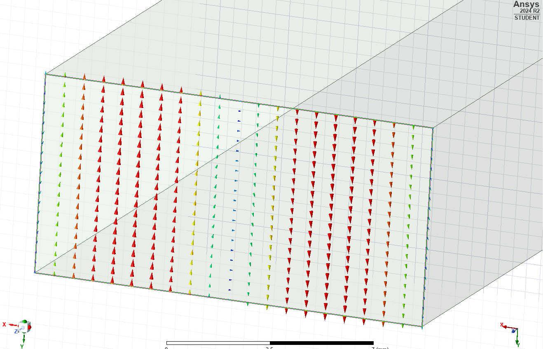
Figure 10 - Task 1A - Port 1 Mode 2 (n=0, m=2)
As shown in Figure 2, Port 1 Mode 2 can be identified as the ${TE}_{20}$ mode, as it exhibits two field maxima along the x-axis but nothing on the y-axis.
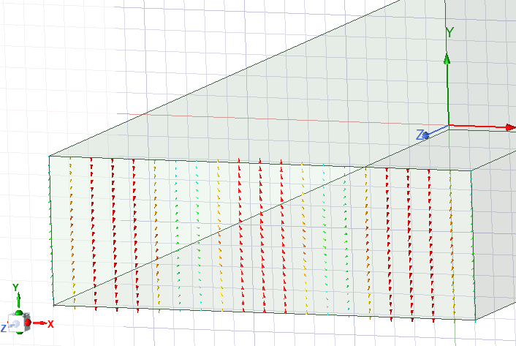
Figure 11 - Task 1A - Port 1 Mode 3 (n=0, m=3)
By viewing the port field display in Figure 3, mode 3 is ${TE}_{30}$ as it exhibits three field maxima along the x-axis but nothing on the y-axis.

Task 1a Electric and Magnetic Field Vectors and Magnitude
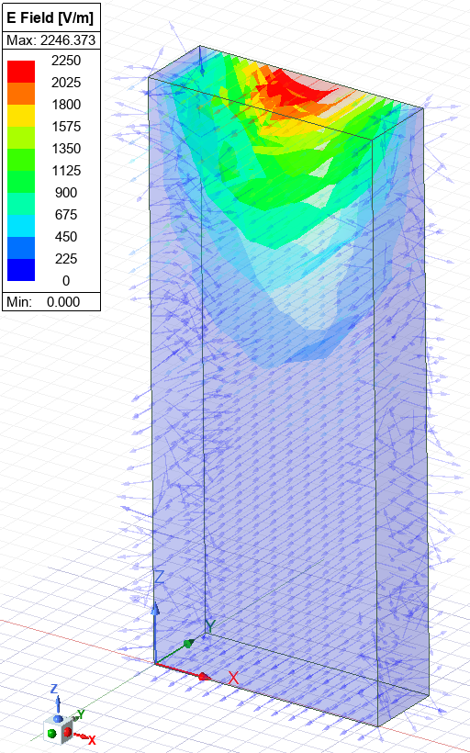  Figure 12 - Task 1A - Electric field magnitude | 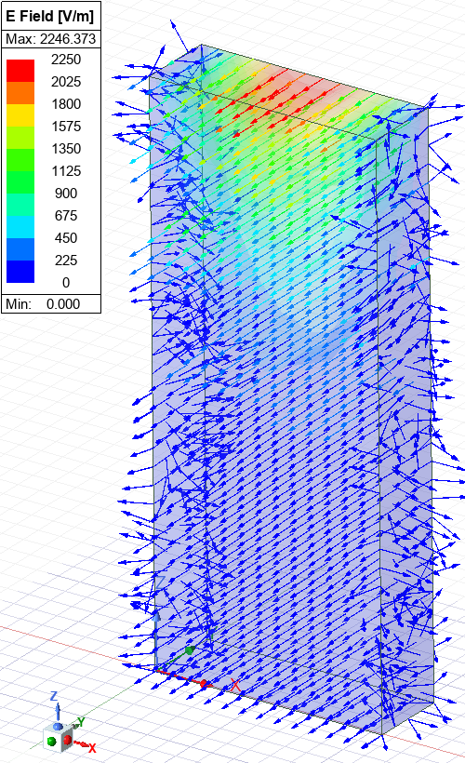  Figure 13 - Task 1A - Electric field vectors
Figure 12 shows the magnitude of electric field within the waveguide, and Figure 13 shows the direction of the electric field within the waveguide depicted by vectors. The blue indicates relatively low electric field intensity and red is the highest intensity, up to 2246.373 V/m.
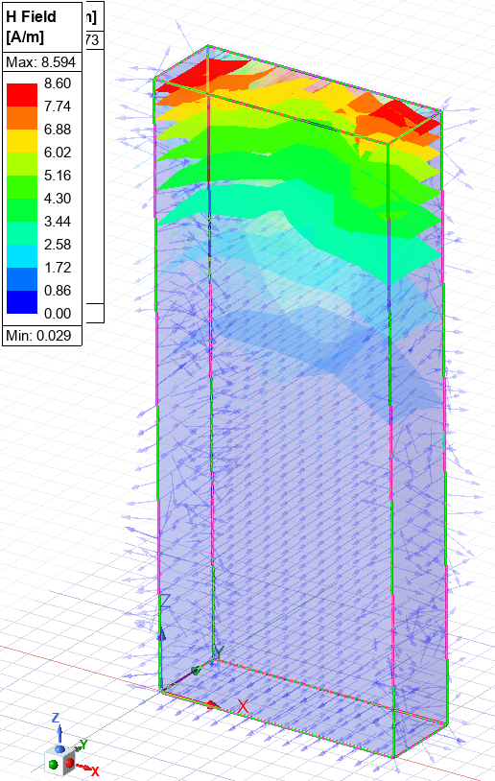  Figure 14 - Task 1A - Magnetic field magnitude | 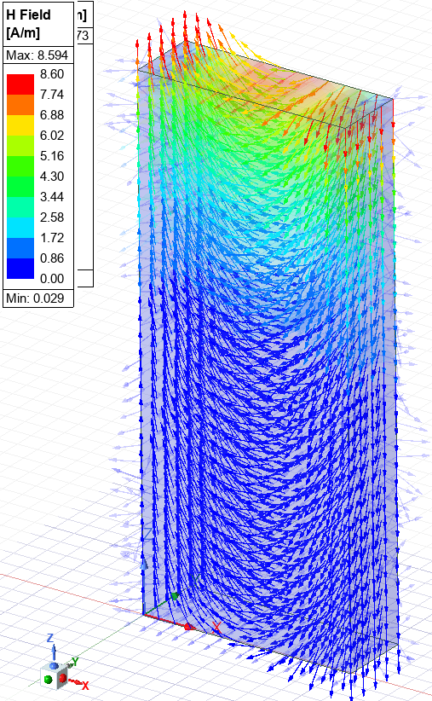  Figure 15 - Task 1A - Magnetic field vectors

Task 1a Cut-off Frequency
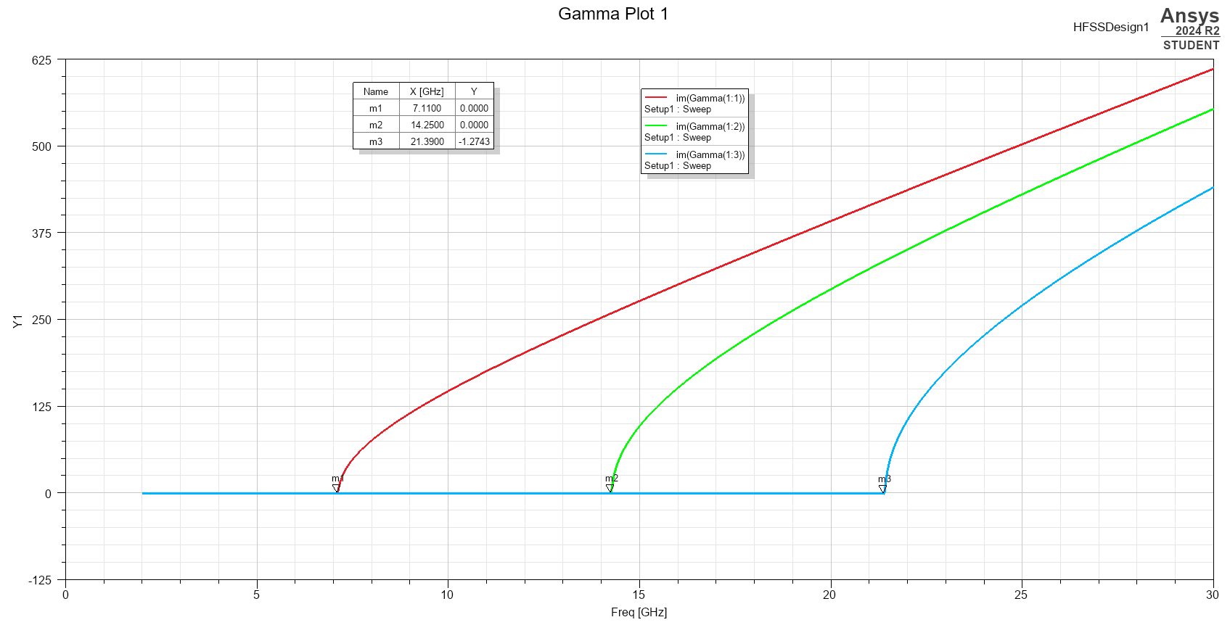
Figure 16 – Task 1a Gamma Plot
Figure 8 shows the gamma plot obtained for each propagation mode of the rectangular waveguide showing the cut-off frequency for mode 1 , 2 and 3.

3.1.4 Task 1a Cut-off Frequency Calculation
The cut-off frequency for a rectangular waveguide can be calculate using the following equation:
$$f_{c}=\frac{c}{2}\sqrt{{(\frac{m}{a})}^{2}+({\frac{n}{b})}^{2}}$$ | Where:  m – number of half-wavelength variations in the width of the waveguide  n – number of half-wavelength variations in the height of the waveguide  a – width of rectangular waveguide  b – height of rectangular waveguide  c – velocity of light in that material
Equation 1 - Cut-off frequency
As shown in Figure 1, Mode 1 corresponds to the TE10 propagation mode in the waveguide. Consequently, the cutoff frequency for the waveguide in this mode is:
$$f_{c}=\frac{c}{2}\sqrt{{(\frac{m}{a})}^{2}+({\frac{n}{b})}^{2}}$$
$$f_{c}=\frac{{3x10}^{8}}{2}\sqrt{{(\frac{1}{0.021})}^{2}+({\frac{0}{0.007})}^{2}}$$
$f_{c}=$ 7.14Ghz
The same calculation was performed for modes 2 and 3, resulting in the following values:
Mode 2 – f_{c} = 14.29GHz
Mode 3 – f_{c} = 21.43GHz

Task 1b
This section shows the model of a rectangular waveguide with PEC walls and a Teflon-filled interior.

Task 1b Port Field Display
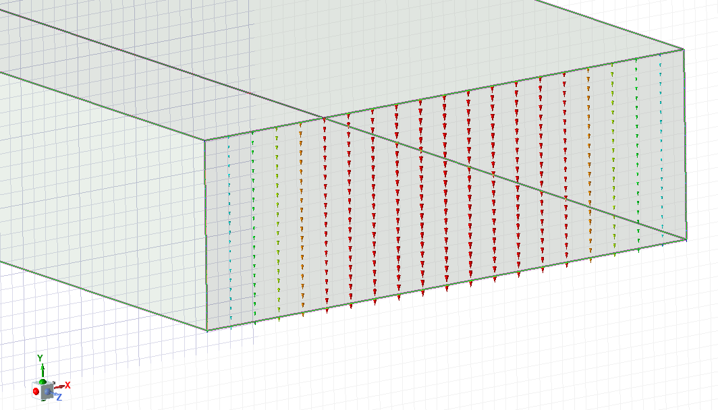
Figure 17 - Task 1b - Port 1 Mode 1 (n=0, m=1)
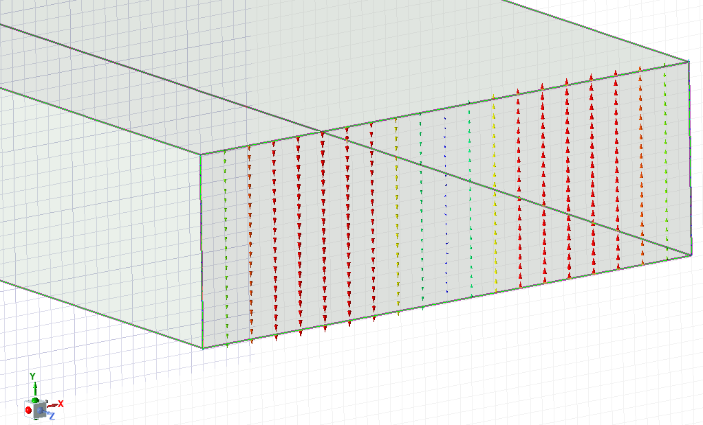
Figure 18 - Task 1b - Port 1 Mode 2 (n=0, m=2)
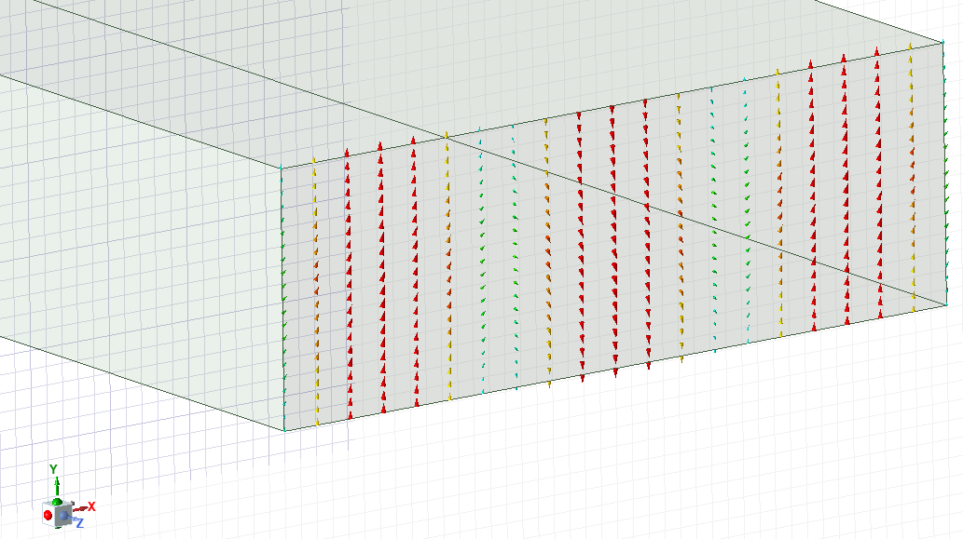
Figure 19 - Task 1b - Port 1 Mode 3 (n=0, m=3)

3.2.2 Task 1b Electric and Magnetic Field Vectors and Magnitude
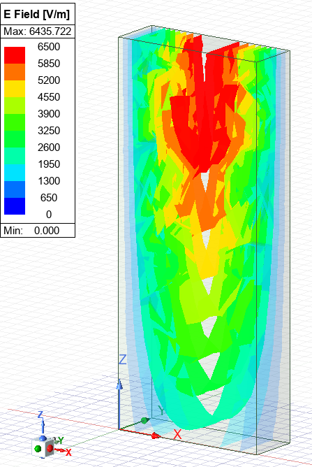  Figure 20 - Task 1b - Electric field magnitude | 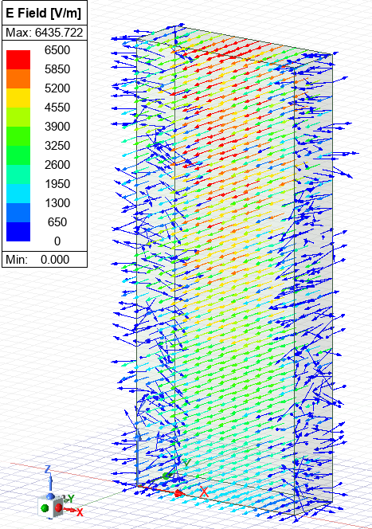  Figure 21 - Task 1b - Electric field vectors

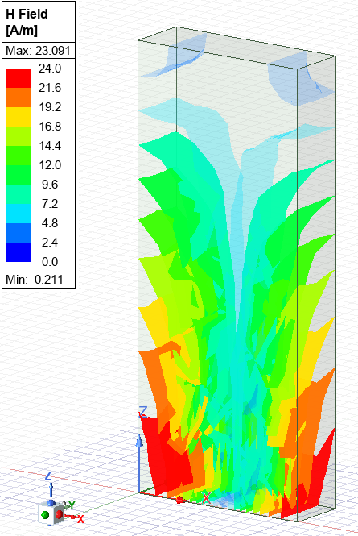  Figure 22 - Task 1b - Magnetic field magnitude | 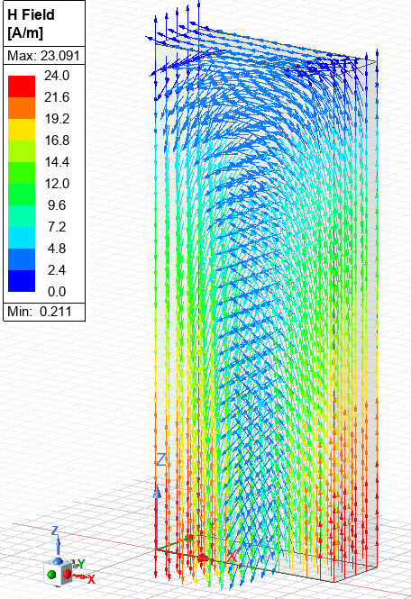  Figure 23 - Task 1b - Magnetic field vectors

3.2.3 Task 1b Cut-off Frequency
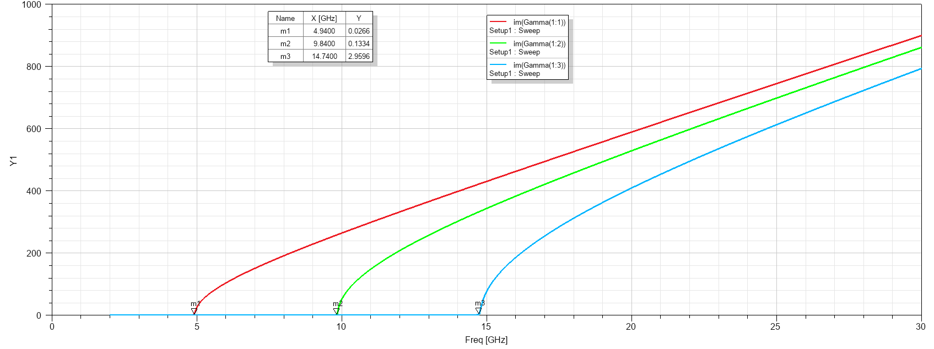
Figure 24 - Task 1b Gamma Plot

3.2.4 Task 1b Cut-off Frequency Calculation
The cutoff frequency for the rectangular waveguide with a Teflon core was then determined. To calculate this, the speed of light in Teflon was first calculated using the following formula:
$$c= \frac{1}{\sqrt{εμ}}$$ | Where:  c – velocity of light (multiplied by velocity of light in air)  ε – permittivity of the medium  µ - permeability of the medium
Equation 2 - Velocity of light for different materials
Given that the permittivity of Teflon is 2.1 and the permeability is 1, the velocity of light in Teflon can be calculated using the following equation:
$$c= \frac{1}{\sqrt{εμ}}$$
$$c= \frac{1}{\sqrt{2.1(1)}}$$
$$c=0.69 x {3x10}^{8}$$
$c= {2.07x10}^{8}$ m/s
Using the speed of light $c$, the cutoff frequency for the waveguide in Mode 1 can be calculated as follows:
$$f_{c}=\frac{c}{2}\sqrt{{(\frac{m}{a})}^{2}+({\frac{n}{b})}^{2}}$$
$$f_{c}=\frac{{2.07x10}^{8}}{2}\sqrt{{(\frac{1}{0.022})}^{2}+({\frac{0}{0.011})}^{2}}$$
$$f_{c}=4.93GHz$$
The same method can be applied to Mode 2 and Mode 3, giving the following results:
Mode 2: f_{c} = 9.86GHz
Mode 3: f_{c} = 14.79GHz
  - Task 2 Data
The designed model is a half-wave dipole antenna made with PEC material and excited through a lumped port with a port impedance of 50 ohms. The radiation pattern and S-parameter plot will be analysed to determine the antenna's operating frequency.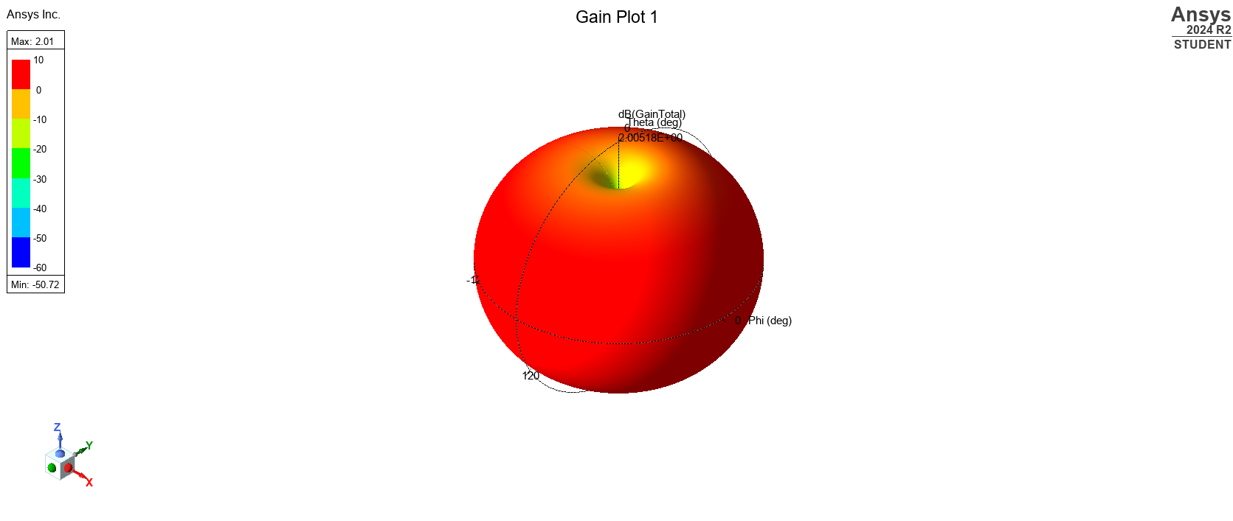
Figure 25 - Task 2 - Antenna radiation pattern
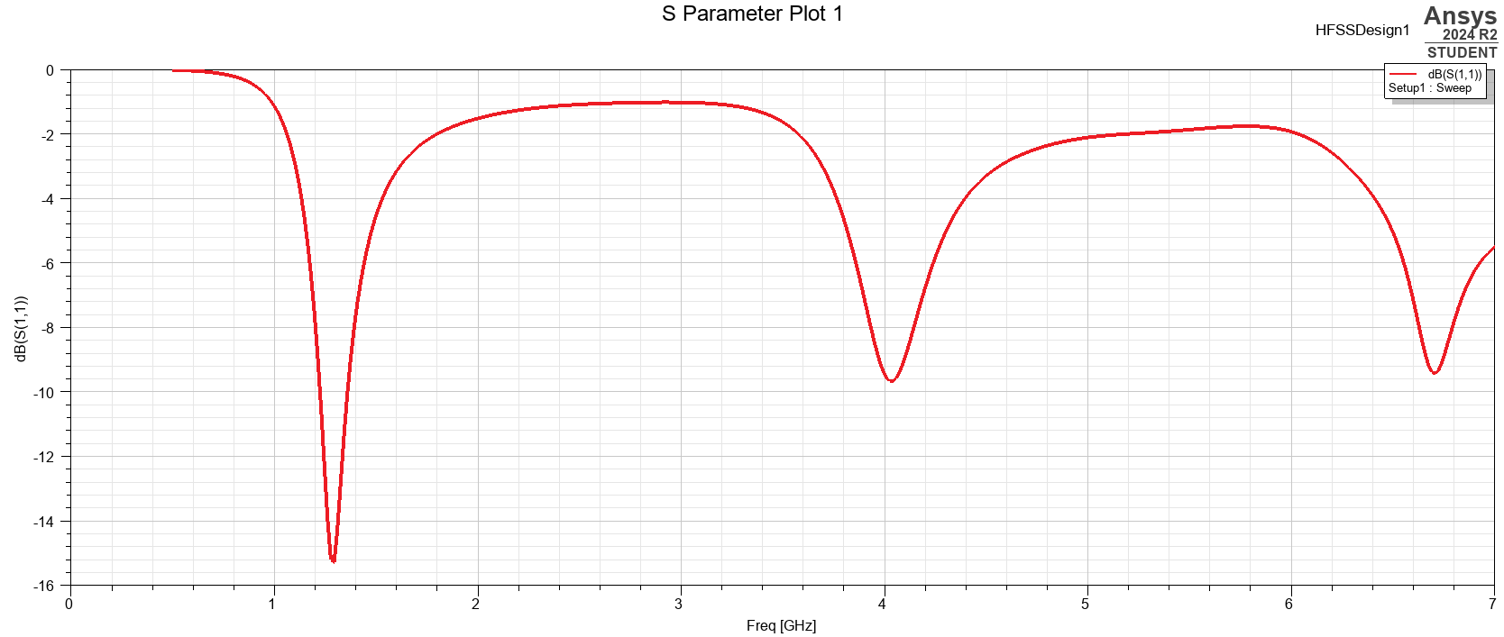
Figure 26 - Task 2 - S-parameter plot
As shown in Figure 13, the operating frequency of the antenna can be determined from the lowest point on the graph, which corresponds to the first resonant frequency on the left. This indicates an operating frequency of approximately 1.3 GHz.

    - Task 2 Calculations
The length at which the dipole antenna is most efficient can be determined using the following formula:
$$L=\frac{λ}{2}$$
Equation 3 - Dipole antenna length
The wavelength at which the antenna radiates electromagnetic waves is 211 mm, which can be used to calculate the optimal length of the antenna.
$$L=\frac{0.211}{2}$$
$L=0.1055$m
The operating frequency can then be calculated using the formula:
$$f=\frac{c}{λ}$$  $$f=\frac{{3x10}^{8}}{0.211}$$  $$f=1.42GHz$$ | Where:  c – velocity of light in medium  λ – wavelength  f – frequency
Equation 4 - Antenna operating frequency

Discussion

Task 1A & 1B
 | Ansys | Calculation
Mode 1 | 7.11GHz | 7.14Ghz
Mode 2 | 14.25GHz | 14.29GHz
Mode 3 | 21.39GHz | 21.43GHz
Table 1 - Task 1a - Ansys vs Calculation table
Table 1 compares the modes in Task 1a which has minimal discrepancy, indicating the reliability and precision of both simulation and calculation approaches in analysing waveguide or electromagnetic systems.

 | Ansys | Calculation
Mode 1 | 4.94GHz | 4.93GHz
Mode 2 | 9.84GHz | 9.86GHz
Mode 3 | 14.74GHz | 14.79GHz
Table 2 - Task 1b - Ansys vs Calculation table
Table 2, referring to the Teflon waveguide also demonstrates excellent agreement between the two methods.
Based on the computed cut-off frequencies shown in Table 1 and Table 2 for a rectangular waveguide filled with either vacuum or Teflon, mode 1 exhibited a cut-off frequency of 7.11 GHz in vacuum and 4.94 GHz in Teflon. This decrease in cut-off frequency is attributed to the fact that electromagnetic waves propagate more slowly in Teflon than in a vacuum. The ${TE}_{10}$ mode is the dominant propagation mode in the rectangular waveguide, as it possesses the lowest cut-off frequency.

Task 2
Figure 25 illustrates the dipole antenna's toroidal radiation pattern, which is consistent in the z-plane, and demonstrates how electromagnetic energy is emitted. It features a main lobe that surrounds the antenna and nulls at both ends along its axis.
The operating frequency of the antenna was calculated to be 1.42 GHz using Equation 4, while the S-parameter plot indicates an operating frequency of approximately 1.3 GHz. This discrepancy arises due to ideal assumptions made during the analytical calculation, such as perfect material properties, ideal geometries, and no losses, which may not fully align with the more realistic conditions simulated in HFSS, including material imperfections, meshing accuracy, and boundary effects.

Conclusion
In Task 1, the dominant propagation mode in the rectangular waveguide was correctly identified as TE₁₀. For the vacuum-filled waveguide, the cut-off frequency obtained through simulation was 6.76 GHz, which closely aligned with the theoretical value of 6.82 GHz. When the waveguide was filled with Teflon ($ε$ = 2.1), the simulated cut-off frequency dropped to 4.66 GHz, again showing strong correlation with the calculated theoretical value of 4.705 GHz. These results confirm the expected influence of dielectric materials on waveguide performance and validate the accuracy of both simulation and analytical methods.
In Task 2, the antenna was designed to operate at a frequency of 1.35 GHz, with simulation results showing a resonant frequency of 1.22 GHz. This demonstrates reasonable agreement and highlights potential design refinements. The simulated radiation pattern exhibited omnidirectional behaviour in the z plane, consistent with theoretical predictions for this type of antenna. The simulation further provided valuable insights into the gain and S-parameters, reinforcing understanding of antenna performance in practical applications.

References

[1] | I. Poole, “Waveguide Modes: TE, TM, TEM,” electronics notes, [Online]. Available: https://www.electronics-notes.com/articles/antennas-propagation/rf-feeders-transmission-lines/waveguide-modes-te-tm-tem.php. [Accessed 04 2025].
[2] | S. Greiner, “Omnidirectional Antenna Radiation Patterns Explained,” mp antenna, 20 12 2019. [Online]. Available: https://www.mpantenna.com/omnidirectional-antenna-radiation-patterns/. [Accessed 04 2025].
[3] | Ansys, “Ansys HFSS,” Ansys, 2025. [Online]. Available: https://www.ansys.com/en-gb/products/electronics/ansys-hfss#:~:text=What's%20New,driver%2Din%2Dloop%20analysis. [Accessed 04 2025].
[4] | ANSYS Discovery SpaceClaim, “https://help.spaceclaim.com/v19.0/en/Content/Transparency.htm#:~:text=The%20transparency%20setting%20from%20the,of%20face%20or%20layer%20settings,” ANSYS Discovery SpaceClaim, 2017. [Online]. Available: https://help.spaceclaim.com/v19.0/en/Content/Transparency.htm#:~:text=The%20transparency%20setting%20from%20the,of%20face%20or%20layer%20settings. [Accessed 04 2025].
[5] | Ansys, “Introduction to ANSYS HFSS for Antenna Design,” 01 02 2012. [Online]. Available: Microsoft PowerPoint - 04_0_hfss-ant_bc. [Accessed 04 2025].
[6] | I. V. L. H. W. a. P. Y.-O. Ari Sihvola, “Material Realizations of Perfect Electric Conductor Objects,” Aalto University School of Science and Technology, AALTO, Finland, 2010.
[7] | Ansys, “Module 6: HFSS Lumped and Wave Port Basics,” 2020. [Online]. Available: https://innovationspace.ansys.com/courses/wp-content/uploads/sites/5/2021/07/HFSS_GS_2020R2_EN_LE6_Port_Basics.pdf. [Accessed 04 2025].
[8] | EMA, “S-Parameters Basics,” EMA, 15 11 2023. [Online]. Available: https://www.ema-eda.com/ema-resources/blog/s-parameters-basics/. [Accessed 04 2025].

Appendix 1
Vacuum
Plot 1
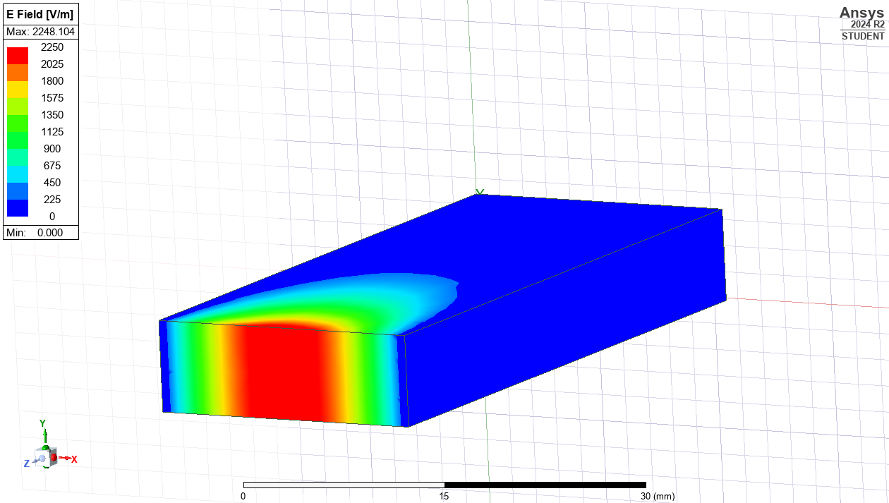 | 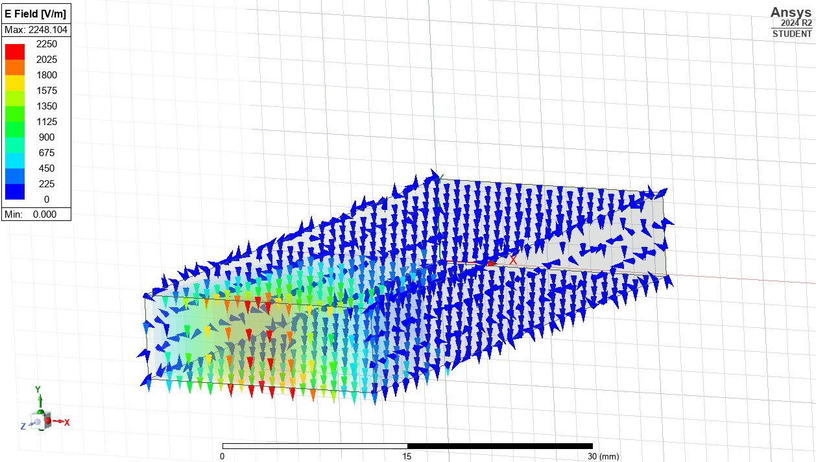
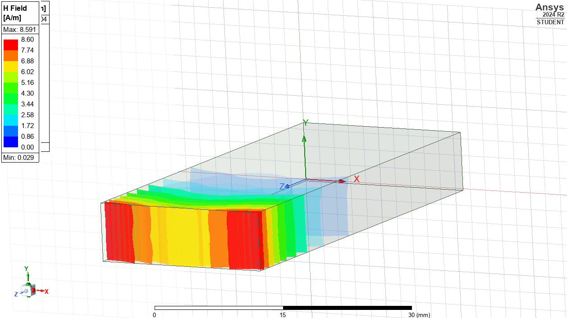 | 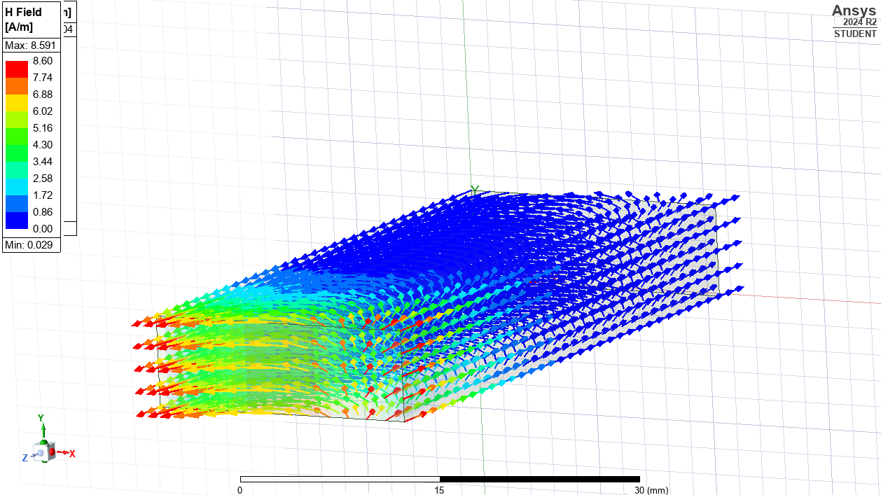
Plot 2
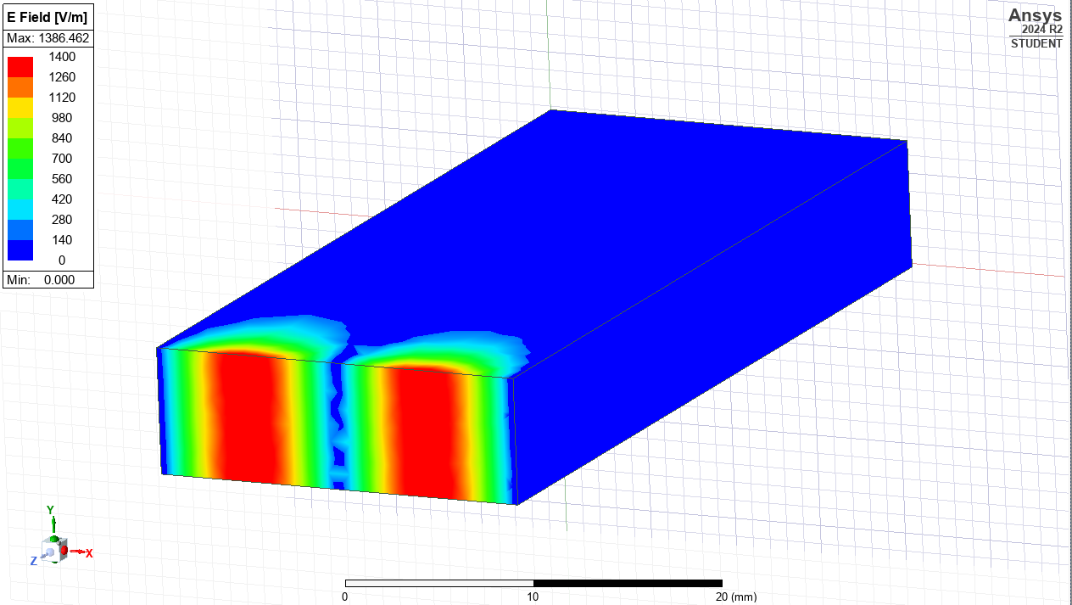  Electric field Magnitude | 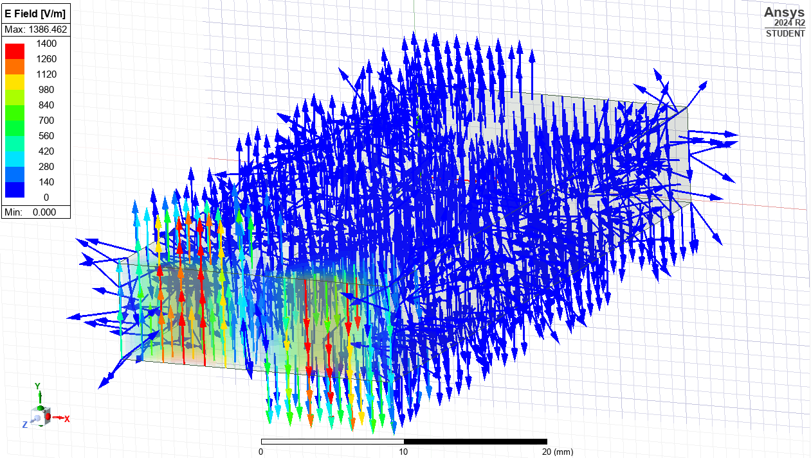  VECTOR Electric field  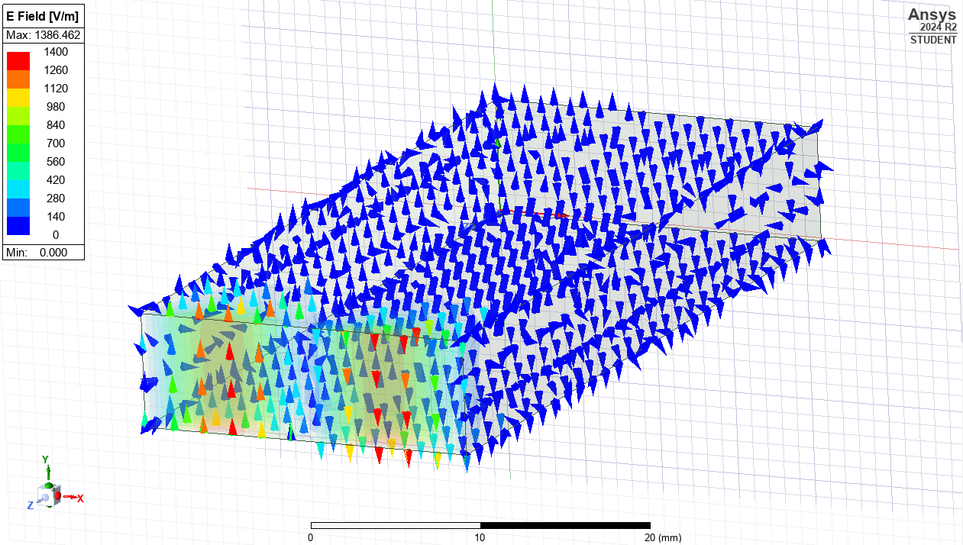Short arrows. Density less
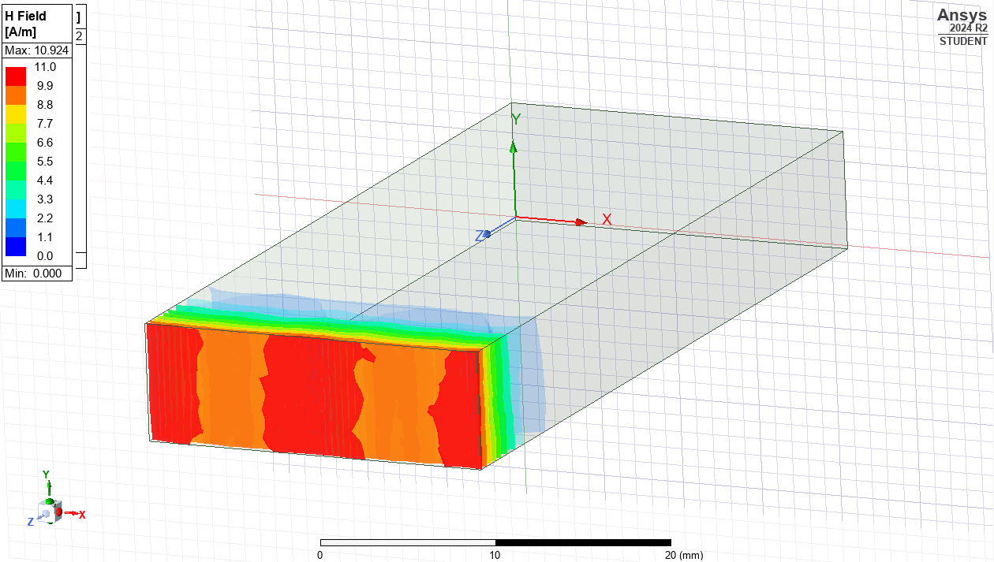Magnetic Field Magnitude | 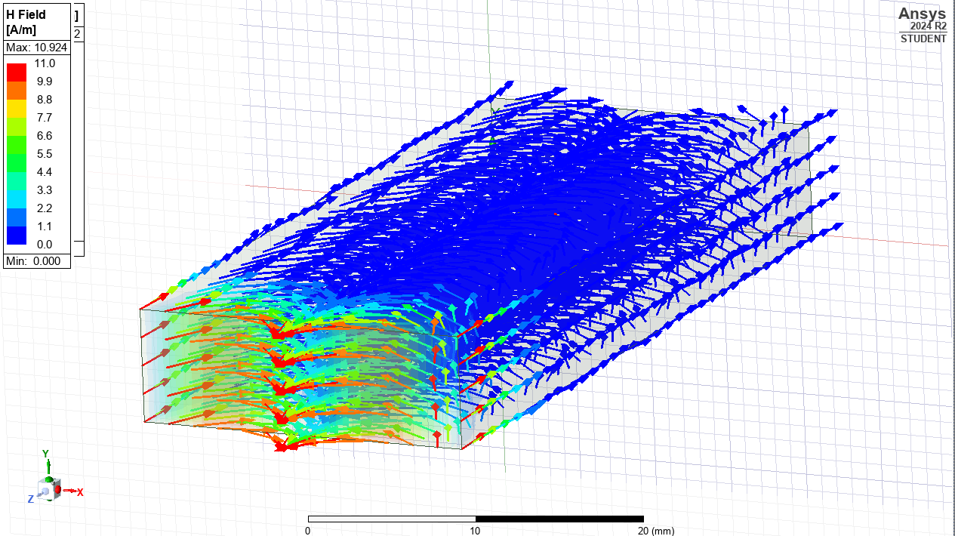 Magnetic Field Vector
Plot 3
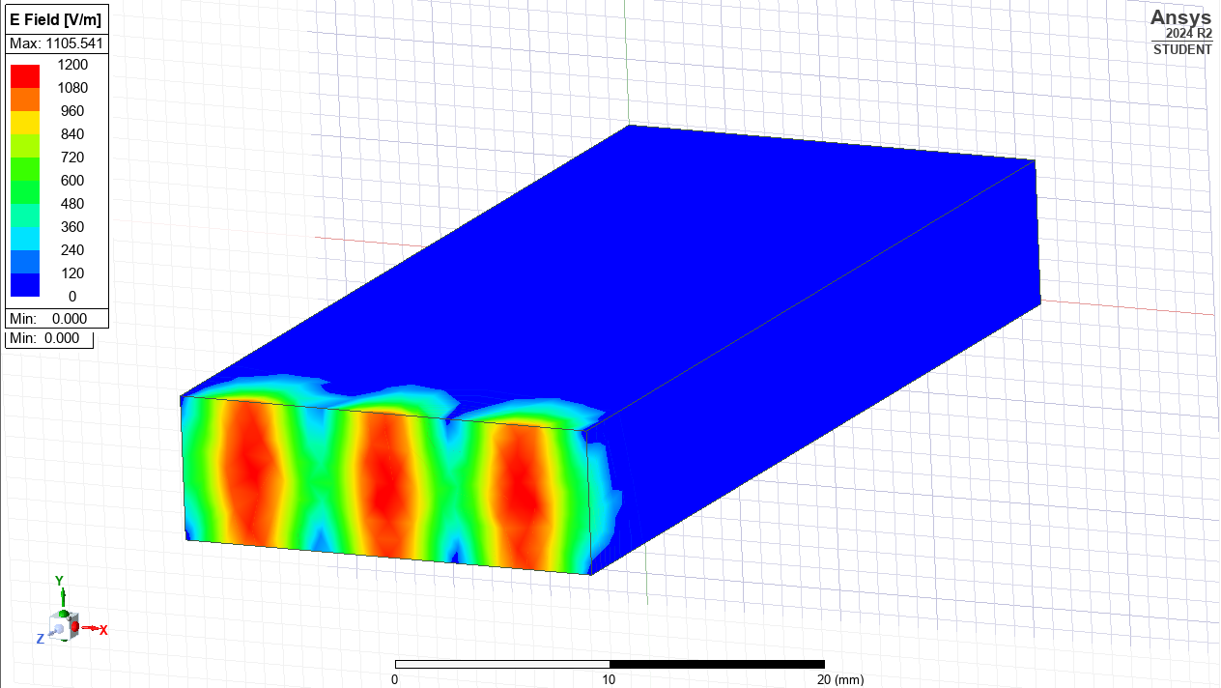  Electric Field Magnitude | 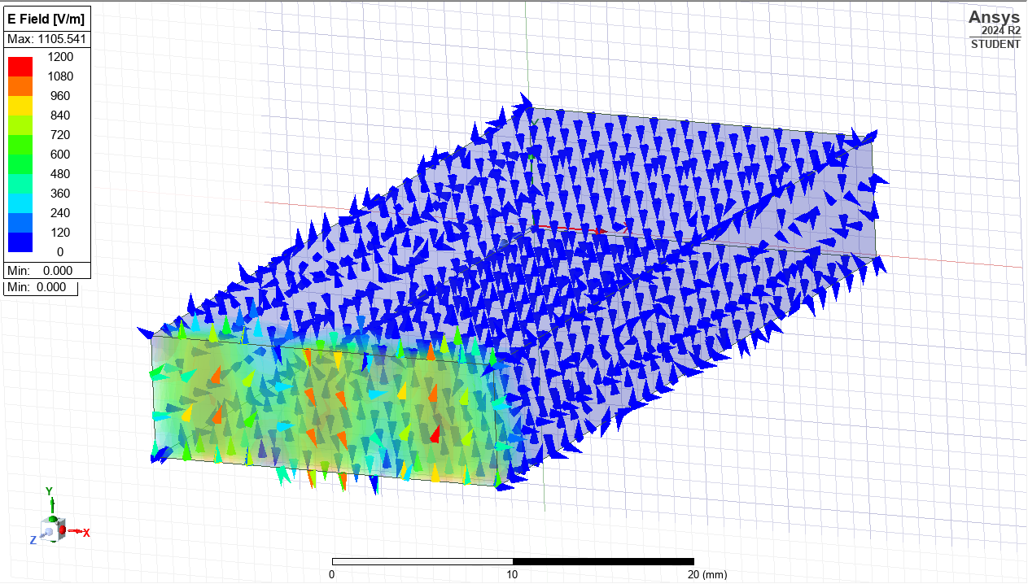 VECTOR Electric field
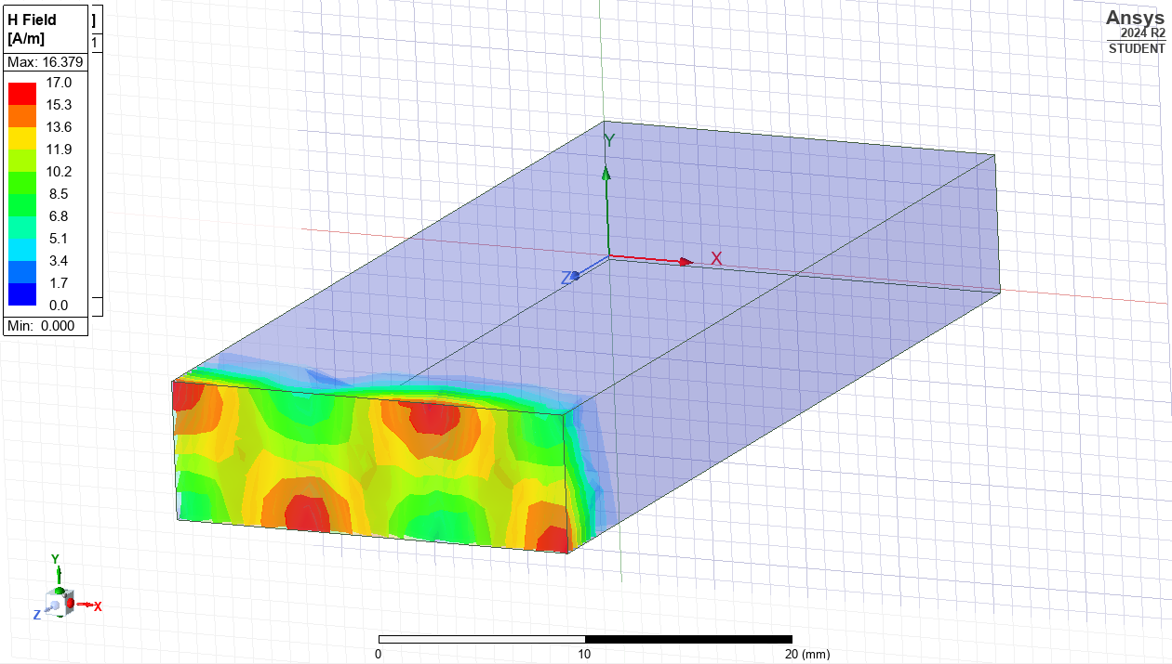 Magnetic Field Magnitude | 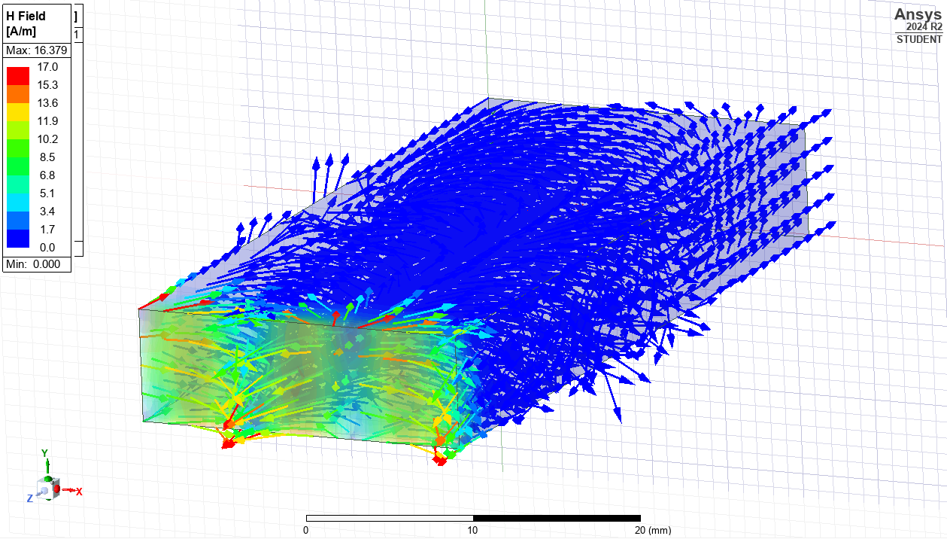 Magnetic Field Vector
Plot 4
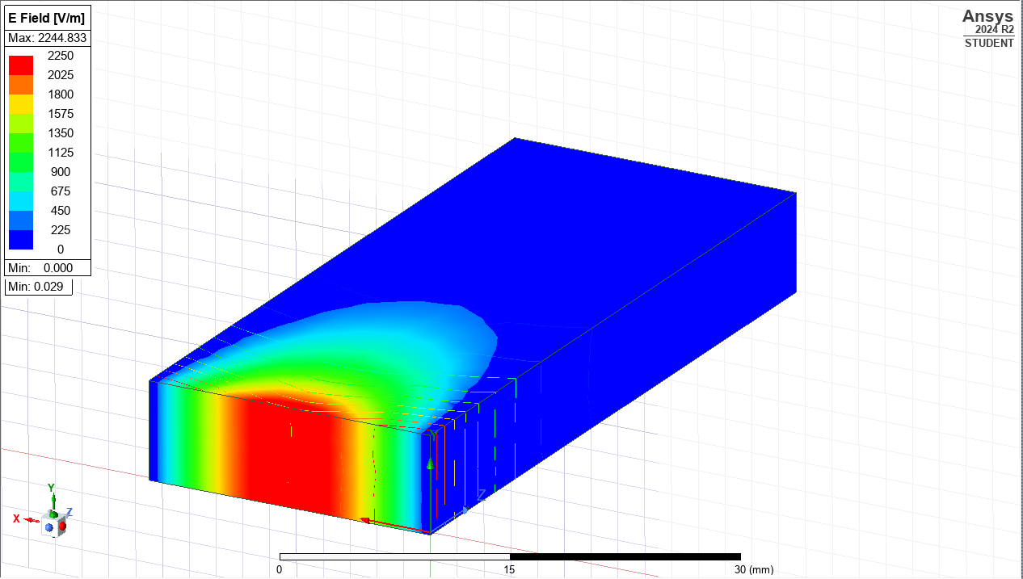  Electric Field Magnitude | 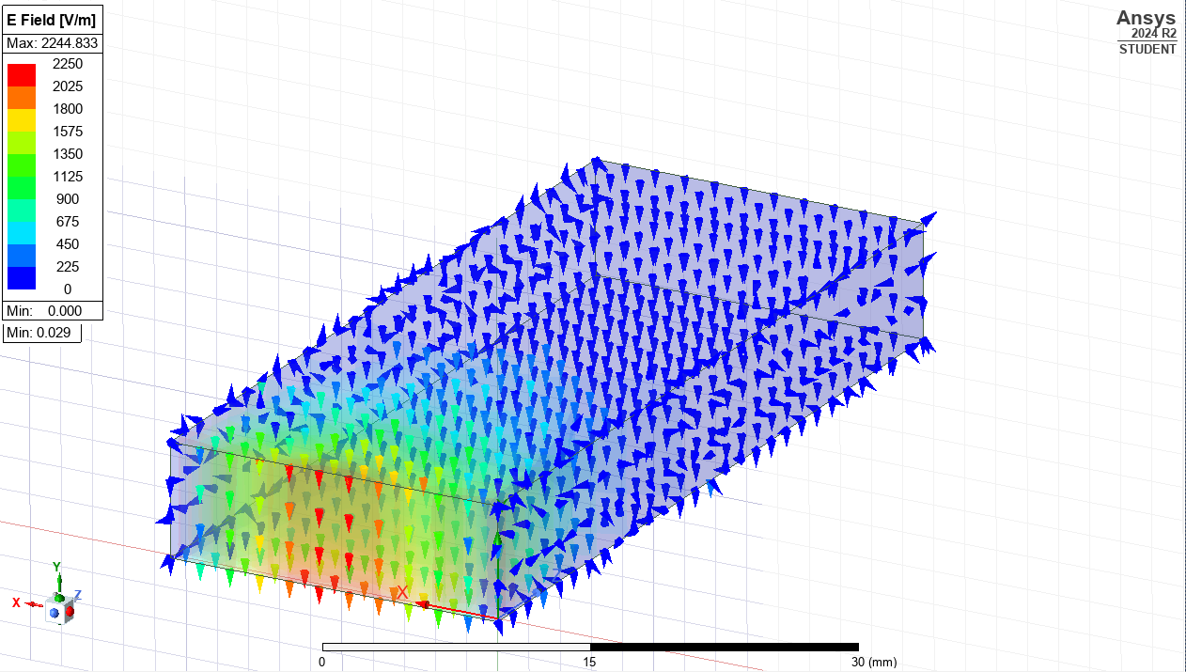 VECTOR Electric field
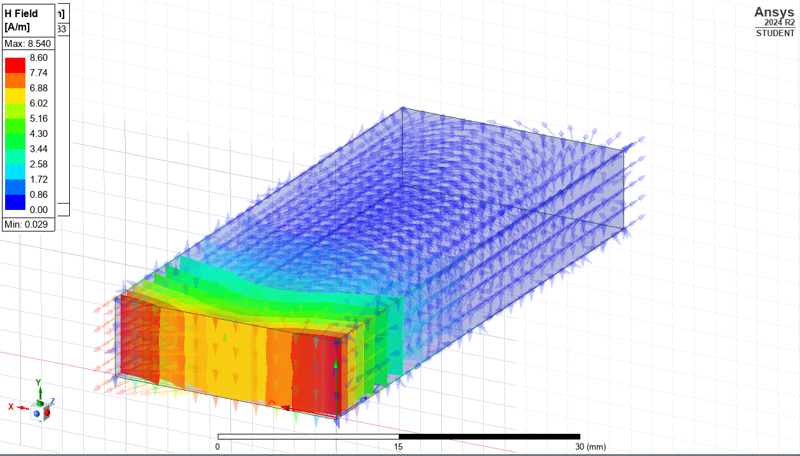 Magnetic Field Magnitude | 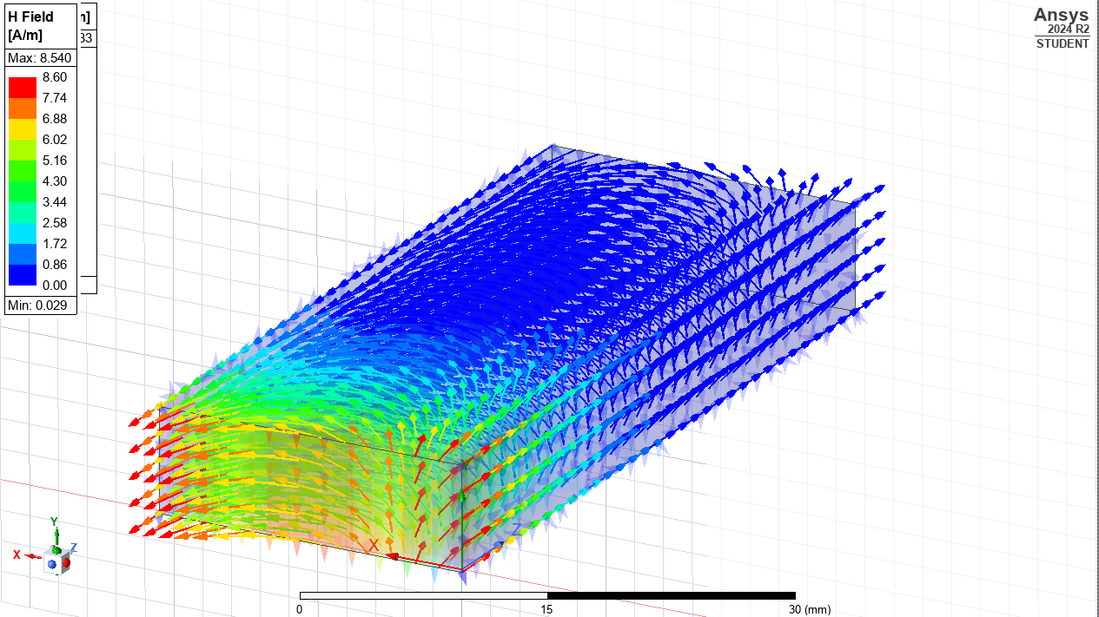 Magnetic Field Vector

