INVESTMENT APPRAISAL
AND CAPITAL RATIONING
Written Interpretation with Graphs
Projects A, B and C | Discount rate: 8% | Capital limit: £100 million
Overall recommendation: Select Project C only.
Project C is the only project that produces a positive NPV and an IRR above the required return.
Prepared for assessment submission
5 August 2026

1. Executive Summary
This report extends the Week 8 investment appraisal model by adding the Profitability Index (PI) and Internal Rate of Return (IRR). It also considers capital rationing under a £100 million investment limit. The analysis uses the cash-flow information and formulas contained in the accompanying Excel workbook.
The results point clearly towards Project C. It pays back in 3.60 years, has the highest Accounting Rate of Return at 6.0%, generates a positive NPV of £0.86 million, has a PI of 1.017, and produces an IRR of 8.59%. Since the IRR is above the 8% required return, Project C meets the financial acceptance criteria.
Projects A and B recover their initial investment before the end of Year 5, but both have negative NPVs, PI values below 1.0, and IRRs well below 8%. This means that they recover the original cash outlay in nominal terms but do not provide an adequate return after considering the time value of money.
Under capital rationing, Project C alone is the best choice because it has the highest feasible NPV and IRR. Although the business has enough capital to invest in two projects, adding Project A or B to Project C would reduce value. If management were forced to use the full £100 million, the best pair would be Projects B and C; however, this combination still has a negative NPV and an IRR below 8%, so it should normally be rejected.

2. Method and Decision Rules
Each project requires an initial investment of £50 million and produces cash inflows over five years. The required rate of return is 8%, and the model assumes straight-line depreciation over five years with no residual value. The decision is based on a combination of liquidity, accounting return and discounted cash-flow measures.
Method | Excel formula or calculation | Decision rule
Payback Period | Full years before recovery + unrecovered amount / next year cash flow | A shorter payback is preferred.
ARR | Average annual accounting profit / initial investment | A higher ARR is preferred.
NPV | =NPV(8%, Year 1:Year 5) - initial investment | Accept when NPV is greater than zero.
PI | Present value of future cash inflows / initial investment | Accept when PI is greater than 1.0.
IRR | =IRR(Year 0:Year 5) | Accept when IRR is above 8%.
NPV is used as the main decision measure because it shows the estimated increase or decrease in shareholder value. PI and IRR are useful supporting measures, especially when capital is limited.

3. Individual Project Results
Project | PBP (years) | ARR | NPV (£m) | PI | IRR | Decision
Project A | 4.50 | 1.6% | -6.54 | 0.869 | 2.72% | Reject
Project B | 4.55 | 2.0% | -6.08 | 0.878 | 3.26% | Reject
Project C | 3.60 | 6.0% | 0.86 | 1.017 | 8.59% | Accept
Project A: The project has a payback period of 4.50 years, which means the original £50 million investment is recovered during the final year. However, the ARR is only 1.6%, the NPV is negative at £6.54 million, the PI is 0.869, and the IRR is 2.72%. These results show that Project A does not earn the required 8% return and would reduce value.
Project B: The cash inflows are steady at £11 million per year, but the payback period is slightly longer at 4.55 years. Its NPV is negative at £6.08 million, PI is 0.878, and IRR is 3.26%. Project B performs slightly better than Project A on NPV and IRR, but it still fails all discounted cash-flow acceptance tests.
Project C: This project has the strongest results. It pays back in 3.60 years, produces the highest ARR at 6.0%, and generates a positive NPV of £0.86 million. Its PI of 1.017 means that each £1 invested generates approximately £1.017 in present value. Its IRR of 8.59% is above the required return, so Project C should be accepted.
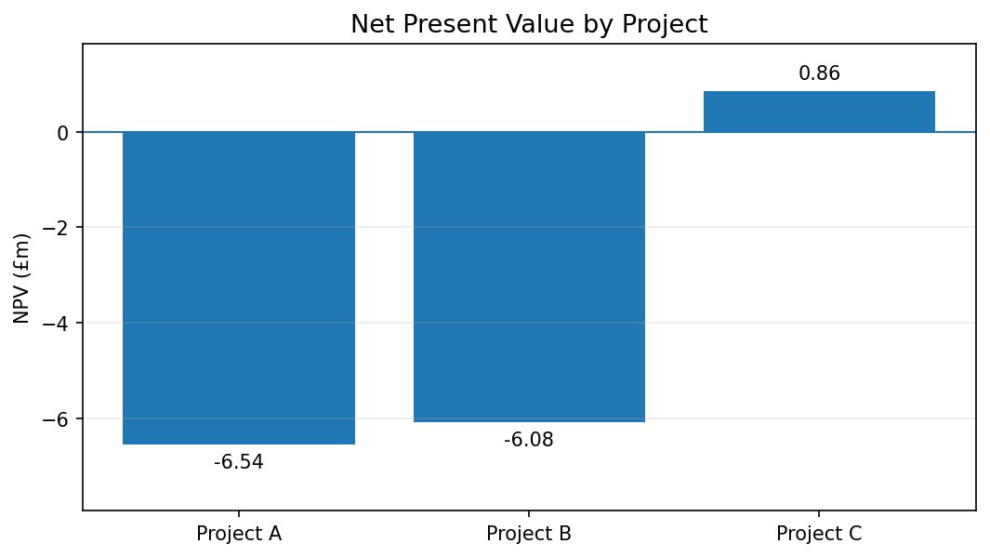
Figure 1. Net Present Value by Project
The graph shows that Project C is the only project with a positive NPV. Projects A and B fall below zero and would therefore reduce shareholder value at an 8% discount rate.

4. Interpretation of NPV, PI and IRR
NPV gives the clearest overall ranking because it discounts future cash flows and expresses the result as an amount of value created. Project C adds approximately £0.86 million, while Projects A and B destroy approximately £6.54 million and £6.08 million respectively. On this basis, the ranking is Project C first, Project B second and Project A third.
The PI results support the same conclusion. A PI above 1.0 indicates that the present value of future cash inflows is greater than the initial investment. Project C has a PI of 1.017, whereas Projects A and B have PI values below 1.0. Therefore, only Project C creates value for each pound invested.
The IRR comparison also supports Project C. The 8% required return acts as the hurdle rate. Project A earns 2.72% and Project B earns 3.26%, which are both well below the hurdle. Project C earns 8.59%, which is slightly above the required return. The small margin above 8% means the project is acceptable, although its value advantage is not very large and should be considered alongside risk and forecast reliability.
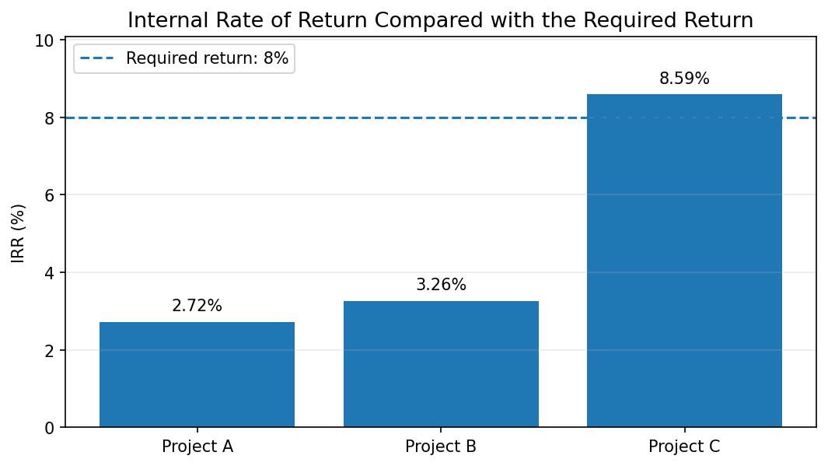
Figure 2. Internal Rate of Return Compared with the 8% Required Return
Only Project C crosses the 8% hurdle rate. This confirms the decision reached using NPV and PI.

5. Payback and Cash-Flow Timing
The payback method focuses on liquidity rather than value creation. Project C recovers the initial investment fastest because it receives large cash inflows in Years 3 and 4. Project A and Project B do not recover the investment until late in Year 5. This makes Project C less exposed to the risk of waiting a long time for the original investment to be returned.
However, payback should not be used alone because it ignores the time value of money and any cash flows received after the payback point. The fact that all three projects eventually pay back does not mean they are all financially acceptable. The negative NPVs of Projects A and B demonstrate why discounted cash-flow measures provide a more reliable decision.
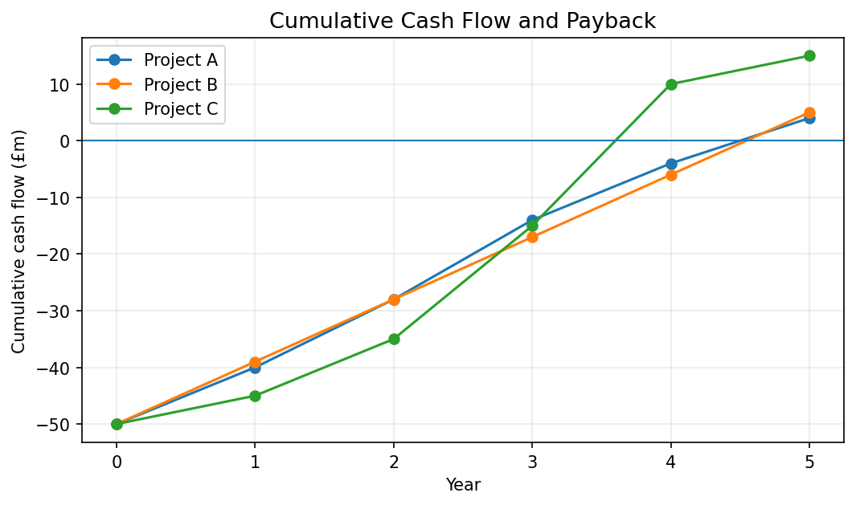
Figure 3. Cumulative Cash Flow and Payback
The zero line represents full recovery of the initial investment. Project C crosses this line during Year 4, earlier than Projects A and B.

6. Capital-Rationing Analysis
Capital rationing is required because the available budget is £100 million, while investing in all three projects would require £150 million. Since the projects are treated as indivisible, the business must compare the NPV of each feasible combination. The main objective is to select the combination that creates the highest total value without exceeding the budget.

Option | Investment (£m) | NPV (£m) | PI | IRR | Decision
A only | 50 | -6.54 | 0.869 | 2.72% | Reject: negative NPV
B only | 50 | -6.08 | 0.878 | 3.26% | Reject: negative NPV
C only | 50 | 0.86 | 1.017 | 8.59% | Accept
A + B | 100 | -12.62 | 0.874 | 3.00% | Reject: negative NPV
A + C | 100 | -5.69 | 0.943 | 5.90% | Reject: negative NPV
B + C | 100 | -5.22 | 0.948 | 6.10% | Reject: negative NPV
A + B + C | 150 | -11.77 | 0.922 | 5.05% | Over budget
Best option by NPV: Project C alone has the highest feasible NPV at £0.86 million. It uses only £50 million of the available budget, but leaving the remaining £50 million uninvested is better than placing it in a project with a negative NPV. Capital should not be spent simply because it is available.
Best option by IRR: Project C alone also has the highest feasible IRR at 8.59%. This is the only option that exceeds the required return. All two-project combinations have IRRs below 8% because they include either Project A or Project B, both of which have weak returns.
Best pair if the full budget must be used: Projects B and C are the strongest two-project combination. They have a combined NPV of negative £5.22 million, a PI of 0.948 and an IRR of 6.10%. Although this pair is better than A plus C or A plus B, it still fails the acceptance criteria. Therefore, it should only be considered if management is required to commit the full budget for non-financial reasons, and even then the value loss should be recognised.
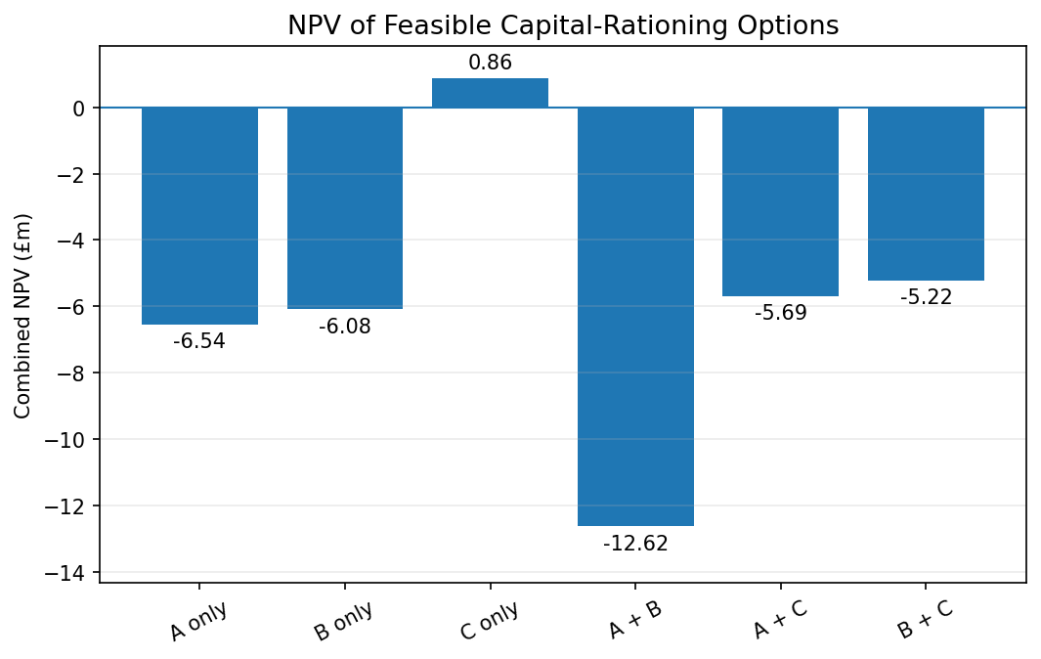
Figure 4. NPV of Feasible Capital-Rationing Options
Project C alone is the only feasible option with a positive combined NPV. Every combination containing Project A or Project B has a negative NPV.

7. Final Recommendation
Recommended decision: Invest in Project C only.
Project C creates the greatest value within the capital limit and is the only project or combination that meets the NPV, PI and IRR decision rules.
The recommendation should not be based on a single calculation. Project C ranks first under all five methods: it has the shortest payback period, the highest ARR, the only positive NPV, the only PI above 1.0, and the only IRR above 8%. The consistency of these results gives confidence in the decision.
NPV should remain the primary measure for the capital-rationing decision because it directly measures value created. IRR and PI provide helpful confirmation, but they should not replace NPV when choosing between indivisible project combinations. Selecting Project C and leaving £50 million available for another future opportunity is financially stronger than using the full budget on a value-destroying combination.

8. Limitations and Non-Financial Factors
The calculations are based on forecast cash flows, so the results depend on the accuracy of the estimates. Project C has only a small positive NPV and its IRR is only 0.59 percentage points above the required return. A modest reduction in cash inflows, an increase in costs, or a higher discount rate could change the recommendation.
Before making the final investment decision, management should also assess strategic fit, operational capacity, project risk, market demand, environmental impact, legal requirements, staff capability and the reliability of the cash-flow forecasts. A sensitivity analysis would be useful to test how Project C performs under less favourable assumptions.

9. Conclusion
The extended investment appraisal shows that Project C is the strongest and only financially acceptable project. It has a positive NPV of £0.86 million, PI of 1.017 and IRR of 8.59%. Projects A and B should be rejected because their discounted cash-flow results are below the required standard.
With a capital limit of £100 million, Project C alone is the best combination by both NPV and IRR. Projects B and C form the best two-project pair if the full budget must be used, but the pair still produces a negative NPV and should normally be rejected. The value-maximising decision is therefore to invest £50 million in Project C and keep the remaining capital available for a better opportunity.
Data source: Week 8 Investment Appraisal Excel model and the Capital_Rationing worksheet. All monetary values are stated in £ millions.

