 |  | Created by
Business Model Canvas tailored for  Glamour Beauty London at Ladbroke Grove |  | IULIA DUNAREANU |  |  |  | 30TH October  2024 |  |  |  | GLAMOUR BEAUTY  Workspace Grand Union Studios  332 Ladbroke Grove, London W105AD
Key Partners | Key Activities |  | Value Propositions |  |  | Customer Relationships |  | Customer Segments
Beauty Product Suppliers: Long-term collaborations with high-quality, eco-friendly brands like London Lash Pro for sustainable, cruelty-free lashes and brow products.  Formulation Labs: Partnerships with labs to develop exclusive, natural, and sustainable treatment formulas that adhere to Glamour Beauty’s quality standards.  Influencers and Brand Ambassadors: Collaborations with eco-conscious beauty influencers to enhance brand visibility and engage with new, like-minded customer segments (De Veirman, Cauberghe & Hudders, 2017).  Booking Platforms: Strategic partnerships with booking services like Treatwell to streamline client appointments and increase accessibility.  Local Eco-Friendly Businesses: Collaborations with sustainable salons and beauty retailers to create cross-promotional offers, increasing community engagement. | - Personalized Beauty Treatments: Providing specialized treatments like lash extensions and brow lamination tailored to each customer.  - Customer Relationship Management (CRM): Maintaining loyalty programs, offering personalized consultations, and engaging clients on social media to build strong customer relationships.  - Marketing and Promotion: Running digital marketing campaigns, social media advertisements, and influencer collaborations.  - Training and Development: Continuous staff training to maintain high standards in both technique and customer service.  - Supply Chain Management: Managing product logistics for in-salon use and retail. |  | - High-Quality Services: Precision-driven lash and brow treatments using top-quality products.  - Customized Experience: Individualized beauty consultations that cater to each customer’s unique preferences.  - Sustainability: Commitment to cruelty-free, environmentally-friendly products and sustainable packaging.  - Convenience and Accessibility: Flexible online booking options, nearby public transport access, and high-quality customer support.  - Trust and Safety: Professional, clean, and safe salon environment. |  |  | - Loyalty Programs: Offering rewards points, exclusive discounts, and early access to new services for repeat clients.  - Personal Beauty Consultations: Individualized consultations to guide clients in choosing products and services.  - Social Media Engagement: Engaging clients on platforms like Instagram and Facebook with tutorials, Q&As, and promotional offers.  - Customer Support: Assistance via chat, email, and social media to address inquiries and provide post-treatment support. |  | - Young Adults: Individuals aged 18-35 interested in makeup, skincare, and trending beauty products.  - Professionals: Working professionals seeking high-quality beauty products for a polished, professional look.  - Skincare Enthusiasts: Customers who prioritize skincare and seek effective, science-backed products.  - Environmentally Conscious Consumers: Customers interested in cruelty-free, sustainable beauty options.  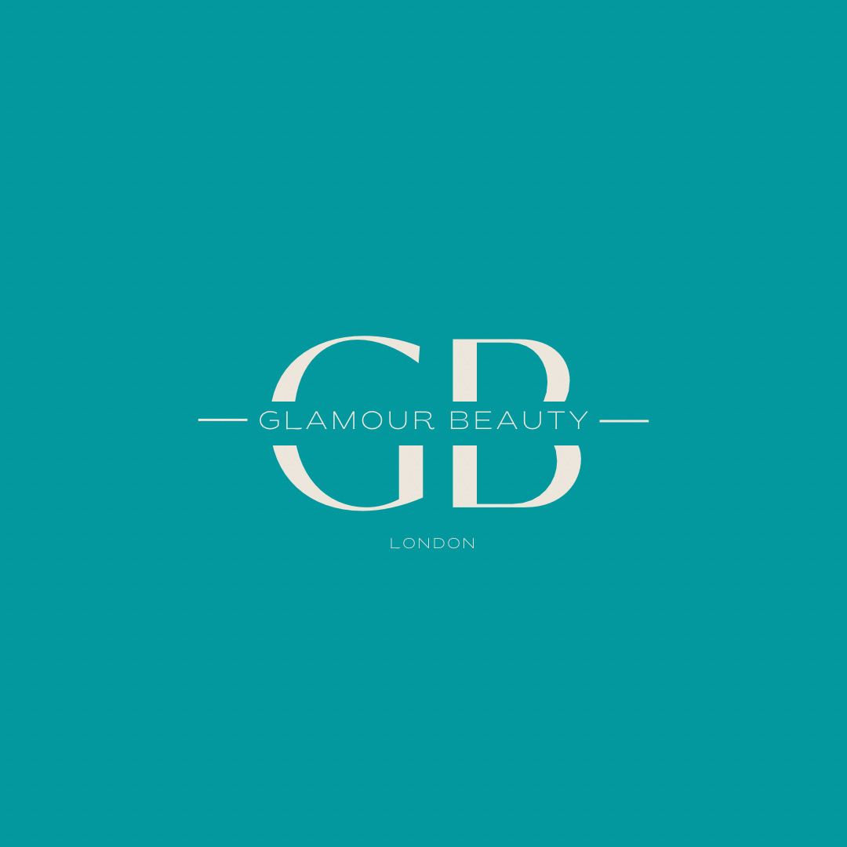
 | Key Resources |  |  |  |  | Channels
 | Human Resources: Skilled beauty consultants, product developers, and marketing staff.  Experienced Technicians: Skilled beauty technicians trained in lash and brow services.  Brand Reputation: Strong reputation for quality service in the local beauty community.  Technology: Online booking system and CRM to streamline customer interactions and loyalty rewards.  Premium Product Access: Partnerships with top brands like London Lash Pro. |  |  |  |  | • Online Booking: Through their website and social media for easy appointment setting.  • Social Media: Instagram and Facebook for promotions and customer engagement.  • In-Salon Promotions: Direct interactions and offers for walk-in customers.  • Treatwell Partnership: Listing on beauty booking platforms to attract new clients.
Cost Structure |  |  |  | Revenue Streams
• Staff Salaries: Competitive pay for skilled technicians.  • Product Costs: High-quality lash and brow materials, sustainable packaging.  • Marketing: Budget for influencer partnerships and social media campaigns.  • Operational Costs: Rent, utilities, and equipment maintenance. |  |  |  | • Service Fees: Income from beauty treatments, including lash extensions, brow lamination, and facials.  • Retail Sales: Selling beauty products used in treatments, such as lash care products.  • Loyalty Packages: Subscription-based packages for frequent customers.  • Event Revenue: Hosting beauty workshops and customer appreciation events
Designed by: IULIA DUNAREANU

