International Hotel Management (BA)

Module: Contemporary themes

Contemporary theme of Sustainability in Marriott Hotels

Module code: BMIH6001

Lecturer: Giulia Chifari

Student: Alexandra Gabriela Atofanei

Student number: 2017051

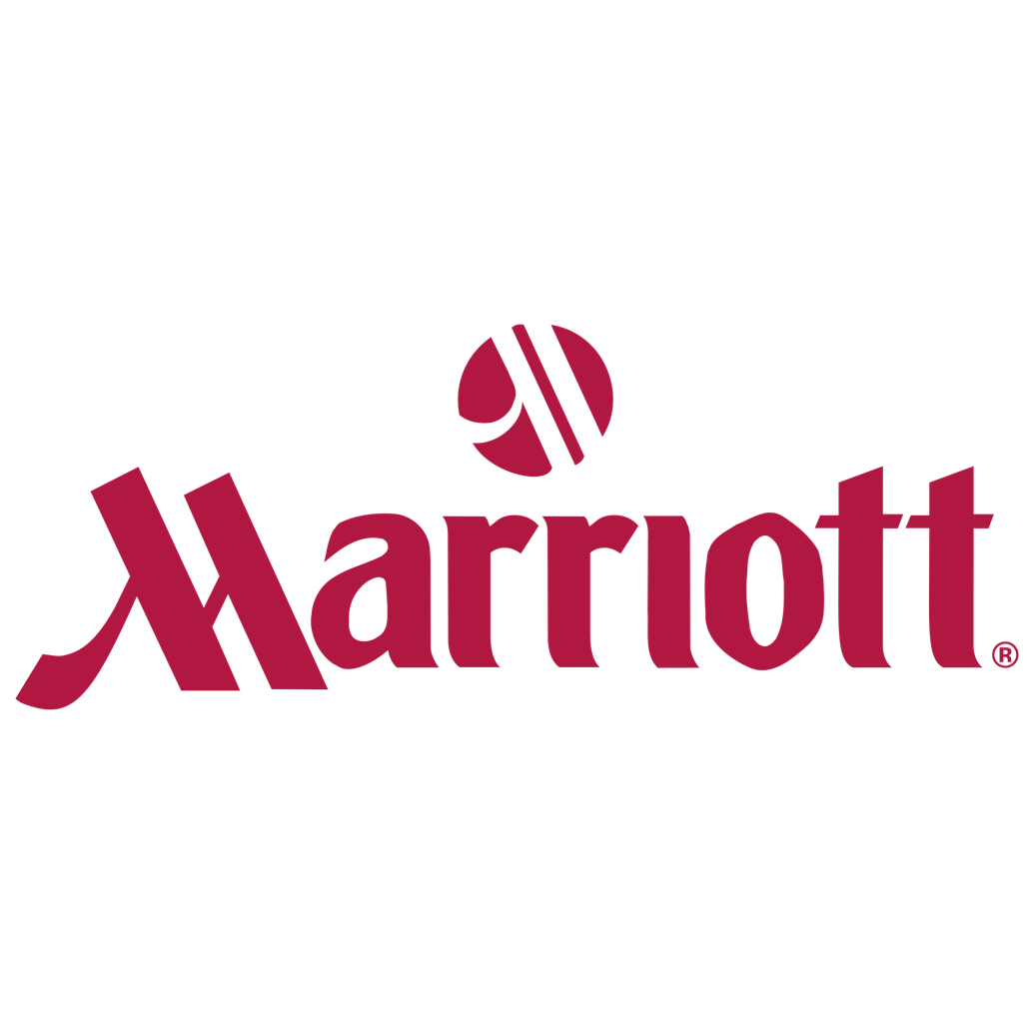

Table of contents:

- Executive summary.
- Introduction.
- Overview of literature.
- Application to the hotel and hospitality sector.
- Evaluate future policy and management options for dealing with the issue.
- Conclusion.
- List of references.

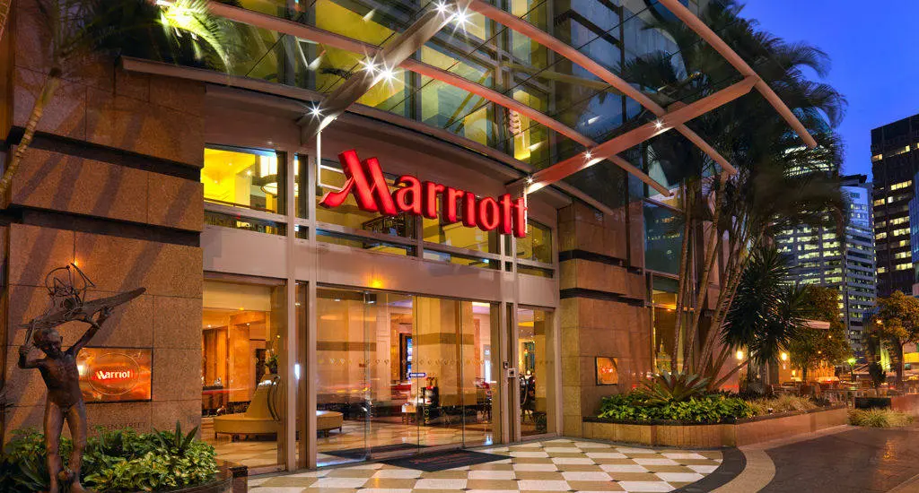

- Executive summary:

The purpose of this report is to present and reflect on the contemporary theme of sustainability theory for Marriott Hotel International. In the report will be presented the importance of the sustainability in the hospitality sector and will be attached and the theme of the importance of staff awareness based on training and education in the hotel industry, the significance, and the role in the reputation of the hotel. The Pestle Analysis, Swot Analysis will be discussed, and their impact will be analysed for the interpretation, overall point of view and understanding of these essential theories and their role in the industry. The training and education theme will be extended for the corelation between this and sustainability, will show how Marriott hotel provide sustainability and together will present benefits and future advanced ideas and recommendations. This will help the industry to improve, to gain a good reputation in relation with other hotels brand. The recommendations will be of the idea to implement in the hotel for the staff well-being tickets for food which will be given monthly together with the salary to retain staff in the industry and create a good environment from the financial side and support them in crisis situations as Covid 19 pandemic. Another one will be the continuation of trainings for the staff. The next recommendation will be reducing the light consumption and the last one will be the implementation of a laundry company within the Marriott hotel.
A conclusion will be created in the end to summarise the entire report and give the overall strategy of the report.

- Introduction

Sustainability is involved with protecting the planet, promoting social development, halting climate change without exposing life on Earth or leaving anyone behind. Tjis theory tend to cover our present needs without compromising resources for future generations.
This idea showed up for the first time in the Brundtland Report published in 1987. This was the first to notify about the negative environmental consequences of economic development and globalization (What is Sustainability? nd).

According to Sloan et. al ( 2019) the practice of sustainable consumption implies that each member of society carries out activities that contributes to this, namely the reduction of energy, water and waste consumption, the recycling , the use of public transport to replace private ones, consumption of local food , support for the environmental projects, among others.

Han et. al (2011) cite that the hotel guest would prefer green hotel instead of non-green hotel due to their eco-friendly attitudes and as to express their intention in preserving the environment.

Lanjewar (2015) cite that green hotels referred to hotels that attempt to be more environmentally friendly in term of efficiency and minimal usage of energy, water and materials which providing quality services.

In this report will be discussed the importance of the sustainability in the Marriott hotels as a brand and will be described in the meantime the importance of training and education within the company itself.

- Overview of literature

One of the principal theories to apply for this report regarding sustainability will be the PESTLE analysis, followed by the SWOT analysis which is a very essential concept.

The PESTLE analysis consists of the key external factors (Political, Economic, Sociological, Technological, Legal and Environmental). This can be included in a range of different scenarios and can guide people professionals and senior managers in strategic decision-making (Pestle analysis, nd).

The advantages of using Pestle analysis are that this theory is simple and straight forward substructure and is easy to implement in a strategic plan. On the other side, this theory give chance to the company to help forward in a great understanding of the wider business environment and how events can affect the business.

The advantages of the Pestle analysis is the idea of easy to simplified the data and to collect insufficient data. On the other hand, this is a great tool, but is not analysing the organisation internal strengths and weaknesses (What is Pestle Analysis? A complete Pestle Analysis Guide, nd).

This report central discussion incorporates the Marriott International hotel brand.
Marriott International is one of the world’s biggest and most well-known hotel operators. Now, Marriott operates around 4.200 hotels in 79 countries and territories, this chain works under 19 different brands including J.W Marriott and Ritz-Carlton.
Starting from the political factors, the major concern is the danger of terrorism, political climate, and international relations. One example of a terrorist attack was in June 2015 , were 39 people were killed at a hotel beach in Tunisia, this will hurt Marriott and make the potential guests afraid.
The economic factors for Marriott hotel is related by the high exchange rate for U.S dollar overseas, which disappointed Americans from travelling. Moreover, foreign tourists will be discouraged to visit U.S destination such as Las Vegas.
The social and cultural factors that affect Marriott hotels is the increased number of Chinese and Asian travellers. Some population in the United States and Europe that are growing older can expand the demand for certain kinds of travel experience such as luxury resorts and packaged tours. Regarding the technological factors, Marriott hotel business can have an impact in the form of online rental services such as Airbnb. The biggest treat Airbnb faces to traditional hotel companies is that the guests can avoid expenses such as hotel taxes and fire regulations.
From the legal side, Marriott hotel major legal factor will the impact for future business related to Airbnb. Some authorities from New York , Barcelona and New Orleans have been fined Airbnb and the hostess because of violating zoning laws, health and safety regulations and hotel regulations.
Regarding the environmental factor, Marriott hotel major factor is the fuel prices. Moreover, a long period environmental impact is included in the increasing electricity costs and climate change (Pestle analysis of Marriott International, nd).

Another essential theory to investigate the hotel and to create a sustainable concept in the SWOT analysis.

Learned et al.(1969) cite that SWOT analysis is a key tool for addressing complex strategic situations by reducing the quantity of information to improve decision-making.

According to Samejima e.al (2006) SWOT analysis is a commonly used method for analysing and positioning an organisation’s resources and environment in four regions: Strengths, Weaknesses, Opportunities and Threats.

Marriott hotel International SWOT analysis is started with the strengths which are the following: market leadership, excellent reputation, global presence, loyal customers, strategic partnership, and strict code of conduct. The second part of the analysis is taken by the Marriott weaknesses and are described as: negative publicity, civil lawsuits, poor positioning, too strict and ineffective data protection. The next aspect from the analysis is Marriott’s opportunities, which are classified as: expand into related sectors, diversity offerings, shifting demographics and forces on emerging economies. The last part of the analysis is the Marriott’s threats which are the following: stiff competition, trade tension, global pandemic, looming recession and risk of terrorist attack ( Marriott Swot Analysis 2023, nd).

- Application to the hotel and hospitality sector

A very essential area to discuss for the Marriott hotel and have a strong connection with the sustainability theory is the staff awareness which will include an importance in the staff training and education. To be educated is crucial in the hotel industry, especially for a brand well-known as Marriott. The hotel is a people first company, and the brand is taking care of the associates, so they can take care of their guests. Marriott hotels have a massive concentration on training and development opportunities for the staff, they provide programs for mentoring, wellbeing, and others. Also, they reassure engaging on inclusion and diversity for women development in the program like women in Leadership Committee. In addition, Marriott International is maintaining a close relationship with universities and schools to recognise and attract talent early on. The company has been acknowledged by Aon as the, Best Employer in New Zeeland, Fiji and Australia as part of the annual Aon Best Employer program (Marriott International is a people-first company, nd).

According to Long et.al (2016) training is an educational procedure in which employees can have opportunities to learn new knowledge, techniques and information and reviews and reinforce their existing skills and knowledge.

According to Thakore (2013) the care purpose of employer training is to build the required skills to effectively complete a specific job task.

Marriott hotel provides to the managers to be involved in over 20 different management training programs. These are given by certified trainers, professional experts, and property-based management. The essential skills for supervisors and managers are included in 15 modules, which are the following: Communicating for Success, Welcome to Marriott Management, Hiring the Best, Coding for Great Performance, Training and Developing your Associates, Building Top Performing Teams, Managing Conflict, Create Experiences, Business Basics, Goal Setting, Effective Daily Meetings, Stress Management and Your Career and You. Marriott International assist the staff with faciliatory lead programs and offerings levels are categorised into three levels and corelate with Marriott Core Competencies. These are: Managing Execution, leadership Building Relationship, Learning and Applying Personal Expertise, Generating Talent and Organisational Capacity and Business Functional Results. Moreover, Marriott gives and additional management training which are: Courtyard by Marriott International University, Property Strategic Planning Implementation, Effective Training skills and Training-on Property Programs (HR: Marriott employee training and development program, nd).

Nischithaa and Rao (2014) cite that due to massive technological development, globalisation, expectations of better customer service quality, economic changes, driving process and attracting and retaining talents, training is needed.

A new training very important for Marriott, which was implemented in the Marriott Hotel International is Trafficking Awareness Training. This training aim is to help the associates to recognise and respond to possible traffic situations. This new development will give guidance to action and continue the fight against the multinational crime. The Chief Executive Office of Marriott relate that: As an industry that cares deeply about human rights and the horrible crime of human trafficking, we have a real responsibility to address the issues in a meaningful way. ’Marriott hotels cooperate with Polaris, which operates the National Human Trafficking Hotline in the United States to create storyboards, select scenarios based on the potential victims. Also, Marriott anti-trafficking efforts are part of its large sustainability and social impact platform, Serve 360 :, Doing good in every direction , which direct the company’s commitment to making a positive sustainable impact wherever it does business ( Marriott International Launches Enhanced Human Trafficking Awareness. Training, nd).

This training will help the guests to choose the hotel because them secure environment and will be a benefit in the hotel review and reputation.

According to Goldberg (2001) , The Massachusetts Institute of Technology (MIT) first talked about learning materials for free on the internet in 2001.

UNESCO (2002) cite that, Open Educational Resources (OER) emerged and was defined as : educational resources, enabled by information and communication technologies , for consultation, use and adaptation of a community of users for non-commercial purposes.

These days environmental awareness is much more frequent in today’s workplace than was a generation or two ago. As we are experience climate change, resource depletion and pollution is more important for business to assist their contribution for a sustainable future. Using fostering environmental awareness in the workplace, the companies can make essential contributions towards reducing their ecological footprints. Taking a green mindset within the workplace help to have physical benefits. This can help in a organisation’s reputation, resource efficiency, attract environmentally conscious customer and lead to cost savings through energy. Environmental awareness is a conscious understanding and recognition of how independent the environment and business life are. It’s aim is to promote a mindset that values and respect the Earth’s natural sources. This is also about minimizing harm to the environment and promote individuals and organisations to take responsibilities for their ecological footprint. Some of the dimensions of environmental changes, advocating for change and promoting sustainable practices. The importance of environmental awareness is done by the following ideas: preserving biodiversity and ecosystems, environmental stewardship, mitigating climate change, cost savings and efficiency, improve corporate image and reputation, employee engagement and well-being and legal compliance and risk management. The environmental awareness in the workplace means engaging employees to set up sustainable practices and promote a culture of responsibility. The organisation can assist the employees with training and education programmes that increase their understanding of environmental issues. This can be about education and sustainable practices and their role is promoting environmental responsibility. This can be realized in form of seminars., workshops, and online research, that can help the employees skills and give them courage to make informed decisions ( All About Environmental Awareness in the workplace, nd).

According to Cantor et. al ( 2012) due to increased pressures from key stakeholders who value sustainability organisations, the importance of employees who who engage In pro-environmental behaviour arise.

Paille et .al (2012,p.6) cite that encouragement and support by management staff for social or environmental initiatives is a way to gain employees respective engagement to achieve environmental or social improvements.

According to Cantor et.al ( 2012, p.33) employee recruitment , retention and engagement can be enhanced by organisational policies and practices that promote employee engagement in environmental behaviours.
Regarding best way to promote sustainability in the hotels is to offer the best training to achieve good results.

The GSTC Sustainable Hotel course is made for hospitality and accommodation professionals and provides practical insights into sustainability practices for hotels. This course is given on-demand, self-online course and is presenting useful resources and real life industry examples and lessons to apply sustainability best practices. This course will cover lessons and each section of GSTC Industry Criteria with examples relevant to the hotel, tips and resources introducing key solutions around current trends , examples of industry practices, sharing inisghts based on real -life experience , tools to download to practise applying the criteria to own situations and the occasion to leanr from GSTC experts and follow hospitality professionals from around the world ( Sustainable Hotel Course-GSTC Training on-demand course, nd).

Regarding sustainability, Marriott hotel implemented a sustainability policy. Marriott hotels aim is to responsible and sustainable in business practices benefits for the environmental and communities where their hotels are located, to contribute in their long term services. Marriott is committed to: concentrate and reporting the progress, operate sustainable hotels, educating and training, developing initiative sustainable and integrating sustainability throughout the supply chain. The also managed to measure and minimise the negative impact on the operations related to carbon footprint climate change, biodiversity, and customer protection, natural resource conservation, waste and pollution management and water risk (Sustainability policy, nd).

By 2025, Marriott hotels will have implemented some sustainability and social impact goals. This will be included by Nurture (Nurture Own World) which will have a contribution of 15M hours of volunteer, service to support the company practice and community engagement strategy. The next one will be Empower (Empower Through Opportunity) and they will invest at least 15M to increase programme and partnership that develop hospitality skills and opportunities among youth, diverse population, people with disabilities, women, refugees. The next point is Sustain (Sustain Responsible Operations) which will reduce environment footprint by 15% , 30% , 45%, 50% across the portfolio by 2025. The last bullet point of the project will be the Welcome (Welcome All and Advance Human Rights) will have 100 % from the associates the completion of human rights training, including on human trafficking awareness ( 2025 , Sustainability and Social Impact Goals, nd).

- Evaluate future policy and management options for dealing with these issues.

In every workplace, the staff play an important role. The same things are happening within the Marriott hotel company. They focus a lot on their employees, their well-being and job satisfaction.

According to Hewlett et.al ( 2009) there are sic types of rewards that were valued more than monetary compensation and these are: high-quality colleagues , flexible work arrangements , prospects for advancement, recognition from management or organisation, advancement and promotion and access to new experiences and challenges.

Sustainably as the overall theory of the report is crucial for Marriott hotels and the employees must be 100% aware about the importance of healthy lifestyle, environment, and security for the guests. From this point, there are some recommendations which can be useful for Marriott hotels. First, the company have a duty to continue the best training procedure as is well doing and to promote the new trainings for this staff. Secondly, Marriott can start new initiatives in the workplace as reducing the light consumption using sensors in the hotel in most places, for example when people are not around the light to be off, and this will help a lot the energy consumption. After this, another advice for Marriott hotel in order to be a step from other hotels will be the implementation of a monthly tickets for food to maintain their well-being and support them more financially every month to make a difference for them and their families. The last recommendation for the hotel is to introduce in their company their own laundry company to look after the bedding, clothes for staff and guests. This will help them to work faster, will promote new work positions and more satisfaction from the guest’s side.

To conclude this report, as was discussed during the overall concept of sustainability within the hotel, Marriott was and will be one of the best examples of eco-friendly company, A part of their reputation, in future, they will have the capacity to implement good ways of helping the planet, the staff and everyone will benefit from their professionalism and care. As the technology will be more advanced, they can expect AI to be part of their chain and to support the industry to succeed in their plans.

References:

- All about Environmental Awareness in the workplace , [online] , Available at: https://cpdonline.co.uk/knowledge-base/business/all-about-environmental-awareness-in-the-workplace/, Accessed on 23.10.2023.

- All World Live Like a Local, Sea front 5 star hotel, [online picture], Available at: https://www.allworld.com/marriott-hotels/, Accessed on 25.10.2023.

- Cantor, D.E., Morrow, P.C., & Montabon.F., (2012) .Engagement in environmental behaviour among supply chain management emplyees .An organisational support theoretical perspective. The Journal of Supply Chain Management, 48(3), 33-51.

- Freebie supply, Marriott logo, [online picture], Available at: https://freebiesupply.com/logos/marriott-logo/, Accessed on 25.10.2023.

- Han, H.L.Hse, J.Lee & C.Sheu.(2011). Are lodging customers ready to go green? An examination of attitudes, demographics, and eco-friendly intentions. International Journal of Hospitality Management, 30(2), 345-55.

- Goldberg, C.( 2001) , Auditing classes at M.I.T , on the web free, New York Times, 4 April, [online], Available at: https://web.mit.edu/ocwcom/MITOCW/Media/NYTimes-040301-MITOcwpdf, Accessed on 23.10.2023.

- Hewlett, S.A. Sherbin, L.& Sumberg, K. 2009.How Gen Y & Boomers will reshape your agenda.Harward Business Review, 87-71-76.

- HR: Marriott employee training and development [online], Available at: https://www.hotelmanagement.net/human-resources/hr-marriott-employee-traning-and-development-program, Accessed on 15.10.2023.

- Lanjewar, J.(2015).Green initiative by Hotels.Sai Om Journal of Commerce & Management. A Peer Reviewed International Journal, 2(1), 2015.

- Learned, E.P., Christiansen, C.R, Andrews, K and Guth, W.D (1969), Business Policy:Text and cases, Irwin Homewood.

- Long, C.S, Kowanf To, Chin TA & Hee Oc (2016).Improving Organisational Performance though Training Function:A review International Business Management, 10(4):475-478.

- Marriott Swot Analysis 2023 [online], Available at: https://bstrategyhub.com/marriott-swot-analysis/. Accessed on 11.10.2023.

- Marriott International is a people-first company [online], Available at: https://www.hcamag.com/nz/specialisation/employee-engagement/marriott-international-is-a-people-first-company/190123, Accessed on 12.10.2023.

- Marriott International Launches Enhanced Human Trafficking Awareness Training [online], Available at: https://news.marriott.com/news/2021/07/28/marriott-international-launches-enhanced-human-trafficking-awareness-training, Accessed on 16.10.2023.

- Nischithaa P & Rao N (2014).The importance of Training and Development Programmes in Hotel Industry.International Journal of Business and Administration Research Review, 1(5):50-56.

- Paille ,P.,Chen, Y., Boiral, O.,& Jin,J. (2012).The impact of Human Resource Management on Environmental Performance:An Employee -Level Study.Dordrecht: Spainger Science Business Media. Pittsburg State University.(2013) . What is Sustainability? https://www.pittstate.edu/office/president/initiative/sustainability/what-is-sustainability,

- Pestle Analysis of Marriott International, [online] , Available at: https://pestleanalysis.com/pestle-analysis-of-marriott/, Accessed on 08.10.2023.

- Pestle Analysis, [online], Available at: https://www.cipd.org/uk/knowledge/factssheets/pestle-analysis-factsheet/, Accessed on :08.10.2023.

- Samejima ,M.Shimizu,Y.,Akiyoshi,M.,& Komoda, N.(2006).Swot analysis support tool for verification of business strategy. In IEEE International Conference on computational cybernetics (pp 1-4).

- Sloan, Philip, Legrand Willy & Chen, Joseph S.(2009). Sustainability in the Hospitality Industry: Principles of Sustainable Operations. Great Britain: Elsevier.

- Sustainable Hotel Cause-GSTC Training (on-demand course) , Available at: https://www.gstcouncil.org/sustainable-hotel-course-gstc-training-on-demand-course/, Accessed on 23.10.2023.

- Sustainable hotel [online], Available at: https://serve360.marriott.com/wp-contact/uploads/2019/05/sustainabilty-policy.2.pdf. Accessed on 25.10.2023.

- Thakore, D.(2013), Training – A strategic HRM Function. International Letters of Social and Humanistic Science, 11:84-90. https://doi.org/1018052/www.scipress.com/icsms.11.84,

- United Nations Educational, Scientific and cultural Organisation (UNESCO) .(2002) . Forum on the Impact of Open Courseware for Higher Education in Developing Countries ,Final Report, [online], Available at: https://unesdoc.unesco.org/images/0012/00/285/128515e.pdf, Accessed on 23.10.2023.

- What is sustainability? [online] , Available at: https://www.activesustainability.com/sustainable-development/what-is-sustainablity/ Accessed on 07.10.2023.

- What is PESTLE Analysis? A complete PESTLE Analysis Guide.Available at: https://onstrategyhq.com/resources/pestle-analysis/. Accessed on 08.10.2023.

- 2025 , Sustainable and Social Impact Goals , [online] , Available at : https://services.marriott.com/wp-content/uploads/2019/02/serve-360.2025-Goals-Dec-14.pdf. Accessed on 25.10.2023.

