Destination Management: London

Student Name: Daniela Serban
Student number: 2109024
Module name: BMIH5006 Sustainable Hospitality & Tourism Management
Lecturer’s name: Ruth Taylor-Davies
Executive Summary
Tourism is a significant economic driver for many cities and countries worldwide, potentially negatively impacting residents and the environment. This report has utilised Richard Butler's Tourism Area Life Cycle Model and Doxey's Irridex Model to understand the development and impact of tourism on London. Problems have an intercom in various stages of the tourism life cycle, which need to be addressed by the organisational bodies responsible for tourism management in London. The government has recommended promoting sustainable tourism practices, developing new attractions and events, and working with residents to address their views about tourism.
Table of Contents
Introduction 4
Tourism Regulations and Organisations 5
Richard Butler's Tourism Area Life Cycle Model 6
Doxey’s Irridex Model 8
Recommendations 11
Conclusion 12
Reference List 13
Appendices 16

Introduction

Tourism can be defined as the economic, social, and cultural phenomenon that determines the reason and motivation behind the movement of people to countries or places outside of their usual environment (UNWTO, 2023). This report emphasises the stages of tourism that London has gone through by applying theories like Richard Butler's Tourism Area Life Cycle Model and Doxey's Irridex Model. London has been the UK's main tourist attraction over the years. However, the current phase has experienced some problems. The report will also list some essential organisational bodies and legal frameworks associated with tourism.

Tourism regulations and organisations
Legal regulations are the laws, rules or orders a prescribed authority provides to control and regulate a specific area (Noll, 2021). Tourism in London and UK is similarly bounded under many such legal frameworks and regulations.
For instance, the Licensing Act of 2003 outlines the prevention of crime and disorder, public safety, lic nuisance, and protecting children from harm (Visit Britain, 2023). Laws like Consumer Protection bind hospitality organisations also bound the hospitality organisations2008, which they have the responsibility not to undertake any unfair trading practices. Further, the marketing practices related to product and services comparison of organisations are controlled by the Business Protection from Misleading Marketing Regulations 2008 Act (Visit Britain, 2023). For the guests and the customers, the organisations must adhere to the Data Protection Act 2018 along with General Data Protection Regulation 2018 which is known for enhancing consumer rights, including the information held by the businesses (Visit Britain, 2023). Moreover, the Equality Act 2010 is known for consolidating and strengthening all sorts of criminal legislation (Visit Britain, 2023). It protects employees within the organisations from direct direction arising from a disability or others.
The tourism industry of the UK is reflected by a dynamic affiliation of public and private sector organisations which comprises small-scale organisations, Destination Management Organisations (DMOs) and even international private businesses. The first important organisation concerned with tourism in the UK and London is VisitBritain/VisitEngland. This non-departmental public body raises its funds from Department for Culture, Media & Sport (DCMS) (Visit Britain, 2023). Further, London & Partners is responsible officially for promoting London as a valuable and attractive tourist destination. However, the overall strategy, policy and objectives associated with tourism are determined by the UK Government.

Richard Butler's Tourism Area Life Cycle Model
The Tourism Area Life Cycle (TALC) model formulated by Richard Butler in 1980 is a recognisable cycle of tourism which sheds light on the areas of development (Sahli, 2020). The cycle is divided into six categories or stages. It was developed on the assumption that the tourist places reflected a similar development pattern to that of the other products.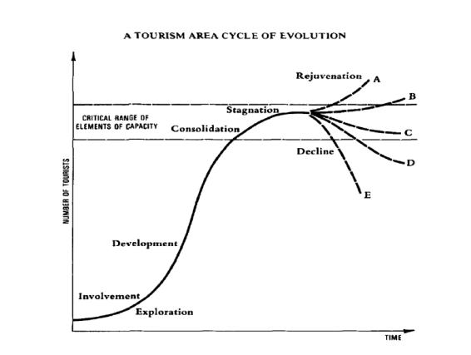
Figure 1: Tourism Area Life Cycle Model
(Source: Sahli, 2020)
- Exploration Stage: This is the initial stage, which is characterised by the presence of a few adventurous tourists who discovers the destination through the attraction of natural and cultural aspects (Butler, 2022). In this stage, the tourists or the visitors are not provided with facilities or amenities by the government or the locals. The people visiting London are expected to engage with the locals highly. London as a tourist hub was discovered 20 years back in 2002, when there were 11 million tourists (Condor Ferries, 2023). However, at that period, tourism was mostly limited to a few wealthy and well-educated individuals. The Significance of tourism in this stage is relatively low compared to the other stages.
- Involvement stage: Tourism starts to bloom as the place gains awareness and more attention (Butler, 2022). As tourists become aware of the destination and its attractions, London has observed an increment in tourist figures. For instance, the 11 million mark in 2002 became more than 19 million in 2016 (Condor Ferries, 2023). As per the statistics, London is the most popular tourist city in the UK. It has been seen that the place attracts tourists eight times more than the other cities. In 2019, there were 21.71 million international visitors to the city (Statista, 2023). With such a tourist-centric place, London became the centre for culture, art, and architecture. Famous landmarks like Buckingham Palace, the Tower of London, and Big Ben have been the centre of attraction for many tourists.
- Development stage: In the development phase stage is characterised by rapid tourism growth since the destination becomes more popular and accessible (McLeod et al., 2021) and is assisted by the development of infrastructure and transportation facilities. Significant factors like the rise of mass tourism, the growth of the British Empire, and the development of air travel have led London to enter the development phase. The construction and development of many new hotels, restaurants, and attractions also characterise the stage. In 2019, the hotel occupancy rate in London was 83 per cent (Statista, 2023).
- The consolidation stage: In this stage, the destination reaches its carrying capacity, and as a result, the tourism rate slows down (Butler, 2022). Despite having excessive growth before the pandemic, the place's growth has slowed in recent years. Apart from the pandemic, the consolidation stage is aided by numerous factors like the rise of competition from other global cities, the threat of terrorism, and the economic downturn. It has been seen that the Consumer price inflation rate within the nation has been 10.1% (ONS, 2023). This has forced hospitality organisations to increase the price of their products and services, for which tourists lately have avoided the city as a tourist destination. Moreover, as per the reports, a series of terror attacks had been planned in the hotspots of London (BBC, 2020).
- The stagnation stage: The decline in tourist numbers is observed in this phase, where the destination becomes less attractive to visitors, or they do not prefer travelling to places for multiple factors (McLeod et al., 2021). Even though London is not currently in this stage, it will enter it in the future, as seen in the graph (refer to Appendix 2). In 2021, there were only 2.72 million overseas visitors in London, which was 21.71 million in 2019 (Statista, 2022).

The decline or rejuvenation stage: In this state, the destination either declines or rejuvenates (Dodds & Butler, 2019). If the declination is observed, the place will eventually reach a point where it is no longer a viable tourist destination. However, the place can enter a new cycle of tourism growth upon having the capability of rejuvenating. London has not entered this phase and is currently in the transition period, where it is unclear whether it will decline or rejuvenate. This phase depends on the available opportunities and the pressures in the external environment. It can be associated with the challenge posed by the pandemic, for which the hotel occupancy rate in 2021 was 46.1 per cent, far less than the pre-pandemic levels (Statista, 2023).

Doxey’s Irridex Model
Doxey's Irridex Model can be referred to as a tourism impact model, which aims to explain the stages of resident attitudes towards tourism with the popularisation of the destination (Dickson et al., 2020). William Doxey 1975 discovered this model based on the idea that in the initial phase, a destination resident will have a positive attitude towards the idea as tourism increases. However, with continuous growth, residents will become increasingly hostile towards it. This model can be a valuable tool for understanding the potential impacts of tourism on a destination. Hospitality organisations can manage tourism growth to minimise the negative impacts and maximise the positive impacts of tourism activities.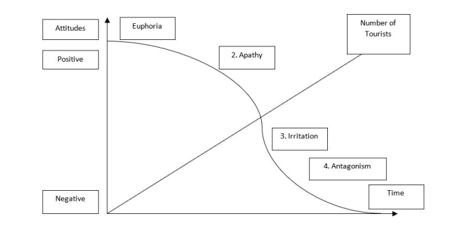
Figure 2: Irridex Model
(Source: Dickson et al., 2020)
Enchantment Stage: In this stage, tourism is characterised by the reflection of a positive attitude from the residents towards the visitors (Shobha, 2019). The residents demonstrate an eagerness to interact with the visitors at this stage. This stage in London can be identified by the arrangements made for the visitors within the city. For example, the visitors can save money on accommodation services by staying in a cheap B&B (bed and breakfast) generally run by native families (Visit London, 2023).
Annoyance Stage: With the continuous growth of tourism, the residents become annoyed with the presence of tourists (KILIÇ and Seçilmiş, 2022). They get irritated about the noise, traffic, and pollution tourists bring. Overcrowding is the main issue identified in this stage, marking a significant increase in tourism. Within 2027, London is expected to attract 20.7 million international visitors (refer to Appendix 3). The recent data have shed light on the fact that with a drop of 1%, 76% of residents currently intend to have a UK overnight trip at any point. The annoyance of the residents in London regarding domestic tourism destinations can be identified from these statistics.
Avoidance Stage: Residents may begin to avoid popular areas with tourists, as they might feel disturbed by tourists taking over their city (Shobha, 2019). The increasing number of tourists makes the residents uncomfortable even n in their homes. From the graph, a decrease in domestic tourism activities in London can be identified where in April 2023, only 8% of people went to the UK overnight trip (refer to Appendix 1).
Revulsion Stage: In Doxey's Irridex model, this is the final stage, where Residents become so hostile towards tourists that they take active steps to discourage them from visiting (KILIÇ and Seçilmiş, 2022). Protests, boycotts, or even violence from the residents can be seen in this stage. In such a stage, the government must be aware of the potential conflict between residents and tourists, especially in popular areas. According to the recent modifications in the VAT refund data, American travellers in European cities must pay up to 80% (Givens, 2022). This has discouraged American shoppers from visiting London. According to Sandler and Young (2022), Burberry's London stores are losing the competition in tax-free Paris because of such laws. Although London has not entered this stage, the continuous disadvantageous situations can influence visitors to choose other destinations.

Recommendations
- London is a popular tourist destination, needs to ensure that tourism is sustainable in the long term. This will need the organisation and the regulating bodies to manage tourism growth to minimise the negative impacts on the environment and the local community (Guo et al., 2019). Promoting public transportation and discouraging the use of private cars can be one way to reduce the carbon footprint of travellers. Moreover, the government can support businesses that are committed to sustainability.
- London also needs to diversify its tourism industry. It has been seen that the city has been heavily reliant on a small number of attractions, such as Buckingham Palace, the Tower of London, and Big Ben. To minimise the risk of over-tourism, the tourism industry has to promote other attractions and activities (Ziyadin et al., 2019). The government can Promote lesser-known attractions, such as the London Transport Museum and the Churchill War Rooms. Promoting outdoor activities like hiking, biking, and kayaking would diversify tourist attractions.
- Lastly, the DMOs and the government can provide more opportunities for residents to get involved in tourism, which also increases the locals’ tolerance level and gives them an enhanced opportunity to increase their income.

Conclusion
On a concluding note, it can be said that Richard Butler's Tourism Area Life Cycle Model and Doxey's Irridex Model are two valuable tools for understanding the development and impact of tourism on London. From Butler’s model, it can be observed that London is currently in the transition period between the consolidation and stagnation stages. As per Doxey's model, the residents are in the annoyance stage. The government must look for ways to manage tourism growth to minimise the negative impacts and maximise the positive ones.

Reference List
Court hears that BBC (2020) Man 'plotted terror attacks on London tourist hot spots'. Available at: https://www.bbc.com/news/uk-51032652. (Accessed: 06 June 2023)
Butler, R. (2022). COVID-19 and its potential impact on stages of tourist Destination Development. Current Issues in Tourism, 25(10), 1682–1695.
Butler, R. (2022). Managing Tourism–A Missing Element? Gestión turística¿ asignatura pendiente?. PASOS Revista de Turismo y Patrimonio Cultural, 20(2), pp.255-263.
Condor Ferries (2023). UK TOURISM Statistics 2020-2021. Available at: https://www.condorferries.co.uk/uk-tourism-statistics (Accessed: 06 June 2023)
Dickson, A.D.O.M., Fazli, A.R., Sajjadi, J. and SEDİGHİ, S. (2020). Factors Influencing Tourism Space Commodification in the Mahmoudabad County, Northern Iran. Journal of Tourismology, 6(2), pp.155-183.
Dodds, R. & Butler, R. eds. (2019). Overtourism: Issues, realities and solutions (Vol. 1). Walter de Gruyter GmbH & Co KG.
Givens, D. (2022). London’s Luxury Shops Take a Hit as US Tourists Flock to Paris and Milan for Tax-Free Shopping. Available at: https://robbreport.com/lifestyle/news/london-brands-struggle-tourists-flock-to-paris-and-milan-tax-free-luxury-goods-1234774426/. (Accessed: 06 June 2023)
Guo, Y., Jiang, J. & Li, S. (2019). A sustainable tourism policy research review. Sustainability, 11(11), 3187.
KILIÇ, İ. and Seçilmiş, C.İ.H.A.N. (2022). Effects of exceeding social carrying capacity on residents’ support for tourism: The mediating role of community participation and quality of life. Turizm Akademik Dergisi, 9(2), pp.341-355.
London DataStore (2023). Estimation of Health Impacts of Particulate Pollution in London. Available at: https://data.london.gov.uk/dataset/estimation-health-impacts-particulate-pollution-london. (Accessed: 06 June 2023)
McLeod, M., Dodds, R. & Butler, R. (2021). Introduction to a special issue on island tourism resilience. Tourism Geographies, 23(3), 361–370.
Noll, R.G. ed. (2021). Regulatory policy and the social sciences. University of California Press.
ONS (2023) Consumer price inflation, UK: March 2023. Available at: https://www.ons.gov.uk/economy/inflationandpriceindices/bulletins/consumerpriceinflation/march2023#:~:text=a%20year%20earlier.-,The%20Consumer%20Prices%20Index%20(CPI)%20rose%20by%2010.1%25%20in,of%2011.1%25%20in%20October%202022. (Accessed: 06 June 2023)
Sahli, E. (2020). Tourism Destination Development An Application of Butler’s (1980) Tourism Area Life Cycle Model to Hammamet, Tunisia. no. May.
Sandle, P. and Young, S., (2022). Burberry's London stores lose out as tourists head to tax-free Paris, Milan. Available at: https://www.reuters.com/business/retail-consumer/burberrys-london-stores-lose-out-tourists-head-tax-free-paris-milan-2022-11-17/. (Accessed: 06 June 2023)
Shobha, K.B. (2019). A case study on irritation among local people towards the growth of tourism in Kodagu district: With the reference of Doxey’s index model. International Journal of Innovative Research and Advanced Studies, 6(1), pp.146–148.
Statista (2022) Number of overseas tourist visits to London, United Kingdom (UK) from 2011 to 2021. Available at: https://www.statista.com/statistics/487467/overseas-visits-to-london-united-kingdom/ (Accessed: 06 June 2023)
Statista (2023) The annual hotel occupancy rate in London (UK) from 2019 to 2021, with a forecast for 2023. Available at: https://www.statista.com/statistics/323719/annual-hotel-occupancy-rate-in-london-uk/ (Accessed: 06 June 2023)
UNWTO (2023) GLOSSARY OF TOURISM TERMS. Available at: https://www.unwto.org/glossary-tourism-terms. (Accessed: 06 June 2023)
Visit London (2023) Best B&Bs in London. Available at: https://www.visitlondon.com/where-to-stay/bed-and-breakfast. (Accessed: 06 June 2023)
VisitBritain (2023) Alcohol, entertainment and gaming licensing. Available at: https://www.visitbritain.org/business-advice/alcohol-entertainment-and-gaming-licensing. (Accessed: 06 June 2023)
VisitBritain (2023) Disabled customers. Available at: https://www.visitbritain.org/business-advice/disabled-customers. (Accessed: 06 June 2023)
VisitBritain (2023) Domestic Sentiment Tracker: May 2023. Available at: https://www.visitbritain.org/sites/default/files/vb-corporate/Domestic_Research/domestic_sentiment_tracker_report_-_may.pdf. (Accessed: 06 June 2023)
VisitBritain (2023) Registration, data protection and surveillance. Available at: https://www.visitbritain.org/business-advice/registration-and-data-protection. (Accessed: 06 June 2023)
VisitBritain (2023) Structure of tourism in Britain. Available at: https://www.visitbritain.org/structure-tourism-britain. (Accessed: 06 June 2023)
VisitBritain (2023) Unfair trading practices. Available at: https://www.visitbritain.org/business-advice/unfair-trading-practices. (Accessed: 06 June 2023)
Ziyadin, S., Litvishko, O., Dubrova, M., Smagulova, G. and Suyunchaliyeva, M. (2019) Diversification tourism in the conditions of the digitalisation. International Journal of Civil Engineering and Technology, 10(2), pp.1055–1070.

Appendices
Appendix 1
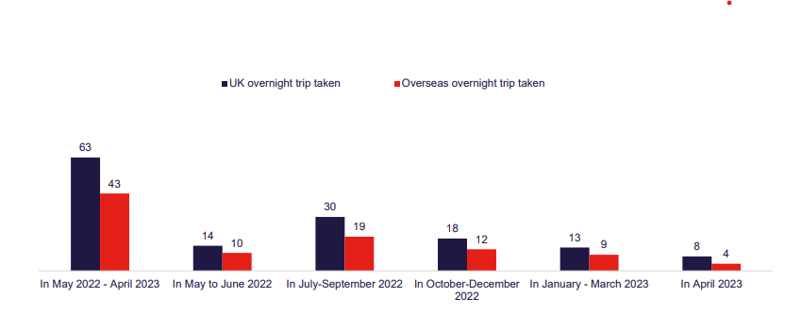
Figure 1: Proportion is taken an overnight UK versus overseas trip
(Source: VisitBritain, 2023)
Appendix 2
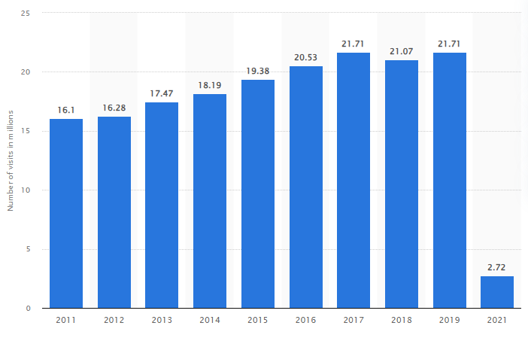
Figure 2: Number of overseas tourist visits to London
(Source: Statista, 2022)
Appendix 3
Period | International visitors | Domestic visitors | All visitors | International visitors | Domestic visitors | All visitors | International visitors | Domestic visitors | All visitors
 | visitor nights | visitor nights | visitor nights | visitors | visitors | visitors | spend | spend | spend
 | ('000s) | ('000s) | ('000s) | ('000s) | ('000s) | ('000s) | £m 2019 prices | £m 2019 prices | £m 2019 prices
2006 | 1,01,068 | 23,973 | 1,25,041 | 15,593 |  |  | £10,549 | £2,976 | £13,525
2007 | 95,846 | 22,657 | 1,18,503 | 15,340 |  |  | £10,803 | £2,760 | £13,563
2008 | 90,815 | 26,500 | 1,17,315 | 14,753 |  |  | £10,331 | £2,833 | £13,164
2009 | 91,790 | 23,450 | 1,15,240 | 15,092 |  |  | £11,093 | £2,712 | £13,805
2010 | 96,370 | 24,318 | 1,20,688 | 15,353 |  |  | £11,455 | £2,911 | £14,366
2011 | 97,864 | 27,060 | 1,24,924 | 16,103 |  |  | £11,638 | £2,768 | £14,405
2012 | 1,01,684 | 27,687 | 1,29,371 | 16,279 |  |  | £12,276 | £3,123 | £15,399
2013 | 1,03,063 | 27,437 | 1,30,500 | 17,474 |  |  | £13,206 | £3,057 | £16,263
2014 | 1,14,616 | 24,358 | 1,38,974 | 18,189 |  |  | £13,736 | £3,114 | £16,851
2015 | 1,15,222 | 30,160 | 1,45,382 | 19,385 |  |  | £14,153 | £3,320 | £17,474
2016 | 1,23,068 | 26,339 | 1,49,407 | 20,533 |  |  | £14,793 | £2,961 | £17,754
2017 | 1,30,488 | 27,832 | 1,58,320 | 21,708 |  |  | £16,966 | £2,802 | £19,768
2018 | 1,23,782 | 27,883 | 1,51,665 | 21,072 |  |  | £15,130 | £3,038 | £18,168
2019 | 1,18,872 | 28,483 | 1,47,355 | 21,713 |  |  | £15,725 | £3,036 | £18,761
2020 | 22,213 | 12,711 | 34,924 | 4,949 |  |  | £3,396 | £1,097 | £4,492
2021 | 16,534 | 13,371 | 29,905 | 2,724 |  |  | £2,528 | £1,187 | £3,715
2022 | 91,861 | 17,875 | 1,09,736 | 15,647 |  |  | £12,419 | £1,804 | £14,223
2023 | 1,15,305 | 22,297 | 1,37,601 | 18,696 |  |  | £14,144 | £2,410 | £16,554
2024 | 1,18,020 | 25,810 | 1,43,830 | 19,209 |  |  | £14,572 | £2,891 | £17,463
2025 | 1,21,351 | 28,500 | 1,49,850 | 19,838 |  |  | £15,097 | £3,260 | £18,356
2026 | 1,24,790 | 30,715 | 1,55,505 | 20,487 |  |  | £15,639 | £3,564 | £19,202
2027 | 1,26,281 | 31,198 | 1,57,478 | 20,732 |  |  | £15,825 | £3,630 | £19,455
2028 | 1,27,790 | 31,687 | 1,59,477 | 20,980 |  |  | £16,014 | £3,697 | £19,711
2029 | 1,29,316 | 32,185 | 1,61,501 | 21,230 |  |  | £16,206 | £3,765 | £19,971
2030 | 1,30,862 | 32,690 | 1,63,552 | 21,484 |  |  | £16,399 | £3,834 | £20,233
2031 | 1,32,425 | 33,203 | 1,65,628 | 21,740 |  |  | £16,595 | £3,904 | £20,500
2032 | 1,34,007 | - | - | 22,000 |  |  | £16,793 | - | -
Table 1: London Tourism Forecasts
(Source: London DataStore, 2023)

