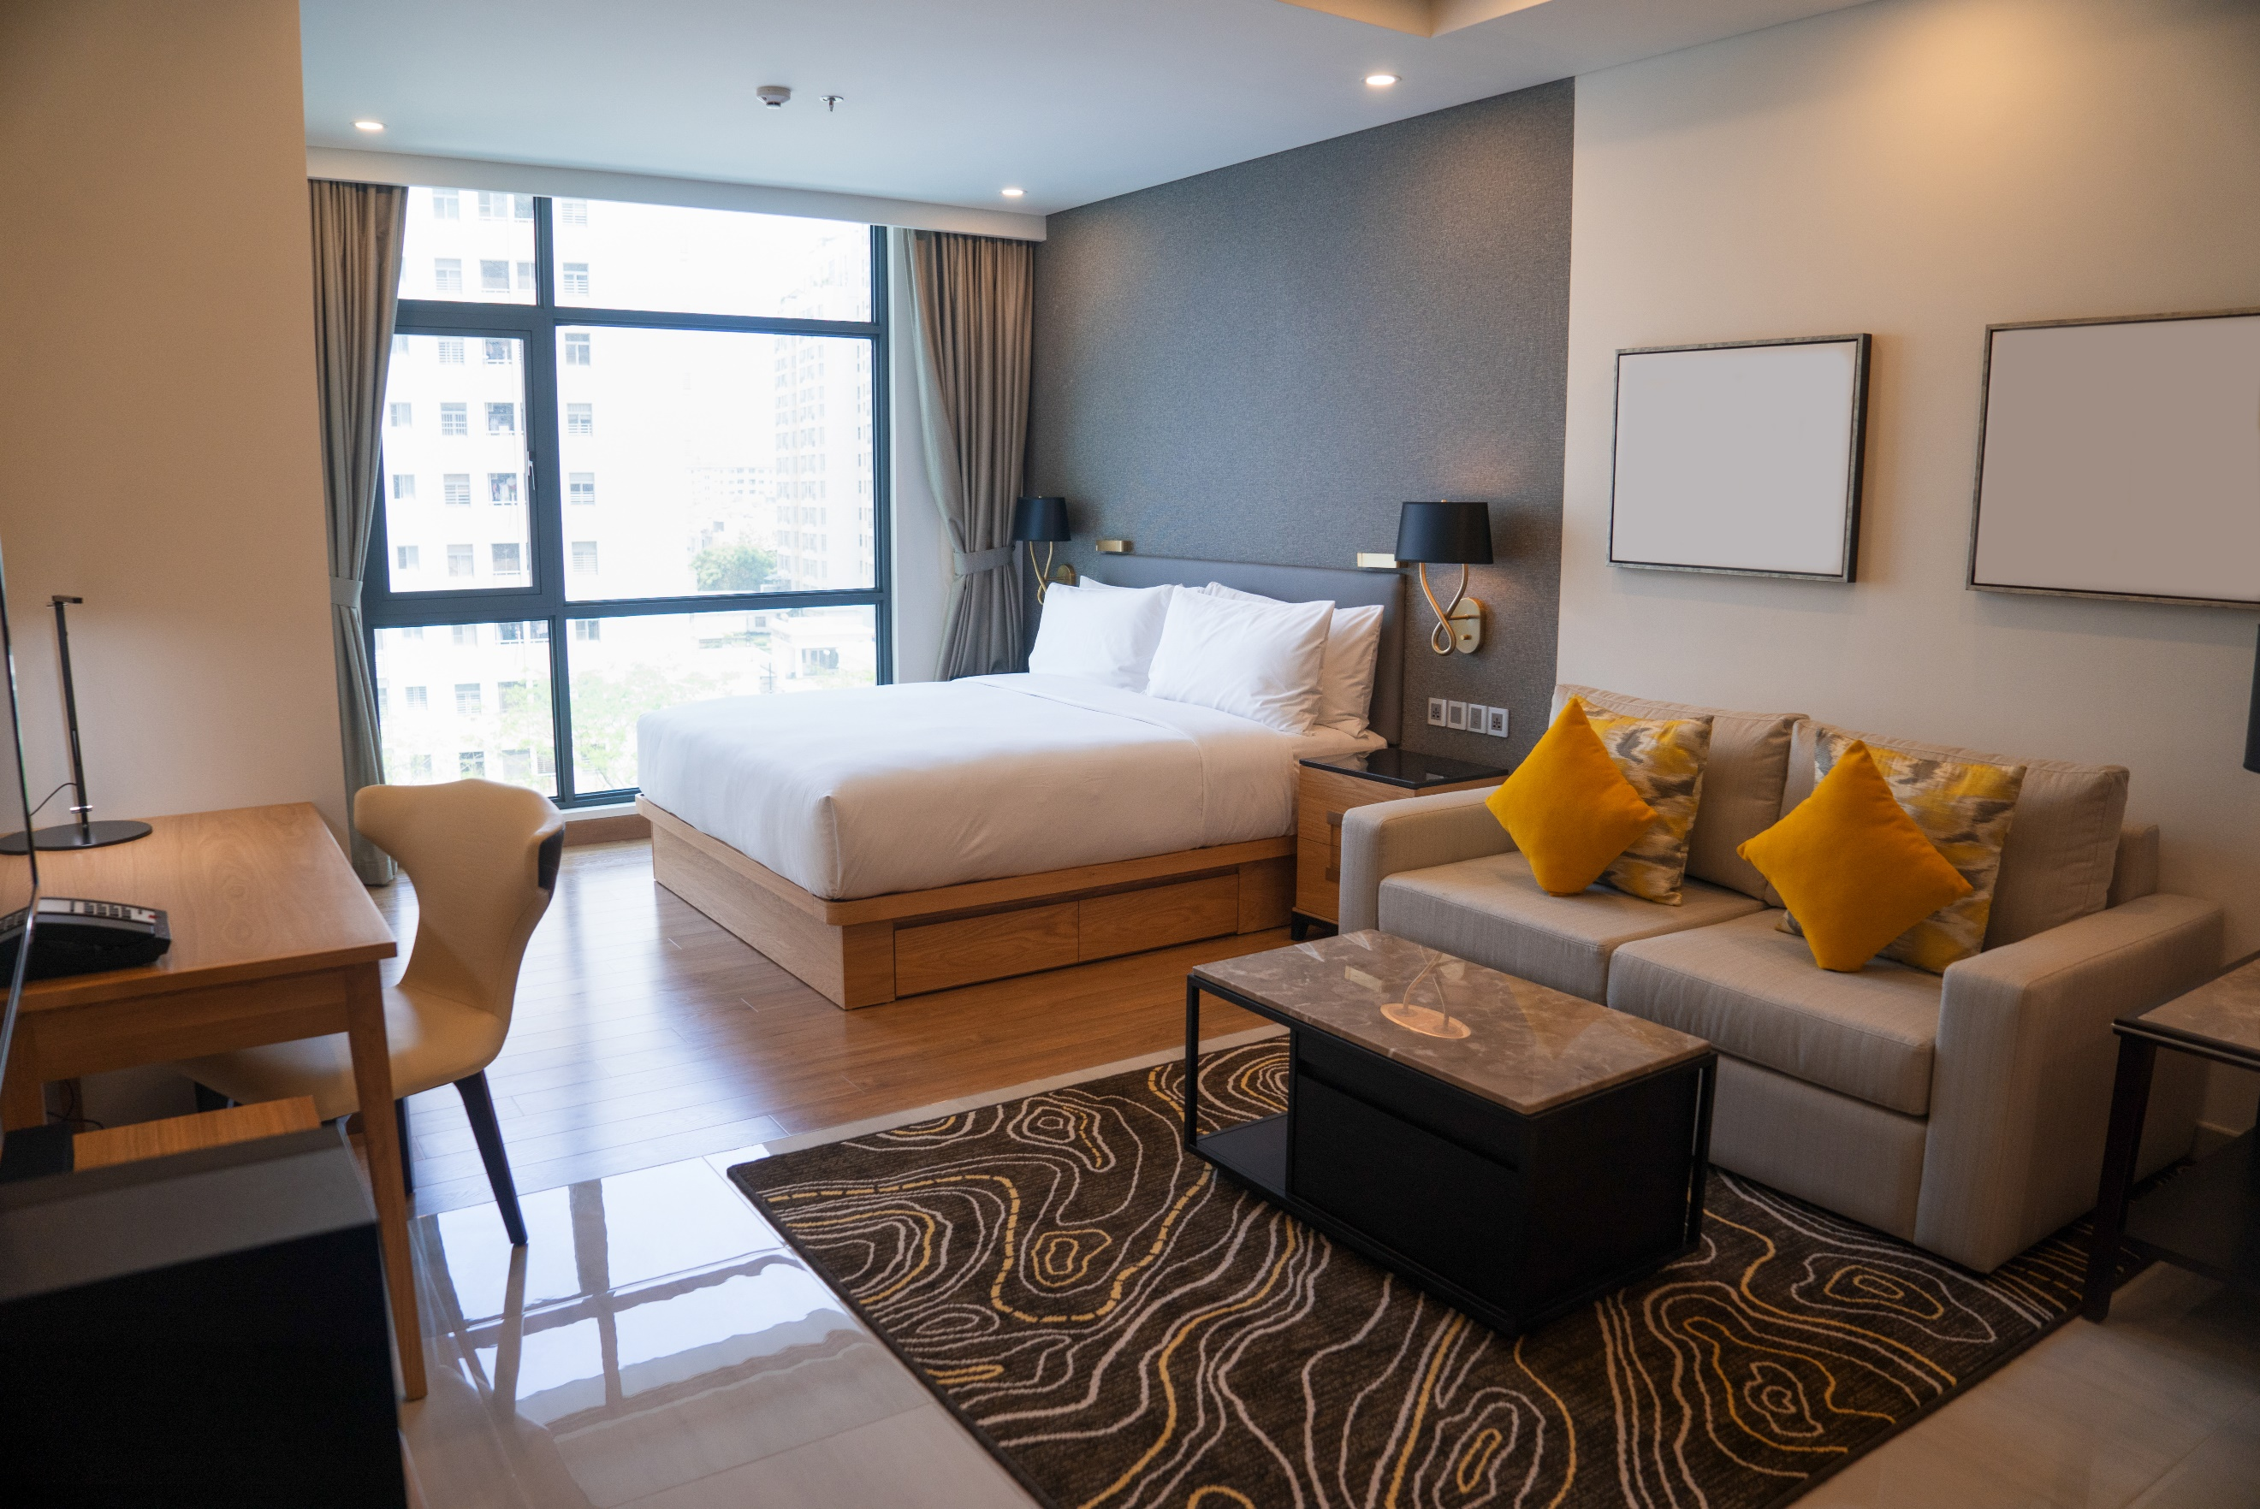  A comparison of the marketing methods of two multinational hotel brands | Robert-Daniel Mihalcea  2240761  Marketing Essentials BMIH4005  Dale Clarke  1617

The hotel and hospitality industry is an exciting yet complex sector recognized by a persistent need for innovation and a thorough grasp of consumer expectations (Kotler, Armstrong, Harris, & He, 2020). Holiday Inn and Six Senses are well-known hotel and hospitality brands, each with its own specific character and target market. The Holiday Inn brand is well-known for its excellent accommodation and dependable service quality (Jobber & Ellis-Chadwick, 2020). It has a global presence and serves a diverse consumer base that includes business travellers, families, and leisure travellers. Six Senses, on the other hand, is a luxury brand that focuses on creating one-of-a-kind and immersive experiences (Bowie et al., 2017). To attract high-end clients seeking exclusivity and rejuvenation, it emphasizes wellness, sustainability, and personalized service.
This essay will compare the marketing strategies of Six Senses Hotels and Holiday Inn, utilizing SWOT and PESTEL analyses. The essay will also examine how these organizations market their products and services using the marketing mix, including segmentation, targeting, positioning, and marketing communications with their target audiences. To support the analysis, the essay will utilize SimilarWeb, a web analytics tool that provides insights into website traffic and user behaviour.
The SWOT and PESTLE frameworks, which are based on solid marketing research concepts (Housden, 2008), will be utilized for internal and external brand analysis. We can acquire full knowledge of their current condition by studying their strengths, weaknesses, opportunities, threats, and the macro-environmental forces affecting them.
The global presence, brand recognition, and broad client base of the Holliday Inn brand are among its many strengths (Jobber & Ellis-Chadwick, 2020). However, it confronts difficulties in maintaining uniformity across its multiple hotels and dealing with increased competition in the mid-range hotel category (Bowie et al., 2017). Six Senses, on the other hand, excels at providing luxurious experiences, sustainable practices, and personalized service (Bowie et al., 2017). However, its restricted availability and expensive price point may limit its appeal.
We will examine the political, economic, social, technological, legal, and environmental variables affecting both brands using the PESTLE framework (Ghauri, 2014). By doing so, we may identify prospective industry opportunities and risks and assess how brands are positioned to address them.
Both brands are affected by the political situation. The policies and regulations of various governments in different nations can have an impact on their operations and expansion strategies (Hollensen, 2015). Inflation, exchange rates, and economic stability all have a substantial impact on the profitability of the hospitality industry (Hollensen, 2015). Customer wants and expectations are shaped by social factors such as cultural preferences and evolving consumer behaviour (Kotler et al., 2020). Online booking systems and digital marketing, for example, have revolutionized the industry's landscape (Ryan, 2012). Legal considerations, such as labour rules and licensing requirements, provide difficulties for both brands (Housden, 2008). Finally, in recent years, environmental considerations, particularly sustainability practices, have grown in relevance (Buhalis & Law, 2008).
We will acquire significant insights into the internal and external variables affecting the Holliday Inn and Six Senses brands by conducting situational analysis and identifying issues and opportunities unique to each brand. These discoveries will serve as the foundation for further investigation in the next portions of this essay.
For both brands, the marketing mix strategy, a key idea in developing a brand identity and moulding customer perceptions (Clow & Baack, 2013), will be investigated. We will compare and contrast the marketing mix elements of Holliday Inn and Six Senses.
Holiday Inn provides comfortable and consistent accommodation across its hotels (Jobber & Ellis-Chadwick, 2020). With a variety of lodging options and amenities, the brand appeals to a variety of customer categories. Six Senses, on the other hand, provides one-of-a-kind and immersive experiences that emphasize well-being and sustainability (Bowie et al., 2017). Their services go beyond typical lodging, with an emphasis on personalized services and environmental awareness.
Holiday Inn uses a mid-priced pricing plan to attract budget-conscious guests and families (Jobber & Ellis-Chadwick, 2020). To entice clients, the brand offers competitive pricing and special bundles. Six Senses, on the other hand, portrays itself as a luxury brand, commanding higher price points to represent the special experiences and personalized care it provides (Bowie et al., 2017).
Holiday Inn has a global presence, with properties in key cities, airports, and tourism sites worldwide (Jobber & Ellis-Chadwick, 2020). This large network enables the brand to meet a wide range of client needs and gain a significant market share. Six Senses, on the other hand, concentrates on exclusive, frequently distant, and one-of-a-kind venues, providing an air of exclusivity and privacy (Bowie et al., 2017).
Holiday Inn uses a variety of promotional tactics, including online and offline platforms, loyalty programs, and collaborations (Jobber & Ellis-Chadwick, 2020). Through tailored advertising and special offers, the brand targets various customer segments. Six Senses, on the other hand, focuses on word-of-mouth marketing and reputation-building, emphasizing the uniqueness of its experiences and environmental activities (Bowie et al., 2017).
Both brands understand the value of well-trained and attentive employees in providing exceptional service. Holiday Inn prioritizes customer service training to ensure that visitors have a consistent experience across all its properties (Jobber & Ellis-Chadwick, 2020). Six Senses invests in knowledgeable employees that can deliver personalized attention and unique experiences for its affluent clientele (Bowie et al., 2017).
To promote a smooth guest experience, Holiday Inn prioritizes operational efficiency and standardized operations (Jobber & Ellis-Chadwick, 2020). The brand emphasizes a simple check-in and check-out experience and works to streamline operations across all its facilities. Six Senses, on the other hand, prioritizes a more personalized and bespoke experience, in line with its luxury positioning (Bowie et al., 2017).
Both companies understand the significance of physical components in establishing client views. Holiday Inn's visual identity is consistent and recognizable across all its properties (Jobber & Ellis-Chadwick, 2020). The brand's logo, signage, and room design all add to a familiar and welcoming environment. Six Senses, on the other hand, selects and distinguishes itself through word-of-mouth marketing and environmental initiatives (Bowie et al., 2017; Kotler & Kartajaya, 2017).
We may examine the differences in methods and strategies by comparing the marketing mix aspects of Holliday Inn and Six Senses. Holiday Inn offers a bigger client base with standardized rooms, a mid-range price plan, and a broad distribution network (Jobber & Ellis-Chadwick, 2020). Six Senses, on the other hand, concentrates on delivering exclusive and immersive experiences to luxury visitors through a selective distribution strategy and premium pricing (Bowie et al., 2017).
Let us now examine the segmentation, targeting, and positioning (STP) tactics used by Holliday Inn and Six Senses. We may learn a lot about their client targeting tactics by looking at their unique techniques and market positioning.
Holiday Inn uses a broad segmentation approach to target diverse consumer segments such as business travellers, families, and leisure tourists (Jobber & Ellis-Chadwick, 2020). The brand responds to the different needs and interests of these categories by providing a variety of room styles, amenities, and services. Six Senses, on the other hand, adopts a more targeted segmentation strategy, focusing on high-end tourists seeking premium experiences, well-being, and sustainability (Bowie et al., 2017). Their emphasis on exclusivity and personalized service attracts a select group of rich individuals. However, the luxury category is very competitive, and economic downturns can have an impact on the brand's performance (Javalgi et al., 2010).
A look at the brands' online presence with technologies like SimilarWeb demonstrates how they interact with the digital generation (Ryan, 2012). This will give them insights into their website traffic, user demographics, and online behaviour, which will help them understand their client segmentation and targeting tactics.
According to SimilarWeb, Six Senses Hotels' website, over the last 28 days, received more visits than Holiday Inn's website. Six Senses’ most of the traffic comes from organic search and direct traffic and on the other side, Holiday Inn's website receives more traffic from paid search and direct traffic. (see Appendix A)
In terms of social media, compared with Six Senses at 36,08%, Holiday Inn has a stronger presence on Facebook at 91,29% and is positioned second on Instagram at 3,11% after Six Senses at 19,72%. (see Appendix B)
Brand positioning is critical for establishing a distinct image and gaining a competitive advantage in the market. Holiday Inn portrays itself as a dependable and comfortable travel option, emphasizing consistent service quality and a global footprint (Jobber & Ellis-Chadwick, 2020). The brand aspires to be the go-to alternative for tourists looking for dependable and economical lodging. Six Senses, on the other hand, advertises itself as a luxury brand that provides holistic wellness experiences in stunning settings (Bowie et al., 2017). To project an image of exclusivity and environmental conscience, the brand emphasizes sustainability and personalized service.
We can see how Holliday Inn and Six Senses approach segmentation, targeting, and positioning differently by evaluating their STP strategies. Holiday Inn has a broad segmentation and differentiated targeting strategy to market itself as a trustworthy and global mid-range choice. Six Senses, on the other hand, employs a focused segmentation and targeting strategy, positioning itself as a luxury brand focused on wellness and sustainability in exclusive settings.
Finally, the segmentation, targeting, and positioning strategies of Holiday Inn and Six Senses in the hotel and hospitality business are revealed. Holiday Inn employs a broad-based segmentation approach, targeting a broader range of client categories with its lodgings, whereas Six Senses concentrates on a niche luxury market with a heavy emphasis on sustainability and wellness. Both companies' targeting and positioning methods are aligned with their different target markets, contributing to their distinct brand image and market placement. In the competitive hotel and hospitality business, the insights gathered are critical for building effective brand management and marketing strategies (Smith & Zook, 2020).

References:
Bowie, D., Buttle, F., Brookes, M., & Mariussen, A. (2017). Hospitality Marketing. 3rd ed. London: Routledge.
Buhalis, D., & Law, R. (2008). Progress in information technology and tourism management: 20 years on and 10 years after the Internet—The state of eTourism research. Tourism Management, 29(4), 609-623.
Clow, K., & Baack, D. (2013). Integrated Advertising, Promotion and Marketing Communications. 6th ed. London: Pearson.
Ghauri, P. N. (2014). International Marketing. 4th ed. London: McGraw Hill.
Jobber, D., & Ellis-Chadwick, F. (2020). Principles and Practice of Marketing. 9th ed. London: Pearson Education Limited.
Hollensen, S. (2015). Marketing management: A relationship approach. Pearson Education.
Housden, M. (2008). Marketing Research & Information. Oxford: Butterworth Heinemann.
Javalgi, R. G., White, D. S., & Ali, A. (2010). Environmental consciousness, customer value, and purchase intention in the lodging industry. Journal of Hospitality Marketing & Management, 19(2), 116-135.
Kotler, P., Armstrong, G., Harris, L., & He, H. (2020). Principles of Marketing. 8th European ed. London: Pearson Education Limited.
Kotler, P., & Kartajaya, H. (2017). Marketing 4.0: Moving from Traditional to Digital. New York: Wiley.
Ryan, D. (2012). Understanding Digital Marketing: Marketing Strategies for Engaging The Digital Generation. London: Kogan Page.
SimilarWeb. (n.d.). Website Performance Comparison. Retrieved May 18, 2023, from https://pro.similarweb.com/#/digitalsuite/websiteanalysis/overview/website-performance/*/999/3m?webSource=Total&key=holidayinn.com,sixsenses.com
Smith, P. R., & Zook, Z. E. (2020). Marketing Communications. 7th ed. London: Kogan Page.
Katemangostar. Available at: https://www.freepik.com/free-photo/modern-studio-apartment-design-with-bedroom-living-space_2448708.htm (Accessed: May 18, 2023)

Appendices
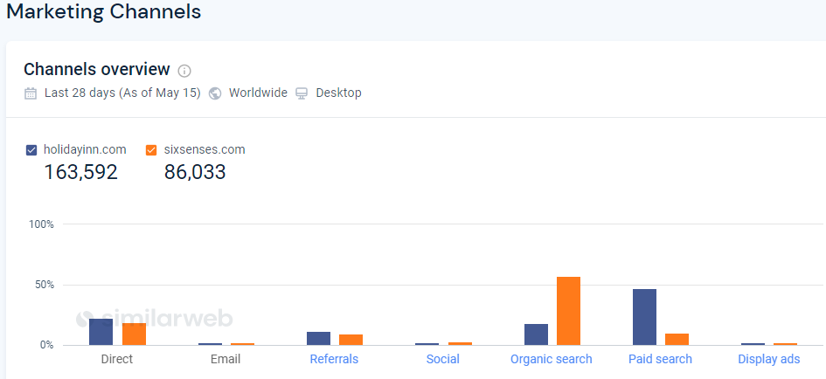
Appendix A – SimilarWeb Comparison between Holiday Inn and Six Senses’ website traffic received in the last 28 days.

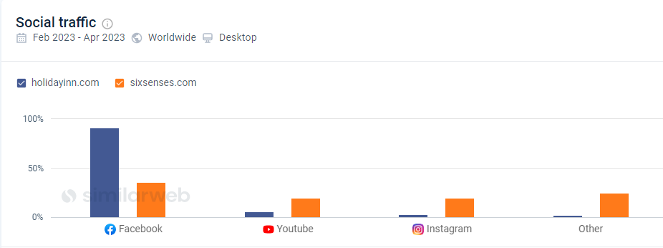
Appendix A – SimilarWeb Comparison between Holiday Inn and Six Senses’ social traffic received in the last 28 days.

