

Machine Learning Model
Wayne Howell (2207408)
Artificial Intelligence and Machine Learning (ACCA6011)

Contents
List of Figures 2
1. Abstract 4
2. Introduction 5
3. Literature Review 5
4. Problem Statement 6
5. Methodology 6
5.1 Dataset Checking and Exploratory Data Analysis 6
5.2 Data Preprocessing 7
5.3 Data Preparation 7
5.4 Decision Tree Classification 8
5.5 SVM Classification 8
5.6 Hyperparameter Tuning 8
5.7 K-Means Clustering 9
5.8 Evaluation Metrics 9
6. Experiments 9
7. Results 10
7.1 Dataset 10
7.2 Supervised Models 12
7.2.1 Decision Tree Model 12
7.2.2 SVM Models 13
7.3 Unsupervised Models 15
7.3.1 K-Means Clustering 15
8. Discussion 16
9. Recommendations 17
10. Conclusion 17
11. References 18
Video Link 18

List of Figures
Figure 1: Initial dataset inspection, structure, and variable summary 6
Figure 2: Data Scaling 8
Figure 3: Summary of Machine Learning Experiments 10
Figure 4: Dataset Structure, Data Types, and Unique Value Summary 11
Figure 5: Correlation Heatmap Between Numerical Variables 12
Figure 6: Baseline Decision Tree Training and Testing Results 12
Figure 7: Comparison of Baseline and Tuned Decision Tree performance on Training and Test Data 13
Figure 8: Top 10 Feature Importances from the Tuned Decision Tree Model 13
Figure 9: Linear Kernel SVM Model Training and Testing Results 14
Figure 10: RBF SVM Threshold Model Testing Results 14
Figure 11: SVM model performance across linear, RBF threshold, and tuned SVM models 15
Figure 12: Silhouette Score Results for K-Means Clustering 15
Figure 13: K-Means Clustering Performance and Segment Summary 16
Figure 14: Numerical Feature Averages by Tuned K-Means Cluster 16
Figure 15: Critical Comparison of Final Supervised and Unsupervised Models 17
Figure 16: Summary of Business Recommendations 17

1. Abstract
This report applies supervised and unsupervised machine learning to the Predict Online Gaming Behaviour Dataset to predict player engagement and explore player segments. Decision Tree and SVM models were used to classify players as Low, Medium, or High engagement, while K-Means clustering was used for segmentation. Results showed that the tuned Decision Tree was the strongest model, balancing performance and interpretability. SessionsPerWeek and AvgSessionDurationMinutes were the most important predictors. Clustering provided useful exploratory insight, but weak cluster separation limited its reliability. Overall, the findings show how machine learning can support retention, engagement monitoring, and game design decisions.

2. Introduction
Online gaming studios use behavioural data to understand engagement, improve retention, and support revenue-focused decisions. Low engagement can lead to reduced activity, churn, and missed opportunities for targeted game design or promotional strategies. Machine learning can help identify patterns in player behaviour that may not be visible through manual analysis.
This report uses the Predict Online Gaming Behaviour Dataset from Kaggle [1], which includes demographic, behavioural, purchasing, progression, and game-related features. The target variable, EngagementLevel, classifies players as Low, Medium, or High engagement, making this a multiclass classification problem.
The aim is to evaluate Decision Tree and Support Vector Machine models for predicting player engagement, apply hyperparameter tuning to improve performance, and use clustering to identify hidden player segments. The findings are used to support recommendations for retention, engagement monitoring, and game design.

3. Literature Review
Artificial Intelligence (AI), particularly machine learning, is increasingly important in game analytics because it can analyse large behavioural datasets, identify patterns, and support prediction and decision-making. Sarker explains that machine learning techniques can enhance intelligent applications and support decision-makers across real-world domains by learning from data [2]. In online games, this is especially valuable because player behaviour data is often session-based, high-volume, and collected over time. AI can therefore support tasks such as churn prediction, engagement profiling, player segmentation, and recommendation.
Previous studies show that machine learning can be effective for predicting player churn and disengagement. Rothmeier et al. used data from ‘The Settlers Online’, an online strategy game, and applied multiple machine-learning algorithms to predict churn and disengagement from user activity data [3]. Their study demonstrates that recorded game activity can be transformed into predictive features and used to identify players who may be at risk of leaving. Similarly, Drachen et al. argue that predicting and improving player retention is important in free-to-play games because many players leave soon after installation, making early prediction valuable for retention strategies [4]. Loria and Marconi also found that in-game activity data can support churn prediction, with time investment and consistency of gameplay linked to the likelihood of players leaving [5].
These studies support the use of supervised learning for player engagement prediction. A Decision Tree model is appropriate because it provides interpretable decision rules and feature importance outputs, allowing the studio to understand which behaviours influence engagement predictions [2]. This is useful in a business context because the model does not only classify players but also helps explain which variables are most influential. Support Vector Machine (SVM) is also suitable because it is a supervised classification method that can use linear and non-linear kernels, making it useful where engagement classes may not be separated by simple linear patterns [6]. Comparing both models allows predictive performance and interpretability to be evaluated.
Clustering provides a different form of insight. Instead of predicting a known engagement label, it groups players based on similarity in demographic and behavioural features. Perišić and Pahor show that clustering can support player segmentation and churn modelling in mobile games, particularly where datasets contain mixed categorical and numerical data [7]. Therefore, clustering is used to explore hidden player segments alongside the supervised prediction models. Combining supervised and unsupervised learning gives the studio both individual-level prediction and broader behavioural segmentation insight.
Together, these studies justify the use of AI-based classification and clustering methods, as they show that player activity data can support both predictive engagement modelling and exploratory behavioural segmentation.

4. Problem Statement
Online gaming studios collect large volumes of behavioural data, but without structured analysis it is difficult to turn that data into useful insight. When player activity declines, studios risk lower retention, weaker loyalty, reduced revenue, and less effective game design decisions.
The problem is how to use this data to predict whether players have Low, Medium, or High engagement, while also uncovering hidden player segments that can support targeted business action.

5. Methodology
This study used both supervised and unsupervised machine learning methods to predict player engagement and identify behavioural player segments. The methodology followed is outlined below.

5.1 Dataset Checking and Exploratory Data Analysis
The first stage checked the dataset structure, data types, missing values, duplicates, and target distribution.
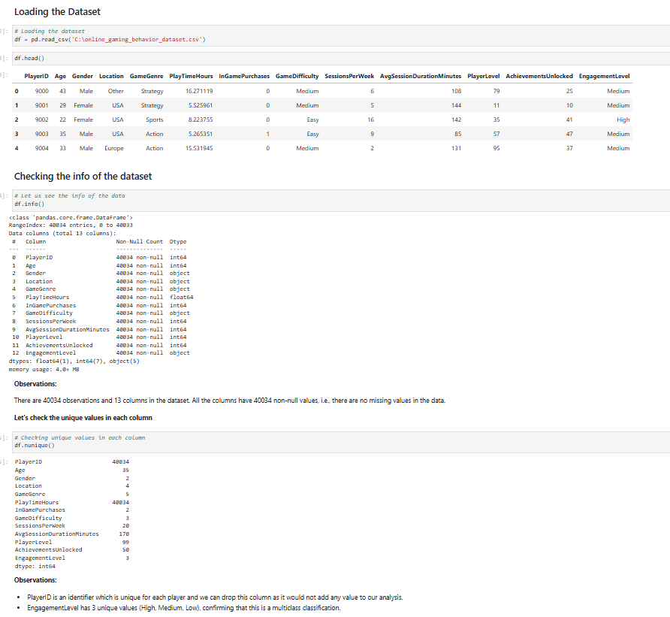
Figure 1: Initial dataset inspection, structure, and variable summary
Exploratory data analysis was then used to review numerical summaries, categorical patterns, engagement-level differences, and relationships between variables. This helped assess whether the data was suitable for machine learning and identify features that may be linked to player engagement.
However, exploratory data analysis is descriptive rather than predictive. A feature may appear related to engagement visually but still have limited value once tested within a model. Therefore, supervised machine learning was needed to formally assess predictive performance.

5.2 Data Preprocessing
The dataset was preprocessed to make it suitable for machine learning. PlayerID was removed because it was only a unique identifier and had no predictive value. The target variable, EngagementLevel, classified players as Low, Medium, or High, so the task was treated as a multiclass classification problem.
Categorical variables such as gender, location, game genre, and game difficulty were converted into numerical format using dummy variables. The predictors were then separated from the target variable, with X representing the input features and y representing the engagement label.
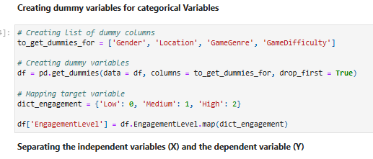
This made the data model-ready, but dummy encoding also increased the number of features and made interpretation less direct. Therefore, encoded variables were interpreted carefully to preserve their original business meaning.

5.3 Data Preparation
The prepared data was split into 70% training and 30% testing. The training set was used to fit the models, while the test set was kept separate to assess performance on unseen data. This helped provide a more realistic measure of model generalisation.
Feature scaling was applied using StandardScaler. The scaler was fitted on the training data and then applied to the test data to avoid data leakage. Scaling was required for SVM and K-Means because both are sensitive to feature magnitude, and the dataset contained variables measured on different scales.
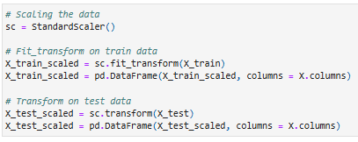
Figure 2: Data Scaling
However, scaling was not necessary for the Decision Tree, as tree-based models split data using thresholds rather than distance calculations. It was still required for SVM and K-Means because these methods rely on distances or decision boundaries.

5.4 Decision Tree Classification
A Decision Tree was used as a supervised classification model to predict whether players had Low, Medium, or High engagement. It works by splitting the data into decision rules based on feature values, allowing patterns between player characteristics and engagement level to be learned.
Its main strength is interpretability. The model can show feature importance, making it useful for identifying which behaviours had the greatest influence on engagement predictions. This is valuable for business decision-making because the studio needs to understand both which players may be at risk and which behaviours contribute to that risk.
The main limitation is overfitting. If the tree becomes too complex, it may learn the training data too closely and perform less effectively on unseen data. Therefore, hyperparameter tuning was required to control model complexity and improve generalisation.

5.5 SVM Classification
Support Vector Machine was used as the second supervised classification method. SVM works by finding a decision boundary that separates classes. A linear kernel was first used as a simpler baseline model, followed by an RBF kernel to allow non-linear class separation. This was appropriate because player engagement may not be separated by simple straight-line relationships.
SVM was useful because it provided a strong comparison against the Decision Tree. The RBF kernel was particularly useful for testing whether a more flexible decision boundary improved classification performance. However, SVM is less interpretable than Decision Tree because it does not provide simple decision rules or feature importance in the same way. It is also more computationally expensive, especially when probability estimates are required for AUC-ROC. For this reason, SVM was valuable for comparison, but Decision Tree was stronger for explainability.

5.6 Hyperparameter Tuning
Hyperparameter tuning was applied to improve model performance and reduce overfitting. For the Decision Tree, parameters such as criterion, max_depth, min_samples_split, and min_samples_leaf were tuned. These parameters control how the tree splits the data and how complex the final tree becomes.
For SVM, the main hyperparameters were kernel, C, and gamma. The kernel controls whether the decision boundary is linear or non-linear. C controls the trade-off between classification errors and margin size, while gamma affects how much influence each data point has in the RBF kernel. A reduced tuning grid was used for SVM because testing too many combinations can be computationally expensive on larger datasets.
The strength of hyperparameter tuning is that it improves the chance of selecting a model that generalises well rather than simply fitting the training data. However, tuning also has limitations because the selected model depends on the parameters tested. A very small grid may miss better settings, while a very large grid can increase processing time.

5.7 K-Means Clustering
K-Means clustering was used as the unsupervised learning method to identify hidden player segments. Unlike Decision Tree and SVM, K-Means did not use the EngagementLevel target variable during training. Instead, it grouped players based on similarity across demographic and behavioural features.
The number of clusters was assessed using inertia and silhouette score. Inertia measured how compact the clusters were, while silhouette score measured how well separated the clusters were. Hyperparameter tuning was also applied to test different K-Means settings, including the number of clusters, initialisation method, number of initialisations, and maximum iterations.
K-Means was useful because it provided a segmentation view of the player base. This could help the studio explore broad player groups and compare behavioural patterns across segments. However, the clustering results had to be interpreted cautiously because low silhouette scores can suggest that the clusters were not strongly separated. Therefore, K-Means was treated as an exploratory segmentation method rather than a direct replacement for the supervised prediction models.

5.8 Evaluation Metrics
Model performance was assessed using separate metrics for supervised and unsupervised learning. For the supervised models, Decision Tree and SVM, accuracy, precision, recall, F1-score, confusion matrices, and AUC-ROC were used. Accuracy was not used alone because the task involved three engagement classes: Low, Medium, and High.
F1-score was prioritised because it balances precision and recall across the three classes. Recall was especially important for the Low engagement class, as missing these players could prevent the studio from targeting users at risk of disengagement. Precision was also considered to avoid wasting resources on players incorrectly flagged as Low engagement.
Confusion matrices showed where misclassifications occurred, while AUC-ROC assessed class separation using a one-vs-rest approach. For K-Means, classification metrics were not suitable because it did not predict EngagementLevel. Instead, inertia measured cluster compactness, and silhouette score assessed how well separated the player segments were.

6. Experiments
The experiments were designed to compare supervised classification models for engagement prediction and an unsupervised clustering model for player segmentation. Figure 3 summarises the models tested, the data used, the evaluation approach, and the purpose of each experiment.
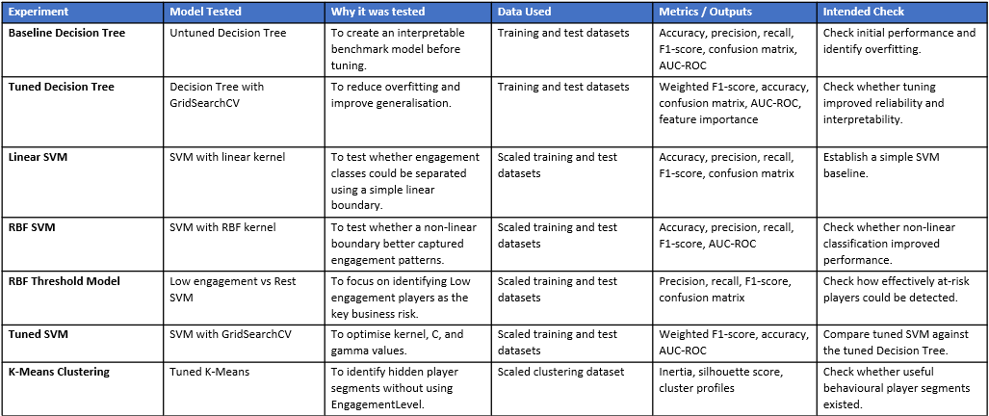
Figure 3: Summary of Machine Learning Experiments
These experiments allowed the supervised models to be assessed for predictive performance, while K-Means was evaluated for exploratory segmentation.

7. Results
This section summarises the main results needed to compare model performance and interpret the key findings. The full detailed outputs are provided in the accompanying HTML notebook submission.

7.1 Dataset
Initial dataset checks confirmed that the dataset contained 40,034 records and 13 columns, with no missing values identified. The target variable, EngagementLevel did indeed contain three classes: Low, Medium.
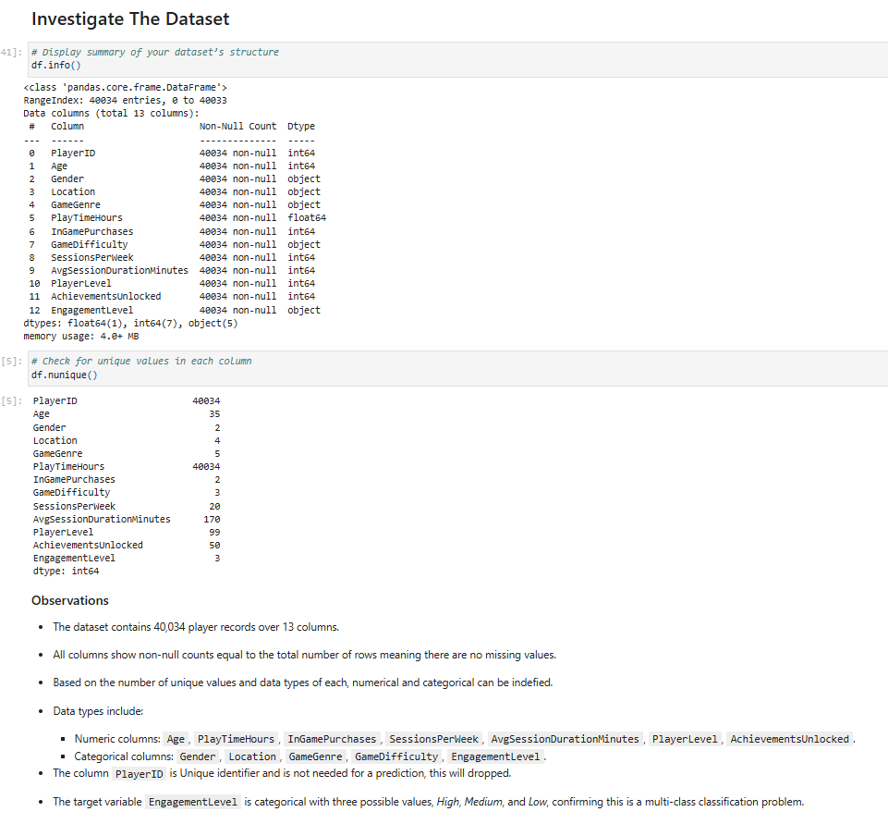
Figure 4: Dataset Structure, Data Types, and Unique Value Summary
The analysis also showed that no single categorical variable had a strong visual relationship with engagement, while the numerical correlation heatmap showed weak linear relationships between numerical features, suggesting the need for machine learning models to capture combined or non-linear patterns.
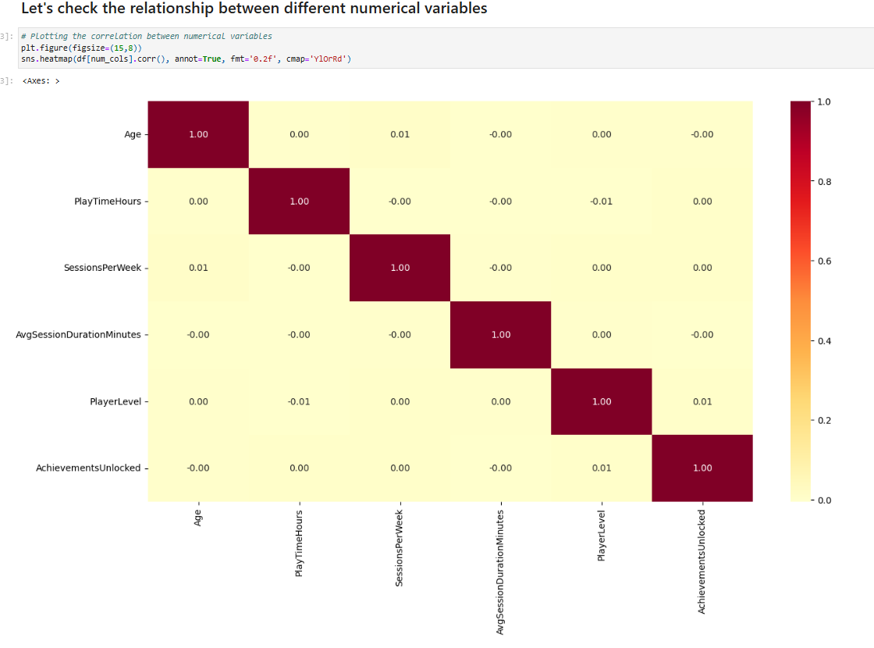
Figure 5: Correlation Heatmap Between Numerical Variables

7.2 Supervised Models

7.2.1 Decision Tree Model
The baseline Decision Tree Model showed clear overfitting. It achieved perfect performance on the training data, but test accuracy dropped to 82.96%, with a test AUC-ROC score of 0.8665. This suggested that the model had learned the training data too closely and did not generalise as strongly to unseen data.
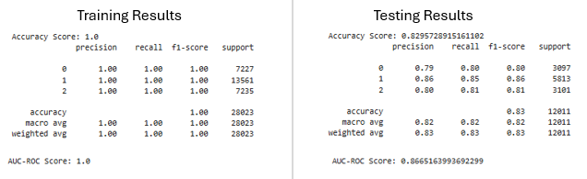
Figure 6: Baseline Decision Tree Training and Testing Results
Hyperparameter tuning improved the Decision Tree by controlling model complexity. The tuned model no longer achieved perfect training performance, but it produced stronger test results. Test accuracy increased to approximately 0.90, and test AUC-ROC improved to 0.936. This suggests that parameters such as max_depth, min_samples_split, and min_samples_leaf helped reduce overfitting and improved the model’s ability to classify unseen players. The table below displays a comparison and main findings of the Decision Tree Models.
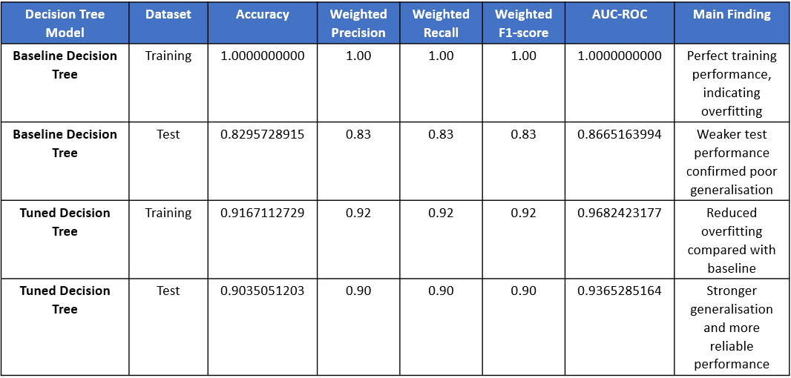
Figure 7: Comparison of Baseline and Tuned Decision Tree performance on Training and Test Data
Feature importance run on the tuned Decision Tree Model showed that SessionsPerWeek and AvgSessionDurationMinutes were the strongest predictors of engagement. This indicates that how often players play and how long they play for were more important than demographic variables such as age, gender, or location.
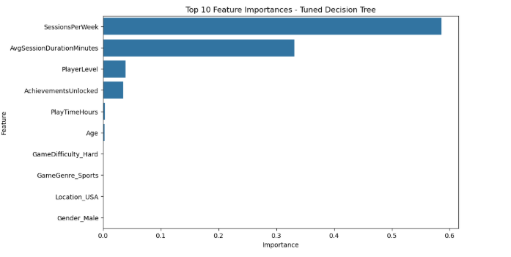
Figure 8: Top 10 Feature Importances from the Tuned Decision Tree Model
Overall, the tuned Decision Tree was stronger than the baseline model because it reduced overfitting while maintaining high test performance and interpretability.

7.2.2 SVM Models
The Linear SVM produced stable training and test results, with test accuracy of 0.82. This suggests that the model generalised consistently and did not show major overfitting.
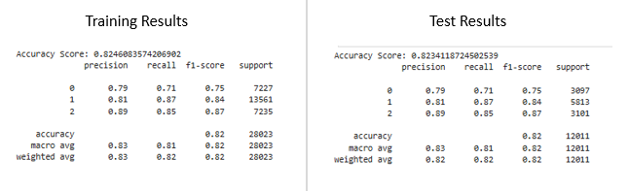
Figure 9: Linear Kernel SVM Model Training and Testing Results
However, its performance was weaker than RBF-based SVM model, indicating that a simple linear boundary was not sufficient to capture all engagement patterns.
The RBF SVM used a Low engagement vs Rest threshold approach. This was tested because identifying low-engagement players was the main business priority. Using a threshold of 0.45 (identified through precision-recall analysis) , the RBF SVM achieved 0.93 test accuracy, with 0.86 precision, 0.85 recall, and 0.86 F1-score for the Low engagement class. This showed that the model was effective at detecting players at risk of lower engagement.
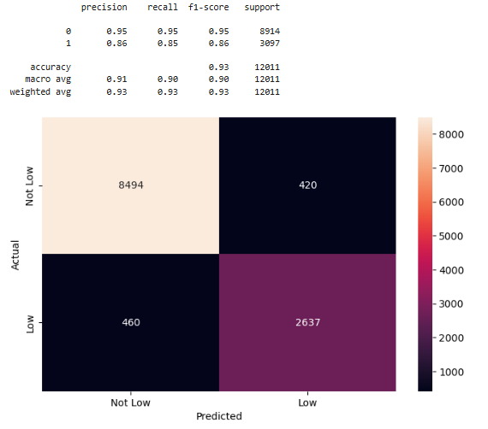
Figure 10: RBF SVM Threshold Model Testing Results
Hyperparameter tuning was applied to both SVM models. The RBF kernel with C = 1 and gamma = scale was selected, confirming that the non-linear kernel was more suitable than the linear SVM for this dataset. The tuned SVM achieved a weighted F1-score of 0.91 on the training data and 0.88 on the test data, showing strong overall classification performance across the Low, Medium, and High engagement classes. It also achieved a test AUC-ROC of 0.9396443477, indicating strong class separation. The small drop between training and test performance suggests that the model generalised reasonably well.
The table below provides a comparison of all SVM models with the main findings.
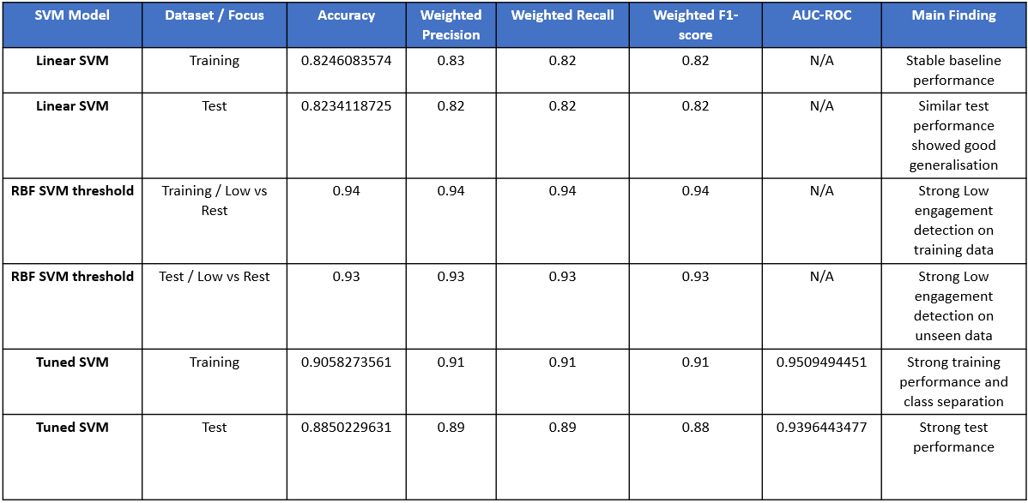
Figure 11: SVM model performance across linear, RBF threshold, and tuned SVM models

7.3 Unsupervised Models

7.3.1 K-Means Clustering
K-Means clustering was evaluated using inertia and silhouette score because it does not predict the known EngagementLevel target variable. The initial silhouette analysis showed the highest score at 0.120195 with 4 clusters, suggesting this was the best initial separation among the tested values. However, the score remained low, indicating weak separation between player groups.
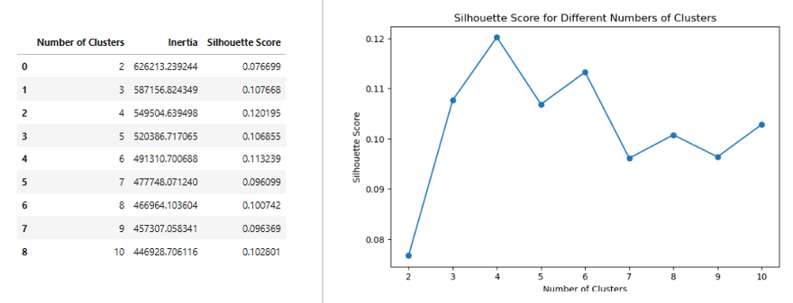
Figure 12: Silhouette Score Results for K-Means Clustering
After hyperparameter tuning, the final K-Means model used 5 clusters and achieved a slightly higher silhouette score of 0.132229. This suggests that tuning improved the clustering structure, although the score was still low and the clusters should be interpreted cautiously.

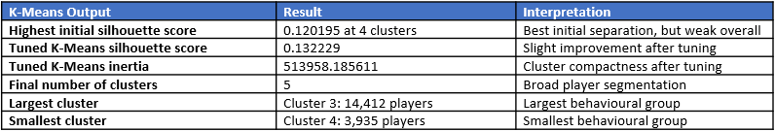
Figure 13: K-Means Clustering Performance and Segment Summary
The tuned K-Means model identified 5 broad player segments, but the low silhouette score shows that the groups were not strongly distinct. The cluster profiles were also similar across numerical variables, and the engagement distribution did not clearly align with the original Low, Medium, and High engagement categories.
To understand whether the tuned clusters represented distinct player groups, the average numerical features were compared across each cluster.
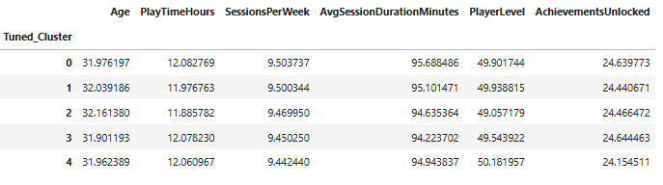
Figure 14: Numerical Feature Averages by Tuned K-Means Cluster
The numerical feature averages show only small differences between the five tuned clusters. This supports the low silhouette score result, indicating that the clusters were not strongly separated. Therefore, the K-Means model should be treated as a broad exploratory segmentation tool rather than a precise method for defining distinct player types.

8. Discussion
The results show that supervised learning was more effective than unsupervised learning for direct player engagement prediction. This is because Decision Tree and SVM used the known EngagementLevel target variable to learn patterns linked to Low, Medium, and High engagement. K-Means did not use this label, so it was better suited to exploratory segmentation rather than individual prediction.
The baseline Decision Tree showed clear overfitting, with perfect training performance but weaker test performance. This means the model learned the training data too closely and did not generalise as effectively to unseen records. Hyperparameter tuning reduced this issue by controlling tree complexity. The tuned Decision Tree achieved stronger test performance and provided clearer feature importance outputs, making it more useful for business interpretation.
The SVM models also performed well, particularly when the RBF kernel was used. This suggests that the relationship between player behaviour and engagement was not fully linear. The tuned SVM model achieved a slightly higher AUC-ROC score than the tuned Decision Tree, showing strong class separation. However, its weighted test F1-score was slightly lower, and the model was less interpretable. This limits its business value because the studio needs to understand not only which players are at risk, but also which behaviours contribute to that risk.
K-Means clustering added a different type of insight by grouping players into broad segments. However, the low silhouette score and similar cluster profiles show that the groups were not strongly separated. This means the clusters should not be treated as fixed or precise player types. Instead, K-Means should be used cautiously as an exploratory tool to support wider segmentation analysis.
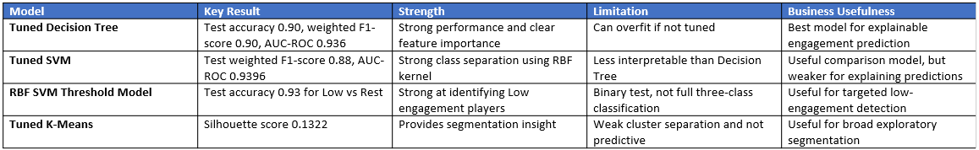
Figure 15: Critical Comparison of Final Supervised and Unsupervised Models
Overall, the tuned Decision Tree was selected as the best supervised model because it provided the strongest balance of predictive performance, generalisation, and interpretability. The Decision Tree was more useful for practical decision-making because it showed which variables influenced predictions (SessionsPerWeek and AvgSessionDurationMinutes).

9. Recommendations
The recommendations below show how the game studio could use the model outputs to support retention, engagement monitoring, player segmentation, and future game design decisions.
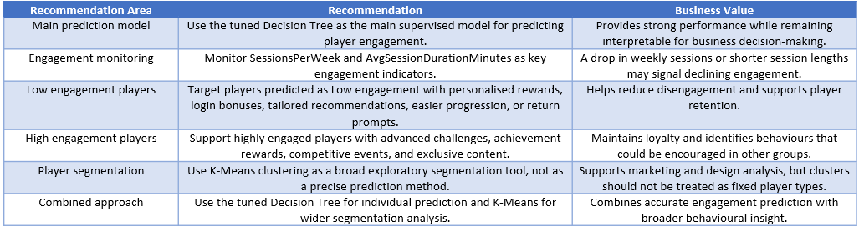
Figure 16: Summary of Business Recommendations
Overall, the game studio should use machine learning models as a decision-support tool rather than a replacement for business judgement. Model performance and player outcomes should be reviewed regularly to ensure that predictions remain accurate, useful, and aligned with changing player behaviour.

10. Conclusion
The project demonstrated that machine learning can support player engagement analysis by identifying at-risk players, highlighting important behavioural indicators, and informing retention and game design strategies. A key reflection is that model accuracy alone is not enough; interpretability, business relevance, and regular monitoring are also important when applying AI methods in a real-world gaming context.

11. References
[1] Rabie El Kharoua, “🎮 Predict Online Gaming Behavior Dataset,” Kaggle.com, 2024. https://www.kaggle.com/datasets/rabieelkharoua/predict-online-gaming-behavior-dataset?resource=download
[2] I. H. Sarker, “Machine Learning: Algorithms, Real-World Applications and Research Directions,” SN Computer Science, vol. 2, no. 3, pp. 1–21, Mar. 2021, doi: https://doi.org/10.1007/s42979-021-00592-x.
[3] K. Rothmeier, N. Pflanzl, J. Hullmann, and M. Preuss, “Prediction of Player Churn and Disengagement Based on User Activity Data of a Freemium Online Strategy Game,” IEEE Transactions on Games, vol. 13, no. 1, pp. 78–88, 2020, doi: https://doi.org/10.1109/tg.2020.2992282
[4] A. Drachen et al., “Rapid Prediction of Player Retention in Free-to-Play Mobile Games,” Proceedings of the AAAI Conference on Artificial Intelligence and Interactive Digital Entertainment, vol. 12, no. 1, pp. 23–29, Jun. 2021, doi: https://doi.org/10.1609/aiide.v12i1.12856.
[5] E. Loria and A. Marconi, “Exploiting limited players’ behavioral data to predict churn in gamification,” Electronic Commerce Research and Applications, vol. 47, p. 101057, May 2021, doi: https://doi.org/10.1016/j.elerap.2021.101057.
[6] scikit-learn, “1.4. Support Vector Machines,” Scikit-learn.org, 2018. https://scikit-learn.org/stable/modules/svm.html
[7] A. Perišić and M. Pahor, “Clustering mixed-type player behavior data for churn prediction in mobile games,” Central European Journal of Operations Research, vol. 33, pp. 165–190, Jun. 2022, doi: https://doi.org/10.1007/s10100-022-00802-8.

Video Link
https://youtu.be/MDsb-js4Hz8

