

I N D I V I D U A L R E P O R T

Funding the Vision
Planning and Managing the ArtBridge Social Enterprise Gallery
Critically Assessing the Project Management Tools and Techniques Used Across the Project Lifecycle

Student Florina Dinitica
Student ID 2321857
Programme BA Developing Leadership and Management
Module Managing Projects in the Organisation (BMSW5009)
Assessment Assessment 2 — Individual Report (50%)
Module Lecturer Maggie Zhang
Group Group 4 — ArtBridge
Project role Funding & Partnerships Lead
Submission date 8 July 2026
Academic honesty: this report is my own work. Sources consulted are credited in the text and listed in full in the reference list.

Contents
Executive Summary 3
1. Introduction 3
2. Findings 4
2.1 Understanding the project management toolkit 4
2.2 Putting the tools to work in ArtBridge 5
2.3 Stakeholders and communication 7
3. Conclusion 8
4. Future improvements and lessons learned 9
Reference List 10

Executive Summary
ArtBridge is a proposed community arts gallery, run as a small social enterprise, that aims to widen creative opportunities for disadvantaged young people and emerging local artists. This report looks back critically over the whole project lifecycle and asks how well the project management tools our group used actually supported the plan. It focuses on the techniques that shaped the pilot — scope definition, the work breakdown structure, the Gantt chart, the risk matrix, stakeholder analysis, the funding model and the Iron Triangle — and weighs their usefulness against their limits. Leading on funding and partnerships, I found that the risk matrix and the mixed-income model most improved our decisions, while the schedule promised more certainty than it could deliver. The report ends with practical recommendations for managing such a project better.

1. Introduction
ArtBridge began with a simple observation: creative opportunities in our community are not shared equally. Disadvantaged young people often have nowhere affordable and welcoming to make and show creative work, and emerging local artists face the same barrier from the other side, lacking space and an audience. Our group of six proposed ArtBridge as a response — a community arts gallery offering workshops, exhibitions, mentoring and performance, run not as a charity dependent on a single grant but as a social enterprise that blends several income streams to stay sustainable (Clegg, Skyttermoen and Vaagaasar, 2020).
The gallery is planned as a realistic twelve-month pilot rather than a finished organisation. Its aim is to build a financially sustainable space that improves creative access and inclusion, and its objectives are specific and measurable: at least twelve inclusive workshops, one or more community exhibitions or open-mic events, two or three active partnerships, more than eighty participants engaged, and a mixed-income funding base. This report is not a summary of the proposal. It is a critical reflection on how the tools of project management served ArtBridge across its lifecycle — from initiation and planning, through funding and delivery, to evaluation — with particular attention to what worked, what did not, and what I would do differently as funding and partnership lead.

2. Findings

2.1 Understanding the project management toolkit
Every project draws on the same core planning tools, and their limits matter as much as their uses. Project management is best understood as the disciplined use of established techniques to deliver a unique result within constraints (Heerkens, 2015). Scope definition comes first. Setting out what a project will and will not deliver is the classic guard against scope creep, the uncontrolled growth of deliverables that Ajmal, Khan and Al-Yafei (2020) trace largely to stakeholder pressure and unclear boundaries, not poor documentation. The work breakdown structure then divides the agreed scope into smaller packages; Heagney (2016) calls it the foundation of any realistic schedule, and Meredith and Mantel (2009) link that breakdown directly to accurate cost and time estimation. The Gantt chart converts this structure into a timeline: it communicates sequencing at a glance, but Reiss (2015) and Hollister (2017) both caution that its neat bars can imply a precision that early-stage estimates do not have, so the schedule is better read as a living plan than a promise.
Risk management is where much of the real value sits. A risk matrix scores threats for likelihood and impact so scarce attention goes to what matters most, yet the technique has well-known blind spots. Kutsch and Hall (2010) show that managers often practise “deliberate ignorance”, filtering out risks they find inconvenient, while de Bakker, Boonstra and Wortmann (2010) find it is the act of discussing risk, more than the register itself, that improves outcomes, and structured risk management has been empirically linked to project success (Teller and Kock, 2013). Zwikael and Ahn (2011) add that risk planning is most effective in high-risk, low-resource settings — which describes a community pilot with little slack to absorb an unexpected threat. Stakeholder analysis complements this by identifying who can affect the project and how, usually through a power–interest grid that then guides communication.
Underpinning all of these is the Iron Triangle of time, cost and quality. It remains the default shorthand for project performance, but Pollack, Helm and Adler (2018), revisiting the model, show how narrowly it frames success as delivery efficiency while ignoring whether a project delivers genuine benefit — a serious gap for a social enterprise whose worth lies in inclusion. Broader models, such as Shenhar et al.’s (2001) multidimensional framework and Serra and Kunc’s (2015) work on benefits realisation, capture longer-term impact and value more fairly. Methodology choice matters too: plan-driven approaches such as PRINCE2 suit stable, predictable work, whereas Agile favours flexibility and short cycles. Wysocki, Kaikini and Sneed (2014) present these as a spectrum rather than a binary, and Joslin and Müller (2015) find that a methodology only improves success when it genuinely fits the project’s governance and context.
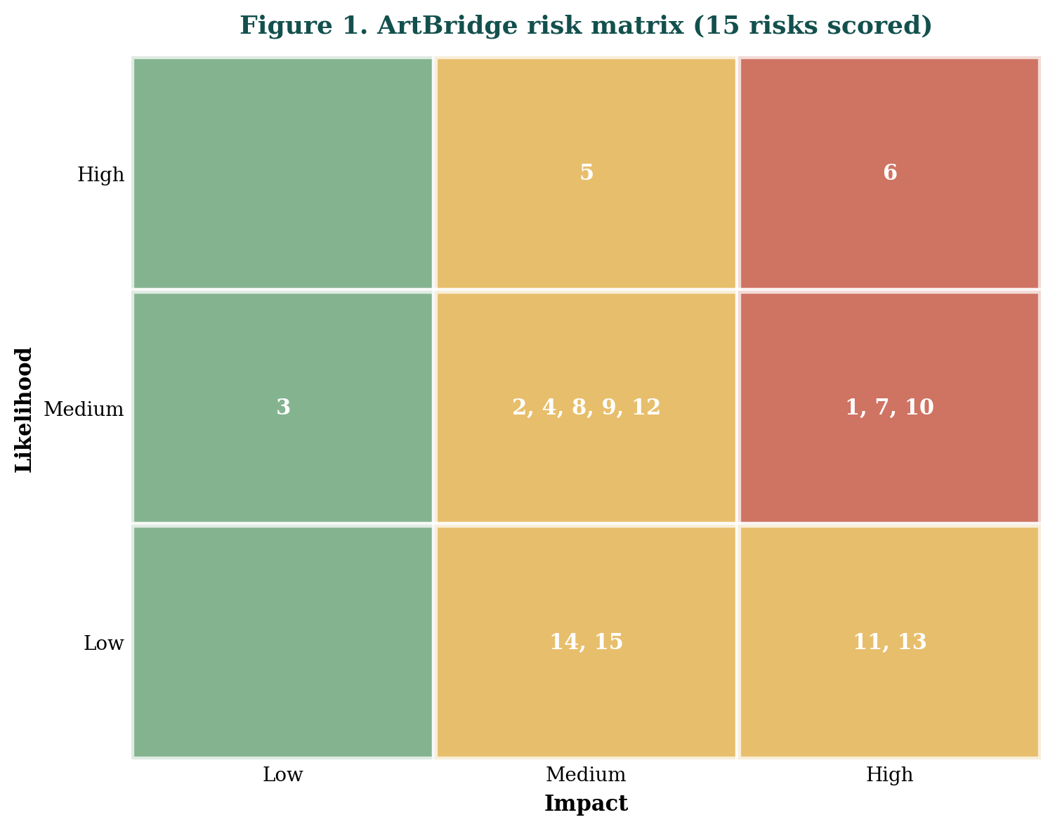
Figure 1. ArtBridge risk matrix.

2.2 Putting the tools to work in ArtBridge
Applying these tools to ArtBridge taught us which ones actually changed our decisions. Scope was the first test. Our in-scope and out-of-scope table drew a firm line — no counselling, no housing support, no full café, no national expansion — and that line mattered more than any other single document, because the temptation throughout was to promise more than a pilot could hold. As the person leading funding, I felt this pull most sharply: every new income idea, from memberships to venue hire, was attractive, and it would have been easy to let the funding plan quietly widen the whole project’s scope. Keeping a “later development” column in the income model let us capture those ideas without committing to them, which in practice was our main defence against the scope creep Ajmal, Khan and Al-Yafei (2020) describe.
The mixed-income model (Figure 3) was, I think, the tool that most improved the project’s credibility. Rather than depending on a single grant, we planned to draw on grants, sponsorship, donations and community partnerships during the pilot, holding back memberships, ticketing, venue hire and commission for later. Spreading income this way is a deliberate risk-reduction strategy, and it directly shaped the £8,100 indicative budget, where the largest lines — facilitator fees, venue hire and materials — are matched to realistic pilot-stage sources. The weakness we could not fully resolve is dependence: grants still make up the largest single slice, so an unsuccessful application would hurt. That is exactly the kind of concentrated exposure a good budget should surface, and ours did. Building the budget line by line also disciplined our thinking: a realistic figure against each activity forced us to admit which ambitions were affordable, and the contingency answered the resource risks we had scored.
The risk matrix (Figure 1) was the most useful analytical tool we used. Scoring fifteen risks across resource, participation and delivery categories produced one clear red-zone risk — low workshop and event turnout — and a cluster of amber risks around funding and commitment. Naming that priority changed our sequencing: we agreed to secure participant referrals before scheduling events, and to apply to several grant streams rather than betting on one. The matrix’s limitation is real, though: it only holds the risks we were willing to name, the blind spot Kutsch and Hall (2010) warn about, and a three-by-three grid compresses genuinely different threats into the same amber box. Its value, as de Bakker, Boonstra and Wortmann (2010) argue, lay less in the colours than in the discussion it forced. By contrast, the Gantt chart (Figure 2) looked authoritative but rested on estimates we could not defend; the twelve-month sequence assumed funding and partnerships would land on time, when in reality those are the least controllable parts of the plan. As Kidston and Haward (2015) stress, a schedule only earns its keep once progress is monitored and controlled against it — which an untested pilot cannot yet do. Measured against the Iron Triangle the project balances time, cost and quality reasonably, but as Mir and Pinnington (2014) note, performance on those axes does not by itself prove the project delivered value for the young people it targets.
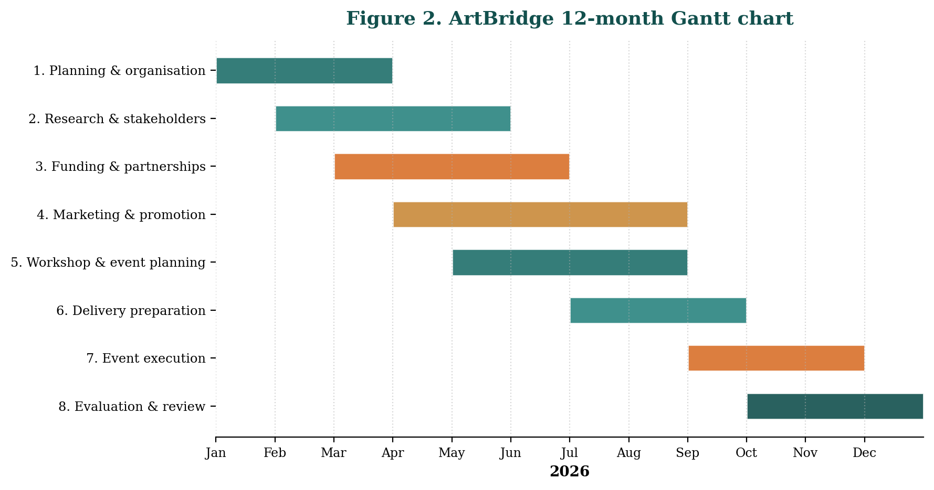
Figure 2. ArtBridge Gantt chart (2026).

2.3 Stakeholders and communication
ArtBridge depends on a wide circle of stakeholders, and mapping them was essential to planning both funding and communication. We identified twelve groups and sorted them by internal and external role and by interest and influence, then placed them on a power–interest grid. Sponsors, donors and the project team fell into the high-power, high-interest group we needed to manage closely; local councils held power over approvals and funding but less day-to-day interest, so they were to be kept satisfied; young people, artists, volunteers and youth organisations had high interest but limited formal power and were to be kept informed; and the wider community sat in the monitor category. As funding lead, the “manage closely” and “keep satisfied” groups mattered most to me, because sponsors, councils and grant-makers control the pilot’s resources. Mapping them this way also exposed their interdependence: schools and youth organisations sit in the keep-informed quadrant, yet without their referrals the participation figures funders want would never materialise — so a seemingly peripheral stakeholder is central to the funding case.
The communication plan matched method and frequency to each group — monthly email and meetings for sponsors, weekly WhatsApp and shared documents for the team, social media and posters for participants before events. For a project with almost no budget, using free and familiar channels was sensible and appropriate (Besner and Hobbs, 2006). Two weaknesses stand out on reflection. First, we planned communication with powerful funders more carefully than with beneficiaries, yet Fernandes, Ward and Araújo (2015) argue that embedding a project in its community is what makes it durable, and that depends on engaging the very groups we treated as low-power. Second, our internal and external classifications were not always watertight; getting these wrong would send the wrong messages to the wrong people and weaken the funding relationships the project relies on (Aubry, Hobbs and Thuillier, 2007). Communication, in short, was well planned on paper but tilted towards the powerful.
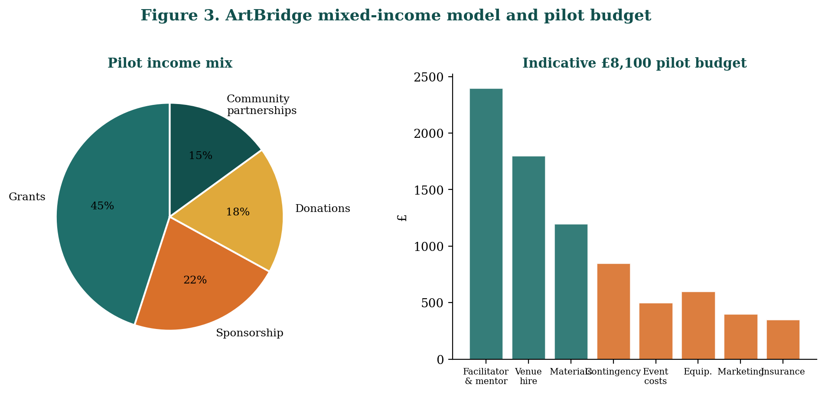
Figure 3. ArtBridge mixed-income model and budget.

3. Conclusion
Looking across the whole lifecycle, ArtBridge was a realistic and well-structured plan rather than a flawless one. The tools gave the project shape: scope discipline kept it honest, the mixed-income model made it credible, and the risk matrix focused our attention where it was most needed. My overall judgement is that the tools worked, but that their usefulness varied more than we expected. The risk assessment and the funding model repaid the effort we put into them, because they changed real decisions; the Gantt chart, for all its polish, promised a certainty the pilot could not honestly claim. Stakeholder and communication planning was sound in principle but leaned too far towards powerful funders and not far enough towards the young people the gallery exists for. Judged on time, cost and quality the plan holds together; judged on whether it would truly deliver inclusion and value, the tools organised the work well but could not, on their own, guarantee the outcome (Shenhar et al., 2001). Badewi (2016) makes a related point: project management yields its full value only when coupled with deliberate benefits management. For me as funding lead, the clearest lesson was that financial credibility and social purpose depend on each other.

4. Future improvements and lessons learned
A second attempt would benefit from several changes drawn directly from what happened. As funding and partnerships lead, I realised too late how much of the plan rested on the grants. First, funding needs less concentration. Because grants dominate the mix, I would start sponsorship and donation campaigns earlier and pursue more streams at once, so one failed application cannot stall the pilot. Second, scheduling should be more honest about uncertainty. Rather than drawing a confident twelve-month Gantt chart, we would add buffers around the funding and partnership stages, since these depend on decisions outside our control, and treat the timeline as a live document updated as grants are confirmed. Third, risk management should become continuous rather than a one-off exercise: each amber risk deserves a named owner and a review date, which would counter the tendency to look away from inconvenient risks that Kutsch and Hall (2010) identify. Fourth, stakeholder communication should be rebalanced towards beneficiaries, with the same planning we gave sponsors devoted to keeping young people engaged across sessions, since their retention is our largest single risk. Finally, the group learned a broader lesson. The most reassuring tools are not always the most reliable, and the discipline that matters most is not producing plans but keeping them alive and using them to make decisions (Pinto and Slevin, 1987).

Reference List
Ajmal, M., Khan, M. and Al-Yafei, H. (2020) ‘Exploring factors behind project scope creep — stakeholders’ perspective’, International Journal of Managing Projects in Business, 13(3), pp. 483–504.
Aubry, M., Hobbs, B. and Thuillier, D. (2007) ‘A new framework for understanding organisational project management through the PMO’, International Journal of Project Management, 25(4), pp. 328–336.
Badewi, A. (2016) ‘The impact of project management (PM) and benefits management (BM) practices on project success’, International Journal of Project Management, 34(4), pp. 761–778.
Besner, C. and Hobbs, B. (2006) ‘The perceived value and potential contribution of project management practices to project success’, Project Management Journal, 37(3), pp. 37–48.
Clegg, S.R., Skyttermoen, T. and Vaagaasar, A.L. (2020) Project Management: A Value Creation Approach. London: Sage.
de Bakker, K., Boonstra, A. and Wortmann, H. (2010) ‘Does risk management contribute to IT project success? A meta-analysis of empirical evidence’, International Journal of Project Management, 28(5), pp. 493–503.
Fernandes, G., Ward, S. and Araújo, M. (2015) ‘Improving and embedding project management practice in organisations’, International Journal of Project Management, 33(1), pp. 72–89.
Heagney, J. (2016) Fundamentals of Project Management. 5th edn. New York: AMACOM.
Heerkens, G. (2015) Project Management. 2nd edn. New York: McGraw-Hill.
Hollister, S. (2017) Project Management: A Quick Start Beginner’s Guide for Easily Managing Projects the Right Way. CreateSpace Independent Publishing Platform.
Joslin, R. and Müller, R. (2015) ‘Relationships between a project management methodology and project success in different project governance contexts’, International Journal of Project Management, 33(6), pp. 1377–1392.
Kidston, P. and Haward, K. (2015) Planning, Scheduling, Monitoring and Control: The Practical Project Management of Time, Cost and Risk. Princes Risborough: Association for Project Management.
Kutsch, E. and Hall, M. (2010) ‘Deliberate ignorance in project risk management’, International Journal of Project Management, 28(3), pp. 245–255.
Meredith, J. and Mantel, S. (2009) Project Management: A Managerial Approach. 7th edn. Hoboken: John Wiley & Sons.
Mir, F.A. and Pinnington, A.H. (2014) ‘Exploring the value of project management: linking project management performance and project success’, International Journal of Project Management, 32(2), pp. 202–217.
Pinto, J.K. and Slevin, D.P. (1987) ‘Critical factors in successful project implementation’, IEEE Transactions on Engineering Management, EM-34(1), pp. 22–27.
Pollack, J., Helm, J. and Adler, D. (2018) ‘What is the Iron Triangle, and how has it changed?’, International Journal of Managing Projects in Business, 11(2), pp. 527–547.
Reiss, G. (2015) Project Management Demystified. 3rd edn. London: Routledge.
Serra, C.E.M. and Kunc, M. (2015) ‘Benefits realisation management and its influence on project success and on the execution of business strategies’, International Journal of Project Management, 33(1), pp. 53–66.
Shenhar, A.J., Dvir, D., Levy, O. and Maltz, A.C. (2001) ‘Project success: a multidimensional strategic concept’, Long Range Planning, 34(6), pp. 699–725.
Teller, J. and Kock, A. (2013) ‘An empirical investigation on how portfolio risk management influences project portfolio success’, International Journal of Project Management, 31(6), pp. 817–829.
Wysocki, R.K., Kaikini, S. and Sneed, R. (2014) Effective Project Management: Traditional, Agile, Extreme. 7th edn. Indianapolis: Wiley.
Zwikael, O. and Ahn, M. (2011) ‘The effectiveness of risk management: an analysis of project risk planning across industries and countries’, Risk Analysis, 31(1), pp. 25–37.

