

LOCATION: Swansea | LLEOLIAD: abertawe
LEVEL 5 | LEFEL 5
EXAMINATION PERIOD | CYFNOD ARHOLIADAU
may 2022 | mai 2022

MODULE CODE: ACCA5032
OBJECT ORIENTED PROGRAMMING AND ALGORITHMS
TIME: 2 HOURS
answer THREE quESTIONs out of FOUR

Equipment or materials required – None
Adnoddau neu ddefnyddiau sydd eu hangen - Dim

ANSWER THREE QUESTIONS OUT OF FOUR

Q1
A program has been written for a small book shop to manage their sales and stock levels. Using syntax acceptable for C#, construct a class to represent the sales controller element of this program. You should assume that a “Customer” class exists within the system that can be used to manipulate customer details. In addition, it should also be assumed an “Order” class exists that may hold the values mentioned below. The created class should provide methods for the following functionalities:

- The creation of a new order, accepting values for Customer ID, Item Code, Item Quantity, Date of Order and Ship Status, an Order ID should be generated through this process.
(5 marks)
- Display the current sales list, accepting a parameter to filter based upon whether an item has been shipped.
(5 marks)
- The amendment of an order in form of change of quantity, accepting arguments for an Order Id and Quantity.
(5 marks)

Further marks will be given for demonstration of the correct use of attributes, constructors and methods within the class.
(5 marks)

[20 marks total]

Q2. The following code extract exhibits a small element of the controlling functionality for game elements with which a player may interact.

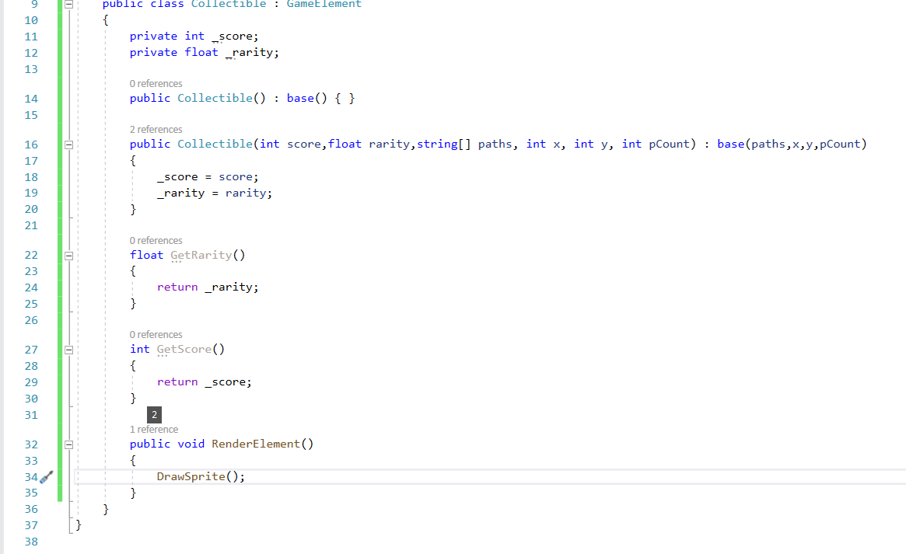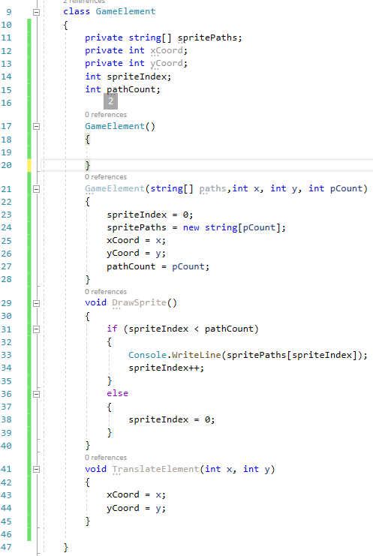
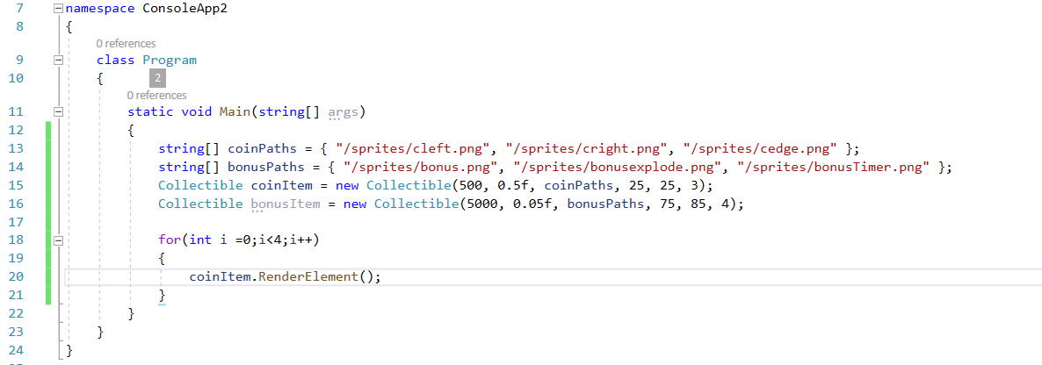

a) Analyse the operation of the code excerpt provided. Explain the features and operation of the code in detail.
(16 marks)
b) Show the exact output of the provided code and explain your answer.
(4 marks)
[20 marks total]

Q3. There are a number of structures that can be used to contain collections of information that relate to one another. When we want to keep like structures together we may use an array. If we need more complex means of storing data entities we may use other forms of storage mechanisms

- List three alternatives to arrays outlining with comparison (5 marks)
- What are benefits of the use of linked lists (5 marks)
- Explain the binary tree structure and operation. (5 marks)
- Give an example use case for implementing a binary tree (5 marks)

[20 marks total]

Q4. Computers have the capacity to house a vast collection of data in many different data structures. In many cases such data structures may need to provide capability for organising or finding specific information found within them

(a)
i) List two types of search algorithm with comparison (4 marks)
ii) Which of the search algorithms identified is the most efficient and why?
(4 marks)
ii) In what circumstances would you use a binary search ? (4 marks)
(12 marks)

(b) Outline the operation of a bubble sort and define its complexity
(8 marks)
[20 marks total]
Diwedd/End

