Student name: Jean Pierre Kiangoma
Student number:1806274
Module title: Digital skills and research methods
Module lecturer’s name: Joy Botu

Contents
Introduction 2
How do digital skills enhance the efficiency at workplace? 2
Use of techniques and methods that helps to increase efficiency and productivity of workplace 5
Effective interpretation of information 6
Proficiency in workplace data handling 7
Conclusion 9
References 10
Appendix 12

Introduction
Digital skills are very crucial in every organization in today’s digitalized world. Every business institution is so relied on technology without which there work would not be completed. Hence, the employees working within such organizations also need to be a pro at digital skills if not they will not be able to work efficiently and give out productivity to the company. In this report, we are going to address the importance of digital skills at workplace and see how contemporary techniques enhance the efficiency of workplace (Säljö, 2010). We will also discuss the effective interpretation of knowledge and how it can be converted to learning process.

How do digital skills enhance the efficiency at workplace?
A digital skill is the study of digital information and technology that is used to operate digital operations within a workplace. Today’s world is so technology driven that everything is operated with technology hence the ways of using the technology should be appropriately known by everyone to make efficient use of it. In nay modern workplace, digital skills are very crucial and important because without it no work can be done since all the business is on laptop. The digital age has gained a larger part of our lives in today’s world and everyone is a part of this change not just the people who work in IT companies. Especially in UK it is become as important as accessing water and electricity because everything in the market there is so digitalized be it grocery shopping or digitalized shopping each and every thing is digitalized. Digital skills are not just used in business institutions but in every other area like medicine, entertainment, communication and in retail industries.
At times, people can avoid digital devices like kindle by reading books and smartphones by using landlines but at workplace it is highly impossible to avoid digital devices. In 2015, the House of Lords suggested that digital skills should be taught as a third core subject in educational institutions since it has gained so much importance in the future generation. Digitalization has become important for each and every person that also includes the old age people (Roeh et al, 2013). It is so largely become a part of our lives that even older people need to learn the basics of it to make it feasible for them to move around and do their day-to-day activities. Workplaces have increasing demand for people who are pro at digital skills to handle the day-to-day operations of the company. Hence, there should be a good understanding of handling smart devices along with their applications in many areas of employment. Nowadays, business is totally online and the brand reputation of a company is the most valuable asset the company has. Therefore, brand image can only be maintained through advertising your products which is done online because more people are able to view your brand rather than putting it up in newspaper and post banners and advertise. Online ads are more feasible and viewed by more people hence it helps to create and maintain a brand image faster and make it broader.
Employees have found a skills gap into students entering into workplace field newly. The best way to decrease this skills gap is to use technology and digital skills to teach the students the necessity and importance of digitalization. Using technology to provide the students with real-world experiences may help them understand things better and faster and also develop employability skills. The technologies that can be used are wikis, stimulations, social media tools, games etc. (Laihonen et al, 2012). Another method to enhance their skills can be done by engaging them with employers. For this, technologies like social media skills, smartphones, e-portfolios all these will help students to build better relationships with employees and understand their perspective better. Social media tools like Twitter, Facebook and LinkedIn have greatly influenced the students to connect to employees and learn digital skills through these apps. Sources and apps like e-portfolios and blogs will help the students to gain feedback from a large audience that reflect and comment on their on-going development and these help them understand by giving them experience from these comments. The diagnostic skills can help the students to develop and identify their employment skills and if they are ready to be an active part of the workplace and add to its productivity. Also career services will help the students detect their employment skills and develop them much better before entering or joining any workplace. Digital literacy will help students learn digital skills appropriately and be ready while they join any business firm. The digital literacies will help students learn and identify appropriate skills required for the job.
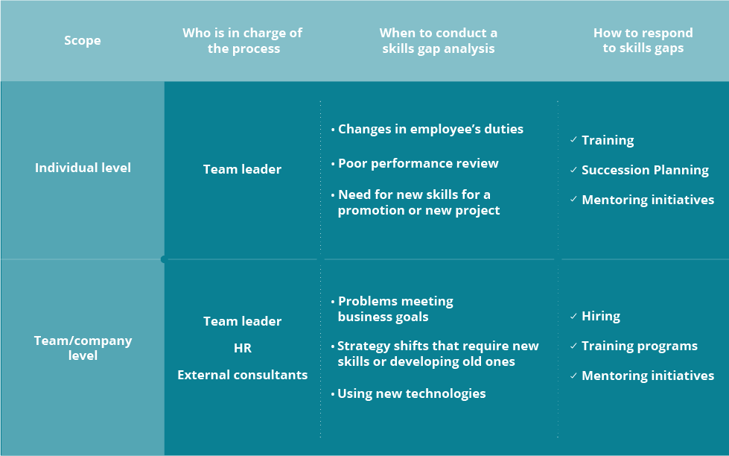
Fig: Skills gap analysis. (Source: resources.workable.com)

Use of techniques and methods that helps to increase efficiency and productivity of workplace
For economic growth of a company it is very essential to enhance the productivity of an organization. Technology in the last decade has eventually increased the feasibility of the processes within workplace and helped in creating an effective workforce (Margaryan et al, 2011). The uses of desktop computers and smartphones have changed the way we receive information and it has now been easier to receive information through these devices without even having to do much. With the advent of low cost sensors it is now become easier to perform data analytics and visualization tools to measure the efficiency of workplace. Effective communication is essential for efficiency at workplace hence there are many communication software’s that are helpful in connecting people in large business firms. For instance, video conferencing apps, team messengers etc. can make communication easier without having to step out of place. Slack method offers a large number of handy features that brings about team collaboration that includes group channels and direct messages, file sharing etc.
To be efficient at workplace is not just being good with technology but also with other skills that are essential for a workplace to work efficiently (Markos and Sridevi, 2010). For this, the employer must know the skills and talent of various employees and provide them with such tasks that they are capable of doing. Allotting them tasks that are out of their skills and reach might just disrupt the work as well as decrease productivity of that particular task. Communication is the key to make workforce work efficiently because it is important for employees to know what they are working for and what this is leading to. Technology has played a very important role in making communication easier and faster through various apps and devices. These devices increases the efficiency of workplace without having to actually talk to a person in person and just send across the message through these devices and put your message across.
Every company needs to have a goal that they are making their workforce work for without it the employees may not know what they are working for. If a goal is clearly defined then the employees may work towards it and help the company achieve the goal. Motivation is another key aspect that increases workplace efficiency because if the employees are not motivated they will not be able to do their work with full efficiency and this may lead to decrease in productivity of the company which is a loss to the company more than the employees. Motivation can be provided through appreciation letters, praising employees in public and also financially by providing them with incentives (Dede, 2010). This will keep the employees motivated and help them work harder towards the goal and make it achievable because their incentives are bound with it. Provide proper training to the employees and make them efficiently in their roles and duties otherwise this may backfire if proper training is not provided they might not know their duties and job well and might end messing up which will prove to be costly for the company. So it’s good that the training provided to fresher is taken into consideration and only when they are completely ready to be a part of the company they should start their work.

Effective interpretation of information
In today’s world information is on everybody’s fingertips but nobody knows if that information is to be trusted and is reliable or no. before using any kind of information from anywhere it is first important to judge if the information we received is reliable and right or no (Collins and Halverson, 2010). There are four basis sources of information where people find what they want i.e. library books, search engines, articles and reference sources but we do not know if the information received from the above sources is true and reliable.
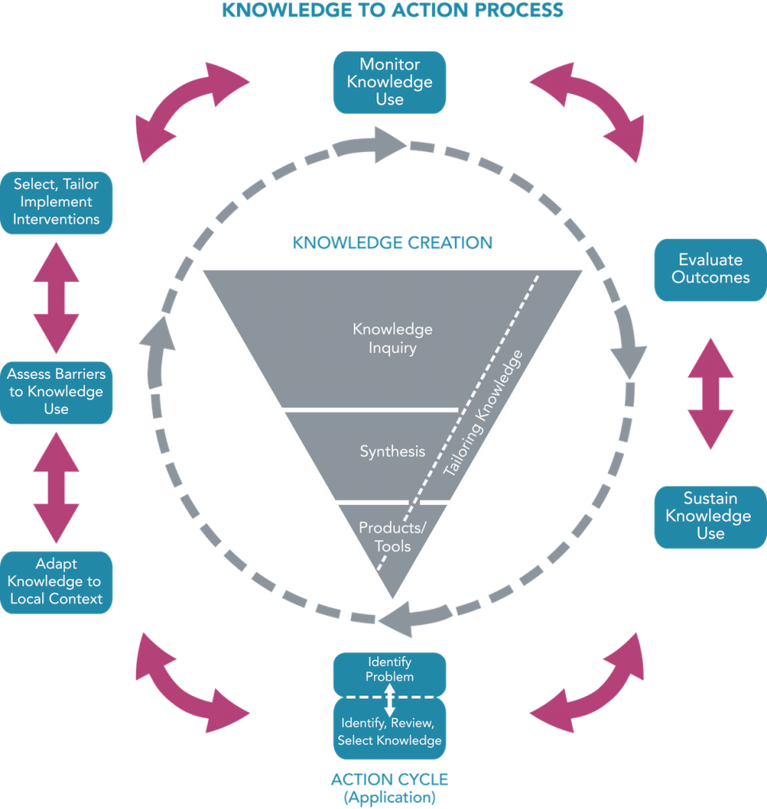
Fig: Knowledge creation. (Source: www.canchild.ca)

Proficiency in workplace data handling
Proficiency is a set of specific skills that an employee must have to be efficient at workplace and perform his tasks well. Proficiency within an employee towards work can only enhance productivity of an organization. To enhance the competence at workplace there are various things that an employee needs to efficient in. For example, active listening skills, effective communication, critical thinking, problem solving, team collaboration etc. the employee must be good enough in effectively listening to both verbal and non-verbal messages within workplace from his colleagues, peers, instructors etc. The employee must be effectively able to set out his thoughts both in writing and in presentation to the audience (Brajer-Marczak, 2014). The employee must also use effective use of language and tone to suit to different audiences and communicate to them through diverse channels like social media, e-mails and verbal communication. The employee must be able to explain himself in a coherent manner and should able be efficient in writing e-mails, letters, proposals etc.
The employee must also be proficient in critical thinking and problem solving process where he should be able to analyze issues and problems and solve them with critical thinking. He should be able to interpret knowledge, facts and data to resolve problems. He should be able to inculcate creativity and originality in the tasks with the help of new technologies available in today’s world. This could also be helpful for addressing other work challenges and apply computing sources and skills for problem solving at workplace.
While working in a team it is important to build collaborative relationships with other team members, colleagues, clients, staff members that represent various cultures, race, religion, place of origin, age, gender etc. The employee must be effectively able to blend with people of every kind and negotiate and work with them to achieve organizational goals (Bilenko and White, 2009). The employee needs to develop professional skills to work with efficient employees and supervisors support the strength of other employees to achieve common goals of the organization. Utilize interpersonal skills to coach and develop gain buy-in from others. Support the pool of talent with the organization and use it accordingly to achieve organizational goals. To make responsible decisions within the workplace with critical thinking and problem solving skills and take responsibility of decisions made by you and learns from mistakes done by you which will help you to avoid these mistakes in future. The employee must understand the data security and privacy issues at workplace and work accordingly within the business firm.
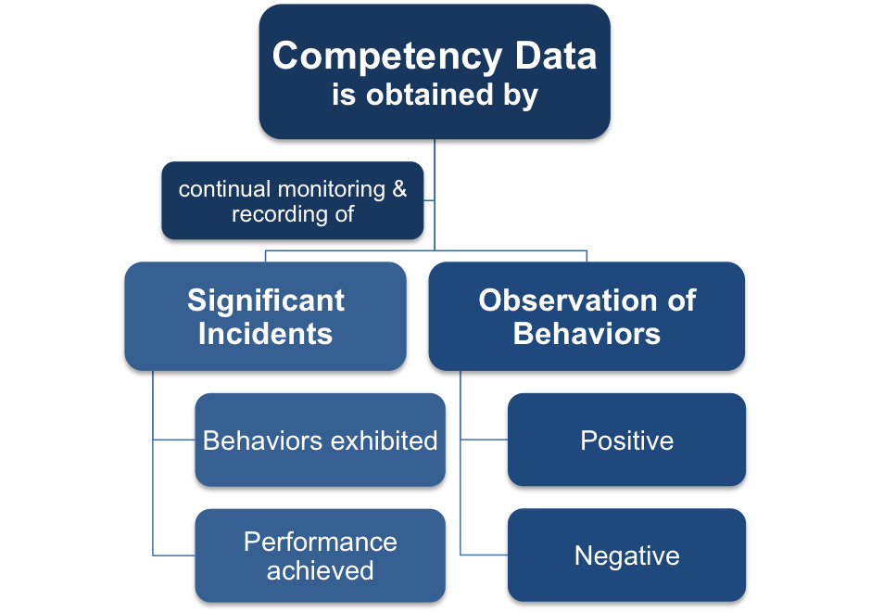
Fig: Competence data. (Source: http://www.free-management-ebooks.com)
The impact of proficiently working within a business environment can enhance the productivity of workplace for which the employees need to have an effective impact on workplace by communication effectively and showing skill, competencies, knowledge of the employee and their experiences.

Conclusion
Communication is a very important aspect of every workplace organization because without it flow of information is not possible. To communicate there are a lot of means these days that are provided to the employees with the use of technology. In this report, we have effectively discussed the digital skills required by an employee and its importance at workplace; we have also addressed the effective analysis of information and its translation into knowledge. The report has also discussed the proficiency of data handling at workplace and how it can enhance the productivity at workplace.

References
Bilenko, M. and White, R.W., Microsoft Corp, 2009. Identifying relevant information sources from user activity. U.S. Patent Application 12/057,491.
Brajer-Marczak, R., 2014. Employee engagement in continuous improvement of processes. Management, 18(2), pp.88-103.
Collins, A. and Halverson, R., 2010. The second educational revolution: Rethinking education in the age of technology. Journal of computer assisted learning, 26(1), pp.18-27.
Dede, C., 2010. Comparing frameworks for 21st century skills. 21st century skills: Rethinking how students learn, 20, pp.51-76.
Markos, S. and Sridevi, M.S., 2010. Employee engagement: The key to improving performance. International journal of business and management, 5(12), p.89.
Margaryan, A., Littlejohn, A. and Vojt, G., 2011. Are digital natives a myth or reality? University students’ use of digital technologies. Computers & education, 56(2), pp.429-440
Laihonen, H., Jääskeläinen, A., Lönnqvist, A. and Ruostela, J., 2012. Measuring the productivity impacts of new ways of working. Journal of Facilities Management, 10(2), pp.102-113.
Roehl, A., Reddy, S.L. and Shannon, G.J., 2013. The flipped classroom: An opportunity to engage millennial students through active learning strategies. Journal of Family & Consumer Sciences, 105(2), pp.44-49.
Säljö, R., 2010. Digital tools and challenges to institutional traditions of learning: technologies, social memory and the performative nature of learning. Journal of computer assisted learning, 26(1), pp.53-64.

Appendix
- Knowledge creation
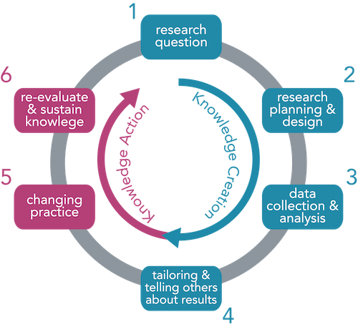
Fig: Interpretation of knowledge. (Source: www.canchild.ca)
- Digital age competency
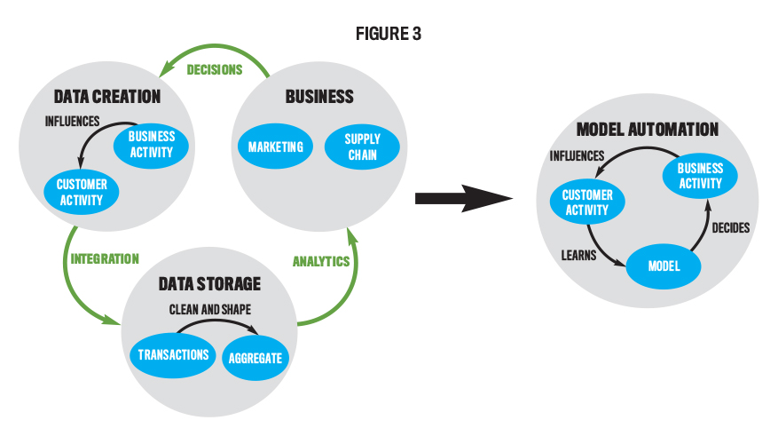
Fig: Digital age competency. (Source: sfmagazine.com)

