

Level 4
Module Code: EMPL4013 Pathway Project 1

An Improvement on Project Leadership Skill: A Case study of project management in developing country (Bangladesh)

Submitted
By
Student Name: Muhammed Gulzar Hossain (ID: 1604632)

Group Name: Muhammed Gulzar Hossain (ID: 1604632)
Md Faisal Ahamed Rana (ID: 1604528)

Table of Contents
10. Introduction 3
2.0 Sustainable development: 3
2.1 Globalisation 4
2.2 Impact of globalisation on project management 5
3.0 Leadership 5
3.1 Leadership theories 6
Great Man Theories 6
Trait Theories 6
Transformational Theory 6
Situational theory: 6
Contingency theory: 6
Transactional leadership: 7
Transformational theory: 7
3.2 Leadership traits and skills 7
Trait: 7
References: 9

10. Introduction
Leadership means the ability to lead a group or community towards a aim or goal. Leader must have the responsibility of developing the nation. The objective of this presentation is to assess the effect of sustainable environment and globalization, leadership and entrepreneurship and participation by the community by both locally and nationally on the potentiality and standard of the project work and performances of successful project in Bangladesh, a developing country.

2.0 Sustainable development:
Several definition of sustainable environment are available, but according to Mullins (2015) statement, without sacrificing the future generations capability of fulfilling their needs, fulfilling the need of present is called development. According to Torrington et al. (2014), the capability of an organization which evolves a plan of growth and development and keeps operating for ever is called development. According to Mullins (2015), based on the concepts of development project, there are different definitions present that are built upon the view and preferences of the stakeholders. In addition Mullins (2015) stated that, sustainability can be called as a system’s capability to undergo any situation and be active for long standing period. So a lively, essential, flexible and adaptive with the frequently changing time over a period can be considered as a “sustainable society”. According to Torrington et al. (2014) the definition of sustainability can be given as persisting of advantages of project after ending of the project period and prolongation of the local activities by the project, and amenity and activities by the descendants as an outcome of Project-built local capacity. The aim of sustainable development is to make strong the abilities and giving a environment where people can get opportunities.

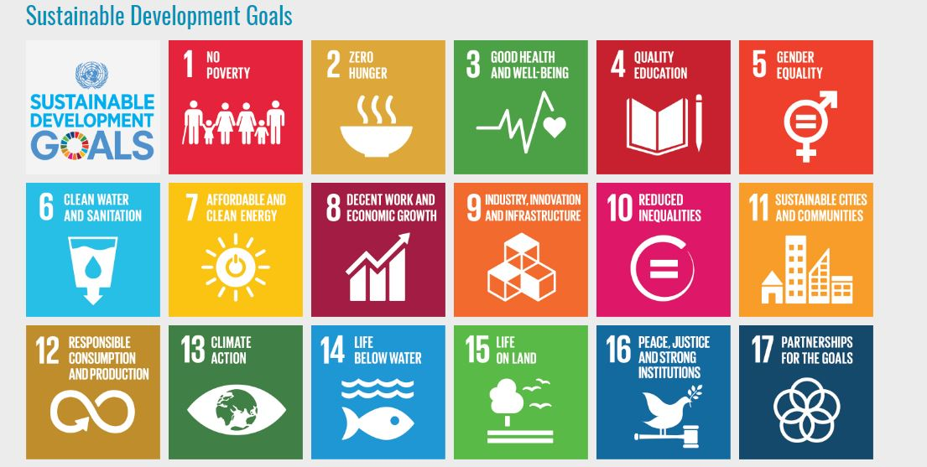
Diagram: sustainable development goals Source: Torrington et al. (2014)
The above diagram shows that there are 17 goals of sustainable development. They are: a) no poverty; b) zero hunger, c) good health and well being, d) quality education, e) gender equality, f) clean water and sanitation, g) affordable and clean energy, h) decent work and economic growth, i) industry, innovation and infrastructure, j) reduced inequalities, k) sustainable cities and communities, l) responsible consumption and production, m) climate action, n) life below water, o) peace, justice and strong industries, p) partnership for the goals.

2.1 Globalisation
Propensity of the firms to expand their business all over the world is called globalization. At the level the globalization occurred in recent years is extraordinary. To increase the competition level in international level, the impact of globalization is very significant. The business companies that only competed in the local area with local opponents, now they have to encounter challenges from the competitors all over the world. According to Ghoshal (1987), penetrable international borders and capital’s trans-border movement gave rise to constant spread of projects that are multicultural in nature. In short, globalization has given a new dimension to the business through which people all over the world are connected and can do the activities involving development together. Globalization has great impact on the modern trade system and socialization.

2.2 Impact of globalisation on project management
To have the success of projects that are international, there are some significant factors figured by the researchers which guide the outcomes of the projects, they are:
- Cultural issues: cultural issues have effect on the international projects as the project enters into a multicultural environment.
- Legal issues: rules and regulations differ from country to country. As the project activities will be international is it important to be conscious about the legal issues internationally.
- Political issues: as there are influences of politics in every sector and every country, for globalization political issue must be in concern of the operator of the project.
- Economical issues: to achieve the success in the international projects, economical issue have great significance in the process of project management.
- Environmental issues: depending on the diversity of the environments of countries all over the world, the business approach and the strategies of selling will be set.
- Technological issues: depending on the technological development of the country the project strategy will be decided, because the plans of business in the countries where the technology is very developed and the country where the technology is under developed not so advanced, will vary significantly.

3.0 Leadership
Leadership means leading and encouraging the followers to perform for achieving the target of any organization or project. According to John (2014), recognizing own capability, having a perception of creating a compelling relation between the members and ability to take effective actions which leads the member toward the goal is called leadership. Leadership is significant feature for earning a positive outcome from a task. Leaders help other to do the correct things. They give direction and guide others and create new vision of motivation in others. Leadership is outlining the strategy where all need to win as team.

3.1 Leadership theories

Great Man Theories
According to John (2014), extraordinary people who have inhabitant qualities and fated to lead the others is called leader. In addition, John (2014) said, in the Great Man theories the term man was deliberate, the context of the theory was about male, military and western.

Trait Theories
According to John (2014) notes, trait or features of a leader’s leadership are countless. The measurement process of the traits is complicated, like is there any way to measure the level of honesty or integrity?

Transformational Theory
As Mullins (2015) stated that, the responsibility of a leader is to motivate individual, gain faith and inspire innovation and self growth. By the motivation from the leader every subordinate grows a perception of a motive to render services to group, society or organization, and these services are beyond self interests. The members are motivated to give services for bigger interests in exchange of recompense or appreciation for their attempt or faithfulness.

Situational theory:
According to John (2014) in this theory the leadership is based on a specific situation. Like some situation need autocratic style and some situation demands more participation. In same organization different segment will need different leadership traits.

Contingency theory:
John (2014) said that, this is revised situational theory and here identification of the situational variable is focused mainly. Here the authentic leadership is clarified according to demand of situation.

Transactional leadership:
According to John (2014) statement, this theory gives importance to the relationship between the leader and the subordinates. A combined decision from the leader and follower is taken and leader gives reward or appreciation to the followers for their performance, participation and loyalty.

Transformational theory:
The main concept of the theory is altered and visualized and applied in the transformational organization performances.

3.2 Leadership traits and skills
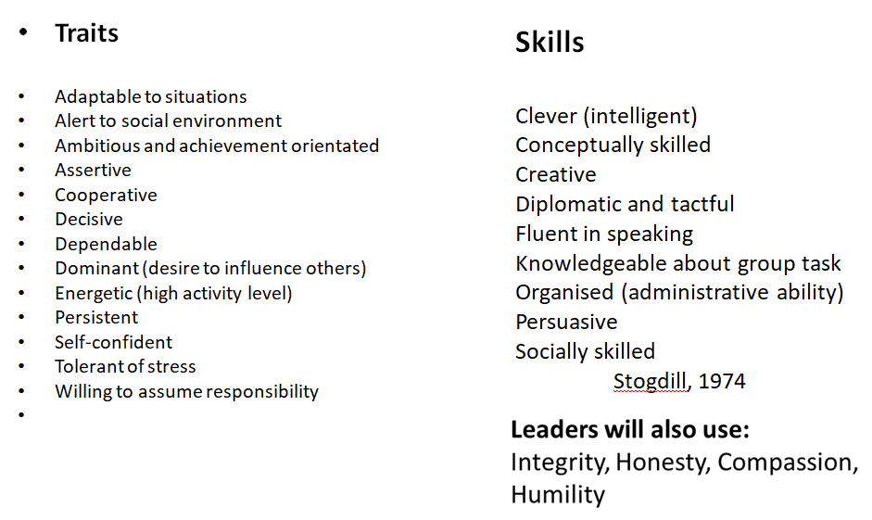
Diagram: leadership traits and skills source: Stogdill (1974)
The diagram above evaluates the traits and skill a leader must have and they are:

Trait:
- Adaptable to situation: a leader must be adaptable with any kind of situation which can either positive or negative. They must have the quality to adjust themselves with with any circumstance coming in the road of project or service and be always ready to face any challenges coming towards the goal.
- Alert to social environment: they must be alert and conscious about the social environment. Any issues with the society must be known by the leader and they must be prepared to render any services they can provide under their ability.
- Ambitious and achievement oriented: a significant feature of a leader is ambitious and achievement oriented. If the leader is ambitious enough they will be able to motivate the members as well towards the goal. And the task will become very easy to be done.
- Assertive: the leader must be always assertive about the situation either it is in their favor or not. The positivity of the leader will create strong motivation in the members and they will able to face any kind of difficulty they face in the path of their activity.
- Co operative: leader must be co operative with the juniors. Leader should be easy going and helpful with the members and should come forward in any situation where the people need their leader.
- Decisive: a leader must be able to make decision quickly and precisely in any kind of situation.

References:
Hesselbein, F. a. (2013) Leader to Leader. San Francisco, CA: Jossey-Bass Publishers.
Hughes, R. G. (2013) Leadership: Enhancing the lessons of experience . Boston: Irwin.
John, A. (2014) Leadership and Motivation. 3rd Ed. Harlow: Kogan Page Publishers, Inc
McShane, S. and Glinow, M. (2013) Organizational behavior. Boston: McGraw Hill
Mullins, J. (2015) Management and Organizational Behavior. 8th Ed. London: Pearson Education Limited
Kotler et al. (2014) Principle of Marketing. 8th Ed. London: Pearson
Northouse, P. G. (2011) Leadership Theory and Practice, second edition. Thousand Oaks, CA: Sage Publications, Inc.

