
Fatimah Choudhry
Student ID: 2012893
Lecturer: Koushik Modak
Module Code: BMW4003
DSR Assessment 2 – Individual Report
ID
The Impact of Virtual Learning Environment (VLE) – Moodle on students’ learning experience at the University of Wales Trinity Saint David London Campus

Digital Skills and Research Methods



Contents
Introduction 2
Rationale 3
Research Objectives 3
Literature Review 4
Summary of Literature Review Findings- Secondary Data Analysis 5
Research Method and Methodology 6
Qualitative, Quantitative and Combined Approach 6
Data and Data Collection Process 6
Population, Sample and Sample Size 6
Ethics in Data Collection 7
Results/Findings, Analysis and Discussion 7
Primary Data Analysis 7
Conclusion 14
References 15
BHANDARI, P. (2020) Population vs sample: What’s the difference? [Online] Scribrr. Available from: https://www.scribbr.com/methodology/population-vs-sample/ [Accessed 25/12/20]. 15
Appendices 17
Appendix 1 (Questionnaire) 17
Appendix 2 (Table of Results) 20

Introduction

“A Virtual Learning Environment (VLE) is a web based software system designed to facilitate learning and teaching with the use of tools and activities.” (Barker, J. et al, 2013). It is used within all educational sectors and workplaces. A virtual learning environment provides access to resources. Not only is a virtual learning environment vital for students but is equally important to be of a high standard for teaching too. The VLE platform used at the University of Wales Trinity Saint David is Moodle. “Moodle is used for blended learning, distance education, flipped classroom and other e-learning projects in schools, universities, workplaces and other sectors.” (Wikipedia, 2020)

Rationale

The digital world of learning is growing rapidly, since Moodle was originally released 18 years ago. This is due to students being limited to little face-to-face time with their lecturers, as they have many duties to fulfill, with countless increasing responsibilities towards teaching. Hence, spending more time researching and planning to enhance teaching (Chetwynd, A., 2017). Due to lack of communication, the impact on students’ level of understanding had to be addressed as their learning was suffering. This was why it was vital the structure of learning was revised and why Moodle was developed. To save time for lecturers and students, enhance the education system and adhere to today’s modern digital world.

Research Objectives

The key aims and objectives of this report are to be analysing primary and secondary data, to investigate if this (VLE) Moodle has a positive or negative impact on the students’ learning at University of Wales Trinity Saint David London Campus, while determining the effectiveness, understanding and level of accessibility for students independent learning through the use of Moodle. This will be achieved by reviewing existing literature, conducting a survey, presenting the survey results in graphs, analysing and concluding.

Literature Review

Throughout this literature review five different articles about VLEs by various authors will be analysed.

“The use of virtual learning environments and their impact on academic performance” (Demian P., et al, 2015). In this report the authors research lecture attendance and academic performance. The methodology used was firstly through the VLE usage logs of students, from a sample size of 54. The second data collection process was from a sample size of 2, one female, one male, who were both interviewed. Overall, the VLE wasn’t effective for the students in the Geotechnics 3 module as they used the VLE too little for it to have enough effect on their academic performance, in comparison to their performance in Design Project.
“Virtual learning environments – help or hindrance for the ‘disengaged’ student?” (Maltby A., et al, 2016) The research conducted for this report was on a much larger sample size, and its main focus was on how to help improve disengaged students. The methodology used was over terms 1 and 2, through tracking statistics of when students logged on to use the VLE. Also, questionnaires and emails were sent to the disengaged users, along with letters and a second questionnaire in term 2. Overall the VLE was a positive tool for ‘model’ learners, and had a negative affect on ‘disengaged’ users.
“The Learning Impact of a Virtual Learning Environment: Students views” (Barker J., et al, 2013). The literature was reviewed (secondary data analysis), and a primary data questionnaire was conducted through a large sample size of 248-second year students. Overall, the authors concluded that VLEs are effective, as it increased the students’ motivation to learn.

“Evaluation of How the Blended Use of a Virtual Learning Environment (VLE) Can Impact on Learning and Teaching in a Specific Module” (Lyndon S. et al, 2015). 47 Students participated in this study through the methodology of a questionnaire, Moodle reports and analysis of the assessments, to find the positive effects of online forums. Overall, the findings in this research highlighted that VLEs and online forums should be used to enhance students learning, communication and collaboration.

“VLE based Analysis and Design” (Chetwynd A., 2017). This report extensively researched a sample size of twelve Civil Engineering students who were taught Structural Analysis and Design and being restricted to learn during lectures due to lack of time. The hypothesis made was that a VLE would enable these students studying this subject to allow them to have more time to research, communicate better with lecturers and have access to further materials to explore on a VLE. A VLE prototype was developed successfully to finally conclude that VLEs were essential in enhancing the students, through a blended learning style of 30-70% online and further teaching through face to face.

Summary of Literature Review Findings- Secondary Data Analysis

To summarise, most literature reviewed supports the use of VLE for students. However, VLE has little impact on academic performance in the report by (Demian P., et al, 2015), due to the fact, research was conducted in 2009/2010 and technology has developed immensely since the past 9-10 years.

Overall, the remaining literature had a positive impact on students learning in various ways. It is visible the research conducted in this report correlates with the findings, especially in comparison to (Maltby A., et al, 2016). Maltby’s findings correlate with graphs produced in this report, (Q.9) as 20 students felt they understood the functionality of Moodle, helping them become independent learners. Below is a graph created by (Malby A., et al, 2016), showing the more students, who used the VLE, scored higher grades.
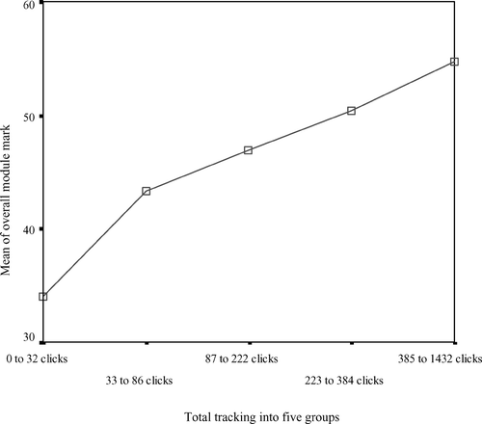

(Maltby A., et al, 2016)

Research Method and Methodology

Qualitative, Quantitative and Combined Approach

“Quantitative data is information about quantities, and therefore numbers, and qualitative data is descriptive, and regards phenomenon which can be observed but not measured, such as language” (McLeod, S., 2019). Combined Approach are both quantitative and qualitative data, first collated separately, and then combined, to interpret and conclude.

For the purpose of this report, the methodology used was through conducting qualitative data research through a survey on 23 students at UWTSD. The data obtained from the population showed the understanding of their experiences using Moodle. From the data collated, it was analysed further by using a combined approach and further developing the primary data into quantitative statistical data of the population by producing a table of results, a combination of some pie charts and some bar graphs showing the observations of results into quantities.

Data and Data Collection Process

“Primary data is information collected through original or first-hand research. For example, surveys and focus group discussions. Secondary data is information which has been collected in the past by someone else. For example, researching the internet, newspaper articles and company reports.” (Channelplay, 2020)

The method used was through conducting a questionnaire, which is primary qualitative data that consisted of a wide range of questions; close-ended, open-ended questions, rating scale questions, likert-scale questions. Then the questionnaires were all filled out online by 23 out of 28 students, analysed and the results table was made, from which the graphs were created. To find the conclusion, secondary data was also reviewed and analysed.

Population, Sample and Sample Size

“A population is the entire group that you want to draw conclusions about. A sample is the specific group that you will collect data from. The size of the sample is always less than the total size of the population.” (Bhandari, P., 2020). “The sample size is a subset, an extract, several persons extracted from that population.” (Omniconvert, 2020)

The population group researched were from the 200 million users of Moodle. “With more than 200 million users, we are the world’s most trusted LMS.” (Moodle, 2020) From the data collated during 2019-2020, the total number of students studying at UWTSD London Campus, is approximately 2,250 (University of Wales Trinity Saint David, 2020). Therefore, according to the focus research, this was the sample number in question. The sample size targeted were the total number of students studying in Group 2, Health and Social Care at the London Campus, UWTSD, with a total number of 28 students in this subset. The expected respondents sample proportion was 20, however the sample size that did respond was altogether 23.

Ethics in Data Collection

(Danvers, E. et al, 2008) explained how it was vital for all following ethical issues to be taken into consideration: Information gathered should not contain personal information and remain anonymous to protect participants’ confidentiality, the participant should be asked for consent to use their answers for research purposes. All data should be used according to Data Protection Act 2018 where the United Kingdom Act of Parliament stated they would protect all personal data by implementing the General Data Protection Regulation (GDPR), (Gov.UK, 2020).

Results/Findings, Analysis and Discussion

Primary Data Analysis

For the purpose of this research project, a total of 10 questions were composed for the sample size of 28 students’ at UWTSD in qualitative data. Following, the results will be shown as quantitative data in two different graph forms. Each primary data displayed will follow an analysis.

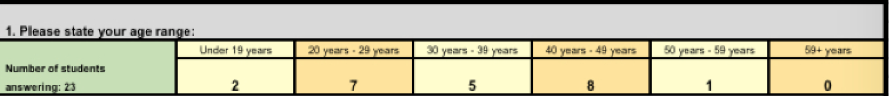

Q.1) Graph Analysis: The age ranges in the sample size subset were ranging from under 19-59 years old. The highest age ranges were between ranges of 40-49 at 35%, 8 people. The next highest percentage of 30% was 7 people between ages 20-29. The ages were investigated to research if age was a factor of limitation to understand the uses of Moodle.

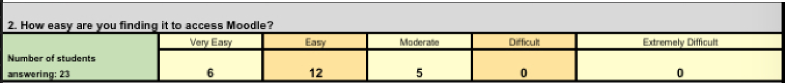

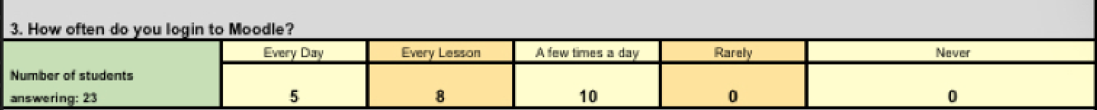
Q.2) Graph Analysis: The likert-scale option with the highest score was “Easy”, with 12 people, that’s 52% who found it easy to access Moodle. This shows the lesson where the class was taught how to access Moodle in the induction was effective. Overall, nobody found it difficult to access Moodle.

Q.3) Graph Analysis: This likert-scale question shows that the students are confident at logging in to use Moodle as 10 people (43%) are able to login a few times a day, and the least amount of times that people are logging in is every lesson, at a minimum of twice a week, is 8 people (35%). This shows that using VLE is an essential tool for a student at UWTSD.

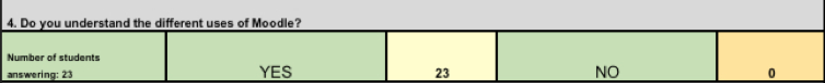

Q.4: Graph Analysis: All 23 of the sample size (100%) said they understood the different uses of Moodle. I left this question as an open ended question, for students to state if ‘no’ then to state difficulties. However, perhaps this question was ambiguous as according to questions 6 and 9, at least 3 students are experiencing difficulties. Therefore I feel this questions findings are inconclusive.

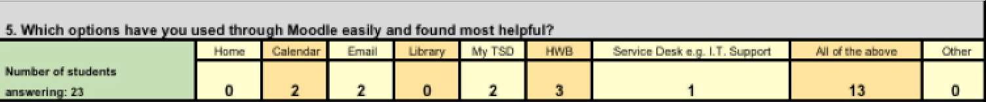

Q.5) Graph Analysis: The most selected option found here in this multiple-choice question was that ‘all of the above’ (56%) were used through Moodle; this also shows that students’ have been using all of the features of Moodle extensively.

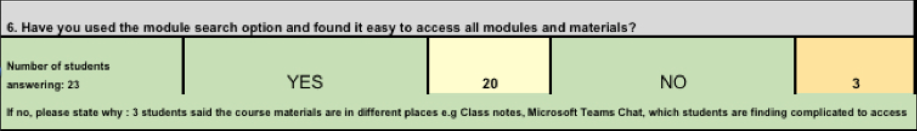

Q.6) Graph Analysis: 20 (87%) of the students have used the module search option to access the modules and materials. 3 students (13%) weren’t able to use this option. This question was left open ended for students who couldn’t access the modules or materials. All 3 students said that due to the materials being in different places, they are finding the materials complicated to access. However, the majority who understand how to use Moodle are definitely finding access to the materials helpful.

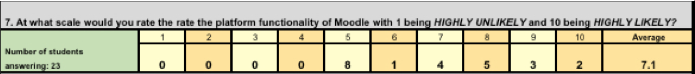
Q.7 Graph Analysis: This rating scale question shows that 8 people (35%) were the highest number of people who rated the scale number 5. 5 out of 10, shows that students feel moderate about the functionality of Moodle.

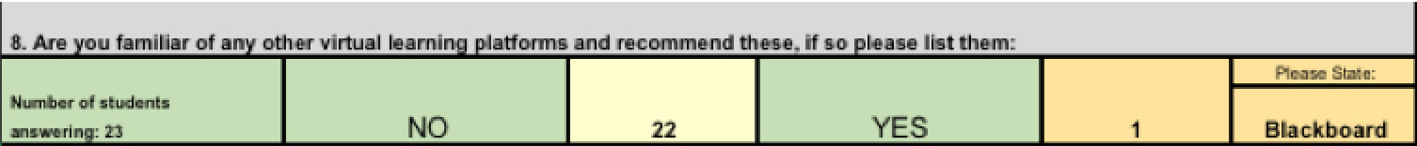

Q.8) Graph Analysis: As the highest rating was 5, by the majority of students in question 7, for the functionality of Moodle, I would have thought that students may be comparing the use of Moodle with another VLE, they may have experiences with. However, in Q.8 only one person knew of another VLE, called Blackboard and recommended this VLE in comparison with Moodle. According to Scavicchio, “both VLEs are often the two LMS front runners for companies and both have a lot in common”, however in comparison Blackboard appears to be more widely used not only in learning environments but in businesses and government agencies as well (Scavicchio, 2017).

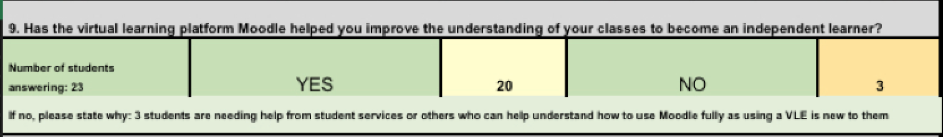

Q.9) Graph Analysis: 87% of students (20) have learnt to understand their lessons better and become independent learners. Moodle has many features that help the students feel like they are in control of their learning. 3 Students, have said that Moodle hasn’t helped them with their learning. Leaving this question open ended, if answered no, was to have clarity of why. I noticed all 3 of these students were of an older age, as they came under the age categories of 50-59 and 40-49. Age may be a factor for them, as they may have had limited access to computers compared to others of younger ages.

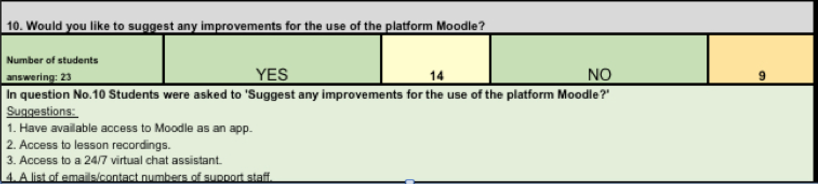

Q.10) Graph Analysis: This was another open-ended question, 14 students suggestions were recorded in the table above. These suggest that the majority of students understood the use of Moodle, and were pleased with the functions, but were interested in improving it, to enhance their learning.
Summary of Findings

The report shows Moodle has become an essential tool for every student’s successful learning at UWTSD London Campus, due to key factors like saving time: through submitting work, communicating through Moodle. Students made positive suggestions. I believe, Moodle has certainly achieved it’s mission stated: “The mission of the Moodle project is to empower educators to improve our world by building the most efficient platform for teaching, learning and collaborating online.” (Moodle, 2020)

Conclusion

Overall, the conclusions drawn are that blended learning (face to face and online learning) is an effective method, as although the majority of students were satisfied with Moodle, there was a small minority of 13% who were unsatisfied with certain aspects of understanding it. Also, the method of blended learning caters for all aged students from different social and cultural backgrounds.

People from different backgrounds could have had an impact on students learning experience through Moodle, as participants who experienced difficulties, were from other countries, therefore English was recognised to be their second language.
If this project was to be extended, I recommend qualitative data to be collected further by conducting an interview on students, from different social and cultural backgrounds. If tracked throughout the remaining two terms and supported, I predict results would show they would also achieve higher.

References
BARKER, J. and GOSSMAN, P. (2013) The Learning Impact of a Virtual Learning Environment: Students’ Views. [Online]. Available at:
https://core.ac.uk/download/pdf/29422368.pdf [Accessed 22/12/20].

BHANDARI, P. (2020) Population vs sample: What’s the difference? [Online] Scribrr. Available at: https://www.scribbr.com/methodology/population-vs-sample/ [Accessed 25/12/20].
CHANNEL PLAY. (n.d.) What is Primary and Secondary Data in Market Research? [Online] Channel Play. Available at: https://www.channelplay.in/india/resources/glossary/what-is-primary-and-secondary-data-in-market-research [Accessed 27/12/20].

CHETWYND, A. (2017) VLE based analysis and design. [Online] University of Plymouth. Available at: https://pearl.plymouth.ac.uk/bitstream/handle/10026.1/14141/TPSS-2017-Vol10n1_102-142Chetwynd.pdf?sequence=1&isAllowed=y [Accessed 22/12/20].

DAMIAN, P. and MORRICE, J. (2015) The use of virtual learning environments and their impact on academic performance, A Journal of the Higher Education Academy, Vol 7, No 1, pp11-19. Available at: https://www.tandfonline.com/doi/full/10.11120/ened.2012.07010011 [Accessed 27/12/20].

DANVERS, E. and DESAI, R. (2008) Ethical considerations for data collection and research tools. [Online]. Available at: https://study.cardiffmet.ac.uk/AcSkills/Documents/Research/Research_Ethics_elesson/page_22.htm [Accessed 26/12/20].

DJURDJEVIC, I., MOGUS, M. A. and SUVAK, N. (2012) The impact of student activity in a virtual learning environment on their final mark. [Online] SAGE Journals. Available at: https://journals.sagepub.com/doi/full/10.1177/1469787412452985 [Accessed 30/12/20].

GOV.UK. (n.d.) Data Protection. [Online] GOV.UK. Available at: https://www.gov.uk/data-protection [Accessed 26/12/20].
MACKIE, S. and MALTBY, A. (2016) Virtual learning environments – help or hindrance for the ‘disengaged’ student? Research in Learning Technology, Vol 17, No 1, pp49-62. Available at: https://www.tandfonline.com/doi/full/10.1080/09687760802657577?src=recsys [Accessed 27/12/20].

MCLEOD, S. (2019) What’s the difference between qualitative and quantitative research? [Online] Simply Psychology. Available at: https://www.simplypsychology.org/qualitative-quantitative.html [Accessed 25/12/20].

MOODLE. (n.d.) About Moodle. [Online] Moodle. Available at: https://moodle.com/about/ [Accessed 20/12/20].

OMNICONVERT. (n.d.) Sample Size. [Online] Omniconvert. Available at: https://www.omniconvert.com/what-is/sample-size/ [Accessed 25/12/20].
SCAVICCHIO, J. (2017) Blackboard vs Moodle: Comparing Features, Costs and Services. [Online] Better Buys. Available at: https://www.betterbuys.com/lms/blackboard-vs-moodle/ [Accessed 29/12/20].

TEACHING HUB. (n.d) Moodle VLE. [Online] Teaching Hub. Available at: https://teachinghub.bath.ac.uk/tools-and-resources/tel/moodle-vle/ [Accessed 25/12/20].

WIKIPEDIA. (2020) University of Wales Trinity Saint David. [Online] Wikipedia. Available at: https://en.wikipedia.org/wiki/University_of_Wales_Trinity_Saint_David [Accessed 25/12/20].

Appendices

Appendix 1 (Questionnaire)
In-Class exercise: Questionnaire Design
Student Name: Fatimah Choudhry
Student ID: 2012893@student.uwtsd.ac.uk
Module Name: Digital Skills and Research Methods (H&SC) Term 1 Group: 2

Aim: This exercise is aimed to help you in your questionnaire design. Please note, you need to use this questionnaire to conduct a survey, which is also one of the important parts of your research report.

Please write down your questions that you are going to use in your primary data collection. Try to have different types of questions such as close-ended question, open ended question, multiple choice question, Likert-scale question.

The Impact of Virtual Learning Environment on Students’ Learning Experience at UWTSD London Campus

Please mark and complete the relevant answers.

Question 1: Please state your age range:

- Under 19 years
- 20 years – 29 years
- 30 years – 39 years
- 40 years – 49 years
- 50 years – 59 years
- 59+ years
Question 2: How easy are you finding it to access Moodle?
- Very Easy
- Easy
- Moderate
- Difficult
- Extremely Difficult
Question 3: How often do you login into the Moodle?
- Every day
- Every lesson
- A few times a week
- Rarely
- Never
Question 4: Do you understand the different uses of Moodle?
- Yes
- No
If no, please state your difficulties: ____________________________________________________________________________________________________________________________

Question 5: Which options have you used through Moodle easily and found most helpful?
- Home
- Calendar
- Email
- Library
- My TSD
- HWB
- Service Desk e.g I.T Support
- All of the Above
- Other. Please specify ________________________________________________________
Question 6: Have you used the Module search option and found it easy to access all modules and materials?
- Yes
- No
If no, please state your difficulties: ______________________________________________________________
Question 7: At what scale would you rate the platform functionality of Moodle with 1 being highly unlikely and 10 being highly likely?
1, 2, 3, 4, 5, 6, 7, 8, 9, 10
Question 8: Are you familiar of any other platforms and recommend these, if so please list them.
- No
- Yes ___________________________________________________________
Question 9: Has the virtual learning platform Moodle helped you improve the understanding of your lessons to become an independent learner?
- Yes
- No
If no, please state why: ______________________________________________________________
Question 10: Would you like to suggest any improvements for the use of the platform Moodle?
- No
- Yes_______________________________________________________

Thank you very much for your kind co-operation.

Appendix 2 (Table of Results)


