Appendices

Appendix 1: Research Lesson Observation Sheets

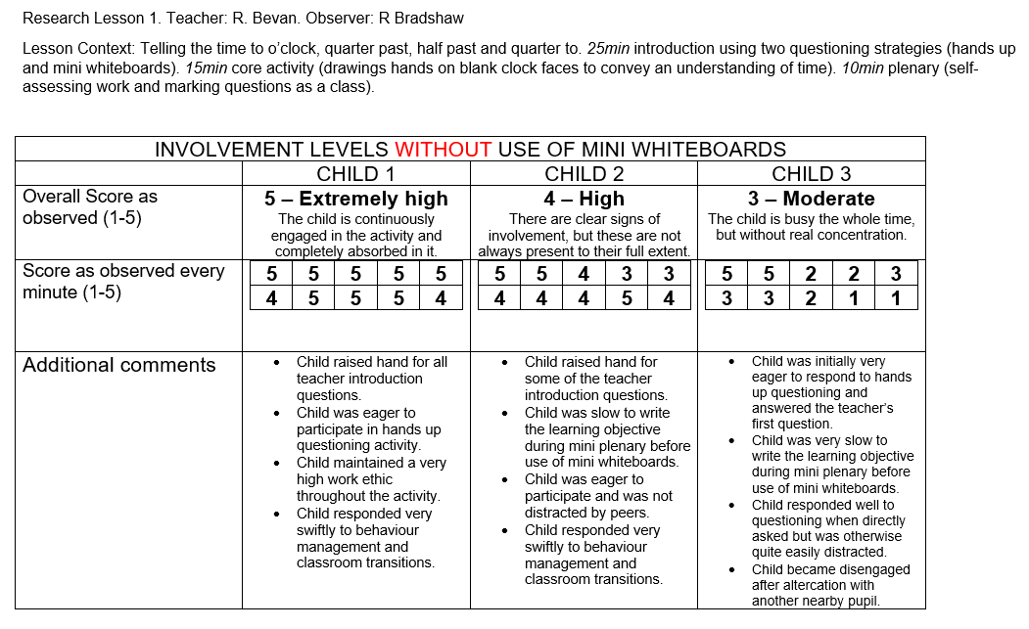
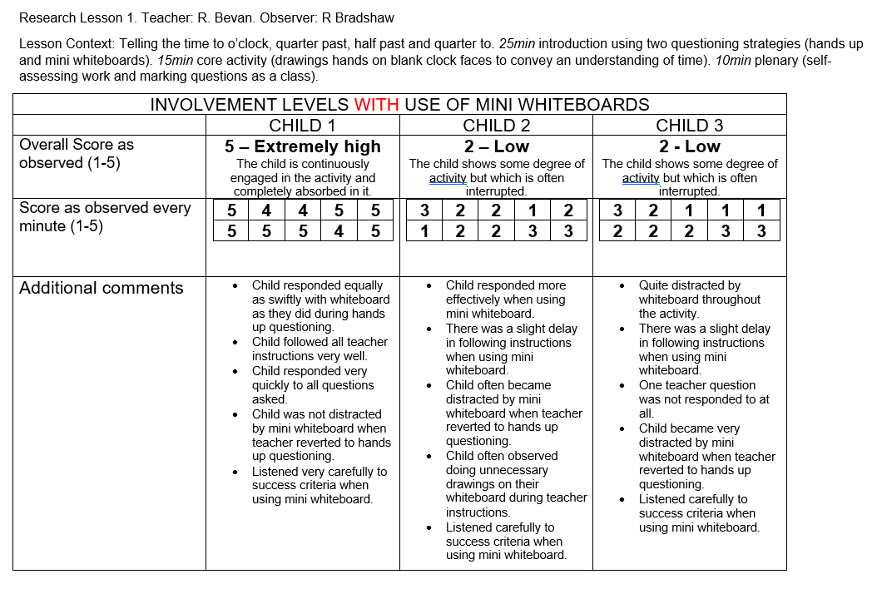
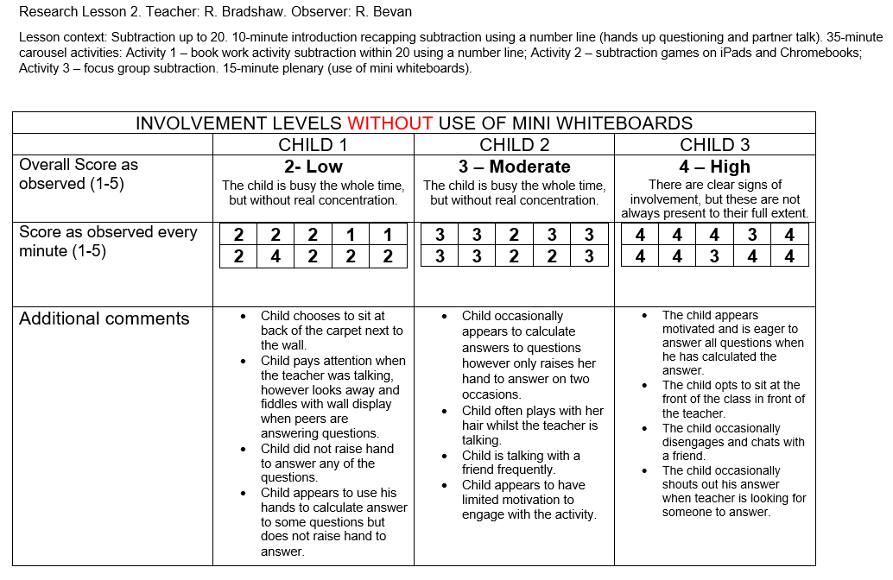
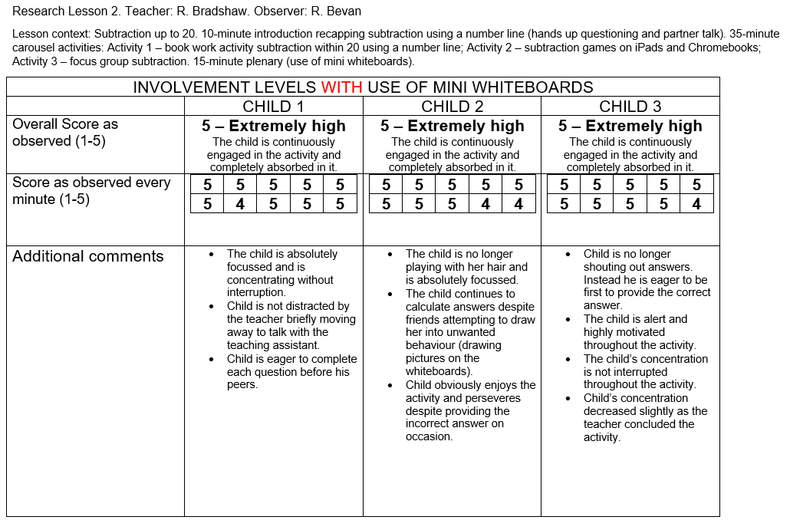
Appendix 2: Post Research Lesson Reflections Using a Reflection Proforma Adapted from Gibbs (1988).

Research Lesson 1
Teacher: Mr Bevan. Observer: Mr Bradshaw.
Classroom context: Year 3, 30 pupils, 1 teacher, 1 teaching assistant, 1 observer.
Lesson context: Telling the time to o’clock. 25 minute introduction using two questioning strategies (hands up and mini-whiteboards). 15 minute activity (drawing hands on blank clock faces to convey an understanding of telling the time). 10 minute plenary (self assessing work and going through the 6 activity questions as a whole class).
Reflection key:
- Teacher
- Observer

Description
What happened in the lesson?
The pupils provided a range of answers during the opening APK questioning activity that served as a scaffold for advancing learning throughout the lesson. The pupils appeared to enjoy the various questioning strategies used and the information shared contributed to them completing the core lesson activity at swift pace. It was evident when comparing answers provided during the plenary to answers provided during the opening phase of the lesson that learning had advanced amongst most pupils in the class.
What were the lesson objectives?
The lesson objectives were to advance the pupils understanding of how to tell the time, specifically focusing on o’clock, quarter past, half past and quarter to.
When and where did it happen?
The lesson happened in a Year 3 class on 3rd February 2020 between 11.10 am and 12.20am. This lesson was in between the pupils’ morning break time and lunch time.
Who was involved?
There were 30 pupils present in the class. All pupils were at their tables for the whole class introduction. Four pupils from the lower ability group were taken by the teaching assistant after the introduction finished to work separately at the other end of the classroom. In total there was 1 teacher, 1 teaching assistant and 1 observer present in the classroom.

Feelings
How did I feel before the lesson?
Before the lesson I did not feel any differently compared to how I felt during previous lessons taught in recent weeks during PTE Part 2. I knew my lesson had been planned comprehensively and that all resources were ready.
How did I feel during the lesson?
During the lesson’s questioning activities, I felt I was focusing on the behaviour and involvement of the three pupils highlighted for observation more so compared to previous lessons where such a research project was not taking place. This may have affected how frequently or infrequently I chose those three pupils to answer questions during the hands up questioning activity.
How do I feel after the lesson?
After the lesson I feel that the lesson successfully advanced the pupils’ learning and the learning objective was achieved. I feel that Child 3 behaved abnormally during the opening phase of the lesson as he knew he was being observed by my research partner. This suggests elements of the Hawthorne Effect were acting upon Child 3.

Evaluation
What went well during the lesson?
Pupils completed their assigned tasks to a high standard, remembering to adhere to the success criteria laid out at the start of the lesson. The use of the mini-whiteboards served as a whole class assessment for learning tool, helping me identify that numerous pupils were struggling with the ‘quarter to’ questions. This enabled me to pause the questioning activity, readdress how to read a clock at quarter to and then continue with the questioning activity, reengaging those pupils who had previously become disinterested due to having difficulty with some of the questions.
Most pupils were fully engaged throughout the entirety of the lesson. The teacher’s initial introduction was very well responded to and all pupils complete the core lesson activity. Pupil behaviour was, overall, very positive and enough time was designated to a sound plenary.
What did not go as well during the lesson?
During the opening phase questioning activities, a hands up questioning strategy was used initially. This was followed by a mini-whiteboard questioning activity. Following the mini-whiteboard activity, I reverted back to asking for hands up to answer the remaining questions. During this final questioning activity, it was evident many pupils were distracted by the mini whiteboards and pens now on their desk, and levels of unwanted behaviour increased.
After reverting back to hands up questioning, some pupils became distracted by the mini whiteboards and this produced less whole class engagement, as was observed during the introductory activities. While the planned plenary was sound, the teacher decided to split the class for separate plenaries, and this served to raise noise levels and create fussiness.
What did I contribute towards the lesson?
I contributed the differentiated resources used amongst the groups for the core lesson activities. The behaviour management strategies I implemented helped ensure there was an acceptable level of noise in the classroom which contributed towards pupils being able to complete their work with minimal distractions.
I maintained a non-participant approach throughout and sought to provide sound analysis of the focus group pupils’ involvement levels, with and without the use of mini whiteboards. During the planning meeting prior to the lesson, I advised that the number of questions during the questioning activities be reduced.
Did your observer have an effect on the lesson?
I feel the observer did have an effect on the lesson. Child 3 had been asking in the days preceding the research study about when it was taking place. It is evident that this lesson was on his mind leading up to the observation. In addition, when in the class during the observation, Child 3 exhibited unusually excellent behaviour during the opening phase of the lesson. Child 3 would occasionally turn to look at the observer, again suggesting the observer was having an effect on the lesson. This is evidence of the Hawthorne Effect. Once the questioning activities were over, the observer actively participated within the lesson, assisting one group of pupils with the core lesson activity. This had a positive effect on their learning, as I would not have been able to spend as much time supporting that group of pupils myself.

Analysis
Why were some aspects of the lesson successful?
The first hand up questioning was successful as pupils enjoyed recalling what they had learnt the previous day. Many pupils evidently felt proud when answering questions and the praise I was distributing helped encourage others to answer. The mini whiteboard activity was successful as this is an infrequent activity within the classroom, occurring only every few weeks. Therefore, pupils always show excitement when they are told to take a mini whiteboard and pen. The core activities were successful as they were differentiated to ensure all pupils in the class were adequately challenged but also provided the opportunity to show ambition and exceed what was expected of them during the lesson.
The introduction was successful as the teacher ensured they had the full attention of the class before delivering it. The introductory activities were also successful because of the use of an example clock; the pupils enjoyed having something tangible to work with and this was reflected in their high level of engagement during this activity. The mini whiteboards section of the lesson was also successful, in that it raised engagement levels with regards to answering questions more quickly and accurately. The core activities were successful as they provided all pupils with a sufficient amount of work to complete in the time given.
Why were other aspects of the lesson less successful?
The third questioning exercise, where the answering strategy reverted to using a hands up approach was less successful as the pupils now had a distraction available to them on the table (mini whiteboard and pen). The plenary was less successful as I planned too many activities (self-assess all 6 activity questions and further questioning using an interactive clock). Furthermore, I was supporting one group with their self-assessment whilst the other group were left to wait for me to finish. This caused confusion amongst some pupils as they did not know what to do whilst other group’s self-assessment plenaries were taking place. In addition, conducting both questioning activities during the introduction was unwise as it resulted in over 20 minutes of questioning, which appeared to cause fatigue and unwanted behaviour amongst some pupils.
Immediately after using the mini whiteboards, some pupils (including Child 3) became distracted by these, even though that section of the lesson had finished. The plenary was not very successful as having two separate plenaries only served to confuse a number of students and created an unnecessary amount of noise.
What knowledge (my own, my observer’s, or academic literature) can help me interpret how successful the lesson was?
My experiences with the class from the previous four weeks of professional teaching experience provide me with an idea of the baseline levels of involvement of the case pupils during questioning activities. I can use this to help me interpret how successful the lesson was by comparing the involvement levels from this lesson to the baseline levels.
Conclusion
What did I learn from this lesson?
From this lesson I have learnt how much of an effect an outside observer can have on particular pupils. For example, Child 3 exhibited fewer periods of unwanted behaviour during this observed lesson when compared to unobserved lessons. I learnt that it is unwise to revert back to using a hands up approach when having already completed a questioning activity using mini whiteboards in the same lesson.
From this observation, I have learnt that mini whiteboards can be an effective Assessment for Learning tool in the classroom, but in order to use them to their highest capacity, work must be embedded within the classroom over a longer period of term. When mini whiteboards are used irregularly – as they had not been used much with this class prior to this lesson – it is noticeable how disengaged some pupils can become while using them. I also learned that whole class plenaries are more likely to be beneficial for all pupils, so that confusion and noise levels can be kept to an absolute minimum.
How could this lesson have been more successful for everyone involved?
The lesson could have been more successful for everyone involved had I prepared more challenging questions for the pupils. Whilst the lesson helped reinforce prior learning about telling the time, more time could have been spent advancing their learning as well.
The lesson could have contained more challenging questions for the higher ability pupils, as they appeared to find much of the work quite easy.
What else could I have done?
I could have introduced the observer to the pupils at the start of the lesson, as a small number of pupils questioned why Mr Bradshaw was present at various points throughout the lesson.
Action Plan
If I had to deliver the lesson again, what would I do differently?
I would conduct the questioning activities in smaller groups, most likely the class’ mathematics ability groups. This would have helped ensure each pupil was receiving questions relevant to their current level of understanding regarding telling the time. Furthermore, it would have allowed pupils to be more involved during the hands up questioning activity as there would be fewer pupils to choose answers from.
What skills do I need to develop in order to improve on my lesson delivery?
I need to develop my time management skills. The questioning activities went on for longer than I had planned, which resulted in there not being enough time to begin and complete the ‘time bingo’ lesson activity that had been planned.
How can I develop these skills?
Providing more structure to my lesson planning would help develop my time management skills.

Research Lesson 2
Teacher: Mr Bevan. Observer: Mr Bradshaw. Classroom context: Year 2, 28 pupils, 1 teacher, 1 teaching assistant, 1 observer.
Lesson context: Subtraction up to 20. 10-minute introduction recapping subtraction using a number line (hands up questioning and partner talk). 35-minute carousel activities: Activity 1 – book work activity subtraction within 20 using a number line; Activity 2 – subtraction games on iPads and Chromebooks; Activity 3 – focus group subtraction. 15-minute plenary (use of mini whiteboards).
Reflection key:
- Teacher
- Observer

Description
What happened in the lesson?
A 10-minute introduction recapping subtraction using a number line allowed pupils to provide answers by putting their hands up and partner talk also occurred. The main part of the lesson was undertaken in a carousel format, consisting of three activities: book work, interactive games, and focus group subtraction activity. A 15-minute plenary then concluded the lesson, allowing for analysis of use of mini whiteboards.
What were the lesson objectives?
The lesson objective was to recap subtraction up to 20, and to advance higher ability learners to subtract within 100.
When and where did it happen?
The lesson happened in a Year 2 class on 3rd February 2020 between 1pm and 2pm. This lesson took place immediately after lunchtime.
Who was involved?
There were 28 pupils present in the class. All pupils were on the carpet in front of the IWB for the introduction and plenary. Pupils were split into three main carousel groups and swapped from one activity to the next every 10-15 minutes. In total there was 1 teacher, 1 teaching assistant and 1 observer present in the classroom.

Feelings
How did I feel before the lesson?
Before the lesson I did not feel any differently compared to how I felt during previous lessons taught in recent weeks during PTE Part 2. I knew my lesson had been planned comprehensively and that all resources were ready.
How did I feel during the lesson?
During the introduction, I focussed on ensuring that enough hands-up questioning took place, so that the observer could gain a sound impression of the participation levels of the children in our focus group. Similarly, during the plenary I ensured that enough questioning took place when using mini whiteboards. During the carousel activities, I felt that each activity was somewhat rushed, and more time should have been allocated to each piece of work.
How do I feel after the lesson?
I feel that subtraction to 20 using a number line has been recapped well during this lesson. I feel that all three children in our focus group behaved extremely well and engaged well with all aspects of the lesson. I wish that more time had been allocated to the book work section of the carousel, as some of this work was either rushed or incomplete.

Evaluation
What went well during the lesson?
All pupils engaged very well with the introduction, providing numerous positive responses. All pupils engaged extremely well within my mini whiteboards focus activity. All pupils enjoyed the opportunity to use technology within the lesson, and this was reflected in their high engagement with Activity 2 within the carousel. Engagement levels were also extremely high in the plenary, where use of mini whiteboards appeared to increase involvement levels across the class.
Pupils engaged well during the introduction’s hands up questioning activity. A small number of pupils appeared to become frustrated as they were not always chosen to answer questions when they raised their hands, resulting in Child 3 shouting out the answer on two occasions. Pupils also engaged especially well with the plenary, when mini whiteboards were used.
What did not go as well during the lesson?
Not enough time was allocated to the book work activity and consequently much of that work was incomplete by the end of the lesson. The introduction was arguably too long and towards the end some pupils became agitated.
Instances of unwanted behaviour increased towards the end of the hands up questioning activity, likely due to some pupils becoming frustrated after sitting on the carpet for an extended period of time.
What did I contribute towards the lesson?
I contributed the resources for the various activities: I prepared the number lines and questions for the book work; I prepared the mini whiteboards and pens for the plenary; I ensured that all technological devices were fully charged prior to the lesson. I ensured that my focus group engaged well with all questions and maintained a hard-working environment across the classroom throughout the duration of the lesson.
I maintained a non-participant role within the classroom throughout the lesson.
Did your observer have an effect on the lesson?
I do not feel that the observer had a noticeable effect on the lesson. After initially being introduced, most students did not engage with the observer and they never became an active participant within the lesson. Child 2 periodically became distracted by the observer’s presence in the classroom, but this did not deter from their overall engagement.
Analysis
Why were some aspects of the lesson successful?
The introduction was successful because most pupils were familiar with the method of subtraction and were willing to provide consistent responses to questioning. The carousel aspect of the lesson was successful as it allowed the pupils to use the method of subtraction in a variety of environments and using a variety of tools.
The use of carousel structure to the lesson ensured pupils experienced a range of teaching approaches throughout the lesson, using a variety of different media to advance their learning (books, iPads, mini whiteboards). This helped ensure engagement remained high and instances of unwanted behaviour were rare.
Why were other aspects of the lesson less successful?
On the other hand, the carousel aspect was not that successful as not enough time was allocated to certain activities. The book work activity was not fully completed by most pupils and pupils in the digital competency section of the carousel completed their work to varying degrees, depending on their proficiency with the technology provided (another TA would have been helpful to have closely monitored this group).
The amount of time the pupils were allocated with each carousel activity was limited, possibly due to the introductory questioning activity continuing for longer than had been planned. It was evident some pupils became frustrated when they had to leave the activity with the iPads to move on to working in their numeracy books. In addition, inability to differentiate questions during whole class questioning activities possibly resulted in higher ability pupils not being challenged as much as they could have been.
What knowledge (my own, my observer’s, or academic literature) can help me interpret how successful the lesson was?
Prior experience with the class will enable me to interpret the successfulness of this lesson. My observer’s verbal and written feedback has helped me to provide ways in which this lesson worked well and ways in which it can be improved for the future. There is a wide range of academic literature surrounding the use of mini whiteboards and other response systems which has enabled me to further investigate how effective this lesson and the assessment for learning strategies were.

Conclusion
What did I learn from this lesson?
From this lesson, I have learned that carousel activities require a longer amount of time in order to function successfully. At least 15 minutes per activity must be allocated in order to allow all students to complete each activity. Additionally, I have learned that using mini whiteboards as a plenary can be successful, but more time is required to embedding this AfL strategy into the classroom.
From this lesson, I have learnt how the use of carousel activities can help maintain engagement throughout a whole lesson. It was evident that pupils enjoyed learning through the use of digital media compared to when working in their numeracy books.
How could this lesson have been more successful for everyone involved?
Allocated more time to each carousel activity would have allowed most, if not all, students to complete each element of the carousel. Additionally, giving the children free roam with the iPads did not ensure that all pupils were completing work to their specific level.
A more succinct introductory questioning activity would have enabled more time to be allocated to the carousel activities where most of the learning throughout the lesson appeared to be occurring. In addition, the whole class aspect of the two questioning activities limited the teacher’s ability to differentiate the questions being asked.
What else could I have done?
I could have shortened my introduction or plenary in order to allow more time for the carousel activities to be completed. I also could have created another independent task, in order to allow for some teacher/TA provision of the iPad activity.

Action Plan
If I had to deliver the lesson again, what would I do differently?
I would not use a carousel-style lesson for each activity to be completed. Instead, I would spend more time ensuring that a coherent introduction and plenary were carried out, and other activities could have been done in a future lesson. In addition, I would use a wider variety of questioning strategies in the introduction, in order to avoid any agitation on the carpet due to boredom or lack of pupil engagement.
What skills do I need to develop in order to improve on my lesson delivery?
I need to develop a wider variety of AfL questioning strategies, in order to prevent repetition of use. Moreover, using peer feedback or partner talk more often is something that I endeavour to use more frequently in future practice. I also need to work on my time management skills, particularly during the planning of lessons, in order to ensure that all planned activities are able to be completed within the time allocated.
How can I develop these skills?
I am in the process of building an AfL strategy bank, that will contain a wide variety of assessment for learning strategies and techniques for each of the strands of AfL. Additionally, I hope that sound time management will naturally improve over time with more teaching practice completed.

Appendix 3: Focus Group Interview Verbatim Transcriptions

Mr Bevan’s Focus Group Interview, Year 3, 03/02/20 am

NB. All three pupils put each flashcard into the “Like” basket, indicating that they like using mini whiteboards equally as much as they do hands up questioning.

Question 1.
Mr Bevan: What did you learn in today’s lesson?
Child 3: Clocks. If the big hand is on the 6 it means half past and if the big hand is on 12 it means o’clock.
Child 2: I learned that...I forgot.
Child 1: If the big hand is on the 9 that means quarter to.

Question 2.
Mr Bevan: Was today’s lesson interesting? Why was it / was it not?
Child 3: Yes.
Child 2: Yes. Because it helped us learn about the clock, because some of us did not know about the clock.
Child 1: Yes. Because some people don’t know their times and it helps lots of people remember their times.

Question 3.
Mr Bevan: Which part(s) of the lesson did you enjoy the most? Why?
Child 3: Everything, but my favorite part was when you moved the clock and we had to write the answers on whiteboards and Mr. Bevan counted down from 5 in Welsh and we had to put our whiteboards up.
Child 2: I enjoyed doing the whiteboards the most because it would help you be a little bit quicker doing stuff because we had to be quicker.
Child 1: The volunteering one because if that person knows more than other people they can tell us what they know about time.

Question 4.
Mr Bevan: Would you like to use mini whiteboards more often? Why / why not?
Child 3: Yes, because we don’t have to move. We just have to lean over and get our whiteboards and pens instead of moving to get our books.
Child 2: Yes I would like it more, because then we don’t have to really walk that far to get our books, we just have to get our whiteboards and the pen and people can help each other to get the whiteboards and the pens.
Child 1: Yes, so then we know what to write in our books after we’ve written it on the whiteboards already.

Question 5.
Mr Bevan: Would you like to have hands up questioning more often? Why / why not?
Child 3: Yes, because people don’t shout and then it’s not too loud. The other day I had a headache because people were shouting out instead of putting their hands up. It’s quieter when we use hands up.
Child 2: Yes I would, because then it’s not so loud and all the people can listen to them instead of just shouting trying to answer.
Child 1: Yes, so then we don’t disturb other classes.

Question 6.
Mr Bevan: Would you be more likely to join in if we used hands up questioning, Think Pair Share, or mini whiteboards?
Child 3: All of them.
Child 2: I think whiteboards, because then we can do a little bit of writing and we don’t just have to put our hands up. When you write things sometimes it helps you to remember how to say something.
Child 1: Answer with a whiteboard.

Mr Bradshaw’s Focus Group Interview, Year 2, 03/02/20 pm

NB. All three pupils put each flashcard into the “Like” basket, indicating that they like using mini whiteboards equally as much as they do hands up questioning.

Question 1.
Mr Bradshaw: What did you learn in today’s lesson?
Child 1: About subtracting items and numbers.
Child 2: I learnt how to subtract.
Child 3: How to take away.

Question 2.
Mr Bradshaw: Was today’s lesson interesting? Why was it / was it not?
Child 1: Yes. Because you can know more about things that you usually do not know.
Child 2: Yes.
Child 3: Yes.

Question 3.
Mr Bradshaw: Which part(s) of the lesson did you enjoy the most? Why?
Child 1: The time when we used whiteboards to write the answers down.
Child 2: I enjoyed when we could write down the answers on the whiteboards.
Child 3: When you getted to write the numbers on the big number line. Because it was fun writing the numbers.

Question 4.
Mr Bradshaw: Would you like to use mini whiteboards more often? Why / why not?
Child 1: Yes. Because you don’t have to put your hands up and it is tiring for your arms.
Child 2: Yes. Because then we do not have to put our hands up when someone asks us a question, so we can just write it down instead.
Child 3: Yes. Because your arms don’t get tired.

Question 5.
Mr Bradshaw: Would you like to have hands up questioning more often? Why / why not?
Child 1: More.
Child 2: Less often.
Child 3: No.

Question 6.
Mr Bradshaw: Would you be more likely to join in if we used hands up questioning, Think Pair Share, or mini whiteboards?
Child 1: More likely to join in if we used mini whiteboards.
Child 2: Whiteboards.
Child 3: Whiteboards.

Appendix 4: Statistical Analysis of Quantitative Data

Table 1. Leuven Scale for Involvement (2005) mean scores across each questioning activity.
Questioning Activity | Using mini whiteboards (Research Lesson 1) | Without using mini whiteboards (Research Lesson 1) | Using mini whiteboards (Research Lesson 2) | Without using mini whiteboards (Research Lesson 2) | Using mini whiteboards (Research Lesson 1 + 2) | Without using mini whiteboards (Research Lesson 1 + 2)
Mean | 2.93 | 3.87 | 4.87 | 2.83 | 3.90 | 3.35
SD | 1.44 | 1.28 | 0.35 | 0.95 | 1.42 | 1.23
SEM | 0.26 | 0.23 | 0.06 | 0.17 | 0.18 | 0.16
N | 30 | 30 | 30 | 30 | 60 | 60
Note: SD: Standard Deviation; SEM: Standard Error of Mean; N: number of Leuven Scale for Involvement scores.

Table 2. Results of the statistical analysis investigating differences in the mean involvement levels between the hands-up and mini-whiteboard questioning activities across the 3 case pupils (paired t-test, two-tailed).
 | N | Mean difference | SE | Df | t | p
Research Lesson 1 | 60 | -0.93 | 0.351 | 58 | 2.6572 | 0.0102
Research Lesson 2 | 60 | 2.04 | 0.185 | 58 | 11.0174 | < 0.0001
Research Lesson 1 + Research Lesson 2 | 120 | 0.55 | 0.243 | 118 | 2.2633 | 0.0254
N: number of Leuven Scale for Involvement scores; SE: standard error of difference; Df: degrees of freedom; p: probability of significant difference in levels of involvement. Significant values of probability are in bold.
Table 3. Results of the statistical analysis investigating differences in the mean involvement levels between the hands-up and mini-whiteboard questioning activities on an individual basis (paired t-test, two-tailed).
 |  | N | Mean | SD | SEM | t-test | P value
Research Lesson 1 | Child 1 (mini whiteboards) | 10 | 4.70 | 0.48 | 0.15 | 0.4932 | 0.6278
Research Lesson 1 | Child 1 (hands up) | 10 | 4.8 | 0.42 | 0.13 | 0.4932 | 0.6278
Research Lesson 1 | Child 2 (mini whiteboards) | 10 | 2.7 | 0.74 | 0.23 | 6.0609 | < 0.0001
Research Lesson 1 | Child 2 (hands up) | 10 | 4.10 | 0.74 | 0.23 | 6.0609 | < 0.0001
Research Lesson 1 | Child 3 (mini whiteboards) | 10 | 2.00 | 0.82 | 0.26 | 1.3527 | 0.1929
Research Lesson 1 | Child 3 (hands up) | 10 | 2.70 | 1.42 | 0.45 | 1.3527 | 0.1929
Research Lesson 2 | Child 1 (mini whiteboards) | 10 | 4.90 | 0.32 | 0.10 | 10.4736 | < 0.0001
Research Lesson 2 | Child 1 (hands up) | 10 | 2.00 | 0.82 | 0.26 | 10.4736 | < 0.0001
Research Lesson 2 | Child 2 (mini whiteboards) | 10 | 4.80 | 0.42 | 0.13 | 10.3571 | < 0.0001
Research Lesson 2 | Child 2 (hands up) | 10 | 2.70 | 0.48 | 0.15 | 10.3571 | < 0.0001
Research Lesson 2 | Child 3 (mini whiteboards) | 10 | 4.90 | 0.32 | 0.10 | 6.6000 | < 0.0001
Research Lesson 2 | Child 3 (hands up) | 10 | 3.80 | 0.42 | 0.13 | 6.6000 | < 0.0001
N: number of Leuven Scale for Involvement scores; SD: standard deviation; SEM: standard error of the mean; p: probability of significant difference in levels of involvement. Significant values of probability are in bold.

