MY REPORT ON WORKPLACE CULTURE AND ITS IMPACT ON ORGANISATIONAL EFFICIENCY

“How do broader external environmental factors along with COVID-19 and ethical dilemmas affect organisational culture and its performance?”

Teletha Duberry
Student I.D - 1917189
Workplace Culture and its Impact on Organisational Efficiency
Term 1 Assignment
Lecturer: MD Kalam

TABLE OF CONTENTS

1. |  | Executive Summary | Pg.3
2. |  | Introduction | Pg.4,5
3. |  | Eggfree Cake Box | Pg.6
4. |  | Covid-19 | Pg.6,7
5. |  | External Factors Analysis | Pg.7
 | 5.1 | PESTEL Analysis | Pg.7,8,9,10,11
 | 5.2 | Porter’s Five Forces | Pg.11,12,13
 | 5.3 | Cultural Web | Pg.13,14,15
6. |  | Ethical Dilemmas | Pg.15,16,17
7. |  | Conclusion and Recommendations | Pg.18
 |  | References | Pg.19
 |  | Appendices | Pg.20,21,22
 |  | Individual Reflective Essay | Pg. 23

Executive Summary

To maintain a high level of organisational performance entails clear objectives, strategic planning and a high standard of organisational culture. However, many external factors impacting on organisational environment is resulting in shifts of ethical behaviour within organisations. In this report we looked at how Cake Box, the UK’s leading cake brand, has maintained a healthy workplace culture for employees and staff impacting on the overall organisational performance.
Have they analysed ALL external factors that could possibly have an impact on internal factors? A PESTEL analysis was conducted to identify the important external factors and go into detail on how these factors can be prevented, or how they were previously resolved after the effect. ‘Porter’s Five Forces’ helped us to identify Cake box’s competition in the industry (if any) giving us a deeper insight on why they have continued to progress throughout the impact of some of the external factors identified in the PESTEL analysis.
This report also highlights the few ethical dilemmas Cake box have been/currently experiencing amongst employees due to Covid-19 guidelines enforcing new health, safety and hygiene rules in the workplace. With critical analysis, this report will look at ways the organisation could mitigate any further risks that could have a negative effect on the organisational culture and performance, but instead create further opportunities.

Introduction

The purpose of this report is to analyse one of the UK’s PLC/Franchise Organisations’ Egg Free Cake Box’s organisational culture, and look at how recent external environmental factors, including Covid-19 and ethical dilemmas has manipulated the performance of the organisation over the last 2 years.
This study could be conducive to similar organisations in the food industry who would like to diagnosticate positive as well as negative practices within the workplace, that would help improve their organisational performance, hopefully avoiding any negative impacts for future reference. Employers may also find the information found in this study useful, as it would allow them to get a perspective that variates from the subjective view on the organisation. This will help them to have a clearer view on how the organisation is being effected and possibly look into making some amendments on the workplace culture.

In the first section of this report, we will give a brief history of Egg Free Cake Box, which will lead me to highlighting the culture of the workplace prior to Covid-19, the impact felt throughout, and how effective their solutions were to the organisation as well as their future plans in accordance with ‘the new normal.’
This will then lead into an analysis section where information from a PESTEL and Michael Porter’s Five Forces Model will be produced, assisting in the highlighting of the organisational challenges and how these could affect the performance within the industry if change is not applied to adhere to the Covid-19 Government guidelines, as well as a successful running of business.
The Cultural Web model will assist in analysing this organisations culture, to identify and support recommendations for changes and new strategies within the organisation.
With recent data on Egg Free Cake Box’s current state, data was gathered from their most recent annual report, and based on this informational data, this section of the report will also highlight the findings of the internal running of Head Office, the Warehouse and the Store Branches, showing the links between the critical analysis and the proven results. At this point the report aims to produce and evaluate this organisations current workplace culture, and how their acts of efficiency are contributing to their financial performance.

The final section of this report will look at the Ethical Dilemmas that have affected the workplace culture since Covid-19, along with possible Ethical Dilemmas that could slightly/heavily affect the organisations performance in future if suitable precautions are not in place based on the critical analysis’s done in this report.
Then to culminate, personal recommendations on solutions that could be applied from an ethical point of view will be explained, with supporting discussion on why these solutions should be validated in the workplace culture of Egg Free Cake Box.

Eggfree Cake Box

According to Chief Executive Officer Sukh Chamdal, The Egg Free Cake Box Journey began in 2008 as a result of his daughter requesting an egg free cake due to following a strict lacto-vegetarian diet. The first store was opened in East London, with the aim to present its new concept to the UK market; delicious fresh cream Celebration Cakes made without eggs and providing an ‘on demand’ service to cater for our ever-increasing busy lives. By eliminating the egg there was no compromising on the taste and texture and appearance of the cakes. ECB cakes were an instant success; they quickly became a favourite amongst many who have certain religious, dietary and/or lifestyle choices. (Chamdal, 2019)
Due to the consistency of their brand commitment, Cake Box’s exposure and popularity in the UK market healthily increased, encouraging them to open their first franchise by 2009. The 50th Egg Free Cake Box franchised store opened by 2016 and the 100th store by 2018, and are also planning to magnify the brand by having outlets in places such as shopping centres and train stations.
Listed on the AIM stock market in June 2018, Cake box benefitted from wider exposure in stock exchange.
Our research team are constantly developing and expanding our product range. We are diversifying all the time and we constantly adapting to new trends, bringing new products to the market quickly. An example of this is the new vegan food trend that is now becoming main stream across the world. In response, we have recently added a range of vegan loaf cakes to cater for customers who follow a vegan diet. (Chamdal, 2019)
Born at the height of the recession in 2008, the business had proved to be resilient in all economic climates, as witnessed by our growth pattern. (Chamdal, 2019)
Appendix A

Covid-19

Covid-19 suddenly approached and impacted on many operating high street businesses. Cake Box was one of the many organisations considered ‘non-essential’ and instructed for all stores to close for business until further notice. During this time, health and safety measures were revised and implemented in preparation for re-opening, it was with major importance that extra care was taken amongst staff especially in stores and in the warehouse where cakes were being baked and prepared.
According to Cake Box’s Health and Safety Manager Nevita Irish, the challenges of Covid-19 has enforced new procedures within the organisation with clear comprehension of the current Government guidelines, along with the NHS and the Food Industry. It was important that they maintained organisational culture however, a few amendments had to be made under the external circumstances in the most effective way.
In preparation to re-open, Nevita Irish discussed some of the many added health and safety measures that have been put in place.
- Safe packaging on deliveries
- Social Distancing
- PPE
- Extra Cleaning and Sanitization
- All staff given new guidelines in Health and Safety
- Extra safety measures within the Head Office & Warehouse
(Egg Free Cake Box, 2020)

The Cake Box Holdings PLC 2019 – 2020 (Ended 31 March 2020) Results produced on 15 June 2020, stated that 131 of 133 stores had reopened on 1 June 2020 and 75% of stores were trading at Pre-Covid 19 Levels. They then started operating their service via online delivery services, such as Uber Eats, Deliveroo and Just Eat and online sales had increased by 60%. (Chamdal, 2020)
Appendix B

External Factors Analysis

We used a PESTEL analysis to identify the current and potential external factors that could possibly have an impact on Cake Box. Covid-19 is at the forefront of most organisational concerns, employees as well as management. So there is no doubt that these external factors will create ethical dilemmas amongst employees and management, but will this shift the consistency in Cake Box’s workplace culture? Will they be able to maintain their aims and values, ensuring that external factors and ethical dilemmas do not impact on organisational performance?

PESTEL ANALYSIS
The PESTEL is analytical tool that an organisation can apply in strategic planning to identify any opportunities and risks in external environmental factors and how this could impact on the organisation. To best analyse, this analysis is broken down into five sections; Political, Economic, Social, Technological, Environmental and Legal.

Political
- Covid-19

The UK Government regulation across the UK is taking as much action possible, to ensure that organisations are operating under very strict guidelines. Based on Cake Box’s 2021 annual report, it is evident that the impact of Covid-19 had a positive result on the organisational performance. However, with the uncertainty of the Government announcing another lockdown in future, and adjustments or implementations of restrictions, could yet again impact on Cake Box by causing temporary closure.
Although this is a medium/low risk of concern, this organisation has a firm balance sheet to forecast any further lockdown that could possibly occur.

- Brexit
Although Brexit has not caused any effect on the Pound Sterling as yet, there is definitely an uncertainty on what is to come over the years. It goes without saying, that weakening of the Pound Sterling will impact on purchase prices causing a decrease in customer spending. So to prepare, Cake box have additionally increased stock levels as well as other suppliers who have dissimilar supply chains. And due to the current delays in importation, they have now extended international supply orders now with a three-week median time frame.

Economical
- Increase in Disposable Income
As a result of the Pandemic, many individuals were saving and generating more income due to lack of recreational activities, working from home etc. Some were even forced to celebrate their special occasions in their homes due to venue closures. And many had to cope with the impact of Covid-19 when it came to their mental and emotional health by comfort eating.
The Food industry’s overall revenue has been rapidly growing. What this meant was, there has been an increase in disposable income throughout the Pandemic, and with sweet treats being at the forefront of the comfort food list, Cake Box was fortunate enough to maintain a healthy number of sales and annual increase of profit and revenue.

- Labour Costs
Due to increased labour costs surging in the National minimum wage and living wage, Franchises are at a risk of becoming less profitable, especially as the costs of operating a shop are increasing also. This can then result in Cake Box having to close existing franchises, which could have an additional impact on potential franchisee interests in future.
The profit margin for Cake box’s franchisees are currently healthy and can therefore cover any minor increase of labour costs.

- Fuel Price Increases
Cake Box’s distribution and delivery services require them to have their own transportation, to transport their products between operational sites and stores as well as stores and customers’ requested locations of delivery. But as fuel prices start to increase, this could mean a price increase on products for Cake Box, in order for franchises to maintain a healthy profit margin.

Social
- Trends in Consumers
Material change in consumer habits within the UK can materially have an effect on financial results.
According to Cake Box, their products are classified as 'treats' and consumers pay no mind to health, sugar and fat concerns when indulging. They have focused on developing new products to attract a wider market, such as vegan and gluten-free.

- Consumer Trends
Shifts in consumer habits result in material change and can impact on financial results in the UK market. With Cake Box producing products referred to as ‘sweet treats’ by many, it is obvious that individuals withdraw from focusing on health concerns such as sugar, fat and calorie intake, when consuming. So as a brand, they have chosen to focus on developing new products to attract a wider market, such as vegan and gluten-free, especially as individuals are becoming more health conscious and holistic.

Technological

- Cyber Security (internal and External)
Most organisations rely on third party hosting to provide a high level of security and maintain customer trust, this is very essential for transactional websites.
Cake Box recently experienced a Malware attack that caused an impingement on their website payment system which resulted in website data breach. Since this incident, the organisation has analysed that cyber threats are maturing and becoming very common with cyber-attacks and data breaching. Controls have been implemented to protect the platforms accessibility as much as possible, and they are now using physical servers as well as clouds to store multiple backups of data. In addition to these implementations, Cake Box uses an external company for regular testing on the website.

Environmental

- Food Supply Chains – The significance of COVID-19 for food supply chains thus comes less from its impact on primary production or overall food demand than from its disruptive effects on the complex web of actors connecting farm to fork, and the sudden change in the demand mix. Disruptions in processing, in particular for meat, can “disconnect” supply and demand, creating simultaneous surpluses for producers and shortages for consumers, while for some specific products demand has also decreased, leading to a temporary oversupply (e.g. potatoes for French fries, or milk for cheese).25 At the same time, shoppers sometimes experienced empty shelves in supermarkets during the early days of COVID-19, as food supply chains adjusted to the sudden demand surge.26
The risk to food security currently does not come from disruptions along supply chains, but rather from the devastating effects of COVID-19 on jobs and livelihoods. Especially in developing countries, where social safety nets are less well-developed, COVID-19 may lead to a severe increase in poverty and hunger.27 The World Food Programme projects that the number of people in acute food insecurity could double to 265 million in 2020 unless swift action is taken.28 But even within developed countries, more vulnerable groups such as the elderly, chronically ill and poorer households may be at risk, and COVID-19 has laid bare pre-existing gaps in social protection systems.29 (OECD, 2020)

Legal

- Covid-19 Guidance for food Businesses – Organisations are expected to adhere to new guidelines under the Covid-19 circumstances to ensure Health and Safety as well as hygiene.
- FSA Safe Method Checklist – Food Safety Guidance for organisation who manufacture and sell food products. This checklist is to ensure that food id being produced in a clean and safe environment.
- NHS Test and Track Services – a service for organisations to implement in their place of work for individuals to get a quick test and receive results as well as trace anyone that they may have been in contact with that was recently tested positive, prompting them to inform other around them and to self-isolate.

This PESTEL analysis shows that Cake Box has considered the most important external factors that could possibly impact on their organisation. Taken into account the website data breach as well as Covid-19 that they experienced within the last year and continue to manage, they have continued to grow in sales and revenue, proving that their position in the market is firm on the ground. Now, with solutions as well as methods to best prevent new or further external issues impacting on Cake Box, it seems like high standard will be maintained through organisational performance, creating further development and opportunities for its position in the market, including its employees, stakeholders and potential franchisees.

5.2 Michael Porter’s Five Forces
In addition to the PESTEL analysis, we used ‘Porter’s Five Forces’ to identify the various external factors within the industry. So we analysed the cake market, and looked at the threats and powers within the industry and whether these are low or high risks for Cake Box.

Porter's Five Forces is a model that identifies and analyzes five competitive forces that shape every industry and helps determine an industry's weaknesses and strengths. Five Forces analysis is frequently used to identify an industry's structure to determine corporate strategy. Porter's model can be applied to any segment of the economy to understand the level of competition within the industry and enhance a company's long-term profitability. The Five Forces model is named after Harvard Business School professor, Michael E. Porter. (Scott, 2020)

The Five Forces:
- Rivalry Amongst Existing Competitors
- Threat of Substitute Products
- Threat of New Entrants
- Power of Customers
- Power of Suppliers

Rivalry Among Existing Competitors

- ‌Lola's Cupcakes - High Customer Loyalty
- ‌Cake Shop - Similar brand look in colours
- ‌Only Eggless, Cakes Delight + More
- ‌Competitive Prices
- ‌Eat-In Services
- ‌Online Services
- ‌Stores and Kiosks

Threat of Substitute Products

- ‌Outsourcing Cakes for Supermarkets
- ‌Cake brands selling vegan cakes 100% organic ingredients
- ‌Competitors - Competing in Price/Branding/Customer Engagement

Threat of New Entrants
- Accreditation for Food Standards - Cake Box has no Accreditation for Food Standards
- Many Cake Brands have entered the UK market with competitive recipes and prices

Power of Customers

- Growing Franchises – 157 stores in operation with 21 kiosks to date and current planning for more – Allowing further interests in buying a franchise.
- Convenience and Availability in Services – Due to the number of franchises, kiosks, Cake Box is becoming widespread across the UK, along with online delivery, click and collect and third party delivery services, making them more available and convenient for existing and new customers.
- Catering to the growing vegan market – approved by The Vegetarian Society who consistently inspect their product ingredients to ensure that they are suitable for vegetarian customers.

Power of Suppliers
- China – Supplies Packaging and Equipment for Cake Box

COVID-19 containment policies first shuttered factories in China. Since manufacturers around the world rely on Chinese inputs, Chinese industrial disruption hit other nations via ‘supply-chain contagion’. As China's economy gears back up, fhe fast spread of cases in the two other manufacturing giants, Germany and America, are likely to create reverse supply-chain contagion – the industrial equivalent of reinfection. International coordination may reduce the chances that multiple waves of supply-chain contagion hobble global manufacturing. (VOX eu, 2020)

According to (China Briefing, 2017) London was seen as an entrance to the EU Market, which provided China with market access of 65million. However, when the UK leave the EU, the economy will depreciate in value as well as the value of China’s past investments and there is a high chance that the EU will implement new regulations to put a stop to importation from china into the UK.

5.3 Cultural Web
In this report we used the Cultural Web to perform an analysis on Cake Box’s organisational culture in conjunction with the OHC (Organisational Health Checklist.) The Johnson and Scholes Cultural Web Model 1992, can be used as an analysis for strategic direction when it comes to organisational culture and its impact on organisational performance. The internal factors identified from the analysis can further help an organisation to make further developments and build on their brand, ensuring that they are in alignment with business objectives and strategies. With the cultural web influencing better organisational culture, employers and its employees will be more inclined to work together in creating a positive and harmonious environment that well have a positive impact on organisational performance and overall success.
Johnson and Scholes identified six distinct but interrelated elements which contribute to what they called the “paradigm”, equivalent to the pattern of the work environment, or the values of the organisation. (Business Balls, 2018)
Appendix C

Stories
- CEO Sukh Chamdal built the brand concept from his daughter requesting an Egg Free Cake for her birthday, as their family followed a lacto vegetarian diet, with no meat including eggs.
- 2020 - Cake Box suffer a cyber-attack causing a website data breach which resulted in customer’s personal information being exposed to the public.

Ritual and Routines
- Employees are expected to show up to work daily and contribute to a positive and healthy work culture.
- Employee opportunities for training and development
- Annual appraisal programme for employees– to review and create personal development plans
- Mental Health Support – ‘Well Being’ drop-in session for all staff
- Facilities – Charging points for hybrid/battery powered vehicles
- Employee Benefits – Private Health policy, ‘Death in Service’ benefit

Symbols
- Theme – Purple and Orange store/kiosk interior/exterior with transparent glass windows ensuring cakes and other items are on display at all times.
- Uniform – Store/Kiosk employees are considered front of house, therefore it’s compulsory they wear Cake Box’s purple and orange logo tops, with orange and purple cap to cover their head any black trousers and black closed toe footwear.
- Operation Sites: Labouring employees wear white lab coats for bakers and blue lab coats for packing and production, along with black steel cap boots and hygiene cap
- Head Office: Optional Logo Top, formal/informal dress code
- Covid-19 – Compulsory for all staff to wear PPE unless exempt (In alignment with Government and NHS Guidelines and Food Safety Rules)

Organisational Structure
Appendix D
Board of Directors – Executive Directors
- Co-Founder and Ceo – Sukh Chamdal
- Co-Founder and Chief Financial Officer – Pardip Dass
- Chief Operating Officer – Dr.Jaswir Singh

Board of Directors – Non Executive Directors
- Non-Executive Chairman – Niel Sadchev MBE
- Non-Executive Director – Martin Blair
- Non- Executive Director – Adam Batty

Control Systems
- QSM (Quality Control Management) – Internal Audits
- Executive Directors – Annual Bonus 75% of salary per annum based on achievement on goals in alignment with the organisations strategies and objectives, at the discretion of the committee. Private Medical Insurance. 2% Pension contribution in the form of a stakeholder pension plan. Equity-settled share-based remuneration schemes where executive directors are awarded for consistent achievements of operational performance in alignment with the brands strategy. The EMI Scheme where challenging performance conditions are set and achieved in alignment with the key objectives of shareholders receiving returns.
- All staff and employees are eligible to buy shares in Cake Box

Power Structures
- Executive Directors (Sukh Chamdal, Pardip Dass and Dr.Jaswir Singh) are the three key individuals that drive Cake Box, and have the biggest influence on strategy, aims and values which impact on the organisational culture and performance, with the Non – Executive Directors on the board supporting them to ensure that Cake box is operating in alignment with both internal and external objectives.

Ethical Dilemma’s

Ethical dilemmas are especially significant in professional life, as they frequently occur in the workplace. Some companies and professional organizations (e.g., CFA) adhere to their own codes of conduct and ethical standards. Violation of the standards may lead to disciplinary sanctions.

Almost every aspect of business can become a possible ground for ethical dilemmas. It may include relationships with co-workers, management, clients, and business partners.

People’s inability to determine the optimal solution to such dilemmas in a professional setting may result in serious consequences for businesses and organizations. The situation may be common in companies that value results the most.

In order to solve ethical problems, companies and organizations should develop strict ethical standards for their employees. Every company must demonstrate its concerns regarding the ethical norms within the organization. In addition, companies may provide ethical training for their employees. (CFI, n.d.)

Example of Ethical Dilemma’s in the workplace:
- Discrimination
- Taking Credit for work other than your own
- Physical/Verbal/Sexual Harassment and Abuse
- Violation of workplace protocol – unauthorised extended lunch breaks, inappropriate use of the internet
- Non-related work
- Dishonesty that can impact on colleagues and brand representation
- Theft
- Nepotism

With Cake Box making adjustments to the workplace in alignment with Covid-19 Government and NHS guidelines, it was certain inevitable that a shift in the workplace culture was going to create ethical dilemmas amongst employees and employers.

PPE

As PPE becomes compulsory in most operational environments, individuals are expected to comply with guidelines and ensure the safety of their work colleagues as well as customers. Even more so, where food is being manufactured and handled, it was already default that high level of health and hygiene were practiced in Cake Box at both stores and operational sites.
However, with the guidelines stating an exception for those who are exempt from wearing PPE, it has now caused worry and concern amongst employees at Cake Box. Some employees are exempt which means wearing PPE is not an option, however it is compulsory that all staff, especially those working in the manufacturing warehouse, are wearing the appropriate PPE and following Government and NHS Guidelines. Cake Box has no room for any other provision, as they cannot afford to take risks when it comes to production. If staff fall ill, this causes a staff shortage which further leads to a slowdown in production.
Therefore, Cake Box has insisted that any employee unable to comply with Government and NHS and Food Safety Guidelines, are to stay at home.

Vaccinations

Not all employees are open to taking the vaccine even though they have been invited to do so. It is understandable that individual have mixed views on the coronavirus, but this is an unhealthy environment in the workplace both mental and physically.
Unfortunately, many individuals have lost loved one’s due to Covid-19 which has caused them major anxiety and depression, as well as taking extra precautions to ensure that they are keeping family at home safe. Working alongside others who may have not been vaccinated or not wearing PPE in the absence of management, is creating tension and arguments amongst employees with adverse views on Covid-19 vaccinations, creating a negative and unhealthy work environment.
It is important that management continue to set precedent for all employees and staff, ensuring that protocol is being followed for the safety of each other and to maintain organisational performance.

Conclusion and Recommendations

Cake Box’s strong organisational performance continues to grow and this is a clear result of their organisational culture and consistency in ethics. External factors will continue to develop in the future, but as long as Cake Box continues to analyse and identify the risks and opportunities, they will suffer impact on a minor scale.
Based on information gathered in this report, a clear organisational structure along with great quality system management can ensure meticulous observation of the cake market.

References
Business Balls, 2018. Johnson and Scholes' Cultural Web Model,1992. [Online]
Available at: https://www.businessballs.com/strategy-innovation/cultural-web-johnson-scholes/
[Accessed 5 September 2021].
CFI, n.d. Ethical Dilemma. [Online]
Available at: https://corporatefinanceinstitute.com/resources/knowledge/other/ethical-dilemma/
[Accessed 6 September 2021].
Chamdal, S., 2019. ECB Annual Report, London: Egg Free Cake Box.
Chamdal, S., 2020. Cake-Box-Holdings-Plc-RNS-FY-2020-results-FINAL, London: Egg Free Cake Box.
China Briefing, 2017. China – UK Trade: The Effects of Brexit. [Online]
Available at: https://www.china-briefing.com/news/china-uk-trade-the-effects-of-brexit/
[Accessed 4 September 2021].
Egg Free Cake Box, 2020. COVID-19 Update. London: Egg Free Cake Box.
EUbusiness, 2021. Will Brexit have an effect on importing goods?. [Online]
Available at: https://www.eubusiness.com/focus/17-09-292
[Accessed 2 September 2021].
OECD, 2020. Food Supply Chains and COVID-19: Impacts and Policy Lessons. [Online]
Available at: https://www.oecd.org/coronavirus/policy-responses/food-supply-chains-and-covid-19-impacts-and-policy-lessons-71b57aea/
[Accessed 5 September 2021].
Scott, G., 2020. Porter's 5 Forces. [Online]
Available at: https://www.investopedia.com/terms/p/porter.asp
[Accessed 9 September 2021].
Spicer, A., 2020. Organizational Culture and Covid-19. London: Wiley Subscription Services, Inc.
VOX eu, 2020. Supply chain contagion waves: Thinking ahead on manufacturing ‘contagion and reinfection’ from the COVID concussion. [Online]
Available at: https://voxeu.org/article/covid-concussion-and-supply-chain-contagion-waves
[Accessed 5 September 2021].

Appendices

Appendix A

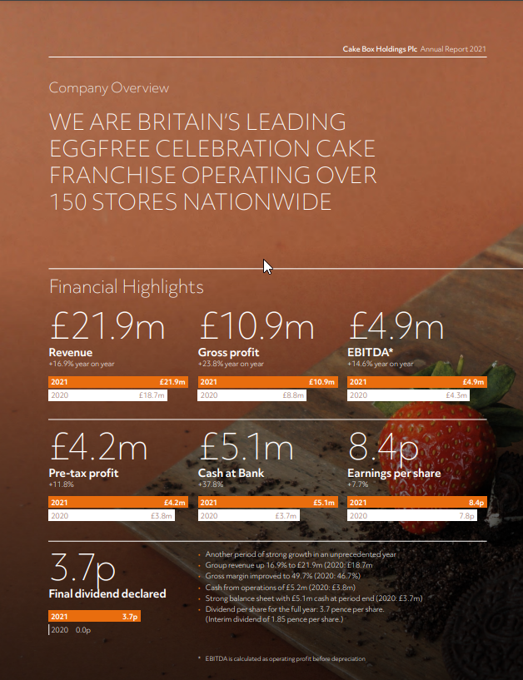

Appendix C
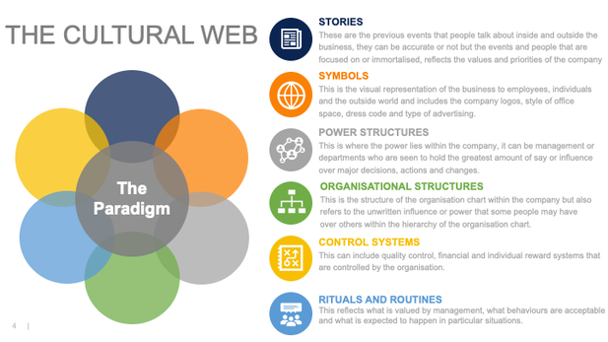

Appendix D

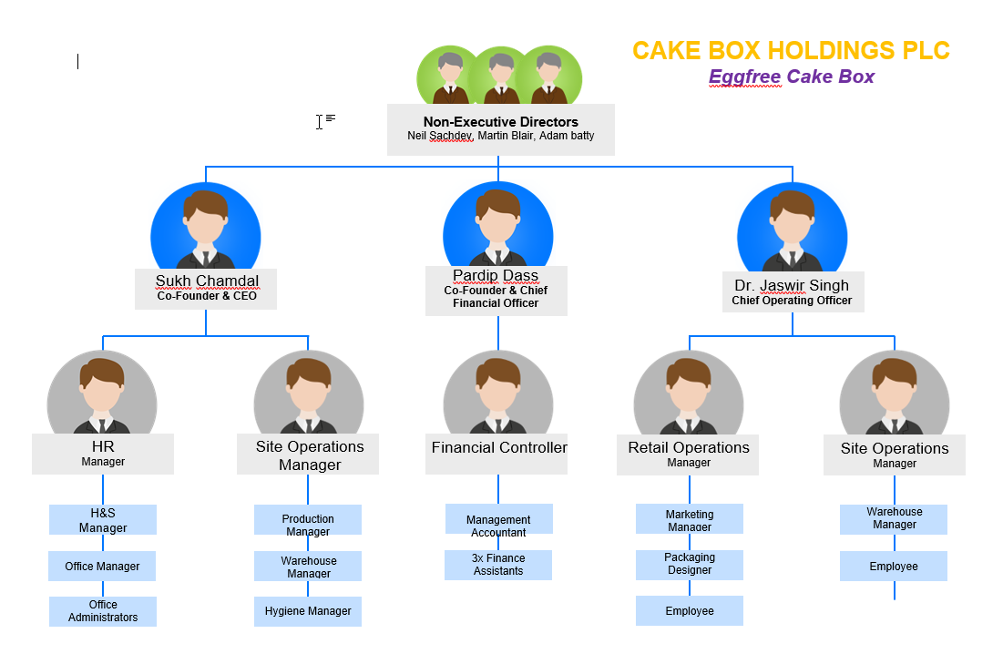

Individual Reflective Essay

As a student of UWTSD, I came unto this course with the intention broaden my knowledge in leadership and business management as I recently started my own online business, with future prospects to expand in years to come.
This module gave me great insight into how organisational culture plays a huge factor in an organisations overall performance, leading them to success. I spent 11 years working for many organisations, and only three of which I was passionate about. However, these years were not wasted, I developed loads of experience, knowledge and wisdom which finally led me to realising that I cannot work for an organisation if I am not passionate about the nature of the job, it was no longer just about income.
I have always been a Kinaesthetic Learner, and although remote learning has allowed some flexibility as a single parent, I would usually prefer to be on campus and around other students physically, to get the full experience of joining discussion, group work etc. I used Kolb’s Reflective Cycle to reflect on my learning during this term, and how this module helped me to gain further knowledge that I can later apply to my own business planning.

Kolb’s Reflective Cycle

David Kolb published the Reflective Cycle in 1984, developing a theory of what he calls ‘experiential learning’ where individuals analyse their own learning experience via a three stage evaluation.

Concrete Experience

Remotely attending lectures for ‘Workplace Culture and its impact on organisational efficiency’ module to understand the external factors that impact on organisational culture and how overall performance is affected. Join in group discussion that helped to define ‘Ethical Dilemmas’ in the workplace based on different beliefs, attitudes and values amongst employees and staff members.

Reflective Observation

Health discussions and debates that took place via remote learning lectures, allowed students to express their views and help get a clearer view on the topics we will be analysing in our assignment. As a kinaesthetic learner, I definitely found group discussions as well as questions and answers between myself and the teacher, conducive to my learning as this was the closest I could get to learning by ‘doing’.

Abstract Conceptualisation

With remote learning still feeling uncomfortable for, in regards to putting on our camera whilst at home etc. I didn’t participate much in group discussion with our cameras on, however I always made an effort to contribute via audio regardless of the lecturer’s instructions. Additionally, lack of physical interaction meant less networking which I think takes away from the confidence of myself in terms of ensuring that I understand the tasks given, having other students to discuss and revise with etc.

Active Experimentation

Moving forward, next term I will try my best to overcome my anxiety and be more active on the camera when instructed to do so. As well as this, I will make the most of the online provisions, and rather than making excuses make the most of it and use the university’s online resources more to ensure that I produce my best work.

