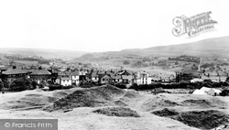  Learning log report  BLAENAVON | ELIZABETH KING 1907567  Distinctiveness and Regeneration  Anthony Burns

Learning Log Report
Blaenavon
Introduction
Blaenavon and its history is what we are going to be looking at in this report. From when Blaenavon became known during the Industrial Revolution, their popularity for Iron making and coal production through to now with The Big Pit Mining Museum keeping the memory going of where it all started and how Blaenavon was made so popular and put on the map. Blaenavon town is in South East Wales and is located at the source of the Afon Lwyd just North of Pontypool. It’s within the boundaries of Monmouthshire and Gwent. The town is on a hillside and has a small population of 6,055. The main attractions at Blaenavon are The Big Pit National Coal Museum, Blaenavon Ironworks, The World Heritage Site and Blaenavon Heritage Railway and they are all a short distance from each other.
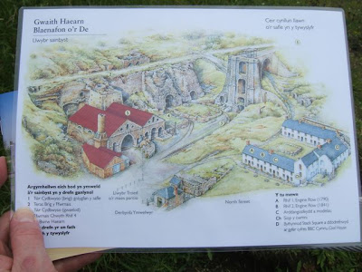

Main Body
Blaenavon was first known for iron and steel. The mountains of Blaenavon was well known for iron ore from 1675 this was used. In 1788 Thomas Hill, Thomas Hopkins and Benjamin Pratt built a new iron works at Blaenavon and with it they used the latest technology. It became one of the largest in the world in 1789 when by using steam to operate their three furnaces. The furnaces were producing around 5,400 tons of iron a year by 1976. (UNESCO-world-heritage-site, February,6,2020). It was at Blaenavon Ironworks that Sidney Gilchrist Thomas found the process for dephosphorising iron to make steel. (engineering-timelines.com,2020). In 1836 The Blaenavon company was sold and became a joint stock company known as The Blaenavon iron and coal company. William Unwin Sims ran this company and James Ashwell was a managing director.
William Unwin Sims died in 1839 and Robert William Kennard then took over the role as head of the company. James Ashwell remained a managing director until 1841. It was while he still worked there that the sites water balance tower was constructed. It was used to bring things up from the casting houses which then went up to the tramroad that connects the ironworks with the forge and the canal. By 1841 at Garn Ddyrys Forge 305 tonnes of wrought iron bars and rails were being produced a week. But by 1861 the forge along with the tramroad stopped operating and today nothing remains of them. Then in 1854 the railway network began in Blaenavon which offered cheaper transport to people and their goods. In 1970 the site at Blaenavon was going to be demolished but was saved in 1974. Since it’s been saved a lot has been done to repair it and preserve it. Then the Big Pit closed as a working colliery in 1980 but has since been opened as a mining museum since 1983. (engineering-timelines.com,2020).
Smelting was a common process used in Blaenavon which involves removing the ore that is needed from other materials. A chemical reaction is needed during this process which involves heat and an agent for this trigger. Adding a flux to bind with certain materials will form something known as slag. This is unwanted material which falls and settles to the bottom where people do their smelting. During this process good air circulation is needed as well as the right heat temperature. (wisegeek.com,2020).

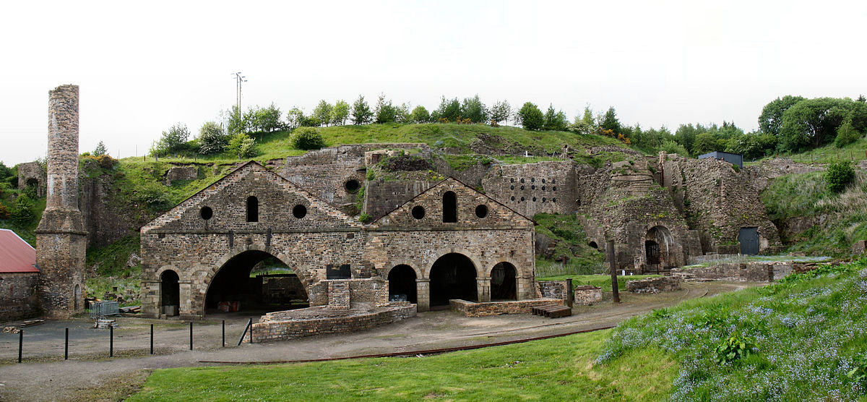

Then there is The Big Pit at Blaenavon which operated alongside the iron works during the 19th and 20th century. Along with this the town’s population grew to around 20,000. (urban75.org,2020). The shaft at the Big Pit has been altered a few times the first being in1860 where it was extended to the depth of 200ft by the Blaenavon company. Then in 1880 it was extended again to 300ft which to this day it is the same. In the early 1920s The Big Pit had around 1,300 men working in the mine and like with many coalmines encountered a number of accidents. With such a high demand for coal which was used for locomotives, steamships, factories and houses Blaenavon saw an opportunity and specialised in the production of coal. The coal they produced was shipped all over the world and was even used by great western railway to fuel their trains. Local demand was also met with the production of coal. Then in 1980 The Big Pit closed but later re-opened in 1983 as a mining museum which still to this day attracts a lot of visitors. (visitblaenavon,2020). Kids as young as five were made to work in the coalmines during this time as there was such a high demand for coal. The working conditions were poor, dangerous and exhausting and definitely not suitable for young children. The older children operated the operated the mine shaft pulleys. (bbc.co.uk,2008).

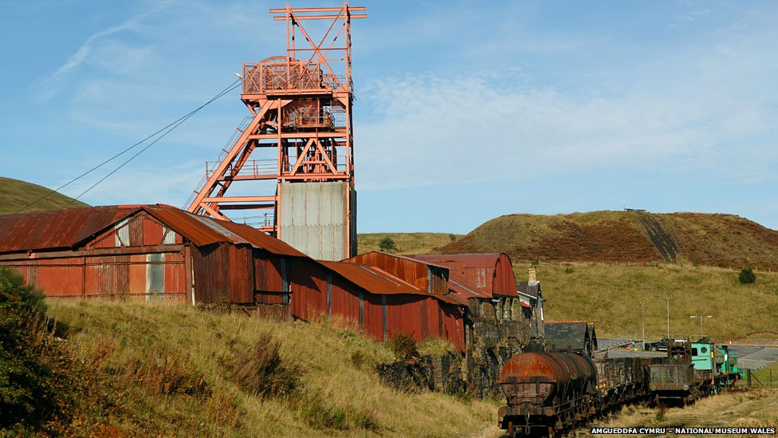

During the mining period of the 19th century pit ponies as they were called were used down the shaft mines to work alongside the miners. They stayed underground for life. The miners and the ponies became friends and the underground stables that were built for them could hold up to 50 horses. Due to the working conditions down the mines they often died from mistreatment, accidents and also explosions. They were overworked and would often drop from exhaustion. Frightened and out of control horses were also responsible for some of the miner’s death but also some miners died trying to rescue their horses. (walesonline.co.uk,2008).

Conclusion
Having looked at Blaenavon, it is fascinating to see that once a place of peace and countryside was then turned into a place where people would travel to work in the ironworks or the big pit. How this transformed a place and helped with the population rise and also created jobs. But looking at the working conditions back then and the use of ponies down the shaft mines would be unthinkable at this time. To see and understand a big part of history is amazing and interesting and to no that it´s been preserved for people to visit and get an idea of what it was like for people is just amazing.

References
Mary McMahon. (2020). Smelting. Available: www.wisegeek.com/what-is-smelting.htm. Last accessed 04th March 2020.

not known. (2020). visit Blaenavon. Available: https://www.visitblaenavon.co.uk/en/publications/blaenavon-story/big.pit.pdf. Last accessed 04th March 2020.

not known. (2020). big pit Blaenavon. Available: www.urban75.org/photos/wales/blaenavon-big-pit-wales.html. Last accessed 04th March 2020.

not known. (2020). Blaenavon industrial landscape. Available: https://everything-everywhere.com/unesco-world-heritage-site-259-blaenavon-industrial. Last accessed 04th March 2020.

not known. (2020). timeline. Available: www.engineering-timelines.com/scripts/engineeringitem. Last accessed 04th March 2020.

not known. (2008). children working in the mines. Available: https://www.bbc.co.uk/bitesize/clips/. Last accessed 5th March 2020.

Steffan Rhys. (2008). pit ponies. Available: https://www.walesonline.co.uk/news/wales-news/darkness-years-dangerous-harsh-life. Last accessed 5th March 2020.

