Introduction
In this I am going to be looking at the Happiness Index dataset which is a dataset that shows the happiness score and world rank for most of the countries in the world. It also has a few other scores such as life expectancy, perceived government corruption, GDP and how much their families contribute to their happiness for each of the countries. With all this data I will look at it and analyses to see if I can see if there is a correlation between all the different data point and see if there are trends in geographic areas by mapping out the different scores onto the world map using the tool that QGIS offers.

Files used

File Description | Source of the file | Format
World Borders Shapefile and Dataset | http://thematicmapping.org/downloads/world_borders.php | Shapefile, .shp
World Happiness index 2017 | https://www.kaggle.com/unsdsn/world-happiness/data | CSV

The Map and Dataset

The base Map

This is going to be the map that I will be using to put all of my data into, it’s a map of the world with all of the borders put in and an attribute data table to go along with it with all sorts of identifying data such as the name, sub region, region and population of each country. Using the attribute table that comes along with this map I can join together my map and my dataset so that I can use the map as a way of representing the data on my chosen dataset. The source that I got this map from was the www.thematicmapping.com which is an organisation that makes sure that their map is up to date and as accurate as possible each year which will help make sure that my conclusions that I get from my analysis is as accurate as possible.

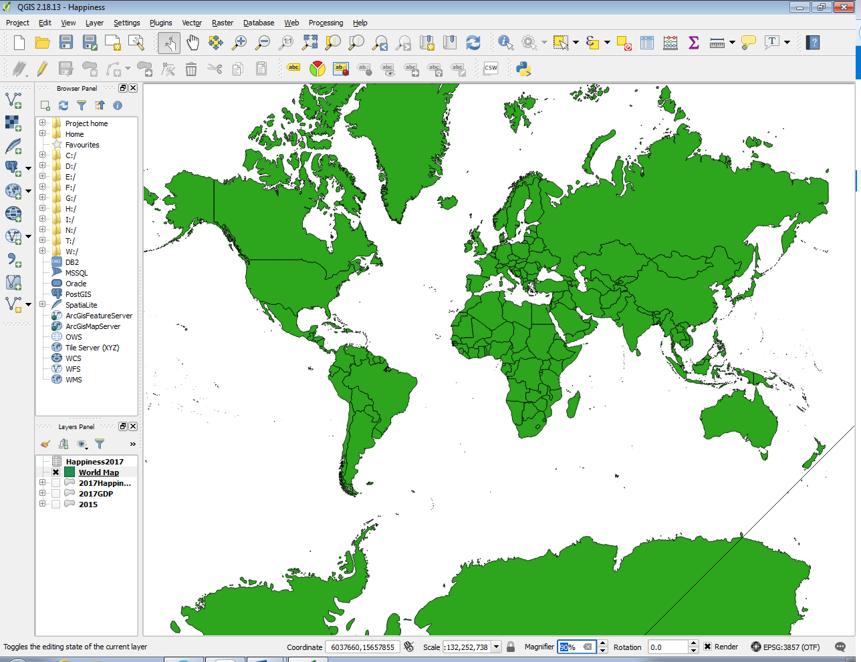

The attributes stored in the base map
This is the table of attributes that goes along with the world map I have, it has lots of data available that you can use to create joins, but I will be using the “NAME” field which I have checked to see if there are any countries that have a different name than my dataset and corrected the names so I will get the most results.
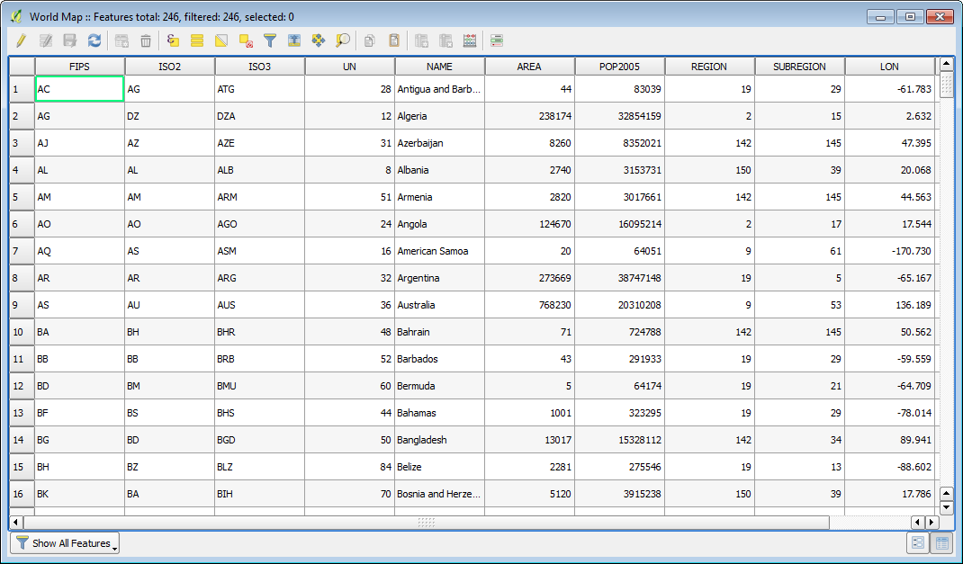

The Dataset

The dataset that I have selected for my analysis is the World Happiness report which contains the ranking of happiness by country and also the countries happiness score. It also has other data that might contribute to the happiness of a country such as the GDP, Generosity of the people in the country, Government corruption and also life expectancy in the countries. This dataset gives a lot of data to compare and try and find trends to work out what mostly contributes to a country as a whole being happy. The data is also available for years 2015, 2016 and 2017 which gives another way to analyse the data and find out if anything has changed in some countries in the last few years which could point to events such as wars, natural disasters or major political changes to explain the big jumps in happiness or GDP. To join this table to my countries map I will be using the Country field with the maps “NAME” field which both contain the correct names for most of the countries in the world which will allow me to then use any of the data about the countries to be represented in the countries physical polygons.

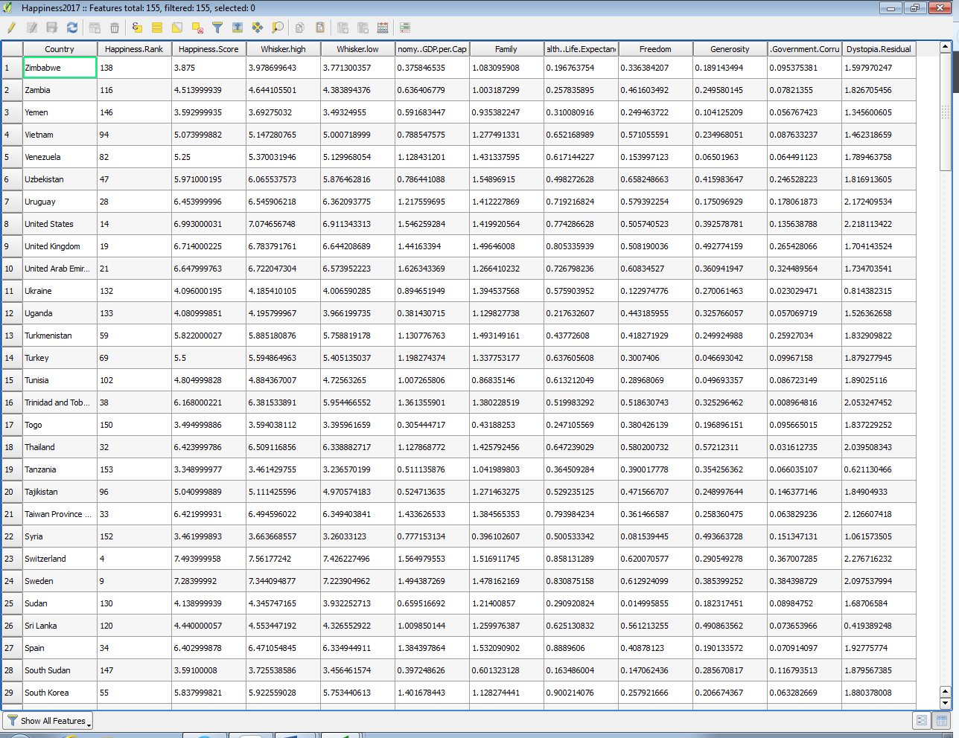

The Table joins

These are the two screens where I have join together the Map attribute table and the Happiness Data tables so that I will be able to use the happiness data in the map, so I can represent the happiness data on the map.
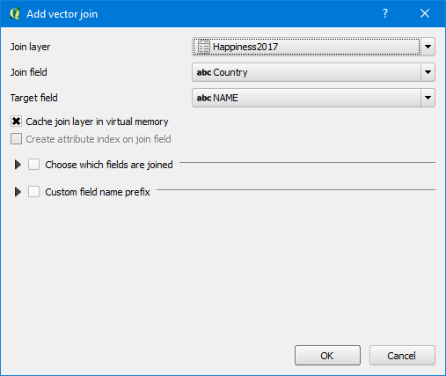

These are the two joins that are in my map and they are the 2015 data and the 2017 data, so I have to points in which to compare the datasets
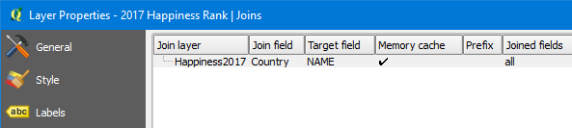
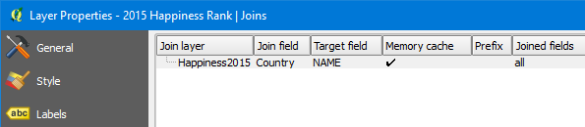

Making the data better for map form

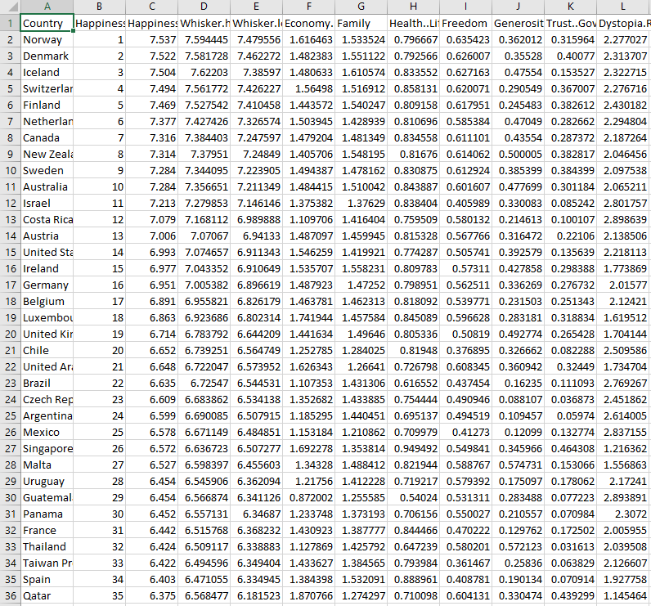
This is what the data looked like when I downloaded it form its source, it has a lot of decimal places that are not needed when viewing the data in the map form. Shortening the numbers to just two numbers after the decimal place allowed me to label the map properly because with the original data the numbers were so long they would not show up with most countries.

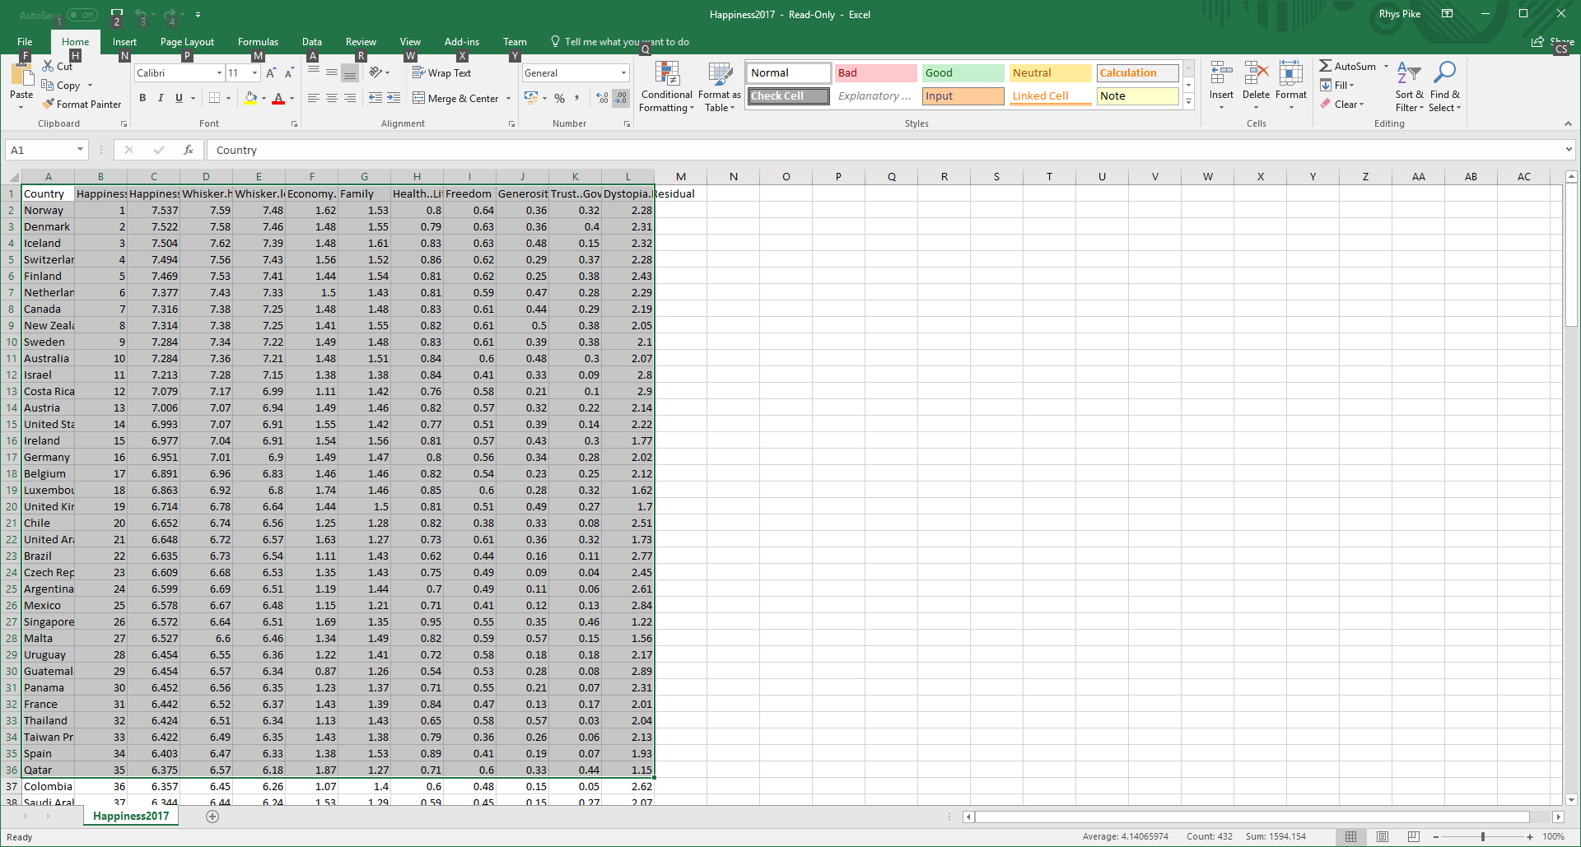
This is what the data looked like when I used the decrease decimal tool in Excel to shorten the numbers to just 2 number after the decimal. The data is still represented the same on the map as before and the numbers will be able to be labelled onto the map so that you can see the individual score of the country rather than just a colour.

Creating the Map

To first get my map into QGIS I downloaded from the source and then dragged the .DBF file into QGIS to load in the map which as you can see in the picture below its just a solid colour with the countries borders represented by a black line now. Next, I wanted to display the happiness ranks of each country on them so that you could clearly see which rank each country was.
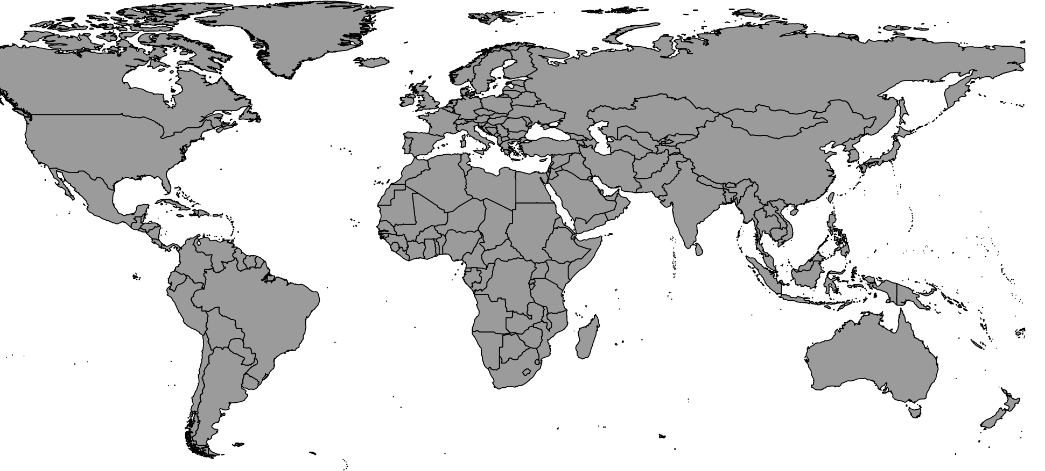

Rule Based Labelling
To get the countries to have their happiness rank displayed on them I went into the rule-based labelling tool which allows you to create a filter for your labels so that you can set what gets labelled by utilizing the use of rules. To get the highest rank countries to be displayed I set the filter to have a look at the happiness score and if the happiness score was above 5.920000076 then label the country with its rank in green text with a white buffer around it so it could be seen easier on the grey background.

The rule that I created to make the green rule was "Happiness2017_Happiness.Score" > '5.920000076', the orange rule was "Happiness2017_Happiness.Score"> '4.735000134' and "Happiness2017_Happiness.Score" < '5.920000076' and the red rule was "Happiness2017_Happiness.Score" < '4.735000134'. Using the greater than and less than functions I am able to make sure that all values in the table are accounted for which makes the represented data complete.

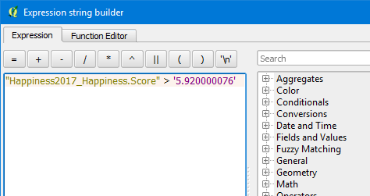
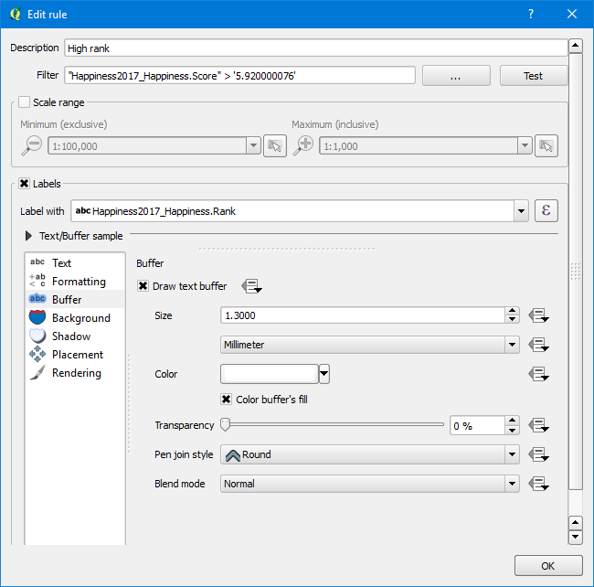

For the next step in creating the map I crated the next two label rules that I needed which were the orange medium rank and red low rank. Using the Green, Orange and Red colour scale for the labels help the viewer see which countries are happy and which are not easier because people naturally associate these colours with the high to low scale that I am using. This rule-based labelling tool makes the analysis of the map a lot easier and allow for the separation of data with big differences in value which for my type of map is vital to the user because of the amount of numbers that are involved.

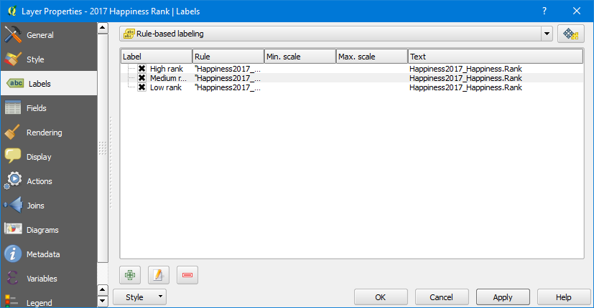
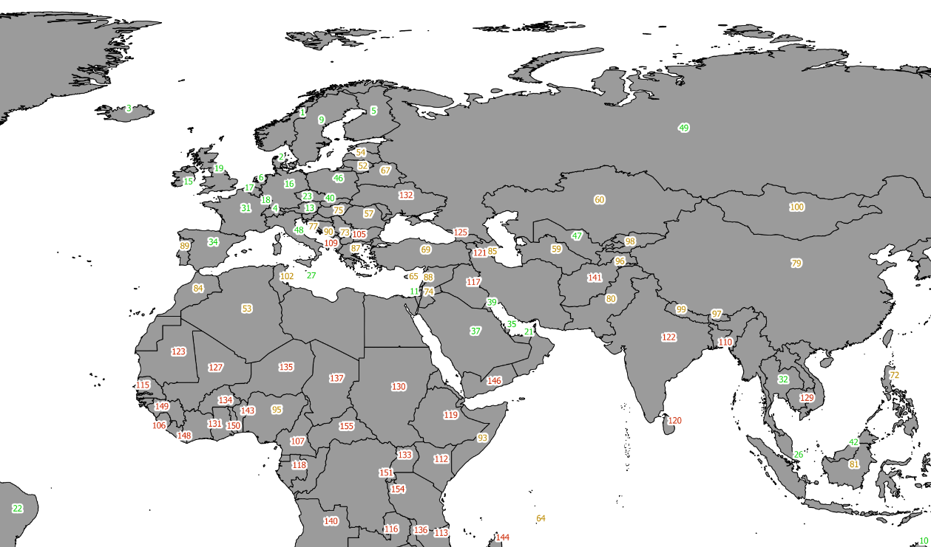

Using a categorised style
For the next tool that I use in creating my map I used a categorised style in order to give each countries polygon a custom colour so that you would be able to look at the map and instantly see what a countries happiness rank was based on the colour that it is. The way that this makes the user instantly recognise the value of the country based on the colour is by adding in a legend where the colour range is explained through a bar of the colours that are used so when they see the colours in the legend on a country they will know roughly where the country would sit on a ranking table.

To get the style to work had to set the source column as the happiness score of each country and then choose a colour ramp which would then take affect when I clicked the classify button which makes a colour for each value that is stored in the source column. I choose the red and blue colour ramp because they are opposite of each other which will make the maps data easier to analyse because it will be easy for the viewer to differentiate.

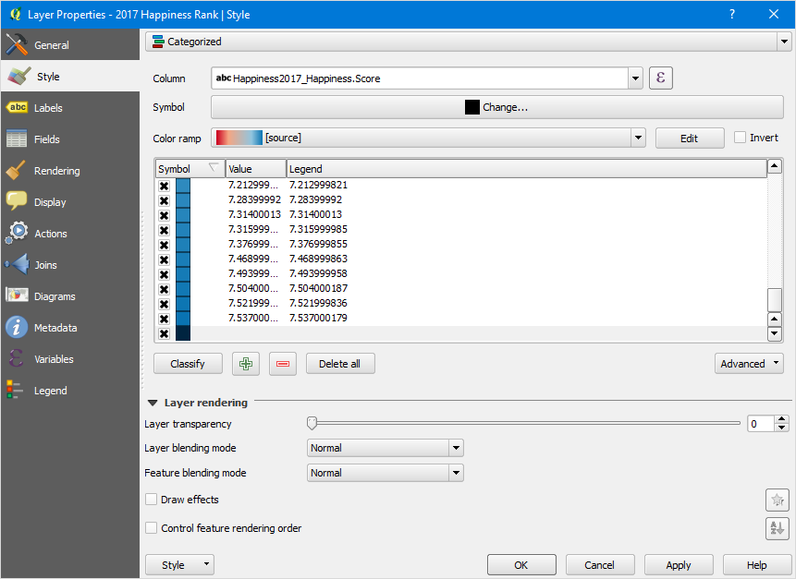
The dataset that I am using has a few countries that were not able to be scored in happiness due to an unavailability of data on them, so they are not in the dataset. The map I used has all of countries in the world so to avoid confusion I have set all of the countries that do not have a value in the table as black so that the user will know that they are not represented in the map.
Higher
Lower

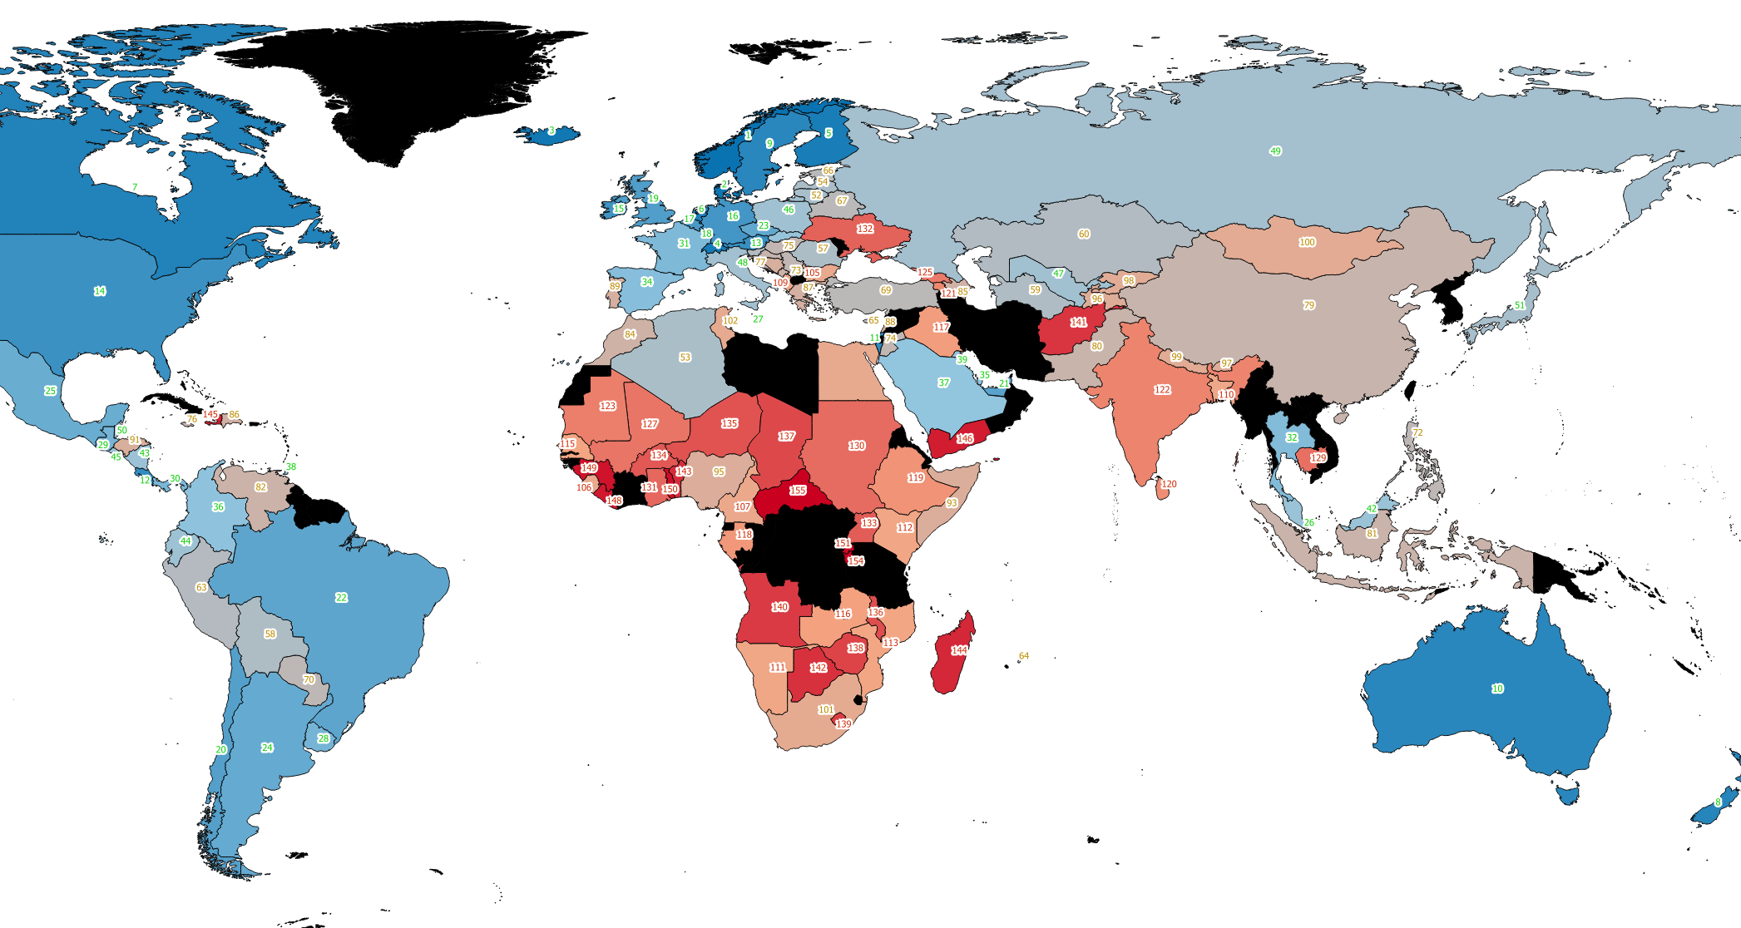

2017 and 2015 Data comparison

Happiness Rank comparison
Higher
Lower

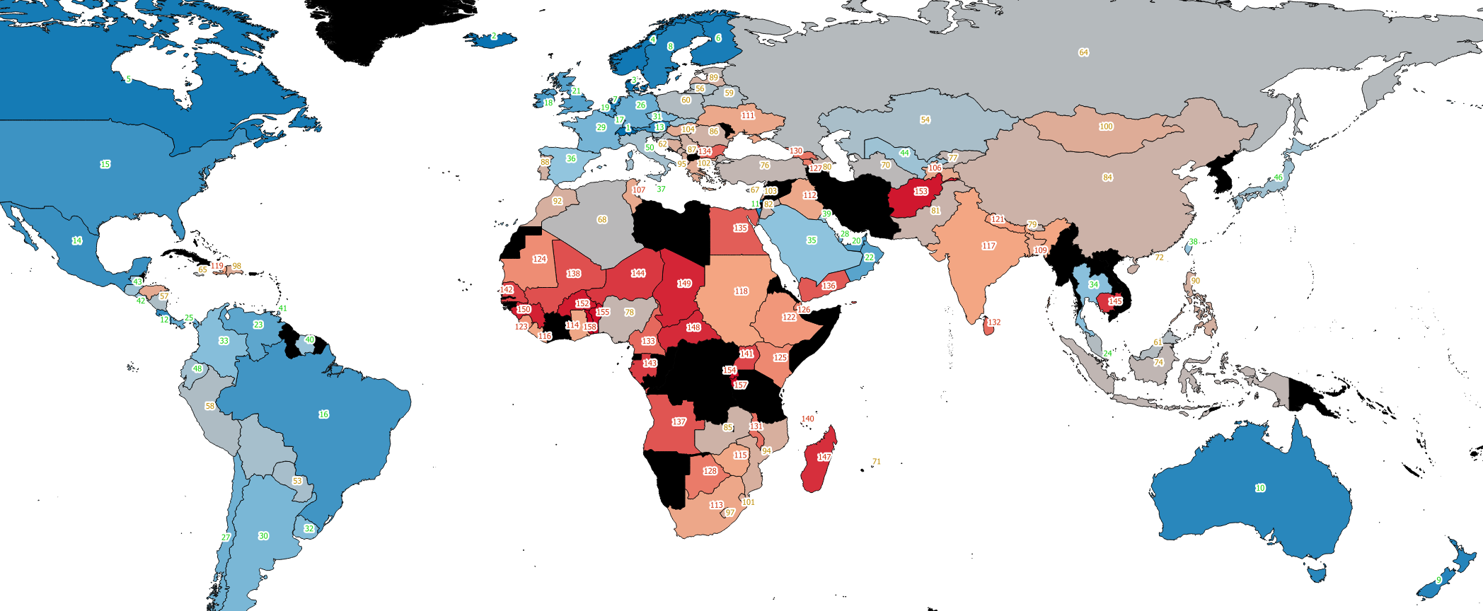
2015
2017
In 2015 you can see that Switzerland is the happiest country in the world with Iceland and Denmark coming in close after it. Switzerland is the happiest country in the world, but it only has the number one spot on the contributing factor of freedom, most people would think that a country with the highest GDP and family score would be in the first spot. Iceland is second on the list and has the number one spot for family score but has an average GDP for the western countries which shows how important the family score is to people’s happiness, Iceland being a small and isolated western country is probably why they have such a high scoring in the family score. For the unhappiest country’s it is Togo with Burundi and Syria coming in behind it in 2nd and 3rd place. Togo and Burundi are both countries in Sub-Saharan Africa which score low on all of the scores with the GDP being the highlight of them both with Burundi being the second most poor country in the world which suggests that if this score is low them most of the other factors and are going to suffer as well because for a good life expectancy, family score and freedom you will need to be in a place where you can safely live your life without any problems such as food shortages, no homes, no healthcare or any other social services.

In 2017 the new highest scoring country on happiness is Norway with Denmark and Iceland coming behind it, Switzerland is now in the 4th spot even though the GDP and Family score is higher than it has in 2015 which is surprising when looking at the trends on the map because they are the clear factors that make a country generally happy. For the country’s that score the lowest for happiness you can see that only one of the bottom country’s from 2015 is still in the lowest 3 which is Burundi which I think attributes to the very low GDP that the country had and still has, the new lowest 3 are Central African Republic, Burundi and Tanzania with Syria now moving to the 4th spot because of a higher GDP but the family has gone down and the life expectancy has gone considerably. The lowest 3 are now African nations with low GDP’s with further reinforces that GDP and life expectancy make all of the other scores higher so they are two of the most important one to have.

Health/Life expectancy
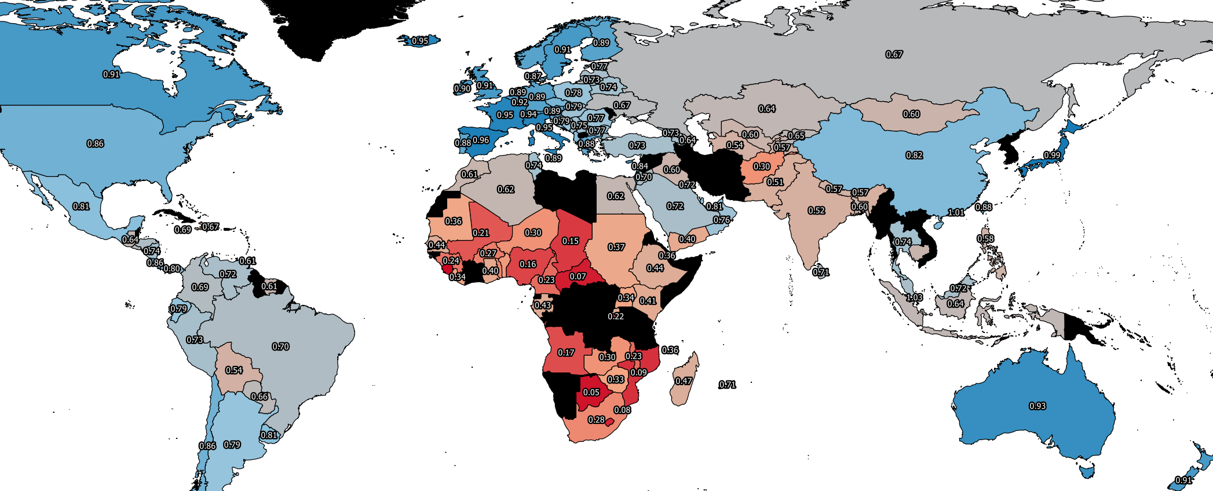
2015
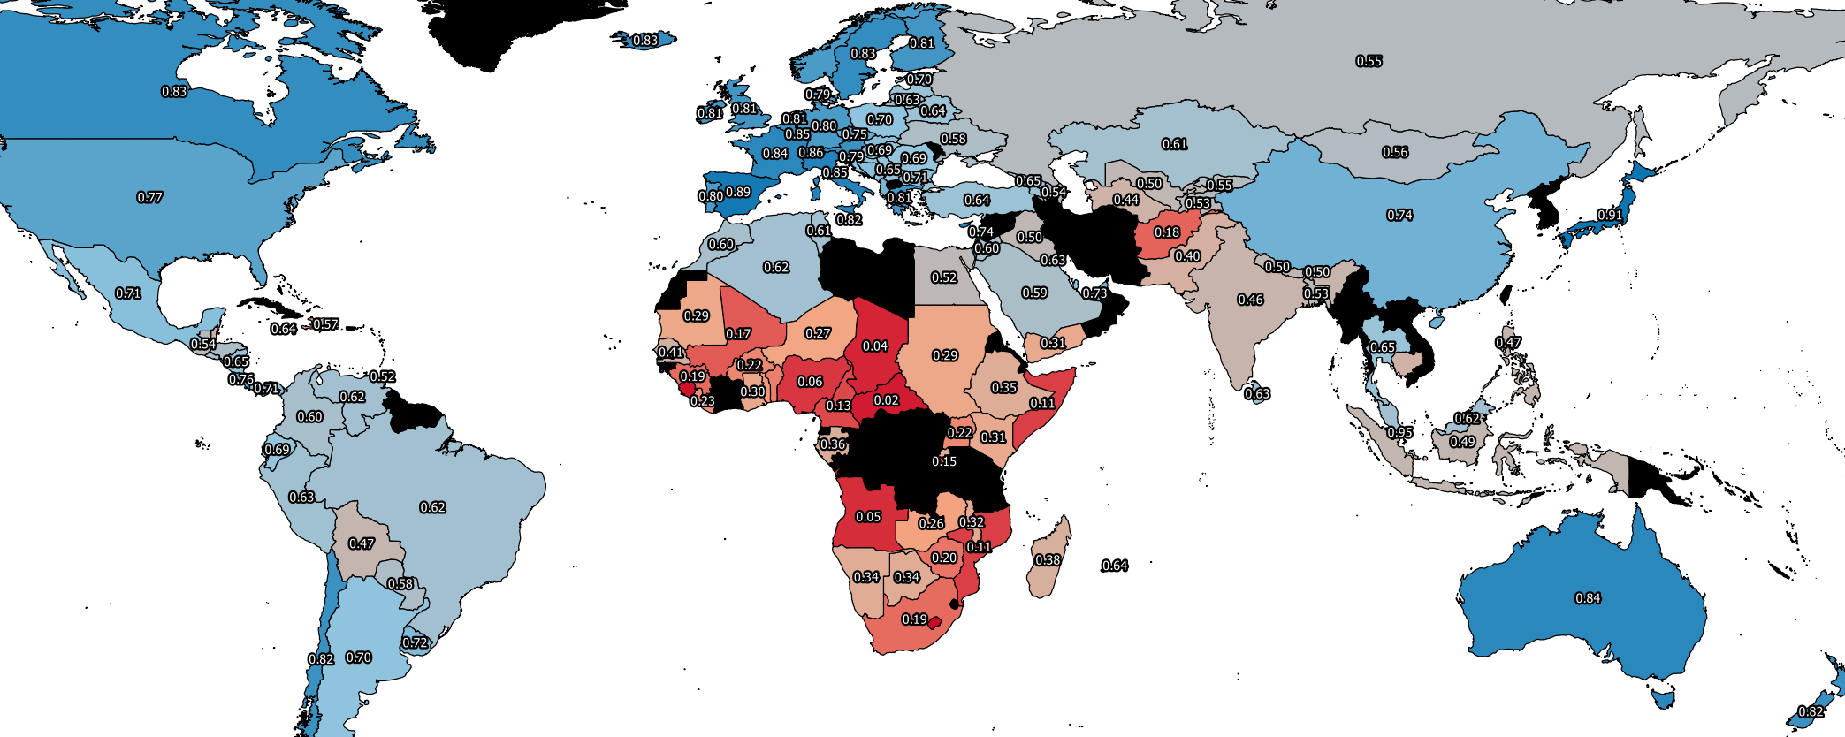
2017
Lowest Scoring countries
When you look at the maps there is not much difference that really stands out but across the board the life expectancy score have gone down a little for every country with no big changes. The lowest scoring in 2015 was Sierra Leone in last, Botswana in second and Central African Republic in third with scores that are much lower than the scores above them so it clear that they have an especially low life expectancy which you can see by the intensity of the red that represents them on the map.

In 2017 the number one spot has been taken my Lesotho with Sierra Leone now in second place and Central African Republic coming in third again, the average between the last 3 has gone very low when compared with 2015 which is surprising because you would think that the life expectancy would be rising through the years but they have now gone to being almost being the same scores with only a 0.01 score difference between them. The top 20 lowest countries in this category are all in The Sub-Saharan Africa region of the map which I imagine will correlate a lot with the GDP map.

Highest Scoring countries
The countries with the highest life expectancy in 2015 were Singapore, Hong Kong and J apan in that order with South Korea being just behind them, they are all East Asian countries with high GDP’s which I think is one of the main factors and the other major factor would be the lifestyle and culture that they have when compared to Western countries of similar GDP, the East Asian countries are still higher in life expectancy.

In 2017 the top 4 spots are still occupied by East Asian countries with all of the same countries in all the same positions on the list even though the average overall has gone down in the world but the gap between the Western Countries and the top 4 East Asian countries has widened which would suggest that the world average has gone down but in reality the East Asian countries have gone up in life expectancy but have been artificially brought down due to the decline average across the board.

Perceived Government corruption
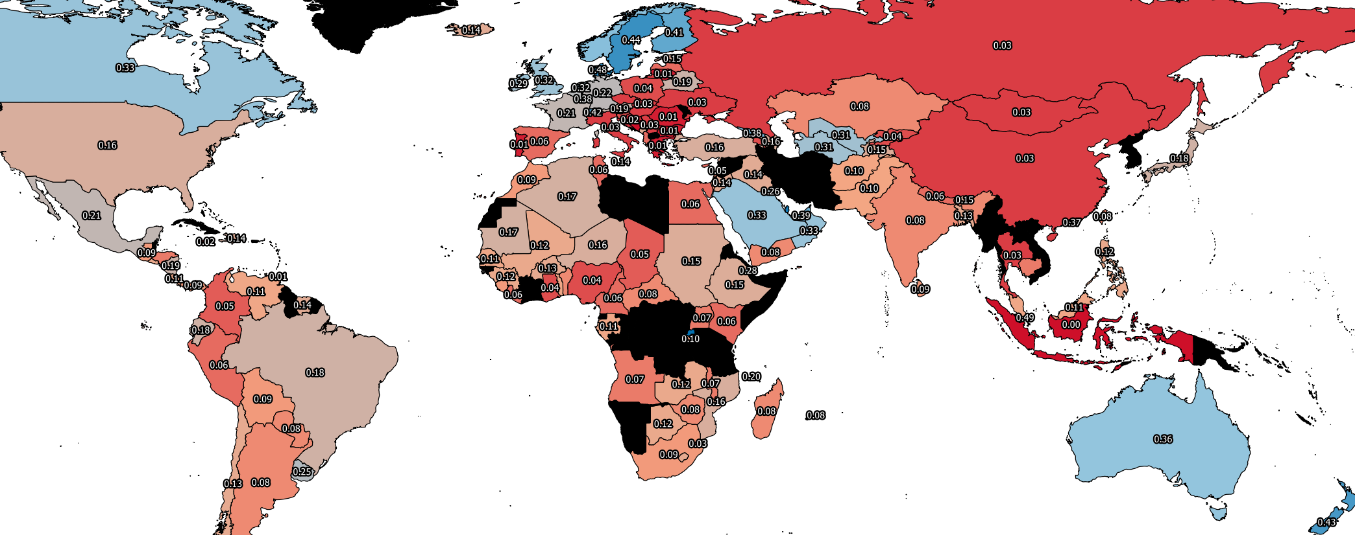
2015
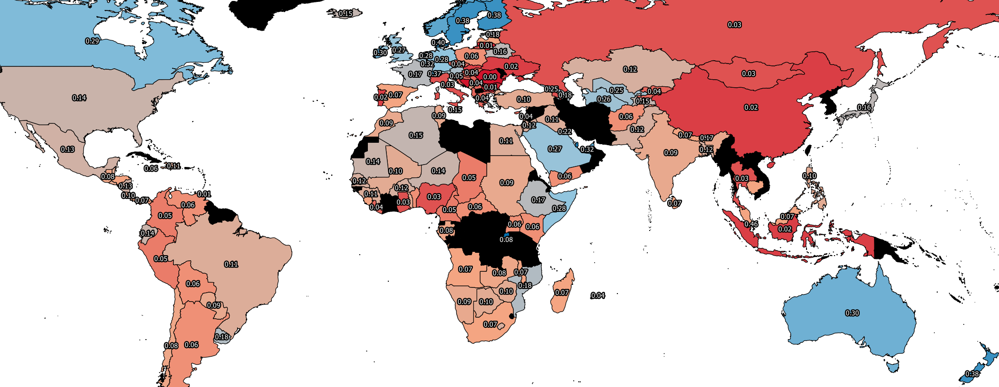
2017
For the perceived Government corruption maps you can clearly see that apart from Western Europe and some other western countries such as Australia and Canada there is not much trust in their Governments. This lack of trust could have a lot of other knock on effects such as lower life expectancy due to bad social services or poor economy due to the amount of corruption leading to the government not sharing the country’s wealth with it citizens.

Lowest scoring countries
The lowest scoring countries in 2015 are Indonesia, Bosnia and Herzegovina and Trinidad and Tobago which is a lot different from the other scores results because usually the top or lowest scoring place seems to be in clusters or in the same regions but these three are all on different continents. Other than Bosnia and Herzegovina being very low scoring in Freedom the other categories for all of them are moderately scored which could suggest that government trust does not contribute to a countries happiness as much as the other categories.

Looking at the worst countries for Government trust in 2017 you can see that there is a lot of distrust in South Eastern Europe and in some parts of Asian with the worst of them all being Romania followed by Bosnia and Herzegovina and also Trinidad and Tobago in third place. A trend with those 3 countries is that they score moderately for almost all of the contributing factors to happiness except for the Government Trust score. This could lead to the conclusion that if the country is well off in terms of GDP then government trust does not matter that much in term of overall happiness for the citizens of that country. Romania is the country that least trusts it government but they are 86th in the overall happiness which is an average score for the area that it’s in.

Highest scoring countries
The highest countries in 2015 for Government trust are very surprising with Rwanda being the country with the most government trust followed by Singapore and then Qatar which are all surprising in their own ways. Rwanda score very low on all other scores apart from the government trust score which seems to go against logic because if the country is in a bad state then you would think that the citizens would not like the government that they have. For Singapore and Qatar they are very high scoring on all of the other scores which could suggest that the citizens are very well treated by their governments. In 2017 the only difference is that Rwanda is now in the number one spot and Qatar is second with Singapore in last which could be due to a political event or election which caused them to be more wary of their government.

Families contribution to happiness
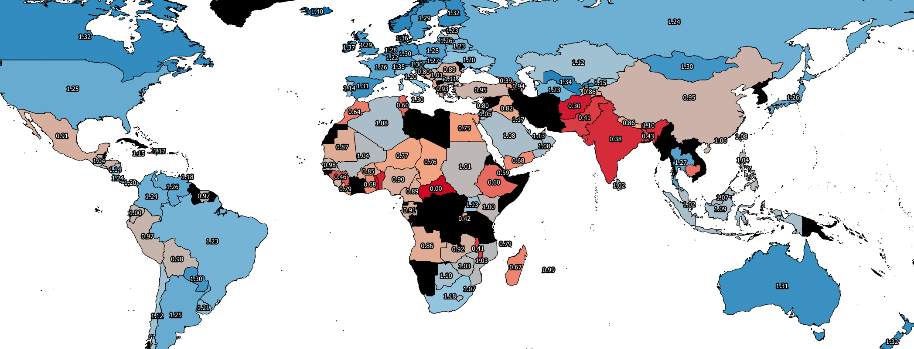
2015
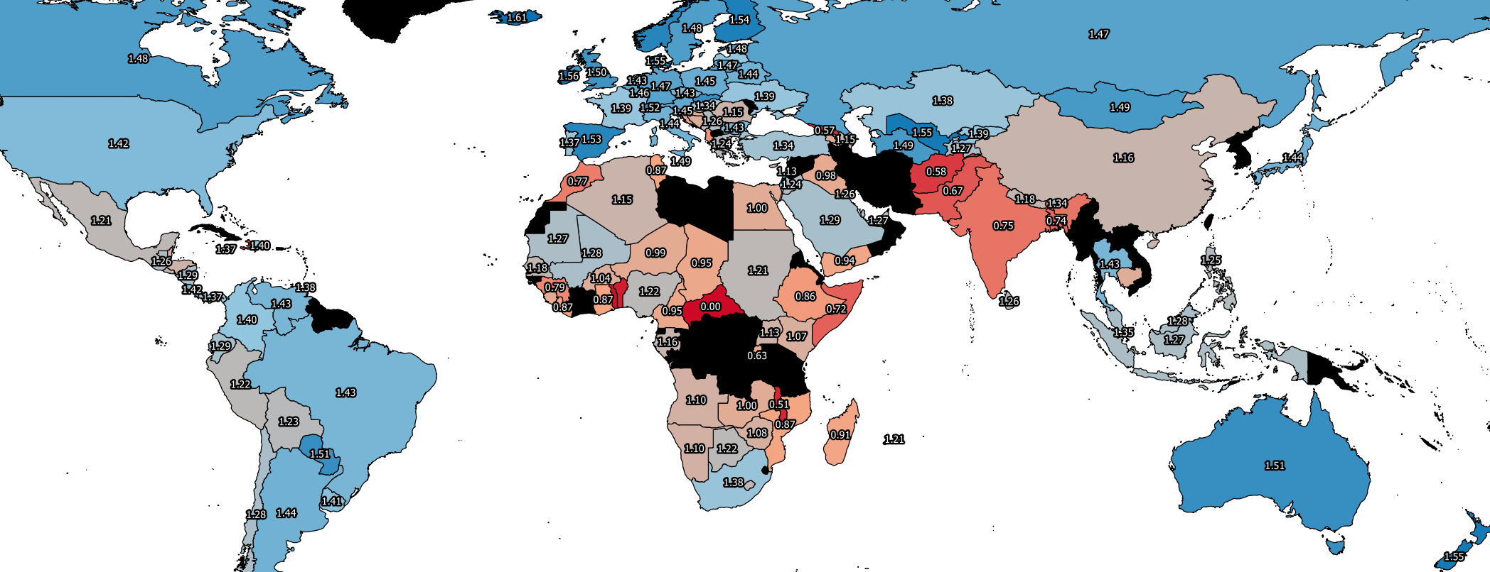
2017

In the family contribution to happiness map it’s one of the only ones were when you compare them both almost all countries have increased their score from 2015 to 2017 apart from some African nations. When you look at the top 20 for 2015 and 2017 you will notice that they are overwhelmingly European nations and the lowest scoring countries are mostly Sub-Saharan African, Southern Asian or Middle Eastern.

GDP
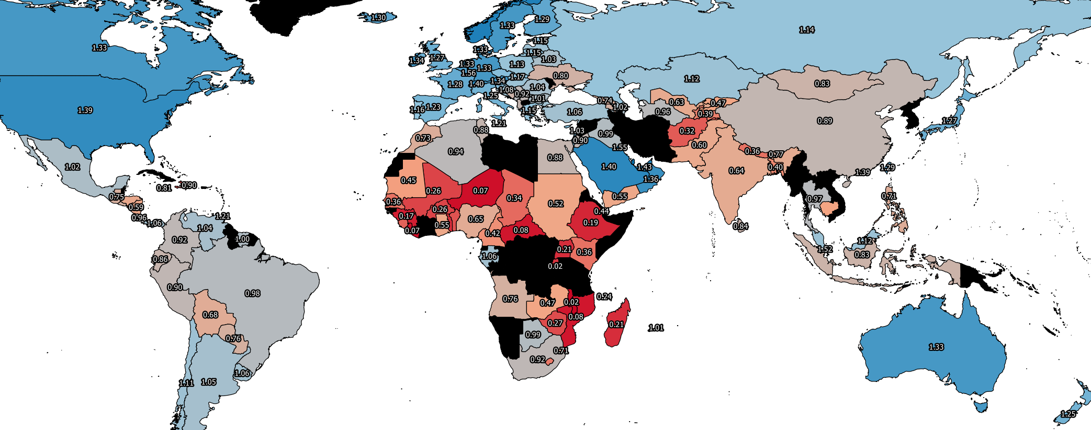
2015
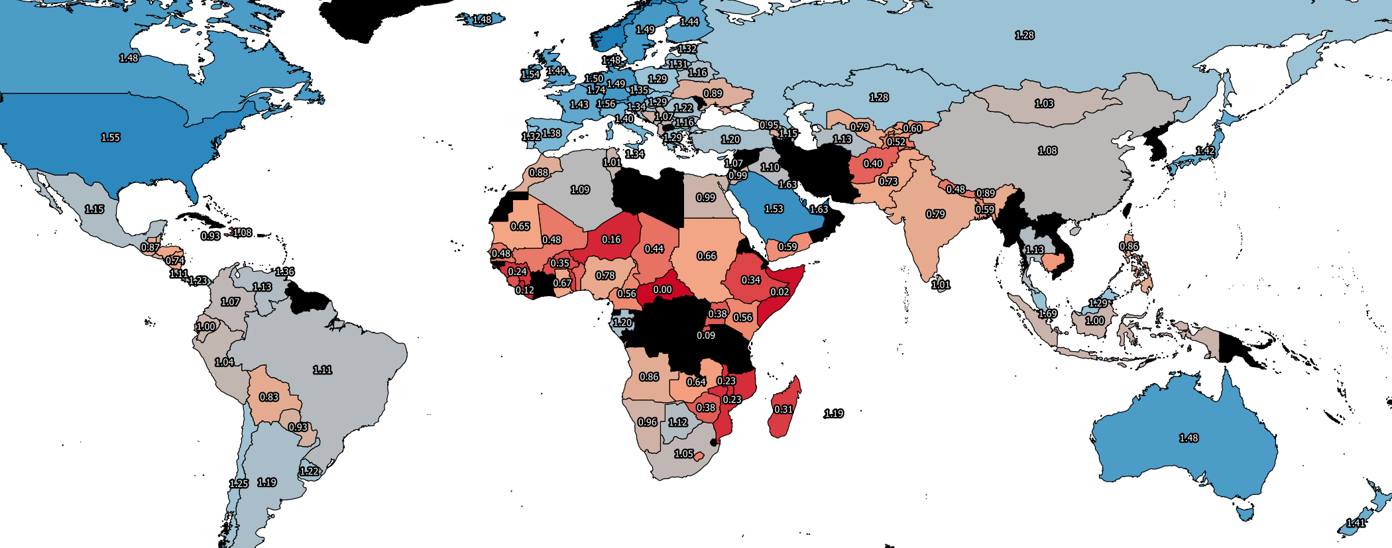
2017

2015
The GDP’s of the 20 lowest countries in 2015 are all in Sub-Saharan Africa with all similarly low scores and in 2017 it’s the same but there is 1 Latin American country which Is Haiti in the 19th spot. For the richest in 2015 its Qatar in the number 1 spot with Luxembourg and Kuwait in the places after it, the trend in the GDP’s is that it’s mostly Western Europe and the Middle East with America, Canada and Australia in there for the top 20.

2017
In 2017 not much has changed for the poorest countries other than the addition of Myanmar which is in Southern Asia has been placed in the top 20 lowest GDP’s but it still majority African Nations that suffer in this category which makes the other score categories in the dataset harder for them to attain. Life expectancy is also very low for these countries when you compare them to rich nations with high GDP’s which can be directly correlated to the lack of money for each person to live on and lack of social services.

In 2017 for the top 20 highest GDP nations not much has drastically changed other than Singapore taking the 3rd spot from Kuwait. The general GDP of all of the nations that were already rich in 2015 have risen steadily across the board even though the average happiness score has gone down across the world which could suggest that it’s not as important as you would think to a countries happiness.

Conclusion

In conclusion to the analyse u have conducted on my maps I have found out that the most important factor in a countries happiness is the GDP but after a certain point it start to have depreciating returns, so the richest country does not mean the happiest country. I also found out that the Government trust seems to be the category that did affect the overall happiness the most and it does not impact the other categories as much because most of the countries that had the highest government distrust would be around the middle ground for overall happiness. I also notice that the happiest countries were small and rich which help in making everyone happy due to not having lots of people with all different need all stretched over a large landmass [2].

The countries that had the highest average happiness over both the years were overwhelmingly Western European countries such as Norway, Switzerland or Denmark. The unhappiest countries were always either in Sub-Saharan African apart from Syria which was mostly likely due to the Syrian Civil war that has ben going on since 2011[1]. The scores for all the African countries were low which I think s due to the low GDP and corruption In the countries so when they do not have necessities for life then they cannot have a good life expectancy or value family life as much.

References

- Global Conflict Tracker, Syrian Civil War, (Cited on 06/02/18) available from: https://www.cfr.org/interactives/global-conflict-tracker#!/conflict/civil-war-in-syria

2 Henrik Christoffersen, Michelle Beyeler, Reiner Eichenberger, Peter Nannestad, Martin Paldam, The Good Society: A Comparative Study of Denmark and Switzerland, 2013, pg5, (Cited on 06/02/18) available from: https://books.google.co.uk/books?id=I0S3BAAAQBAJ&pg=PA2&lpg=PA2&dq=european+always+the+happiest+countries&source=bl&ots=mdjSzSsp44&sig=bZa5XuBamieXFPB6nZ4_A6L5RKg&hl=en&sa=X&ved=0ahUKEwiSwqjSnJLZAhWHLsAKHShfCYYQ6AEIZzAJ#v=onepage&q&f=false

