

Student name:Tosin Yusuf
Student ID:2334371
Module name: Changemakers: Building your Personal Brand for Sustainable Employment
Module code: BMHP5015
Lecturer name: G2 Christopher Mafuva

Table of contents
Introduction 3
1. Job Description of the Selected Job 7
1.1. Job Description and Person Specification 7
1.2. Employability Skills Need for the Role 8
2. Skills needed for the Job and Assessing Personal skills and Experience 9
3. Development of Personal Skills and Resources 11
4. Action Plan and Timeline 12
5. Communication of skills to potential employers 13
6. Conclusion 14
References 14
Appendix A: CV 17
Appendix B: LinkedIn Profile 18

Introduction
This report focuses on the role of a Healthcare Assistant (HCA) at Sixways Clinic, a primary care practice operating within the UK National Health Service (NHS) (NHS Jobs, 2026). A Healthcare Assistance helps nurses and cares for patients. They do simple task like basic health checks and support patient wellbeing.
I want this job because I like helping people and want to work in healthcare. It will help me gain experience and build skills for my future career.
This report aimed to assess the requirements for a HCA role at Sixways Clinic and evaluate my skills, experience, and suitability for this position. It will first analyse skills; qualifications need for HCA role using NHS frameworks and employability models. Then it will assess my own skills against these requirements. It will discuss how I can build my personal brand and professional identity and an action plan to bridge skill gaps. Lastly, it will conclude by summarising my career goals and development journey.

https://www.jobs.nhs.uk/candidate/jobadvert/A0350-26-0006?searchFormType=main&keyword=public%20health&location=wales&language=en

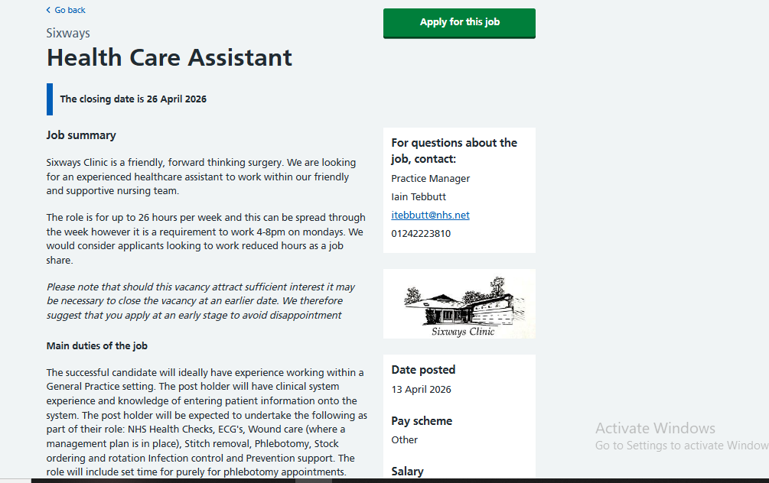
Figure 1 Job Vacancy
Source (NHS Jobs, 2026)
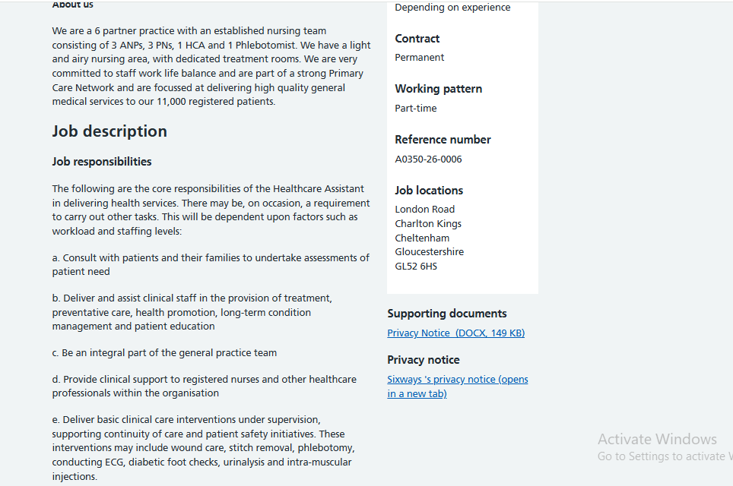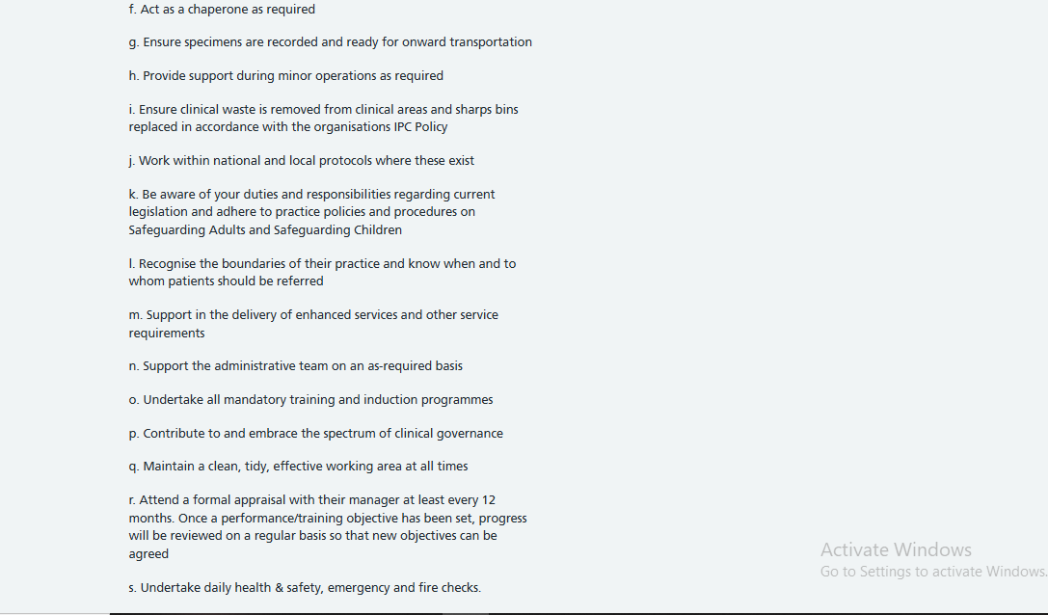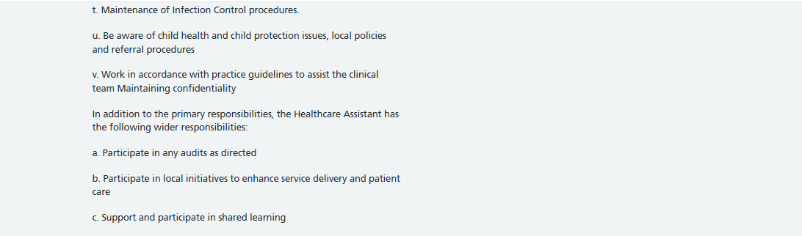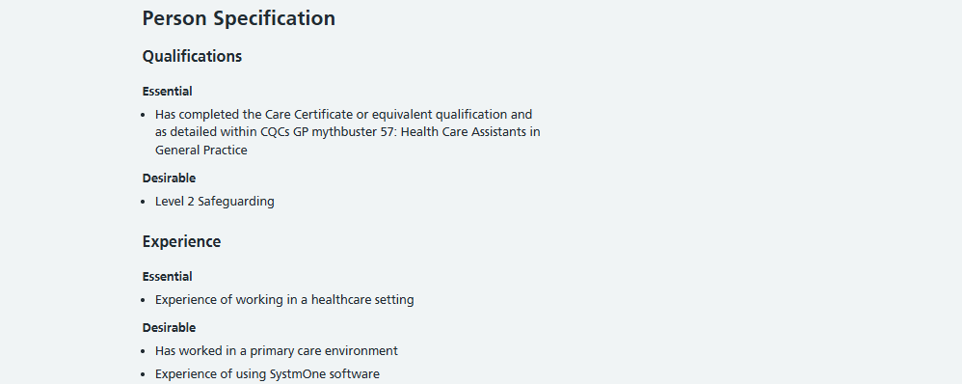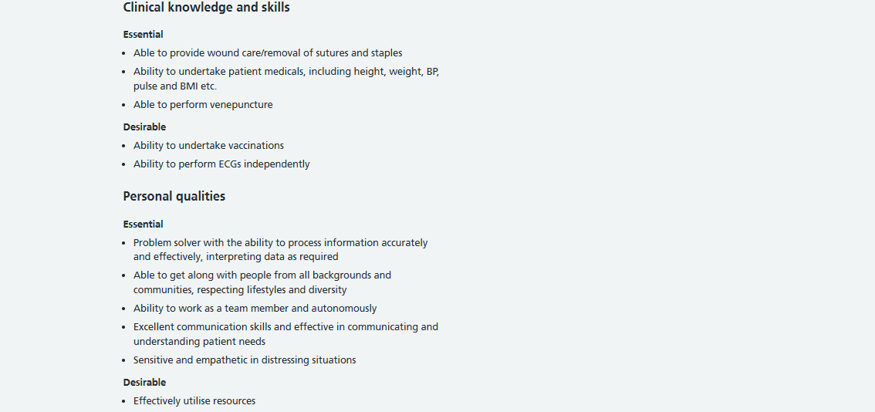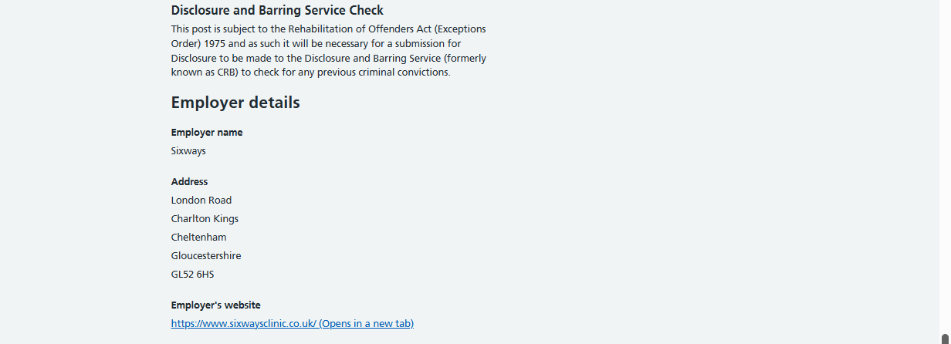

Job Description of the Selected Job

Job Description and Person Specification
The selected job is the HCA at Sixways Clinic that needs a combination of clinical competence, interpersonal skills, and professional behaviours to support effective patient care within a primary care setting (NHS Jobs, 2026). According to the job description and person specification, candidates must hold the Care Certificate (or equivalent), have experience in a healthcare environment, and demonstrate practical clinical skills like venepuncture, wound care, Electrocardiogram (ECGs), and basic health assessments. Further, the role emphasises safeguarding awareness, infection control, and adherence to clinical governance standards.

Employability Skills Need for the Role
One of the most essential employability skills for this role is communication. HCAs interact directly with patients from diverse backgrounds, mainly in sensitive situations. Effective communication ensures that patients feel heard and understood. Indicatively, when conducting NHS Health Checks, an HCA must clearly explain procedures and results so that patients can understand. This aligns with NHS 6Cs framework particularly communication, care, and compassion which are fundamental to delivering patient-centred care (NHS England, 2026). Teamwork is another critical skill, as HCAs work closely with nurses, GPs, and other healthcare professionals within a multidisciplinary team. The Skills for Care Core Skills Framework highlights teamwork and coordination as essential for safe and effective service delivery (Skills for Health, 2025). For instance, an HCA assisting in wound care must collaborate with a nurse to ensure correct treatment plan is followed. This improves patient outcomes and ensures continuity of care.
The role also requires emotional intelligence and resilience, particularly when dealing with anxious or distressed patients. Gualandi et al. (2019,) highlighted that in real healthcare settings, patients can feel nervous during procedures like blood tests or Electrocardiogram (ECG). An HCA must use empathy and reassurance to calm patient and maintain a supportive environment. Indicatively, in a situation where a patient is fearful of needles, the HCA can use a calm tone, explain the process step-by-step, and offer reassurance to reduce anxiety. This shows emotional intelligence and aligns with caring values expected in health and social care roles (Nightingale et al., 2018, p.2). Further, digital literacy is important in modern healthcare. The job description highlights the need for experience with clinical systems like SystmOne for recording patient information and managing appointments.
The Employability Skills Framework also identifies problem-solving and adaptability as key competencies (Koe et al., 2022,). HCAs must respond to changing situations like task prioritisation during busy clinic hour or when a patient need the input of a nurse or GP. Theoretically, skills required for the HCA role can be acquired via experience learning. According to Kolb’s Experiential Learning Cycle, individuals learn through experience, reflection, conceptualisation, and application (Kolb, 1997). For example, an HCA could first observe a nurse performing venepuncture (concrete experience), reflect on the technique used (reflective observation), understand underlying clinical principles (abstract conceptualisation), and then perform the procedure under supervision (active experimentation). This process contributes to the development of competence and confidence in the long term.
The STAR model (Situation, Task, Action, Result) can also be used to demonstrate how these skills are applied in practice. For example, in a situation where a patient becomes distressed during a procedure, the HCA’s task is to ensure patient comfort and safety. The HCA can act by calmly explaining the procedure and offering reassurance, resulting in a more relaxed patient and successful completion of the task. Thus, HCA job needs a balanced skill set incorporating clinical skills, communication, teamwork, and emotional stability.

Skills needed for the Job and Assessing Personal skills and Experience
The HCA role at Sixways Clinic entails a combination of clinical skills like interpersonal skills, and professional behaviours to deliver safe and effective services to patients (NHS Jobs, 2026). According to the job description, key skills are communication, teamwork, empathy, clinical competence like wound care, venepuncture, digital literacy (use of systems such as SystmOne) and working within safeguarding and clinical governance frameworks. To identify my suitability for this job, I conducted a self-assessment suing SWOT analysis and with reflection on my experience and feedback from others.
Strengths | Weaknesses
- Strong communication and interpersonal skills developed through volunteering with elderly individuals.  - Empathy, patience, and ability to support vulnerable individuals.  - Experience working in a team within a rehabilitation centre.  - Excellent knowledge of patient health and emotional assistance.  - Compassionate, reliable and devoted to care. | - The absence of clinical technical skills like venepuncture, ECGs and wound care.  - No formal Care Certificate qualification (required for HCA role).  - Poor experience in working with clinical systems such as SystmOne.  - Lack of understanding of UK clinical governance and infection control practices.  - Lack of confidence in clinical/medical environments.
Opportunities | Threats
- Opportunity to complete the Care Certificate and gain required qualifications.  - Access to training in clinical skills including phlebotomy, ECG training.  - Volunteering or part-time roles in healthcare settings to gain experience.  - Mentor, lecturer, and professional network support. | - There is a high level of competition in HCA positions in the NHS.  - Lack of UK-based healthcare experience compared to other candidates.  - Healthcare technology has rapidly changed demanding ongoing upskilling.  - Financial or time constraints affecting ability to access training.

Based on this analysis, my strengths strongly align with the demands of the HCA job. Through volunteering at a rehabilitation centre, where I assisted elderly people in their everyday routines and emotional support, I have acquired good communication and interpersonal skills. This required patience, empathy and the ability to connect with individuals of diverse backgrounds. Moreover, I demonstrated teamwork, since I collaborated with care staff to ensure residents’ wellbeing, which reflects the multidisciplinary working environment required in general practice settings (Alsubaie et al., 2024). My involvement in community health initiatives also strengthened my community engagement and health promotion skills, which are directly relevant to supporting NHS Health Checks and patient education.
However, a critical reflection also indicates developmental areas. While I have good interpersonal skills, I lack some of the technical clinical skills required in the job performing ECGs, venepuncture, and using clinical systems like SystmOne. This is the evident gap in my current skill set and on the job requirements. Moreover, despite my experience of working with vulnerable persons, I require developing my understanding of clinical governance, infection control protocols, and protection policies in a UK healthcare setting. These gaps show the necessity of professional training and certification to reach professional standards.
On qualification and experience front, my background includes volunteering for over three years in a rehabilitation centre, where I assisted elderly individuals with daily living activities, provided emotional support and assisted to ensure a safe care environment. This experience helped me to develop essential qualities like compassion, reliability, and resilience. Further, participation in community health initiatives exposed me to health promotion and public engagement, which are important for this role. However, I still have not completed the Care Certificate that is a compulsory requirement for HCA role, and this is an area for immediate development. Further, as per lecturer and supervisor feedback, I excel in communication, empathy, and dedication to learning. Contrarily, it also indicated the need to build more confidence in clinical environments and develop technical healthcare skills. This feedback supports my self-assessment and gives me a clear path to work on.
Through Gibbs Reflective Cycle (1998), I can reflect on my experience at a rehabilitation centre where I assisted an elderly resident who felt isolated. During one shift, I noticed a resident who appeared withdrawn and reluctant to engage with others (Description). I felt empathetic but initially uncertain about how to approach the situation effectively (Feelings). I chose to have a quiet talk with the resident and took time to offer companionship, which made them feel better and more cooperative (Evaluation). This demonstrated that emotional support plays a vital role in enhancing patient wellbeing, particularly among vulnerable individuals (Busch et al., 2021) (Analysis). Through this experience, I got to know that good care is not just about physical assistance but also include emotional and social needs (Conclusion). In future, I will combine empathy with more structured communication strategies and obtain guidance from senior staff to offer more holistic care (Action Plan).

Development of Personal Skills and Resources
Building a strong personal brand is important to stand out in the competitive Health and Social Care sector, particularly when applying for an HCA role. My personal values revolve around compassion, empathy, respect, and desire to enhance the wellbeing of vulnerable people. Such values align with the expectations of health and social care professions, particularly, the NHS 6Cs model, which prioritises care, compassion, competence, communication, courage, and commitment (NHS England, 2026). Through my actions and interactions, I can establish myself as an ethically responsible and patient-centred professional.
To promote myself effectively, I will use a professional CV (see Appendix A) alongside a well-developed LinkedIn profile(see AppendixB). My LinkedIn profile will consist of a clear headline like “Aspiring Healthcare Assistant, Health and Social Care Student, Rehabilitation and Community Health Experience”. It will highlight my volunteering experience, key skills like communication, teamwork, empathy, and career goals. I will also add professional photograph, descriptions of my roles and examples of the accomplishments like community health initiatives.
I have a unique selling point (USP) of having hands-on experience and interpersonal skills. I have over three years of experience supporting elderly individuals in a rehabilitation setting, where I developed empathy, patience, and the ability to provide person-centred care. This practical experience along with my involvement in the community health initiatives, enables me to communicate easily with various communities, as well as contribute to health promotion activities. I will also be involved in professional networks like LinkedIn healthcare networks and organisations like Royal College of Nursing (RCN) to develop my professional identity. This aligns with Social Capital Theory which emphasis the value of establishing networks and relationships to gain access to opportunities and knowledge (Van and Horak, 2024,). I will be able to get mentorship, knowledge, and career prospects by networking with healthcare practitioners.
Regarding development, I will develop my personal brand through taking relevant training including the Care Certificate, CPD courses and additional clinical experience. These resources will make me more credible and ready to work in the technical field of the HCA role.

Action Plan and Timeline
To close the gap between my existing competencies and those of the HCA role, I have created a step-by-step plan with SMART objectives (Specific, Measurable, Achievable, Relevant, Time-bound). This plan highlights both long-term and short-term goals.
Timeframe | Goal | Activities | Resources Needed | Expected Outcome
0–6 months | Complete Care Certificate | Enrol in NHS-approved training programme | Online courses, tutor support | Obtain essential qualification needed for HCA role
0–6 months | Enhance clinical knowledge | Attend workshops on safeguarding, infection control | CPD courses, online learning | Better understanding of healthcare standards
6–12 months | Develop clinical skills | Shadow health providers, perform basic practices. | Placement chances, supervision | Confidence in practical skills
6–12 months | Increase digital literacy | Learn systems like SystmOne | Online tutorials, practice systems | Capability to effectively manage patient records.
1–2 years | Obtain paid healthcare experience | Apply to be part time HCA or care assistant. | Job applications, CV | Practical experience in clinical settings
2–5 years | Career progression | Pursue further qualifications like Nursing Associate. | University courses, funding | Long-term career development

This plan can be supported by Bandura’s Self-Efficacy Theory which states that confidence in one’s ability to succeed is developed through practice and experience (Bhati and Sethy, 2022). These goals will make me confident and competent in clinical settings because I will accomplish them gradually.

Communication of skills to potential employers
I will use different professional platforms to communicate my competencies to potential employers. In my CV, I will clearly state my relevant experience, skills, and qualifications, which are specific to the position of HCA. I will highlight my volunteering experience, communication skills and dedication to patient care. Furthermore, I will also develop my LinkedIn profile as a digital portfolio that will reflect my professional experience, achievements, and career aspirations. I will use the STAR method in interviews to demonstrate my skills through real-life examples. This will help me present my experiences fairly and positively.

Conclusion
This report aimed to evaluate HCA role’s requirement at Sixways Clinic and assess my current skills, experience, and suitability for this position. Overall, my profile demonstrates that I have strong foundation in communication, empathy and teamwork, supported by my experience as a volunteer in rehabilitation and community health. However, certain areas of developments can be observed, particularly among such clinical skills as venepuncture, Electrocardiogram, and the completion of the Care Certificate. The action plan presented in this report offers a systematic way to address these gaps through training, practical experience, and continuous professional development. This process has improved my cognition about the skills and roles that are needed within healthcare and the necessity to correspond personal abilities with professional norms. This journey helped me understand my passion for working with vulnerable individuals and motivated me to pursue the experiences and skills required to become a confident and competent Healthcare Assistant.

References
Alsubaie, S.S., Bukhamseen, Z.F.A., Alyami, F.S.A., Alotaibi, M.F., Alkahtani, F.A.,Alkhamsan, M.S., Alaseel, A.J., Albahri, M.A.S., Bahrani, J.I.A.A. and Khamees, Z.H.A. (2024) ‘Multidisciplinary approaches in general medical practice: enhancing collaboration for better patient care’, J Ecohumanism, 3(7), pp.2659-2669. Available at: https://doi.org/10.62754/joe.v3i7.4665
Bhati, K. and Sethy, T. (2022) ‘Self-efficacy: Theory to educational practice’, The International Journal of Indian Psychology, 10(1), pp.1123-1128. Available at: DOI: 10.25215/1001.112
Busch, I.M., Moretti, F., Campagna, I., Benoni, R., Tardivo, S., Wu, A.W. and Rimondini, M. (2021) ‘Promoting the psychological well-being of healthcare providers facing the burden of adverse events: a systematic review of second victim support resources’, International Journal of Environmental Research and Public Health, 18(10), p.5080. Available at: https://doi.org/10.3390/ijerph18105080
Gibbs, G. (1988) ‘Learning by doing: A guide to teaching and learning methods’, Further Education Unit.
Gualandi, R., Masella, C., Viglione, D. and Tartaglini, D. (2019) ‘Exploring the hospital patient journey: what does the patient experience?’, PloS one, 14(12), p.e0224899. Available at: https://doi.org/10.1371/journal.pone.0224899
Koe, A.R. (2022) ‘The influence of employability skills toward career adaptability’, Social Sciences, 12(7), Available at: http://dx.doi.org/10.6007/IJARBSS/v12-i7/14445
Kolb, D. A. (1984) Experiential Learning: Experience as the Source of Learning and Development. Englewood Cliffs, NJ: Prentice Hall.
NHS England. (2025) The 6 Cs of Care. [online] NHS Professionals. Available at: https://www.nhsprofessionals.nhs.uk/nhs-staffing-pool-hub/working-in-healthcare/the-6-cs-of-care. (Accessed 17 Apr. 2026)
NHS Jobs. (2026) Job Advert. [online] Jobs.nhs.uk. Available at: https://www.jobs.nhs.uk/candidate/jobadvert/A0350-26-0006?searchFormType=main&keyword=public%20health&location=wales&language=en (Accessed 17 Apr. 2026)
Nightingale, S., Spiby, H., Sheen, K. and Slade, P. (2018) ‘The impact of emotional intelligence in health care professionals on caring behaviour towards patients in clinical and long-term care settings: Findings from an integrative review’, International journal of nursing studies, 80, pp.106-117.
Skills for Health. (2025) How can I use Core Capabilities Frameworks? | Skills for Health. [online] Skills for Health. Available at: https://www.skillsforhealth.org.uk/article/how-to-use-a-core-capability-framework/ (Accessed 17 Apr. 2026)
Van Bakel, M. and Horak, S. (2024) ‘Social capital theory. In A guide to key theories for human resource management research (pp. 261-267)’, Edward Elgar Publishing.

Appendix A: CV
Tosin Yusuf
London, United Kingdom. Email:(tosyusuf@yahoo.co.uk)
Personal Profile

A compassionate and dedicated Health and Social Care graduate with hands-on experience in community health and rehabilitation settings. Experienced in working with vulnerable people, enhancing wellbeing, and in collaborating effectively in care teams. Shows strong communication, empathy, and organisational skills, with a commitment to delivering high-quality patient-centred care.
Experience

Public Health Worker (Volunteer) London, UK
2021 – Present
- Contributed to community health initiatives through volunteering and support roles
- Supported health promotion activities and awareness campaigns.
- Engaged with diverse community members to support public health services
- Acquired effective communication, teamwork, and community participation.
Rehabilitation Support Volunteer Ainslie Rehabilitation Centre, London
(3+ years’ experience)
- Helped and attended to the elderly in a rehabilitation facility.
- Assisted with daily living activities and offered emotional support.
- Promoted wellbeing, comfort, and independence of residents.
- Worked collaboratively with healthcare staff to deliver quality care.
- Ensured safe, respectful, and supportive atmosphere.

Education

University of Wales Trinity Saint David 2024 – 2027
Bachelor of Applied Science in Health and Social Care
Skills & abilities

- Communication and interpersonal skills
- Compassion and Empathy
- Teamwork and collaboration
- Patient Support and care
- Organisation and time management
- Problem-solving skills
- Community engagement

Additional Information

- Strong commitment to working with vulnerable individuals
- Patient, reliable and adaptable
• Interested in acquiring clinical skills in healthcare facilities.

Appendix B: LinkedIn Profile


