Network Programmability
Assessment 1

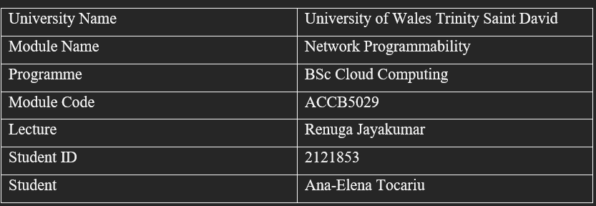

Work Group
- Stage 1
  - Team Name: Desperados

  - Team-Member Roles
 | Name | Skillset, Interests
Facilitator | Dzhuliano | He is setting the structure of GitHub group project and he developed main.py python file and API implementation.
Team Member | Luigi | Design HTML structure and implementation
Team Member | Ana | Structure, implementation, and research of API for main.py file
Team Member | Carlos | Design HTML structure and implementation

  - Ice-Breaker Questions

Member Name | Question | Answer
Ana | If you could try any food, what would it be? | I will love to try Asian Food.
Dzhuliano | Do you like dogs or hot dogs? | Both.
Carlos | How often do you open the fridge and wander what to cook? | Few times a day.
Luigi | Do you like to cook | Yes, a lot.

- Stage 2

2.1 Team Name: Ana, Carlos, Luigi and Dzhuliano
2.2 Scrum Leader: Dzhuliano
2.3 How did you select the scrum leader:
We have a short meeting with all the members of the project, and we have decided that Dzhuliano will be the perfect matching for this position of team leader based on his collaboration, able to foster teamwork and cooperation, a servant leadership, his having ability to support and empower the team. He has good experience of how to use GitHub and he has passed DevOps training which was useful in our project.

2.4 Did you define any other agile team roles?
When we start to discuss with our team what everyone should do, we have decided that Carlos and Luigi are going to build the interface of the web design and Ana and Dzhuliano they are going to build the python and the API part of the project. We try to meet the requirement based on each one’s qualities.

2.5 Which communication tools did your team decide to use and for what purpose?
Tools | Purpose
Zoom | We were doing some session of zoom call meetings
Email | File exchange
WhatsApp | Daily communication
Trello | As a mind map and task completion.

- Stage 3
3.1 What were the reasons your team selected this option?
Our team selected option number two because our ideas and implementation are that we always wanted to solve a certain problem and to build our own solution for the problem that we face.
3.2 Describe your team’s application and its deliverables. What are the specific objectives of this application?
For this application we try to solve a customer problem us our main objectives of the project.
Our problem which we have face and solve was if a person is not too sure what recipes to cook due to a limited ingredients in the fridge, the person can easily access our app and type: ‘’Please cook for me a portion of pasta with these limited ingredients.’’. Our application will generate how to cook the recipe with the ingredients that you have it.

3.3 Record your team member roles and skillsets.
Team Member | Role/Knowledge/Skillset
Dzhuliano | Python and API
Ana | Python and API
Luigi | Web Design
Carlos Abreu | Web Design

3.4 Project Plan Strategy
As a team, our strategy was to provide a solution to an already existing problem, to try to do as much research as possible and, we try to come up with a good idea that will solve our existing problem efficiently.

3.5 What is the link to your GitHub repository?
GitHub - dzhuliano/NetworkProgramabilityGroupProject: UWTSD Network Programability

3.6 Describe how GitHub was used in your project?
We have used GitHub to push the code, check the errors, and collaborate with our team by making sure that a certain workflow was followed for completion of the project.

3.7 List of future enhancements
Our teamwork was to improve the design and create video tutorials about cooking that will showcase on the website.

- Stage 4

1.I found myself deeply engaged in both personal and collaborative growth while working on this project. As a team member, I was responsible for a variety of tasks that contributed considerably to the project's overall success. While this journey was filled with accomplishments, it was not devoid of challenges that ultimately shaped my learning and problem-solving abilities. To address this challenge, we initiated a series of meetings to collectively reassess our approach. It became apparent that open and honest communication was vital to finding a solution. We redistributed tasks based on individual strengths and timelines, aligning them with the revised project scope. During this project my responsibility was structure, implementation, and research of API for main.py file.
To surmount this challenge, we initiated an open dialogue within the team. By voicing our concerns and insights, we collectively arrived at a consensus to reevaluate our priorities and reallocate resources. This process of candid communication and collective problem-solving not only resolved the issue but also strengthened our team dynamics.
We were doing much research and communicate a lot to face our problem and to try do develop a website to help people solving their issue while they are cooking with few ingredients.
In conclusion, this project was a transformative experience that expanded my skill set, increased my capacity for collaborative problem-solving, and solidified my understanding of the intricacies of Agile methodologies. The journey was marked by my contributions to team coordination, the challenges we encountered and overcame, and the invaluable lessons I absorbed along the way. I'm confident that the insights gained from this project will continue to shape my approach to future endeavours.

Some screenshots of our web design:


