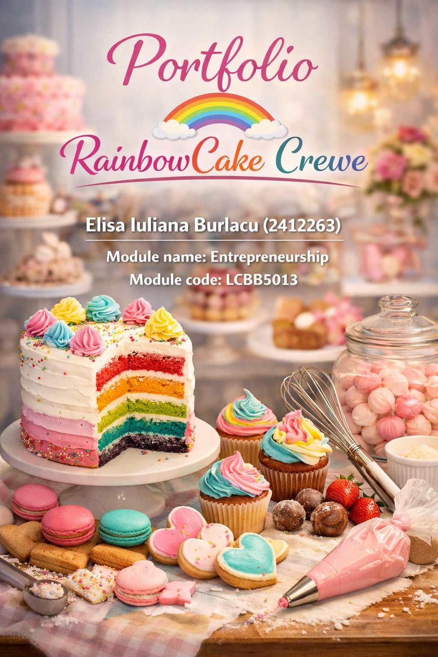

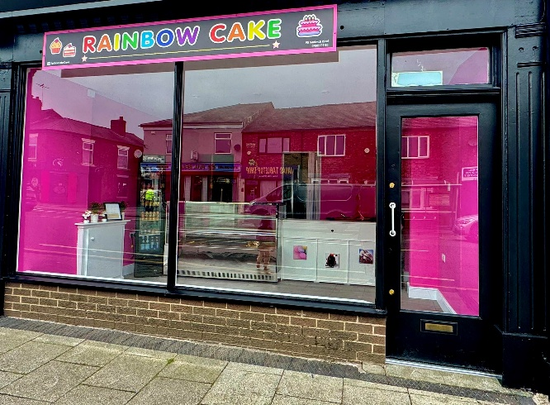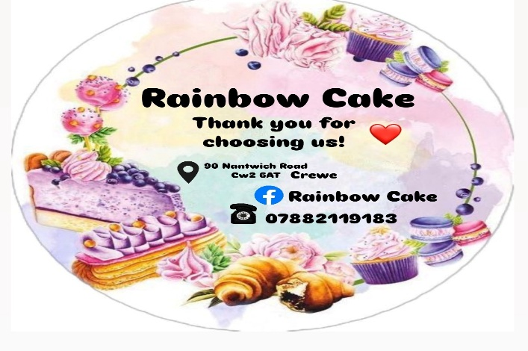

Rainbow Cake Crewe

1.Business Concept

Rainbow Cake Crewe is a new small independent bakery and confectionery business that will be launched on Nantwich Road in Crewe, United Kingdom. We pin it down that the concept is to build a colourful modern cake shop, built around high-quality hand-made cakes, desserts and celebration pastries. The bakery will specialize especially in eye-popping cakes — rainbow cakes, birthday cakes, cupcakes and customized celebration cakes for events like birthdays, weddings and anniversaries.
Rainbow Cake Crewe main idea is to use high quality ingredients with unique cake designs that will attract customers who are looking for something special. Over the past few years, consumers in the UK have begun to embrace artisan and bespoke bakery items over store-bought desserts. This trend presents an excellent opportunity for small artisanal bakeries supplying handmade products.
The business plans to operate mainly as a takeaway bakery, though there will be limited seating for customers who want to dine in and enjoy desserts and drinks in the shop. The shop site on Nantwich Road is perfectly situated as it is one of the most heavily trafficked roads in Crewe boasting a plethora of restaurants, cafés and grocery stores that attract thousands of students, workers and residents.
Instead of a sprawling menu, Rainbow Cake Crewe will focus on a very narrow selection of products. The primary products will be celebration cakes, cupcakes, cake slices, cheesecakes and basic hot drinks including coffee and tea. There will also be a custom cake order where customers can order personalised cakes. We’re all about cakes for birthdays and special moments. Our two standout treats. Rainbow Layer Cake and Chocolate Fudge Cake. People love them—not just for the taste, but because they look amazing and always end up on someone’s Instagram. That colourful rainbow cake really sets us apart and makes sure folks remember us. Step inside “Rainbow Cake,” and you’ll see the vibe right away—bright, cheerful decorations, soft pastel colours, and modern displays. We want the place to feel inviting, somewhere you just must snap a photo and share it. At the end of the day, Rainbow Cake Crewe is here to deliver top-notch handmade cakes, friendly service, and desserts that look as good as they taste. We want every visit to feel special.

Business Objects

Every business that goes the distance needs goals to steer it. Rainbow Cake Crewe is not any different. We are setting our sights on what we want to achieve now, and where we want to be in a few years. First up, the short-term stuff.
—what is on our plate for the first 12 months?
We need a smooth launch, no question about it. People in Crewe should know who we are, spot our logo around town, and think of us when they want something sweet. The real win? Getting regulars who come back for our cakes and love how we treat them. Hitting steady sales matters too. We are aiming to sell 25 to 30 cakes a week, plus cupcakes and other treats every day. We want to cover our bills and see a profit. That is how we know things are working. Social media can’t be ignored. Instagram, Facebook, TikTok, these are where bakeries shine, honestly. People love showing off what they are eating, and we want Rainbow Cake treats popping up in feeds all over Crewe.
Now, looking further ahead
—three to five years down the line
We want to do more. We will add new products, bake more cakes at once, and roll out catering for weddings, parties, and business events. We are also thinking about a second location or setting up delivery for nearby towns like Nantwich or Stoke-on-Trent. Why not? Spreading the Rainbow Cake name feels right. Most of all, we want people to know us as one of the best independent bakeries in Crewe. When someone says “Rainbow Cake,” it should mean something special around here.

Unique Selling Point (USP)

Rainbow Cake Crewe stands out because it blends top-notch handmade cakes with bold colours and custom designs. Sure, plenty of bakeries sell cakes. But Rainbow Cake Crewe leans hard into creativity, cakes that do not just taste good but look amazing in photos and fit right in at any celebration. The signature rainbow cake? That’s the showstopper, and it is what really sets the shop apart. Speed matters, too. Rainbow Cake Crewe lets people order personalized cakes fast, and the prices stay reasonable. Want a cake in your favourite colours, with a special message or unique decorations? You can get it here, without a long wait. And let us talk about freshness. Every cake starts with real ingredients and handmade baking, so people get that premium taste without the premium price tag. It is a dessert spot that feels special but still fits most budgets.

Analysis of the Business Environment & Competitors

PESTEL
Analysis A PESTEL analysis looks at the outside forces that shape a business. (business and management & marcheting, 2026)

Political Factors
Food safety and hygiene rules are a big deal for bakeries. Rainbow Cake Crewe needs to follow UK food safety laws, register with the local council, and keep up with inspections from the Food Standards Agency. Getting food hygiene certification isn’t just smart—it’s a must. ( Hickey , 2026)

Economic Factors
The economy affects how much people spend on treats like cakes. When things are good, people splurge more on desserts. But when prices go up—like when butter, flour, or sugar get more expensive—costs rise, and people might cut back.
Social Factors
Clear labels and honest communication about allergens matter, and customers notice when they’re missing. No one likes surprises when it comes to allergies, and a simple heads-up can make all the difference. (Starting your food business safely, 2026) People in the UK want more than just a slice of cake—they are after unique food experiences, especially desserts that look amazing. Thanks to social media, colourful cakes and creative bakery treats have exploded in popularity. A lot of customers pick bakeries based on whether the desserts will look good in their photos .

Technological Factors
Tech is a big deal for food businesses now. Online ordering, social media marketing, and delivery apps like Deliveroo or Uber Eats help bakeries connect with way more people. RainbowCake Crewe plans to use social media to reach new customers and probably set up online ordering to boost sales
. Environmental Factors
People care more about the environment these days. RainbowCake Crewe wants to use recyclable packaging and cut down on food waste whenever possible. Running the business sustainably doesn’t just help the planet—it makes the company look better, too.
Legal Factors
It’s not just about allergens, either. You need to pay staff correctly, sort out National Insurance and taxes, and keep everyone safe at work. But honestly, when it comes to allergens, there’s no room for being vague. (Key regulations, 2026) Customers count on you to tell them exactly what’s in their food. RainbowCake Crewe has to follow UK employment laws, health and safety rules, food hygiene standards, and pay the right business taxes.

SWOT
They also need to label allergens correctly since that’s a legal must for food businesses in the UK. SWOT Analysis A SWOT analysis shows what a business does well, where it struggles, and what’s happening outside that could help or hurt it . (remi, 2026)
Strengths
RainbowCake Crewe stands out with its bold, colourful cakes and creative ideas. These eye-catching desserts aren’t just tasty—they’re perfect for sharing on social media, which brings in customers. The shop sits on Nantwich Road, a busy street in Crewe, so there’s plenty of foot traffic. They use fresh ingredients and handmake their cakes, which keeps the quality high.
Weaknesses
Like a lot of small start-ups, RainbowCake Crewe doesn’t have endless cash to spend. That means advertising and growing the business could be tough at first. Another drawback? Not many people know the brand yet, especially in the first year.
Opportunities
People really want customized cakes for birthdays, weddings, and all sorts of special occasions. If we offer more personalized cake options, we can bring in a lot more business. Social media is another big chance for us. It's a great way to reach new customers without spending a ton on advertising.
Threats
Supermarkets and other bakeries nearby are tough competition. They usually sell cakes for less, which can make it hard to keep up. If the economy takes a hit or ingredient prices go up, our profits shrink too.

Analysis of competitors-direct, indirect, and future
The bakery’s jumping into a tough market. Customers have plenty of choices and won’t hesitate to swap bakeries if they spot a better price, tastier treats, or just want to try something new. That’s why it’s so important to size up the competition—really dig in and figure out how to stand out and build a loyal following.

- Direct Competitors
Other cake shops and bakeries in Crewe that basically offer what you do—cakes, cupcakes, custom orders, the whole lot.
- Greenway Cakes does artisan cakes, cupcakes, and brownies.
Amazing Cakes has a reputation for custom cakes and high-end desserts. (our shop, 2026)
- Cakes by Stacey Anderson makes personalized cakes, though sometimes only seasonally or in limited runs. These shops go head-to-head with you on cake variety, custom options, and quality.

- Indirect Competitors
- Now, there are also places that sell sweet treats, but cakes are not their main thing. Still, they pull in the same crowd. Finigan's Bakery serves up classic pastries, cakes, and other desserts. Greggs is a big chain with cakes by the slice, sweet pastries, and all sorts of grab-and-go desserts. Plus, you have a bunch of small cafés and dessert shops around town, all offering ready-to-eat sweets. Here, the competition is about convenience, price, and those quick sugar fixes. (Parker , 2026)

- Future Competitors
Looking ahead, a few players could shake things up in Crewe:
- Cake Box, a big franchise, is already eyeing expansion in the area. Supermarkets like Tesco and Aldi keep growing their fresh cake and dessert sections. And then there are these new ideas popping up, like interactive cake shops where you pick your own toppings and customize everything. These newcomers could pull in a different crowd or bring something new and convenient that changes what people want from traditional cakeshops. (about cakes, 2026)

By laying out competitors in these three buckets, a bakery gets a clear look at what’s happening around them. This helps spot market gaps, catch onto new trends, and figure out smart ways to stand out—like creating signature recipes, using premium ingredients, or giving customers a more personalized experience.

4Ps, Market Segmentation & Marketing Strategies

Market Segmentation

Segmentation
Rainbowcake Crewe, sorts the local bakery and pastry crowd by how people behave, what they care about, where they live, and who they are. Everyone’s welcome—students, working folks, retirees. Some people come in for a well-deserved treat or a pick-me-up in their busy day. Others just want something quick and convenient, especially if they work nearby. The bakery focuses on customers who actually go out of their way for fresh, artisan pastries, with Crewe as the starting point.

Segments to target
- Health-conscious, casual dessert fans These customers want to know what’s in their food. They go for “lighter” options—think fruit tarts, yogurt parfaits, wholegrain pastries. If the quality’s good every time, and they can add a little something special like nuts, chocolate, or fresh fruit, they’ll keep coming back.

- Professionals and commuters who are always on the go .

This group covers working people of all ages who need a reliable bakery that’s fast and easy. They don’t have time to wait, so grab-and-go, click-and-collect, and speedy service matter most.

- Young adults, kids, and students
Younger customers pay attention to price. They listen to what their friends say, look for specials, and love desserts that look great. To draw them in during the week, Rainbowcake Crewe, offers a student discount if you show your student ID.

- High-end weekend treat seekers Some folks want the best and are happy to pay more for it. They come for gourmet pastries, fancy cakes, and desserts that look as good as they taste—perfect for sharing on the weekend.
- Targeting Rainbowcake Crewe, focuses first on the health-conscious and busy professionals because they show up during the week and are likely to become regulars. Students and young adults get special deals to boost weekday business. On weekends, the bakery shifts attention to people looking for something extra special, aiming to raise the average spend.
- Positioning Right now, Rainbowcake Crewe, is all about Crewe. The plan is to build a reputation here over the next few years, then branch out to share quality, artisan pastries with more people in other cities.

4Ps (Product, Price, Place, Promotion)

- Product rainbowcake Crewe stands out with its core menu—artisan sponge, tarts, and pastries. If you want to upgrade, you can add things like specialty chocolate, seasonal fruit, or order layered cakes. Recipes stay consistent to keep quality high and training simple, plus it cuts down on waste.
- Price The bakery uses a tiered system: single pastries or small tarts for entry-level, cake slices or dessert bundles in the middle, and whole cakes or special desserts at the top. This way, there’s something for bargain-hunters and people who want a premium experience. Smart portion sizes, tempting add-ons, and bundled deals help boost sales without muddying the brand.

EXAMPLE
Cupcakes £2.50
Cake slices £4.50
Small celebration cake £25
Custom cakes £40-£80
- Place Location matters, so the bakery sits in a spot that’s easy for commuters and locals to find Nantwich Road , with great visibility in Crewe. Whether you want to eat in, take away, or grab your order fast with click-and-collect, you’re covered. They’ll also test delivery to nearby offices, making sure quality and speed stay high.
- Promotion Rainbowcake Crewe its look consistent everywhere—on social media, in the shop, and on the menu. Eye-catching photos show off what makes the bakery special. The grand opening features bundle deals, free pastry samples, and encourages customers to leave reviews. For ongoing buzz, they’ll team up with local businesses like gyms and cafes and offer promos aimed at commuters to keep people coming back during the week.

Marketing strategies
Get Noticed
Let’s start with the basics: keep your Google Business Profile sharp. Choose the right categories, link up seasonal menus, update your hours, and swap in fresh photos regularly. Keep the reviews coming in, too. All this pushes your local SEO to the top. Then, grab some attention with quick, snappy content and affordable, geo-targeted social posts. If you post in the morning, you’re more likely to catch people nearby.
Make It Easy to Buy
Ordering should be a breeze. Lay out the menu so people can pick a cake, add a filling, toss on some toppings—done. A setup like this makes decisions faster and lines move quicker, even when things get busy. Clear add-ons and go-to options help boost orders without slowing service.
Keep Them Coming Back A loyalty deal
Like “buy 5 pastries, get 1 free”—gives people a reason to return. Ask for honest reviews and invite folks to sign up for updates. When you keep up with regular promotions and show off happy customers, you build real trust and keep those connections strong.

Legal, Management, and Financial Planning

- Limited Company (Ltd)
A Limited Company is a business set up and registered at Companies House in the UK. It stands on its own as a legal entity, separate from the people who own it—the shareholders. If you’re a shareholder, you only risk the money you’ve put in, so your personal assets stay safe. Limited companies can hire staff, own buildings, sign contracts, and borrow money. Directors run the show, and if you own more than 25% of the shares, you’re officially called a Person with Significant Control (PSC). (macey, 2026)

- Sole Trader

Being a Sole Trader is the simplest way to start a business in the UK. One person owns and runs everything, and there’s no legal wall between you and the business. If the business owes money, you’re on the hook for it. You pay tax on your profits through self-assessment, and you need to let HMRC know you’re self-employed. (What a sole trader is, 2026)

- Partnerships

A Partnership is when two or more people join forces to own and run a business together. They usually draw up a partnership agreement that spells out who does what, how profits get split, and who’s responsible for debts. In the UK, most partnerships stick to 20 partners or fewer unless stated otherwise. (HMRC internal manual, 2026)

- Franchises
A Franchise lets someone (the franchisee) buy the right to run a business using another company’s (the franchisor’s) brand, products, and systems. The franchisee pays fees—usually an upfront cost and then regular royalties—and follows the franchisor’s rules. In return, the franchisor offers training, support, and the use of their brand. ( Montevirgen, 2026)
- Social Enterprises
Social Enterprises are businesses with a mission beyond just making money—they exist to make a social or environmental impact. In the UK, there are about 100,000 of them, employing around 2.3 million people and bringing in roughly £78 billion a year. These businesses reinvest their profits back into their projects, which can range from recycling schemes and cafés to creative agencies and public services. (Social Enterprise UK, 2026)
- Online Enterprises
(CIO / Digital Businesses) Online Enterprises in the UK sometimes take the form of Charitable Incorporated Organisations (CIOs) when they have a charitable goal. A CIO can own property, sign contracts, and hire employees, but trustees aren’t personally liable for its debts. Instead of registering with Companies House, CIOs go through the Charity Commission. Of course, plenty of digital-only businesses are set up as Limited Companies or sole traders too. (Plutus Blog, 2026)

Legal and Management

We’ve set up Rainbowcake Crewe, as a Private Limited Company (Ltd) because it keeps our personal assets safe if anything goes wrong—like lawsuits or debts. That’s a big deal for bakeries, since we’ll be signing leases, hiring people, and jumping through all those health and safety hoops . This LTD setup also makes it easier for us to grow, manage things properly, and attract future investment. Investors and partners like knowing there’s a clear structure and a bit of transparency. At the start, we’re keeping things simple—a team of four. I’m the owner and CEO, but you’ll find me in the kitchen, hands deep in dough most days. My spouse is jumping in as manager, looking after admin and making sure everything runs smoothly up front. The other two team members have their hands full too, helping with baking, cleaning, serving customers, and picking up the pace when things get busy. (gov.uk, 2026)

Financial planning

Starting Rainbowcake Crewe, will cost anywhere from £25,000 to £70,000. The exact amount depends on what equipment we need and the shape of the place we move into. This budget covers all the basics—ovens, mixers, furniture, small stuff like trays and utensils, signs, fitting out the shop, and enough working capital to get us through those first few months. We’ll use that working capital to pay salaries, keep the lights on, run marketing, cover insurance, pay for licenses, train the team, and buy our first round of ingredients and packaging. To actually get the money, we can look at asset finance or leasing equipment, which takes some pressure off up front. There are also UK Start Up Loans through GOV.UK and the British Business Bank, plus whatever we can put in from our own savings. Since a lot of baked goods have allergens—think dairy, nuts, gluten—we’ll make sure to display allergen info clearly. If we package anything for direct sale, we’ll follow the Food Standards Agency’s rules on labelling, so customers always know what’s inside. (gov.uk, 2026)

Cost Category | Purpose | Estimated Cost (£)
Rent (12 months) | Premises cost at £1,800 per month | 21,600
Fit-out and interior setup | Preparing the bakery for trading | 5,500
Signage and branding | External signage and brand materials | 1,500
Seating and smallware’s | Tables, chairs, utensils, serving items | 2,000
Preparation and refrigeration equipment | Bakery ovens, mixers, and refrigeration | 8,500
Initial inventory and packaging | First stock of ingredients and packaging | 3,000
Insurance and licensing | Business insurance and legal compliance | 1,200
Staff training | Food hygiene and service training | 1,000
Wages and salaries | Staff support during the first year | 12,000
Utilities | Electricity, water, and other running costs | 2,500
Marketing | Launch and first-year promotion | 1,500
Working capital buffer | Reserve for cash flow and unexpected costs | 4,000
Total Estimated Cost: £63,800 – covering start-up and first-year operational support.

