

Assessment 1 – Reading Task Template
PART 1: Upload your photo of your A3 in-class notes here:
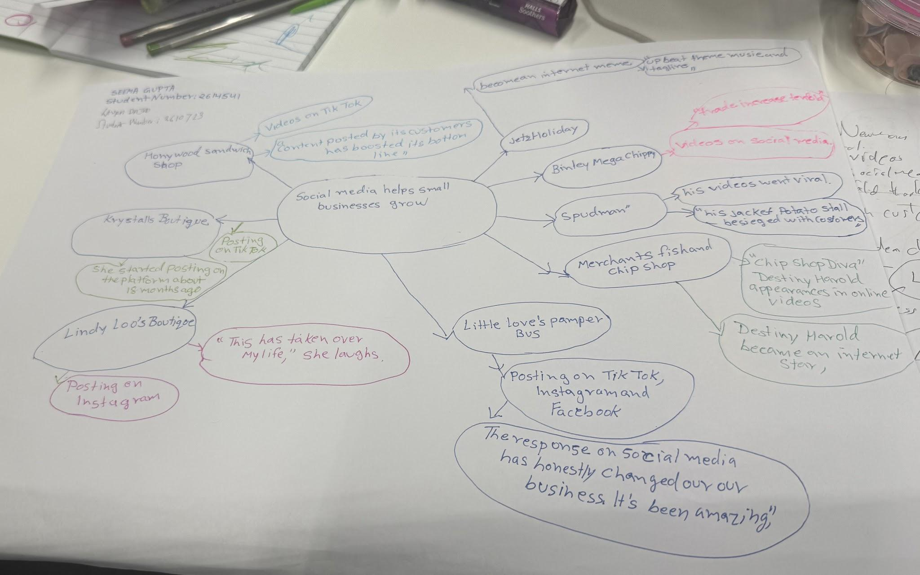

PART 2:
- Answer every question below in 1-3 full sentences.
- Use your own words. Do not use generative AI to answer these questions.
- Include a specific detail from the text when asked.
REMINDER
- The main idea is the overall message of the whole text.
- A key point helps to explain the main idea.
- A specific detail or example from the text shows that the key point is true.

- What is the main idea of the whole text?

The main idea is that businesses are thriving because of social media.

- What is one key point that supports the main idea, and which specific example from the text shows this?

A few businesses have benefitted from the rise of social media.

“Businesses are currently enjoying boost in business after going viral”

- What is a different key point that supports the main idea, and which specific example from the text shows this?

The sandwich shop posts videos on TikTok and numbers of customers are increasing.

“`A flurry of customers have already been through the door” and “people will be turning up from far and wide”.

- Which part of the text do you think is most important, and why?
"Subliminal marketing and little skits... are such a good way of showing someone your brand in a really authentic, relatable way so they can look at that and go, 'Oh, I like that brand - I'm going to purchase from them.'"
It summarises the whole article by relating it to people and what they want and need - human connection (via social media) to then sell the brand.

Reflection:
- What did you find difficult in this task (including in-class components), and why was it difficult?
I think it was deciphering what the most important points were, as there were a lot of names of people and instances but understanding the crux of what was being said felt a bit tricky.

- What helped you with this difficulty, and how did it help you?
Just re-reading things and analysing the text and scanning for information needed. Just taking the time to do it rather than rushing.

