Shericka Nelson

Certificate of Higher Education in Skills for the Workplace
29/08/2019

Table of Contents
Introduction 1
What is communication 2
How it works 2
The importance of communication 2
What are the different types of communication? 3
How communication can be effective in a businesses or organisations 4
Outcomes of applied effective communication 4
…………………………………………………………………………….5
Established models 6
Effectiveness 6
Communication in my workplace 7
Our workplace further improvement aims 7
Conclusion 8
Reference list 9
Appendices 10
Section A 10
Section B 11
Section C 12

Introduction
Communication is like a form of transport but in a way for humankind to correspond. Today I am going to be explaining, what communication is and its effectiveness. This report will also comprehend of relevant theories and the different types of communications. You will find key information on, how we solve communication problems in our workplace, and if it is a good idea to apply theories in workplace to improve communications. At the end of this report you will have a clear understanding, on specific related questions in this report. Finally, there will also be a reference list at the end of this report, with efficient information for those who want to research on these factual studies.

What is communication

How it works
Communication is a form of a pervasive process. As I have mentioned in the introduction communication can be seen as a type of transport. Many people would be wondering how that makes sense. To elaborate further on this, without communication there would be no way of humanity to conversate and exchange information. This means that people can send and reciprocate information, ideas, opinions and concepts from one place to another in different types of styles in communication.
Most people think that communication is a type of language. This is not a fact, to break it down in an easier interpretation the term of language is a tool that originates from communication itself. The process of communication is that we put to together meanings as we communicate with other people. This is done by processing information in our heads. This is explained by (Duck 1994; Keyton & Beck, 2010) as cited in (Quintanilla & Wahl 2017).

The importance of communication
It is very important because it is used on a regular daily basis, in numerous of different kinds of environments. Communication is needed for work placements, presenting information to a group, and commonly it is additionally used to make friendships. I have stated furthermore information about this further on in this report. Work placements is one of the most efficient frequently places where certain levels of communication are required within organisations. This is because most all job entails communications in some kind of way.

What are the different types of communication?

There are four types of communication that people use every day in different types of fields in life.
- Verbal communication
- Written communication
- Nonverbal communication
- Visual communication
Verbal communication happens in a way of speaking, not only that but equally sign language to. This type of communication is seen in phone calls, video conferences, meetings and face-to face conversations. When using this type of communication there are multiple ways of making it effective, an example of this is using a strong cadence speaking tone. This means according to the message a person is sending their voice can get higher or lower as they speak. Generally, it all comes down to, as to how you want the other party or parties to receive your message. According to Mehrabian’s (1981) done a seminal research on nonverbal communication. He found out the verbal component that a listener uses to interpret a message, which he came to the calculation that was 7% of verbal cues are from words.
Nonverbal communication is used in a way of gestures, facial expressions and even body language. Using this kind of communication is more of an emotional way of an expressing. This can be seen when a person crosses their arms or legs. This gives of the sign that the person could be angry or anxious. Nonverbal communication is not very precise, this means conversations can be a twist of information at times. If you are mindful and intentional when using this type of communication, you can make your message come across to how you want the other person to receive. This can be whether you want it to be received in a positive or negative way. Research indicates that about 55% of interpersonal messages are conveyed nonverbally (Lavan 2002) cited in (Quintanilla 2017).
Written communication is a function of writing or typing. This communication is seen sharing information like sending emails, writing letters, books and memos. I have mentioned previously that communication is needed in work placements, this is because referring to written communication it plays a big role in this profession. Written communication must always be clear for the reader to understand, as it has a different impact to verbal and nonverbal communications. Punctuations in texts are usually used in type of communication. This is because it helps the writer to express their emotions in their text.
Visual communication is known by the use of art, drawings and photos. Customarily this communication associates with presentations. It sustains a great aid alongside written and verbal communication. This kind of communication is very beneficial to those who find it easier in learning visually, as it helps them gather better ideas and information relating to topics. This communication is based on all to do with the eyesight.

How communication can be effective in a businesses or organisations

Outcomes of applied effective communication
It is very vital to have an effective way of communicating. If a business owner does not communicate effectively, it can result in the business turning out to be a failure along with other problems. Effective communication can result in goals and aims being achieved within these industries. This is because staffs will have a clear understanding of what the manager wants and expects. Also, with effective communications managers and staffs can analyse what is working for the business.
Staffs can work towards aims and deadlines and given tasks can be completed much quicker. The reason for this is because there will be less confusion. Your skills of communication are what makes your communication effective. A few examples of this is attentiveness, positive body language, and understanding nonverbal signs. More useful effective communication can be:
- By using proper language this means that the message should be appropriate and understanding to the reference of the receiver.
- Constance behaviour in work also work well, this mean by giving credibility were its due whenever its due. A manager should always be aware that their actions and deeds they perform, should be according with their communication of what they present.
- Feedback has an advantage and must be analysed to be effective for a workplace. Without feedback communication is less effective.

It is very important that all individuals learn to practice pitch and tone when speaking. This is only if they want to become an effective communicator, as is plays a role in effective communications. This was also spoken on by (Prachi Juneja n.d.).
Teamwork is very important when it comes to workplace industries. Teamwork is working with a number of people to accomplish a task or a goal. Muchinsky (2003) argued that group and teamwork are actually the same thing, where it consists of a number of people working together to complete something cited in (Morgan 2017). When working in a group communication is the key for success, people need to have an understanding and needs to be able to communicate with each other.
There are a few key elements that a required when working in a team. Assertiveness is important in a group as many others have their own opinion and beliefs. Being assertive also means to stand up for your rights or what you believe in, while being mindful of others. Baney (2004) suggests that attentive can best be expressed by including the following three components: I think, I feel, I want this is found in (Morgan 2017)
Active listening should also be applied when working in a group. This is so you can be able to gather and collect information from the speaker. This method also helps to not miss out on key points, and to not have misunderstandings within your group. Kegan (1994) said an accurate understanding of others is needed before a meaningful response can be made cited in (Morgan 2017). This is true because if a person does not have an understating all interpretation will be inaccurate. Listening is all part of understanding and can have an impact when done in the correct manner
Playing your role in a team means being involved by contributing your duties within the group. This also relates to a group to not have a centralized communication. Brown & Miller (2000) has observed that one of the most important features of group communication, is the level of centralization cited by (Morgan 2017). When only certain members of a group do most of the talking, generally comments are directed towards these specific members in the group, it is then said to have a centralized communication structure (Huang & Cummings, 2011) cited by (Morgan 2017).
The last resort to improve communication within a business or an organisation, after trying all the suggested examples above, would be to take further training via communication. Training via communication this means that, people in a business or an organisational firm usually encounter training to develop and improve their skills that is associated within their role. It also trains them to improve in other roles within their organisation.

Established models

Effectiveness
There are three commonly known models of theories on communication which are: Shannon and Weaver, Schramm and Berlo. These theories are very effective when they are being used in a business or an organisation. I am going to explain the differences between them all, how effective they are? and how they are used?
Shannon and Weaver: This model was established in 1948, when Claudia Shannon also known as just Shannon wrote an article about a “Mathematical theory of communication” in Bell system technical journal with scientist, Warren Weaver also known Weaver cited in (Shannon & Weaver 1949). One of the differences with this model compared to other models is that, this model is a lot more scientific and more of technical knowledge. The concept of this model is all to do with:
- Sender this is the person who sends the messages, this is also named as (information source)
- Encoder this is the machine that is used to transmit the information source to the other person. The machine then converts the sender message in to signals or a binary data. This is also known as (transmitter)

- Channel this is the type of medium used to send the message. Medium means how the communication is being received for example it can be nonverbal, written or oral. The channel part is nevertheless the form used to communicate for example by telephone, letter or email.

- Decoder is known as the receiver the person on the other end. The decoder converts binary data or signals into the message, this is done by a machine which is the decoder. Another term for this is also known by receiver, who translates a message from the signals.

- Receiver this is the person the sender sends a message to; this is known as final destination.

- Noise this is the background side of a message being sent. An example of this is environments or people, which does not allow the message to be sent to the receiver as what is was sent.

Schramm this model was established in 1954 by Wilbur Schramm. Schramm theories was based on effects of communication with the receiver. Uma Narula (2007) suggests that Schramm used effects and effects analysis components of Berlo model in 1960. Schramm strongly believed that communication is not effective, if the receiver does not send a feedback to the recipient, this was stated in (Schramm’s Model of Communication 1954).
The disadvantage with this model is that it does not focus on noise concept as much. This model has similarities to Shannon and Weaver (1948). This is where semantic noise interpretation can affect the communication between the sender and the receiver.
Berlo this model was established in 1960 (see Appendix section A). It is known for a being a logic way of communication according to Janse B (2018). This model is not known for having feedback and is consisted with four components. These are sender, message, channel and receiver, the same kind of method as the previous models stated. This model looks into more thorough details around communication. Berlo model also analyses aspects that can affect the source which are, the five senses, social systems, religion and values.

Communication in my workplace

In my workplace it is very efficient for employees to have a high effective standard of communication skills. I work as an emergency call handler which is a very busy place, we deal with all different kinds of emergency calls all day and approximately every 10 seconds. Communication is done in many contrasting ways. The importance of our job is to be able to communicate with the caller and find safe and reasonable solution to solve their problem. Sometimes in the workplace interruption does affect the communication levels between two parties. This is similar to the theory of (Schramm 1954) with noise interruption. This is called external background factors this is what has an impact on hearing the message from the sender, this is described more in (Morgan 2017, p. 248).
In reality no business or organisation runs smoothly with no communication problems at all. in my workplace we try our best to always having an understanding with our colleagues. We use have a policy that we follow this includes:
- Being clear when spoken
- Listen intently
- Make eye contact when speaking
In our office we also practice improving out communication skills, attending work meeting regular. Individuals brings their own ideas to the table; with other effective way they speculate communication can be improved at work. Because we follow a policy that I have previously mentioned above, people are willing to work as a team. We always make sure other employees feel comfortable, by using friendly body language and polite tones of voice. We have an effectual team at work, and we have accomplished that by following our policy which built loyalty and satisfaction amongst other employees to be able to work together.
I have also learnt about effective communication at my university. We have practice some theories models see (Appendix section C).

Our workplace further improvement aims
Communications
We intend to follow the approach of Sandler Rules: 49 Timeless Selling Principles and How to Apply Them (Mattson, 2010). His rules signify tips on how to make communication effective, he speaks about on professionalism, ways to engage and observation. If this rule come takes place in the workplace, it will improve many aspects to everyone communication skills. There will also be a clear division.

Conclusion

This report has showed us, that communication is very crucial and can be influential if done with the correct technique. Before following our policy in our workplace, people were experiencing a lot of confusion. It affected them in the way in which they worked and communicated with other staffs. Since applying these theories in our workplace, there has been a significant improvement. This has been seen in the aims and goals of the workplace, being achieved more efficiently and quickly. Finally, it has been proven to say that applying theories in a workplace is really efficacious, as it has worked magnificently in our workplace.

Reference list

Businesstopia, 2018, Shannon and Weaver Model Of Communication, digital image, viewed 28 August 2019, https://www.businesstopia.net/communication/shannon-and-weaver-model-communication.
Janse, B 2018, Berol’s Model of Communication, digital image, viewed 28 August 2019, https://www.toolshero.com/communication-skills/berlos-smcr-model-of-communication/.
Janse, B 2018, Berol’s SMCR Model of Communication, viewed 28 August 2019, ToolsHero, < https://www.toolshero.com/communication-skills/berlos-smcr-model-of-communication/>.
Mattson, D 2010, The Sandler rules: 49 timeless selling principles and how to apply them, Hamilton, N.Z, New Zealand.
Mehrabian, A 1981, Silent messages: Implicit communication of emotions and attitudes, Wadsworth Publishing Company, Belmont.
Morgan, P 2017, The Business Student's Guide to Study and Employability, SAGE, London.
Narula, U 2007, Communication Models, Atlantic Publishers & Distributors Pvt Ltd, India.
Quintanilla, K 2003, Business and Professional Communication: KEYS for Workplace Excellence, SAGE Publications, California.
Quintanilla, K, & Wahl, S 2017, Certificate in Higher Education: Skills for the Workplace Student Yearbook, SAGE Publications, London
Schramm’s Model of Communication 1954, viewed 28 August 2019, < https://www.managementstudyguide.com/schramm-model-of-communication.htm>.
Shannon, C & Weaver Warren 1949, The Mathematical Theory of Communication, University of Illinois Press, [s.n.]
Shannon, C 1948, ‘A Mathematical Theory of Communication’, The Bell System Technical Journal, vol. 27, pp. 379-656.

Appendices

Section A

Figure of Berlo model of communication.
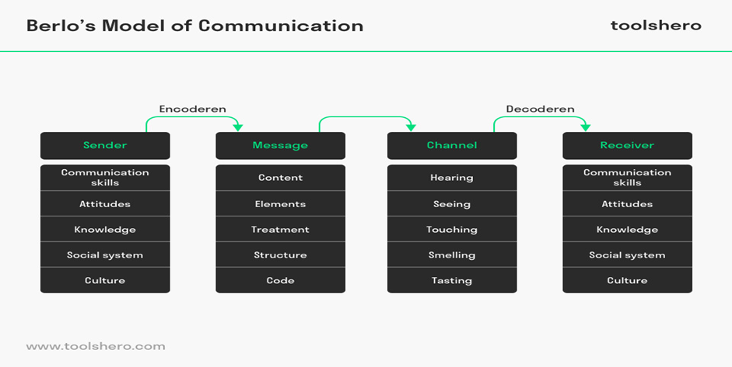

.

Section B

figure shows Shannon and Weaver model on communication.
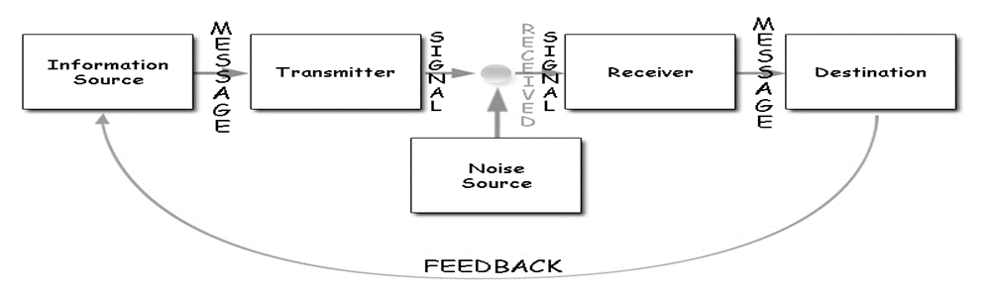

Section C



