University Of Wales Trinity Saint David
School of Engineering

MODELLING INDUSTRIAL CONTROL SYSTEMS IN MATLAB
ACMA6001

Aled Thomas
2206212
28th July 2025

Table of Contents
1 Introduction 1
2 Cruise control code 2
2.1 Signal encoding/decoding functions 2
2.2 Feedback controller design 3
3 Controller tuning methodology 5
3.1 PID tuning 5
4 Additional challenges 10
5 Conclusion 11
6 References 12
7 Appendix 13
7.1 Cruise control script 13
7.2 PIDcontrol function 17
7.3 getRawVelocityDemand 18
7.4 getRawVelocity 18

Figure 1 - getRawVelocity() function encoding the velocity in x-bit binary from mph (x is the number of binary digits) 2
Figure 2 - Decoding raw velocity signal from binary to decimal (R = 2¹⁶ = 65,535). 2
Figure 3 - Proportional part 3
Figure 4 - Integral part 3
Figure 5 - Derivative part 4
Figure 6 - PID control output formula 4
Figure 7 - Oscillations at ultimate gain 5
Figure 8 - Code to find period of oscillations 5
Figure 9 - Table of Ziegler-Nichol method formulae (Woolf, 2009) 6
Figure 10 - Velocity response to Ziegler-Nichols method 6
Figure 11- Throttle/brake effort for Ziegler-Nichols method 6
Figure 12 - 15% steady state error, P only tuning 7
Figure 13 - Throttle and brake control effort trial and error method 8
Figure 14 - Best acceleration response trial and error method 8
Figure 15 - Best Jerk response trial and error method 9
Figure 16 - Code for average error 11

Table 1 - Bit resolution and steps (steps includes index 0 in range) (Mushtaq, 2023) 2

Introduction
This report will analyse a digital cruise control system created using MATLAB. The control method will be a Proportional-Integral-Derivative (PID) controller (Panda, 2012). PID controllers are feedback correcting logic controllers that use the addition of its three parts to reduce its error. Proportional represents the present, integral is the past, and derivative attempts to predict the future ( Åström & Hägglund, 2001). PIDs are used to control highly complex processes, often within industrial processes such as flow level, and temperature regulation. Such as chemical coating mixtures, machine tooling, etc. They are also used for speed and position regulation in most types of vehicles, such as cruise control systems ( Voloşencu, 2025).
408 tuning rule sources were recorded prior to 2006 as per a paper by the Dublin Institute of Technology (O'Dwyer, 2006). These are methodologies developed using control engineering to enable fine control response outputs for actuators from the input signals of sensors. This report attempts to find a method with a high degree of accuracy and use it to tune a PID to be used in a simulated cruise control system for a car. The velocity, acceleration and jerk will be recorded over a simulated period and plotted. The PID will then be tuned to ensure the program falls within the acceptable criteria of a cruise control system. This will be achieved using specifications and general data from passenger comfort studies.

Cruise control code

Signal encoding/decoding functions
Velocity is generated from a function called getRawVelocity() which is a simulated sensor measurement called from the communication bus. The function is encoded in a variable binary bit number using the MATLAB function ‘dec2bin()’ (see figure 1 below), this allows decimals to be converted to a binary number (Mathworks, n.d.). 16-bits was chosen as the encoding size which allows the mapping of the speed limits of the vehicle, 0 to 150mph, to be mapped to the 16-bit decimal storage of 0 to 65,535. This gives a resolution of 0.00229 mph/bit. This means any data that falls under this resolution will fail to be picked up by the PID, this is a very small loss, which is unavoidable in digital/analogue conversions (Quevedo & Goodwin, 2015). 16-bit was chosen as the storage amounts jump drastically. 8-bit can only store between 0 and 255. These bit numbers are related to computer architecture and chip memory addresses. 16-bit is a common, low-cost CPU (central processing unit) architecture (Mushtaq, 2023).
Table 1 - Bit resolution and steps (steps includes index 0 in range) (Mushtaq, 2023)
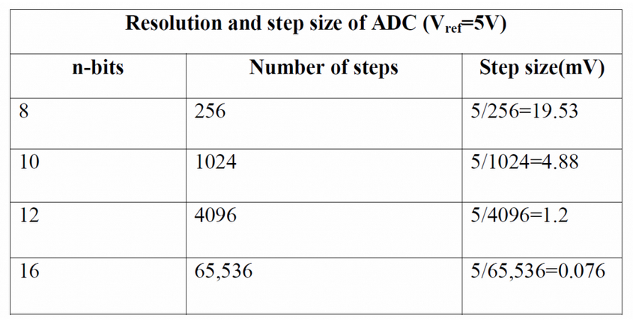
The code then decodes the returned raw binary value from the function back to decimal using the opposite function ‘bin2dec()’, to simulate the retrieving and decoding of measurement signals in the controller (see figure 2).
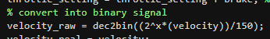
Figure 1 - getRawVelocity() function encoding the velocity in x-bit binary from mph (x is the number of binary digits)
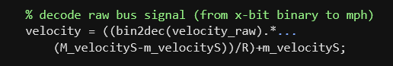
Figure 2 - Decoding raw velocity signal from binary to decimal (R = 2¹⁶ = 65,535).
The demand from the simulated driver is also encoded and decoded in the same manner with a possible range of 30 to 110 mph. The resolution for this signal is 0.00122 mph/bit.

Feedback controller design
To moderate the vehicle’s velocity regarding the driver’s demand, a PID controller is implemented in the code as a function. The PIDcontrol() function aims to lower an error value, calculated as the difference between the demand and the velocity, using a feedback loop adjusting the control to make the velocity equal to the demand. The error value should get smaller the closer velocity gets to the demand.
The proportional part is calculated simply as the error multiplied by the proportional gain variable ‘P’ (see figure 3). In a closed loop system, it represents the simplest continuous control part. But it can introduce steady state error through an offset from the set-point (Woolf, 2009).
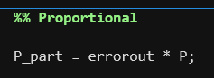
Figure 3 - Proportional part
For the first loop of the PIDcontrol() function, the previous I part needs to be persistently set as the starting control variable which is initialised as 50% throttle so it can be called on the next iteration. In subsequent iterations the previous I part is set as the current I part only after it has been used. The variable ‘prev’ stores the previous error value. These values are important as they are used in the calculation of the Integral and derivative parts of the PID control output. The integral’s role is to remove the offset by responding to accumulated past error, it does this by taking the average of the current and previous error multiplying it by the sampling time and adding the persistent variable then multiplying by the integral gain value (see figure 4) (Woolf, 2009).
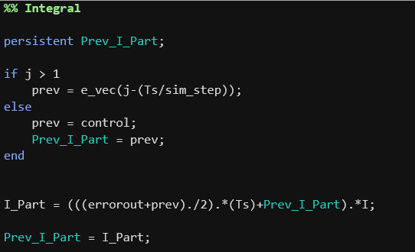
Figure 4 - Integral part
The derivative part is a forward control that focuses on the future ( Åström & Hägglund, 2001). It does this by analysing the change in the error over time to predict conditions. This can resist changes to the system, such as oscillations caused by the integral, thus improving the stability of the system. This is calculated by subtracting the previous sim step error from the current one over the time step to give the rate of change in relation to time. This is then multiplied by the derivative gain value (see figure 5) (Woolf, 2009).
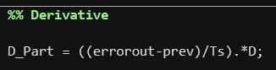
Figure 5 - Derivative part
All these parts are then added together to form the PID control output value. There are limitations where the output might sometimes want to act more aggressively than the actuators are capable of to return to a steady state. These limits are programmed in as +100% throttle and -100% braking limits (see figure 6)
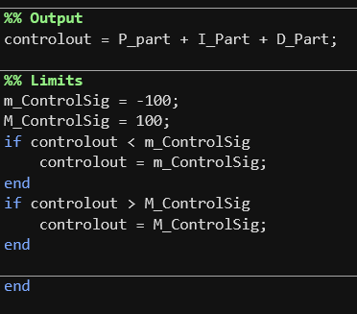
Figure 6 - PID control output formula

Controller tuning methodology

PID tuning
Initially, the Ziegler-Nichols PID tuning method was used. This works by making the integral and derivative zero and slowly increasing the proportional gain (P) until oscillations are observed at every point of the simulation, once reached this was plotted as figure 7 below. This value, called the ultimate gain (Ku), happened at P = 17. The oscillation period (Po) was measured using the code in figure 8. This was outputted as Po = 0.59017.
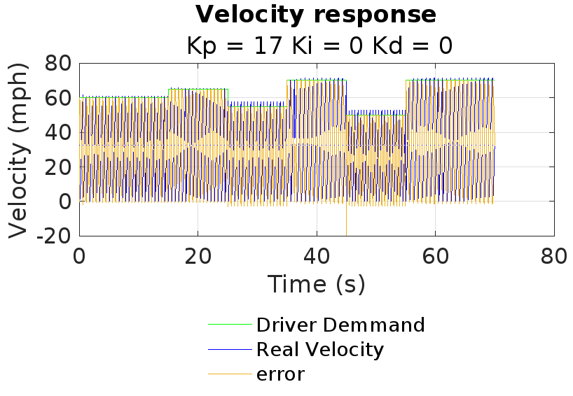
Figure 7 - Oscillations at ultimate gain
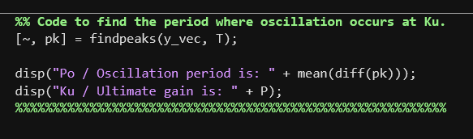
Figure 8 - Code to find period of oscillations
Then using the Ziegler-Nichols formulas for the gains, the parameters were set to P = Ku / 1.7, I = Po/2, and D = Po/8) (Woolf, 2009).
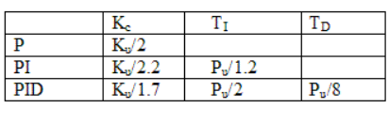
Figure 9 - Table of Ziegler-Nichol method formulae (Woolf, 2009)
However, using these values led to oscillations in areas where demand dropped suddenly, outside of oscillation zones, the steady state error was more than 10% off the set-point (see figures 10 and 11). The oscillations caused Acceleration to reach maximum values of 2685.68 m/s² and the Jerk reached 134284.07 m/s³. This method assumes linearity and lacks the adaptability for the complexity of the controller. The simulated car was too much for this approach to properly tune for and as such, a new method was required.
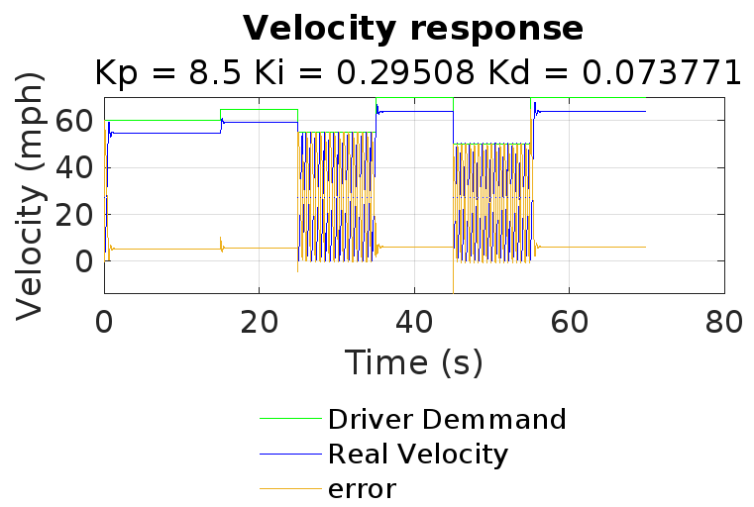
Figure 10 - Velocity response to Ziegler-Nichols method
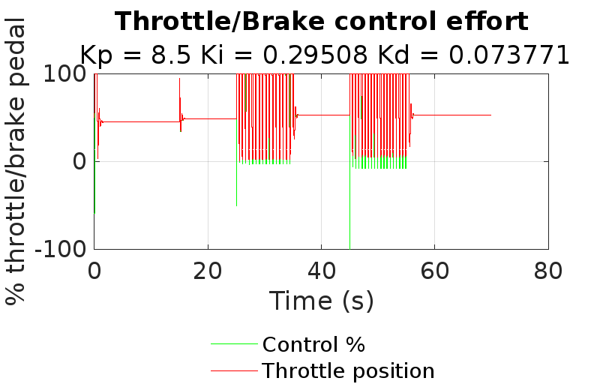
Figure 11- Throttle/brake effort for Ziegler-Nichols method
A trial-and-error manual tuning method was then applied instead. The P value was raised to 15% steady state error (as shown in figure 12 below), the I value was then raised to offset the error closer to the demand value. Lastly, the D value was raised to smooth out any overshoot and unsteady oscillations. The best values were found to be P = 0.1985, I = 1.0002, and D = 0.02655 as plotted in figures 13 to 15 which show good steady state error, minimum overshoot, no oscillations or rogue braking events. However, a max acceleration of 6.16 m/s² was briefly reached, and jerk reached a huge value of 301.58 m/s³ in the start and 140 m/s³ from running demand change (see figures 14 and 15). These values are over the acceptable thresholds for comfortable acceleration/Jerk of an adaptive cruise control system, which are roughly ±2 m/s² and ±3m/s³ respectively. Although no numbers for standards for cruise control exist, these figures were found in a study by the applied ergonomics journal for passenger comfort in automated vehicles (de Winkel, et al., 2023). At these values, no matter which way the gains were further tuned it would cause the max acceleration and jerk to start climbing again or cause integral windup.
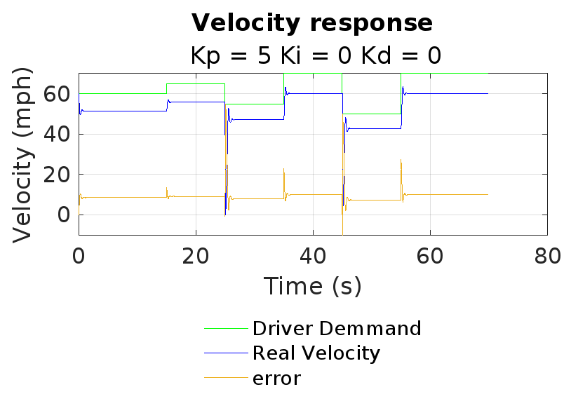
Figure 12 - 15% steady state error, P only tuning
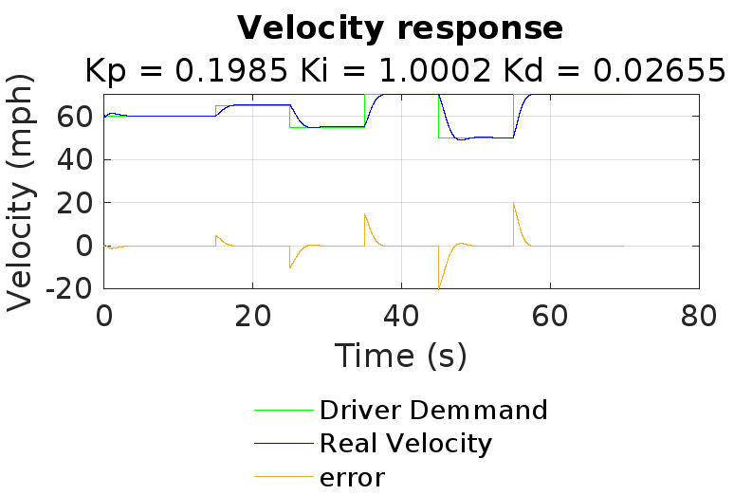
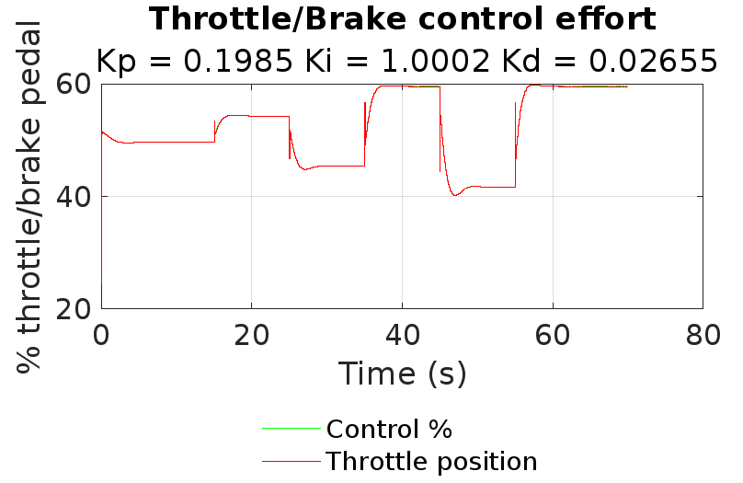
Figure 13 - Throttle and brake control effort trial and error method

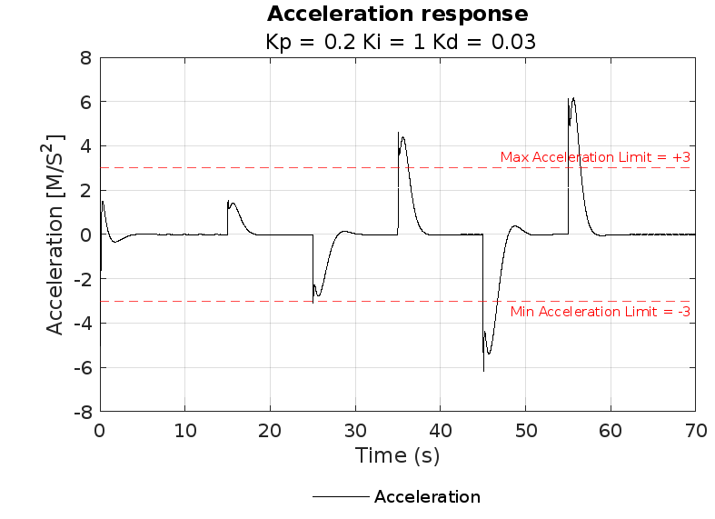
Figure 14 - Best acceleration response trial and error method
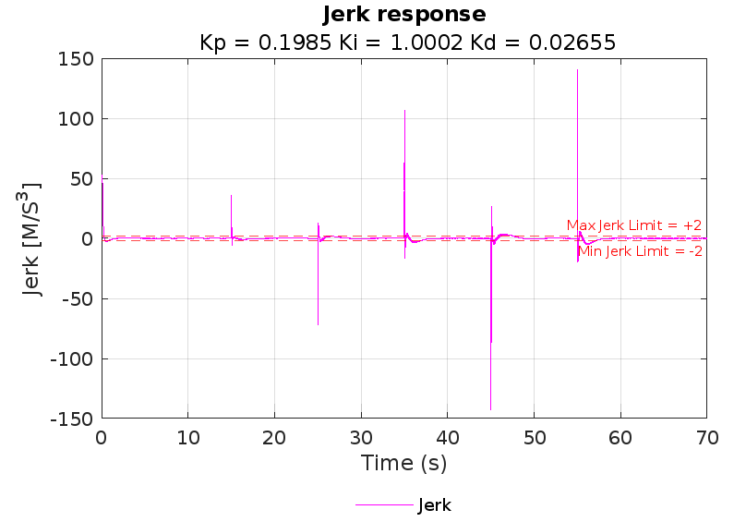
Figure 15 - Best Jerk response trial and error method

Additional challenges
This simulated environment didn’t include everything that the real-world would enact on the car. For example, the drivetrain for the car would have a maximum possible instantaneous jerk and acceleration values as the values shown would require a sports car to perform. The average new car in 2021 had a 0-60 time of 7.7 seconds. This is an acceleration of just 3.48 m/s² which is much lower than any of the results from the PID simulations (U.S Environmental Protection Agency, 2022).
Sensor reliability and noise within the electrical systems are not possible to simulate but can be somewhat accounted for with attenuation but is unable to fully resolve all noise (Zhang, et al., 2011).

Conclusion
In conclusion, although the Ziegler-Nichols tuning method provided a good theoretical starting point, it did not provide a satisfactory steady-state nor react to the input demand sufficiently. There was severe overshoot, oscillation, and steady state error. The manual trial-and-error tuning method resulted in a more acceptable system in terms of basic stability and velocity reaction. It showed minimised steady state error with an average error of just 0.092 mph. This was calculated by taking the mean difference between the velocity and the demand.
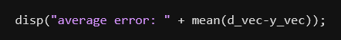
Figure 16 - Code for average error
Despite the success of the tuning, a maximum acceleration of 6.16 m/s² and jerk of 301.58 m/s³ were recorded, this highlights limitations of the code itself as this is insufficient for a vehicle and falls outside of accepted comfort ranges of ±0.2m/s² for acceleration and ±0.3m/s³ for jerk (de Winkel, et al., 2023). It was found that there is a lack of constraints on the control output within the code. A more robust system would have limits for acceleration/jerk and wouldn’t have to rely on PID tuning to ensure the system didn’t accelerate or decelerate too quickly when a change in demand is set. It would be ideal for a slower velocity response as the control could be increased over a longer period to lower the acceleration/deceleration to reach the set point.

References
Åström, K. J. & Hägglund, T., 2001. The future of PID control. Control Engineering Practice, 9(11), pp. 1163-1175.
Voloşencu, C., 2025. PID control. Rijeka : IntechOpen.
de Winkel, K. N., Irmak, T., Happee, R. & Shyrokau, B., 2023. Standards for passenger comfort in automated vehicles. acceleration and jerk. Applied Ergonomics, Volume 106.
Mathworks, n.d. Matlab Dec2Bin documention. [Online]
Available at: https://www.mathworks.com/help/matlab/ref/dec2bin.html
[Accessed 27 07 2025].
Mushtaq, A., 2023. Discuss the characteristics of ADC in detail. [Online]
Available at: https://eevibes.com/computing/discuss-the-characteristics-of-adc-in-detail/
[Accessed 27 07 2025].
O'Dwyer, A., 2006. PI and PID controller tuning rules: an overview and personal perspective. Dublin, IET Irish Signals and Systems Conference.
Panda, R. C., 2012. Introduction to PID Controllers - Theory, Tuning and Application to Frontier Areas. Rijeka: Intech.
Quevedo, D. E. & Goodwin, G. C., 2015. Quantization issues in signal processing & control system design. Australian Journal of Electrical and Electronics Engineering, 2(2), pp. 127-139.
U.S Environmental Protection Agency, 2022. The 2022 EPA Automotive Trends Report, Washington: U.S Environmental Protection Agency.
Woolf, P. J., 2009. 9: Proportional-Integral-Derivative (PID) control. In: Chemical Process Dynamics and Controls. Michigan: University of Michigan Engineering Controls Group.
Zhang, H., Shi, Y. & Mehr, A. S., 2011. Robust ℋ︁∞ PID control for multivariable networked control systems with disturbance/noise attenuation. International Journal of Rubust and Nonlinear Control, 22(2), pp. 183 - 204.

Appendix

Cruise control script
The following is the code for the cruise controller:
%% MAIN FILE FOR CRUISE CONTROLLER SYSTEM %%%%%%%%%%%%%%%%
% (1) initialize
% (2) set implementation parameters
% (3) set simulation parameters
% (4) simulation loop
% (5) plot results
%%%%%%%%%%%%%%%%%%%%%%%%%%%%%%%%%%%%%%%%%%%%%%%%%%%%%%%%%%
%% (1) Initialize %%%%%%%%%%%%%%%%%%%%%%%%%%%%%%%%%%%%%%%%
tic
clc
clear
close all % house keeping

% Ultimate gain where P alone continuously oscillates
Ku = 17;

%Period of oscillation, found at P=Ku with findpeaks()
Po = 0.59017;

P = 0.1985; %best: 0.1985
I = 1.0002; %best: 1.0002
D = 0.02655; %best: 0.02655

% Limit variables as per ISO15622.
acc_limit_pos = 3;
acc_limit_neg = -3;

jerk_limit_pos = 2;
jerk_limit_neg = -2;

%%%%%%%%%%%%%%%%%%%%%%%%%%%%%%%%%%%%%%%%%%%%%%%%%%%%%%%%%%

%% (2) set implementation parameters %%%%%%%%%%%%%%%%%%%%%

% sampling time must be an integer multiple of sim_step
Ts = 0.05;
% number of bits used to encode velocity sensor signal. velocity sensor
% range in mph [0,150]
m_velocityS = 0;
M_velocityS = 150;
n_bits_sensor_signal = 16;
% number of bits used to encode velocity demand signal. demand
% range in mph [30,110]
m_demand = 30; M_demand = 110;
n_bits_demand_signal = 16;
% number of bits used to encode throttle/brake actuator signal. actuator
% range in mph [-100,100] where [-100,0) is percentage of braking and
% (0,100] is percentage of throttle
n_bits_actuator_signal = 16;
R = 2.^n_bits_actuator_signal;
%%%%%%%%%%%%%%%%%%%%%%%%%%%%%%%%%%%%%%%%%%%%%%%%%%%%%%%%%%

%% (3) set simulation parameters %%%%%%%%%%%%%%%%%%%%%%%%%

sim_step = 0.01; % simulation time step in seconds
sim_time = 70; % simulation time length in seconds
T = 0:sim_step:sim_time; % simulation steps vector
% initialize vector where to store results for plots
[d_vec,u_vec ,y_vec,e_vec,Th_vec] = deal(nan(size(T)));
throttle_setting = 50; % initialize control action (throttle/brake setting)
% communication delay between controller and actuator in seconds.
% must be an integer multiple of sim_step
actuator_signal_delay = 0.00;
%% remove when in function
m_ControlSig = -100;
M_ControlSig = 100;
%%%%%%%%%%%%%%%%%%%%%%%%%%%%%%%%%%%%%%%%%%%%%%%%%%%%%%%%%%
[u, control] = deal(50);
%% (4) simulation loop %%%%%%%%%%%%%%%%%%%%%%%%%%%%%%%%%%%
velocity_real = 60;
demand = velocity_real; % default initialisation value for demand
for j = 1:length(T) % for every simulation step

loops_remaining = length(T)-j; % display progression
disp(loops_remaining)
% get vehicle raw veocity sensor measurement from the communication bus
[velocity_raw, velocity_real,throttle_setting] = getRawVelocity(n_bits_sensor_signal,velocity_real,throttle_setting, sim_step,u);

% decode raw bus signal (from x-bit binary to mph)
velocity = ((bin2dec(velocity_raw).*(M_velocityS-m_velocityS))/R)+m_velocityS;

if mod((j-1)*sim_step,Ts) == 0 % every sampling time

% get driver's velocity demand raw signal from the communication bus
demand_raw = getRawVelocityDemand(n_bits_sensor_signal,sim_step,j);

%% decode raw signal (from x-bit binary to mph)
demand = (bin2dec(demand_raw)*(M_demand-m_demand)/R)+m_demand;

%% calculate control signal and error (range of control [-100,100])
[control, error] = PIDcontrol(demand,velocity, P, I ,D, j, e_vec, Ts, sim_step, control);

%% encode control signal into x-bit binary number
control_raw = dec2bin(((control-m_ControlSig)*R)/(M_ControlSig-m_ControlSig));

%% send control command to throttle/brake actuator via communication
% bus (record the control signal instance as u)
u = sendControlCommand(control_raw,n_bits_actuator_signal,actuator_signal_delay,j, sim_step, u_vec);

end

% store values for plotting
e_vec(j) = error;
d_vec(j) = demand;
u_vec(j) = control;
y_vec(j) = velocity_real;
Th_vec(j) = throttle_setting;

end

vms_vec = y_vec.*0.44704; % convert mph to m/s
a_vec = gradient(vms_vec)./sim_step; % Formula to calculate acceleration as derivative of velocity m/s^2
j_vec = gradient(a_vec)./sim_step; % Formula to calculate jerk as derivative of acceleration m/s^3

% gradient uses central difference and this is more accurate
% than diff() since the step size is consistent. This also neatly keeps the
% vectors the same size.

disp("Max acceleration: " + max(abs(a_vec)));
disp("Max Jerk: " + max(abs(j_vec)));

%%%%%%%%%%%%%%%%%%%%%%%%%%%%%%%%%%%%%%%%%%%%%%%%%%%%%%%%%%

%% (5) plot results %%%%%%%%%%%%%%%%%%%%%%%%%%%%%%%%%%%%%%
Plotfontsize = 7;

% plot velocity response
figure(Name="Velocity");
F1= figure;
plot(T,d_vec,'g-');
hold on
plot(T,y_vec,'b-');
plot(T,d_vec-y_vec);
grid;
title('Velocity response');
subtitle([' Kp = ', num2str(P),' Ki = ', num2str(I),' Kd = ',...
num2str(D)]);
ylabel('Velocity (mph)'); xlabel('Time (s)');
lgd4 = legend('Driver Demmand','Real Velocity','error');
legend('boxoff')
lgd4.Location = "southoutside";
supersizeme(1.5);

% Plot throttle/ brake effort
figure(Name="Control");
F2= figure;
stairs(T,u_vec,'g-');
hold on;
plot(T,Th_vec,'r-');
grid;
title('Throttle/Brake control effort');
subtitle([' Kp = ', num2str(P),' Ki = ', num2str(I),' Kd = ',...
num2str(D)]);
ylabel('% throttle/brake pedal');
xlabel('Time (s)');
lgd3 = legend ('Control %','Throttle position');
legend('boxoff')
lgd3.Location = "southoutside";
supersizeme(1.5);

% Plot acceleration
figure(Name="Acceleration");
F3= figure;
plot(T,a_vec,'k');
hold on;
yline(acc_limit_pos, '--r', "Max Acceleration Limit = +" + num2str(acc_limit_pos), FontSize=Plotfontsize);
yline(acc_limit_neg, '--r', "Min Acceleration Limit = " + num2str(acc_limit_neg), LabelVerticalAlignment='bottom', FontSize=Plotfontsize);
grid;
title('Acceleration response');
subtitle([' Kp = ', num2str(round(P,2)),' Ki = ', num2str(round(I,2)),' Kd = ',...
num2str(round(D,2))]);
ylabel('Acceleration [M/S^2]');
xlabel('Time (s)');
lgd1 = legend('Acceleration');
legend('boxoff')
lgd1.Location = "southoutside";
supersizeme(1);

% Plot jerk
figure(Name="Jerk");
F4= figure;
plot(T(10:end),j_vec(10:end),'m');
hold on;
yline(jerk_limit_pos, '--r', "Max Jerk Limit = +"+ num2str(jerk_limit_pos), FontSize=Plotfontsize);
yline(jerk_limit_neg, '--r', "Min Jerk Limit = "+ num2str(jerk_limit_neg), LabelVerticalAlignment='bottom', FontSize=Plotfontsize);
grid;
title('Jerk response');
subtitle([' Kp = ', num2str(P),' Ki = ', num2str(I),' Kd = ',...
num2str(D)]);
ylabel('Jerk [M/S^3]');
xlabel('Time (s)');
lgd2 = legend('Jerk');
legend('boxoff')
lgd2.Location = "southoutside";
supersizeme(1);

disp("average error: " + mean(d_vec-y_vec));

% Create dynamic naming convention for plots with current variable changes.
P1_NAME = "PLOT GRAPH 1 P=" + num2str(P) + " I=" + num2str(I) + " D=" + num2str(D) + ".png";
P2_NAME = "PLOT GRAPH 2 P=" + num2str(P) + " I=" + num2str(I) + " D=" + num2str(D) + ".png";
P3_NAME = "PLOT GRAPH 3 P=" + num2str(P) + " I=" + num2str(I) + " D=" + num2str(D) + ".png";
P4_NAME = "PLOT GRAPH 4 P=" + num2str(P) + " I=" + num2str(I) + " D=" + num2str(D) + ".png";

% Save plots to image file.
saveas(F1, P1_NAME);
saveas(F2, P2_NAME);
saveas(F3, P3_NAME);
saveas(F4, P4_NAME);

%% Code to find the period where oscillation occurs at Ku.
% [~, pk] = findpeaks(y_vec, T);
%
% disp("Po / Oscillation period is: " + mean(diff(pk)));
% disp("Ku / Ultimate gain is: " + P);
%%%%%%%%%%%%%%%%%%%%%%%%%%%%%%%%%%%%%%%%%%%%%%%%%%%%%%%%%%

PIDcontrol function
The following is the code for the function PIDcontrol.
function [controlout,errorout] = PIDcontrol(demand,velocity, P, I, D, j, e_vec, Ts, sim_step, control)
%This is a PID controller
% Output variables:
% controlout = Control signal output.
% errorout = Error output = difference between demand and velocity.
errorout = demand - velocity;

%% Proportional

P_part = errorout * P;

%% Integral

persistent Prev_I_Part;

if j > 1
prev = e_vec(j-(Ts/sim_step));
else
prev = control;
Prev_I_Part = prev;
end

I_Part = (((errorout+prev)./2).*(Ts)+Prev_I_Part).*I;

Prev_I_Part = I_Part;

%% Derivative

D_Part = ((errorout-prev) / Ts).*D;

%% Output
controlout = P_part + I_Part + D_Part;

%% Limits
m_ControlSig = -100;
M_ControlSig = 100;

if controlout < m_ControlSig
controlout = m_ControlSig;
end
if controlout > M_ControlSig
controlout = M_ControlSig;
end

end

getRawVelocityDemand
Below is the code for the function getRawVelocityDemand.
function [d]=getRawVelocityDemand(x,sim_step,j)
%% simulate driver's velocity demand (in mph)

% driver velocity demand can go from 30 to 110 mph at steps of 5 mph.
% Only x bits are used to encode this signal. 00...0 corresponds to 30
% mph and 11...1 to 110 mph

% global sim_step
% global j

if j*sim_step >= 0 && j*sim_step < 15
d=dec2bin((2^x*(60-30))/(110-30));
elseif j*sim_step >= 15 && j*sim_step < 25
d=dec2bin((2^x*(65-30))/(110-30));
elseif j*sim_step >= 25 && j*sim_step < 35
d=dec2bin((2^x*(55-30))/(110-30));
elseif j*sim_step >= 35 && j*sim_step < 45
d=dec2bin((2^x*(70-30))/(110-30));
elseif j*sim_step >= 45 && j*sim_step < 55
d=dec2bin((2^x*(50-30))/(110-30));
elseif j*sim_step >=55
d=dec2bin((2^x*(70-30))/(110-30));
end

getRawVelocity
Below is the code for the function getRawVelocity.
function [velocity_raw, velocity_real,throttle_setting] = getRawVelocity(x,old_velocity,throttle_setting,sim_step,u)

%% %%%%%%%%%%%%%%%%%%%%%%%%%%%%%%%%%%%%%%%%%%%%%%%%%%%%%%%
% u initial throttle setting as whole percentage

h = sim_step;
throttle_setting = u;% (u/300)+ throttle_setting;
persistent d v_dot x_v v_dot_last x_v_old

if isempty (d) % this just Initializes
d = 1;
% x_v = 0.25;
x_v_old = 0.25;
v_dot_last = 0;
end

% parameters
gear = 1.2;
final_drive = 2.82;
rs_to_rpm = 9.549; % rad/s to rpm
mps_to_mph = 2.2369;
radius = 0.3;
cd = 0.29;
roh = 1.23;
area = 2;
mass = 1854;

if abs(throttle_setting) > 100 % limit throttle to +/-100%
throttle_setting = 100;
end

if throttle_setting < 0
brake = abs(throttle_setting);%P;
throttle_setting = 0;
else
brake = 0;
end

wheel_speed = (old_velocity / mps_to_mph) / radius; % rad/s
engSpeedRPM = wheel_speed * rs_to_rpm * gear * final_drive;

x_v_dot = (-10 * x_v_old + 0.05 * (throttle_setting)); %internal dynamics of throttle actuator
x_v = x_v_old + x_v_dot*h; % numerical integration
x_v_old = x_v;

engSpeedRPM = 528.7 + (engSpeedRPM * 0.152) + (-0.0000217 * engSpeedRPM^2);
engine_torque = x_v * engSpeedRPM*gear * final_drive;

%v_dot = ((engine_torque / radius) - (cd * roh * area* 0.5 * velocity^2) - (0.05 * mass * 9.81) -(brake * mass * 9.81)) / mass;
% N wheel force % - aero force N
v_dot = ((engine_torque / radius) - (cd * roh * area* 0.5 * old_velocity^2) ...
- (0.05 * mass * 9.81) -(brake * mass * 9.81)) / mass;

acc = v_dot + (h / 2) * (v_dot - v_dot_last);
v_dot_last = v_dot;
velocity = old_velocity + acc;
% old_velocity = velocity;

if velocity < 0 || isnan(velocity)
velocity = 0;
end
if velocity > 150
velocity = 150;
end
throttle_setting = throttle_setting + brake; % gives negative output to plot if braking
% convert into binary signal
velocity_raw = dec2bin((2^x*(velocity))/150);
velocity_real = velocity;

