

5C001

Organisation performance and culture in practice

Centre Number: 669
Learner Number: 9149279
Learner Surname: Astell
Learner other names: Lynda Jane

Unit Code: 5C001
Unit Title: Organisation Performance and culture in practice
Assessment ID: CIPD_5C001_24_01
Assessment start date: 9.4.25
Assessment Submission date: 23.06.25
Declared word count:

August 20


AC 1.1
Taylor and Woodhams (2022) draw upon the Campbell and Craig (2005) definition as ‘the pattern of relationships of the workforce and their relative positions in the organisation’.

There are many types of structure that exist within organisations (see figure 1.1a):
Fig 1.1a – Organisational structure types
Hierarchical structures are the most traditional but over recent decades structures have become flatter, partly due to a drive to reduce costs (Waite et al., 2021).

A functional structure is one of the most common (Organ, 2024) and often operates alongside a divisional structure. For example, a company is organised into different site-based factories (divisions), which are semi-autonomous, but within each factory, resources are organised by function.

A divisional structure offers clear accountability by assigning leadership to each division allowing for focused performance tracking and outcome measurement. It fosters specialisation, enabling divisions to tailor strategies and resources. However, this structure can lead to duplicated support services, inefficiencies, and a silo mentality that hinders collaboration and the sharing of best practices. Additionally, inconsistent policies across divisions may challenge quality assurance.

By contrast, a matrix organisational structure combines both functional and project-based elements, allowing employees to report to multiple managers. This type of structure can appear complex but is often used in large project-based organisations in the construction or technology sectors.

Matrix structures often benefit from enhanced cross-functional collaboration, efficient use of resources through shared staffing, and increased agility in responding to strategic initiatives such as technological transformation. However, these advantages come with challenges, including potential role confusion due to dual reporting lines, the complexity of managing across multiple dimensions, and increased pressure on staff who may feel stretched between competing priorities.

Selecting the appropriate structure is vital for business success, and this will often need to evolve in response to the organisation’s stage of development and shifting priorities. Figure 1.1b illustrates this dynamic through the example of Coleg Gwent. While the college typically operates under a divisional or functional structure, emerging strategic priorities—such as the urgent need to develop an AI strategy and policy—necessitated a different approach. In response, leadership opted to implement a project-based (matrix) structure to effectively address these high-priority initiatives.

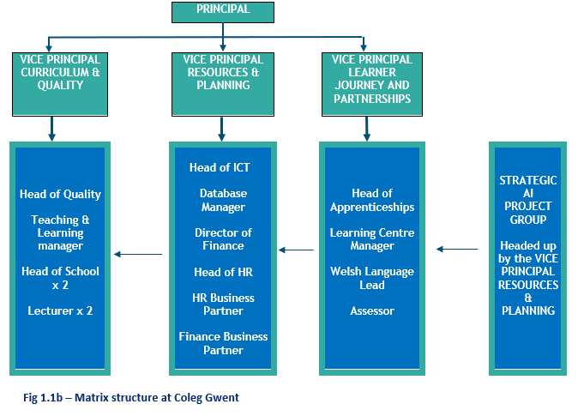

In conclusion divisional structure works well for scale and subject-specific autonomy, but risks fragmentation whereas a matrix structure supports collaboration and innovation, but demands strong leadership and communication. Structure design should be clearly linked to strategy as models might need to vary over time.

AC 1.2

Bryson (2018) defines a strategic plan as ‘a disciplined effort to produce fundamental decisions and actions that shape and guide what an organisation is, what it does, and why it does it, with a focus on the future’

It is widely accepted that a strong mission statement and vision are at the heart of organisational strategy.

Coleg Gwent’s mission and vision is as follows:

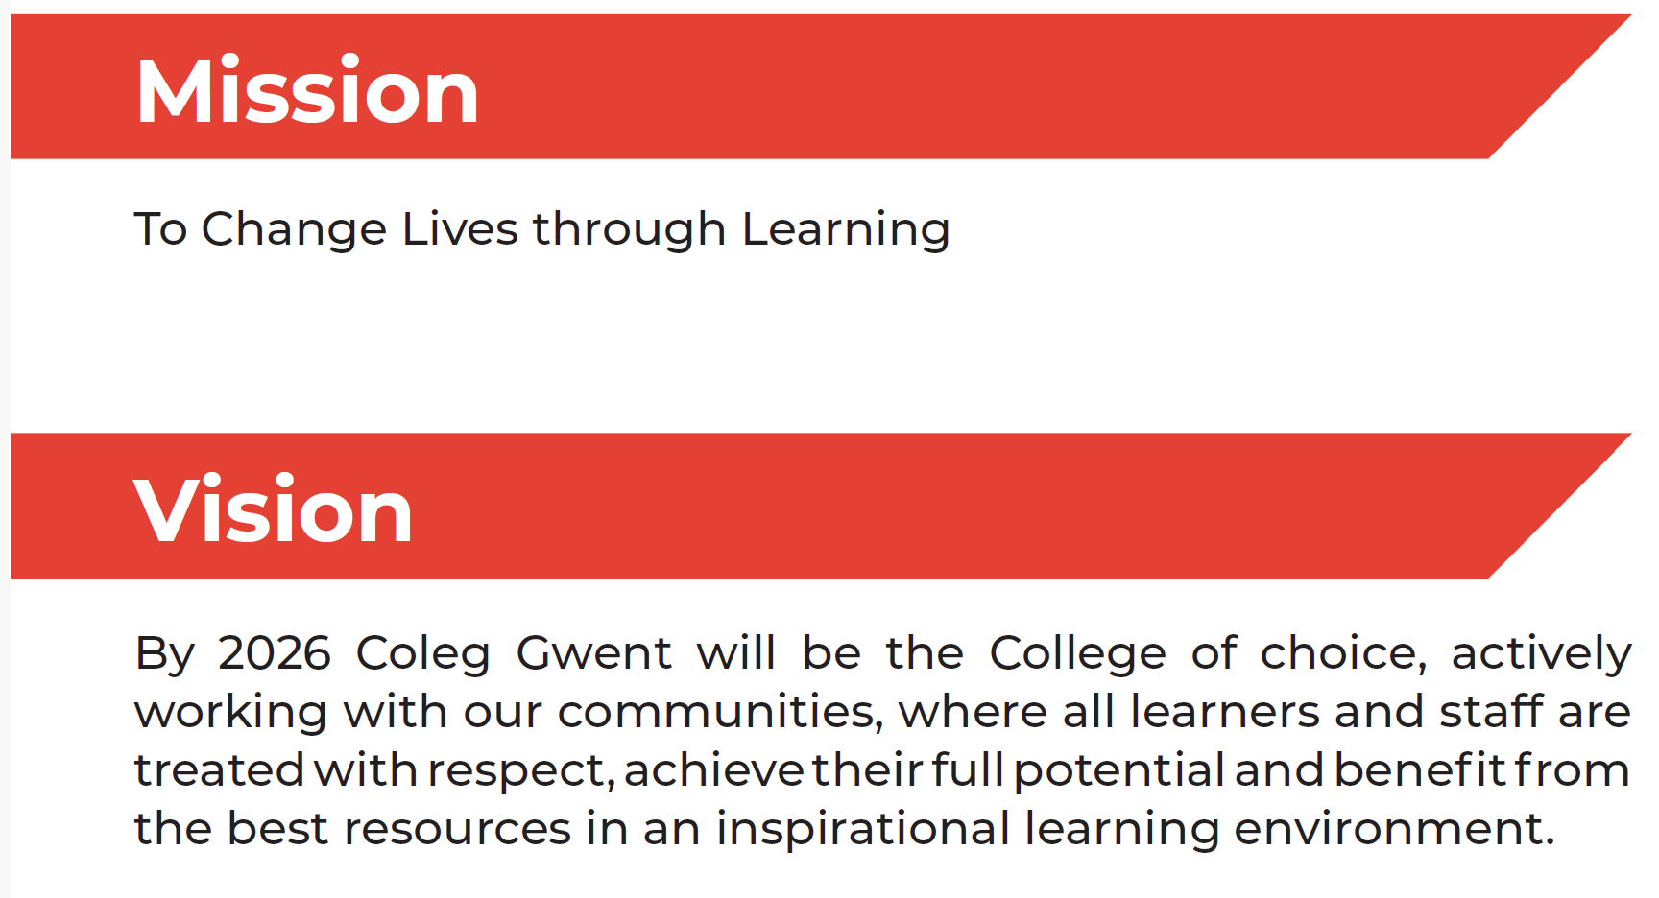
Fig 1.2a – Coleg Gwent Mission and Vision

Mintzberg (2000) defines strategy not only in the context of strategy as a plan, a guide or course of action into the future or again as a plan to get from here to there, but also as a pattern or a consistency in behaviour over time.

This is particularly relevant at Coleg Gwent, where both the strategic plan and the core values and associated behaviours are used to ensuring that curriculum, support services and resources are aligned with the needs of a diverse range of learners. Coleg Gwent’s core values are summarised in fig 1.2b (Coleg Gwent, 2019)

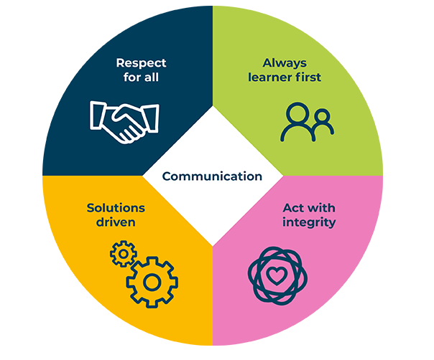
Fig 1.2b – Coleg Gwent Core values
Coleg Gwent’s strategic aims are summarised in the following diagram:

Fig 1.2c – Coleg Gwent Strategic Aims

Germain and Cooper (1990) found that when a company has a mission that puts customers first helps companies stay focused and perform better.

A review of Coleg Gwent’s Mission, Vision, core values and strategic aims clearly shows them to be learner (customer) focused with a strong alignment with ensuring that products and services (educational programmes and learner support) meet the needs of customers (learners, employers, and the wider community).

The strategy is clearly learner-centred, as reflected in its mission to “change lives through learning” and its core value of “Always learner first.” Strategic aims such as empowering learners through high-quality teaching, delivering industry led curriculum, and ensuring every lesson and grade matters, all point to a commitment to learner success and satisfaction. The plan also includes measurable outcomes, such as ensuring at least 94% of learners rate their experience positively and that all learners improve in key academic areas like literacy and numeracy.

The strategy recognises the importance of employer engagement which ensures that the curriculum remains relevant to industry needs and that learners are equipped with the skills required for the workforce.

The plan also addresses inclusivity, digital innovation, and sustainability, all increasingly important to learners and employers. By committing to advanced digital training for staff, zero waste to landfill, and a welcoming, inclusive environment, the College is proactively responding to evolving expectations.

In conclusion, Coleg Gwent’s strategy is aligned and actively shaped by the needs of its learners and stakeholders.

AC 1.3

In recent years FE colleges have faced significant challenges to resource levels through the perfect storm of Covid, rising inflation and a new era of higher interest rates (Pryce, 2023)
More specifically, inflation and rising interest rates are significantly impacting further education (FE) colleges in Wales. These institutions are facing increased costs for energy, construction, and staff, while also experiencing pressure on their budgets due to the rising cost of living for both staff and learners. (Colegau Cymru, 2023).

Another external factor impacting Coleg Gwent is the ongoing impact of pay parity between school teachers and FE lecturers.

Fig 1.3a sets out the 6 year trend in inflation, interest rates (Bank of England, 2025) and FE pay awards (Coleg Gwent, 2025) over the last 6 years

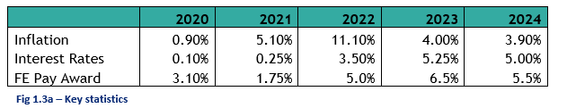
Fig 1.3b sets out the estimated impact of energy inflation on the Welsh FE sector in the three years to 2023/24, an overall 164% increase in the total cost.

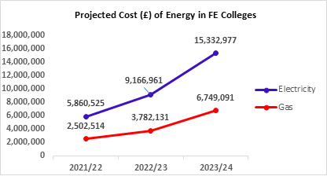
Fig 1.3b – Colegau Cymru

Coleg Gwent has seen a similar trend in energy prices with estimated annual increase of over £1m.
Inflation has a significant impact on construction projects across the further education sector. This is evident at Coleg Gwent with two planned major strategic capital developments, with a combined estimated cost approaching £180m. These projects are essential for modernising facilities and meeting future learner needs.
The compounded inflation rate for UK construction projects over the last 6 years (ONS, 2024) is approximately 37.77%, adding at least £50m to Coleg Gwent projects since planning began.
Inflation is already driving up construction costs, but rising interest rates add further pressure, with around 35% of the £180m project cost reliant on borrowing.
Pay parity between school teachers and FE lecturers in Wales was introduced on 1 April 2004. While colleges support parity to attract and retain talent, it poses a financial challenge due to the difference in funding mechanisms between colleges and local authorities.
The ratio of staff costs to income at Coleg Gwent is close to 70% against sector benchmarks of below 65% (Coleg Gwent, 2025).
Mounting financial pressure has necessitated plans to deliver £8m in financial efficiencies at Coleg Gwent by 2026/27, including staff cost reductions (Coleg Gwent, 2024)
Coleg Gwent’s priorities in response to financial pressures include ongoing management of staffing costs, growing income, harnessing digital capability to drive down cost and continued lobbying for increased funding.

AC 1.4
Advances in AI are likely to have a profound, widespread effect on the UK economy and society although the precise nature and speed of this effect is uncertain (Department for Education, 2023).

A 2023 Gartner survey, found that 79% of corporate strategists said that the use of AI, automation, and analytics would be critical to their success over the next two years. But interestingly only 20% of them reported using AI in their daily activities.

This statement aptly reflects the current landscape at Coleg Gwent. While the leadership team has recognised the potential of AI for some time, tangible progress has been limited, likely due to lack of familiarity and understanding. However, this is beginning to shift. A draft AI policy has now been formulated, with the intention of securing Board approval in July, followed by a comprehensive communication plan to inform all staff in the coming months.

Like Coleg Gwent, FE colleges in the UK are now increasingly exploring AI to enhance teaching, learning, and administration. According to the Department for Education (2025), AI is already being used in areas such as lesson planning and creating and adapting teaching materials; assessing learner work and providing feedback and improving administrative efficiency through use of chatbots to deal with learner queries.

AI undeniably has great potential to alleviate one of the greatest challenges currently faced by teachers in FE: the ever-increasing workload. (Webb for JISC, 2023)

Taskin (2024) and Sharma (2024) anticipate future uses of AI in colleges will include:
- predictive analytics such as identify students at risk of dropping out or underperforming
- improving curriculum design through analysing labour market data to help colleges align courses with emerging industry needs.
- enhancing learning outcomes through personalised feedback and adaptive learning platforms which improve student engagement.

According to JISC (2025) students are increasingly integrating AI tools into their academic and personal lives and are calling for clearer policies from their institutions, equitable access, and education on ethical and effective AI use to be embedded in their curriculum to ensure they are prepared for an AI-enhanced future.

Howlett (2019) urges ethical, human-centered AI in workplaces, led by HR. Innovation must be balanced with strong governance to protect people and ensure AI benefits all.

AC 2.1

Charles Handy’s organisational culture model illustrates how leadership styles and structural frameworks shape the character of an organisation. Handy (1993) proposed that organisations tend to adopt one of four dominant cultural types. Each type influences how decisions are made, how people interact, and how work gets done.

He outlines four distinct cultural types, each defined by its approach to management and decision-making.

Power Culture: Authority is centralised among a few key individuals, with decisions flowing from the top. Structures are often informal and adaptable, making this culture effective in environments that demand swift, decisive leadership.

Role Culture: This culture is built on a formal hierarchy, where roles and responsibilities are clearly defined. Success is measured by how well individuals perform within their designated roles. It is typically found in large organisations and public sector bodies, where procedures and regulations guide operations.

Task Culture: Emphasising collaboration, this culture brings together individuals from various levels to solve problems and achieve objectives. Rather than relying on hierarchy, it values expertise and teamwork, making it ideal for project-driven environments.

Person Culture: Centred on the individual, this culture prioritises personal autonomy and development. Employees have significant control over their work, and the organisation exists primarily to support their growth and aspirations.

David Rock’s SCARF model outlines five key social and emotional drivers, Status, Certainty, Autonomy, Relatedness, and Fairness (Rock, 2018). These influence how people behave and respond in the workplace. Understanding these elements helps organisations foster better collaboration, motivation, and well-being.

Status: refers to one’s perceived standing within a group. A lack of recognition can trigger feelings of threat and insecurity

Certainty: people seek predictability. Ambiguity in goals or expectations can cause stress, while clear communication reduces anxiety

Autonomy: the ability to make choices independently boosts engagement. Without it, employees may feel frustrated and disengaged

Relatedness: a sense of connection and trust among colleagues enhances teamwork. Isolation, by contrast, can harm morale and productivity

Fairness: Perceptions of justice in decision-making and treatment are crucial. Unfairness can erode trust, while transparency builds morale
It is interesting to consider to what extent SCARF’s model aligns with Handy’s cultural types. Fig 2.1a

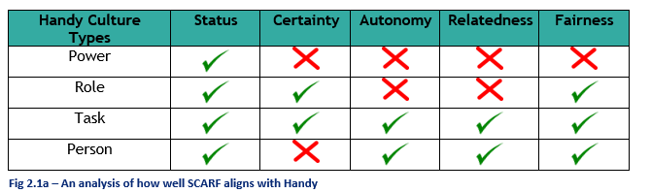

This would suggest that Handy’s task culture is the most SCARF aligned. It is ideal for organisations aiming to support psychological safety and motivation across diverse teams.

AC 2.2

Employee selection plays a critical role in shaping organisational culture and behaviour, especially in the further education (FE) sector, where colleges rely heavily on staff to deliver high-quality learning experiences.

Organisational culture has been widely studied as a critical determinant of institutional success. Cameron and Quinn (2011) emphasize that a strong culture aligned with organisational values significantly impacts performance and employee engagement.

Strategic employee selection is vital in public administration, not only for operational effectiveness but also for cultivating a culture aligned with public values (Reina and Scarozza, 2020).

In the 2018 AoC survey “Issues facing colleges”, staff pay, difficulty in recruiting qualified teaching staff and succession planning were found to be within the top three concerns from respondents.

Employee selection can impact culture and behavior in a number of ways.

Hiring people who share the college’s values helps create a strong and united team. For example, a college that puts students first will benefit from staff who are caring, flexible, and passionate about teaching.

New staff can boost team spirit and energy, while a poor hire can cause problems. For instance, someone with good people skills can help departments work together.

The way staff behave sets an example. If the college always hires people with high standards, it encourages others to aim high too. For example, hiring creative teachers can inspire others to try new teaching methods.

A diverse team brings different ideas and experiences, which makes the college more inclusive and better able to support all students.

Finally, staff who are open to learning and change help the college keep improving.

Fig 2.2a extracts key employee selection elements from the Coleg Gwent People Strategy (2021–2026)

It is clear that Coleg Gwent takes a thoughtful and inclusive approach to recruiting staff. Finding people with the right skills and values to help the college grow and succeed is a priority.

The hiring process is designed to give everyone a fair chance. Coleg Gwent values diversity and wants a welcoming workplace. There is a focus on keeping staff happy by offering good pay, benefits, and development opportunities.

Coleg Gwent uses recruitment to shape a positive, respectful, and high-performing work environment, a way to build a strong, diverse, and forward thinking team which supports its mission of ‘Changing Lives through Learning’.

Fig 2.2a – Coleg Gwent, extract from People Strategy

AC 2.3

The post-pandemic push to bring employees back to the office has met with widespread reluctance in many sectors (Bloom, 2022).
Changes to hybrid working arrangements can be an extremely emotive issue for employees and must be handled sensitively whilst ensuring the outcomes that meet business need.
Kotter’s eight stage process is one of the most widely recognised models for change management (Pollack, 2014) and is a powerful framework for managing such a change.

Using the Kotter model, here are the eight steps that could be followed to deliver the transition to employees working at least two days a week on site:

Step 1 – Create Urgency - Highlight why returning to the office at least two days a week matters. Emphasise the benefits of face-to-face collaboration while keeping hybrid flexibility. Possibly focus on impact on the customer (this is particularly true in many educational settings where learners are on-site at all times and need a staff presence)
Step 2 – Build a Coalition - Form a leadership group of managers and respected staff from across the organization to support and promote the change.
Step 3 – Define Vision and Strategy - Clearly outline the hybrid work model, balancing flexibility with time spent on-site. Expectations of both staff and leadership should be set out and be transparent.
Step 4 – Communicate the Vision – Utilise all available means of communication (digital, meetings, trade unions, staff podcasts, newsletters) to explain the new policy, how it works, and the benefits it will bring.
Step 5 – Empower Employees - Remove barriers to hybrid work by offering the appropriate technology, ongoing training and personal flexibility.
Step 6 – Celebrate Early Wins - Share early successes such as improved teamwork or increased morals to build momentum.
Step 7 – Build on Progress - Keep improving the hybrid working arrangements through staff and stakeholder feedback loops to ensure long-term success.
Step 8 – Make It Part of the Culture - Embed hybrid work into policies, evaluations, and team goals. Promote flexibility and collaboration as core values.

AC 2.4
The Kübler-Ross model was designed by physician Dr. Elisabeth Kübler-Ross based on the observation that terminally ill patients and their relatives experienced similar emotions during bereavement. This model has been adapted to reflect stages of personal and organisational change as the Kübler-Ross Change Curve (Abebe, 2023).

Fig 2.4a (Miller, 2022) illustrates the different emotional stages of the curve:

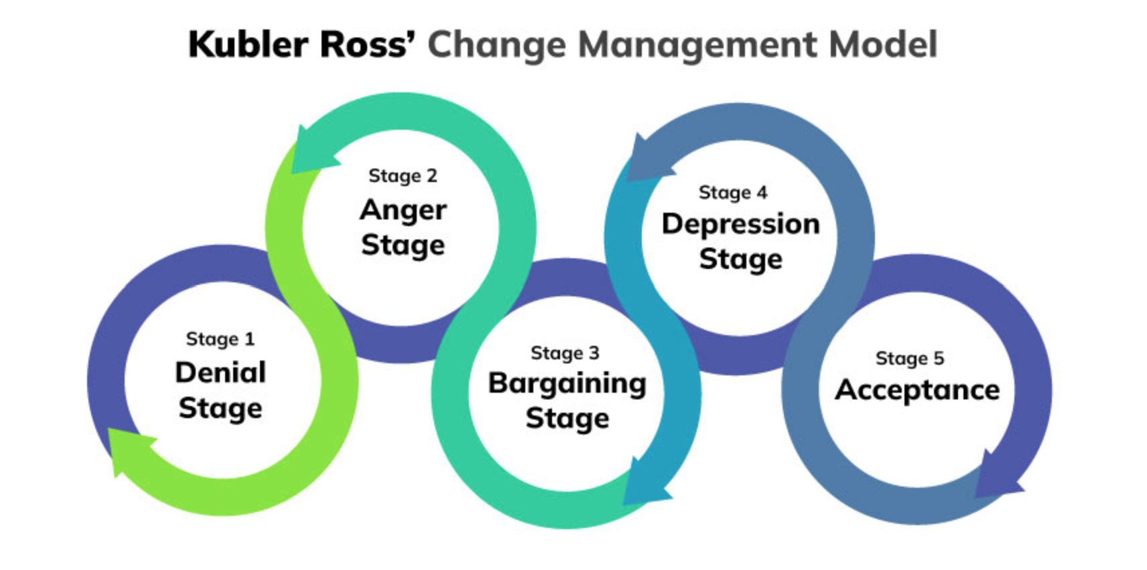
Fig 2.4a

Kübler-Ross (1969) emphasized that these stages are not necessarily experienced in a fixed order. Since the 1980s, the Kübler-Ross Change Curve has become a cornerstone of change management.

We will now explore each stage in turn, drawing on the author’s reflections and observations of staff responses to a recent major transformation at Coleg Gwent. This change initiative, designed to achieve financial efficiencies through headcount reduction, also involved substantial structural realignments within two key curriculum areas.

Step 1 - Denial - At first, some staff in affected areas refuse to acknowledge that change is happening, becoming difficult to contact and avoiding engaging in the change process and in communication with the HR team. Further down the process, refusing to apply for redeployment opportunities.

Step 2 – Frustration or Anger - once staff realise that the change process is not going to go away, frustration and resentment can start to build. Employees may feel like they are losing control, especially when the change affects their job security. At Coleg Gwent, a small number of staff went to the local press raise concerns along with threats raisinge a vote of no confidence in the leadership team.

Step 3 - Bargaining - at this stage, people try to negotiate ways to make the transition easier, to regain some sense of control or to lessen the disruption caused by the change. This was experienced at Coleg Gwent both positively (the receipt of many useful and appropriate counter proposals, may of which resulted in amendments to proposals) and negatively (the threat of strike action)

Step 4 - Depression - As the reality of change sets in, employees may feel overwhelmed, anxious, unmotivated or sad. This stage is a critical period where support and reassurance are necessary to help individuals regain their confidence. Coleg Gwent’s change process saw a tangible dip in workplace ‘mood’ following confirmation of proposals post consultation.

Step 5 - Acceptance - Eventually, people come to terms with the change. While they may still have lingering emotions from the earlier stages, they begin to adjust and find ways to succeed in the new environment. At this point, they are more open to learning and adapting, allowing them to move forward with confidence. An example of this at Coleg Gwent was affected staff starting to apply for redeployment opportunities and looking to the future.

In organisations experiencing change, people practitioners are key to making the journey through these stages as positive as it can be through regular and effective communication and constant reassurance and support.

AC 2.5

Wellbeing at work is one of the most important dimensions of an individual’s overall wellbeing and a contributing factor to the economic growth of a country through its workforce (Ofsted, 2019)

Workplace wellbeing can be broadly defined as ‘all the related aspects of working life, from the quality and safety of the physical environment, to how workers feel about their work, their working environment, the climate at work and work organization’ (International Labour Organisation, 2009)

The following statistics (fig 2.5a) for 2023/24 (Health and Safety Executive, 2024) (provide context to the importance of staff wellbeing for organisation efficiency and effectiveness and for the economy as a whole:

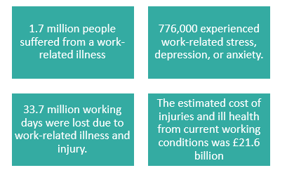
Fig 2.5a

Focusing on staff well-being offers a range of significant benefits for both employees and organisations. These can be summarised as follows (World Health Organization, 2022):

Improved Mental Health and Reduced Absenteeism - a healthy work environment can reduce the risk of mental health issues such as anxiety and depression. Safe and supportive workplaces help minimize stress, reduce absenteeism, and improve overall mental health.

Increased Productivity and Performance - when employees feel well-supported, they are more engaged and productive.

Higher Employee Retention and Satisfaction - organisations that prioritise well-being tend to have lower turnover rates. A positive work culture fosters loyalty and job satisfaction, which helps retain top talent.

Enhanced organisational reputation - companies known for caring about employee wellbeing are more attractive to potential new staff. This can improve brand image and competitiveness in the recruitment market.

Better team dynamics and reduced conflict - a focus on well-being often leads to improved communication, collaboration, and reduced workplace conflict, contributing to a healthier organizational climate.

The CIPD’s Good Work Index emphasises the belief that good work is fundamental for an individual’s wellbeing and goes on to provide a definition of good work which is captured in fig 2.5b.

Fig 2.5b

The HSE emphasises that good work design helps reduce work-related stress and improves mental health outcomes

Research (CIPD, 2025) evidences a strong link between health and work outcomes. Those whose work affects their mental health negatively are more likely to quit, less likely to recommend their employer, and have lower job satisfaction

For organisations aiming to thrive in a competitive and evolving landscape, embedding well-being into workplace culture is no longer optional but essential.

AC 3.1

Every employee follows a journey from the moment they see a job advert to leaving the company. This journey includes key stages and at each stage an organisations people practitioners play a crucial role in supporting employees. This journey is often referred to as an employee lifecycle.

Fig 3.1a (recreated from Waite et al., 2021) illustrates the six key stages of an employee lifecycle.

Fig 3.1a

Human Resources (HR) plays a pivotal role in supporting all aspects of the employee lifecycle but we will focus in this text on three key areas, recruitment, development and separation.

Recruitment plays a pivotal role in shaping an organisation’s future. People professionals should design compelling job descriptions and cultivate an attractive employer brand. The next step is to manage a fair and transparent selection process which complies with employment laws and equality standards. This is followed by providing support to hiring managers with interview techniques and decision making.

According to AIHR (2024), modern recruitment should prioritise candidates who meet the technical requirements and align with the company’s culture and long-term vision. This cultural fit ensures engagement, retention, and performance.

In today’s competitive talent landscape, HR must anticipate future workforce needs by building talent pipelines and nurturing relationships with potential candidates. Proactive recruitment strategies such as employer branding campaigns, employee advocacy, and targeted outreach help organisations stay agile. Ultimately, recruitment is no longer about filling vacancies but building a resilient, future-ready workforce.

Development - employee development begins the moment a person joins the organisation. Demonstrating confidence in their potential builds a sense of loyalty and trust. Implementing a robust and supportive performance management framework, meaningful learning opportunities and engaging challenges is one of the most effective ways to grow employee skills.

Organisations that focus on their people’s performance are 4.2 times more likely to outperform their peers (Betterworks, 2024). Career development should be a central focus for employers (aspiring manager programmes, mentoring, reverse mentoring and other tailored opportunities help staff see a positive path ahead).

Separation - The employee life cycle comes to an end with separation. This should not be considered as the end as many ex employees continue to spread the word about organisations long after leaving. People professionals have roles in enriching every touchpoint of the employee life cycle (Mann, 2022).

The offboarding process must be handled with empathy and professionalism, conducting exit interviews to gather valuable feedback and using that insight to refine retention strategies. HR also plays a critical role in maintaining compliance with legal and ethical standards during employee exits.

Final pay should be accurate and the return of employer assets should be smooth. A well managed separation process can turn departing employees into future advocates. The HR team’s involvement during this stage is essential for maintaining morale among remaining staff and safeguarding organisational knowledge.

AC 3.2

Aligning HR functions with business objectives drives organisational success (Bosley and Gifford, 2023).

By Integrating HR strategies both vertically and horizontally, organisations can create a more cohesive people strategy that supports long-term growth (CIPD, 2023).

Martinson and de Leon (2018) call upon Wright and McMahan (1992) to define vertical integration as the alignment of HR goals and objectives with strategic objectives. This ensures that HR initiatives like workforce planning, leadership development and performance management are directly contributing to the organisation’s strategic direction (Armstrong & Taylor, 2023). For example, in a Further Education college where learner success is a key strategic driver, the HR function will ensure that workforce planning and development strategies are aligned with this by recruiting staff with strong pedagogical skills and experience in driving learner engagement and success.

Horizontal integration ensures that different HR functions work together rather than operating independently and ensures that such functions do not work against each other. This involves aligning HR activities like recruitment and onboarding, learning and development, reward and employee relations so that they reinforce rather than contradict each other (Kehoe, 2021). This internal consistency is important for delivering a joined up employee experience and avoiding strategic misalignment. Again, an example of this in a Further Education college would see the HR onboarding process ensuring that all new recruits are inducted with a shared understanding of the college’s learner centred values and trained on safeguarding, inclusive teaching and student wellbeing whilst HR performance management frameworks would include shared KPIs related to student satisfaction, retention, and progression. This ensures that all staff are working towards common learner centred outcomes.

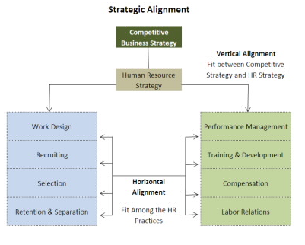
Fig 3.2a Vertical & Horizontal Alignment (Steward et al., 2008)
The above diagram describes how vertical and horizontal integration works together to provide a cohesive people strategy for an organisation

When HR strategies are aligned both vertically (with business goals) and horizontally (across HR functions), employees experience more consistent communication, development opportunities, and recognition which leads to higher engagement and lower turnover (Griffis, 2023)

This is supported by a recent study published in the World Journal of Advanced Research and Reviews (2024) which examined how academic institutions aligned HR practices with institutional goals to improve faculty development and diversity. The research highlighted that vertical integration, linking HR development initiatives with strategic goals such as inclusive teaching and digital transformation was complemented by horizontal integration across recruitment, training, and inclusion functions. This led to evidenced improvements in staff engagement and staff turnover, and a more inclusive academic environment.

AC 3.3

Before announcing any company-wide four-day week pattern, businesses should carefully plan whether it will initially be implemented on a trial basis and, if so, how long any trial will last and the criteria for assessing its success. It’s also wise to consult with employees and management about their views and suggestions (Lynch, 2023)

Taylor and Woodhams (2022) draw upon Marchington et al (2020) in describing Employee involvement and participation (EIP) as a situation were employees participate in organisation decision making through representatives, functioning like and union whilst not an union.

The use of EIP practices was optional for organisations until 2005 when the Information & Consultation of Employees Regulations (ICE) were implemented in the UK (Taylor and Woodhams, 2022).

Key Processes to follow for effective Consultation and Engagement with staff are as follows:

Boaz et al. (2018) present a comprehensive framework for stakeholder engagement that includes:

- Initial Stakeholder Mapping - Identify key stakeholders: senior leaders, line managers, union reps, and employee groups.

- Focus Groups and Workshops - Conduct small-group discussions to get feedback and ideas

- Pilot Programme Design - collaborate to design a pilot

- Regular Communication - using newsletters, intranet updates, and Q&A sessions

- Feedback Loops - create channels for ongoing feedback during and after the pilot (consider pulse surveys, manager check-ins, anonymous suggestion boxes)

- Review and Evaluation - assess the impact using both qualitative and quantitative data.

- Share findings transparently and involve staff in deciding next steps.

This discussion now focuses on three of the above, analysing how each contributes to understanding internal customer needs.

Stakeholder mapping is foundational in aligning HR practices with organisational goals and enhancing performance through inclusive engagement (Krkač, 2023; Hermans, 2010)
Stakeholder mapping helps HR identify key internal customers such as leaders, managers, unions, and staff and assess their influence and needs. This enables targeted engagement and communication strategies. For example, when exploring a four-day workweek, HR must balance leadership goals, operational needs, and employee wellbeing (Lynch, 2023). Mapping also promotes inclusive decision making by ensuring diverse voices are heard.

Focus groups enhance employee voice and engagement, offering qualitative insights that complement surveys and support HR decision-making (Cucina & Gast, 2020)

Focus groups offer a structured yet informal way to collect employee feedback, test ideas, and explore concerns. They support employee involvement and participation (EIP), fostering trust and transparency. Taylor and Woodhams (2022), referencing Marchington et al. (2020), highlight EIP as a key mechanism for collaborative decision-making. Focus groups are especially effective when paired with formal consultation processes like the ICE Regulations (2005).

Feedback Loop Theory emphasises structured, ongoing feedback as a driver of engagement, learning, and organisational performance (Rachmad, 2022)

Feedback loops such as pulse surveys, check-ins, and suggestion boxes enable continuous engagement. They help HR monitor sentiment, adapt strategies, and foster a culture of responsiveness. During change initiatives, regular feedback ensures alignment with employee needs and supports continuous improvement.

In conclusion, consulting and engaging with internal customers requires more than one-off conversations—it demands structured, inclusive, and ongoing processes. Stakeholder mapping, focus groups, and feedback loops each play a vital role in helping HR understand and respond to employee needs. When used effectively, these processes foster trust, improve decision-making, and align HR services with the realities of the workforce.

Bibliography

Abebe, A., Truong, V. and others, 2023. Understanding Opinions and Emotions of Generative Artificial Intelligence Assets Using the Gartner Hype Cycle and the Kübler-Ross Change Curve. 17th World Congress on Engineering Asset Management (WCEAM 2023).

AIHR, 2024. HR Trends Report 2024. [online] Academy to Innovate HR. Available at: https://www.aihr.com/resources/AIHR-HR-Trends-Report_2024.pdf [Accessed 24 May 2025].

Al-dahabi, Z.M.A., Algazo, F.A., Hajjaj, R.Y. and Abukhait, R.O. (2024) ‘Remote work and human resource management: Challenges and solutions’, World Journal of Advanced Research and Reviews, 24(1), pp. 1204–1208. Available at: https://wjarr.com/sites/default/files/WJARR-2024-3126.pdf [Accessed 19 August 2025]

Andersen, J.A. and Jonsson, P. (2006) ‘Does organization structure matter?: On the relationship between structure, functioning and effectiveness’, International Journal of Innovation and Technology Management, 3(2), pp. 237–263.
Armstrong, M. and Taylor, S. (2023) Armstrong’s Handbook of Human Resource Management Practice. 16th edn. London: Kogan Page.
Association of Colleges, 2018. AoC International Survey Report 2018. [online] Association of Colleges. Available at: https://www.aoc.co.uk/about/international-work/aoc-international-survey-report-2018 [Accessed 24 May 2025].
Bank of England (2025) Monetary Policy Report – February 2025. [online] Available at: https://www.bankofengland.co.uk/monetary-policy/inflation [Accessed: 24 May 2025].
Betterworks (2024) 30 Performance Management Statistics to Shape Your Organization. Available at: https://www.betterworks.com/magazine/performance-management-strategy (Accessed: 24 May 2025).
Bloom, N., 2022. The Great Resistance: Getting employees back to the office. [online] Available at: [Accessed 11 Jun 2025].
Boaz, A.L., Hanney, S., Borst, R., O’Shea, A. and Kok, M. (2018) ‘How to engage stakeholders in research: Design principles to support improvement’, Health Research Policy and Systems, 16(60), pp. 1–9. Available at: https://pure.eur.nl/files/47923888/document.pdf [Accessed 19 August 2025]
Bosley, A. and Gifford, J. (2023) Effective people managers: An evidence review. Practice summary and recommendations. London: Chartered Institute of Personnel and Development. Available at: https://www.cipd.org/globalassets/media/knowledge/knowledge-hub/evidence-reviews/2023-pdfs/8424-effective-people-managers-practice-summary.pdf (Accessed: 11 June 2025).
Bryson, J.M., 2018. Strategic planning for public and nonprofit organizations: A guide to strengthening and sustaining organizational achievement. 5th ed. Hoboken, NJ: John Wiley & Sons.
Campbell, D. and Craig, R. (2015) Organisational Behaviour and HRM. London: Chartered Institute of Personnel and Development (CIPD).
Cameron, K.S. and Quinn, R.E. (2011) Diagnosing and changing organizational culture: Based on the competing values framework. 3rd edn. San Francisco: Jossey-Bass.
Carreño, A.M. (2024) ‘An Analytical Review of John Kotter’s Change Leadership Framework: A Modern Approach to Sustainable Organizational Transformation’.
Chizyuka, M. and Daka, H. (2021) ‘The Relationship between Organisational Structure and the Provision of Quality Education: A Comparative Study of a Private and Public Secondary School’, International Journal of Educational Management.
CIPD (2024) Strategic human resource management. Available at: https://www.cipd.org/uk/knowledge/factsheets/strategic-hrm-factsheet/ (Accessed: 11 June 2025).
ColegauCymru (2023) FE Colleges in Wales: The Impact of Inflation and Rising Costs. Available at: https://www.colegau.cymru (Accessed: 10 June 2025).
Coleg Gwent (2023) People Strategy. Unpublished internal document.
Coleg Gwent, 2025. Core Values. [online] Available at: https://www.coleggwent.ac.uk/our-college/our-values [Accessed 10 Jun 2025].
Cucina, J.M. and Gast, I.F. (2020) ‘Focus groups: Blending qualitative and quantitative methodology to improve the survey process’, in Macey, W.H. and Fink, A.A. (eds.) Employee Surveys and Sensing: Challenges and Opportunities. Oxford: Oxford University Press, pp. 103–120. Available at: https://academic.oup.com/book/36966/chapter/322274146 [Accessed 19 August 2025]
Department for Education (2025) Using AI in Education: Support for School and College Leaders. [online] Available at: https://www.gov.uk/government/publications/ai-regulation-a-pro-innovation-approach/white-paper [Accessed 23 Jun. 2025].
Gartner (2023) Key Findings From the Gartner 2023 Board of Directors Survey. Available at: https://www.gartner.com/en/articles/see-the-key-findings-from-the-gartner-2023-board-of-directors-survey (Accessed: 23 June 2025).
Germain, R. and Cooper, M.B. (1990) How a customer mission statement affects company performance. Industrial Marketing Management, 19(2), pp.47–54.
Goold, M. and Campbell, A. (1987) Strategies and Styles: The Role of the Centre in Managing Diversified Corporations. Oxford: Blackwell.
Griffis, K. (2023) Bridging the Gap: Aligning HR Strategies With Business Realities. Forbes. Available at: https://www.forbes.com/councils/forbeshumanresourcescouncil/2023/10/10/bridging-the-gap-aligning-hr-strategies-with-business-realities (Accessed: 23 June 2025).
Handy, C. (1993) Understanding Organizations. 4th edn. London: Penguin Books.
Hayden, J. (2023) Vertical Integration: Aligning HR with Organisational Goals. In: 5CO01 Assignment Example. CIPD Assignment Help. Available at: https://cipdassignment.help/5co01-assignment-example/ (Accessed: 10 June 2025).
Health and Safety Executive (2023) Mental health conditions, work and the workplace. [online] Available at: https://www.hse.gov.uk/stress/mental-health-overview.htm [Accessed 24 May 2025].
Health and Safety Executive (2024) Work-related ill health and injury statistics for 2023/24. [online] Available at: https://press.hse.gov.uk/2024/11/20/hse-publishes-annual-work-related-ill-health-and-injury-statistics-for-2023-24/ [Accessed 10 Jun. 2025].
Howlett, W. (2019) Four ways to be an ethical AI business leader. HR Magazine. Available at: https://www.hrmagazine.co.uk/content/features/four-ways-to-be-an-ethical-ai-business-leader (Accessed: 10 June 2025).
International Labour Organization (2009) Workplace well-being. [online] Available at: https://www.ilo.org/resource/workplace-well-being [Accessed 11 June 2025].
Jisc (2025) Student perceptions of AI 2025. [online] Available at: https://www.jisc.ac.uk/reports/student-perceptions-of-ai-2025 [Accessed 10 June 2025].
Kehoe, R.R. (2021) ‘Revisiting the concepts of vertical and horizontal fit in HRM: What we know, what we don’t know, and where we might go’, Academy of Management Perspectives, 35(2), pp. 175–180.
Kotter, J.P. (1995) ‘Leading Change: Why Transformation Efforts Fail’, Harvard Business Review.
Krkač, K. (2023) ‘Stakeholder mapping’, in Encyclopedia of Sustainable Management. Springer. Available at: https://hbr.org/2023/05/how-to-create-a-stakeholder-strategy [Accessed 19 August 2025]
Kübler-Ross, E., 1969. On Death and Dying. New York: Macmillan.
Leisink, P. and Steijn, B. (2008) ‘Recruitment, attraction, and selection’, in Perry, J.L. and Hondeghem, A. (eds.) Motivation in public management: The call of public service. Oxford: Oxford University Press, pp. 118–135.
Lynch, E. (2023) The 4 day working week: Managing change requests. Available at: https://www.peoplemanagement.co.uk/article/1825802/four-day-week-handling-requests [Accessed 10 June 2025]
Mann, K. (2022) Employee Life Cycle And Beyond: Eight Stages Of The Employee’s Journey. Forbes. Available at: https://www.forbes.com/councils/forbescoachescouncil/2022/11/07/employee-life-cycle-and-beyond-eight-stages-of-the-employees-journey (Accessed: 10 June 2025).
Martinson, B. and De Leon, J. (2018) Testing horizontal and vertical alignment of HR practices designed to achieve strategic organizational goals. Journal of Organizational Effectiveness: People and Performance. Available at: https://ssrn.com/abstract=3806115 (Accessed: 11 June 2025).
McCarroll, A.S. and Lambert, S. (2024) ‘General further education colleges: the continuing dilemma of organisational culture’, Journal of Further and Higher Education, 48(1), pp. 1–13. DOI: 10.1080/0309877X.2023.2250730.
Miller, K., 2022. The Ultimate Guide to Kübler-Ross’ Change Management Model. [online] Crowjack. Available at: https://crowjack.com/blog/strategy/change-management-models/kubler-ross-model [Accessed 11 Jun 2025].
Mintzberg, H. (2000) The rise and fall of strategic planning. London: Pearson Education.
Office for National Statistics (2024) Construction statistics, Great Britain: 2023. Available at: https://www.ons.gov.uk/businessindustryandtrade/constructionindustry/articles/constructionstatistics/latest (Accessed: 24 May 2025).
Ofsted, 2019. Teacher well-being at work in schools and further education providers. [online] GOV.UK. Available at: https://www.gov.uk/government/publications/teacher-well-being-at-work-in-schools-and-further-education-providers [Accessed 10 June 2025].
Organ, C. (2024) 7 Organizational Structure Types (With Examples). Forbes Advisor. Available at: https://www.forbes.com/advisor/business/organizational-structure/ (Accessed: 10 June 2025).
Pollack, J. and Pollack, R. (2015) ‘Using Kotter’s Eight Stage Process to Manage an Organisational Change Program: Presentation and Practice’, Systems Practice and Action Research, 28, pp. 51–66. DOI: 10.1007/s11213-014-9317-0.
Pryce, V. (2023) Further Education: The Economic Case for Investment. London: Centre for Economics and Business Research.
Rachmad, Y.E. (2022) Feedback Loop Theory. León Cuero Publicaciones Internacionales, Edición Especial. Available at: https://osf.io/fsrde/ [Accessed 19 August 2025]
Rajput, S. (2020) ‘Impact of Selection on Behavior of Employees in Companies’, International Journal of Advances in Engineering and Management (IJAEM). Available at: https://ijaem.net/issue_dcp/Impact%20of%20Selection%20on%20Behavior%20of%20Employees%20in%20Companies.pdf [Accessed 11 Jun. 2025].
Reina, R. and Scarozza, D. (2020) Human Resource Management in the Public Administration. Organizational Development in Public Administration. Springer. Available at: https://link.springer.com/chapter/10.1007/978-3-030-43799-2_3 (Accessed: 10 June 2025).
Rock, D., 2008. SCARF: A brain-based model for collaborating with and influencing others. NeuroLeadership Journal, (1), pp.1–9.
Selwyn, N. (2019) Should Robots Replace Teachers? AI and the Future of Education. Cambridge: Polity Press.
Simpson, J.M. (2022) ‘Understanding change in the university workplace: are metaphors of bereavement helpful?’, Perspectives: Policy and Practice in Higher Education, 26(3), pp. 96–101. DOI: 10.1080/13603108.2022.2056253.
Springer Case Study (2014) ‘Using Kotter’s Eight Stage Process to Manage an Organisational Change Transition’.
Stewart, Greg L. and Brown, Kenneth G., 2008. Human Resource Management: Linking Strategy to Practice. Hoboken, New Jersey: John Wiley and Sons Incorporated.
Taylor, S. and Woodhams, C. (2016) Human Resource Management: People and Organisations. 2nd edn. London: Kogan Page.
Waite, K., Beevers, K., Small, N., Tomlinson, K. and Hussain, S. (2021) People Practice: A Complete Guide. London: Kogan Page.
Webb, M. (2023) Artificial Intelligence in Tertiary Education Pilots. Jisc. Available at: https://www.jisc.ac.uk/reports/artificial-intelligence-in-tertiary-education-pilots (Accessed: 11 June 2025).
White, A.E. (1990) ‘Organizational Structure and Design in Higher Education’, Journal of Higher Education.
Williamson, B. and Eynon, R. (2020) ‘Historical threads, missing links, and future directions in AI in education’, Learning, Media and Technology, 45(3), pp. 223–235.
World Health Organization (2022) Promoting healthy, safe and resilient workplaces for all. [online] Available at: https://www.who.int/activities/promoting-healthy-safe-and-resilient-workplaces-for-all [Accessed 11 June 2025].
Wright, P.M. and McMahan, G.C. (1992) ‘Theoretical perspectives for strategic human resource management’, Journal of Management, 18(2), pp. 295–320.
Young, J. and Tong, D., 2025. CIPD Good Work Index 2025: Survey report. London: Chartered Institute of Personnel and Development. Available at: https://www.cipd.org/globalassets/media/knowledge/knowledge-hub/reports/2025-pdfs/8868-good-work-index-2025-report-web.pdf [Accessed 11 June 2025].

