

University of Wales
Trinity Saint David
School of Engineering
Can FEA Replace Physical Testing?
Xiaotong Jiang
1904747
Year 3
24/04/2020
Advanced Stress Analysis & FEA(M6X00420)

Content
1. Introduction 3
2. Companies’ preference- FEA together with physical testing 4
2.1 The definition of FEA (Finite Element Analysis) 4
2.2.1 The reducing demand of the physical testing prototype after assessing the consistence 4
2.2.2 FEA and physical testing shows the strong test facility and improve the consumer perception of the product 5
2.2.3 Initial comparison of test and FEA help assumptions evolve 6
3. Correlation between FE model and physical testing 7
3.1 Verification and Validation 7
3.1.1 Definition 7
3.1.2 Correlation 7
3.2 Application 9
4. Can FE analysis ever replace physical testing? 14
4.1 The advantage of FEA 14
4.2 The disadvantage of FEA 14
4.3 Two independent ideas 15
5. Conclusion 16
6. Reference 17

Introduction
The report mainly puts emphasis on the relationship between FEA which represents the strong and advanced virtual analyzing tool and real-world physical testing. With the rapid development of the computational analysis software, FEA gradually becomes an essential and popular tool in the designing and producing process of the product. With FEA, convenience can be provided considering that FEA enables people to predict the issues of model designing, results in the less test analysis time, lower test cost, and also improves the rate of success before the real-world prototyping.
In this report, the author explained and discussed three different aspects of the relationship between FEA and physical testing. Firstly, from companies’ perspectives, the author discussed how the combination of these two bring the greatest benefit and efficiency to the company.
Secondly, the correlation needs to be explained to indicate how physical testing works on the FE model. Theoretical analysis about their correlation was conducted by the author, and also a case was conducted and showed to illustrate it.
For the last topic, the question whether FEA is the substitute for the physical test, in fact, is an open topic. The author began from his own perspective and explained it from both sides.

2. Companies’ preference- FEA together with physical testing

2.1 The definition of FEA (Finite Element Analysis)
FEA is a method which could analyze the performance of parts or assembly throughout their life cycle. One of its function which is provided for people is to anticipate potential design problems, thereby minimizing risk to the product, profits, and your business (Caliber Design, 2015).
Nowadays it is not uncommon to find that FEA has gradually becomes an efficient way during the process of company’s production, which is also accompanied by the physical testing. From the author’s perspective, FEA shows both merits and demerits over the physical testing. However, for the companies, FEA along with physical testing could create the highest profit and provide customers with maximum protection.
2.2 The effects of the combination between FEA and physical testing
For the company, not only the quality and detailed performance of the product need to be considered, but also the consumer perception and the cost and time of the product are included into the design.

2.2.1 The reducing demand of the physical testing prototype after assessing the consistence
From Changan automobile technology center, one staff called Dinglu once applied FEA model of a mini-truck which was established to analyze the FEM modal frequencies of BIW, using the MSC. Nastran and MSC.Patran software. At the same time, he also did the physical testing to assess the consistent between these two ways for the modal analysis.
In automotive product design, it is very important to grasp the dynamic characteristics of the designed product in advance and design the product from a dynamic perspective so that the products involved meet the dynamic requirements (Zhou, 2002). During the two modal analysis methods, Dinglu held the attitude that the FEM needs to have high accuracy and then the result was credible. Finally, he compared two results and obtained the consistence which meant the FEA analysis could be applied to the product design.
Hence, FEA together with the physical testing, to a large extent, could assess the reliability and accuracy about the FEA compared with the physical testing results. Then after the verification this part of the analyzing task could use FEA to substitute testing modal analysis in laboratory and even apply it before the prototype producing to reduce the cost and time spent in the physical testing. However, in order to further study the dynamic characteristics of the car, other content analysis and detailed experimental analysis of the car must be carried out and FEA must be along with the physical testing.
To be concluded, the companies choose FEA with physical testing to assess the reliability of FEA to decide whether FEA could replace the physical test in the same process or task to minimize the cost and time.

2.2.2 FEA and physical testing shows the strong test facility and improve the consumer perception of the product
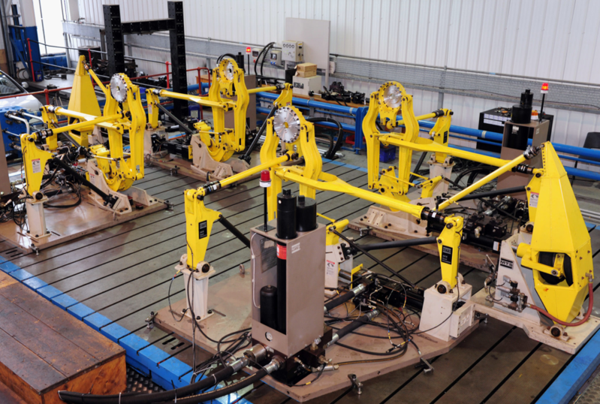
For the GKN company, its website shows the advanced and world class test facilities like hub systems testing, structures testing which are shown below.
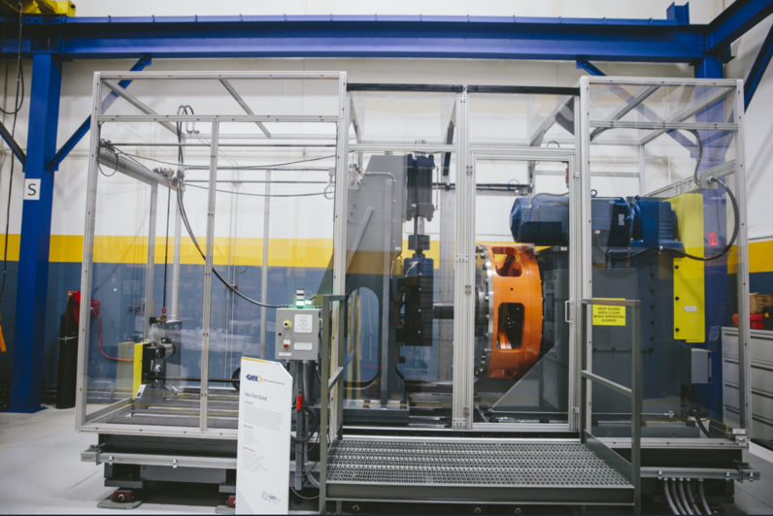
Fig 2.1 structure testing at GKN (Test Facilities - GKN, 2020)
Figure 2.2 hub systems testing (Test Facilities - GKN, 2020)
Most companies such as GKN spend lots of time and cost on the test facilities which covers computational tools (FEA) and laboratory test (physical test).
As to GKN company, it applied a wheel test which conducts tests in the real-world environment, hub and wheel tests can simulate almost any operating conditions to provide accurate performance data, which is beneficial to customers and contributes to improve the customer perception of the product, and also, in other aspects, provides a basis for its further manufacturing, development and investment plans (Test Facilities - GKN, 2020).
For the wheels test facilities, GKN sets FEA tools, field testing, data acquisition etc. These facilities cover both FEA and physical testing to improve its strong test capacity and high-quality products. Also, FEA along with physical testing could provide the company with more competitiveness in the market.
To be concluded, FEA could provide enterprises with lower cost and time on the real-world test and high-efficient work to accelerate products to be applied in the market, while the physical test is also a strong tool to show the advanced test facilities and excellent or even extreme performance of products to improve the satisfaction of customers. FEA alongside with physical test, at a large extent, could create the biggest profit for companies.

2.2.3 Initial comparison of test and FEA help assumptions evolve
When doing the FEA and physical testing, results can be compared to minimize the error during the process of the product designing. And for early program comparisons, which can help plans and assumptions evolve. Many companies use FEA to predict strength and stiffness of physical testing fixtures, considering that the interaction between fixture and product is inevitable but it can be quantified (Abbey,2015). And the quantified interaction can be the dynamic interaction or fixture flexibility. In this way can the companies accelerate to conduct the development of the designing product.

3. Correlation between FE model and physical testing
The relationship between a physical test and an FE model has become a topic to talk about and do the research in this report. From the author’s perspective, there is a relationship about validation between physical test and FE model.

3.1 Verification and Validation
When it comes to FEA, verification and validation seem to be a vital part among mathematical method, FEA and physical testing. In 2005, Tony Abbey once did the discussion and task about what verification and validation are in relation to the FEA.

3.1.1 Definition
Firstly, for the definition of verification and validation, the American Society of Mechanical Engineers (ASME) and the Los Alamos National Laboratory (LANL) both gave the agreed definitions. “The process of determining that a computational model accurately represents the underlying mathematical model and its solution”, ASME defines verification, while LANL also gives the similar definition that it shows the function of evaluating that the FE model could accurately represent developers’ initial design, computational method and solution about the model.
And for the validation, ASME believes that validation is the process of determining the degree to which a model is an accurate representation of the real world from the perspective of the intended uses of the model. They both hold the attitude towards physical test that can play a validation role for the FE model.

3.1.2 Correlation
(1) Flow chart
ASME once created a chart where the relationship between verification, validation, FE model and physical testing can be concluded and described. It is shown below.
Anticipating the physical results of the model is one of the crucial part of verification (Abbey, 2015). In addition, the initial assumptions about the FE model like modeling details, boundary conditions, accurate loads and constraints need to be estimated and thought as the part of the verification.
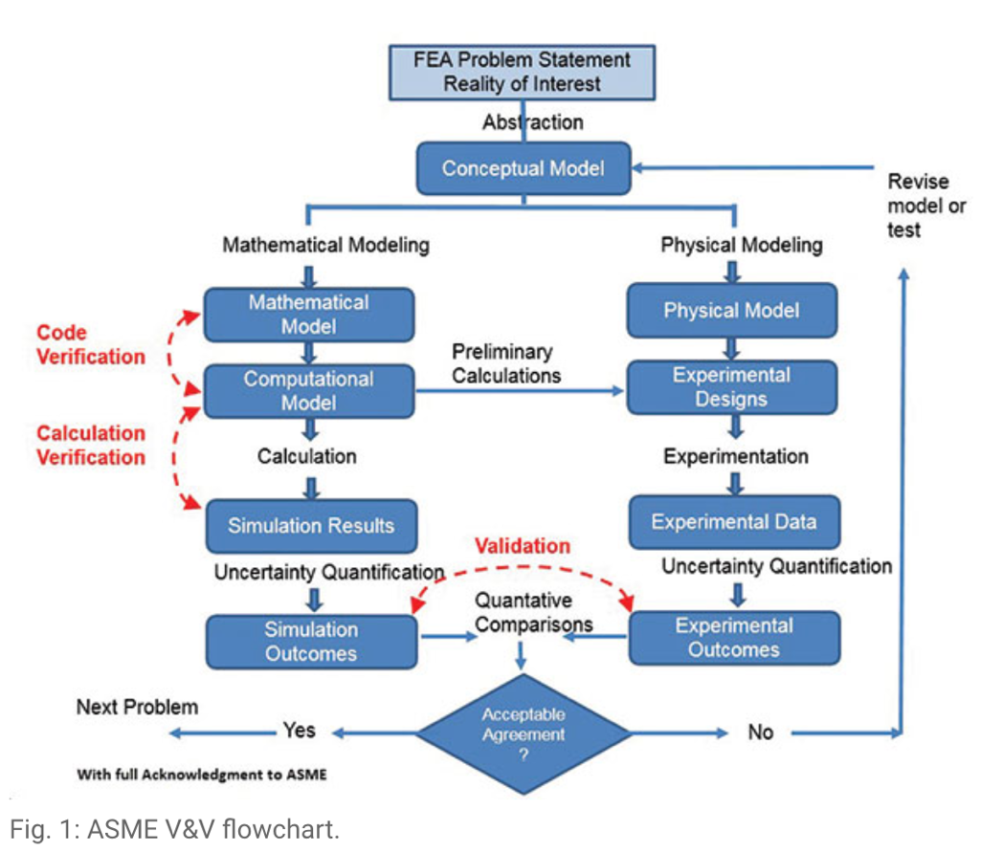
In fact, FEA is an integrated process between computational analysis and physical testing disciplines.
Figure 3.1 Verification & validation flow chart (Leonard, 2007)
(2) Validation section
The physical testing is correlated with FE model through the validation process. The validation process can be divided into 2 parts:
1. Conducting the experiments to estimate whether the model have the capability which is predicted in the designing stage.
2. Assessing the accuracy by quantifying the comparison of experimental and simulated results (Leonard, 2007).
(3) Uncertainty quantification
From the flow chart, a process called uncertainty quantification can be found in FEA and physical testing procedures. This uncertainty quantification is attributed to the error which may be classified as being either random error or systematic error. A meaningful comparison should be conducted with a comprehensive estimate of the uncertainty in FE mode and physical testing, and assess these two uncertain outcomes (Leonard, 2007).
For the uncertainty, on the one hand, the simulated model has limitations. On the other hand, for the test method, people could not guarantee the accuracy and consistency of the test. For example, for some drop analysis, due to the influence of the gap, the simulation value will be lower than the test value. If the simulation and the test are very close, one of them should be wrong.
(4) Validation metrics
In fact, in the validation process, comparisons between test and FEA results are based on a set of metrics. And the fact is that validation becomes better as the number of metrics increase, which means that the big and single comparison (such as material’s yield strength or maximum deflection) is supplemented by many metrics (Abbey, 2015). More metrics can provide a broader validation between FE model and physical test. After applying these metrics, the result should be a quantitative assessment of the agreement between FEA and test (Leonard, 2007). Finally, according to the metrics, the relative error between FE model and test can be obtained and submitted to the decision maker to determine the effectiveness of the model for its intended use in the decision-making process.

3.2 Application
The correlation between FE model and physical testing serves as an important part to minimize the differences between the test outcomes and the FEA predictions by adjusting the FE model (such as boundary conditions, loads). For static and dynamic load analysis, test results for specific load conditions can be correlated to verify model predictions.
The author is doing the project which is concerned with both FEA and physical tests. For the aim of this project, the torsional stiffness of a vehicle structure should be tested and analyzed in respectively real-world and SOLIDWORKS. And the final goal is to accomplish the optimization of the model in the computational software. For these project, it subtly indicates the relationship between FEA and physical testing as followed.
For the FE model, the author with her classmates together calculated the relative parameters of the vehicle and then according to these data they built an FE model in SOLIDWORKS.
For the torsional stiffness testing process in real life, there are 10 points on the chassis to test. In the test, the author applied 65 kg on the bar to twist the vehicle. The bar was linked with the whole chassis through bolts. And the rear part of the chassis was fixed to the ground. The process of the physical test can be found in the following pictures.
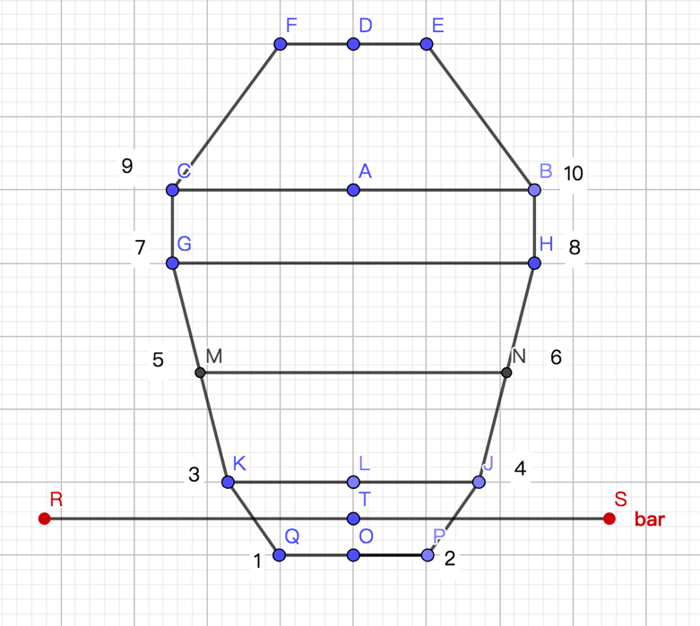
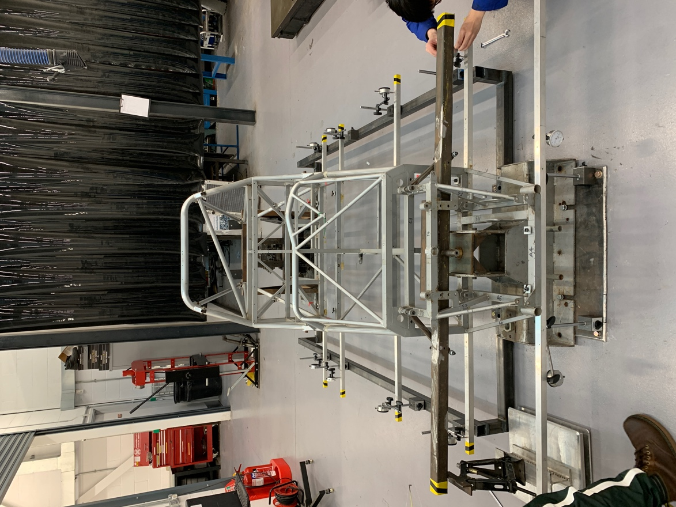
Figure 3.2 torsional stiffness (physical testing)
Figure 3.3 Simplified model
To conclude and simplify the test, the task was calculated 10 displacements from the 10 points, and convert the measured displacements value into rotated angles, through mathematical calculations.
 |  | 65kg on the bar | Displacement/Distance (tan$θ$)
I | 1 | 2.942mm | 0.0063
I | 2 | 2.25mm | 0.0063
II | 3 | 4.018mm | 0.00518
II | 4 | 4.018mm | 0.00518
III | 5 | 3.069mm | 0.00374
III | 6 | 3.07mm | 0.00374
IV | 7 | 2.03mm | 0.0024
IV | 8 | 1.779mm | 0.0024
V | 9 | 1.74mm | 0.0020
V | 10 | 1.380mm | 0.0020
Table 3.1 Physical testing data
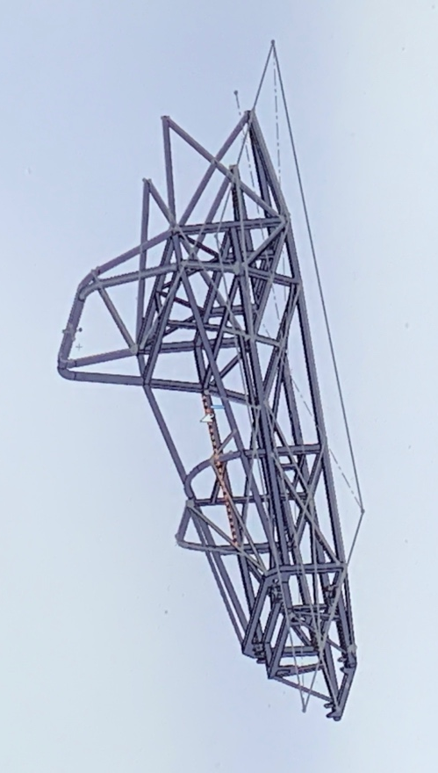
For the FE model, firstly, the author needs to do the basic calculations of the model, like relative parameters, actual loads applied to the vehicle itself, and particularly the intended result of the chassis. The author built the model in the SOLIDWORKS and the mesh also was created in the following pictures.
Figure 3.4 The model created in the SOLIDWORKS

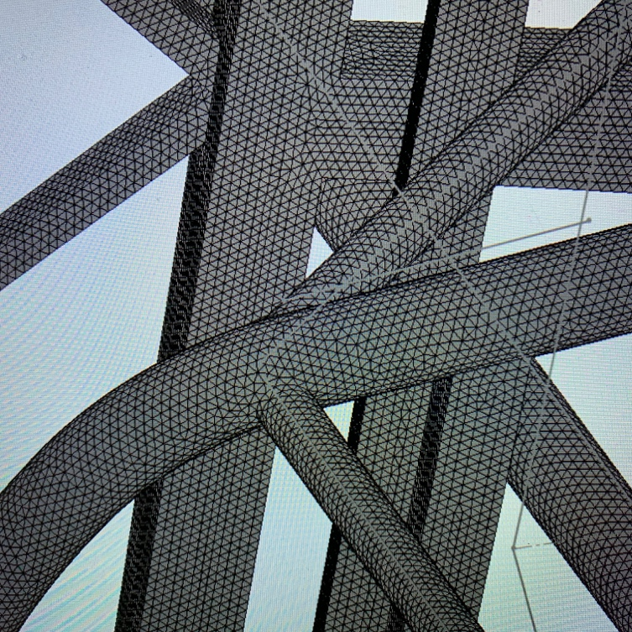
Figure 3.5 Mesh in SOLIDWORKS
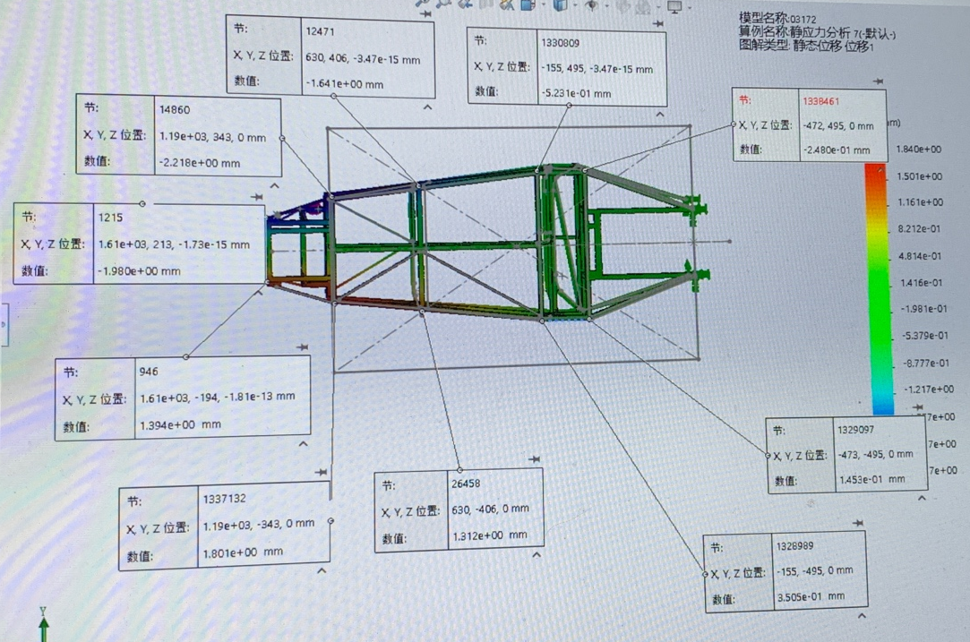
In fact, mesh could exert a tremendous effect on the outcomes of FEA by influencing the accuracy of the model. However, the mesh convergence can almost ensure its accuracy to FEA local stresses. And for the value of the force which needs to be added to the vehicle, the author measured the length of bar and distance between the stress point and middle line to calculated the actual force (2403N). Hence, the transferring force is a point where FEA may easily fall in the trap. The author chose the relative points to obtain the displacements in the computational FEA outcomes, and compared the results with the physical testing one.
Figure 3.6 Choosing 10 points’ displacement
 |  | FEA Displacement/Distance (tan$θ$) | Physical testing Displacement/Distance (tan$θ$)
I | 1 | 0.0083 | 0.0063
I | 2 | 0.0083 | 0.0063
II | 3 | 0.0058 | 0.0052
II | 4 | 0.0058 | 0.0052
III | 5 | 0.0036 | 0.0037
III | 6 | 0.0036 | 0.0037
IV | 7 | 0.0088 | 0.0024
IV | 8 | 0.0088 | 0.0024
V | 9 | 0.0038 | 0.0020
V | 10 | 0.0038 | 0.0020
Table 3-2 Comparative table for the torsional angle
Through the comparative table between FE model outcomes and physical testing outcomes, the sets of IV, V have some problems. From the author’s intended outcome, the area closer to the rear part, the more stiffness it may have. And this two part statistics show that in FEA the torsional angle is bigger than the physical one. Nevertheless, no matter FEA or physical testing, they all have the uncertainty quantification or the error. Hence, they cannot be much similar to each other.
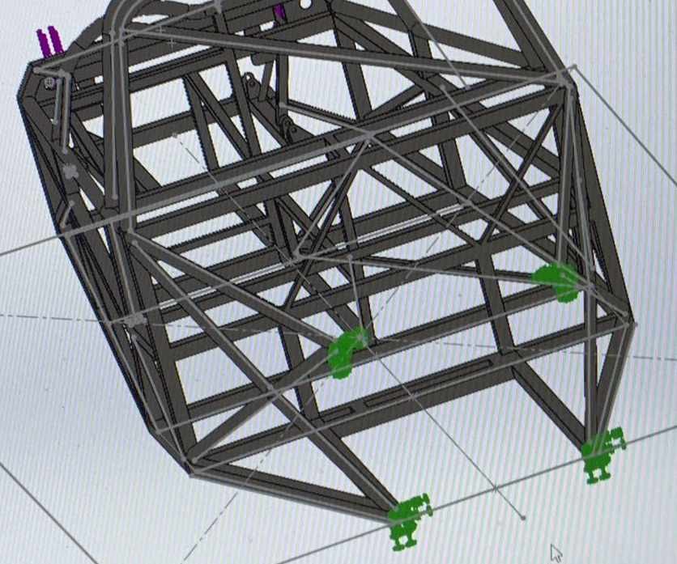
The author gave a deep thought about why some FEA outcomes cannot be right with the predicting outcomes. The author found that in FEA the model was fixed with just 4 faces of the rear vehicle, but in reality, the chassis was fixed with the ground by the clamping device.
Figure 3.7 Fixtures in SOLIDWORKS
As mentioned above, the relative interaction between fixtures and chassis cannot be neglected. Hence, the author needs to adjust the FE model by adding the clamping device.

4. Can FE analysis ever replace physical testing?
FEA is the product of the increasingly development of technology and highly demand of efficient companies. The emergence and rapid development of FEA have caused a certain impact on the product design and production methods. Previously physical testing is the only key point to assess the product quality, but it may cost much time, labor and money. Nowadays, some people have suggested whether FEA can directly replace physical tests for product analysis. The author will discuss this topic in terms of discussing the merits and demerits of FEA.

4.1 The advantage of FEA
(1) FEA can provide a sight where the effects which real world extremes will exert on the product designing process are analyzed and simulated, which could save the cost and time because of the smaller demands and trials of the real world physical prototypes (Caliber Design, 2015).
(2) FEA can also be applied to the optimize or modify the performance of a product. Before the physical prototyping of a new product being produced, FEA can anticipate the mechanical properties of the product which provide theoretical basis for the design (Zhou, 2002). For the companies, it will be worth to the business to predict the potential problems which could reduce the warranty claims and make consumers aware of it.

4.2 The disadvantage of FEA
(1) To get a stress plot through FEA is not difficult, but the accuracy of the results needs to be considered and even validated seriously. Generally, the accurate analysis happens when analyst combines experience and engineering judgment with it.
(2) Mesh quality exerts enormous effects on the FEA outcomes. A coarse mesh may cause the inaccurate stress while an exactly fine mesh may take long time to run and solve.
(3) Boundary conditions, incorrect restraints or load may influence the outcomes. The FE model can easily be made mistakes once one step of the assumption is wrong (Test Facilities - GKN, 2020).

4.3 Two independent ideas
From the author’s perspective, FEA and physical are two independent ideas for verifying phenomena. There is no more essential relationship between the two methods. The FEA has its own set of procedures and programs. As long as the FEA personnel are true and accurate about the FE model, the boundary and other simulation processes, the FEA results are referenced. And the FEA is the process of solving partial differential equations, so one FEA is one time. The solution process is an experiment on the process of partial differential equations. As for the actual physical test, it is impossible for the test to achieve a 100% reduction of the actual result. It is only a special test and verification for special circumstances, and then forms a design criterion. In addition, Due to the limitation of the device like test instruments, loading and extraction, etc. the error of the test is greater than the error of the FEA in some cases. On the other hand, it is also noted that FEA and physical testing must be complementary to each other. The complementary simulations serve to improve the FEA and test schemes, and ultimately can be used as a predictor to avoid actual dangerous situations.
In conclusion, the author holds the attitude that it is that there is no FEA that can replace physical tests. They are all independent individuals. If they can be analyzed together, the maximum benefit can be achieved. Physical testing could be the validation process for the FEA which can minimize the test required to save cost and time, but FEA could not be the substitute for the final test.

5. Conclusion
In this report, the author discussed three questions which are all concerned with the relationship between FEA and physical testing.
For the question one why companies choose to do the FEA together with physical testing, the author listed three explanations. Firstly, when FEA was validated with the physical testing, FEA can be repeated for the same analysis to reduce the physical tests required and costs. Secondly, these two together can improve the consumers’ perception of the product. Finally, early comparisons between them before the physical prototyping could contribute to the evolving of the assumption for the product designing stage.
Then the author explained the verification and validation between FE model and physical testing. And the author detailed the validation process to express the correlation. The validation process is concerned with FEA and test, but it is important to notice these two uncertainty quantifications which should be compared to validate whether the FE model could realize the predicting capability.
For the last topic, the author held the attitude that FEA cannot replace the test because they are respectively independent ideas to deal with the performance of the product. They both have its advantages and limitations. The author particularly believed that the condition when FEA and physical testing are complementary to each other makes the best profit.

6. Reference
1. Caliberdesign.co.nz. 2020. [online] Available at: <https://www.caliberdesign.co.nz/wp-content/uploads/2015/05/Caliber-Design-HowToGuide-Intro-to-FEA.pdf> [Accessed 21 April 2020].
2. GKN. 2020. Test Facilities - GKN. [online] Available at: <https://www.gknwheels.com/rd/test-facilities/> [Accessed 22 April 2020].
3. Schwer, Leonard. (2007). An overview of the PTC 60/V&V 10: Guide for verification and validation in computational solid mechanics: Transmitted by L. E. Schwer, Chair PTC 60V&V 10. Eng. Comput. (Lond.). 23. 245-252. 10.1007/s00366-007-0072-z.
4. Abbey, T., 2015. Verification Vs. Validation In Relation To FEA - Digital Engineering. [online] Digital Engineering. Available at: <https://www.digitalengineering247.com/article/verification-vs-validation/> [Accessed 23 April 2020].
5. Zhou, D., 2002. Comparison of FEM modal Analysis and Test Modal Analysis for Body of Mini-Truck. MSC.SOftware.

