Danielle Lewis
Course Title: Photography in the Arts
Student number:1705173
Tutor: Paul Duerinck
Word count excluding bibliography:1994
Assignment – Lens-based Image Making 2,000-word essay -

Using at least 3 examples, consider how image makers have utilised digital technology to explore one of the following: Conflict, Identity, the Surveillance State, the Technological World?

We view and express ourselves through our identity which include our qualities, beliefs, looks and expressions. The experiences we go through in life change the way we see ourselves or are seen by others. Friends and fashions or political beliefs are also based on our identities. These characteristics determine our personal and social identity and are often explored and expressed by artists.

Individuals can be captured, within a society or a nation with attributes such as gender, sexuality, race, nationality and heritage distinguishing us from each other.

My research will provide information on various artists who have explored their own perception of identity from differing viewpoints and eras which they illustrate through their work. I was inspired by ‘identity’ because it will allow me to look at a variety of photographers and will prompt me to question my own identity.

Diane Arbus was the first artist I researched. She was a distinctive American photographer of the 20th​ century. She used black and white through all of her work and photographed​ marginalized individuals​ such as circus performers, nudists and midgets that were identified as ‘The Freaks’ at that time. She photographed ‘The Freaks’ in their own natural environments by going into their homes and work environments and took close up portraits to focus on their facial expressions and clothing.

“There's a quality of legend about freaks.
Like a person in a fairy tale who stops you and demands that you answer a riddle. Most people go through life dreading they'll have a traumatic experience. Freaks were born with their trauma. They've already passed their test in life. They're aristocrats.”
― Diane Arbus

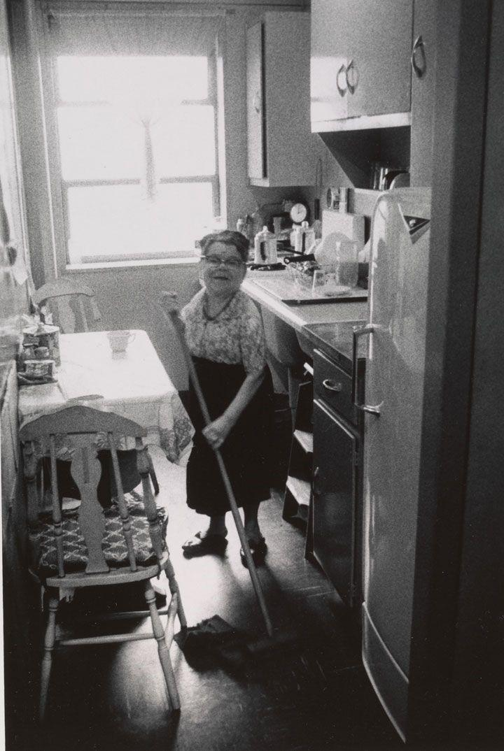
This image is an example of Diane's work. The photograph shows a Russian midget, in her kitchen. I found this image captivating because of the way the women is looking at the camera as if she was taken by surprise, it makes the image dramatic and almost intense.
I also think this photograph is powerful and storytelling because it shows the close relationship Diane had with the people she photographed and shows how much she interacted with them and became involved with their personal lives.

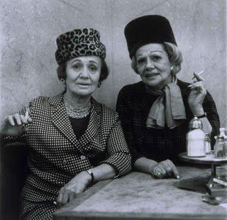
Another image taken by Diane is called “Two Ladies at the Automat’’.t shows two transvestites having lunch in New York. She found these two men intriguing because they were different from ordinary society. She supported their identity and lifestyle and wanted to photograph them to challenge the viewer.

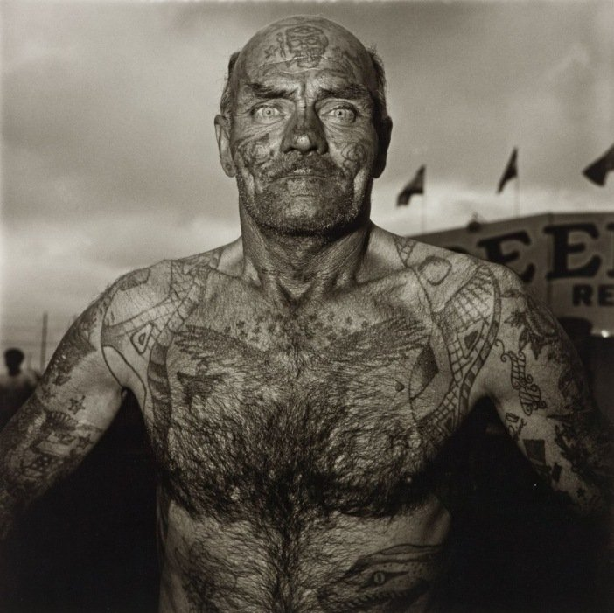
This image shows a tattooed man standing at a festival. The close up shot fills the frame and allows us the viewers to focus on his facial features such as his wrinkled skin and body hair. His intense facial expression and body language makes the photograph really powerful and almost dramatic.I think this image and many other images by Diane have many hidden meanings and messages behind them.

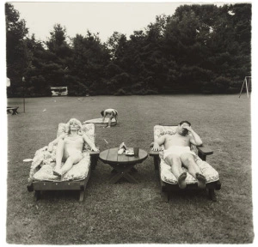
Another photograph by Diane was this photograph called ‘A Family on their Lawn one Sunday in Westchester, NY’. The photograph shows parents who are sitting on deck chairs in the garden. They both portray very different facial expressions, the women looks relaxed while the man looks stressed. I think the meaning behind this piece was to show the type of society during that time by how men worked and women stayed at home.

Diane was generally criticized for her work especially by a well-known writer and author Susan Sontag. She disliked Diane’s work and stated that Diane was exploiting the ‘freaks’ rather than photographing them as part of artwork.
In one of Susan Sontag’s books she wrote that “In photographing dwarfs, you don’t get majesty and beauty, you get dwarfs.” The way Susan Sontag has expressed her feelings and opinions towards Diane’s work shows how much she disliked Diane’s artwork and the subjects she photographed with the words she used to describe ‘the freaks’ as ‘ugly’ proves how strong she felt towards people who were different.
The quotes below are from Diane herself:
“Freaks was a thing I photographed a lot. It was one of the first things I photographed, and it had a terrific kind of excitement for me. I just used to adore them. I still do adore some of them. I don’t quite mean they’re my best friends but they made me feel a mixture of shame and awe.” This statement from Diane shows the love and appreciation she felt towards her subjects.

I personally disagree with Susan Sontag's opinions on Diane’s work. I think Diane wanted us to see and accept the reality of marginalized people and their individuality. I think the purpose of her work was to show viewers the true reality of society by photographing people who were different, to create strong storytelling photographs and to surprise the audience.
Overall I think Diane is a very talented photographer, and I think her work could not be changed in any way otherwise it would lose its meaning. Her use of creative lighting and composition in her images, makes her work visually appealing.

I next researched August Sander who was described as ‘the most important German portrait photographer of the early 20th Century’. Like Diane Arbus, Sander photographed people from all segments of society between the 1890s and 1950s such as politicians, farmers and movie stars in order to tell a story about each of their backgrounds including their social situation, politics, and their profession. He captured people in their natural settings to show their places of work. He managed to represent every element that built society and how it expanded. His images have an vintage style to them and the poses he uses within his portraits makes his body work much interesting and storytelling.
Someone who criticizes Sanders work was a military historian and writer Stephen bull. In one of his articles he wrote “Perhaps there is something suspicious too about those folks depicted in the principal mass of Sander’s project. Many of them could almost be character actors trying out roles for their portfolio.” He describes photos depicting - The ‘Trade-Unionist’, sleeves rolled up to his elbows, posing dramatically in front of a white backdrop and others displaying basic props, such as a Postman for registered mail an Unemployed man waits, cap in hand and a ‘Barrister’ holding up his papers. “Rarely do we see these people actually acting out their roles.”
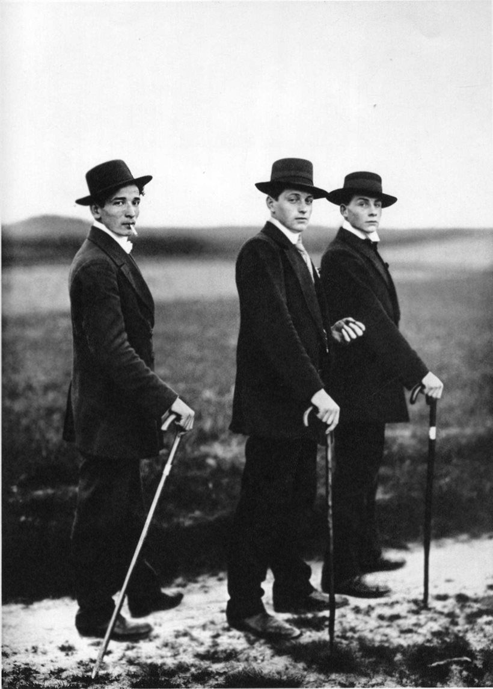
An example of August Sanders is this portrait called ‘young farmers’ which was taken in 1914 from his series of work that was taken taken between world war 2. It shows three farmers standing on a countryside road looking directly towards the camera, their posture suggests he captured them unexpectedly while walking. The way they are dressed does not depict their occupation. These farmers were obviously influenced by popular culture and advertising, and represent a trend that saw workers move away from the land towards the city.
“The Marxist critic John Berger famously wrote about the image, arguing that the peasant’s suits are ill-fitting copies of a more bourgeois attire. These farmers,influenced by popular culture and advertising, may represent a trend that saw workers move away from the land towards the city.”
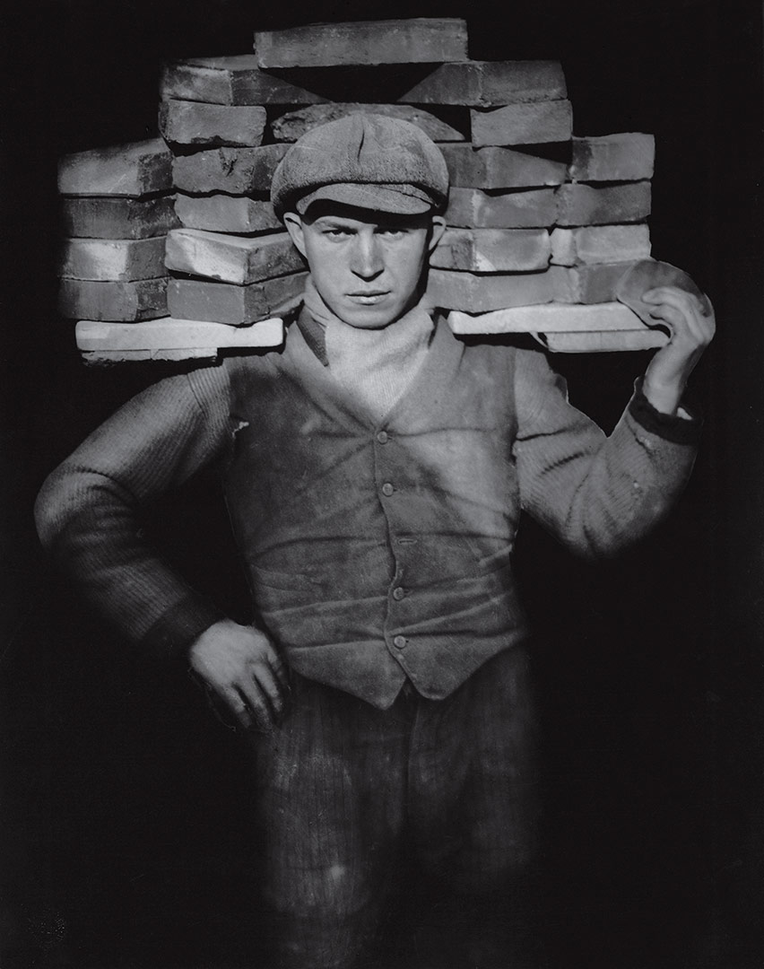
In the above image, the eyes of the man are the most effective part and without the gaze this image would not be so captivating. Sanders photographs focuses on real people and the impact greater things have on them. Through this photograph we can see this idea. Sander tried to portray to his audience the story of people and making us aware that we all have our own background which what makes us and our identities so interesting. This photograph shows us strength of character and power, not only in the fact that he is carrying heavy weight but through his gaze and posture. This is an interesting example of how the subjects have a relationship with the photographer.
Another critic of his work says ‘’August Sander’s work as nothing beyond portraits of people’’ I disagree with this, I personally think his work is interesting because he manages to portray the story of the people in his photographs, in their surroundings which makes viewers feel connected to his work.
His ethos was ‘to project an image of our time with absolute fidelity to nature by means of photography,” he stated. “Let me speak the truth in all honesty about our age and the people of our age.”
Sander produced a book ‘face of our time’ in which he revealed his subjects’ professions and status where their clothes and their settings tells us more of their standing in society. He also produced a series of images documenting the daily life of individuals of different ages in order to show the different stages of life. The photographs begin by showing peasant children and how they progress through stages of life. I think the way he creates story within his body of work is really captivating.

My next researched artist was Cynthia Morris Sherman (known as Cindy) who was a contemporary American photographer and filmmaker. Her work was mainly focused on her own body in roles or personas by dressing up and masquerading as all manner of characters offering a critique of gender and identity with portrayals of female stereotypes found in film, tv and advertising.
Throughout her work, Sherman dresses up as dramatic female roles, some of the characters are a Hitchcock heroine, a busty Monroe, an abuse victim, a cowgirl, amongst many others. She uses vintage clothing to identify with these characters.
Her best known work was “Complete Untitled Film Stills” which was a series of black and white photographs taken using first her apartment as a setting and later outside in the urban and rural landscape, which took over three years to complete .
There is an absence of title and colour and highlights different female figures in daily life as presented in so-called progressive arts at the time : cinema.
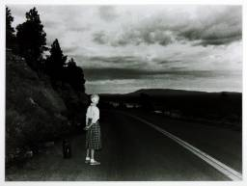
This an example of one of the collection of the ‘stills’ taken in a rural landscape with Cindy Sherman as the outstanding character. Making the person her main focal point in a very delicate way. The dark shadows in the photographs gives depth, whilst also making it rather miserable and mysterious with the light shining on the woman.
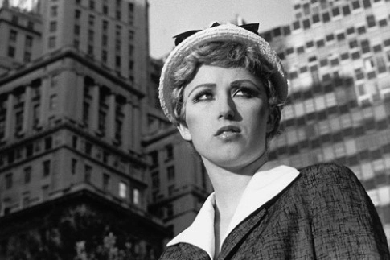
This above photograph shows a self portrait of Cindy in a city environment. The photograph was taken at low angle which makes cindy appear imposing giving a dramatic effect. The black and white effect helps convey the emotion and adds a classic vintage look to the portrait.
The meaning behind Cindy Sherman's work is feminism because of the way her photographs show the different types of roles women were seen to have in society.
Many critics criticized Cindy's series of portraits called ‘black face’ for being ‘racist’ because of the dark skin types she photographed herself in using black makeup. Other critics say that Cindy makes fun out of the types of people she photographed herself as. However, her work was well respected when Sherman was given a MacArthur Fellowship and an honorary doctorate from the Royal College of Art London

These three 20th century artists, through the image of technology allowed us, the viewer, to see the identity and personalities that were in society at the time of their work. Although they covered different aspects, their images followed a similar line bringing to the forefront unusual characters in society. All the artists photographed distinctive people. They captured people in unusual situations and circumstances.
They have all depicted subjects that have certain traits either their looks or professions and tried to portray human civilisation through their photography and their instinct of pinpointing certain aspects of human life giving each of their characters individual identity.
En.wikipedia.org. (2018). Diane Arbus. [online] Available at: https://en.wikipedia.org/wiki/Diane_Arbus [Accessed 13 Dec. 2018].
Biography. (2018). Diane Arbus. [online] Available at: https://www.biography.com/people/diane-arbus-9187461 [Accessed 13 Dec. 2018].
Nikolova, I. (2018). Diane Arbus and Her Work. [online] Dptips-central.com. Available at: http://www.dptips-central.com/diane-arbus.html [Accessed 13 Dec. 2018].
Moma.org. (2018). August Sander | MoMA. [online] Available at: https://www.moma.org/artists/5145 [Accessed 13 Dec. 2018].
Photographer, S. (2018). August Sander | Photography and Biography. [online] Famousphotographers.net. Available at: http://www.famousphotographers.net/august-sander [Accessed 13 Dec. 2018].
Encyclopedia Britannica. (2018). August Sander | German photographer. [online] Available at: https://www.britannica.com/biography/August-Sander [Accessed 13 Dec. 2018].
Artsy.net. (2018). Cindy Sherman - 235 Artworks, Bio & Shows on Artsy. [online] Available at: https://www.artsy.net/artist/cindy-sherman [Accessed 13 Dec. 2018].
The Art Story. (2018). Cindy Sherman Overview and Analysis. [online] Available at: https://www.theartstory.org/artist-sherman-cindy.htm [Accessed 13 Dec. 2018].
The Art Story. (2018). Cindy Sherman Overview and Analysis. [online] Available at: https://www.theartstory.org/artist-sherman-cindy.htm [Accessed 13 Dec. 2018].
All-about-photo.com. (2018). Cindy Sherman Photographer | All About Photo. [online] Available at: https://www.all-about-photo.com/photographers/photographer/132/cindy-sherman [Accessed 13 Dec. 2018].
Goodreads.com. (2018). Diane Arbus Quotes (Author of Diane Arbus). [online] Available at: https://www.goodreads.com/author/quotes/77548.Diane_Arbus [Accessed 13 Dec. 2018].

