University of Wales Trinity Saint David
LONDON CAMPUS
Individual Report
Module Name: Digital Skills and Research Methods
Module Code: LCHS 4007
Student name: Maria-Gabriela Ion
Student ID: 2509672
Lecturer’s Name: Sadeque Imam Shaikh

Table of Contents
Research Topic: <Healthcare Workforce Shortages and Burnout in the UK: Impact on Recruitment, Retention and Patient Care> 2
Introduction 2
Problem Statement 2
Justification 2
Information Sources and Justification 2
Task 2: Research Methodologies 2
Give a brief overview of quantitative and qualitative research. 2
What type of research methodology will you use for your research and why? 3
Task 3: Data Collection 3
Overview of primary and secondary data collection 3
What form of data will be used to address your research problem, and why? 3
Conclusion 3
References 3

Research Topic:<Healthcare Workforce Shortages and Burnout in the UK: Impact on Recruitment, Retention and Patient Care>

Introduction
The present study examines the ongoing challenges facing the healthcare workforce in the United Kingdom. It focuses on key issues such as recruitment difficulties, staff retention, and the overall health and well‑being of employees working across health and social care settings. The sector continues to experience significant staff shortages and high turnover rates, which are further intensified by increasing workloads and inadequate support for caregivers (Michaeli et al., 2024). These challenges directly influence the quality of patient care and contribute to rising levels of burnout among healthcare professionals. The purpose of this research is to explore these workforce issues in depth and to identify strategies that can strengthen staff well‑being, improve retention, and support the long‑term sustainability of the healthcare system.
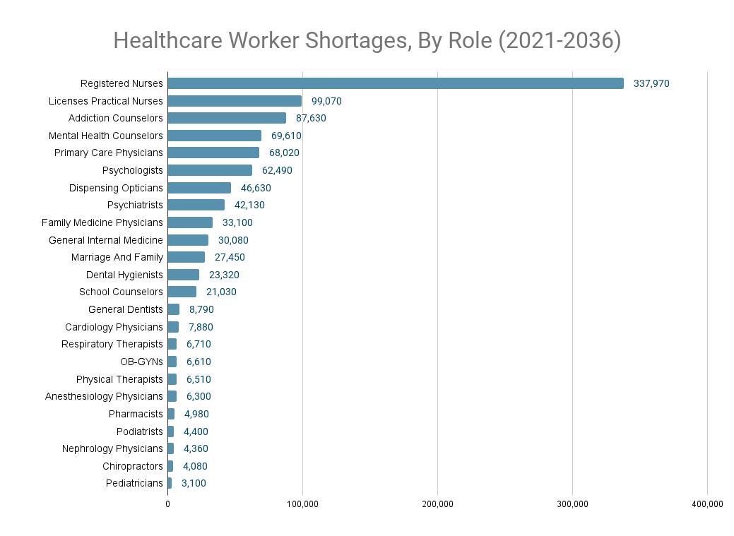
Fig.1 – Source internet, available at : Healthcare+Worker+Shortages,+By+Role+(2021-2036).png (1039×759)

Problem Statement
A major issue affecting the UK healthcare sector is the persistent shortage of healthcare workers, particularly nurses, social care staff, and allied health professionals. Workforce deficits have been widely reported across the NHS and social care services, with many organisations struggling to fill vacancies or retain experienced staff. According to NHS Digital (2024), vacancy rates remain high across several clinical areas, and the demand for services continues to rise due to an ageing population and increasing complexity of care needs.
Burnout is a significant contributing factor to these shortages. Healthcare workers frequently report high levels of stress, emotional exhaustion, and reduced job satisfaction, driven by heavy workloads, long hours, and limited organisational support (West et al., 2020). These pressures have intensified since the COVID‑19 pandemic, which placed unprecedented strain on the workforce. As a result, many staff members leave the profession entirely, creating a cycle in which shortages worsen over time.
The consequences of understaffing are far‑reaching. Patients experience longer waiting times, reduced continuity of care, and an increased risk of medical errors. Healthcare organisations face financial strain due to reliance on agency staff, overtime payments, and repeated recruitment cycles. Without effective interventions, workforce shortages will continue to undermine the sustainability and effectiveness of the UK healthcare system.

Justification
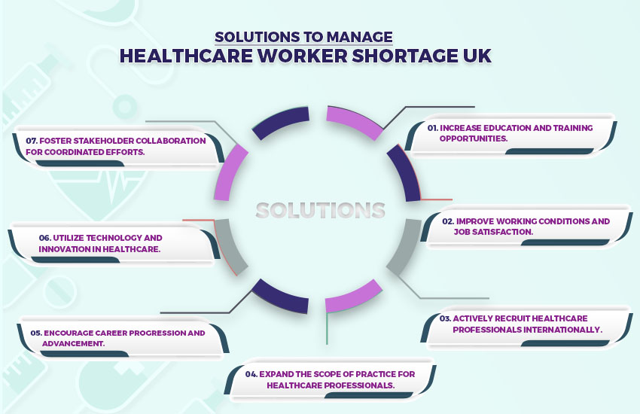
Fig.2 – Source internet available at : Impacts-of-Shortage-of-healthcare-workers-UK.jpg (850×550)

The study is critical to the origin and impact of workforce deficits in the UK healthcare industry. The study will yield meaningful insights into the issue of recruitment and retention by revealing the cause of staffing problems and burnout. The results have the potential to impact the healthcare policies, recruitment policies, and retention to improve workforce shortages. The studies can contribute to the initiatives of improving working conditions and job satisfaction and promoting professional growth in healthcare workers (Hammad, 2024). These challenges are critical in the future sustainability of the healthcare system, which should satisfy the rising needs of an ageing population and rising patient demand.

Impact on Stakeholders

Patients

Patients are directly affected by workforce shortages, often experiencing delays in treatment, reduced access to services, and shorter or rushed interactions with staff. The Care Quality Commission (2023) reports that insufficient staffing levels can compromise patient safety, increase the likelihood of errors, and reduce the overall quality of care.

Healthcare Workers

Frontline staff face increased workloads, emotional strain, and reduced job satisfaction. High levels of burnout negatively impact their mental health and contribute to high turnover rates (West et al., 2020). Many workers report feeling undervalued and unsupported, which further reduces morale and motivation.

Healthcare Organisations

Hospitals, clinics, and care homes struggle to maintain service quality while managing rising operational costs. High turnover leads to increased spending on recruitment, induction, and training. Reliance on temporary staff disrupts team cohesion and continuity of care.

Government and Policy Makers

Workforce shortages place pressure on national healthcare budgets, requiring investment in recruitment campaigns, training programmes, and retention initiatives. Policymakers must address systemic issues such as pay, working conditions, and career development to ensure the long‑term sustainability of the health and social care workforce (The King’s Fund, 2022).

Information Sources and Justification
This research is essential for understanding the root causes and consequences of workforce shortages and burnout in the UK healthcare sector. By examining recruitment challenges, retention barriers, and the emotional experiences of healthcare workers, the study will provide insights that can inform policy development and organisational strategies. The findings may support improvements in working conditions, job satisfaction, and professional development opportunities, all of which are crucial for building a resilient and sustainable workforce. Given the increasing demands of an ageing population, addressing workforce shortages is vital for ensuring high‑quality patient care and safeguarding the future of the healthcare system.

Information Sources and Justification
Source 1: NHS Digital – NHS Workforce Statistics
Content & Relevance: Provides official national data on staffing levels, vacancy rates, and workforce demographics across the NHS.
Justification: This is the most authoritative source for understanding the scale and distribution of workforce shortages.
Available at: https://digital.nhs.uk/data-and-information/publications/statistical/nhs-workforce-statistics
Accessed: 07 December 2025
Source 2: Care Quality Commission (CQC) – Workforce Well‑being Report
Content & Relevance: Analyses staff well‑being, burnout, and organisational culture within care settings.
Justification: Provides essential insights into the emotional and psychological challenges faced by healthcare workers.
Available at: https://www.cqc.org.uk/publications
Accessed: 07 December 2025
Source 3: De Vries et al. (2023) – The Race to Retain Healthcare Workers: A Systematic Review on Factors that Impact Retention of Nurses and Physicians in Hospitals
Content & Relevance: Examines how job satisfaction, workload, and career growth influence healthcare professionals’ decisions to remain in or leave their careers.
Justification: Important for identifying factors that drive retention and turnover. Offers evidence to support strategies aimed at enhancing job satisfaction and reducing workforce attrition.
Available at: The Race to Retain Healthcare Workers: A Systematic Review on Factors that Impact Retention of Nurses and Physicians in HospitalsAccessed: 07 December 2025

Task 2: Research Methodologies

Give a brief overview of quantitative and qualitative research.
Overview of Quantitative and Qualitative Research
Quantitative Research
Quantitative research involves the collection and analysis of numerical data to identify patterns, measure variables, and test relationships statistically. It uses structured tools such as surveys, questionnaires, and numerical datasets. This approach is particularly useful in healthcare workforce research because it allows the measurement of burnout levels, turnover rates, job satisfaction scores, and vacancy trends across large groups (Alwan, 2020).

Qualitative Research
Qualitative research focuses on exploring experiences, perceptions, and meanings through non‑numerical data. Methods such as interviews, focus groups, and open‑ended questionnaires allow researchers to gain deeper insight into the lived experiences of healthcare workers. This approach is valuable for understanding complex issues such as emotional strain, workplace culture, and the personal impact of staff shortages (Mohajan, 2018).

What type of research methodology will you use for your research and why?
Selected Research Methodology and Justification: Mixed‑Methods Approach
This study will adopt a mixed‑methods approach, combining both quantitative and qualitative research. Using both approaches provides a more comprehensive and balanced understanding of workforce shortages and burnout in the UK healthcare sector.
Strengths of Quantitative Data
Quantitative methods will help measure:
• the scale of staff shortages
• levels of burnout
• turnover rates
• job satisfaction trends
• demographic patterns

Strengths of Qualitative Data
Qualitative methods will explore:
• personal experiences of stress
• emotional exhaustion
• perceptions of organisational support
• reasons behind decisions to stay or leave

Why Both Are Needed
Mixed‑methods research strengthens the validity of findings by allowing the two types of data to complement each other. Quantitative data identifies what is happening, while qualitative data explains why it is happening. This approach is widely recommended in health and social care research (Fetters & Molina‑Azorin, 2020) and aligns with current UK workforce research practices (The King’s Fund, 2022).

Task 3: Data Collection

Overview of primary and secondary data collection
Primary Data
Primary data is information collected first‑hand by the researcher for the specific study. Methods include interviews, surveys, and observations. In this research, primary data may involve interviewing healthcare workers about burnout and workplace pressures (Kabir, 2016).

Secondary Data
Secondary data refers to information that already exists, such as government reports, academic articles, and organisational publications. This research will use NHS Digital and CQC reports to understand national workforce trends (Johnston, 2017).
Overview of Primary and Secondary Data Collection
Primary data collection involves gathering new information directly from participants. This may include interviews, surveys, or observations designed specifically for the research question. It provides original, up‑to‑date insights that reflect the real experiences of healthcare workers.
Secondary data collection involves using information that has already been collected and published by other organisations or researchers. Examples include NHS workforce statistics, government reports, academic studies, and CQC publications. Secondary data is useful for identifying national trends, comparing findings, and supporting the context of the research.

Difference Between Primary and Secondary Data
• Primary data is collected directly by the researcher, making it highly relevant and tailored to the research aims. It provides detailed, personal insights but can be time‑consuming and resource‑intensive.
• Secondary data is collected by external organisations or researchers and already exists before the study begins. It is quicker to access, often covers large populations, and provides reliable background information, although it may not fully address the specific research focus.
In this study, secondary data will provide a broad understanding of national workforce trends, while primary data will offer deeper insight into the lived experiences of healthcare workers.

What form of data will be used to address your research problem, and why?


Fig.3 – Source internet, available at : methods-COLLECTING-DATA.webp (1000×500)

This research will use a combination of primary and secondary data, in line with the mixed‑methods approach adopted for the study. Using both forms of data will provide a comprehensive understanding of workforce shortages and burnout in the UK healthcare sector.

Secondary Data as the Core Evidence Base

Secondary data will form the primary source of evidence for this research. This includes NHS Digital workforce datasets and CQC reports, which provide large‑scale, reliable, and up‑to‑date information on staffing levels, vacancy rates, turnover trends, and workforce well‑being. Secondary data is particularly valuable because it allows the researcher to identify national patterns and quantify the scale of workforce shortages (Johnston, 2017).

Primary Data to Capture Lived Experiences

Primary data will complement secondary data by providing first‑hand insights into the experiences of healthcare workers. Interviews or open‑ended survey questions will explore burnout, emotional strain, workload pressures, and perceptions of organisational support. Primary data is essential for understanding the human impact of workforce shortages, which cannot be fully captured through numerical datasets alone (Kabir, 2016).
Why Both Are Needed
Using both primary and secondary data strengthens the research by combining broad, statistical evidence with rich, personal accounts. Secondary data identifies what is happening at a national level, while primary data helps explain why these issues occur and how they affect staff.

Conclusion
This research highlights the significant and ongoing challenges posed by workforce shortages and burnout within the UK healthcare system. By examining both national workforce data and the lived experiences of healthcare workers, the study provides a comprehensive understanding of the structural and personal factors contributing to recruitment and retention difficulties. The mixed‑methods approach strengthens the analysis by combining large‑scale secondary data with primary insights, allowing the research to capture both the measurable extent of workforce shortages and the emotional and psychological impact on staff.
The findings emphasise that workforce pressures are not only operational issues but also deeply human ones, affecting staff well‑being, patient safety, and the overall sustainability of health and social care services. Addressing these challenges requires coordinated action from healthcare organisations and policymakers, including improved working conditions, enhanced support systems, and long‑term workforce planning. Ultimately, tackling workforce shortages and burnout is essential for ensuring high‑quality patient care, protecting staff welfare, and maintaining a resilient and effective healthcare system for the future..

References
Alwan, N. (2020) Quantitative Research Methods: An Overview. Available at: https://www.researchgate.net/publication/344482390_Quantitative_Research_Methods_An_Overview (Accessed: 07 December 2025).
Care Quality Commission (2023) Workforce Well-being Report. Available at: https://www.cqc.org.uk/publications (Accessed: 07 December 2025).
Fetters, M. and Molina-Azorin, J. (2020) ‘The future of mixed methods research’, Journal of Mixed Methods Research. Available at: https://journals.sagepub.com/doi/10.1177/1558689820935906 (Accessed: 07 December 2025).
Johnston, M.P. (2017) ‘Secondary data analysis: A method of which the time has come’, Qualitative and Quantitative Methods in Libraries, 3(3), pp. 619–626. Available at: https://www.researchgate.net/publication/319127443_Secondary_Data_Analysis_A_Method_of_Which_the_Time_Has_Come (Accessed: 07 December 2025).
Kabir, S.M.S. (2016) Basic Guidelines for Research: An Introductory Approach. Available at: https://www.researchgate.net/publication/325846997_Basic_Guidelines_for_Research_An_Introductory_Approach (Accessed: 07 December 2025).
Michaeli, D., et al. (2024) ‘Workforce pressures in UK healthcare: Trends and implications’, British Journal of Healthcare Management, 30(2), pp. 45–52.
Mohajan, H. (2018) ‘Qualitative research methodology in social sciences’, Journal of Economic Development, Environment and People, 7(1), pp. 23–48. Available at: https://www.researchgate.net/publication/324151529_Qualitative_Research_Methodology_in_Social_Sciences_and_Related_Subjects (Accessed: 07 December 2025).
NHS Digital (2024) NHS Workforce Statistics. Available at: https://digital.nhs.uk/data-and-information/publications/statistical/nhs-workforce-statistics (Accessed: 07 December 2025).
The King’s Fund (2022) NHS Workforce: Key Challenges. Available at: https://www.kingsfund.org.uk (Accessed: 07 December 2025).
West, M., Bailey, S. and Williams, E. (2020) The Courage of Compassion: Supporting Nurses and Midwives to Deliver High-Quality Care. London: The King’s Fund.

