Programme: BA Business Management
Module: Community Engagement
Module code: LCBB4002 Contribution to
Assignment Title: Assessment 2
Community Engagement

Student ID: 2030424

Contents
Introduction 3
Main body 4
Recommendations 8
Conclusion 9
Reference list 9

Introduction

Based on the assignment one for community engagement we can see that the level of crime across the young people is becoming serious issue for the UK community. In this work there will be more focus over community programs which could possibly support the level of crime issues and to work for prevention and decreasing the crime level in London and UK.
Although there is no universal definition of crime, there is a particular clarification for this act. Crime as a breach of the criminal procedure, as a breach of national consciousness, as a breach of moral standards, as a socially constructed, as philosophical disapproval, as a breach of human rights, as a breach of social damage.

Main body
There is no universally accepted definition of 'community engagement,' a concept that refers to a variety of methodologies and proposals aimed at assisting and empowering communities to identify and solve problems. Collaboration building and communication, social mobilization, and society bipartisan cooperation are all conditions that have been used loosely to describe community engagement techniques.
It can be hard to engage societies that have been impacted by violent action. Fear of retaliation, a "no grass" society, and a lack of confidence that disclosure crime will result in intervention are all obstacles that must be overcome. It's hard to build a highly cohesive society from scratch, but government entities like the organizations and community safety collaborations can help.
Neighborhood councils, steering groups, committees, and policy action teams are examples of government agencies that can allows participants engage.
A young people's discussion board has been formed in some regions to start engaging those implicated in youth and gang activity. From a youthful adult's viewpoint, the forum leads in investigation, layout, and distribution of intervention strategies. Younger folks should have a say in the treatments that are intended for them, and they should be inquired to assist in their delivery.
When used correctly, mentoring has a history of success. Mentorship appears to be effective when it is done regularly, for longer periods of time, and when it is combined with other prominent concept. Nevertheless, studies suggest that when incorporating mentorship program, prudence should be exercised.
Encourage projects and strategies that would provide younger generation with local positive examples, such as productive business owners from different backgrounds, youthful sports/Olympics athletes who grew up in the area, and similar programs that can serve as hangers for youngsters. For instance, in the some areas, the Fire Service is establishing community-based programs. The hook for participating with teenagers, family members, and family members is cage sports, which contains fire consciousness educational services, motorbikes, and animatronic fire fit classes.
In the United Kingdom, for instance, treating violent behaviour as a matter of public health is a novel technology. "Protecting People," a document from the State health Department. Improving one's health. "A health promotion to preventing violence in England" underlines the critical role that wellness policymakers can play in enhancing community safety.

That according Statista, there were 6.43 million violence misdemeanors documented in the UK for the time frame 2019-2020, an alarming quantity that is up 120 thousand from the previous period 2018-2019. It's entertaining that when looking for information on crime statistics by age, there isn't much accessible, and the administration and statistic organizations tend to focus on the sort of offence evaluated per 1000 people rather than looking at the level of crime among young people.
As shown in graph 1, the number of fatalities in England and Wales in 2017-2018 was at an all-time high among those aged 18 to 24. This data demonstrates the importance of young people's behavior in reducing crime. This is usually aided by maintaining them engaged in sports and education programs, which reduces the likelihood of them becoming involved in criminal activity.
Figure 1
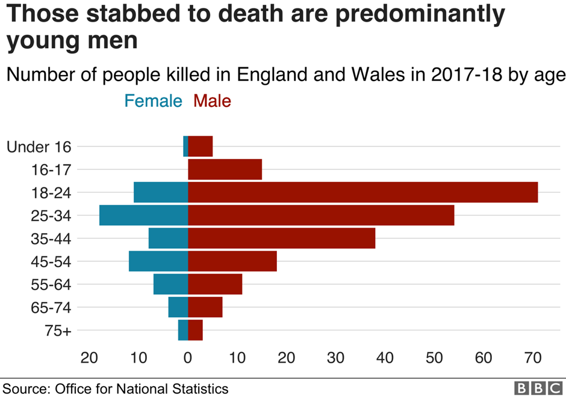

There were 5.8 million offences in the year ending March 2020, with the majority of them occurring among the risk youngsters aged 16 to 19. In order to avoid offences and threat, there are already initiatives and sports events for schools in the United Kingdom. The greatest risk and concern is for young kids who grow up in elevated areas, since it is hard to manage them to avoid them from gang membership and engaging in violent behavior.
Childhood was not reviewed in specifics and in order to improve safety in the past, but now that crime is on the rise, there is a lot more concentrate on it. Today's crime issues necessitate proposed rules, organizations, and specialized personnel, as well as legislative action and vocabulary aimed at controlling, preventing, and offering a decent commencement for each child. If we look at the data on child crime and whether the child classified as belonging to a wealthy or poor household, we can see that the wealthy are more likely to use marijuana, engage in antisocial behavior, and engage in staling.
According to Pearson (1983), attitudes and behaviors toward young people are based on assumptions and stigmas associated, which is bolstered by social media today. We can conclude from all of these facts and information that the administration must develop a very stringent and powerful teaching program, school events, and fun activities, as well as measure lifestyle factors and take preventative measures, in attempt to lessen the rising number of teenagers committing crimes. For the past five years, the society and government have placed a greater focus on the significance of young reducing crime, as well as rising initiatives and information gathering in order to reduce the amount of young crimes and to provide an improved start in life.
If we compare the current media focus on young crimes to that of the previous 20 years, we can clearly see that society began to take young crime levels and prevention methods more seriously. Poor parental supervision and easily accessible to knives, combined with a lack of prevention, are driving up crime rates among children of a young age, particularly among poor families and in higher places across the UK. According to data, a crime occurs every two and a half minutes on average in London, indicating that protection is insufficiently efficient, particularly when considering the young crime rate, which accounts for roughly 30% of all crimes.

Recommendations

Every year in England, approximately 35,000 case of emergencies hospitalisations more than 300,000 emergency hospital visits are caused by violent action. There were 13,000 urgent hospitalizations for assault between the ages of 13 and 24 in 2010/11. Every year, massive amounts of people in England are affected by violence, which is a significant public health issue. In England, attempting to prevent violence has to be a primary concern for public health, health care, and multi-sectoral collaboration.

Initiatives should be assessed at all times. Before resources are apportioned, there must be straightforward and impartial proof to show if they've been accomplished somewhere else.

It might be cost-effective to train some employees in assessment techniques. Institutions of higher learning, on the other hand, are frequently interested in social research study classmates producing a final year doctoral thesis based on real-world intervention strategies.
Working with suitable stakeholders involved and consulting with people in the area through local organizations, which helps to broker connections. For instance, it may be challenging for statutes companies to perform directly in cooperation with different residents who have low confidence and trust in their offerings, so collaborating through civic organizations to negotiate a deal these friendships could help.

Conclusion

With this report we can see the importance and what difference the community engagement can deliver to preventing and decreasing the young crime levels. There is need special needs for community engagement programs for yearly years engagement for every child in risk surrounding with risk environment. It is very important for the London and UK to have in place consistent and strong programs in order to have proper results and preventions for the risk groups.

Reference list

Andresen, M.A., Frank, R. and Felson, M., 2014. Age and the distance to crime. Criminology & Criminal Justice, 14(3), pp.314-333.
Boxford, S., 2013. Schools and the Problem of Crime. Routledge.
Burke, R.H., 2016. Young people, crime and justice. Routledge.
Finkelhor, D., 2008. Childhood victimization: Violence, crime, and abuse in the lives of young people. oxford university Press.
Furlong, A. and Cartmel, F., 2006. Young people and social change. McGraw-Hill Education (UK).
Haigh, Y., 2009. Desistance from crime: Reflections on the transitional experiences of young people with a history of offending. Journal of Youth Studies, 12(3), pp.307-322.
Halsey, K. and White, R., 2008. Young people, crime and public perceptions: a review of the literature. Berkshire: National Foundation for Educational Research.
Haw, K., 2010. Risk and resilience: The ordinary and extraordinary everyday lives of young people living in a high crime area. Youth & society, 41(4), pp.451-474.
Hodgson, P. and Webb, D., 2005. Young people, crime and school exclusion: a case of some surprises. The Howard Journal of Criminal Justice, 44(1), pp.12-28.
Maguire, M. and McVie, S., 2017. Crime data and criminal statistics: A critical reflection (Vol. 1, pp. 163-189). Oxford: Oxford University Press.
McCall, P.L., Land, K.C., Dollar, C.B. and Parker, K.F., 2013. The age structure-crime rate relationship: Solving a long-standing puzzle. Journal of Quantitative Criminology, 29(2), pp.167-190.
Rocque, M., Posick, C. and Hoyle, J., 2015. Age and crime. The encyclopedia of crime and punishment, pp.1-8.
Smith, R., 2011. Doing justice to young people: Youth crime and social justice. Routledge.
Sweeten, G., Piquero, A.R. and Steinberg, L., 2013. Age and the explanation of crime, revisited. Journal of youth and adolescence, 42(6), pp.921-938.

