An Analysis of the Culture and Structure of Faith in Families and the Impact these Factors have on the Performance of Faith in Families

According to (Mullins, 2016, p. 621) an organisation’s culture is the “values, policies, beliefs and attitudes that constitute a pervasive context for everything we do and think in an organisation.” This means that the culture of Faith in Families has a direct impact on the motivation and activities of employees while they are at work. Another author stated that “Organisational structures are concerned with the recurrent relationships between the various members of an organisation.” (Davidson, 1996) My interpretation of this in relation to Faith in Families is the way in which employees, like Leanne Evans, interact with each other both in a professional manner and in an informal manner. Throughout this essay, I will be analysing how structure and culture have an impact on my chosen organisation’s performance because “the ultimate survival of the organisation depends on the attainment of its goals and objectives.” (Mullins, 2016, p. 571)

Strategy forms a significant part of an organisation’s culture. In his book, Mullins brings up the question “how much concern is shown for broader social responsibilities?” (Mullins, 2016, p. 542) For my chosen organisation, social responsibility is a considerable factor in employee motivation and the overall aims of the charity. For example, they say they include “a wide variety of activities at our projects including: Parent and Toddler Groups, Playgroups, After School Clubs, Healthy Family Lunches, Play scheme Fun Days, Drop-in Sessions, Outreach Home Visits, Crèches, Parenting Courses, Basic Skills courses for Parents, Back to Work Projects, Arts and Crafts Sessions and much more.” (Faith in Families, N/A) The fact that the charity provides these types of services suggests that they hold the community at the centre of their attention and that they aim to help families with day to day life. The type of services they provide and the manner in which they provide them have an impact on performance. When the local community make use of centres such as the Penplas Family Centre, the power of word of mouth brings in new customers when existing customers speak of the cultural aspect of Faith in Families, such as the way in which they are welcomed or the atmosphere created within the building and outside.

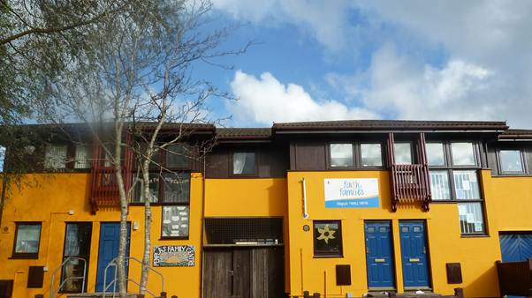
In every organisation, including Faith in Families, Schein’s Three Levels of Culture can be seen. The first level consists of Artefacts. This is the environment in which employees work and customers receive services. For Faith in Families, the physical environment is bright, happy and seems to provide hope in a place where people may not be in the best of situations. For example, Figure 1 shows that the outside of Penplas Faith in Families is painted in a bright yellow colour (Faith in Families, N/A), which suggests that the centre is a place where people can find hope and light in their darkest of times. Inside the centre, employees are both friendly and approachable, which creates a social environment where people can feel safe. For many of Faith in Families’ customers, a safe place where they feel welcome and as though they can talk through their issues is extremely important for helping them to cope with their daily lives. Schein’s second Level of Culture is where Espoused Beliefs and Values belong. The third Level of Culture includes Basic Underlying Assumptions. In the second level, responses and ways of dealing with situations are learned. In the third, it is discovered that a number of solutions to problems work repeatedly, so they get taken for granted and begin to guide behaviour and change the way people act in different situations. These things are the way people are almost expected to act, since they become the ‘social norm.’ For example, at Faith in Families’ centres, people are encouraged to talk through their problems and seek advice. Some people may be unwilling to ask for help and so this behaviour must be learned. An example of this is parents who are reluctant to admit that they have a problem beginning to attend parenting classes run by Faith in Families and gaining the confidence to ask for help and seek out any advice they may need. In my opinion, for these reasons, I believe that Schein’s Three Levels of Culture have a massive impact on the approachability of the Faith in Families and the organisation’s ability to draw customers in. (Schein, 2010)
Figure 1: Penplas Family Centre (taken from http://www.swanseabrecon.org.uk/?page=penplas website) (Faith in Families, N/A)

Speaking to Leanne Evans, who is the manager of Penplas Family Centre, allowed me to realise that The Church in Wales is the reason that Faith in Families was set up (Evans, 2017) In 1999, The Children’s Society stopped providing any and all services which were once provided in Wales. The Church stepped in and dispersed the workload which was once the responsibility of The Children’s Society equally between the bishoprics in Wales. Swansea and Brecon bishopric was handed the responsibility of providing support for those who need it, such as children and young families. It was at this point that the Faith in Families charity was set up in order to provide various kinds of support, strong friendships and advice for those in need. There are currently three separate centres in Swansea where a number of projects are run. Also run by Faith in Families is a centre in Brecon. These centres include a flying start setting along with an outreach project. Overall, the information given to me by Leanne Evans has caused me to realise that religion is at the heart of the organisation alongside the community’s best interests.

A sense of belonging and community seems to be extremely important to the employees at Penplas centre, who have described their jobs as “amazing!” according to (Evans, 2017) who also said that the job can give you “the lowest of lows or the highest of highs.” To me, this symbolises a dedication to the job and a sense of supporting each other in the individual jobs that employees have. For example, when an employee is having a tough day, one of their co-workers will step in to provide support. Having said that, everyone at the centres works hard to maintain confidentiality where needed, which gives service users the confidence to talk to the workers. It also makes me think that the employees of Faith in Families are proud of the jobs that they do and love to help the local community. I believe that the Penplas centre employees, along with the people working in other centres, enjoy helping communities such as Blaenymaes and Portmead, which are among the poorest areas in Wales.

Overall, I believe that the culture of Faith in Families has previously, is currently and will always play a significant role in the organisation’s performance. For example, the beliefs of the employees are very strong and I feel they empower employees to continue working to the best of their ability. Furthermore, the environment created by centres like Penplas draw people in. Welcoming, positive exteriors encourage potential customers to either walk through the doors or to call the company and ask for help. Once you’re inside the building, staff work hard to ensure that they remain friendly and appear approachable at all times. They create a safe environment where anyone can talk about their issues and give people the opportunity to receive help they may otherwise have been able to receive. Faith in Families are successful in encouraging repeat purchases, or uses of services available to those who cannot afford to pay. I believe this is due to their responses to situations people may find themselves in. For example, employees react in a calm ad reassuring manner and are always willing to help. If there is an issue which cannot be solved by the workers themselves, they will put their customer in touch with somebody who can.

Schein has stated that formal organisations are “the planned co-ordination of the activities of a number of people for the achievement of some common, explicit purpose or goal, through division of labour and function, and through a hierarchy of authority and responsibility.” (Schein, 1988, p. 15) I would definitely say that Faith in Families is a formal organisation because all resources are used to provide a safe place for those who need it and also to provide support. This makes the organisation successful because it has a set continuous goal and each employee understands this and does their very best to contribute to the attainment of their common goal.

(Mullins, 2016, p. 619) states that a hierarchy within an organisation is “clearly delineated levels of management authority as a means of co-ordination and control.” For Faith in Families, this means separating the board and sub-committee from the core services team and from the project and staff teams.

It became apparent to me that Faith in Families employees operate within a hierarchical structure when Leanne Evans showed myself and my project team a diagram of their structure. At the top of the structure, there was a Board and Sub-Committee. In the next level down, there was a Core Services Team. Underneath this, there was a number of Project and Staff Teams. Below, I have included my interpretation of the hierarchical structure of Faith in Families that I was shown.
Core Services Team
Project and Staff Team Leader
Project and Staff Team Member
Project and Staff Team Member
Project and Staff Team Member
Project and Staff Team Member
Project and Staff Team Member
Project and Staff Team Member
Project and Staff Team Member
Project and Staff Team Member
Project and Staff Team Member
Project and Staff Team Member
Project and Staff Team Member
Project and Staff Team Member
Project and Staff Team Leader
Project and Staff Team Leader
Project and Staff Team Leader
Project and Staff Team Leader
Project and Staff Team Leader
Board and Sub-Committee

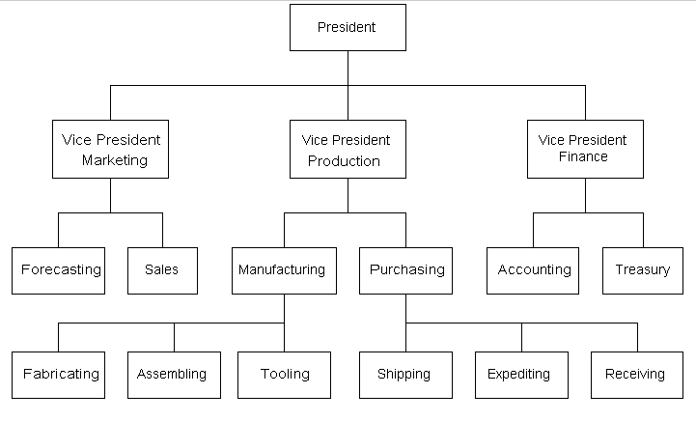
Figure 2: An example of a hierarchical structure. (Taken from https://corporateideasleadership-brando.blogspot.co.uk/2011/03/blog-post_27.html) (N/A, 2011)
As you can see, the hierarchical structure of Faith in Families is set out according to the project teams the employees work in. While I am aware that the structure should be more like Figure 2, where there are more people on the same level at the bottom of the diagram, this is a representation of the hierarchical structure shown to me by the manager of Penplas Family Centre. Figure 2 (N/A, 2011) is an image of a typical hierarchical structure, which is sectioned by the area that employees work in. The groups shown in the Faith in Families’ hierarchical structure diagram are formal groups, which are groups of individuals formed with the vision of achieving a common goal, which may be, for example, to successfully run a parenting class for a whole year. I believe this structure contributes significantly to the successful performance of Faith in Families because the role of each employee is made clear. Their wages are clear, their responsibilities are made clear and their lines of contact and authoritative figures are easily understandable. For example, if one of the project team members had an issue, they would know exactly who their leader is and will be able to speak to the necessary people in order to get the issue solved as quickly as possible.

While the above diagram is of Faith in Families’ formal groups, such as their project teams, the organisation also has a number of informal groups. While they each have a formal group that they belong to, the employees have also formed informal groups. (Zuolo, 2013, pp. 288-289) stated that informal groups are “sets of individuals having something in common (such as beliefs, features, goals or attitudes), but lacking an organisation, common rules and representatives.” While the informal groups of Faith in Families, such as friendship groups, are part of an organisation, they do not have a specific leader. Each person within the informal group is recognised as an individual person and is respected equally by the other group members. Each person within the group is able to contribute as much or as little as they would like to in conversations and while taking part in activities.

To conclude, the culture and structure have a considerable impact on the performance of Faith in Families. Culture has a massive impact on the successful performance of Faith in Families, particularly in the Penplas Family Centre. The welcoming exterior helps to lure potential service users in and the relaxed, safe social atmosphere created in the building helps people to gain the confidence to ask for help. The hierarchical structure of Faith in Families definitely contributes to the successful performance the organisation has. Power and authority over other staff members are made clear for those working in project or staff teams, which appears to be the bottom of the structure. For Faith in Families, the hierarchical diagram allows all employees to see where their power lies and also who they should report to with any issues they may come across. This leads to the successful running of the organisation, which therefor means the organisation can perform well.

References
- Davidson, L., 1996. The Handbook of Organizational Studies. 1st Edition ed. London: Sage.
- 2. Evans, L., 2017. UWTSD PROJECT. Swansea: N/A.
- Evans, L., 2017. UWTSD PROJECT. Swansea: N/A.
- Faith in Families, N/A. Diocese of Swansea and Brecon Homepage. [Online]
Available at: http://www.swanseabrecon.org.uk/?page=home
[Accessed 22 11 2017].
- Faith in Families, N/A. Diocese of Swansea and Brecon Homepage. [Online]
Available at: http://www.swanseabrecon.org.uk/?page=penplas
[Accessed 23 11 2017].
- Faith in Families, N/A. Penplas Family Centre. [Online]
Available at: http://www.swanseabrecon.org.uk/?page=penplas
[Accessed 22 11 2017].
- Mullins, L. J., 2016. Management & Organisational Behaviour. Eleventh ed. Harloe: Pearson Education Limited.
- Mullins, L. J., 2016. Management & Organisational Behaviour. 11th Edition ed. Harlow: Perason Education Limited.
- Mullins, L. J., 2016. Management & Organisational Behaviour. 11th Edition ed. Harlow: Pearson Education Limited.
- Mullins, L. J., 2016. Management & Organisational Behaviour. 11th Edition ed. Harlow: Pearson Education Limited.
- Mullins, L. J., 2016. Management and Organisational Behaviours. 11th Edition ed. Harlow: Pearson Education Limited.
- N/A, 2011. Invoking Ideas of Best Business Practiceses. N/A: N/A.
- Schein, E. H., 2010. Organizational Culture and Leadership. 4th Edition ed. San Francisco: Jossey-Bass.
- Schein, H. E., 1988. Organizational Psychology. 3rd Edition ed. s.l.:Prentice Hall.
- Zuolo, F., 2013. Toleration and informal groups: How does the formal dimension affect groups’ capacity to tolerate?. Sage Journal, 2nd June, 12(3), pp. 288-289.

