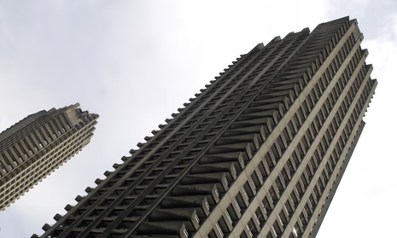  Construction Materials  ACBA4016 | PROPERTIES OF FRAMING MATERIALS – THE BARBICAN ESTATE  Matthew Jay  2516508

Contents
1.0The Barbican Estate, London, UK 2
1.1Original Design 2
1.2 Method of Construction 2
2.0 Analysis of Concrete Framing Material 4
2.1 Strength, Durability and Climatic Resistance 4
2.2 Time, Labour, Programme and Cost compared to Steel Framing 4
2.3 Ease of Assembly and Adaptability Over Building Life Cycle 5
2.4 Integration of Services Provision 5
2.5 Challenges at Demolition and End of Life Cycle 6
3.0 Negative Impact of Concrete Production 7
4.0 Sieve Analysis 8
4.1 Data Table 8
4.2 Coarse and Fine Aggregate 8
4.3 Particle Size Distribution Chart 9
4.4 Sampled Aggregates Particle Size and Suitability 9
5.0 Appendices 10
5.1 Cross Wall 10
5.2 Cantilevered Balconies 10
6.0 References 11

The Barbican Estate, London, UK

Original Design
The Barbican Estate in London is a large-scale concrete framed development constructed between 1965 and 1976, designed by architects Chamberlin, Powell and Bon. The original design intent was to transform a 35-acre site that was destroyed during the blitz, into an attractive residential area that would lure affluent young professionals back to the financial district of London. Following the second world war the population of London fell drastically and there was a fear that this this part would never recover, the Barbican development initiated by the City of London corporation was proposed to help remedy the issue (Astbury, n.d.)
The design reflects Brutalist architecture, where reinforced concrete is both the primary structural material and the final architectural finish. The intention was to create a self-contained urban living space, “a city within a city” elevated above street level, separating pedestrians from traffic via podium decks (Astbury, n.d.)
The architect’s intent was to offer a holistic lifestyle and includes over 2000 modern top of the range flats with schools, library and an arts centre all contained within the three towers. Amongst the grounds there were to be diverse cultural amenities and soft landscapes for the residents to enjoy (Nicky Hughes, 2022).

1.2 Method of Construction
The construction of the Barbican estate represents a great piece of post-World War II engineering, which is encompassed by the use concrete that was mixed, poured and cured directly on site (Nicky Hughes, 2022). This sets Barbican is set apart from other concrete structures of its time, it allowed the architects to achieve complex geometries and provided the structural integrity required for the estate’s towers of which, for a brief period were the tallest residential tower blocks in Europe (Williams, 2023).
One of the defining features of the Barbican is the finish of the concrete. The architects wanted to avoid the smooth finish that untreated concrete would offer and therefore opted for a labour-intensive process that involved workers using pneumatic drills to manually engrave the surface of the concrete. Whilst doing this they uncovered the ‘glittering’ Penlee granite aggregate that had been used within the concrete mixture (Barbican, 2026).
The structural loads rely on the external perimeter to take the load, this method meant that they could construct without the need of internal columns which gave the design a free-flowing internal layout (Tsubaki and Allan, 2021). For the terrace blocks a cross-wall construction method was used (appendix 5.1), supporting the cantilevered balconies (appendix 5.2) which double up as emergency walk ways (Nicky Hughes, 2022). Beneath this sits a sophisticated podium system, built up of a multi layered concrete deck that provides the separation between pedestrians and the London Underground lines that pass directly under the site (City of London, 2022). The impressive structure of the Barbican took over ten years of pouring to complete.

2.0 Analysis of Concrete Framing Material

2.1 Strength, Durability and Climatic Resistance
It is commonly known that reinforced concrete offers high compressive strength, making it suitable for multi-storey residential buildings such as the Barbican towers (MacGregor and Wight, 2012). Although concrete itself is a highly effective building material, its performance is improved when combined with steel reinforcement. The addition of steel increases tensile strength, enabling the structural frame to resist bending moments and lateral forces more effectively (MacGregor and Wight, 2012). This is particularly important for the cantilevered balconies at the Barbican which project outwards without end supports.
As already discussed, the Barbican Estate is almost entirely constructed from reinforced concrete. For a building so large in the middle of London, durability isn’t an optional extra, its fundamental to the buildings long term structural performance. The weather in the UK covers the whole spectrum when it comes to weather, from Freezing temperatures to hot sunshine (Williams, 2023). London particularly provides chemical content in the rain which can affect concrete. During its design the concrete at the Barbican was created with durability in mind. It was made with large granite aggregate and high-quality mixes. It was given careful detailing and finishing techniques to produce a weather resistant product. (Williams, 2023).

2.2 Time, Labour, Programme and Cost compared to Steel Framing
Concrete framed construction generally requires longer programme durations than steel framing due to formwork erection, reinforcement fixing and curing times. In-situ construction is labour intensive and sensitive to weather conditions, which can affect productivity (Buildings-UK, 2022).
Steel framing typically usually out performs concrete when it comes to erection times and improved programme certainty through off-site fabrication and lower labour hours required to erect onsite (Buildings-UK, 2022). However, Steel framing does require additional fire protection measures (Narayanan, 2014). At the time of the Barbican’s construction, concrete was cost-effective due to lower material costs and the availability of skilled labour, despite extended construction periods that would be associated with steel framing (ONS, 2022).

2.3 Ease of Assembly and Adaptability Over Building Life Cycle
Concrete frames are complex to assemble, this is due to factors previously discussed such as labour, curing time and increased onsite complexity (MacGregor and Wight, 2012). Once constructed, concrete frames are usually rigid, limiting adaptability for changes in building use (Buildings-UK, 2022).
Structural walls, columns and slab penetrations restrict reconfiguration and any alterations require structural assessment to avoid compromising load paths however the initial design of the Barbican, using a cross-wall system significantly helps with the adaptability (Narayanan, 2014). Also, the robustness of concrete frames allows them to support additional loading if correctly assessed, extending the building’s functional life.
There is currently a Barbican regeneration scheme underway where the aim is to renew the architectural icon. The scheme focuses on access, sustainability and more dynamic use of space for arts and bringing people together, without adding a single square metre (City of London, 2026)

2.4 Integration of Services Provision
The integration of services within concrete framed buildings needs to be planned meticulously during the design stage as drilling holes for pipework could affect the structural integrity of buildings especially when considering the load of which concrete framed buildings can be put under (Narayanan, 2014).
At the Barbican, these challenges were overcome through early design coordination, the use of cast-in service risers, and increased floor-to-ceiling heights to accommodate service zones. Mistakes when constructing a concrete framed building can be very expensive so putting in the work during the design stage was key especially as during this time modern technology such as Bim was not available (Chamberlin, Powell and Bon, 1982).

2.5 Challenges at Demolition and End of Life Cycle
The demolition and end of life cycle of the Barbican estate presents huge challenges from a variety of aspects. The first issue is heritage, the building is a grade II listed building, having the listed status extremely limits the scope of alterations or even demolition unless there were exceptional circumstances and consent was given by the government (Historic England, 2015).
Secondly, we have the structure itself and its location. The estate is a reinforced concrete megastructure and would not be able to dismantle piece by piece. To successfully demolish the structure in a controlled manner it would take energy intensive mechanical breaking (HSE, 2015). The intertwined reinforcement combined with on-site pouring concrete means the disassembly would be labour intensive and would not be very recyclable, posing the question of what would happen to the byproduct as it would be difficult to be used in any other forms of construction (Pomponi and Moncaster, 2017).

3.0 Negative Impact of Concrete Production
Concrete production has significant environmental and social impacts mainly caused by the production of cement, the key ingredient to concrete. Cement manufacturing is very energy-intensive, according to the BBC cement production contributes approximately 7–8% of global carbon dioxide emissions, largely stemming from limestone calcination and fossil fuel combustion (International Energy Agency, 2023). It is estimated that between calcination and energy use, the production of one tonne of cement results approximately in the emission of 1 tonne of CO2 into the atmosphere. This makes concrete one of the most carbon-intensive common building materials (Di Stefano, 2022).
On top of the emissions given off during the production of the key ingredient of concrete there are other key negative impacts, one of those is the amount of water that is consumed during concrete production. Water is vital in concrete production as it causes the key chemical reaction in cement which enables the paste to bind to aggregates and gives the concrete workability enabling it to be poured and pumped. It is estimated that water used in concrete production accounts for 9% of the world’s supply (Miller, Horvath and Monteiro, 2018).
Another notable negative of concrete production includes the destroying of habitats through quarrying for limestone and other aggregates. Sand is a rapidly depleting raw material. Not all sand can be used, desert sand is too smooth which means usable sand needs to be pulled from riverbeds which damages aquatic habitats (Di Stefano, 2022).
4.0 Sieve Analysis

4.1 Data Table
Sieve Size (mm) | Mass(g) | % on sieve | % Passing
125 | 0 | 0.00% | 100.00%
75 | 0 | 0.00% | 100.00%
63 | 0 | 0.00% | 100.00%
37.5 | 120 | 9.60% | 90.40%
20 | 137 | 10.96% | 79.44%
10 | 143 | 11.44% | 68.00%
6.3 | 105 | 8.40% | 59.60%
3.35 | 45 | 3.60% | 56.00%
2 | 130 | 10.40% | 45.60%
1.18 | 63 | 5.04% | 40.56%
0.6 | 105 | 8.40% | 32.16%
0.3 | 102 | 8.16% | 24.00%
0.212 | 109 | 8.72% | 15.28%
0.15 | 98 | 7.84% | 7.44%
0.063 | 55 | 4.40% | 3.04%

4.2 Coarse and Fine Aggregate
Fine aggregate is defined as material with a particle diameter smaller than 4.7 mm, while coarse aggregate consists of particles larger than 4.7 mm. As no 4.7 mm sieve reading was available, the exact proportions of fine and coarse aggregates are subject to some uncertainty. In this case, the fine aggregate accounts for somewhere between 40.4% and 44% of the total sample, while the coarse aggregate represents between 52.96% and 56.56%.

4.3 Particle Size Distribution Chart
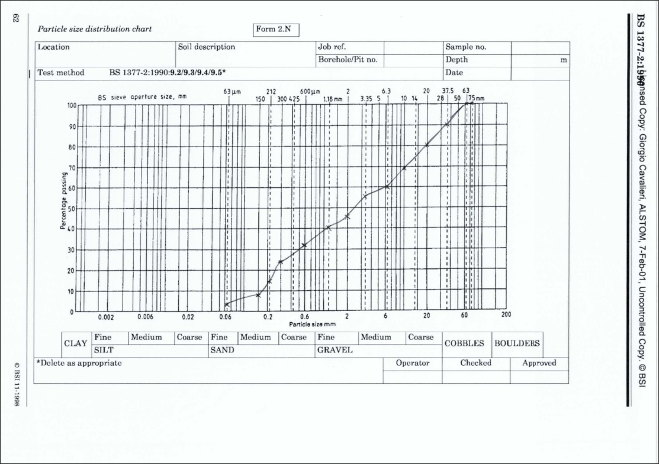

4.4 Sampled Aggregates Particle Size and Suitability
A typical mix of aggregate for course and fine concrete is commonly two parts fine to four parts course. This is commonly referred to as the ‘1:2:4’ mix, one part cement, two parts fine aggregate such as sand and four parts gravel or crushed stone. This blend balances the characteristics needed such as workability, strength, and durability (Green Circle Concrete, 2024).
This sample generally has good coverage of a variety of aggregate sizes however it does show a flat spot around the 2-6.3mm, which would result in it being gap graded meaning it lacks sufficient quantity of the small gravel aggregate.
This sample size would likely not be suitable for use in concrete without processing and supplementing some sizes that are lacking volume. The main reason would be that the mix would require extra cement paste to full the voids. That’s not to say it wouldn’t be suitable for other uses such as road bases.

5.0 Appendices

5.1 Cross Wall
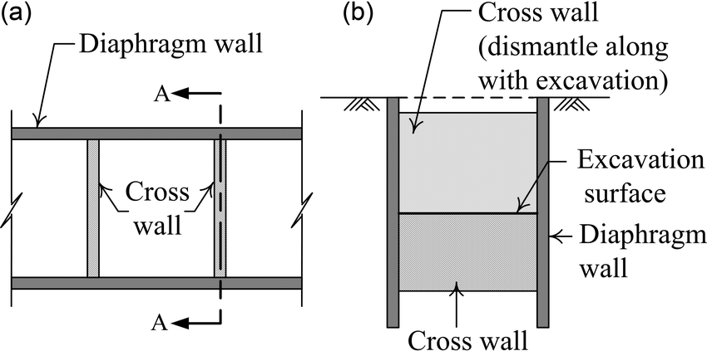
(Hsieh, Pio-Go, 2012)

5.2 Cantilevered Balconies
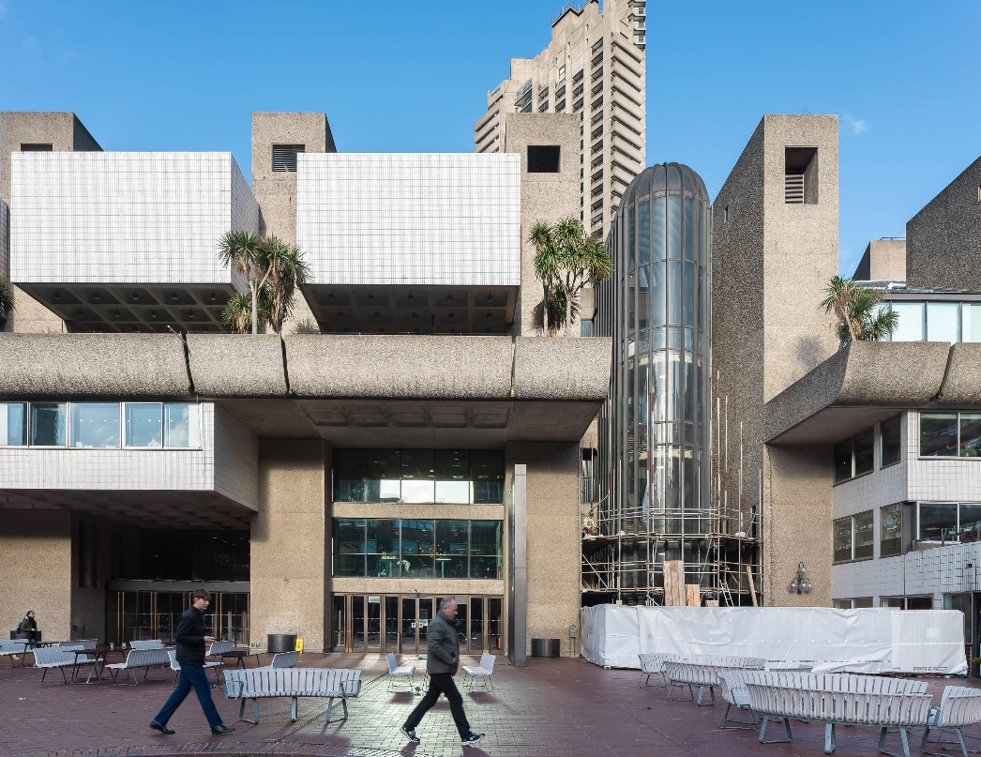

6.0 References
Astbury, J. (n.d.). Everything You Wanted to Know About Barbican Architecture. [online] sites.Barbican.org.uk. Available at: https://www.Barbican.org.uk/s/Barbicanfacts/. (Accessed: 25 February 2026).
Barbican Living (n.d.) Barbican architectural features. Available at: www.Barbicanliving.co.uk (Accessed: 25 February 2026).
Barbican Renewal plans approved to secure Europe’s largest multi-arts centre for future generations. (2026). Barbican Renewal plans approved to secure Europe’s largest multi-arts centre for future generations. [online] Available at: https://news.cityoflondon.gov.uk/barbican-renewal-plans-approved-to-secure-europes-largest-multi-arts-centre-for-future-generations/ [Accessed 8 Mar. 2026].
Buildings-UK (2022). Steel Vs Concrete Buildings. [online] Buildings-UK. Available at: https://buildings-uk.com/steel-vs-concrete-buildings/.(Accessed: 04 March 2026).
City of London (2022). Barbican Estate history. [online] City of London. Available at: https://www.cityoflondon.gov.uk/services/Barbican-estate/Barbican-estate-history. (Accessed: 25 February 2026).
Di Stefano, D. (2022). Cement: the Most Destructive Material in the World or a Driver of Progress? [online] Renewablematter.eu. Available at: https://www.renewablematter.eu/en/cement-the-most-destructive-material-in-the-world-or-a-driver-of-progress. [Accessed 8 Mar. 2026].
Green Circle Concrete. (2024). How Much Aggregate Do I Need For Concrete? [online] Available at: https://www.greencircleconcreteltd.co.uk/how-much-aggregate-do-i-need-for-concrete/. [Accessed 8 Mar. 2026].
Historic England (2015). Building the Brutal: the Barbican Redevelopment | Historic England. [online] historicengland.org.uk. Available at: https://historicengland.org.uk/images-books/archive/collections/photographs/building-the-Barbican/. [Accessed on 04 March 2026]
HSE (2015). Demolition. [online] Hse.gov.uk. Available at: https://www.hse.gov.uk/construction/safetytopics/demolition.htm. [Accessed on 04 March 2026]
Hsieh, Pio-Go & Ou, Chang-Yu & Shih, Chiang. (2012). A simplified plane strain analysis of lateral wall deflection for excavations with cross walls. Canadian Geotechnical Journal. 49. 1134-1146. 10.1139/t2012-071.
IEA (2023). Cement. [online] IEA. Available at: https://www.iea.org/energy-system/industry/cement. [Accessed on 04 March 2026]
Miller, S.A., Horvath, A. and Monteiro, P.J.M. (2018). Impacts of booming concrete production on water resources worldwide. Nature Sustainability, [online] 1(1), pp.69–76. doi:https://doi.org/10.1038/s41893-017-0009-5. [Accessed on 08 March 2026]
Narayanan, R.S., Institution Of Structural Engineers (Great Britain and Institution Of Civil Engineers (Great Britain (2014). Manual for the design of reinforced concrete building structures. London: Institution Of Structural Engineers.
Nicky Hughes (2022). Brutal and Beautiful: The Story of London’s Barbican. [online] The Historic England Blog. Available at: https://heritagecalling.com/2022/02/28/brutal-and-beautiful-the-story-of-londons-Barbican/. (Accessed: 25 February 2026).
Pomponi, F. and Moncaster, A. (2017). Circular economy for the built environment: A research framework. Journal of Cleaner Production, 143, pp.710–718.
Pomponi, F. and Moncaster, A. (2017) ‘Embodied carbon mitigation and reduction in the built environment – What does the evidence say?’, Journal of Environmental Management, 181, pp. 687–700.
This is concrete. (2020). Five ways concrete is creating lower-carbon buildings. [online] Available at: https://www.thisisukconcrete.co.uk/Tackling-climate-change/Five-ways-concrete-is-creating-lower-carbon-buildi.aspx. (Accessed: 04 March 2026).
Tsubaki, S. and Allan, J. (2021) 'Social endurance at the Barbican Estate (1968–2020)', The Journal of Architecture, 26(6). [Online] Available at: www.tandfonline.com (Accessed: 25 February 2026).
Wight, J.K. (2021). Reinforced concrete mechanics and design. Hoboken Pearson.
Williams, M. (2023). Brutal or beautiful? The Barbican Estate. [online] ww3.rics.org. Available at: https://ww3.rics.org/uk/en/modus/built-environment/homes-and-communities/Barbican-estate.html. (Accessed: 25 February 2026).
United Nations Environment Programme (2019) Sand and sustainability: Finding new solutions for environmental governance of global sand resources. [online] https://unepgrid.ch/storage/app/media/documents/Sand_and_sustainability_UNEP_2019.pdf (Accessed: 04 March 2026).

