Obesity Initiatives for Wales
Skye Jones

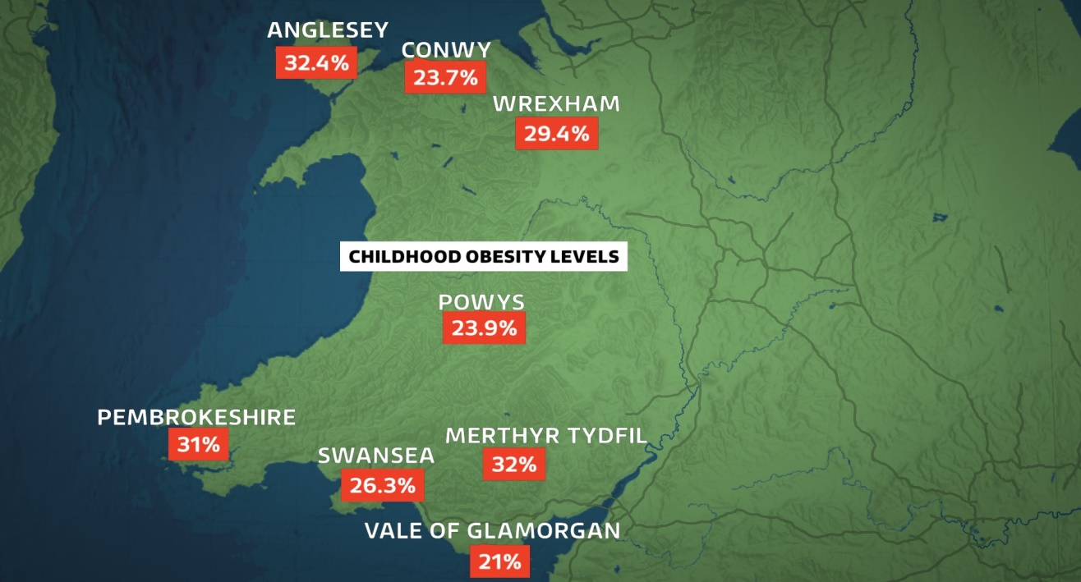
(ITV, 2016)

Contents Page

- Introduction…………………………………………………………page 3
- About obesity………………………………………………….….page 4-6
- The National Exercise Referral Scheme………………………….page 7-8
- The Active Travel Wales Act (2013)…………………..………..page 9-11
- Change4Life……………………………………………….…..page 12-14
- Conclusion……………………………………………………..page 15-16
- References………………………………………………...…...page 17-23
- Appendix………………………………………………………..…page 24

Introduction
The following academic report will analyse three different Welsh initiatives that have been created to combat the growing problem of obesity in Wales. Growing numbers, including children, are being diagnosed as obese and classed as overweight. This report will focus on the National Exercise Referral Scheme, the Active Travel (Wales) Act and the Change4Life Wales scheme. This report will evaluate the advantages and disadvantages of each initiative and how effective they are in fighting obesity in Wales. The report will conclude with recommendations for how each initiative can improve and be more successful in tackling obesity.

Obesity in Wales
Both the National Health Service (NHS) (2016) and the World Health Organisation (WHO) (2019) describe obesity as a person being overweight and is usually diagnosed by measuring a person’s body mass index (BMI). Obesity can lead to adverse health effects such as diabetes, cardiovascular disease, kidney or liver disease and cancer (Abdelaal, Le Roux, and Docherty 2017). Dixon (2010) agrees by reporting that obesity can cause cardiovascular disease, type 2 diabetes, cancer and osteoarthritis. Dixon (2010) also goes on to say that obesity can also cause psychological problems. Guillemot-Legris and Muccioli (2017) both agree that obesity can cause a person to have psychological problems such as depression and impaired cognitive function. The Telegraph (2018) report that if current trends persist, obesity will become the biggest cause of cancer in women, over taking smoking; however; men are more likely to be diagnosed as obese (British Nutrition Foundation, 2018). The BBC (2019) also agree that obesity is overtaking smoking as the biggest cause of cancer and argues that cheap junk food is to blame.
During 2016 in Wales; 23% of adults were diagnosed as obese and a further 36% of adults were classed as overweight. Obesity is also effecting the children of wales with a total of 26.2% being overweight which is higher than rates in England (House of Commons Library, 2018). The NHS Wales (2019) agree with these statistics and go on to say that between 2003 and 2015 there was a 4% increase in cases of obesity with a 3.6% decrease in healthy weight. NHS Wales (2019) also comments that nearly 60% of adults in Wales are overweight with a quarter being diagnosed as obese.
It has been estimated that obesity related illnesses will cost the Welsh Government £465 million a year by 2050 with a cost of £2.4 billion to the Welsh economy and society; this is why obesity is such a big issue in wales (The Welsh Government, 2019).
Figure one illustrates adult obesity rates in Wales, whilst figure 2 illustrates childhood obesity rates in Wales.
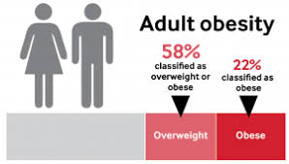
(National Assembly for Wales, 2019)

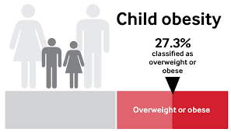
(National Assembly for Wales, 2019)

The National Exercise Referral Scheme (NERS)
The British Medical Association (2019) explains that the Welsh Government has introduced a programme called NERS; it is an evidence-based programme and has been put in place to increase a patient's commitment to exercise and a healthy lifestyle. The NERS programme can also help to improve mental health that obese people usually suffer with. NHS Wales (2014) describes NERS as a 16-week programme for individuals that have been diagnosed as obese. The patient will meet with a qualified exercise instructor that will tailor an exercise programme specifically for the patient; the patient will then take part in 32 sessions including going to the gym, home exercise and walking groups. The Welsh Local Government Association (WLGA) (2019) suggests that NERS has physical benefits such as: reduced weight and blood pressure and a lower risk of diabetes, stronger muscles and joints, improved sleep and energy levels. The WLGA (2019) also explains that NERS can reduce anxiety and depression, help patients take responsibility for their own health, give confidence and higher self-esteem. NERS can also give patients social benefits as it gets patients out of the house and enables them to meet new people who are in the same position. People who are classed as overweight and are eligible for the NERS must be referred by their GP, nurse or a condition specific physiotherapist. The NERS meetings are usually held in local leisure centres; sometimes there can be a charge of £2 per session (NHS Wales, 2019).
Murphy et al (2012) conducted a report about the effectiveness and cost-effectiveness regarding the NERS. The report concluded that the NERS was effective for patients referred for obesity related illnesses. Murphy et al (2012) also reported that the NERS also reduced anxiety and depression; supporting the WGLA’S earlier findings. Edwards et al (2013) agree with Murphy et al (2012) by reporting that NERS is effective in patients with obesity related illnesses such as heart disease and argue that NERS is cost effective but only in patients who are fully committed to the programme, as they are more likely to maintain a healthy lifestyle in the future therefor reducing NHS costs.
Rowley et al (2018) agree with both Murphy et al (2012) and Edwards et al (2013) in saying that the NERS is effective for patients with obesity related illnesses, however, they argue that 16-week schemes are not long enough and that NERS should last for at least 20 weeks in order to promote patients to keep physically active even after their programme has finished. Rowley et al (2018) also criticise the fact that there is a lack of research regarding to individual health conditions such as heart disease, thyroid problems and arthritis.
Table 1 in the appendix reports statistics about participants of the first trial.

The Active Travel (Wales) Act 2013
The Welsh Government want to increase the amount of walking and cycling that Wales as a nation does in order to change behaviours on physical activity. The Active Travel Wales Act’s main goal is to develop walking and cycling routes in wales to give local people the opportunity to use active travel to access jobs, schools, services and tourist destinations (Welsh Government, 2017).
If active travel was successful it would help reduce cases of death by physical inactivity, cardiovascular or respiratory disease, cancer, diabetes and obesity, all reducing costs for the NHS and Welsh society and economy (National Assembly for Wales, 2018). The Welsh Government (2017) are working with public bodies to create safe walking and cycling routes in order to encourage people to walk or cycle short journeys, for example, to school or work. The Sustrans charity is working with the Welsh Government and is committed to designing and publishing user friendly maps, consulting with the community about the active maps and statements and ensuring existing and new routes are in safe condition (Sustrans, 2019). The Active Travel Wales Act 2013 has come under some criticism. The National Assembly for Wales (2013) argues that there is limited information available about safe walking and cycling routes, the route maps are not readily available and do not include all the routes.
The National Assembly for Wales (2018) argues that the Active Travel for Wales Act was ‘lacking’ in strategic leadership and that creating active maps was taking a considerable amount of time. BBC NEWS (2018) agrees with The National Assembly for Wales by reporting that there has been no increase in cycling since the act was passed and there has even been a decrease in the number of local children walking to school. Potoglou and Arslangulova (2016) report that children living within one mile of their school were more likely to participate in active travel to and from school, however, potoglou and arslangulova also found that a child’s age, mother’s unavailability and home ownership had a negative impact on people taking part in active travel to and from school. It was also found that teenage girls in secondary school were less likely to walk to school. This suggests that wider advertising and campaigning is needed for some areas of Wales and more education is needed in secondary schools. The Institute of Welsh Affairs (2018) have outlined that less than 30 schools in Wales received funding for safe routes for active travel. If the Welsh Government want the Active Transport for Wales Act to be successful; more funding and information and awareness is needed.
The table below shows what percentage of different age groups participate in cycling and walking.
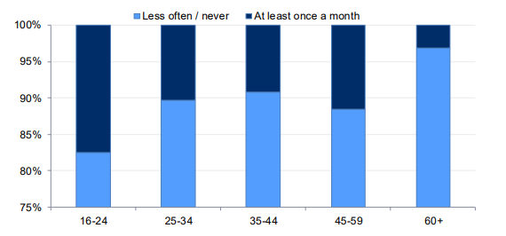
(Welsh Government, 2018)

Change‘4’Life Wales
Change‘4’Life was launched in Wales in 2010, it is an advertising campaign that will encourage families to eat well and exercise more (NHS Wales, 2010).
Change4Life aims to motivate millions of people to eat well and ‘move more’ to make sustainable changes to save the UK from the cost of obesity. Change4Life work with major national retailers, household name brands, and government departments to support them in changing people’s behaviours and health outcomes (Change4Life, 2019).
A report was conducted by Wrieden and Levy (2016) on how effective Change4Life Wales is. The report showed during weeks 2 and 3, a significant number of participants made ‘smart swaps’, choosing smaller healthier options such as sugar free drinks, and after week 3, 58% of participants swapped to low fat dairy products whilst 19% of participants chose sugar free drinks and 24% of the group switched to low sugar cereals (Wrieden and Levy, 2016). The National Social Marketing Centre (NSMC) (2019) has reported that the Change4Life campaign has been successful in engaging and explaining the values of a healthy lifestyle, engaging with the latest evidence, sharing the evidence and using expert opinions, bringing together companies and government departments and engaging the NHS and schools in the campaign, however, the NSMC also points out that although the Change4Life campaign was developed so fast, they underestimated how long it would take engage with the public. Many families who had signed up to the programme had to wait months for their welcoming packs and there could be more products specifically for professionals such as doctors and teachers to use. The British Heart Foundation National Centre (BHFNC) (2010) agree with the NSMC by reporting that there should be more products developed for professionals who have a professional interest in combating obesity. The BHFNC (2010) also explain that the campaign needs to raise more awareness on issues such as diabetes, cancer and heart disease and how a healthy lifestyle can combat these health problems.
Khanom et al (2015) conducted a report focusing on families that had signed up to the Change4Life campaign and their ability to identify triggers to unhealthy food, for example parents taking children to fast food restaurants due to shift patterns, lack of personal transport, not having the experience or knowledge to cook, and the parent’s own childhood diets. Khanom et al (2015) recommend that the Change4Life campaign needs to target a wider audience such as single fathers, minority ethnicities and help teach parents how to budget for a healthy food shop as well as store and prepare healthy meals.
The table below shows target numbers for the first year of the Change4Life scheme and what they actually achieved.
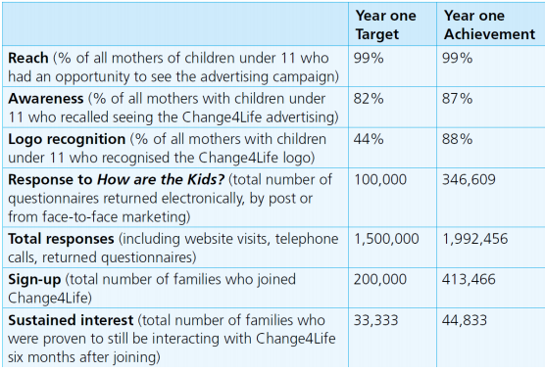
(BHFNC, 2010)

Conclusion
The NERS, Active Travel Wales and Change4Life Wales all aim to combat obesity rates in Wales in order for the public to live healthier lifestyles which in turn will cut costs for the NHS, however as demonstrated within the report, each one presents its own limitations, as well as its beneficial contributions to the reduction of obesity.
The NERS scheme has been very successful but has room for improvement, for example, studies conducted by Murphy et al (2012), Edwards et al (2013) and Rowely et al (2018) have shown that the programme should last around 20 weeks rather than the current 16 weeks, in order to ensure patients will maintain a healthy lifestyle. It is also suggested that more research is undertaken to better understand an individual's illness and more support be provided for patients after their individual programme has ended.
Active travel Wales has come under a lot of criticism as the number of people cycling has not risen since the Act was introduced and the number of children walking to school has fallen. The National Assembly for Wales (2013), the BBC NEWS (2018) and Potoglou and Arslangulova (2016) recommend that the Act include stronger strategic leadership, more advertisement and information about the Act, new routes and maps and more funding for schools. It is also important for the changes to be made as quickly as possible.
Change4Life Wales has been proven to be effective in changing people’s behaviours towards food and exercise, however, it does raise some recommendations from Wrieden and Levy (2016), the NSMC (2019) and the BHFNC (2010), such as, developing more products for professionals to further educate the public on a healthy lifestyle and to offer wider support to single fathers and ethnic minorities.

References
Abdelaal, M., Le Roux, W, C. and Docherty, G, N. (2017) Morbidity and mortality associated with obesity. ANNALS OF TRANSLATIONAL MEDICINE. [online]5 (7). Available at: https://www.ncbi.nlm.nih.gov/pmc/articles/PMC5401682/ [Accessed 2nd April 2019]
BBC NEWS (2018) No increase in cycling in Wales despite active travel law. Available at: https://www.bbc.co.uk/news/uk-wales-politics-44230493 [Accessed 3rd April 2019]
BBC (2019) Obesity overtaking smoking as biggest Welsh health risk. Available at: https://www.bbc.co.uk/news/uk-wales-46883437 [Accessed 2nd April 2019]
British Medical Association (2019) Tackling obesity in Wales by Dr Michael Thomas. Available at: https://www.bma.org.uk/connecting-doctors/bmacymruwales/b/weblog/posts/tackling-obesity-in-wales-dr-michael-thomas [Accessed 3rd April 2019]
British Nutrition Foundation (2018) Obesity and overweight. Available at: https://www.nutrition.org.uk/nutritionscience/obesityandweightmanagement/obesity-and-overweight.html [Accessed 2nd April 2019]
Change4Life (2019) About Change4Life. Available at: https://www.nhs.uk/change4life/about-change4life [Accessed 4th April]
Dixon, B, J. (2010) The effect of obesity on health outcomes. Molecular and Cellular Endocrinology. [online]316 (2) P104-108. Available at: https://www.sciencedirect.com/science/article/pii/S0303720709003645#! [Accessed 2nd April 2019]
Edwards, T, R. et al (2013) Cost-effectiveness of a national exercise referral programme for primary care patients in Wales: results of a randomised controlled trial. BMC Public Health. [online] Available at: orca.cf.ac.uk/55252/1/Murphy%201471-2458-13-1021%202013.pdf [Accessed 3rd April 2019]
Guillemot-Legris, O. and Muccioli, G, G. (2017) Obesity-Induced Neuroinflammation: Beyond the Hypothalamus. Trends in Neurosciences. [online] 40 (4) P237-253. Available at: https://www.sciencedirect.com/science/article/pii/S0166223617300255 [Accessed 2nd April 2019]
House of Commons Library (2018) Obesity Statistics. Available at: D:/Downloads/SN03336.pdf [Accessed 2nd April 2019]
Institute of Welsh Affairs (2018) Wales needs to step it up. Available at: www.iwa.wales/click/2018/02/wales-needs-step/ [Accessed 3rd April 2019]
ITV News (2016) Focus on Obesity: Wales in numbers. Available at: https://www.itv.com/news/wales/2016-03-21/focus-on-obesity-wales-in-numbers/ [Accessed 4th April 2019]
Khanom, A. et al (2015) Parental recommendations for population level interventions to support infant and family dietary choices: a qualitative study from the Growing Up in Wales, Environments for Healthy Living (EHL) study. Health behaviour, health promotion and society. [online] Available at: https://bmcpublichealth.biomedcentral.com/articles/10.1186/s12889-015-1561-4#Absl [Accessed 4th April 2019]
Murphy, M, S. et al (2012) An evaluation of the effectiveness and cost effectiveness of the National Exercise Referral Scheme in Wales, UK: a randomised controlled trial of a public health policy initiative. Evidence-based public health policy and practice. [online] Available at: https://jech.bmj.com/content/66/8/745 [Accessed 3rd April]
National Assembly for Wales (2013) Bill summary: Active Travel (Wales) Bill. Available at: www.assembly.wales/Research%20Documents/Bill%20summary%20Active%20Travel(Wales)%20Bill%20-%20Bill%20Summary%20-22032013-244477/13-024-English.pdf [Accessed 3rd April 2019]
National Assembly for Wales (2018) Active Travel Act Five Years On- short cut or long road? Available at: https://seneddresearch.blog/2018/09/13/active-travel-act-five-years-on-short-cut-or-long-road/ [Accessed 3rd April 2019]
National Assembly for Wales (2018) Post Legislative Scrutiny of the Active Travel (Wales) Act 2013. Available at: https://www.assembly.wales/laid%20documents/cr-ld11566-r-e.pdf [Accessed 3rd April 2019]
National Assembly for Wales (2019) Obesity in Wales. Available at: www.yourassembly.org/obesity-wales/ [Accessed 4th April 2019]
NHS Wales (2010) Change4Life launches in Wales. Available at: www.wales.nhs.uk/news/15765 [Accessed 4th April 2019]
NHS Wales (2014) Physical Activity: Welsh Initiatives. Available at: www.wales.nhs.uk/sitesplus/888/page/74769 [Accessed 3rd April 2019]
NHS (2016) Overview: Obesity. Available at: https://www.nhs.uk/conditions/obesity [Accessed 2nd April 2019]
NHS Wales (2019) Overweight and Obesity. Available at: www.wales.nhs.uk/sitesplus/888/page/97832 [Accessed 2nd April 2019]
NHS Wales (2019) Wales National Exercise Referral Scheme. Available at: www.cardiffandvaleuhb.wales.nhs.uk/national-exercise-referral-scheme [Accessed 3rd April 2019]
National Social Marketing Centre (2019) Change4Life. Available at: https://www.thensmc.com/resources/showcase/change4life [Accessed 4th April 2019]
Potoglou, D. and Arslangulova, B. (2016Factors influencing active travel to primary and secondary schools in Wales). Special Issue: Universities Transport Study Group UK Annual Conference. [online] Available at: https://www.landfonline.com/doi/full/10.1080/03081060.2016.1238573?needAccess=true&instName=Univeristy+of+Wales+Trinity+Saint+David [Accessed 3rd April 2019]
Quine, O. (2018) Obesity to overtake smoking as top cause of cancer in women. The Telegraph. Available at: https://www.telegraph.co.uk/news/2018/09/23/obesity-become-top-cause-cancer-women/ [Accessed 2nd April 2019]
Rowely, N. et al (2018) BMC Public Health. The effects of exercise referral schemes in the United Kingdom in those with cardiovascular, mental health, and musculoskeletal disorders: a preliminary systematic review. Available at: https://bmcpublichealth.biomedcentral.com/articles/10.1186/s12889-018-5868-9 [Accessed 3rd April 2019]
Sustrans (2019) Delivering the Active Travel Act in Wales. Available at: https://www.sustrans.org.uk/wales/communities/delivering-active-travel-act-wales [Accessed 3rd April 2019]
The British Heart Foundation National Centre (2010) BHFNC Summary of ‘Change4Life one year on’. Available at: https://www.be-activeltd.co.uk/assets/BHFNC-Fact-Sheet-Nov-2009.pdf [Accessed 4th April 2019]
Welsh Assembly Government (2010) The evaluation of the National Exercise Referral Scheme in Wales. Available at: https://gweddill.gov.wales/docs/caecd/research/101104nationalexerciseschemeen.pdf [Accessed 4th April 2019]
Welsh Government (2017) An Active Travel Action Plan for Wales. Available at: https://gov.wales/sites/default/files/publications/2017-09/active-travel-action-plan.pdf [Accessed 3rd April 2019]
Welsh Government (2017) Active Travel. Available at: https://gov.wales/sites/default/files/publications/2017-10/active-travel-annual-report-2017.pdf [Accessed 3rd April 2019]
Welsh Government (2018) Walking and cycling in Wales: Active Travel, 2017-18. Available at: https://gov.wales/sites/default/files/statistics-and-research/2018-12/active-travel-financial-year-2017-to-2018_l.pdf [Accessed 4th April 2019]
Welsh Government (2019) Healthy Weight: Healthy Wales. Available at: https://gov.wales/sites/default/files/consultations/2019-01/consultaton-document_0.pdf [Accessed 2nd April 2019]
Welsh Local Government Association (2019) National Exercise Referral Scheme (NERS). Available at: https://www.wlga.gov.uk/national-exercise-referral-scheme-ners [Accessed 3rd April 2019]
World Health Organisation (2019) Obesity. Available at: https://www.who.int/topics/obesity/en/ [Accessed 2nd April 2019]
Wrieden, L, W. and Levy, B, L. (2016) ‘Change4Life Smart Swaps’: quasi-experimental evaluation of a natural experiment. Public Health Nutrition. [online] 19 (13) P2388-2392. Available at: https://www.ncbi.nlm.nih.gov/pmc.articles/PMC4981896/ [Accessed 4th April 2019]

Appendix
Table 1

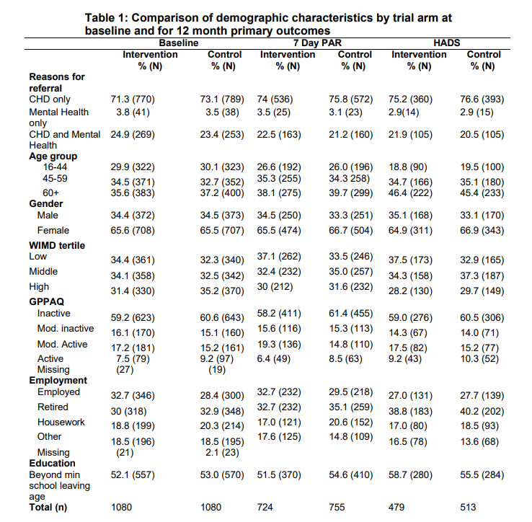
(Welsh Assembly Government, 2010)

