28/04/2020
Kieran Gay
CBM WAles ltd.
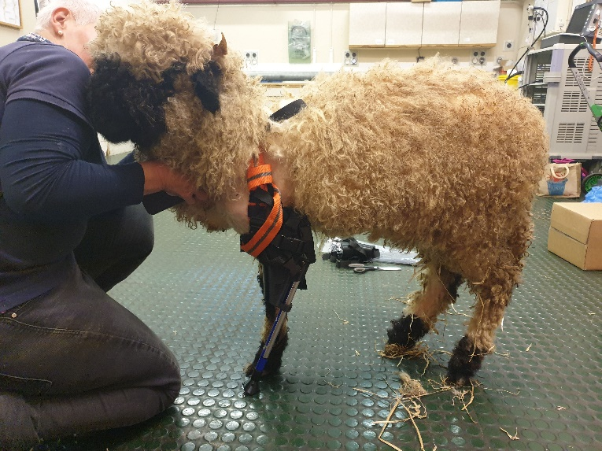
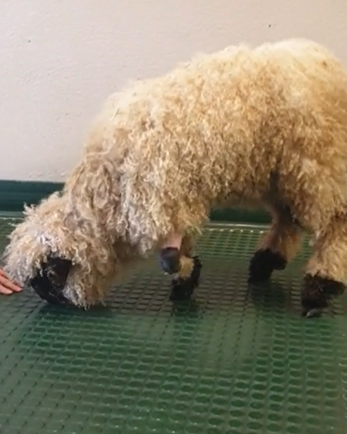
HNC Mechanical Engineering Year 2
SGDM5024 – Individual Project
Component 1 – Project Report

Summary
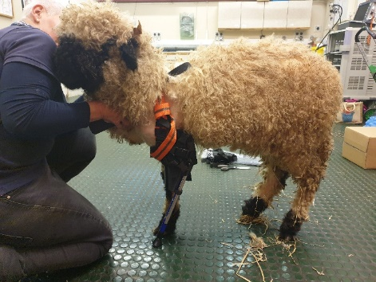
Stated by Horton’s Orthotics & Prosthetics, 2015:
“Each patient who has undergone an amputation is unique, which means that each prosthetic limb must be custom designed and built to fit the patient’s body. The design and production process for prosthetics involves a number of steps to create an effective and functioning artificial limb.”
This quote embodies the approach taken with this project as the final outcome was successful and unique to the animal, despite deviating from what was originally planned as it:
- Took multiple design changes to reach a working prosthetic due to lack of knowledge and experience.
- Went over the original timing plan by 6 weeks, affecting other tasks that were planned in this time.
- Went over the budget of £800 by £470 as the quote only covered the cost of developing the initial prosthetic design.
The total costs were accumulated, providing the following costs of each process and their percentage contribution:
Manufacturing Total – £170.78 – 13.5%
Design Total – £550 – 43.25%
Visits Total – £550 – 43.25%
This shows that manufacturing contributed the least which has been demonstrated through consistent and successful prints with low costs of materials. The process also required minimal post processing which aids in reducing the time and money put into the job.
It could be deduced that the root cause of the project going over budget was mostly due to having a lack of knowledge and experience in prosthetics. Taking this into account, future prosthetic cases can be quoted appropriately to allow for multiple design changes and visits to develop a working prosthetic while making a profit. More experience in future cases will also give CBM a more informed idea of how much to charge.
The following recommendations were also given upon completion:
- Utilise Finite Element Analysis using Ansys software available in the facility to ensure confidence that the prosthetic will withstand the load of the patient with the design and material choices made.
- Further research can be done to either ensure that PLA is an adequate material to use, or to research other types of 3D printing material that can be utilised. This recommendation comes from the potential problem of layer adhesion in FDM processes and that PLA is biodegradable.
- The improvements that have been seen in the human prosthetic field will likely be applied to animals in the near future in which CBM would benefit from remaining a participant in so that they may improve their understanding of prosthetics and become a competitor within that field.

Table of Contents
Summary i
Table of Figures 1
Acknowledgments 2
Introduction 3
Background Research 4
History of Prosthetics 4
Possible Manufacturing Processes 4
Hand built 4
3D Printing – EBM 5
3D Printing – FDM 5
Material Properties 6
Project Specification & Planning 7
Project Solutions 8
Design & Implementation 9
Design 1 9
Design 2 11
Design 3 12
Analysis, Results & Evaluation 14
Conclusion 17
Recommendations 20
Bibliography 21
Works Cited 22
Appendices 23
Appendix 1 – Project Proposal 23
Appendix 2 – Timeline of Prosthetics 24
Appendix 3 – Product Design Specification 25
Appendix 4 – Criteria Analysis 28
Appendix 5 – Elongation at Break Comparison 29
Appendix 6 - Quotation 30
Appendix 7 – Initial Sketches from Discussion With Client 31
Appendix 8 – Parameters 32
Appendix 9 – Start Procedure 33
Appendix 10 – Initial Sample Inspection Report 34

Table of Figures

Figure 1 - Limpet Before Prosthetic Development 3
Figure 2 - Ambroise Paré's Above-Knee Prosthetic (Amputee Coalition, 2019) 4
Figure 3 - Fundamental Parts of a Prosthetic (How Products Are Made, 2020) 4
Figure 4 - Example of PLA Use in an Animal Prosthetic (Sculpteo, 2018) 5
Figure 5 - Material Comparison (3D Hubs, 2020) 6
Figure 6 - CT Scan Data 9
Figure 7 - 3D Scan Data 9
Figure 8 - CAD Data (First Design) 10
Figure 9 - CR10S 3D Printer 10
Figure 10 - Assembled Prosthetic 11
Figure 11 - 3x Feet Print 11
Figure 12 - CAD Data (Second Design) 12
Figure 13 - 3D Print (Second Design) 12
Figure 14 - Harness Test 12
Figure 15 – 3D Print (Third Design) 13
Figure 16 - CAD Data (Third Design) 13
Figure 17- First Design Test 14
Figure 18 - Second Design Test 14
Figure 19 - Third Design Test 15
Figure 20 - Limpet Stationary with Prosthetic 15

Acknowledgments

Assistance has been provided from the following team members at CBM throughout the project:
Ben Alport (Design Engineer) – who dealt with the design aspects of the prosthetic, providing more of an insight into how the design process works and the capabilities of 3D scanning.
Ffion O’Malley (Medical Design Engineer) – who dealt with the medical aspects of the job, providing an insight into the more in-depth medical design process to comply with ISO13485 standards.
The further knowledge and experience provided throughout the project from these team members has been greatly appreciated for my career progression and experiences.

Introduction

CBM Wales Ltd. is an industry focused, advanced research, product development, and batch manufacturing facility based in Swansea, South Wales, and comprises of manufacturing, design, research and medical departments. The medical department received an enquiry regarding a 6 month old Valais Black Nose sheep named Limpet, whose front left leg was to be amputated from the knee down due to a deformity at birth. The owner required a prosthetic leg to aid Limpet in walking as normally as possible for Limpet’s comfort and to prevent damage to the amputated section.
CBM has not had much involvement with prosthetic cases in the past. However, the application of 3D scanning, additive manufacturing (3D printing) and design technology, along with the technical expertise of Ben Alport (design engineer), Ffion O’Malley (medical design engineer) and Kieran Gay (apprentice manufacturing technician), this project has the potential to be a success and add to the knowledge and understanding in prosthetic cases. With an added potential of CBM becoming a competitor in the market and to receive more cases in future.
Following the enquiry, a project proposal (Appendix 1) was made, providing a description and aim for the project.
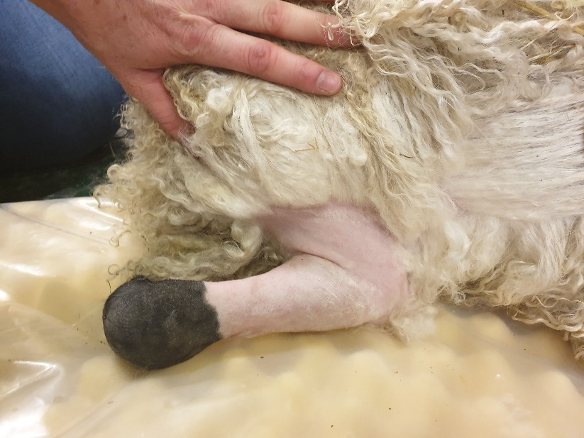
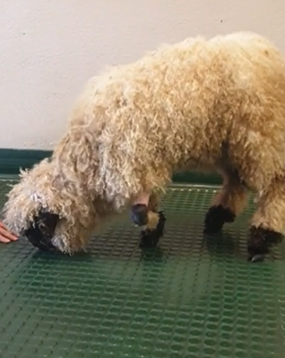
Figure 1 - Limpet Before Prosthetic Development

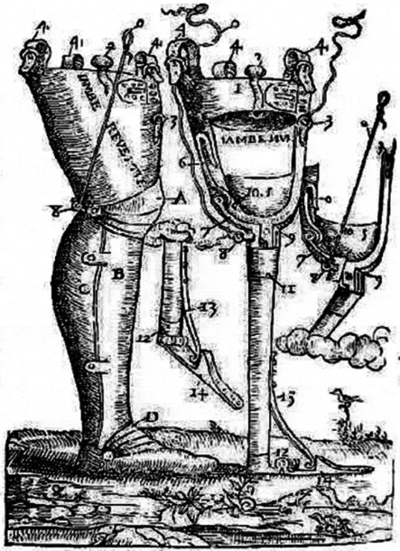
Background Research

History of Prosthetics
The greatest development in prosthesis was seen between 1510 and 1590, in which a surgeon named Ambroise Paré was able to develop functioning prosthetics for all parts of the body. The more significant one being an above-knee prosthetic, including a hinged knee with lock control and adjustable harness as seen in Figure 2 to the right. From the 17th to 19th century a vast amount of improvements in prosthetics was made, particularly after the American Civil War. Appendix 2 shows a timeline of major improvements.
Figure 2 - Ambroise Paré's Above-Knee Prosthetic (Amputee Coalition, 2019)

Prosthetic devices started to become more successful and efficient, to the extent in which scientists were almost able to replicate a fully functioning biological limb. However, it was only until the late 20th century that notable improvements were made for animal prosthetics and is an ever-evolving process in the veterinary field, with the advancement in technologies of 3D scanning and additive manufacturing (3D printing) to assist surgeons.

Possible Manufacturing Processes

Hand built
Figure 3 - Fundamental Parts of a Prosthetic (How Products Are Made, 2020)
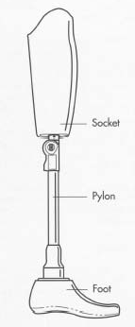

“Traditional prosthetics use polypropylene, polyethylene, acrylics, and polyurethane. There is also an internal structure called a pylon that is composed of a lightweight materials such as titanium, aluminium, or carbon fibre” (Reidel, 2017). The socket would generally be cast in a mould created from a plaster cast of the amputee’s stub and cast in a choice of the materials explained above. The pylon could be sourced and cut to size and the foot hand-made out of a variety of materials such as wood, rubber, plastic, foams or a combination of these.

3D Printing – EBM

CBM Ltd.’s medical team have been involved in over 70 cases over the past 3 years, including cases where medical grade titanium (Ti6Al4V) implants are required via Electron Beam Melting (EBM) technology. These implants are extremely durable and can withstand high loads, therefore it could be applied to prosthetic cases. As explained above, traditional methods often used titanium parts and so would it would be a credible method to use. The price of titanium is very high however, costing £2,550 for 20kg of powder (£127.50 per 1kg) which is a highly influential factor in deciding whether the method should be used or not.

3D Printing – FDM

Fused Deposition Modelling (FDM) is another 3D printing process involving plastics and is much cheaper than the EBM process. Multiple and cheaper material types are also available for use in this process (generally £20 per 1kg spool) and it is a quicker process for setting up machinery. There are questions surrounding whether FDM is a durable enough process for 3D printing however there are animal cases where PLA has been used as shown below, where the dog is roughly the same size as Limpet. In this case, they also began with a traditional approach, where “their first prototypes were made from white plastic and metal, but later on, they turned to PLA because it was an easier material to work with” (Zeijderveld, 2018). Layer adhesion is a possible problem as the process involves building the product layer by layer, therefore molecular bonding may not be as effective as using resins for example.
Figure 4 - Example of PLA Use in an Animal Prosthetic (Sculpteo, 2018)

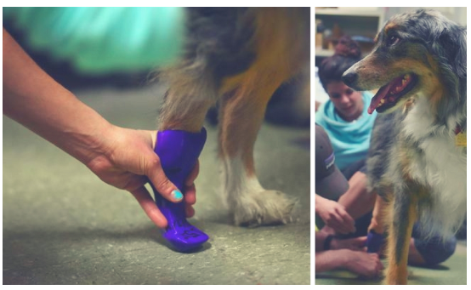

Material Properties

For FDM processes, the following materials are available along with their performance in 7 different categories.
Figure 5 - Material Comparison (3D Hubs, 2020)
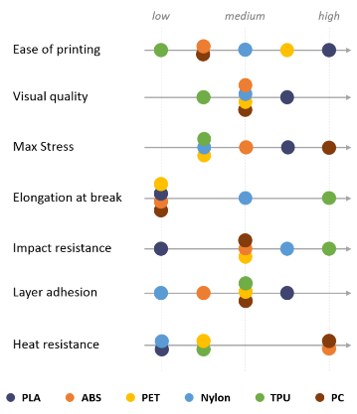

- Polylactic Acid (PLA)
- Acrylonitrile Butadiene Styrene (ABS)
- Polyethylene Terephthalate (PET)
- Nylon
- Thermoplastic Polyurethane (TPU)
- Polycarbonate (PC)

Project Specification & Planning

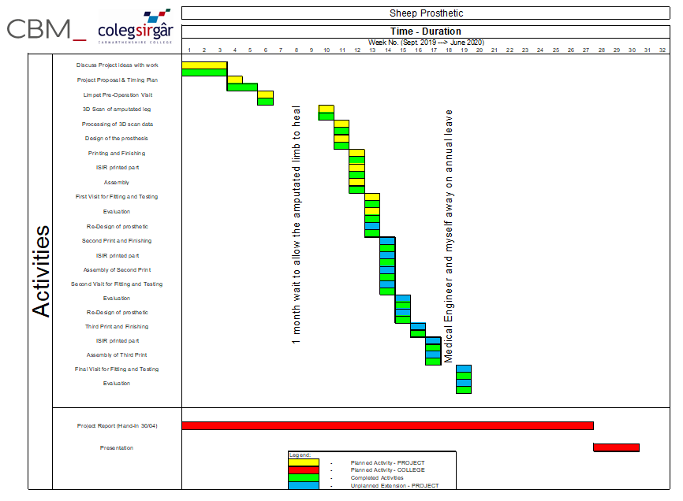
Appendix 3 shows the Product Design Specification made for this project, highlighting the main requirements on CBM’s part and specific requirements from the client for the prosthetic. Below is a timing plan for the project, including the original planned activities for college and project, all unplanned activities and whether the tasks were completed or not.

Project Solutions

Proposal A – Hand-made
Before Limpet’s owner approached CBM, they had a prosthetic made by another company which was handmade, comprising of a cup and sock for the stub to fit inside and PVC pipe for the pylon. This was not a modern approach to the problem and cost the owner more than if it were 3D printed. It wouldn’t have been safe to use over a long period of time as there was not a suitable choice of material made and it wouldn’t have lasted the lifetime of Limpet.
Proposal B – 3D printed in Titanium
An Arcam machine is available at CBM utilising Electron Beam Melting technology, and the medical grade titanium is renowned for its high strength and durability, making it the preferred material for custom made internal implants for weight bearing injuries. This does come with a high cost for material and use of the printer, however product life and safety are very good.
Proposal C – 3D printed using FDM technology
A Creality CR10S printer is also available for use which utilises Fused Deposition Modelling (FDM) technology which costs far less than EBM technology and material. Although the materials available are weaker than the medical grade titanium, they are significantly cheaper and easier to print with and hand finish. Spools of filament are more readily available compared to titanium as the titanium is ordered from abroad and takes time to arrive, whereas there are plenty of websites available that sell filament.
Appendix 4 shows the criteria analysis carried out for the three proposals which covers; cost, safety, ease of manufacture, weight, durability, reliability, product life and aesthetics. Although proposal B has the better score, it was decided that proposal C would be used due to the highly influential cost factor. The scores were also very close between proposal B and C so although the higher quality of titanium was not being utilised, there wasn’t much of a sacrifice of quality, durability and strength by utilising FDM technology.
As seen under background research, Polylactic Acid (PLA) is the more favourable material to work with in most criteria, the only unfavourable categories for PLA are:
- Heat resistance – the prosthetic will not experience high temperatures.
- Elongation at Break – Appendix 5 shows that the titanium used for high load implants at CBM has an elongation value of 14%. PLA has a low value of 5.5% and is over half the value for titanium so may become a problem.
- Impact Resistance – Limpet will not be subject to high impact environments and is only used as an aid for walking.

Design & Implementation

Firstly, a quotation was made which included the cost of 3D scanning the sheep, designing and manufacturing the prosthetic and visiting Langford Vets located in Bristol, costing £800 in total. Once this quote (Appendix 6) was accepted, the process of designing the prosthetic could be started.

Design 1
Design of the prosthetic from 3D and CT scan data – drawings
CBM’s medical design engineer visited Langford Vets to assess Limpet’s deformed limb pre-operation. On this occasion, the vets and owner could highlight their requirements for the prosthetic which led to the initial sketches of their ideas shown in Appendix 7. A CT scan was carried out after the visit and sent to CBM to assist in the design process as seen below:
Figure 6 - CT Scan Data
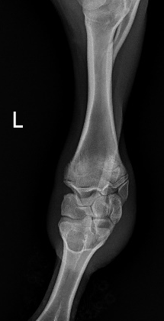
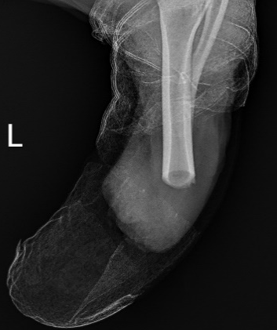
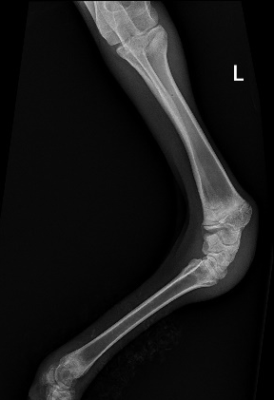

The limb was then amputated which led to a second visit from the medical design engineer and design engineer to 3D scan the remaining stub post-operation and assess the wound. The scan data was taken back to CBM where a scanning technician could stitch the data together and provide the following data.
Figure 7 - 3D Scan Data
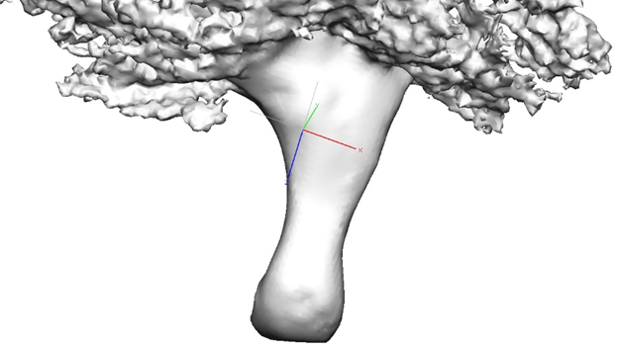

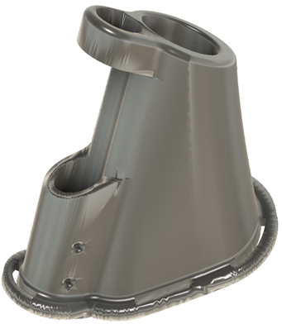
Figure 8 - CAD Data (First Design)

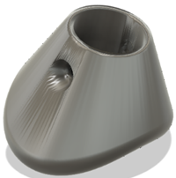

Manufacturing of the prosthetic
Once the design was complete and finalised, it was then ready to 3D print. The STL was sent from the design engineer to the Creality CR10S technician where the STL was placed into the slicing software ‘Cura’. Black PLA were to be used for this job, so parameters were set based on PLA previously used before this job, see Appendix 8 for the parameters and estimated time given. The medical design engineer was informed of the estimated time so the client could also be informed as to when the prosthetic would be taken to them for testing.
Figure 9 - CR10S 3D Printer
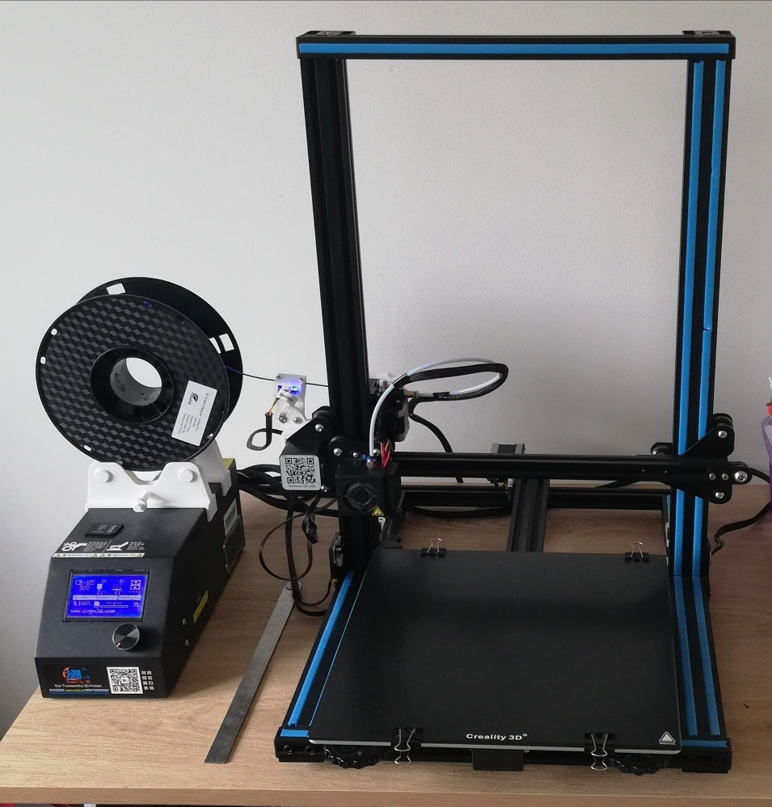
The print files were saved as a GCODE onto the CR10S’ memory card where the card was placed into the machine. The prosthetic print could then be started by following a start procedure, Appendix 9 shows the start procedure for the CR10S. The print was successful so the prosthetic could be removed, and the build plate wiped with warm soapy water. The next build of the foot could then be printed using the same procedure as before which also went successfully.

The printed parts were transferred to the workshop for finishing. Any support material was removed, and a combination of a scalpel and sandpaper were used to remove any sharp edges or rough surfaces. The trekking pole had been ordered prior to the parts being printed and had been cut by the design engineer’s desired length using a hacksaw. With the finished prosthetic and foot, they were placed over the cut pole, where holes could be drilled for the total of three M4 x 30mm nuts and bolts, two on the prosthetic and one on the foot to secure them to the pole as seen below. Velcro straps were purchased to fit through the slots of the prosthetic and hook over the elbow of Limpet’s amputated leg. Once the printing and finishing was complete, any waste material was placed in the PLA recycling box for the correct disposal.
Figure 10 - Assembled Prosthetic
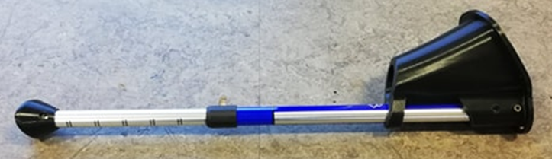

Figure 11 - 3x Feet Print
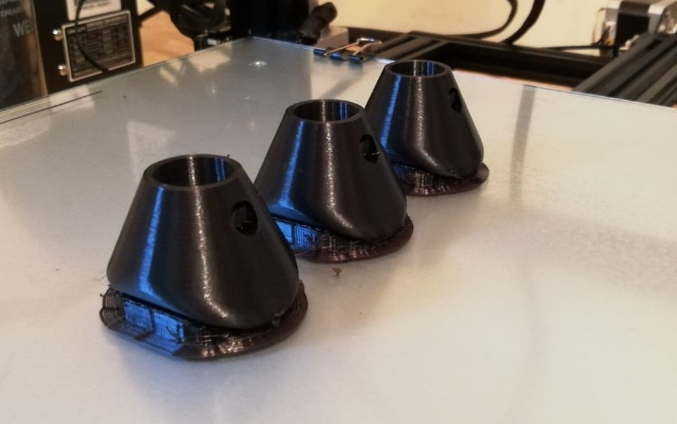

Design 2

The second design saw an added section at the top-front of the prosthetic to prevent the stub from being able to fall out. This modification was carried out promptly and manufactured and assembled using the same process as the first design. A harness system was devised by the medical design engineer and produced using a local seamstress. The harness was tested on a dog of roughly the same size as Limpet to have an idea if it would function correctly on the next test visit.

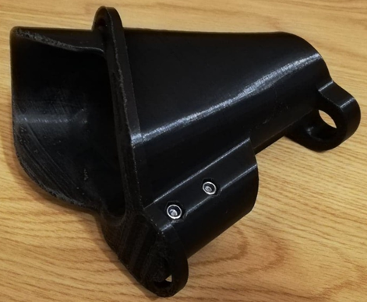
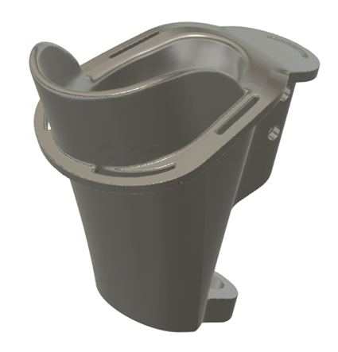
Figure 12 - CAD Data (Second Design)
Figure 13 - 3D Print (Second Design)

Figure 14 - Harness Test
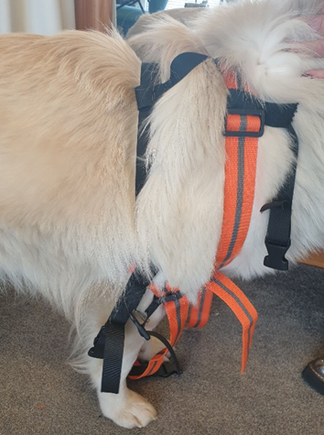

Design 3

Design 3 saw the implementation of an extra cupped feature on the top-back of the prosthetic to prevent the elbow from being able to fall out the back. The new prosthetic was printed and assembled using the same process as the first and second design, and the harness was also tidied in the exact positions that would be required which were discussed with the owner.

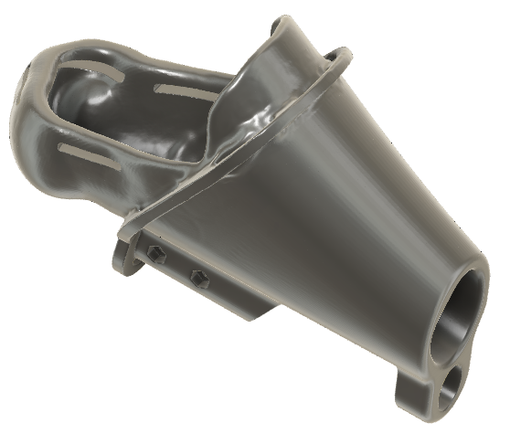
Figure 15 – 3D Print (Third Design)
Figure 16 - CAD Data (Third Design)
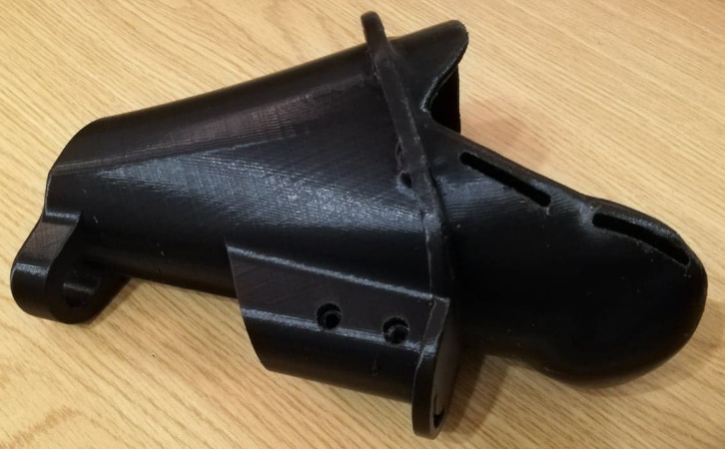

Analysis, Results & Evaluation
The first prosthetic made was taken to the owner at Langford Vets in Bristol to test for fitting and functionality. The results showed that it was not successful due Limpet being able to remove the stub from the prosthetic, leaving it unsupported. The initial Velcro straps that were used were also ineffective being hooked over the stub’s elbow and there was not enough clearance internally for the end of the stub to fit through the whole prosthetic.
Figure 17- First Design Test
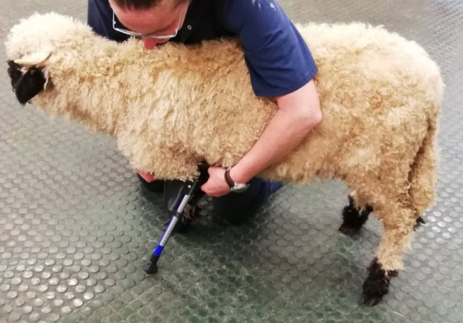

These problems led to the second design discussed previously, including a new added section of material at the front of the prosthetic in order to try and reduce the likelihood of the stub falling out. A harness system was also constructed, hoping it would be more effective than the Velcro previously used. The results from the second visit showed that the extra material was ineffective as Limpet was then able to remove the stub from the back of the prosthetic instead. However, the harness showed great improvement in securing the prosthetic to Limpet and ease of fitting/removal with the added clips. The only negative point of the harness was that the excess of the straps was loose, where the owner said it would make it difficult to work with on a daily basis.
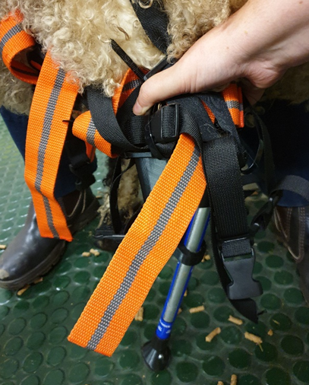
Figure 18 - Second Design Test
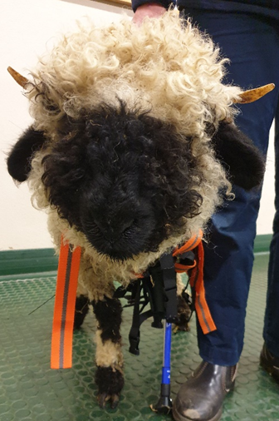

This saw the third and final design of the prosthetic, implementing a cupped feature at the top-back of the prosthetic to hook around the elbow of the amputated leg. This added feature proved to be successful on the final visit as Limpet was able to walk while being supported by someone holding the harness. The owners also stated the tidied harness would be much easier to work with on a daily basis. The prosthetic weighed a total of 400g (Prosthetic 287g; Extendable Bar 97g; Foot 15g) which reached the specification of not weighing any more than 1kg and was also able to be extended to allow for growth.
Figure 19 - Third Design Test
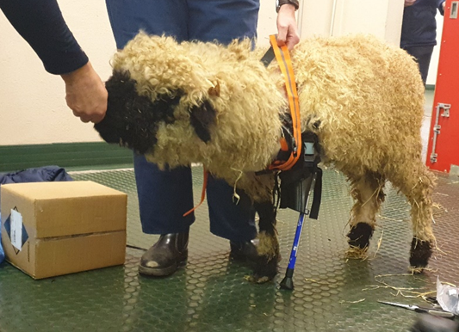

It was advised that Limpet should be subject to the use of the prosthetic in short periods of time to begin with, to ensure she could get used to the sensation of using it and prevent further injury. They could then use the prosthetic more regularly to assist Limpet when she is comfortable using it. The only times it was advised not to use the prosthetic was when activities where the prosthetic would be too restrictive are carried out, such as sleeping, eating, drinking or any other activity requiring Limpet to lower to the ground.
Figure 20 - Limpet Stationary with Prosthetic
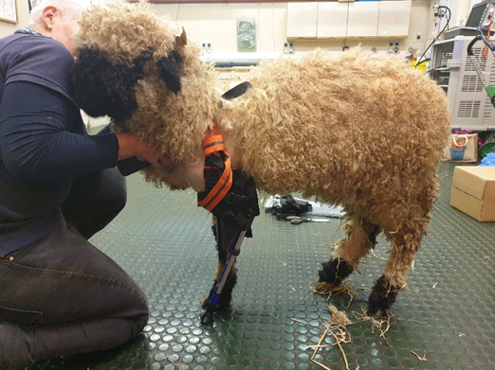

The client was satisfied with the fit and use of the prosthetic so an Initial Sample Inspection Report (ISIR) could be filled in for completion of the job – Appendix 10 shows this ISIR. Physical dimensions were not required here as the success of the prosthetic was dependant on the physical fit, which was achieved in the final design. Generally, feedback is given from the client 3 – 6 months prior to receiving their product, however, there has unfortunately been no feedback to date. When feedback is received, if there are negative points then these will be reviewed and discussed with the client to establish a plan to rectify the problem.

Conclusion

In conclusion, this project was successful in terms of the product’s outcome, however the process to get there did not go as planned. The following problems occurred throughout:
- As seen in the report, it took multiple design changes to reach a successful outcome. This was mainly due to a lack of knowledge and experience going into this project as CBM have only been involved in one other prosthetic case. These extra design changes led to;
- Going beyond the original timing plan by 6 weeks, which affected the medical team’s ability to commence other tasks that were planned in that 6-week period. Subsequently leading to;
- Going over the project’s budget as the quoted price only covered the cost of developing the prosthetic’s first design.
Although the project went over budget, the manufacturing of the prosthetic was carried out effectively and is not the root cause of going over budget. The costing table below shows that the design and visits contributed more to the cost as manufacturing only cost £60.12, however, a profit of £150 would have been made if it took one design to achieve a successful outcome.

Process |  | Hours Taken (£50/hr) | Cost
Manufacturing:  1 Prosthetic  4 Feet  1 Hiking Pole | Prosthetic Material (206g used of a 1kg spool at £20) | - | £4.12
Manufacturing:  1 Prosthetic  4 Feet  1 Hiking Pole | Hiking Pole | - | £6
Manufacturing:  1 Prosthetic  4 Feet  1 Hiking Pole | Finishing | 1 | £50
Manufacturing:  1 Prosthetic  4 Feet  1 Hiking Pole | Total |  | £60.12
Design | 3D Scan | 1 | £50
Design | Post Process Scan | 2 | £100
Design | Design of Prosthetic | 3 | £150
Design | Total |  | £300
Visits | Total Visit Time | 4 | £200
Visits | Car Hire (£30 a day) | - | £90 (3 Visits)
Visits | Total |  | £290
Overall Cost |  |  | £650.12
Quoted Price |  |  | £800

The following table shows the extra costs due to the unplanned activities.
Process |  | Hours Taken (£50/hr) | Cost
Manufacturing:  2 Extra Prosthetics | Prosthetic Material (533g used of a 1kg spool at £20) | - | £10.66
Manufacturing:  2 Extra Prosthetics | Finishing | 1 (30 mins per prosthetic) | £100
Manufacturing:  2 Extra Prosthetics | Total |  | £110.66
Design | Design Meetings | 2 | £100
Design | Design Changes | 3 | £150
Design | Total |  | £250
Visits | Total Visit Time | 2 | £200
Visits | Car Hire (£30 a day) | - | £60 (2 Visits)
Visits | Total |  | £260
Total Cost |  |  | £620.66
Cost of First Attempt |  |  | £650.12
Overall Cost |  |  | £1,270.78
Quoted Price |  |  | £800

The table clearly shows that it was the extra designs causing the project to go over budget, bringing the overall cost to £1270.78, around £470 over the quoted price so no profit made. Below shows the total contribution of each process, showing that manufacturing contributed the least, with design and visits contributing equal amounts. This denotes that the main reason the project went over budget was due to the hours put into designing and multiple visits to the client, which also highlights the lack of knowledge and experience CBM have in prosthetics.
Manufacturing Total – £170.78 – 13.5%
Design Total – £550 – 43.25%
Visits Total – £550 – 43.25%
A potential problem has arisen since the completion of the task, this being that PLA degrades in various ways when in different environments. Although being biodegradable is good for the environment, the prosthetic needs to last the potential lifetime of Limpet of 20 years. PLA prints “will take around 6 months for the object to develop cracks and to show signs of decay” (3DPrinterGeeks, 2019), however this occurred when buried in soil to reach 60°C, and although the prosthetic will not experience these temperatures, it will still be subject to dirty and humid areas and so may begin to develop cracks in future. Despite appearing to be a problem, if a break or degradation were to occur, a solution would be that because the CAD data is kept on CBM’s system, a reprint, modification or attempt at manufacturing a different method to reduce the problem would be possible. Layer adhesion may become a problem as the molecular bonding may not be at its greatest quality in FDM processes, creating stress points in the prosthetic.
Although there have been problems reaching a successful outcome, the design looks similar to the fundamentals of the above-knee prosthetic developed by Ambroise Paré under background research. The cup, pylon and foot are all present in the sheep prosthetic but in a more modern and intuitive form after utilising 3D scan and additive manufacturing methods to achieve the exact geometry of the amputated limb – minimising pain or further injury. The hiking pole with added suspension will also help in reducing the pressure placed on the limb. PLA was an informed choice of material in relation to the ease of manufacture and cost as it considerably reduced the manufacturing costs, though future feedback will allow further analysis of whether it was the correct material choice – there have been successful animal cases where PLA has worked as explained under background research so it is hopeful that this prosthetic works as planned.

Recommendations
Overall, I was satisfied with the outcome of this project and my contribution. I was given full responsibility for the manufacturing of the prosthetic on my personal 3D printer which gave me greater depth and knowledge into the process and what is achievable via additive manufacturing. I kept waste to a minimum and produced each individual part to the correct specifications. It gave me great satisfaction being part of a small team to produce a prosthetic in the tight timescales that were given.
Although the final outcome worked well, problems have been highlighted throughout this report. The following recommendations would be made to reduce the likelihood of these problems occurring in future:
- Multiple design changes – in future, the problems with each design in this project can be avoided as CBM will have learned from the previous mistakes The problems can be foreseen to potentially aid in reaching a successful design with less changes.
- Going beyond the timing plan – now CBM have more experience in how long it takes to produce a prosthetic from start to finish, this can be accounted for in future which will lead to not;
- Going over budget – now CBM know that it may take multiple designs until a working prosthetic is made, this can be accounted for in the quotation to minimise going over budget in future.
It would be recommended that CBM continue taking on enquiries for prosthetics to gain more of an understanding in the process of developing them effectively. As stated by Horton’s Orthotics & Prosthetics, 2015:
“Each patient who has undergone an amputation is unique, which means that each prosthetic limb must be custom designed and built to fit the patient’s body. The design and production process for prosthetics involves a number of steps to create an effective and functioning artificial limb.”
So, it is important that CBM understand that it is a process that takes time to gain the knowledge and expertise required to be able to minimise error in the design.
There is the capability of Finite Element Analysis using Ansys software in the facility so it would be advised to utilise the technology in future, ensuring the prosthetic will withstand the load of the patient with the design and material choices made. Further research can be done to either ensure that PLA is a suitable material to use, or to research other types 3D printing material that can be utilised. The improvements that have been seen in the human prosthetic field will likely be applied to animals in the near future which CBM would benefit to remain involved with to improve their understanding of prosthetics.

Bibliography
3DMatter, 2020. 3D Hubs. [Online]
Available at: https://www.3dhubs.com/knowledge-base/fdm-3d-printing-materials-compared/#conclusion
[Accessed 03 2020].
3DPrinterGeeks, 2019. 3D Printer Geeks. [Online]
Available at: https://3dprintergeeks.com/pla-3d-printed-object-durability/
[Accessed 04 2020].
AmputeeCoalition, 2019. Amputee Coalition. [Online]
Available at: https://www.amputee-coalition.org/history-prosthetic-leg/
[Accessed 12 2019].
Arcam, 2020. Arcam. [Online]
Available at: http://www.arcam.com/wp-content/uploads/Arcam-Ti6Al4V-Titanium-Alloy.pdf
[Accessed 03 2020].
HortonsOrthotics&Prosthetics, 2015. Hortons Orthotics & Prosthetics. [Online]
Available at: https://www.hortonsoandp.com/custom-limbs-how-are-prosthetics-made/
[Accessed 04 2020].
HowProductsAreMade, 2020. How Products Are Made. [Online]
Available at: http://www.madehow.com/Volume-1/Artificial-Limb.html
[Accessed 03 2020].
Millets, 2020. Millets. [Online]
Available at: https://www.millets.co.uk/equipment/147391-expedition-anti-shock-walking-pole.html
[Accessed 04 2020].
Reidel, H., 2017. PreScouter. [Online]
Available at: https://www.prescouter.com/2017/07/3d-printed-prosthetics/
[Accessed 04 2020].
SRAirsoft, 2019. S R Airsoft. [Online]
Available at: https://www.srairsoft.com/blog/pk8fawnc7r8go39xi9brr72fehuvp2
[Accessed 04 2020].
Stratasys, 2020. SYS UK. [Online]
Available at: https://www.sys-uk.com/news/top-5-3d-printed-animal-prosthetics/
[Accessed 03 2020].
Zeijderveld, J. V., 2018. Sculpteo. [Online]
Available at: https://www.sculpteo.com/blog/2018/05/02/3d-printed-prosthetics-8-incredible-animal-prostheses/
[Accessed 04 2020].

Works Cited
3DPrinterGeeks, 2019. 3D Printer Geeks. [Online]
Available at: https://3dprintergeeks.com/pla-3d-printed-object-durability/
[Accessed 04 2020].
HortonsOrthotics&Prosthetics, 2015. Hortons Orthotics & Prosthetics. [Online]
Available at: https://www.hortonsoandp.com/custom-limbs-how-are-prosthetics-made/
[Accessed 04 2020].
Reidel, H., 2017. PreScouter. [Online]
Available at: https://www.prescouter.com/2017/07/3d-printed-prosthetics/
[Accessed 04 2020].
Zeijderveld, J. V., 2018. Sculpteo. [Online]
Available at: https://www.sculpteo.com/blog/2018/05/02/3d-printed-prosthetics-8-incredible-animal-prostheses/
[Accessed 04 2020].

Appendices

Appendix 1 – Project Proposal
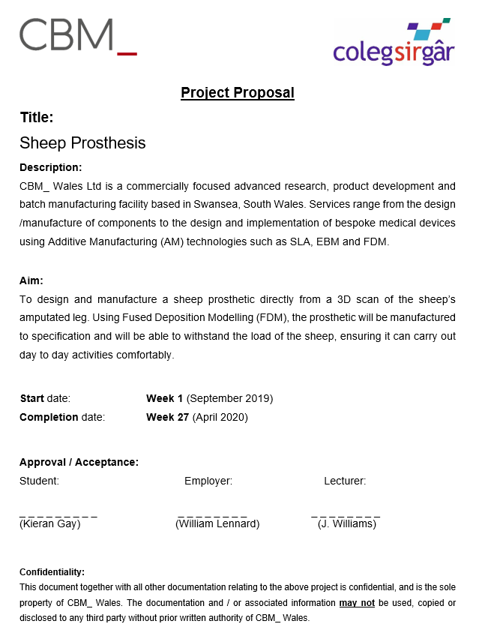

Appendix 2 – Timeline of Prosthetics
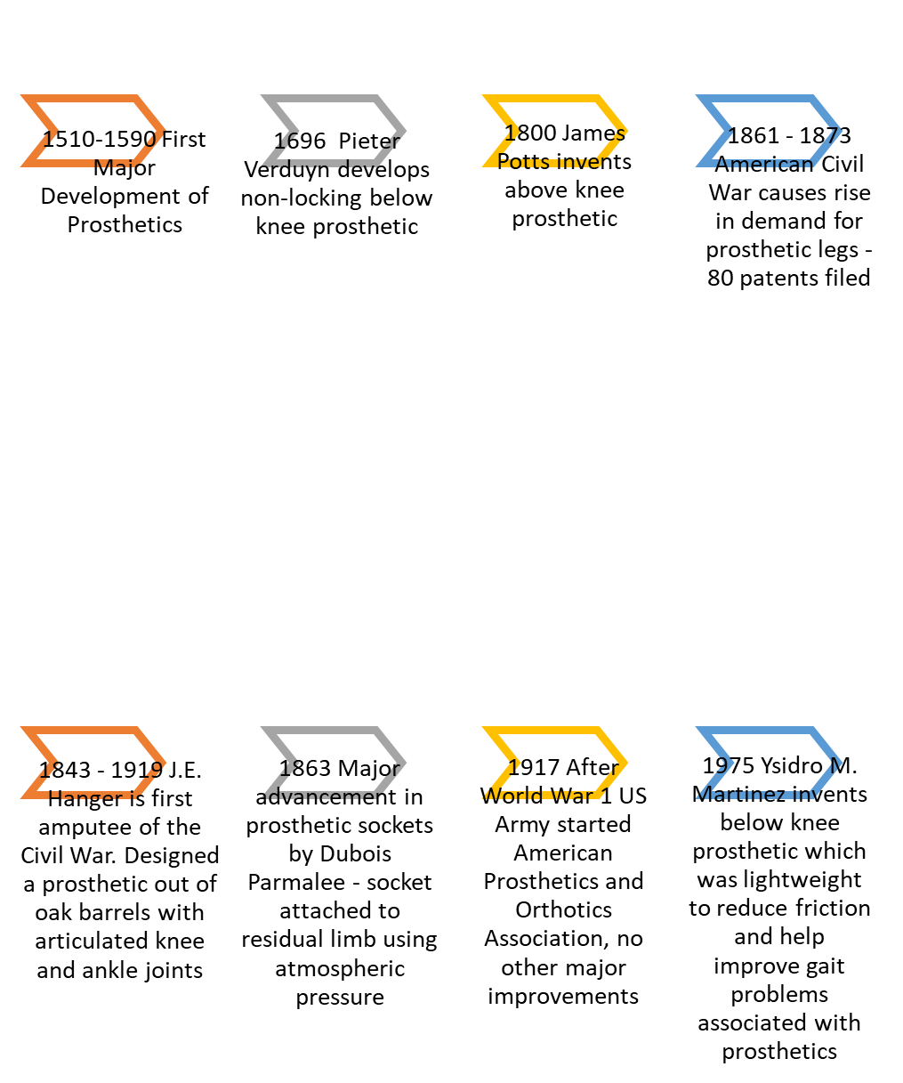

Appendix 3 – Product Design Specification

Sheep Prosthetic
Design Brief
CBM_ Wales’ medical team have been tasked with designing a prosthetic for a Valais Black Nosed sheep named Limpet, utilising 3D and CT scan data

1.0 Performance
1.1 The prosthetic must be able to withstand Limpet’s load (70kg – 90kg when fully grown).
1.2 The longevity of the prosthetic is paramount so must be considered when designing.
1.3 The prosthetic needs to be extendable as Limpet is only 6 months old and will grow to 73 – 78cm tall.
1.4 Should be easy to take on and off due to it having to be fitted and removed on a daily basis
2.0 Environment
2.1 The product will be subject to a farming, muddy and undulating environment, it will be advised to the owner to only use the prosthetic in dryer and more level ground conditions to prevent Limpet from getting stuck.
3.0 Product Life Span
3.1 The prosthetic will last the lifespan of Limpet, up to 20 years
4.0 Life in Service
4.1 Should be able to withstand day to day activities such as walking and possibly running dependant on how Limpet responds to the prosthetic.
4.2 It will be difficult for Limpet to lay down and eat with the prosthetic on so it will be advised to remove it when carrying out these activities.
5.0 Shelf Life
N/A
6.0 Target Costs
6.1 Client quoted £800 for the job.
7.0 Quantity
7.1 The following amount is required
- 1 x Prosthetic (PLA)
- 1 x Extendable Bar (Bar from a hiking pole)
- 4 x Foot (PLA)

8.0 Maintenance
8.1 To be maintenance free, except for regular cleaning due to the environment it is subjected to.
8.2 There will be regular contact between CBM and Limpet’s owner on the progress of the prosthetic and whether they need another manufactured in future due to wear and tear or breaks.
9.0 Marketing
N/A
10.0 Packaging
10.1 No Packaging required, prosthetic will be delivered by hand when testing and fitting on Limpet.
11.0 Size and Weight Restrictions
11.1 Prosthetic should not weigh any more than 1kg.
11.2 Prosthetic should not restrict movement for Limpet but needs to be big enough to support the weight.
12.0 Shipping
12.1 Being delivered by hand, no shipping required.
13.0 Manufacturing Processes
13.1 The extendable bar will be ordered from ‘Millets’.
13.2 Black PLA material will be ordered from the supplier ‘Technology Outlet’.
13.3 Creality CR10-S 3D printer will be used to manufacture the prosthetic and feet.
13.4 Any finishing to be done on the prosthetic will be carried out in CBM’s workshop.
14.0 Aesthetics
14.1 Although it won’t be seen by the public eye, the owner will still be seeing it so wants it looking aesthetically pleasing.
15.0 Ergonomics
15.1 Prosthetic needs to be easy to handle and install by the owner as it will be fitted and removed on a daily basis.
16.0 Customer Requirements
16.1 Customer required a prosthetic with an interchangeable extension for transition from juvenile to adult height.
17.0 Competition
17.1 N/A

18.0 Quality and Reliability
18.1 The quality of the prosthetic must reach the standards the client approved before manufacturing. Due to the prosthetic being highly geometric, it would be difficult to gather accurate measurements. Therefore, the Initial Sample Inspection Report (ISIR) will be carried out based on whether the prosthetic fits and works as it should.
18.2 Prosthetic should be consistently reliable in holding the weight of Limpet and assisting with day to day activities.
19.0 Standards and Specifications
19.1 Standards to be adhered to:
- Health and Safety at Work Act 1974
- ISO 9001
- ISO 13485
- Control of Substances Hazardous to Health 2002
- Reporting of Injuries, Diseases and Dangerous Occurrences Regulations 2013
- Provision and Use of Work Equipment Regulations 1998
20.0 Company Constraints
20.1 N/A
21.0 Processes
21.1 All components and processes to be of metric form and comply with ISO 9001 and ISO 13485 process standards
22.0 Safety
22.1 Prosthetic should not be utilised in wet and/or undulating ground conditions to prevent Limpet injuring herself.
23.0 Testing
23.1 Testing is carried out when visiting the owner to check fitment and to ensure the prosthetic works.
24.0 Legal
24.0 Owner is aware of all risks utilising the prosthetic so no liability for CBM.
25.0 Installation
25.1 Prosthetic to be fitted with a harness which wraps around Limpet and clips to allow for easy removal and fitting.
26.0 Documentation
26.1 Owner will be provided with the relevant documentation from the progress of the prosthetic from start to finish.
26.2 All relevant technical information will be documented correctly to ISO9001 and ISO13485 standards for traceability.
27.0 Disposal
27.1 Any waste material from the manufacturing process will be disposed of through a company who can recycle PLA plastic.

Appendix 4 – Criteria Analysis
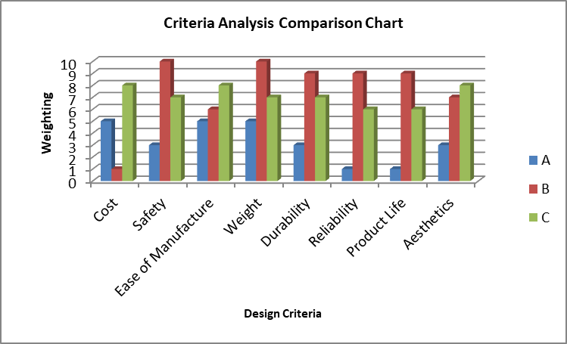
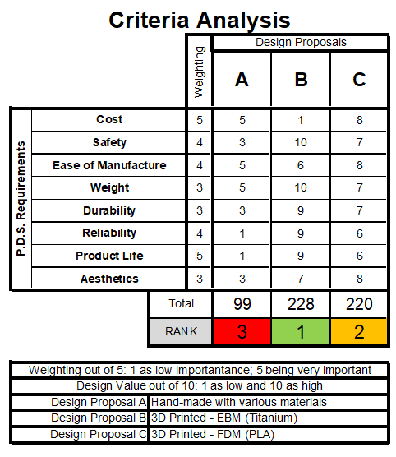

Appendix 5 – Elongation at Break Comparison

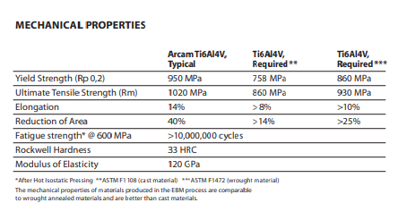
(Arcam, 2020)

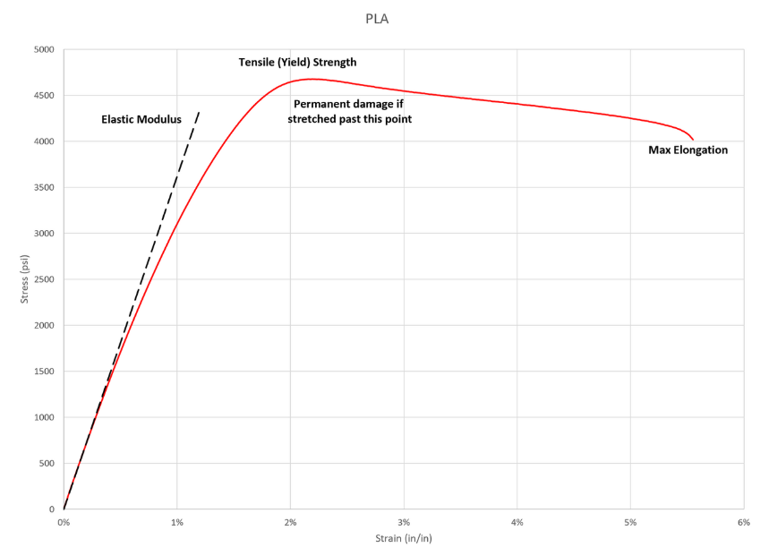

(S R Airsoft, 2019)

Appendix 6 - Quotation

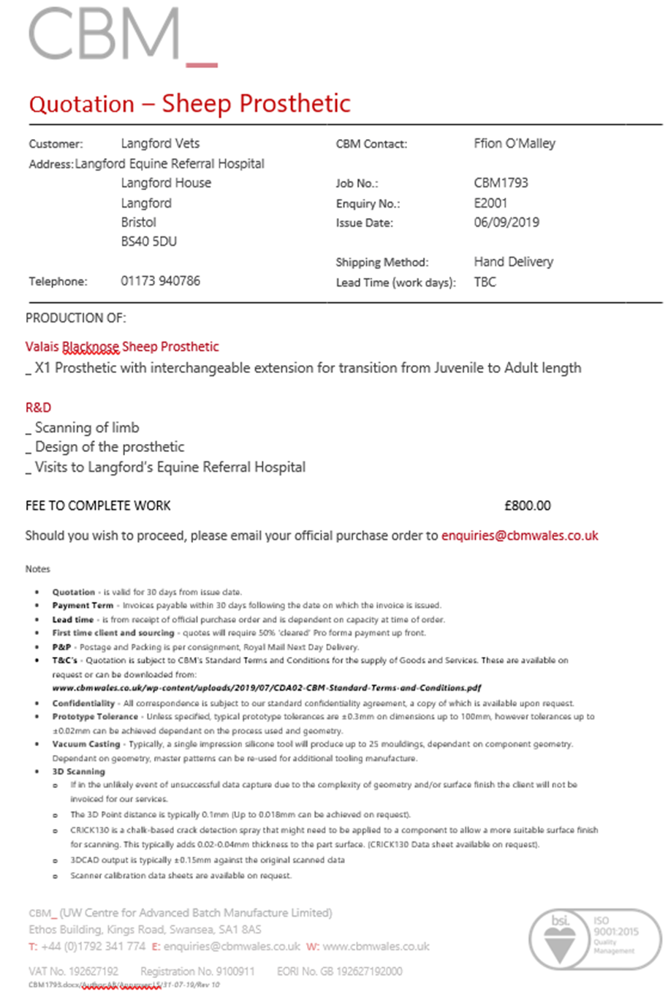

Appendix 7 – Initial Sketches from Discussion with Client

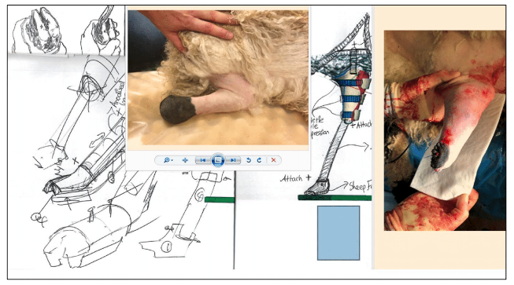

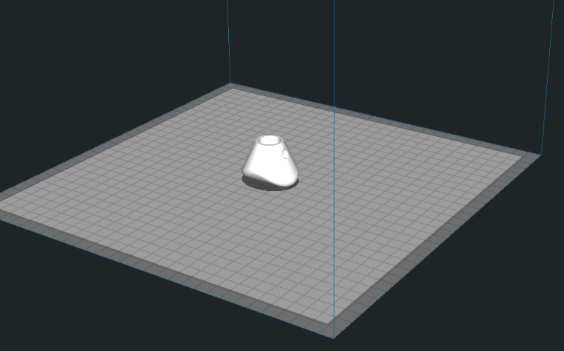
Appendix 8 – Parameters
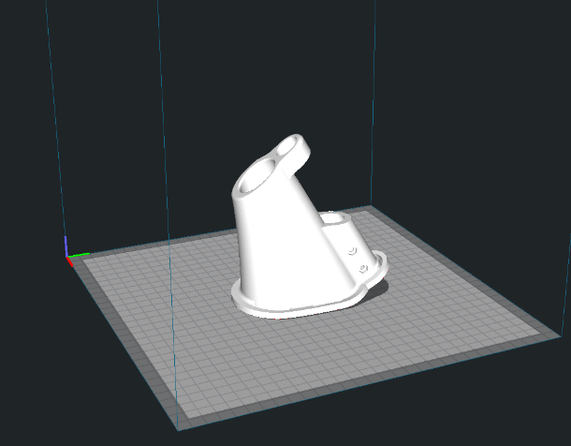

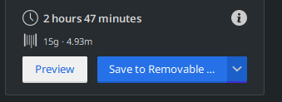
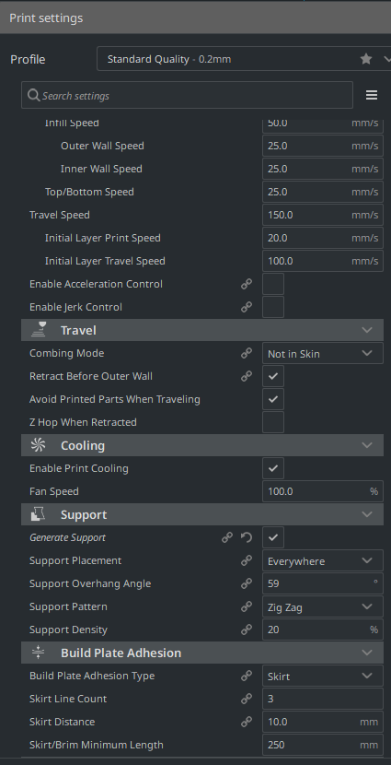
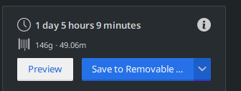
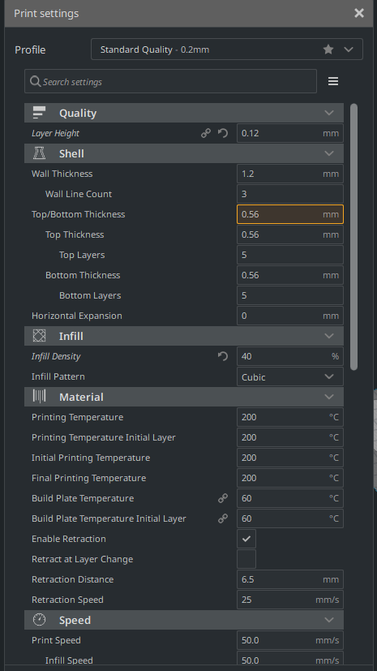

Appendix 9 – Start Procedure

Creality CR10S Start Procedure
- Ensure the area around the printer is safe and clear of any obstruction.

- Ensure all printer cables have some room for movement and that they won’t affect the build by getting tangled.

- Ensure the build plate is clean. If dirty, wipe with warm soapy water.

- Switch the printer on using the control box.

- Adjust nozzle and heated bed to the temperatures of the filament being used.

Press down on selector – Control – Temperature – Nozzle/Bed – Turn dial to temperature

- Load the filament to be used and prime the nozzle by manually pushing the filament through the hot end once it has heated up, checking that there is no clog and the material is extruding consistently.

- Select the GCODE file to be printed.

Press down on selector – Print from SD – Select file to be printed

- Spray a light layer of 3DLAC adhesive spray over the build surface.

- The print will begin. Clear the nozzle before it comes into contact with the build plate to prevent clogging.

- Watch the first couple of minutes of the build to ensure the material is adhering well to the build plate.

- Occasionally check on the build progress to ensure it is not failing.

Appendix 10 – Initial Sample Inspection Report


