Worksheet 4 - ROUTING AND PACKET FILTERING WITHIN CORE TCP/IP SERVICES AND CRITICAL FAILOVER/REDUNDANCY PRACTICES
Contents
Introduction 1
Task 1 – Utilising ARP and Routing Tables: 1
Task 2 – Deploy Core Services (FTP Server): 3
Task 3 – Installing and Configuring the Routing and Remote Access Service: 7
Task 3A - How do Routers reference which networks they are able to connect to? 9
Task 4 –IP Packet Filtering: 9
Task 5 – Failover Clustering for High Availability Systems/Services: 11
Task 6 – Observational Tasks: 12
Draft Network Security Policy 12

Introduction
Tasks throughout worksheet 4, tasked users

Task 1 – Utilising ARP and Routing Tables:
The first task makes use or
Screenshot/Evidence | Annotation
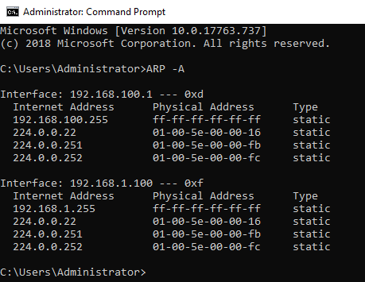 | Output from running the “ARP -A” command.
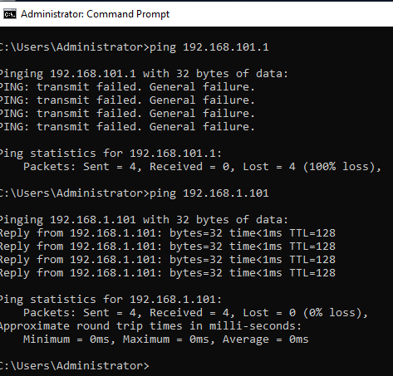 | Ping results from server 1 to server 2. This shows that PublicNet responds successfully to ICMP, however PrivateNet fails.  No screenshot is included for ping results to client 1, however there was no response. Pings to client 2 also had the transmit failed problem, this means the host cant be reached.
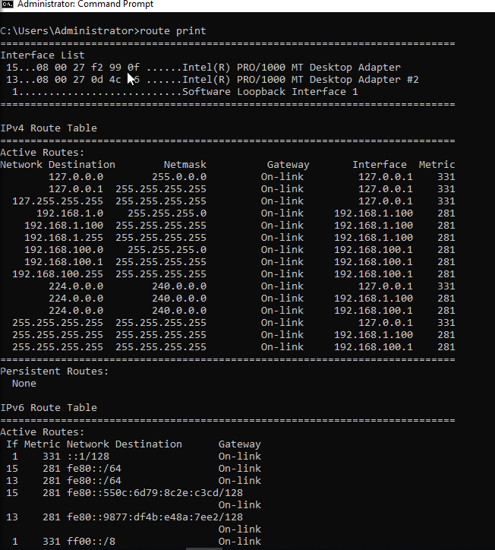 | After running the route print command, the following output is displayed.  This is useful for establishing which routes are active.

Task 2 – Deploy Core Services (FTP Server):
The next task is to install the FTP role onto server 2, the process is evidenced below:
Screenshot/Evidence | Annotation
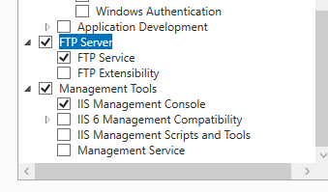  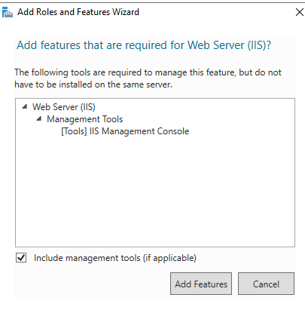 | Web Server IIS role is enabled on server 2.
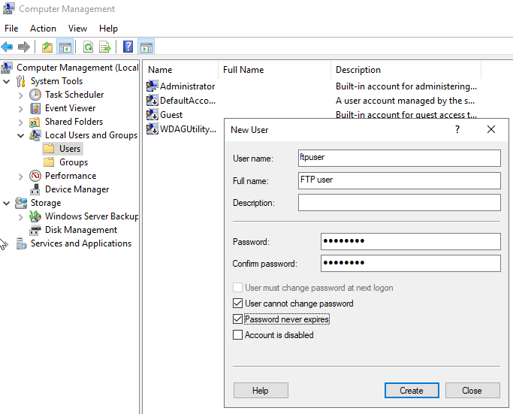 | The ftpuser has been created under the local users and groups snap-in.
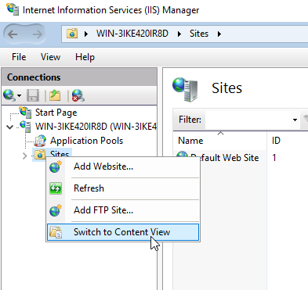 | Selecting add FTP site under IIS Manager.
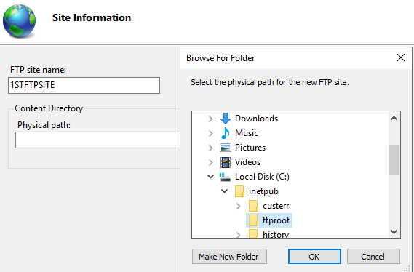 | Entering site name, and selecting the Physical path.
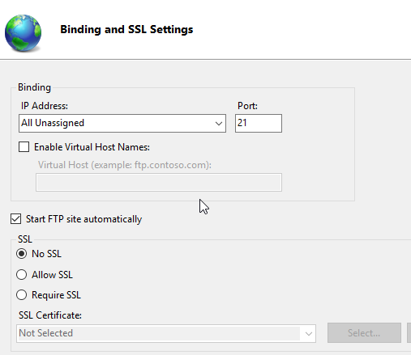 | No SSL is selected under the bindings and SSL settings.
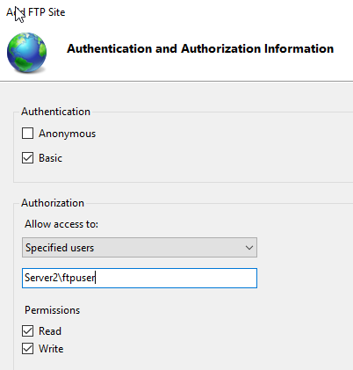 | Basic authentication is chosen.  Along with Specified users, and the earlier created user. Read and write permissions are permitted.
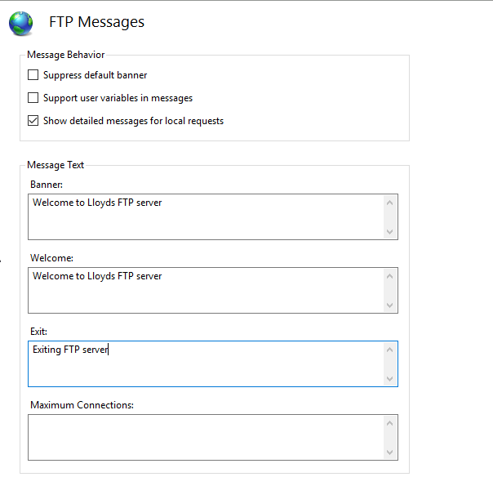 | The image shows the messages set in FTP messages for the site.
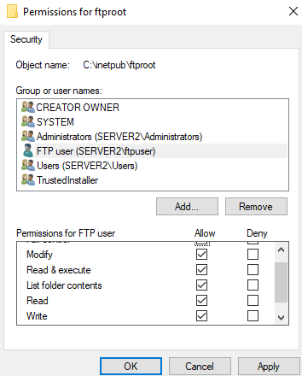 | FTP user has been granted permissions to the FTP share.  The firewall is disabled, this has been evidenced previously in worksheet 1.
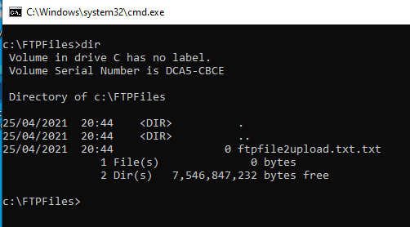 | On client 2 the FTPFiles directory is created, and contains the ftp txt file.
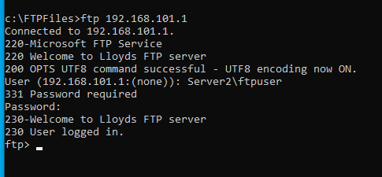 | Screenshot shows connecting to the ftp server and authenticating using the credentials created earlier.
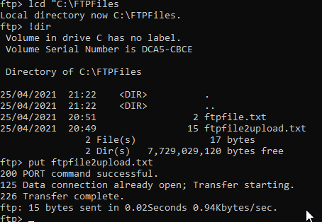 | Here the local directory is changed to the one create earlier, then local directory contents are checked by prefixing the dir command with a “!”. Lastly the put command is used to upload the file to the ftp server.
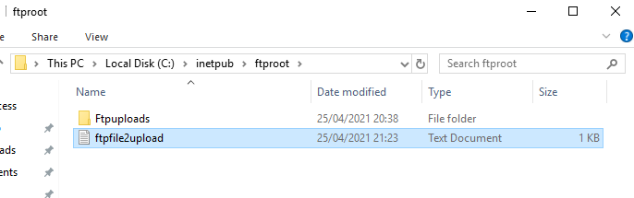 | Screenshot provides evidence that the file was successfully uploaded.

Task 3 – Installing and Configuring the Routing and Remote Access Service:
Screenshot/ Evidence | Annotation
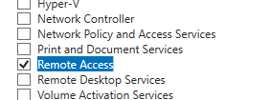 | Remote access is selected under the add server roles page.
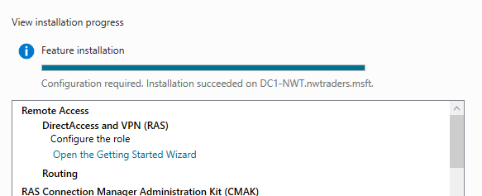 | Screenshot shows the Direct Access and routing were installed successfully.
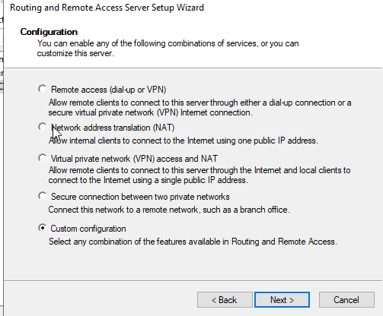 | After opening the configuration wizard, custom configuration is selected.
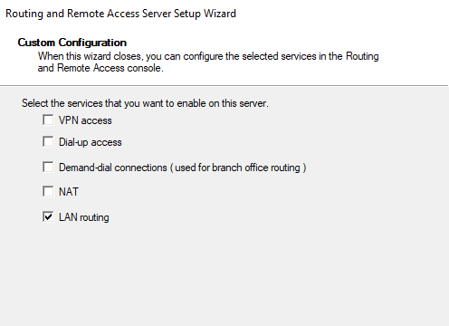 | Next LAN Routing is selected.
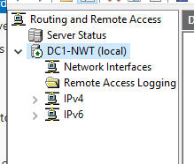 | Following the completion of configuration, the service is started successfully and the icon next to the hostname is green.
D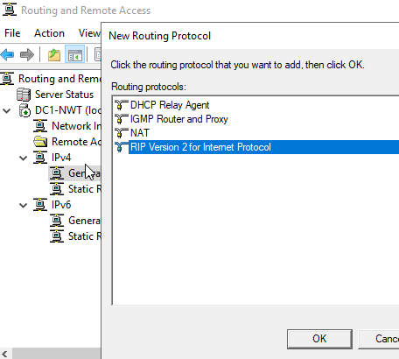 | RIP v2 is chosen for the routing protocol after navigating under IPv4 and general.
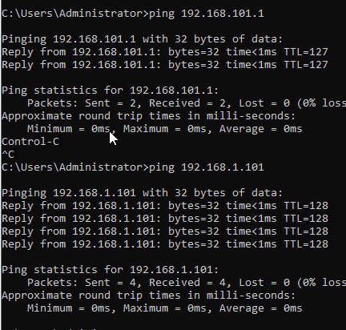 | After applying configuration to both servers, the pings demonstrate connectivity form server1 to server 2.
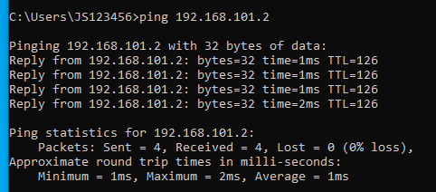 | Pings are now successfully responding from client 2.

Task 3A - How do Router’s reference which networks they are able to connect to?
Routers will reference the routing table to be able to know which networks they are able to connect too. Cisco [1] advise that “a routing table, which is stored on your router, is a list of all possible paths in your network.”. The routing table will also assign a metric value to each of the networks that are logged in the routing table, this metric value will allow the router to intelligently send packets of data via the most efficient route. This is because network paths with the lowest metric value will always be used first.

Task 4 –IP Packet Filtering:
Screenshot/Evidence | Annotation
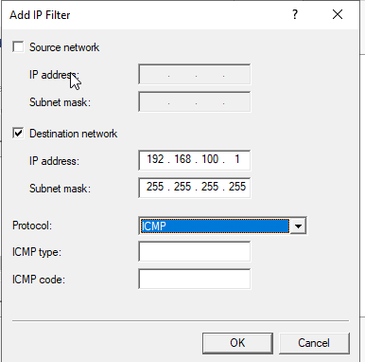 | The IP inbound filter is applied for PrivateNet1.
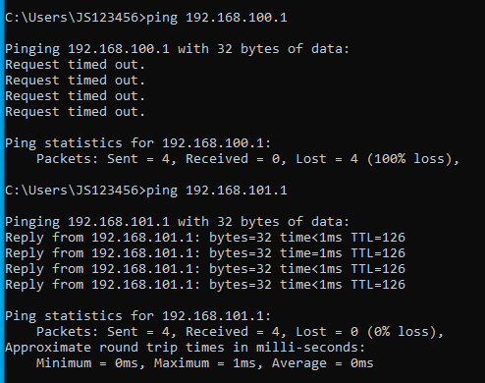 | Screenshot shows that pings do not respond when pinging the address that the inbound filter was applied too. Also shows that pings are successful to another address.
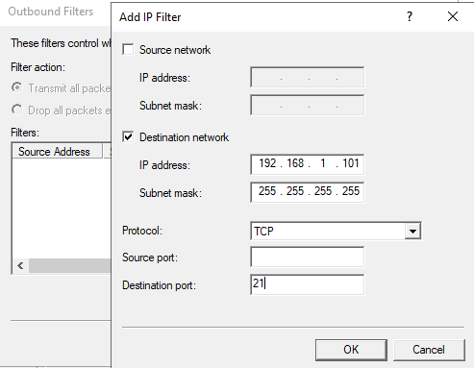 | Next an outbound filter is created with the following settings which will restrict ftp access.  A second outbound filter was created on server 1, with destination port 20 set, as client one was still able to reach the ftp server.
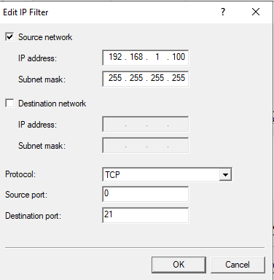 | Next the inbound rule to the left was implemented on server 2 (as well as the same rule for port 20), to prevent access
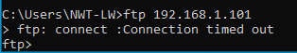 | Screenshot shows that after implementing filter on server 2, client 2 could not connect to the ftp server.
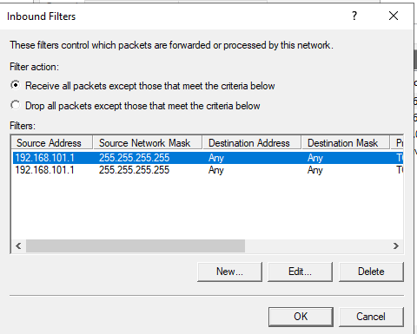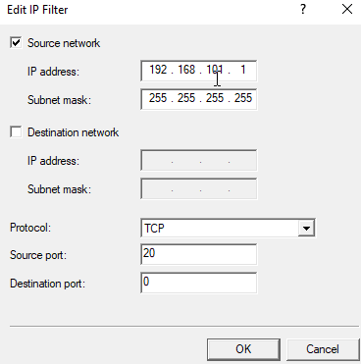 | Next the rule to the left was put in place. It specifically stopped access from client 2. And allowed all other access. Thinking was that FTP access was to be restricted but other ports should be allowed to communicate with the server from client 2.  With this setup only client 1 can access ftp.
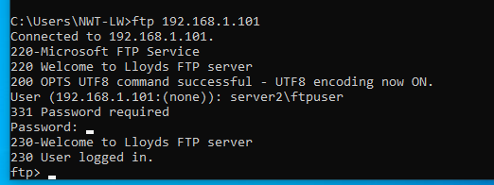 | Able to access from client 1.

Task 5 – Failover Clustering for High Availability Systems/Services:
Failover clustering is a windows feature which facilitates multiple servers with the same purpose to act in a group, where they “work together to increase the availability and scalability” state Microsoft [2]. The installation process is displayed in the below table:
Screenshot | Annotation
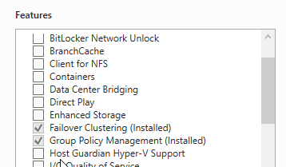 | Screenshot show Failover clustering feature being selected.
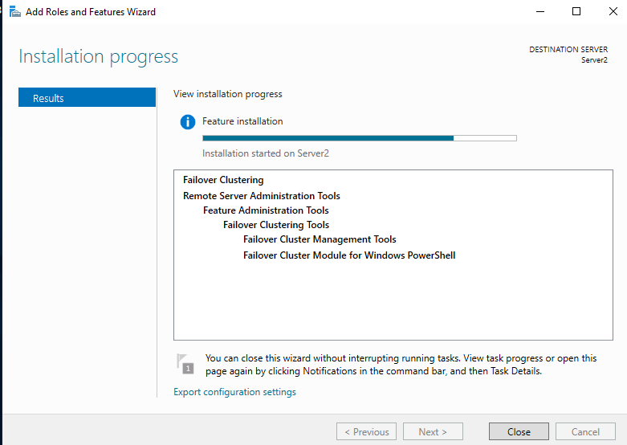 | Screenshot show installation process of Failover clustering feature.
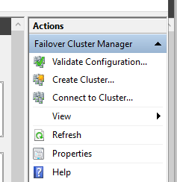 | Once the feature installation is installed, next you would validate the cluster, to confirm the server has the specification to run in a clustered environment.  After the configuration is validated, the create cluster feature would be used.

Clustering resources together has many benefits, such as providing a high availability, resilient platform. Clustering also provides scalability as extra resources can be added to a cluster to increase availability. Other clusters can also be dedicated to high performance, as well as load balancing.
A use case where failover clustering is useful would be where multiple servers which are used to run a critical service, can be installed in multiple datacentres. The servers which are spread across different geographical locations can be in the same cluster, which means that if there was an error such as the air conditioning failing at one of the datacentres, the service would continue to run with potentially only seconds of down time while the service was moved across to the new datacentre. This would not likely be noticed by users of the services however, and simply put down to a ‘network blip’. This failover aspect of the feature can also be very useful when it comes to patching compliance, if servers need to be restarted to complete the installation of security patches, the service can avoid downtime by failing to the servers in the other datacentre.
MicroStrategy [3] also raise a valid point that, when resources are placed in a cluster this “simplifies the management of large or rapidly growing systems”. Where resources are in a clustered environment is means that monitoring performance and other aspects of system health is much easier.
Before implementing, server operating systems should be identical for systems in a cluster. The shared storage must be fast enough to handle the amount of data travelling through the network too.

Task 6 – Observational Tasks:

Assumptions
- The company replies on their website for sales, as well as the back-end infrastructure to support an ecommerce site.

Draft Critical business continuity & high availability plan
“Business continuity (BC) refers to maintaining business functions or quickly resuming them in the event of a major disruption” state CIO [4].

Scope
The Business continuity plan will address server infrastructure which run the critical business applications, specifically the web servers, SQL servers in the back end. As well are the file servers which store the company’s documentation.

Pre-plan network configuration
Firstly, to establish a baseline for ‘normal’ service, the below points highlight how critical servers should be configured to best prepare for an emergency.
- Team which supports the infrastructure should have monitoring tools in place to report back any issues that could result in an emergency.
- Infrastructure support teams should also have a rota system where teams members are on call to respond quickly if any issues arise.
- Servers which run the critical applications should be in more than one geographical location, this will mean if one location has an issue, the service can run from a different geographical location.
- Independent servers spread across locations with a shared purpose should be placed into a cluster. This will enhance how resilient the business is to a number or problems that could occur and allow for processing power to be load balanced and reduce the single load on any server. Overtime this will also prolong the lifecycle of systems as they will not run as close to their maximum performance.
- A backup plan should be in place, for files and SQL databases. A backup plan should include full backups, most likely on a weekend as bandwidth will be less impacted as not as many staff will be in the offices. Differential backups should run throughout the week, which will take less time to backup as they include “only the files that changed since the last full back.” [5].
- Ensure systems are connected to a uninterrupted power supply (UPS)

Plan
Natural disaster –
If a natural disaster occurs at one of the locations where critical services are stored the following steps should be undertaken.
- Systems should be failed across to a different data-centre to ensure that the service can continue to run this should happen very quickly, and users will notice minimal disruption to the service.
- The latest backups should be compared to those at a new site to confirm no data has been lost as a result of the outage.

Virus Infection
- Firstly, all affected systems should be disconnected from the network, at this point the aim is to minimise the effect the virus has on the organisation.
- The next step is to identify when the virus first reached the network
- Backups should then be restored on top of the existing data, from a date before the virus was a problem.
- Scans should take place trough the anti-virus programme to confirm that the threat has been removed.
- Systems can then be returned to the network once a full scan ahs confirmed this is safe to do so.

Power Loss
- If power is lost, UPS systems should provide power to systems for a short period of time. This would be useful if a power surge had caused an outage, and was likely to be restored quickly.
- If power is not likely to be restored quickly, then systems should failover to a different location.
- Once failed across, systems can be safely powered down without loss of data.

Pandemic
- In a pandemic where users are unable to attend the office, capacity to access the network via a secure tunnel, such as VPN should be in place.
- Other users could access business resources using multi-factor authentication, this will allow access to the Microsoft office suite and certain business files which are allowed access.

Review
This plan should be tested on a regular basis, such as every 3-6 months. This will confirm hat the plan is still able to successfully provide continuity to the business services.

Draft Network Security Policy

Purpose
The purpose of this document is to outline security polices which must be adhered too, to ensure the security of the network.

Scope
This policy will apply to all users and computers which use the business’ network environment.

Roles
Head of IT – responsible for overseeing all administrative tasks, and managing incident and problems.
IT Administrators – Administrators must manage the network and support users.
Information Governance Manager – This role will be responsible for ensuring the organisation complies with all information governance regulations.

Rules and Regulations

Acceptable use
Users should only use company devices for purposes related to the business, personal devices must be authorized to access company resources. This will be accepted if needed for business use. In which case, a mobile device management solution must be installed onto the device to secure company data that can be accessed.

Data Handling
- All data must be handled in a secure manner, this includes not duplicating data, modifying data, and protecting data against destruction and misuse.

Software Installation
- Only authorized users will have permissions to install software. Authorized users will include IT admin staff. This right will be given to an ‘admin’ account which will have elevated rights. Admins should use their normal day-to-day user account for normal task, and only use their admin account when required.
- Software, which is regarded as non-standard, must go through the request process before being installed on any company device. As part of the request process software will be tested to make sure it is compatible and does not contain any viruses. This is especially important for third-party software. If granted, then an admin will install the software if the user does not have rights.
- All computers will be imaged using the same image, this image will contain the Microsoft office package and anti-virus software. All other software must be requested.
- Anti-virus must be installed onto each computer.

Monitoring Systems
- Systems should be monitored to make sure that services minimise downtime, as well as making administrators aware of any potential threats before they become an issue.
- Monitoring tools will be reviewed on a regular basis to ensure the best tools are used. Tools for review, would include SolarWinds, Microsoft System Centre Operations Manager. This will provide a holistic view of the network and allow admins to undertake a proactive approach to resolving issues and preventing threats.

Password Policy
- Password complexity will be enforced at domain level. This will force all users to chosen sensible passwords which are unique. Chosen password will need to be at least 10 characters, and include an uppercase letter, lowercase letter, number, and a special character.
- Use of password management software is advised for all staff. This will allow staff to choose more complex passwords and be able to copy them from their password manager. The software will also be able to generate passwords rather than use common words.
- Passwords must be changed on a 2-month basis, this will also be enforced via a group policy at the domain level.

Connecting to the Network
- Only authorized computers should connect to the corporate network, guest should use the dedicated guest network.
- To use the corporate Wi-Fi network, users will need the relevant 802.11 certificate on their machine to be able to authenticate.
- Ports not in use should be disabled by network administrators. This will mean that unauthorized users will not be able to plug into any port as a way into the network.

Incident and problem management
- Incidents and problems should be logged into the main ITIL based system.
- Incidents should be dealt with by IT administrators in a promptly manner. Any issues should be escalated to Senior colleagues.
- Problems will be overseen by the head of IT to ensure investigations find solutions within a suitable timeframe.
- Incidents should be logged by users as soon as they are recognised.

Protecting the Network
- Firewalls must be in place, with the correct configurations to block all ports apart from those required for business operations. This would mean on ports such as 443 for https would be allowed. This is a process of thinking often in place regarding security. The thought process is to block all access expect specific nodes which are known to need access. This is a better way of assuring security, rather than allowing any node to access, and blocking systems that you do not want to access the resource.
- Mail filters must be in place to help avoid users receiving phishing emails which could cause harm.

Education
- Users should undergo annual training around cybersecurity topics to make sure they are aware of new threat and techniques which are used by cyber criminals to target organisations. The best way to stop threats is by educating users to recognise threat before they become a problem.

References

[1] | Cisco, “How Does a Router Work? - Cisco,” Cisco, 10 June 2020. [Online]. Available: https://www.cisco.com/c/en_uk/solutions/small-business/resource-center/networking/how-does-a-router-work.html#~how-routers-route-data. [Accessed 29 April 2021].
[2] | Microsoft, “Failover Clustering in Windows Server,” Microsoft, 6 June 2019. [Online]. Available: https://docs.microsoft.com/en-us/windows-server/failover-clustering/failover-clustering-overview. [Accessed 29 April 2021].
[3] | MicroStrategy, “Benefits of Clustering,” MicroStrategy, 5 October 2019. [Online]. Available: https://doc-archives.microstrategy.com/producthelp/10.11/SystemAdmin/WebHelp/Lang_1033/Content/Benefits_of_clustering.htm. [Accessed 29 April 2021].
[4] | K. L. &. E. Tittel, “How to create an effective business continuity plan,” CIO, 18 July 2017. [Online]. Available: https://www.cio.com/article/2381021/best-practices-how-to-create-an-effective-business-continuity-plan.html. [Accessed 30 April 2021].
[5] | Acronis, “What's the difference between differential and incremental backups (and why should I care)?,” Acronis, 2021. [Online]. Available: https://www.acronis.com/en-gb/articles/incremental-differential-backups/. [Accessed 30 April 2021].

