

Developing Innovation and Creativity for Business Advantage BMSW6102

Forename: Ivo
Surname: Gazepov
Banner ID: 2133589
Course Lecture: Charles Nwaogwugwu
Assignment Title: Development of innovative products

TABLE OF CONTENT
Executive Summary 3
Classic Volkswagen Vehicles by Electric 4
SCAMPER Method 5
Marketing 7
Privacy and Data Protection: Awareness of GDPR and the Data Protection Act 2018 13
Conclusion 15
Reference List 16
Appendix 17

Executive Summary
E-classic is a UK-based company that combines the elegant design of classic Volkswagen vehicles with the cutting-edge technology of electric propulsion systems. We aim to preserve the unique appeal and historical significance of antique autos while offering an environmentally friendly and cost-effective alternative. Our team of experts provides high-quality electric conversions, ensuring each vehicle retains its distinctive qualities while reaping modern efficiency benefits. They prioritize customer satisfaction and offer individualized services and experienced support during the conversion process.
The company recommends combining classic aesthetics with contemporary technology, forming partnerships with charging stations, and offering personalized services. We also suggest modifying aspects of the product or process, such as design, production, user interfaces, and sales models. E-classic's marketing strategy includes digital marketing, public relations, collaborations, and direct customer connections.
Our organisation guarantees customer satisfaction and security by adhering to PCI-DSS compliance standards. We execute digital marketing strategies, including SEO, content marketing, social media, email marketing, events, partnerships, customer engagement, testimonials, referral programs, educational content, and webinars.
Incremental innovation is essential for confronting transformational difficulties within our organisation and is particularly effective because of its communal and collaborative attributes. The General Data Protection Regulation (GDPR) and the Data Protection Act 2018 establish the guidelines for the management of personal data in the UK, making privacy and data protection essential for the establishment of a classic electric vehicle firm.

Classic Volkswagen Vehicles by Electric
E-classic is dedicated to revolutionising the manner in which the people who are passionate about vintage automobiles interact with the vehicles that they really appreciate. Our headquarters are located in Cambridge, United Kingdom, and our mission is to bring together the timelessly elegant design of classic vehicles with the cutting-edge technology of electric propulsion systems. At the same time as we acknowledge the unique appeal and historical significance of antique autos, our goal is to preserve these characteristics while simultaneously offering an alternative that is more environmentally friendly and cost-effective. (Trott, 2017)
Our team of experts is committed to offering electric conversions of the highest quality, ensuring that each vehicle does not lose any of its distinctive qualities while simultaneously reaping the benefits of modern efficiency. (Trott, 2017)
At E-Classic, we place a high priority on the happiness of our customers and provide individualised services as well as experienced support during the conversion process. Participate with us in our efforts to create a future that is less harmful to the environment while also ensuring that the visual appeal of your historic car is maintained. Our conversion are VW SAMBA BUS T1-E VW BEETLE-E and VW KARMANN GHIA-E. (Enrique, Valdes and Miguel, 2018)
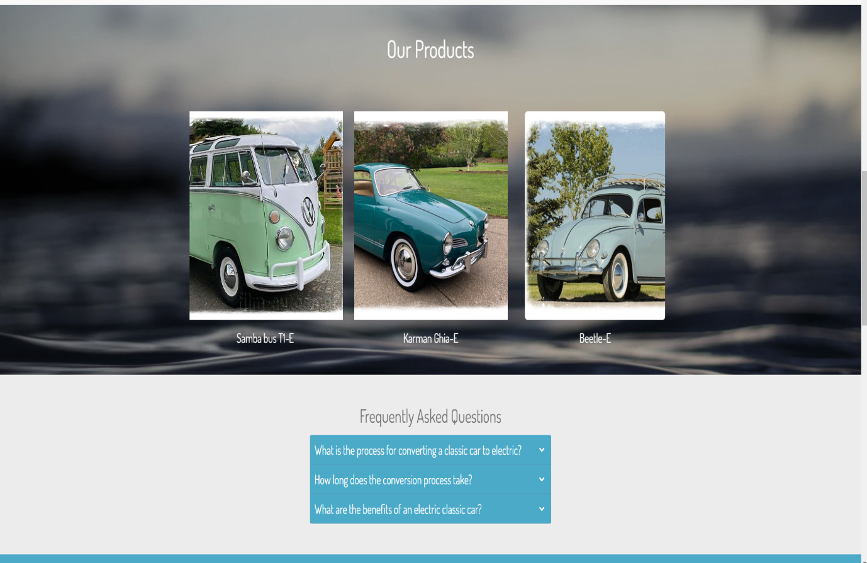

SCAMPER Method
When implemented to traditional classic electric cars, the SCAMPER technique has the potential to offer unique ideas that can be used to improve both the product and the business process.
Substitute, Combine, Adapt, Modify, Put to another use, Eliminate, and Reverse are the actions that are referred to by the acronym SCAMPER. How each component may be used is as follows (Altiparmak and Eryilmaz Muştu, 2021)
Substitute components, materials, or people:
Materials: To enhance efficiency and lessen the effect on the environment, automobile bodywork should be constructed out of materials that are lightweight and sustainable.
Suppliers: Make the switch to suppliers that provide components of higher quality or solutions that are more environmentally friendly.
Combine products, services, or elements:
Classic Aesthetics with Contemporary Technology: Combine the designs of classic automobiles with the most cutting-edge electric vehicle technology, such as sophisticated information and entertainment systems and autonomous driving capabilities.

Infrastructure for Charging: In order to offer integrated charging solutions during the purchase of a vehicle, establish partnerships with companies that provide charging stations. Access to a network of rapid converters or private charging stations may be included in these solutions.
Personalised Services: Integrate the sale of vehicles with individualised customisation services, enabling consumers to personalise their classic electric car according to their preferences. (Altiparmak and Eryilmaz Muştu, 2021)
Adapt to fit different contexts:
Urban Settings: It is recommended that classic electric vehicles be adapted for use in urban contexts by concentrating on small and manoeuvrable versions that include characteristics that are suitable for driving in the city, such as increased regenerative braking for stop-and-go traffic.
Use of Fleets: Adapt cars for commercial use, such as delivery services or ride-sharing, by optimising for efficiency, durability, and simplicity of maintenance. Fleet use has been more popular in recent years. (Altiparmak and Eryilmaz Muştu, 2021)
Modify aspects of the product or process:
Design: Make adjustments to the design in order to improve aerodynamics without sacrificing the traditional appearance, which will result in increased range and performance.
The production process: Should be streamlined in order to make the conversion process more effective and scalable. Modulear conversion kits that are more readily installed should be considered as a viable installation option.
Improve the user interfaces: By making it more user-friendly and intuitive by including contemporary digital dashboards and connection capabilities. This will be accomplished by upgrading the user interface and controls. (Mindtools, n.d.)
Put to another use
Heritage and Experience Tours: For heritage and experience tours, vintage electric vehicles may be used to provide rides that are reminiscent of the past in historic locations while also being environmentally conscious.
Film and Photography: For usage in films, television programs, and photo shoots that demand historical automobiles but with the dependability and convenience of electric power, classic electric vehicles may be rented out for use in these types of projects.
Eliminate elements or processes that are unnecessary:
Complexity: Reduce the complexity of the user experience by removing controls that are too complicated or features that are not essential and do not contribute to the overall value of the traditional driving experience. (Mindtools, n.d.)
Emissions: Eliminate the need for fossil fuels by guaranteeing that all models are entirely electric and promoting the environmental advantages as a primary value proposition. This will help reduce emissions.
Reverse the order or way of thinking:
Design and Production: The design and manufacturing process should be reversed by beginning with the electric powertrain and developing the classic automobile around it. This will ensure that the electric powertrain is well integrated into the vehicle and that it performs really well.
Sales Model: Instead of using standard sales methods, you could want to think about offering a subscription service that allows clients to periodically trade in their classic electric vehicle for a new model. This will ensure that the experience remains interesting and refreshing. (Mindtools, n.d.)

Marketing
Our strategy For the purpose of efficiently promoting a conventional classic electric vehicles (EV) product, it is necessary to use a multifaceted that incorporates digital marketing, public relations, collaborations, and direct connections with customers.
In order to increase the likelihood of the product being successfully promoted, this is essential. The following is an all-encompassing strategy that you may use when it comes to promoting your antique electric car: (Snyder, 2023)
Brand Development and Identity
Desing Logo: In the process of branding, one of the most significant steps is the creation of a strong and memorable our firm logo and branding that exemplifies the marriage of classic aesthetics and modern technology.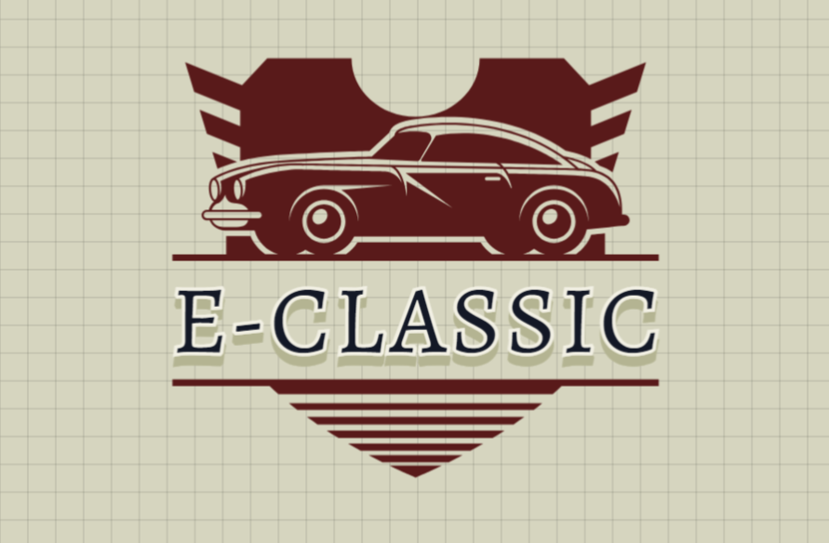
Website: (https://www.e-classic.online)
Creating our website that is not only visually beautiful but also easy to use and that shows our products, their characteristics, and the benefits of vintage electric cars is a challenge that we try to do. Incorporating movies, high-quality pictures, and testimonials from satisfied customers is an essential component.

The PCI-DSS compliance standards, which outline the operational and technical requirements for protecting the information of cardholders, are adhered to in a stringent manner by our company, which accepts payments made by credit cards and debit cards. JCB, Discover Financial Services, American Express, MasterCard, and Visa Inc. are among the founding members of the PCI Security Standards Council (PCI SSC) that oversee the management of these standards and have primary responsibility for ensuring compliance (PCI Security Standards Council, 2018).
Compliance with PCI DSS is mandatory for all organisations that store, manage, or transmit cardholder data. This standard encompasses both technical and operational system components. (Cefai-Cox, 2020)
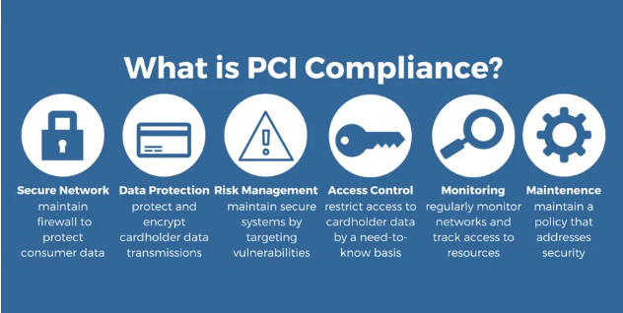

Digital Marketing
Search Engine Optimisation (SEO) involves optimising your website using appropriate keywords to improve its ranking on search engines. Direct our attention towards phrases such as "classic electric vehicle conversions" and "vintage electric vehicles from the past."
Content Marketing: Our firm implement content marketing strategies by creating and distributing blogs, articles, and videos that highlight the advantages of classic electric vehicles (CEVs), provide information on the conversion process, and provide anecdotes about particular car models. (Snyder, 2023)
Social media: Our firm utilise sites such as Instagram, Facebook, and YouTube to present your automobiles via fascinating posts, stories, and videos. Our firm Showcase exclusive insights into our conversion process, feedback from our clients, and engaging our events.
Email Marketing: Our firm create a database of prospective consumers' email addresses and regularly distribute newsletters with information about new models, business updates, and industry trends.
Events and Partnerships
Car shows and Expos: Our firm showcase your cars in events that are held within the automotive sector. These events include expos for electric vehicles, the exhibition of antique automobiles, and other gatherings that are similar in nature. This is a wonderful opportunity to engage in direct interaction with customers and to cultivate connections with other people.
Partnerships: Our firm In order to cross-promote our goods, we work together with organisations that sell electric vehicles (EVs), antique automobile clubs, and other businesses that are associated to the automotive industry (such as companies that provide charging stations). By doing so, you will be able to promote your items to prospective buyers in a more effective manner.
Our firm organise events where prospective consumers may test drive your classic electric vehicles (CEVs) and see how they will perform. E-classic, allow participants to participate in a hands-on experience that demonstrates the advantages and effectiveness of your conversions.

Customer Engagement and Testimonials
Customer Stories and anecdotes: Our firm include on our website and social media platforms specific customer anecdotes and other testimonials. Personal experiences have a strong level of resonance with prospective purchasers.
Referral Program: Our firm Establish a referral program that encourages consumers to recommend new purchasers by providing them with rewards. It is possible for word-of-mouth to be an effective advertising tactic.

Educational Content and Webinars
Workshops and Webinars: Our firm Organising online webinars and workshops to discuss the process of converting vintage automobiles to electric vehicles, the advantages of doing so, and the prospects for electric vehicles in the future. Our firm will stand out as an expert in the area as a result of this.
Guides and E-books: Our firm Come up with comprehensive guides and e-books on historic electric vehicles and the process of converting them. In order to increase our email list, our customers can access them also available as free downloads.

Targeting Costumers
Classic Car Enthusiasts Profile: These are individuals who possess a strong admiration for vintage and classic automobiles. They are interested in modernising classic vehicles with electric powertrains, despite their appreciation for the aesthetics, heritage, and craftsmanship.
Motivation: Their primary objective is to preserve the car's original appearance and feel while simultaneously reducing the environmental impact and maintenance requirements that are commonly affiliated with internal combustion engines.
Example: A classic car enthusiast who cherishes their 1960s Volkswagen Beetle may elect to convert it to electric power in order to continue operating it on a daily basis without experiencing environmental repercussions.

Environmentally Conscious Consumers Profile: These consumers are motivated by the desire to reduce their carbon footprint and are environmentally aware. They may be passionate about sustainability and perceive the conversion of a classic vehicle to electric as a means of reconciling their appreciation for vintage aesthetics with their environmental principles.
Motivation: They desire the allure of a vintage automobile but are unwilling to sacrifice environmental responsibility. Electric conversions provide them with the opportunity to operate a distinctive, fashionable automobile without contributing to environmental degradation.
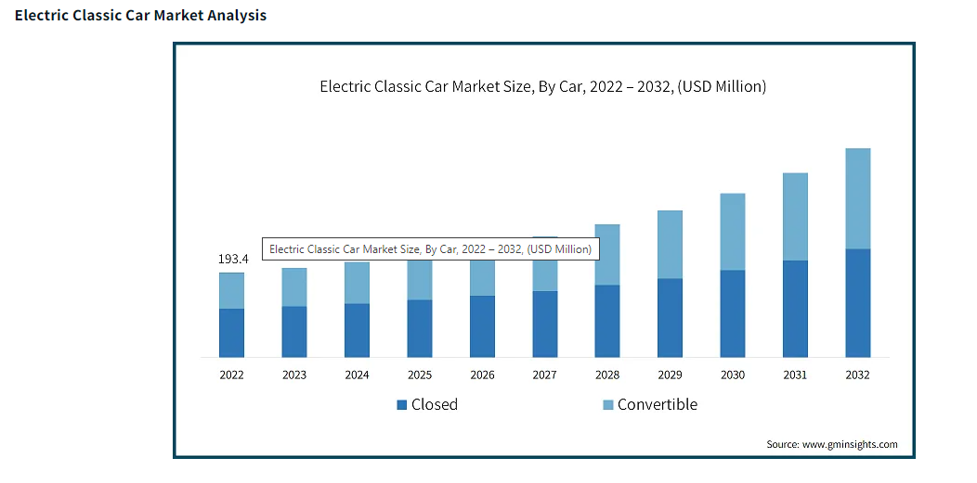
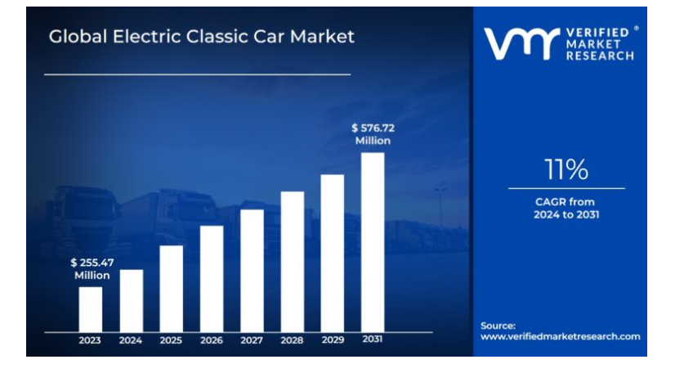
(Verified Market Research, 2024) (Global Market Insights Inc., n.d.)

Types of innovation and Competitive Analysis
Incremental innovation is the systematic endeavour of progressively and consistently improving existing products and services. Despite being the least visually striking among all the categories, it offers the most evident advantage to a predetermined bottom line. Organisations may achieve two objectives, namely expanding their market share and minimising stagnation, by continuously enhancing their products, services, and business processes. (Ottinger, 2021)

Incremental innovation, also known as continuous improvement, is the progressive enhancement of an already existing product or service. Incremental innovation, while less conspicuous and revolutionary in comparison to other types of innovation, remains highly effective in addressing transformative issues within an organisation. (Coudert, 2022)
Furthermore, incremental innovation is particularly potent due to its collaborative and communal characteristics. Client-facing staff, who engage in regular conversations with clients, often provide value-creating ideas. Furthermore, accomplished leaders in human resource development have effectively used it as a valuable tool in fostering a shared culture of progress. (Coudert, 2022)
Our company is more fortunate than our other two competitors because e-classics is located far away from the United Kingdom as a location and it means an extra 20% tax to be paid, in addition to this, we have the Karmann Ghia E product, which these two companies do not have but we have, which we believe will make us more successful in this race and struggle.
Electric Classic Cars (ECC): ECC has successfully replaced conventional engines with electric ones, integrated vintage aesthetics with contemporary performance, and accommodated the requirements of environmentally conscious consumers (Electric Classic Cars, 2024).
Volkswagen e-BULLI (eClassics): Volkswagen's T1 Samba Bus electric conversion, the e-BULLI, uses some of these ideas. It skillfully integrates current electric technology with the classic bus design, demonstrating successful implementation of these ideas. This company located at Germany (Harrison, 2021).

Privacy and Data Protection: Awareness of GDPR and the Data Protection Act 2018
The UK's General Data Protection Regulation (GDPR) and the Data Protection Act 2018 (DPA 2018) are crucial for managing personal data in the UK. These regulations outline principles such as legality, fairness, transparency, and limited purpose. Data should be collected for legal reasons and stored for the required time. Data should be secure and up to date. Personal liberties and rights include access to personal information, rectification of erroneous data, erasure, restrictions on processing, data portability, and objecting to processing. (Legislation.gov.uk, 2018)
Companies must appoint a Data Protection Officer (DPO) for large-scale operations and notify the appropriate supervisory body within three days of a data breach. Data Protection Impact Assessments (DPIAs) are essential for processing operations that pose a significant threat to individuals' rights. The Data Protection Act of 2018 (DPA 2018) supplements the GDPR and includes additional standards relevant to the UK. The Information Commissioner's Office (ICO) is an independent body established to protect individuals' rights to access and use information. (Legislation.gov.uk, 2018)

Conclusion
E-classic is revolutionizing the classic car industry by offering environmentally friendly electric conversions of iconic Volkswagen models. The company blends the timeless appeal of classic vehicles with cutting-edge electric propulsion technology, preserving their historical significance while meeting modern sustainability and efficiency demands.

E-classic offers personalized services and expert support throughout the conversion process, ensuring each vehicle retains its unique charm while benefiting from modern advancements. The company uses the SCAMPER method to innovate, substituting traditional materials with sustainable ones, combining classic aesthetics with contemporary technology, and adapting vehicles for urban settings or fleet use. E-classic prioritizes data protection and PCI-DSS compliance, making it a leader in the growing market for classic electric vehicles.

Reference List
Altiparmak, T. and Eryilmaz Muştu, Ö. (2021). The Effects of SCAMPER Technique Activities in the 8th Grade Simple Machines Unit on Students’ Academic Achievement, Motivation and Attitude Towards Science Lessons. International Journal of Educational Methodology, [online] 7(1), pp.155–170. doi:https://doi.org/10.12973/ijem.7.1.155.
Cefai-Cox, J. (2020). PCI Compliance What Is it, and Why Is It important? [online] Linkedin.com. Available at: https://www.linkedin.com/pulse/pci-compliance-what-why-important-joshua-cefai/ [Accessed 3 Aug. 2024].
Coudert, G. (2022). What Are the 4 Types of Innovation ? [online] Agorize. Available at: https://get.agorize.com/en/resources/what-are-the-4-types-of-innovation/ [Accessed 30 Jul. 2024].
Design.com. (n.d.). Create Logos, Business Cards, Social Designs and More. [online] Available at: https://www.design.com/ [Accessed 15 Jul. 2024].
E-classic.online. (2024). E-Classic. [online] Available at: https://www.e-classic.online/ [Accessed 1 Aug. 2024].
Electric Classic Cars. (2024). Beetle Conversion Kit. [online] Available at: https://www.electricclassiccars.co.uk/products/electric-classic-beetle-conversion-kit [Accessed 3 Aug. 2024].
Enrique, J., Valdes, S.O. and Miguel, L. (2018). Applications of Conscious Innovation in Organizations. IGI Global.
Global Market Insights Inc. (n.d.). Electric Classic Car Market Size - by Car (Closed, Convertible), by Application (Tourist Attraction, Large Amusement Parks, Closed Communities, Campuses), by End Users (Personal, Commercial), Growth Prospects, Regional Outlook & Forecast, 2024 - 2032. [online] Available at: https://www.gminsights.com/industry-analysis/electric-classic-car-market [Accessed 8 Aug. 2024].
Harrison, T. (2021). The VW e-BULLI Concept Is an Incredible Retro EV Van. [online] Top Gear. Available at: https://www.topgear.com/car-news/electric/vw-e-bulli-concept-incredible-retro-ev-van [Accessed 3 Aug. 2024].
Legislation.gov.uk. (2018). Data Protection Act 2018. [online] Available at: https://www.legislation.gov.uk/ukpga/2018/12/contents/enacted [Accessed 2 Aug. 2024].
Leonard, K. (2024). SEO Marketing in 2024: the Ultimate Guide – Forbes Advisor. [online] www.forbes.com. Available at: https://www.forbes.com/advisor/business/seo-marketing/#what_is_seo_marketing_section [Accessed 30 Jul. 2024].
Mindtools (n.d.). MindTools | Home. [online] www.mindtools.com. Available at: https://www.mindtools.com/ao2rt8j/scamper [Accessed 30 Jul. 2024].
Ottinger, R. (2021). Create Sustainable Success with the 4 Types of Innovation. [online] Fresh Consulting. Available at: https://www.freshconsulting.com/insights/blog/the-4-types-of-innovation/ [Accessed 30 Jul. 2024].
PCI Security Standards Council (2018). PCI DSS Quick Reference Guide Understanding the Payment Card Industry Data Security Standard Version 3.2.1 for Merchants and Other Entities Involved in Payment Card Processing. [online] Available at: https://listings.pcisecuritystandards.org/documents/PCI_DSS-QRG-v3_2_1.pdf [Accessed 13 Aug. 2024].
Snyder, K. (2023). What Is Marketing? Definition, Strategies & Best Practices – Forbes Advisor. [online] www.forbes.com. Available at: https://www.forbes.com/advisor/business/what-is-marketing/ [Accessed 8 Aug. 2024].
Trott, P. (2017). Innovation Management and New Product Development. 6th ed. Harlow, England: Pearson.
Verified Market Research. (2024). Global Electric Classic Car Market Size by Type (Closed, Convertible), by Application (Tourist Attraction, Large Amusement Parks), by Geographic Scope And Forecast. [online] Available at: https://www.verifiedmarketresearch.com/product/electric-classic-car-market/ [Accessed 2 Aug. 2024].

Appendix
PowerPoint Slides


