PORTFOLIO

Contents Page
Front cover…………………………………………………………………………………………………………………………….P.1
Contents page………………………………………………………………………………………………………………………..P.2
Part 1.0 Essay…………………………………………………………………………………………………………………………P.3
The importance of academic writing at university………………………………………………………………….P.3
  - Introduction……………………………………………………………………………………………………………………..P.3
  - Context…………………………………………………………………………………………………………………………….P.3
  - Conclusion……………………………………………………………………………………………………………………….P.4
Part 2.0 Job Advert………………………………………………………………………………………………………………..P.5
2.1.1 Opening a New Tourism Traveling Agency…………………………………………….........................P.5
2.1.2 Legal and Regulatory Requirements……………………………………………………………………………….P.5
2.1.3 Business Plan and financial projections………………………………………………………………………….P.5
2.1.4 Expertise and Experience……………………………………………………………………………………………….P.5
2.1.5 Partnerships and Networking…………………………………………………………………………………………P.5
2.1.6 Technology and Infrastructure……………………………………………………………………………………….P.6
2.1.7 Marketing and Branding………………………………………………………………………………………………..P.6
2.1.8 Training and Staff Development…………………………………………………………………………………….P.6
2.1.9 Operational Costs and Funding………………………………………………………………………………………P.6
2.2.1 Insurance and Risk Management……………………………………………………………………………………P.6
2.2.2 Conclusion………………………………………………………………………………………………………………………P.6
2.3 Personal Development Plan………………………………………………………………………………………………P.7
Part 3.0 Professional Development…………………………………………………………………………………………P.8
3.1 Online CV Link…………………………………………………………………………………………………………………….P.8
3.2 LinkedIn Profile Link……………………………………………………………………………………………………………P.8
Part 4.0 Digital Skills……………………………………………………………………………………………………………….P.10
4.1 Online Video CV Link………………………………………………………………………………………………………….P.10
4.2 Video Script Notes……………………………………………………………………………………………………………..P.10
Portfolio Conclusion………………………………………………………………………………………………………………..P.12
References……………………………………………………………………………………………………………………………….P.13

PART 1.0 ESSAY

The Importance of Academic Writing at University
1.1 Introduction
Academic writing is an essential component of a student's academic journey at university. It equips students with the necessary skills and knowledge to think critically, present their ideas coherently, and communicate effectively. Developing this skill enables students to express themselves in a structured and logical manner, which is essential for their academic progress and success over the years. Moreover, academic writing equips students with valuable transferable skills that are applicable in various professional settings. It fosters effective problem-solving abilities, attention to detail, and the ability to present complex information in a clear and concise manner. Therefore, academic writing is not only essential for academic success but also for future success in their chosen careers.

1.2 Context
Firstly, academic writing allows students to structure their thoughts and arguments coherently. It enables them to express their opinions, analyse complex information, and present their findings in a logical and compelling manner. This process of organizing information helps students develop critical thinking skills, as they are forced to think deeply about the subject matter and challenge their own assumptions. By honing their writing skills, students become better equipped to analyse complex problems, evaluate evidence, and make informed decisions.
Moreover, academic writing fosters a sense of professionalism and helps prepare students for their future careers. Employers value employees who can communicate their ideas clearly and effectively, both verbally and in writing. By engaging in academic writing assignments, students learn how to present their ideas in a concise and persuasive manner. They learn how to structure their arguments, use proper grammar and punctuation, and adhere to the required formatting guidelines. These skills are essential for effective communication in any professional setting, whether it be writing reports, proposals, or presenting research findings.

Academic writing encourages independent thinking and problem-solving. When students are required to write research papers, they are required to conduct in-depth research, gather information from multiple sources, and synthesize it into a cohesive argument. This process requires students to think critically, evaluate the credibility of sources, and come to their own conclusions. It also helps them develop their ability to analyse complex information, identify key points, and effectively communicate their ideas. By engaging in academic writing, students become independent learners who can think critically and solve problems independently.
When it comes to my strengths, I identify as being resourceful, time-oriented, and possessing a high level of determination. When it comes to weaknesses, I acknowledge that I struggle with comprehending complex technical programs such as Microsoft Word, PowerPoint, and other software embedded in Microsoft 365. While I recognize the importance of these programs, I find it challenging to navigate and use them efficiently. This weakness limits my productivity and effectiveness in certain tasks that require proficiency in Microsoft Office. Overall, my determination and resourcefulness allow me to overcome this weakness by seeking guidance and seeking alternative solutions when necessary.
The guidance is offered by the University of Wales Trinity Saint David and is available free of charge to students enrolled into said University and can be accessed online. It serves as a great benefit for students, providing them with step-by-step tutorials on essential programs that they are currently struggling with. This guidance is designed to simplify the learning experience and help students overcome their challenges. By following the step-by-step tutorials, students can enhance their skills and feel confident in utilizing the program effectively. Whether it's a programming language, graphic design software, or any other specialized area, this guidance offers valuable support to help students achieve their goals throughout their career pathways.
1.3 Conclusion
In conclusion, academic writing is of utmost importance in the university setting. It provides students with the opportunity to develop their critical thinking skills, professionalism, and independent thinking. By engaging in academic writing assignments, students learn how to present their ideas coherently, analyse complex information, and communicate effectively. This skill is not only valuable for academic success but also for future career endeavours. Therefore, students must embrace academic writing as an integral part of their university experience.

PART 2.0

Job Advert

2.1.1 Opening a New Tourism Traveling Agency
Opening a new tourism traveling agency can be a rewarding and lucrative venture, but it requires careful planning and preparation. There are several key steps and requirements that need to be met to successfully launch a new travel agency.
2.1.2 Legal and Regulatory Requirements
Before anything else, it is crucial to familiarize yourself with the legal and regulatory requirements for your country or region. These may include obtaining licenses, permits, and certifications specific to the tourism industry. It is important to consult with local government agencies or consult with a legal professional to ensure compliance.
2.1.3 Business Plan and Financial Projections
Developing a clear and well-thought-out business plan is essential for the success of any new business venture. The business plan should include an overview of your travel agency's mission, vision, target market, marketing strategies, and financial plan. It should also outline projected revenue streams, expenses, and growth objectives.
2.1.4 Expertise and Experience
Opening business such as a travelling agency requires a deep understanding of the tourism industry and a strong background in travel planning. It is advisable to have firsthand travel experience or work with individuals who have experience working in the travel industry. This expertise will help you provide exceptional customer service and tailor itineraries to your clients' specific needs.
2.1.5 Partnerships and Networking
Building relationships with tour operators, hotels, and other travel industry companies can help secure exclusive deals, access resources, and establish credibility. Networking events, trade shows, and industry associations are effective ways to connect with potential partners and clients.

2.1.6 Technology and Infrastructure
To efficiently manage travel agency operations, investing in reliable and robust technology is a key factor. This may include booking systems, inventory management tools, and customer management software. Additionally, having a user-friendly website and a strong online presence is crucial for attracting potential clients and showcasing the company’s services.
2.1.7 Marketing and Branding
By developing a comprehensive marketing strategy that encompasses both online and offline channels can create a strong brand identity and logo and establish a consistent online presence through social media platforms and search engine optimization. Considering offering promotions and discounts will attract new customers.
2.1.8 Training and Staff Development
Hiring knowledgeable staff who are knowledgeable and passionate about travel is essential. By providing comprehensive training to the company’s team members will ensure they have the necessary skills to provide excellent customer service, handle bookings, and answer clients' questions. Continuous training and industry updates will keep the staff well-informed and up to date with the latest travel trends.
2.1.9 Operational Costs and Funding
Opening a new tourism travel agency involves initial and ongoing expenses. By initially researching the expected costs, such as licensing fees, marketing expenses, office rent, and staff salaries, this will improve the company’s revenue in the long term. One consideration is to securing funding through loans, investors, or bootstrapping your business. Having a solid financial foundation will help secure the success of your travel agency.
2.2.1 Insurance and Risk Management
In the tourism industry, accidents and unforeseen circumstances can happen. It is crucial to have a comprehensive insurance policy that covers various aspects of the travel agency operations, including travel accidents, property damage, and liability. Additionally, developing risk management strategies is key to mitigate potential risks and ensure the safety of the company’s clients and staff.
2.2.2 Conclusion
Taking everything into account stated, opening a new tourism travel agency requires careful planning, expertise, and a strong understanding of the industry. By fulfilling the legal and regulatory requirements, developing a comprehensive business plan, establishing partnerships, investing in technology, implementing effective marketing strategies, and focusing on staff development, anyone will be well-equipped to excel in this dynamic and evolving sector.

2.3 Personal Development Plan
In the currently active job as a warehouse worker, I have developed certain skills that have proven valuable in my role. By conducting a SWOT analysis, I can now identify the necessary skills required for opening a new tourism agency.
As a warehouse worker, my strengths include resourcefulness, time-oriented, and determination. These qualities have helped me navigate complex tasks, meet deadlines, and stay motivated even in challenging situations. These skills will be crucial in starting and successfully running a tourism agency.
While my warehouse job has not required extensive proficiency in Microsoft 365, I recognize the importance of technology in tourism and acknowledge that proficiency in Microsoft 365 will be an asset for running the agency. However, I recognize that this weakness may require additional training and resources to overcome.
Opportunities for starting a tourism agency are abundant in the current global tourism growth. With people seeking new experiences and destinations, there is potential for a new agency to capture market share. Additionally, digital transformation can provide innovative tools and platforms to enhance customer experience. By leveraging technology, the agency can offer personalized recommendations, tailored packages, and seamless online booking processes.
However, starting a tourism agency also presents threats. Economic downturns, natural disasters, and industry regulations can pose challenges. The agency must be prepared to navigate economic fluctuations, adapt to changing customer needs and preferences, and ensure compliance with industry regulations. Cybersecurity and privacy are also crucial concerns, as the agency handle sensitive information and manage online bookings.
The skills I have developed as a warehouse worker, such as resourcefulness, time-oriented and determination, will be highly valuable in opening a tourism agency. However, I also acknowledge and address my weaknesses, such as limited proficiency in Microsoft 365 which I am actively engaged to improve. Opening a tourism agency presents both opportunities and challenges. Economic downturns, natural disasters, industry regulations, and cybersecurity threats are some of the challenges that may arise. However, by capitalizing on global tourism growth and leveraging digital transformation, forming strategic partnerships, and collaborating with industry experts, I am confident in my ability to thrive in the competitive tourism market.

PART 3.0

Professional Development
3.1 The following link is to access my online CV: file:///D:/Internet%20Downloads/White%20Clean%20Minimalist%20Business%20Real%20Estate%20Resume.pdf
Also, below is a preview of my online CV:
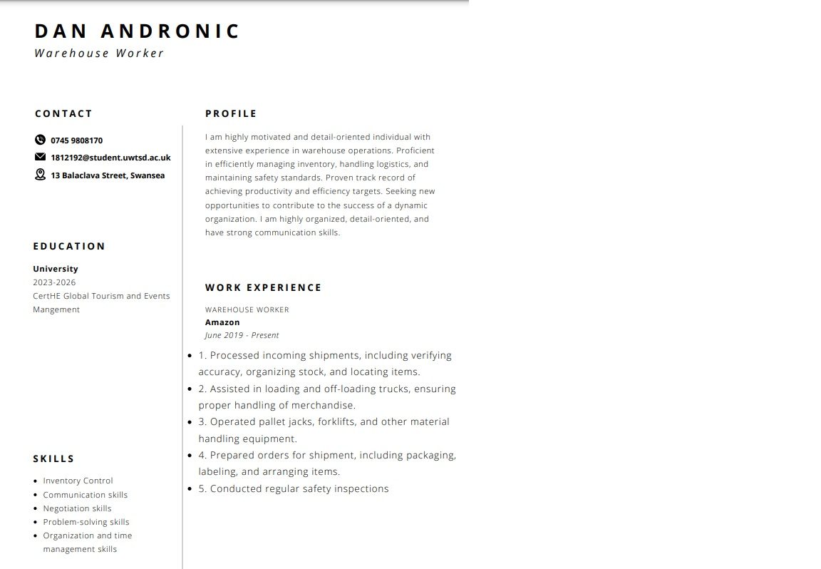
3.2 The following link is to access my LinkedIn profile:
www.linkedin.com/in/dan-andronic-966805299
Furthermore, below is a preview of my LinkedIn profile and my About info from my LinkedIn profile:
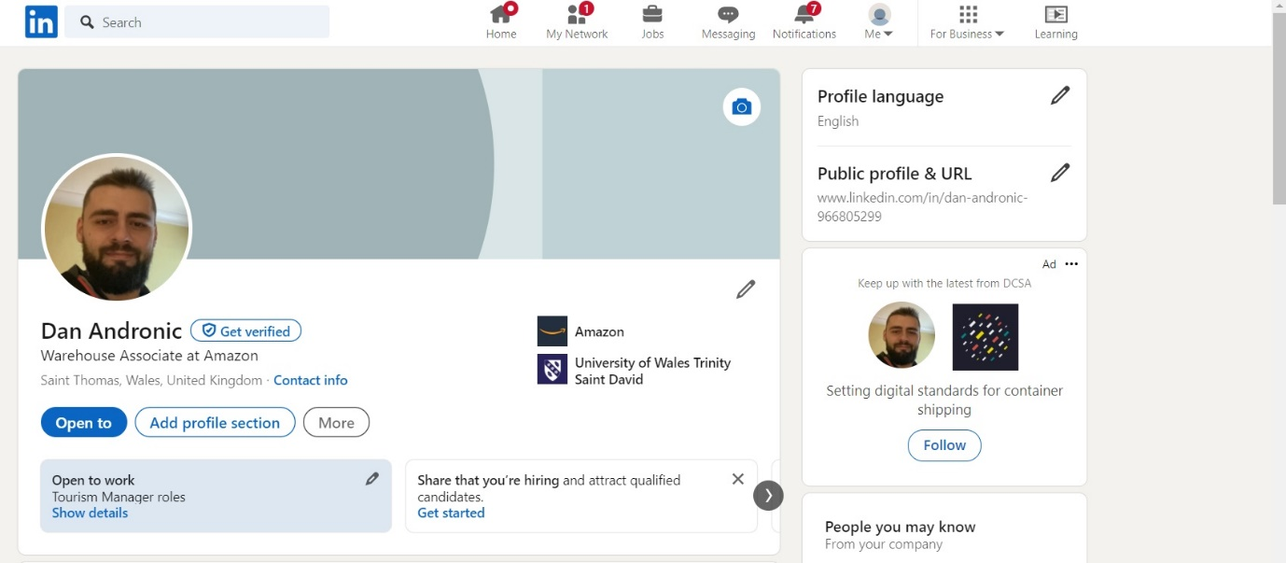
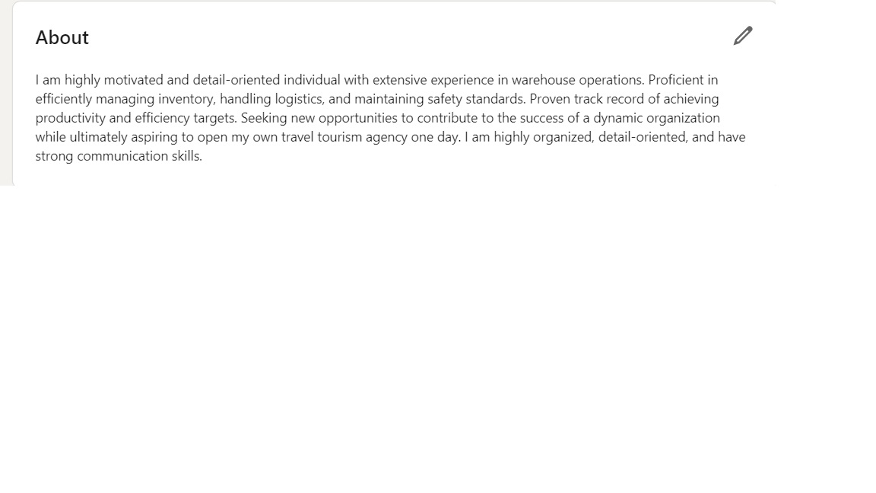

Part 4.0

Digital Skills

4.1 Video CV
Below you will find the link to my Video CV:
Recording-20231215_230341.webm
Moreover, I’ll embed my Video script notes below:
4.2 Video Script Notes:
“Welcome to this informative video on the professional journey of which is myself, Dan Andronic. In this video, we will explore my expertise, skills, and achievements in the field of warehouse management and operations.
I’m a dynamic and results-driven professional guy with extensive experience in warehouse operations. With a passion for efficiency and accuracy, I have consistently demonstrated a strong work ethic and commitment to delivering exceptional results.
Let's take a closer look at My educational background and qualifications.
I am currently pursuing my Certificate of Higher Education in Global Tourism and Events Management. This reflects my ability to adapt to changing industry trends and demonstrates my willingness to continuously learn and grow.
My skills set is diverse and encompasses various aspects of warehouse management. Let's explore some of my key strengths:
Inventory control: I possess exceptional skills in monitoring and maintaining inventory levels. I ensure that stocks are accurately accounted for, preventing any discrepancies or disruptions in the supply chain.
Communication skills: I possess excellent communication skills, both written and verbal. This allows me to effectively collaborate with team members, stakeholders, and clients, ensuring clear and transparent communication throughout projects.
Negotiation skills: My negotiation skills are second to none. I am able to negotiate favourable terms with suppliers, ensuring cost savings and securing high-quality products and services.
Problem-solving skills: I approach challenges with a problem-solving mindset. I identify issues promptly and develop innovative solutions to mitigate risks and ensure smooth operations.
Now let's delve into my professional experience.
Currently I am employed at Amazon, and I have been at the forefront of warehouse operations since June 2nd, 2019. My skills and expertise have been instrumental in driving productivity, efficiency, and maintaining exceptional safety standards.
As a Warehouse Associate at Amazon Warehouse, I successfully handled various duties related to the processing and handling of shipments. Responsibilities included:
1. Processing Shipments: I diligently verified the accuracy and completeness of incoming shipments, ensuring they matched the purchase order specifications. I organized stock within the warehouse, locating items efficiently and facilitating their retrieval.
2. Assisting in Loading and Off-loading Trucks: I assisted in the loading and unloading of trucks, ensuring proper handling of merchandise. I collaborated with team members to lift and position large items, ensuring their safety and avoiding any damages.
3. Operating Material Handling Equipment: I confidently operated pallet jacks, forklifts, and other material handling equipment. This involved manoeuvring heavy loads, navigating tight spaces, and ensuring smooth operations within the warehouse.
4. Preparing Orders for Shipment: I was responsible for preparing orders for shipment, including packaging, labelling, and arranging items. I paid attention to detail, ensuring all items were securely packaged and labelled correctly for efficient tracking and identification.
5. Conducting Safety Inspections: I conducted regular safety inspections within the warehouse to identify any potential hazards or non-compliance issues. I reported any findings or concerns to management, contributing to a safe working environment for all team members.
During my tenure at Amazon Warehouse, I demonstrated strong organizational skills, attention to detail, and the ability to work well in a team environment. My strong work ethic and commitment to excellence contributed to the success of the warehouse operations.

Throughout my professional journey, I have achieved notable milestones and accomplishments. Let's highlight a few:
I have consistently achieved productivity targets, exceeded expectations, and ensured timely delivery of products.
My attention to detail has been instrumental in identifying and resolving inventory discrepancies, minimizing errors, and improving overall operational efficiency.
I am certified by industry regulatory bodies and continuously seek opportunities to enhance my skills and knowledge.
Looking ahead, my ambition is to contribute to the development of a dynamic organization. I am driven by my strong work ethic and the desire to make a lasting impact with the aspiration that one day I’ll open and lead my own tourism agency.
To sum it all up, I am a highly skilled and experienced professional in the field of warehouse management. My expertise, dedication, and commitment to excellence make me a valuable asset to any team or organization. “

Portfolio Conclusion

In conclusion, opening a new travel agency is an exciting and promising venture. With the growing demand for travel and the increasing popularity of personalized travel experiences, there is ample room for growth in the industry. By offering unique itineraries, exceptional customer service, and leveraging technology, a travel agency can create a niche and stand out from competitors. However, it is important to conduct thorough market research, build a strong brand, and continuously adapt to meet the evolving needs of travellers. With careful planning, dedication, and a vision for the future, a new travel agency has the potential to succeed and thrive in the competitive world of travel and with my strong determination and effective communication skills the opportunity to open a new travelling agency is just within reach.

References

Fang, Z. (2021). What Is Academic writing? (and Other Burning Questions about it). [online] www.routledge.com. Available at: https://www.routledge.com/blog/article/what-is-academic-writing-and-other-burning-questions-about-it#:~:text=Why%20is%20academic%20writing%20important (Accessed 15 Dec. 2023).
Hays (2023). Personal Development Plan | Career Advice | Hays. [online] www.hays.com.au. Available at: https://www.hays.com.au/career-advice/career-development/personal-development-plan (Accessed 14 Dec. 2023).
Junglebee (2021). 8 Top Tourism Advertising Tips to Grow Your Company | Website & Search Engines. [online] junglebee.com. Available at: https://junglebee.com/blog/8-top-tourism-advertising-tips-to-grow-your-company (Accessed 14 Dec. 2023).
Tsvetkov, T. (2018). How to Start a Tour Company with (Almost) No Money. [online] Regiondo. Available at: https://pro.regiondo.com/blog/how-to-start-a-tour-company/ (Accessed 14 Dec. 2023).

