BA Computer Games Design

Learning in the Digital Era

(BA GAMES/ANIMATION STUDENTS)

Assignment 2: Personal Development Plan (PDP)

Michael Dawe (2206831)

Contents:
Self-evaluation ………………………………………………………………………………………………………….. page 3
Professional Development Plan ……………………………………………………………………………….… page 3
Moodle Unit 4 Section Summary ……………………………………………………………………………….. page 4
Video Presentation ……………………………………………………………………………………………………. page 5
PowerPoint download ……………………………………………………………………………………………….. page 5

Self-evaluation:
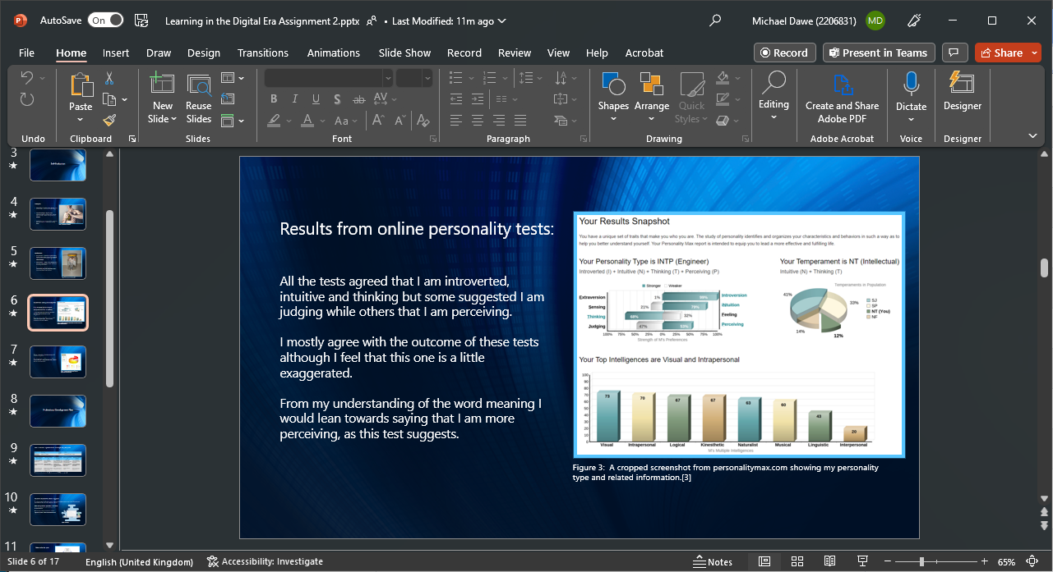
Figure 1: Screenshot of part of my self-evaluation task answer in Microsoft PowerPoint.
Professional Development Plan:
I copied the template for the PDP directly into the PowerPoint presentation, which you can view here https://uowtsd-my.sharepoint.com/:p:/g/personal/2206831_student_uwtsd_ac_uk/EW96hdez18JNiaf6BKI3WVkBr4KE7itVuTa89NDLoUPnMQ?e=IJNlhY
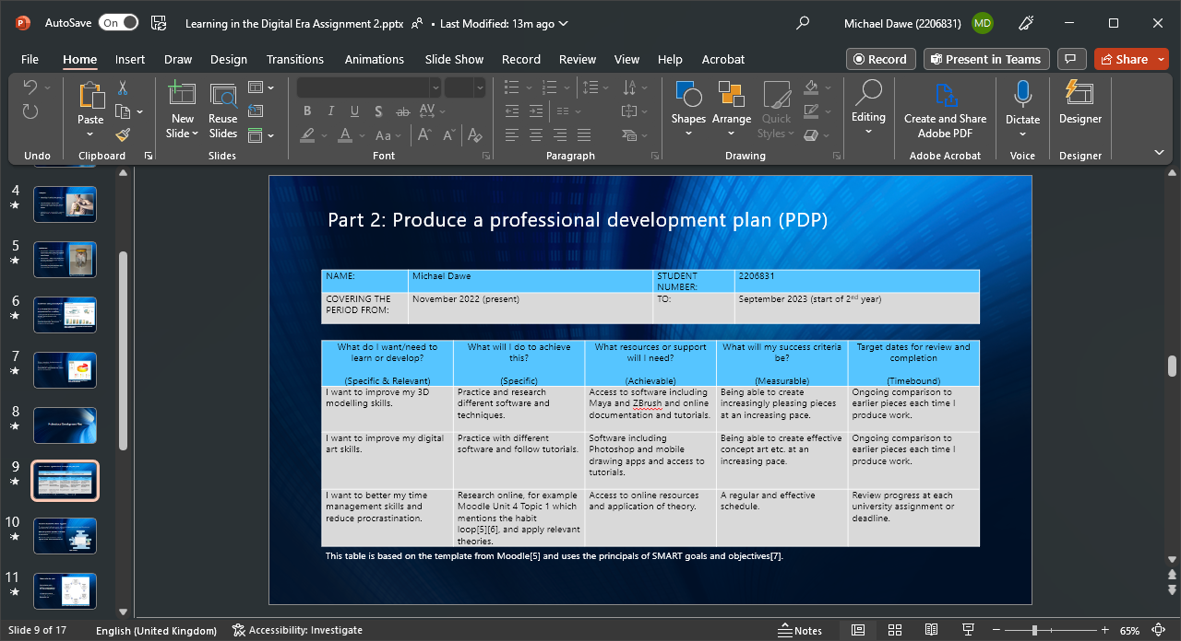
Figure 2: Screenshot of my PDP in Microsoft PowerPoint.
Moodle Unit 4 Section Summary:
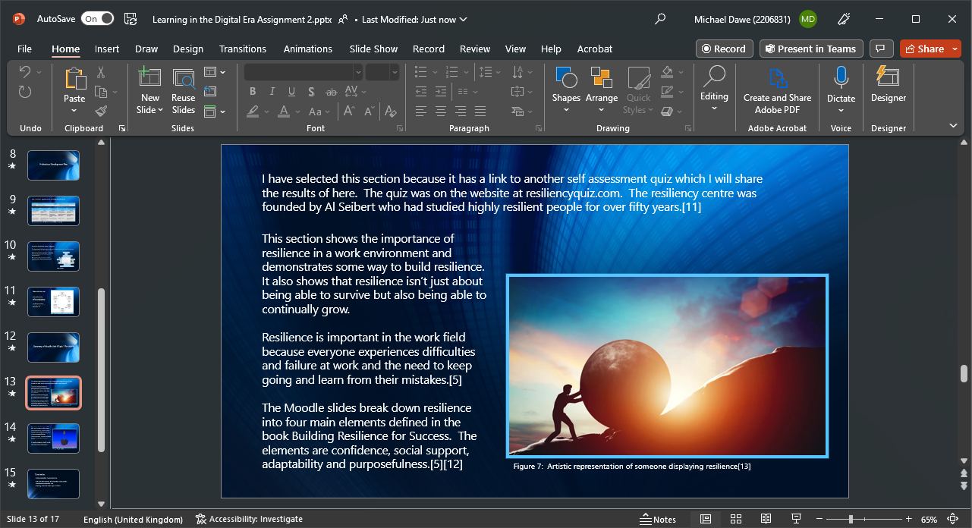
Figure 2: Screenshot of part of my Moodle Unit 4 section summary in Microsoft PowerPoint.

Video presentation:
My video presentation is available on YouTube here https://www.youtube.com/watch?v=rrec-DxEnC8
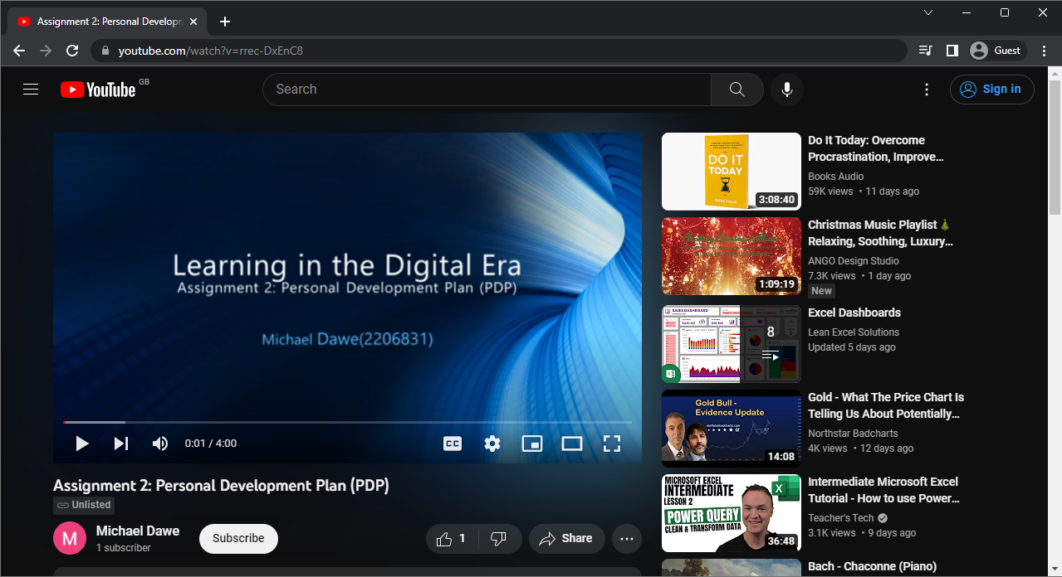 Figure 2: Screenshot my video presentation hosted on YouTube.

You can download the original PowerPoint presentation here https://uowtsd-my.sharepoint.com/:p:/g/personal/2206831_student_uwtsd_ac_uk/EW96hdez18JNiaf6BKI3WVkBr4KE7itVuTa89NDLoUPnMQ?e=IJNlhY

