Document Properties
Document Owner | Alliance Construction Design Team
Author | Al David Ikete | ID | 1902411
Organisation | Alliance Construction
Client | University of Wales Trinity St David’s
Title | E9 Project Sustainability and Energy Approach
Project Stage | Pre-Design Recommendations

Table of Contents
1. Introduction 3
2. Heating and Cooling Systems 4
2.1 How Solar Water Heater Works 5
2.2 Benefits of Solar Water Heaters 5
2.3 How an Air Source Heat Pump Works 5
2.4 Benefits of Air Source Heat Pump 5
2.5 Project Recommendation 6
3. Electricity 6
3.1 Power Source 8
3.1.2 Wind Turbine 8
3.1.3 Solar Panels (PV) 8
4. Lighting 9
5. Water 10
5.1 Water Recycling Method 11
5.1.2 Sand Filter 11
5.1.3 Wetland 11
5.1.4 Biological Systems (Including Food Debris) 11
5.1.5 Mechanical Filters (For Using the Water to Flush Toilets) 11
5.2 Limitations 11
6. Carbon Emission and Project Sustainability 12
6.1 Consideration: 13
6.1.2 Transportation of Materials and Assets 13
6.1.3 Project Delivery 13
6.1.4 Workforce Sourcing 14
7. Conclusion 15
Bibliography 16

Introduction
As a contractor we aim to guide and consult our clients to adapt sustainable products and services during the design and construction phase of the project. The document aims to compare and evaluate the various energy sources that could be used to generate green low carbon energy for the building once built. Low carbon is defined as “less carbon dioxide Co2”, as carbon dioxide is a key greenhouse gas that’s driving climate change and is the main by-product of the energy industry (Moses, 2020). The document also provides clients with an in-depth knowledge on why it is important to incorporate green energy sources in buildings. Furthermore, explain what green energy source are and how they could benefit the building in the future. Government and industry statics will be used to evaluate and make an informed decision on what source should be used and the impact it will have on public interaction with the building. Information on efficiency U values and R ratings will also be provided in this document to give the clients an estimate on energy consumption and running cost of the building.

Document also aims to provide the client with heating solutions as the project compromises of residential and commercial units which both required heating and cooling solutions. Furthermore, the document aims to provide the stakeholder with the most cost-effective solutions to building services and promote a sustainable approach to the running of the building as sustainable construction doesn’t end when the building is complete the building itself should have a reduced impact on the environment over the life span of the building. Furthermore, considerations to the project’s delivery will be explored in this document due to the clients request for the project to be sustainable, therefore, it will aim to look at ways in which the project can be delivered sustainably and ethically.

Listed below are some of the legislation and acts that help guide the recommendations in the document:

- Environmental Protection Act 1990
- Clean Air Act 1993
- Control of Pollution Act 1974
- Environmental Bill 2020
- Building Regulations
- Flood and Water Management Act 2010
- Building Act February 1984

Heating and Cooling Systems

Most residential developments either using burnt fossil fuel or converting electricity into heat. However, heat pumps are different because they don’t generate heat. On the contrary, they move existing heat energy from outside into your home. This makes them more efficient. Since they deliver more heat energy than the electrical energy they consume. So, a heat pump system typically costs less to run than traditional boiler heating system. An alternative to using air source heat pumps is using solar water heating system, the system uses the sun’s energy for domestic or commercial heating purposes.

2.1 How Solar Water Heater Works | Solar water heating systems collect the heat from the sun with the use of solar collectors. Collectors are generally fitted to the roof which can be fitted to a pitched or flat roof, where they receive the most sunlight. The solar heating systems can also be mounted at ground level or even on a south- facing wall which our site provides. The system can be bolstered by the addition of an immersion heater or a boiler that can be used as an additional option to increase the temperature of water when necessary (Kunz, 2021).
2.2 Benefits of Solar Water Heaters | - Solar hot water heaters provide hot water all throughout the year.  - It reduces the price of utility bills as it can provide a third of a client’s hot water needs.  - It reduces the buildings carbon footprint by saving between 30kg and 510 kg of carbon dioxide (Kunz, 2021).
2.3 How an Air Source Heat Pump Works | An air source heat pump works by absorbing heat from outside air at a low temperature into a fluid which is passed through a compressor to increase its temperature. The most common air source heat pump is air to water systems, where the high temperature of the fluid is transferred to the heating and hot water system in a property.
2.4 Benefits of Air Source Heat Pump | Air source heat pumps provide clients with various benefits, these benefits include the cost of running an air source heat pump to heat your home is considerably less than most alternative methods, such as oil, LPG, or conventional electric heating. Also, an air source heat pump has a low carbon footprint as it uses a natural source of renewable energy. The energy that clients may generate with an air source heat pump can be used to heat your home and provide hot water.

2.5 Project Recommendation
Given the benefits offered by the implementations of ASHP’s, it will be used as the main source of heat in the buildings final design. The air source heat pumps will be mounted on the side of the building in a fenced off to avoid public interaction with them and to ensure security. However, it is to be noted that the installation of air source heat pumps may ruin the buildings aesthetics. Although it may compromise the buildings aesthetics it offers a greater efficiency output as opposed to solar water heating which was the other option that was considered.

Electricity
Electrical energy is defined as the of energy that is formed through the movement of the electrons from one point to another such type of energy is called electrical energy (Electrical technology, 2021). Given the location of the site it would be advised that client acquire two wind turbines and roof mounted solar panels to provide power to the building.

Each turbine consists of a set of blades, a box beside called a nacelle and a shaft. The breeze from the wind then propels the blades creating kinetic energy. The rotating blades then turn the shaft and generator in the nacelle, converting the kinetic energy into electricity. This is then fed to a transformer to increase the voltage to be used in the properties.

Wind turbines can operate in very light winds or very strong wind speeds. Electricity is generated 80% of the time (National Grid Group PLC, 2021). However, the power generated is not always full capacity therefore will require a backup source which potentially could be provided by solar panels or the national grid.

This would be of great benefit to the project as the given site is by the sea front and would benefit from south facing wind in coming from the Swansea Bay. This is because the wind turbines need to be located at the windiest point on the site to maximise energy productivity (Moses, 2020).

Solar panels as an electricity system, also known as photovoltaics (PV), capture the energy from the sun using photovoltaic cells. These cells can generate electricity on an overcast day therefore not relying on direct sun light to function. Solar being a renewable source of energy means that we can diminish reliance on national grid power supply and reduce the structures carbon footprint. Furthermore, by adopting a blended approach to powering the building we can ensure that the is a constant power supply being fed to the building, whilst achieving BREEM excellent standards and installation cost can also be mitigated by the low maintenance cost solar energy systems only require cleaning twice a year.

For efficiency the solar panels would have to be fitted south facing, as this means they will be facing the sun for most of the day maximising their efficiency. It is also imperative that they are fitted at the optimal angle of tilt as in the UK the sun is higher in the sky in the summer and lower in the winter therefore if the panels are in the position of the sun at midday in midsummer, they’ll maximise efficiency during summer, however, lose out during the winter. In the UK panels that are tilted at 15 degrees or more benefit of being cleaned by the rainfall ensuring maximal cost effectiveness and performance.

3.1 Power Source | Information
3.1.2 Wind Turbine | Roof mounted:  Roof mounted turbines utilise the height advantage of buildings and the electricity generated can be fed directly into the property.  This type of turbine is easier to install and cheaper than other versions, costing up to £3,000 for a 1kw system.  Standalone turbine:  Standalone wind turbines, also called free-standing wind turbine or pole-mounted turbines, are more effective when situated on top of a hill, away from obstructions and turbulence. Stand-alone turbines produce more electricity than roof mounted alternatives. However, they can sometimes be subject to planning permission objections.  Standalone turbines cost on average £9,000-£19,000 for a 2.5kw system, while 6kw system costs £21,000-£30,000 (Hiesscheme, 2021).  Micro domestic turbine:  Micro domestic turbines are ideal to charge battery banks with electricity and cost around £800 pricing as of 2019. A power inverter will also be required to convert the AC electricity to DC as well as a bank of batteries.
3.1.3 Solar Panels (PV) | Number of solar panels needed:  The number of solar panels needed will depend on the size of the space in which the panels will be situated and how much electricity the space will consume. A 4KWp solar PV systems require 12 to 16 panels as different panels have different wattage capabilities. The average cost for a 4KWp solar PV system cost between £5000-£8000. However, the long-term benefits out way the costings making it a considerable investment.  Government grants  One benefit of the installation of Solar PV is that there are government grants available to subsidise the price of the investment. Following the closure of the Feed-in tariff on 31st March 2019, the government have introduced a proposed replacement in the form of Smart Export Guarantee (SEG), which, if implemented would see energy providers pay homeowners and business for energy they generated. This could benefit the project due to its size, scale and the amount of energy generated to power the building.

Lighting

This section aims to provide the client with the most efficient lighting solutions in accordance with the advised energy system. Lighting accounts for a significant portion of the energy usage in commercial and residential buildings. Furthermore, heat generated by lighting contributes to additional thermal loads that need to be removed by the buildings ventilation systems (Krarti, 2017) therefore, highlighting the importance for an energy efficient lighting system.

For said project the aim is to achieve a high level of BREEM, therefore, energy efficient building service solutions need to be implicated. Taking this objective into consideration the lighting solutions are an important focal point as light bulbs that are left on cost building operator an average of £800 more on their energy bill each year (edf Energy , 2021). Therefore, the use of Passive Infrared Sensors (PIR) will be a sensible approach to cutting electricity wasted by lighting spaces. Reducing the carbon emissions created by powering generated to light the buildings, as lighting left on in buildings creates 37,440,000kg of carbon dioxide in greenhouse gas emissions every year in the UK, or the equivalent of 62 flights round the world (Utility , 2018).

Furthermore, the use of PIR lighting systems provides minimal energy usage because with PIR systems lights are not always left on therefore not draining the battery’s used to store energy produced by the solar panels and wind turbine resulting in a low cost and energy efficient lighting system. The option to use PIR systems takes into further consideration that the site will compromise of student accommodation rooms as part of the residential quarters of the building. Student accommodations are high energy consumption environments as students tend to be forgetful and leave lights on.

Water
As high-water consumptions become a more concerning issue for designers all over the country due to its impact on climate change and its long-term impact on daily life. Therefore, it is imperative that water recycling systems be included in the project as it brings many economical and sustainable advantages to the project, with one main benefit being reduction in water bill for all leaseholders of the estate.

One water recycling system that can be proposed for said project is the use of greywater recycling systems. Greywater recycling systems collect the water used in the sinks, dishwashers, showers and baths and cleans it up and plumbs the water straight back into the toilet, washing machine and outside tap (Ferguson, 2014). The use of such systems can reduce water usage by 50%. And unlike rainwater harvesting systems, which relies on rainfall, greywater is in plentiful supply on a daily basis- the cleaner water that is used more the grey water is produced resulting in a never-ending cycle where used water is repurposed for the system.

Greywater making up 50-80% of a household’s wastewater, reusing the water offers a chance to offer cheaper water rates to tenants making the development more attractive to students and young professionals as well as potential summer renters. Furthermore, if recycled correctly greywater can save approximately 70 litres of potable water per person per day in domestic households (Ferguson, 2014).

5.1 Water Recycling Method
5.1.2 Sand Filter | The initial filtration can be simply achieved using a sand filter that removes any large particles. The greywater enters the top of the sand filter and travels down through the sand via gravity, with the sand removing sizable particles.  Once the greywater has gone through the pre-treatment stage, it can then be filtered using a soil box consisting of four layers of material. The top layer is roughly 2 feet deep of humus-rich topsoil, which sits on a bed of very fine building sand, which in turn sits on a layer of course sand. Finally, there is a layer of pea-shingle at the bottom to achieve excellent drainage. The water is initially pumped in at the top of the place in the topsoil level where soil organisms feed of and reproduce using the nutrients in the soil, essentially purifying the water.
5.1.3 Wetland | One other way of treating greywater systems is the use of wetlands, where the water is retained at a level close to the surface, allowing aquatic plants such as reeds and bulrushes to flourish. Subsurface wetlands are considered as the best way to treat greywater, because they reduce the chance of foul odours escaping. However, there is also less chance of the water freezing over during cold weather and less need for human contact which is potentially dangerous. The water is initially treated by both aerobic and anaerobic bacteria whilst the plants absorb dissolved organic materials, helping speed up the process (the greenage , 2021).
5.1.4 Biological Systems (Including Food Debris) | Greywater with food debris require to be treated anaerobically using septic tank. The water that comes out of the other end of the septic tank can then be treated in a soil box filter or using wetlands as mentioned above.
5.1.5 Mechanical Filters (For Using the Water to Flush Toilets) | Mechanical Filtration is a simple process to undo the u-bend under a sink and capture wastewater in a bucket, which you could then manually pour into the cistern of the toilet. However, this may prove to by time consuming and may deduct from project completion times.

5.2 Limitations
 | If the greywater is inadequately treated, it can lead to contaminated groundwater, which may have adverse effects on ecology (the greenage , 2021). Groundwater contamination could result in serious consequences for an stakeholders involved as Groundwater is considered a major source of fresh water for global population and is used for domestic, agricultural, and industrial uses therefore in a case of contamination stakeholders may be held accountable and fined also in some circumstances jail sentence may be awarded to the convicted party.

Carbon Emission and Project Sustainability

The section aims of the document is to explore the various strategies in which the project can be delivered sustainably. One of such strategy being the reduction of carbon emissions which is one of the industry’s biggest downfalls, with UK construction industry contributing 40% of national carbon emissions (Sutton, 2021).

To efficiently reduce project emissions three key aspects of the project must be reviewed closely these aspects being transportation of materials, construction method, workforce sourcing to formulate the most sustainable project delivery pack.

Furthermore, to ensure sustainable project delivery elements of the buildings design will look incorporate green spaces adjacent to the retail spaces to promote public interaction, as this is a key client requirement. As green spaces can improve public interaction by act as an agent for social cohesion as well as the sustainable development and inter-connectedness of communities by providing community sustainability, cohesion, and space of engagement for locals therefore, building a community hub, in which community value can derive from (Burrage, 2011). The major reasoning behind the push for social inclusion is that it promotes sustainability within communities because it eliminates social boundaries that maybe created by new developments, where social divides are emphasised, due to gentrification of an area.

6.1 Consideration: | Complication: | Solution:
6.1.2 Transportation of Materials and Assets | Transportation of materials and assets producing 27% of the UK’s total carbon emissions in 2019 and of these the majority being 91% were road vehicle which make up the preferred mode of transport in construction as an industry whether that be to access site, transportation of plant and machinery and material transportation.  Given the requirement to use state of the art building materials which are provide by international producers a sustainable but time efficient will need to be considered when considering mode of transportation as suitable transportation methods are usual slower and more time consuming. | Offsetting the carbon emissions of transportation poses many challenges with one such challenge being identifying the fuel source of the mode of transport as many haulage companies use diesel powered truck, to solve this we advise the acquisition of hybrid powered truck to conduct the transportation of materials to and from the site. Also, partner up with contractors
6.1.3 Project Delivery | To eradicate foul practice which sometimes plague large scale projects. Foul practices include illegal dumping of excess materials and rubbish, dust pollution, noise pollution etc. Furthermore, the listed issues not only affect those working on the site but the local population which pose further ethical dilemmas as it promotes an anti-development attitude with the locals, and this can lead to site burglaries and vandal of materials and machinery which will slow down the projects progress. | To ensure sustainable project delivery the project delivery team aim to follow the considerate contractors code of practice, the schemes main aim is to “improve the image of the construction industry by striving to promote and achieve best practice under the code (Considerate Constructors , 2022). The code of considerate practice outlines the scheme’s expectations which coincide with what our contractual obligations.  See Figure A for Considerate Contractors Code of Practice.
6.1.4 Workforce Sourcing | Another key part to delivering a sustainable project is workforce acquisition as its key decision and milestone in the commencement and completion of the project, it can all increase or decrease the overall carbon footprint of a project should the contractors being tendered be sourced from a wider radius of the project as their travel will be accounted for when calculating the overall carbon footprint of the project. | To reduce the project carbons footprint contractor tendering will first be opened to local contractors to reduce over project footprint and help bolster the local economy. However, exemptions will be made for suppliers and specialist fitters as demand maybe sparce meaning that outsourcing will need to be done from greater radiuses but to offset emissions tendering for such roles will be based on invitation after meeting stakeholder criteria.

Figure A Considerate Contractors Code of Practice
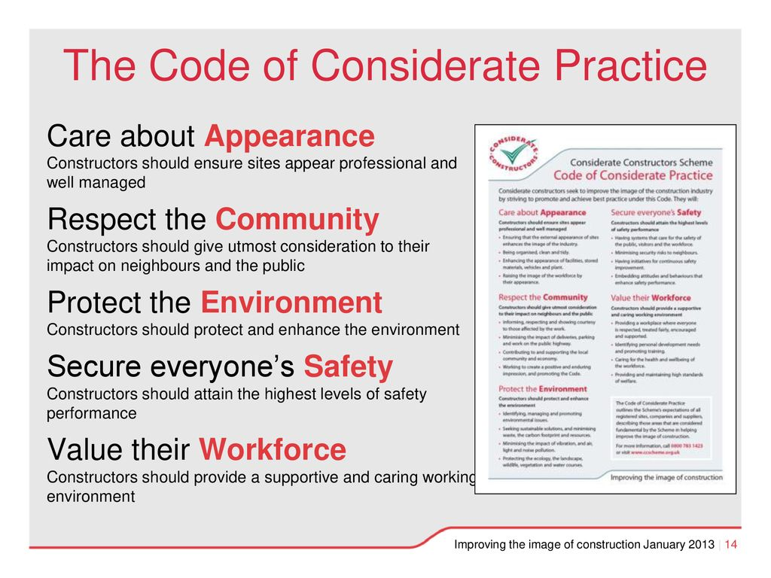

Conclusion
Overall, the document has aimed to consider all aspect of project sustainability approach by considering the two main areas which were energy and project delivery. Firstly, energy sourcing of the building was review and environmentally friendly options were drafted from these recommendations were made on how the client can move to a more off grid green energy systems.

Secondly, we reviewed the project delivery approach to provide the client with the most sustainable project. This review to into consideration three main points which would help reduce the projects carbon footprint and help increase community interaction with the project. The three points were transportation of materials, project sustainability and workforce sourcing. By considering how materials are delivered to the site and how far the materials have travelled, it means that we are promoting the use of local suppliers therefore boosting the local economy and reducing the carbon footprint which will help in the BREEAM scoring process. Making considerations to project delivery is essential in creating a sustainable project, this is because, how the project is delivered can affect different aspect of a project life cycle. The recommendations in this document provide our client with the highest level of sustainability.

Bibliography
Burrage, H., 2011. Green Hubs As Social Inclusion And Community Engagement. [Online]
Available at: https://hilaryburrage.com/2011/09/21/green-hubs-as-social-inclusion-and-community-engagement/
[Accessed 15 01 2022].
Considerate Constructors , 2022. Complaints procedure. [Online]
Available at: https://www.ccscheme.org.uk/affected-by-work/complaints-procedure-monitor-affected-works/
[Accessed 15 03 2022].
edf Energy , 2021. What is the average gas and electricity bill in the UK?. [Online]
Available at: https://www.edfenergy.com/for-home/energywise/what-is-the-average-energy-bill-in-the-uk
[Accessed 18 09 2021].
Electrical technology, 2021. Electrical Energy- Definition, Examples, Formula and Units. [Online]
Available at: https://www.electrical-technology.com/2019/05/electrical-energy-definition-examples-formula-and-unit.html#electrical-energy-definition
[Accessed 19 12 2021].
Ferguson, D., 2014. Greywater systems: can they really reduce your bills?. The Gardian .
Hiesscheme, 2021. RENEWABLE ENERGY Home Wind Turbines. [Online]
Available at: https://www.hiesscheme.org.uk/renewable-energy/home-wind-turbines/
[Accessed 19 12 2021].
Krarti, M., 2017. Lighting Systems. In: Energy-Efficient Electrical Systems for Buildings 1st edn. s.l.:CRC PRESS.
Kunz, N., 2021. Solar Water Heating. [Online]
Available at: https://www.greenmatch.co.uk/solar-energy/solar-water-heating#how-it-works
[Accessed 19 12 2021].
Moses, M., 2020. What is Low Carbon Energy. [Online]
Available at: https://www.edfenergy.com/for-home/energywise/low-carbon-energy
[Accessed 19 12 2021].
National Grid Group PLC, 2021. How does a wind turbine work?. [Online]
Available at: https://www.nationalgrid.com/stories/energy-explained/how-does-wind-turbine-work
[Accessed 19 12 2021].
Sutton, J., 2021. Construction sector must move further and faster to curb carbon emissions, say engineers, London: Royal Academy of Engineers.
the greenage , 2021. Greywater Recycling. [Online]
Available at: https://www.thegreenage.co.uk/tech/greywater-recycling/
Utility , 2018. Leaving The Lights On | A Study From Utility Design. [Online]
Available at: https://www.utilitydesign.co.uk/blog/leaving-lights-on/
[Accessed 19 12 2021].

