

Course Name: Digital Skills
Module Name: Skill Developments in workplace
Student ID: 2229222
Student Name: MD ANISUL ISLAM

Assignment: TASK 3 and TASK 4

TASK 3: Topic 4: Be in It to Win It

Introduction:
Social Media is the driving force of digital world, by navigating social media, I gained insights into various social media platforms. I have learned the importance of understanding the different features and functionalities of platforms such as Facebook, Instagram, Snapchat, Twitter, and YouTube. By grasping their unique dynamics, I discovered how to influence social media to my advantage.
According to data from researchers More than 4 billion people use internet which is 54 percent of the world populations. Approximately, 2.64 billion are using social media. [10]




Figure1: List of Social Media platform
[Facebook, Snapchat, Instagram, Twitter and YouTube] [Lecture Vedio]

Finding, analysis and Result
I have learned how to create a Facebook page for businesses, it helps to creating compelling content that resonates with the target audience. Understanding their preferences, needs, and interests helped me tailor my content to capture their attention. I also researched into the importance of consistency in posting content and maintaining an active presence on social media. I developed a stronger connection with my audience as well as future clients. [1] [3][7]

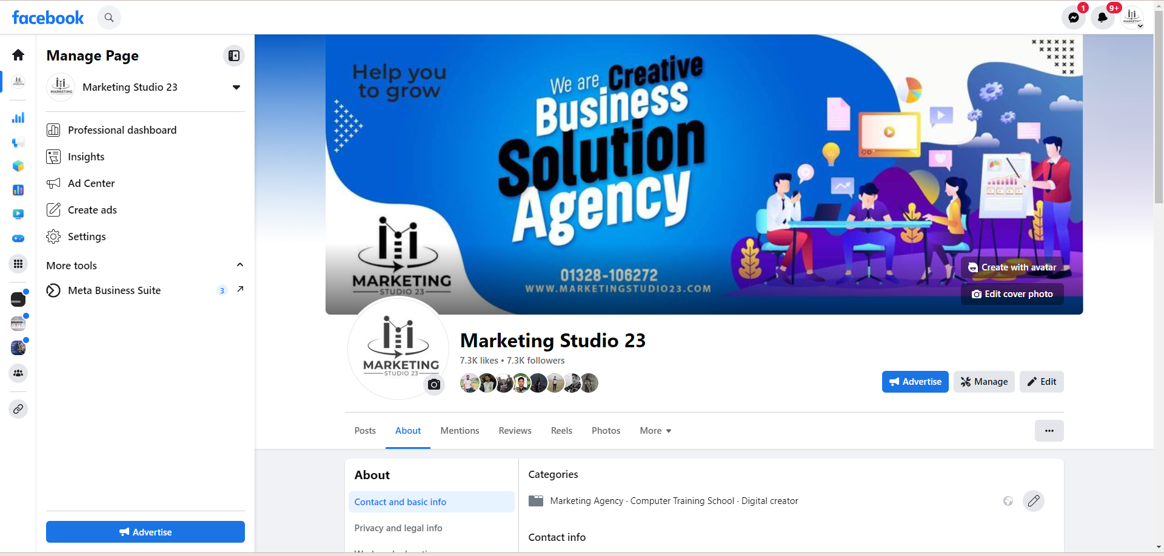
Figure 2: Creating a Facebook page for business to grow digitally [6]
Moreover, I gained a deeper understanding of the significance of building relationships through social media. I discovered that authentic engagement, such as liking, sharing, and commenting on others' posts, contributes to creating a supportive and collaborative online community. I bring up connections and expanded my network. [6]

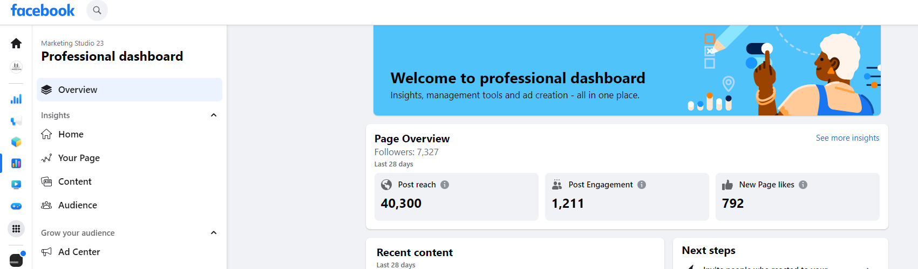

Figure 3: Professional Dashboard illustrates the social media page overview [6]

Developing professional persona reflecting personal bradding and revolved around refining a strong professional image online. I learned that in today's digital era, people often search for information about individuals online. This realization prompted me to proactively manage my online presence and shape my professional persona. Therefore, I have developed my personal website to promote my services as digital marketing consultant, what make me to established my own branding for future career.

Personal website Link: https://anissyscom.wixsite.com/socialmediamarketing [8]
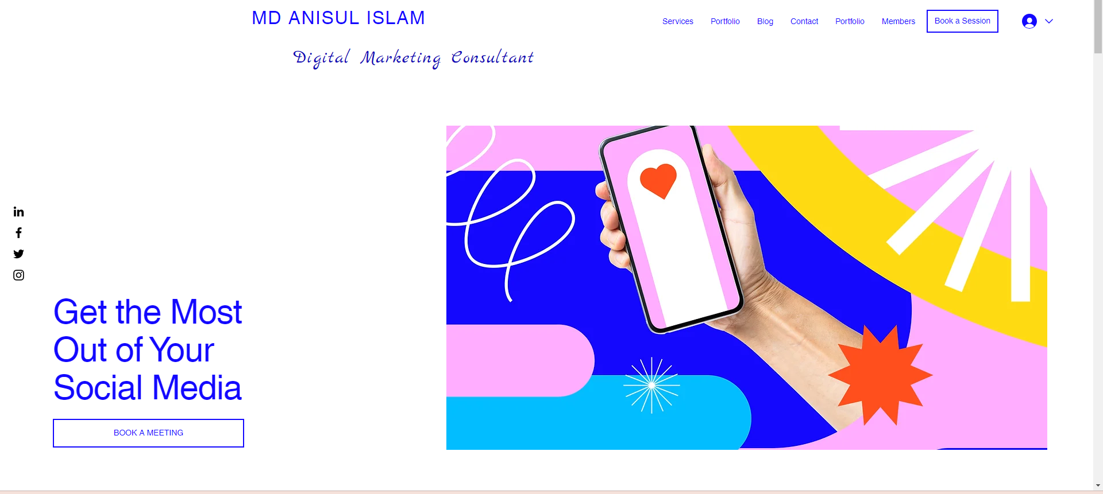

Figure: Developed a personal portfolio website to demonstrate my expertise. [8]

I discovered the importance of creating my online profiles to showcase my expertise, skills, and achievements. By generating a compelling and informative services, I presented myself as a credible professional in my field. I also explored strategies for highlighting my accomplishments, such as sharing project outcomes, testimonials from clients. These efforts helped me establish credibility and build trust among those who interact with my online profiles and services. [8]

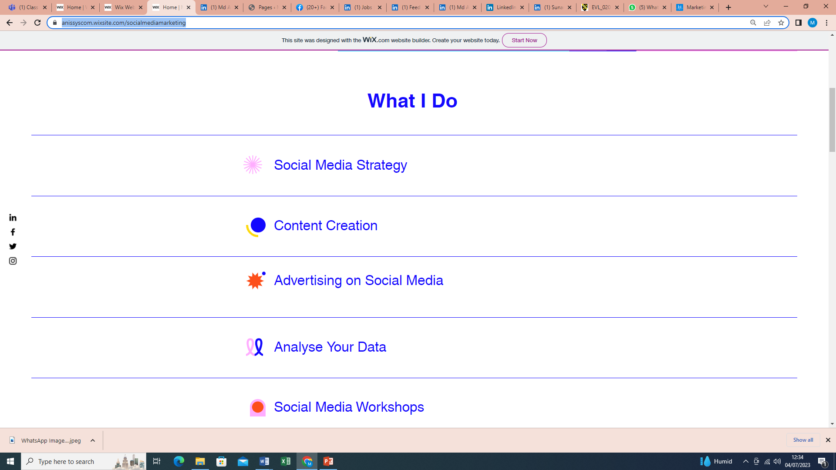

Figure: This picture is illustrated my services [8]

Furthermore, I realized the significance of maintaining a consistent brand across different platforms. By aligning my visual identity, including profile pictures, cover photos, and colour schemes, I created a recognizable personal brand. This consistency contributed to reinforcing my professional image and making a lasting impression on those who encounter my online presence. Finally, I have linked social media link (LinkedIn profile link: https://www.linkedin.com/in/md-anisul-islam-10b401282/ ) with website what gain more trust to potentials clients. [8]

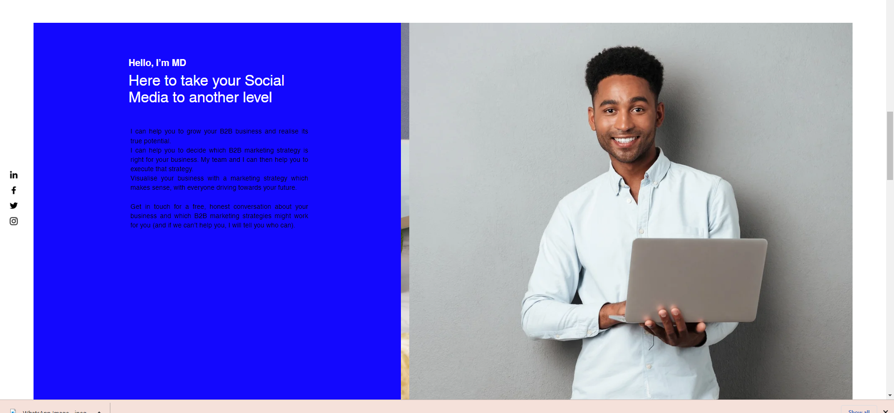
Figure: Personal Branding to impress potential clients [8]
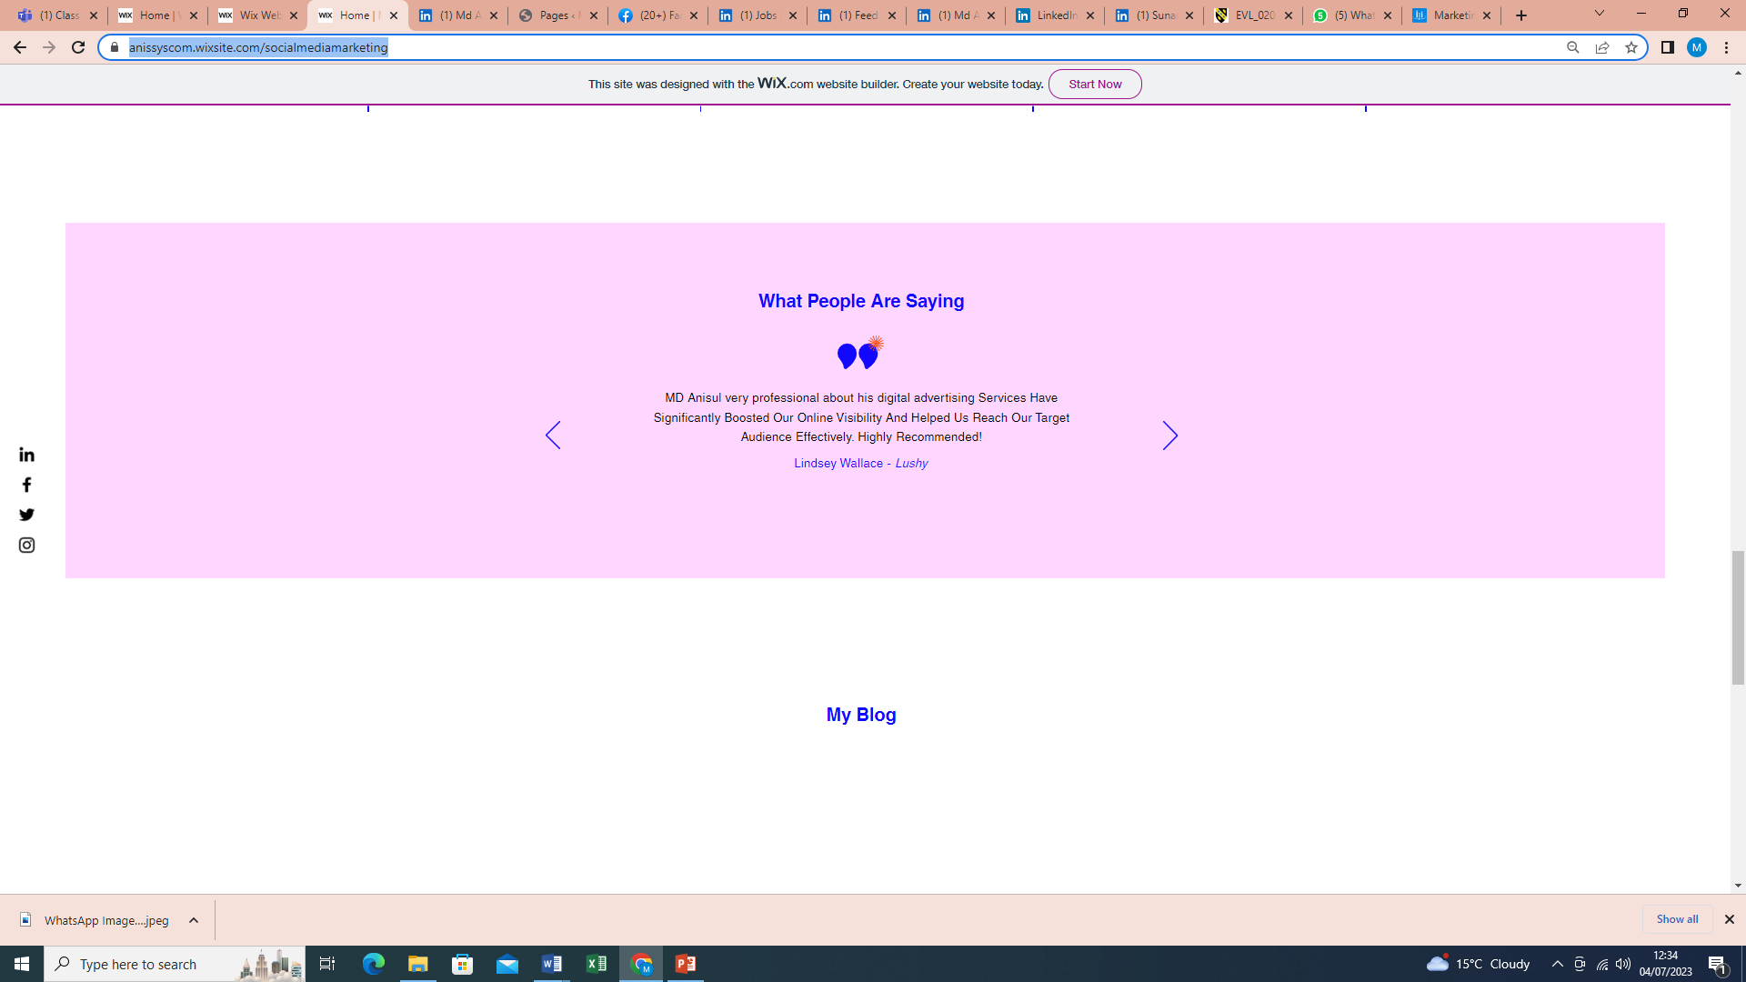
Figure: Clients testimony is vital to gain trust and reliability towards potential clients [8]
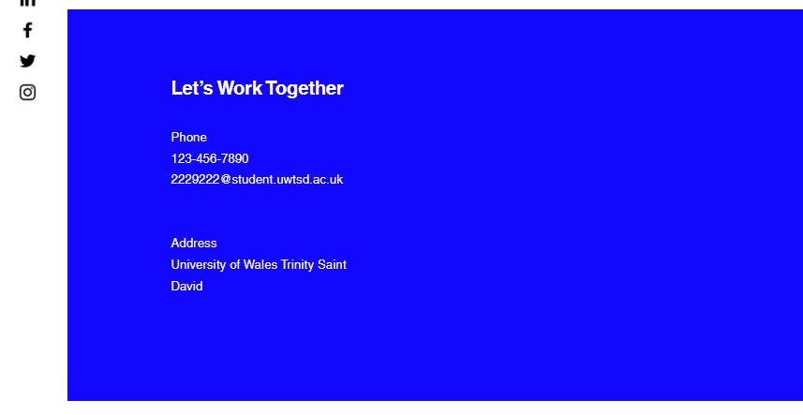
Figure: Contact Information helps to the clients to get the services remotely and globally [8]

Step by step guide to create a professional LinkedIn profile:
LinkedIn, a powerful platform for building professional connections and expanding my network. I gained a general understanding of the platform's features and functionalities. [9]

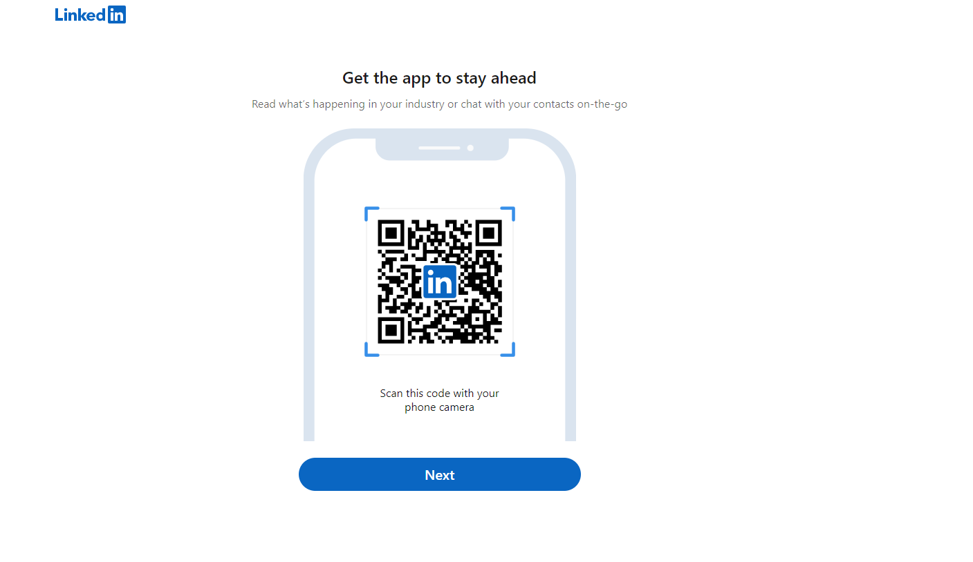
Figure: Downloading the apps easier way to access the opportunity

During the creation of LinkedIn profile. I have learned how to optimize each section, including the headline, summary, experience, education, and skills. I created a profile that showcased my expertise. [9]

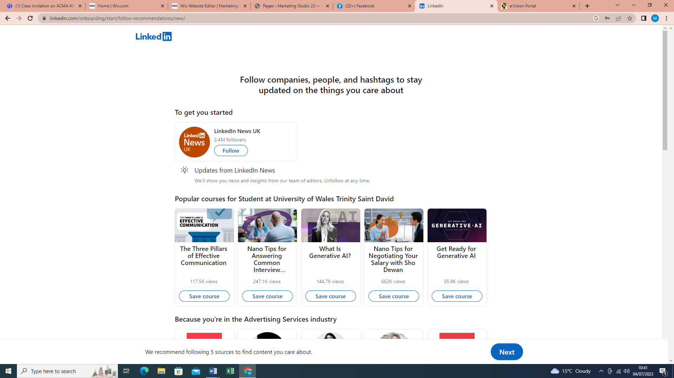
I also explored the importance of actively engaging with the LinkedIn community. I discovered various ways to connect with professionals in my field, such as joining relevant groups and participating in industry-related discussions. For instance, digital marketing executive, digital marketing consultant, digital marketing services, digital marketing agency etc. [9]

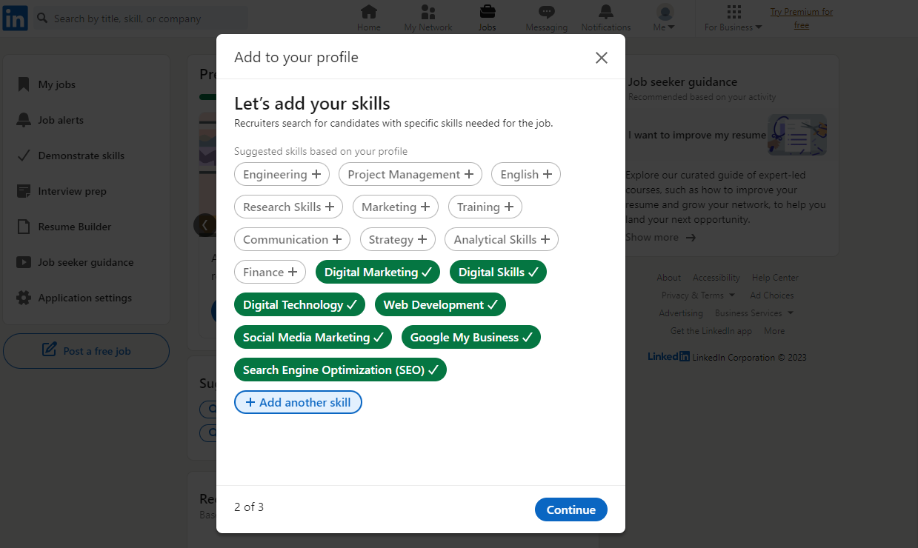
Figure: Keyword are important when we leave footprint in digital world. Therefore, search engine optimisations (SEO) helped us to identify the relevant topic and interest from digital world.

Moreover, I learned how to influence LinkedIn's advanced search features to identify and connect with individuals who align with my professional goals. I expanded my network and opened doors to new opportunities. Therefore, I have added on LinkedIn profile relevant keywords and attributes skills, so that people in the digital marketing filed more concise way. For Instance, Digital Marketing, SEO, Web development, Digital skills etc.
In my LinkedIn profile I have tried to highlight my expertise and use several keywords what I have learned throughout the course and study. It will help me to re shape my professional online presence towards the recruiter as well as clients. [9]

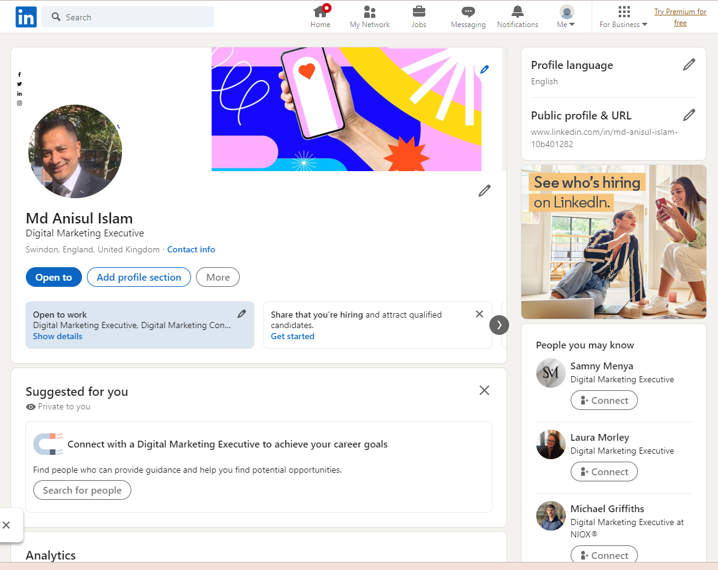
Figure: LinkedIn Profile to tailored professional online presence [9]

Conclusion:
In conclusion I can say, I have developed my professional online presence by social media platform. Furthermore, I have learned about the importance of privacy settings and online reputation management. I became aware of the potential risks associated with sharing personal information and the need to protect my online identity. By adjusting privacy settings, I ensured that I maintained control over the information visible to the public, safeguarding my personal and professional interests.

Task 4: Topic 4: Closing the Loop: Skills Learned from the course and study
Skill developments in workplace course help me to choose and fortified me with valuable skills and knowledge in the areas of digital marketing industry as well as social media marketing, planning, and implementation. Through this topic, I have improved my abilities and developed key attributes that enable me to excel in the field. Allow me to highlight my skills and attributes, as well as showcase my work through an A3 poster.

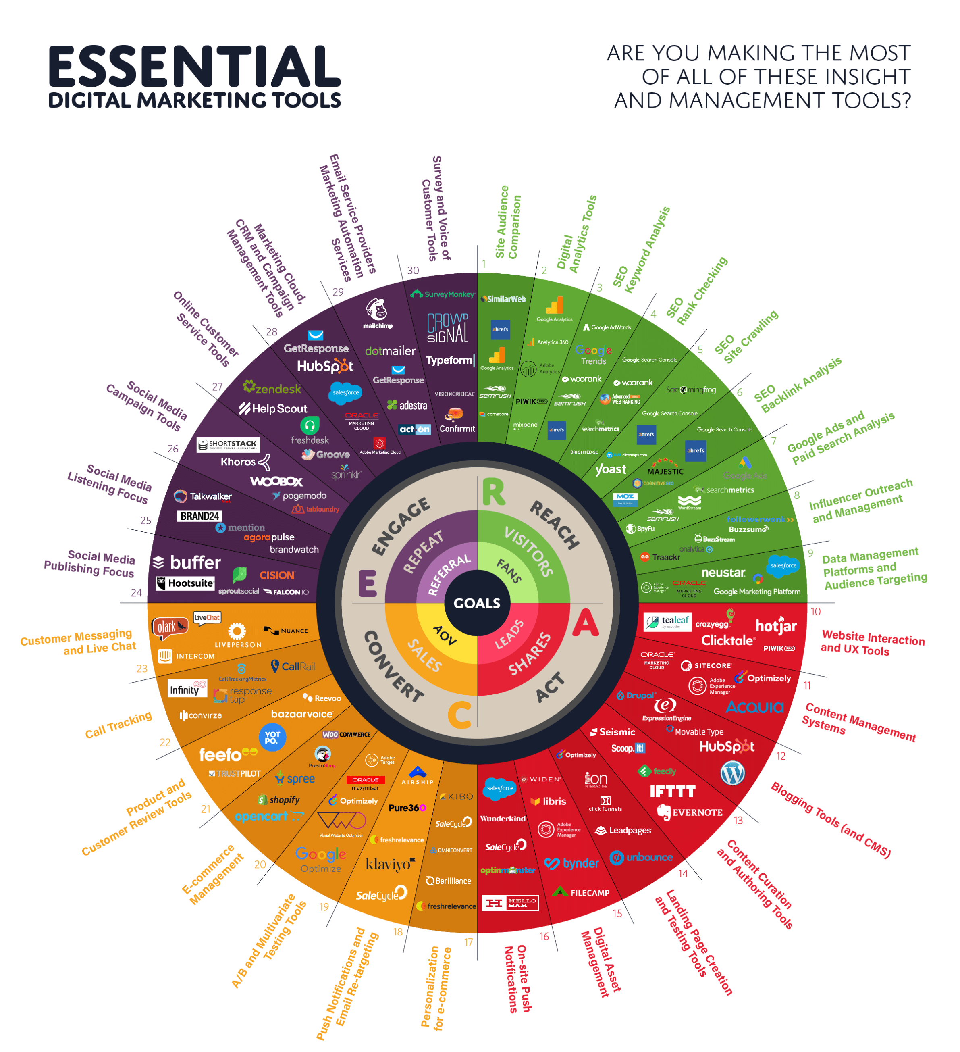
Figure: Essentials Digital Marketing Tools [1]

Throughout the course I have gained knowledge about Facebook Meta Business Suite, specifically the Professional Dashboard, is a powerful tool designed to assist businesses in efficiently managing their online presence and analysing data. This suite offers features that enable businesses to handle content, messages, promotions, campaigns, advertisements, target markets, audiences, and insights across various platforms, including Facebook, Instagram, and WhatsApp Business. [3][4][5][6]

Figure: Facebook Professional Dashboard on Meta Business Suite displayed the overview of page, content, audience and ad centre.

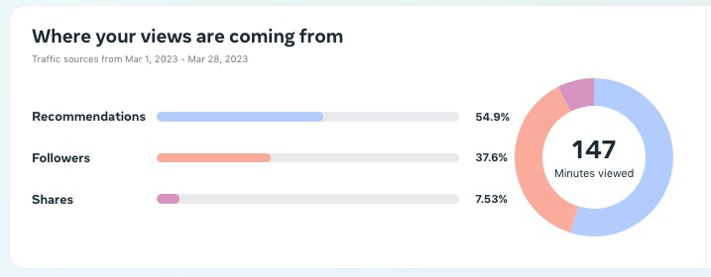

Figure: This figure illustrated segmentation of the views of your contents

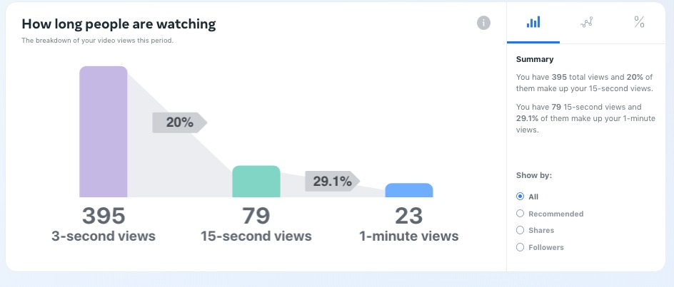
Figure: This picture displaying the data about the duration of watched time by the audience
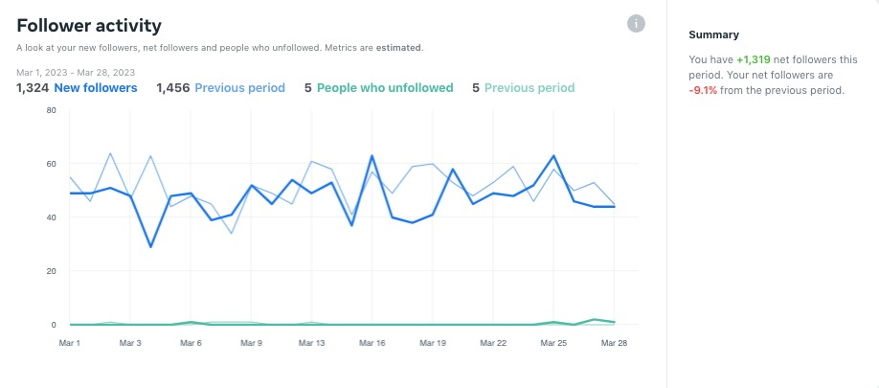
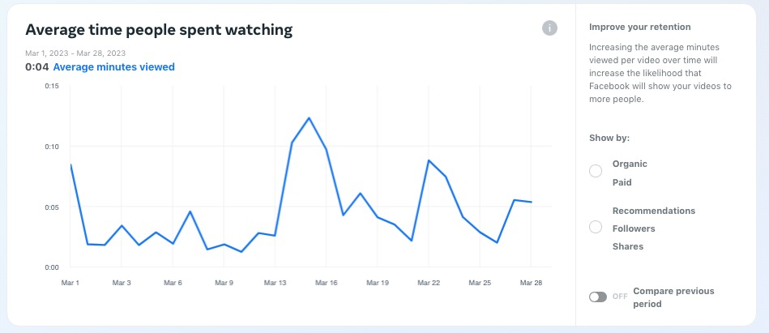

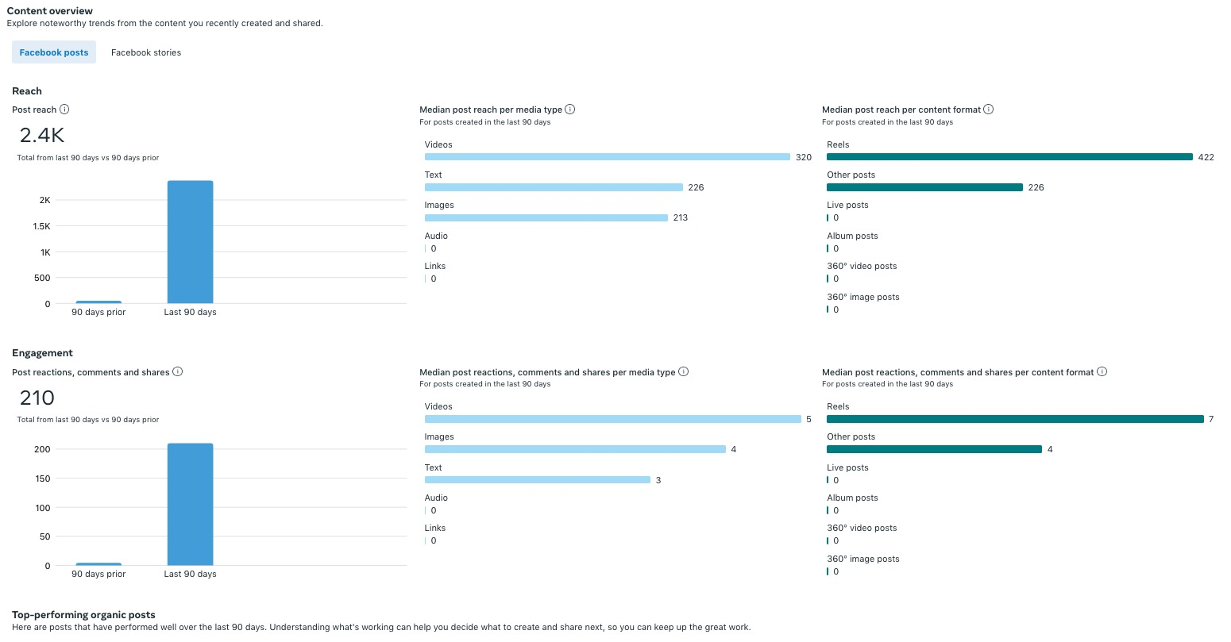
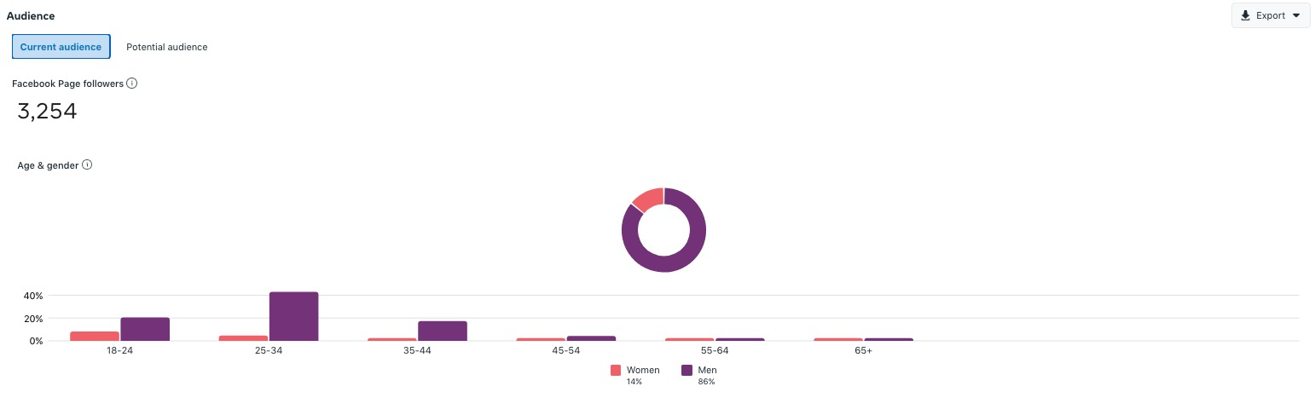
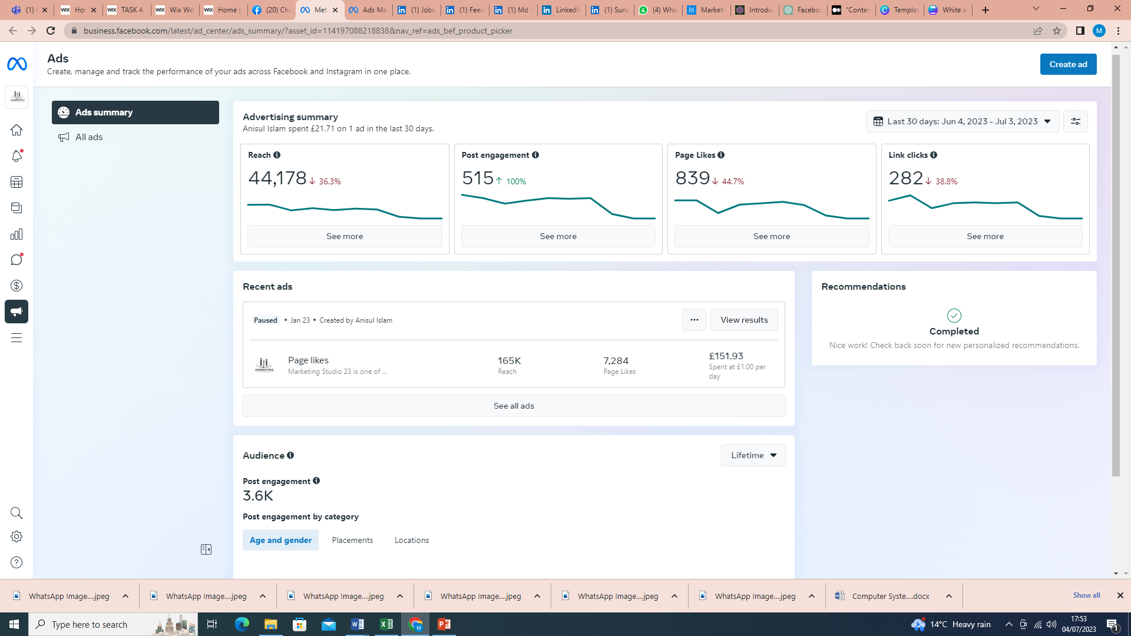

Figure: This all pictures are illustrated and displayed the result and findings of ad campaign on by using Facebook Meta business suite.
A practical example of utilizing the Facebook Meta Business Suite is by utilizing the Professional Dashboard, Ad Manager, and integrating multiple social media accounts into a single centralized platform. This integration allows businesses to access and manage their assets, roles, tasks, scheduling, and performance analysis of advertising campaigns and video content performances all in one place. By leveraging these features, clients can gain a better understanding of their target market, target audiences, customer responses, communications, advertisement costs (ROI), revenue, and overall business performance. [1][4][5][6]

Skills and Attributes what I have gained from this Course and self-study [1]-[6]

- To Develop Digital marketing and Social Media Strategy for clients.
- Generate quality Content creations to drives the business to grow digitally.
- To excel in fostering meaningful connections by actively engaging with followers, responding to comments and messages.
- Utilizing social media analytics tools to gather and analyse data, which is enable me to make data-driven decisions, identify areas for improvement, and optimize future strategies to achieve better results.
- To run Advertisement Campaign Planning and Execution.

Conclusion:
In calculation, we can say, the Facebook Meta Business Suite, with its Professional Dashboard, provides businesses with a comprehensive toolset for managing and analysing their online presence. By utilizing this suite, businesses can streamline their operations, gain insights into their target market and audiences, assess customer responses, monitor advertisement costs and revenue, and ultimately make informed decisions to improve their overall performance.

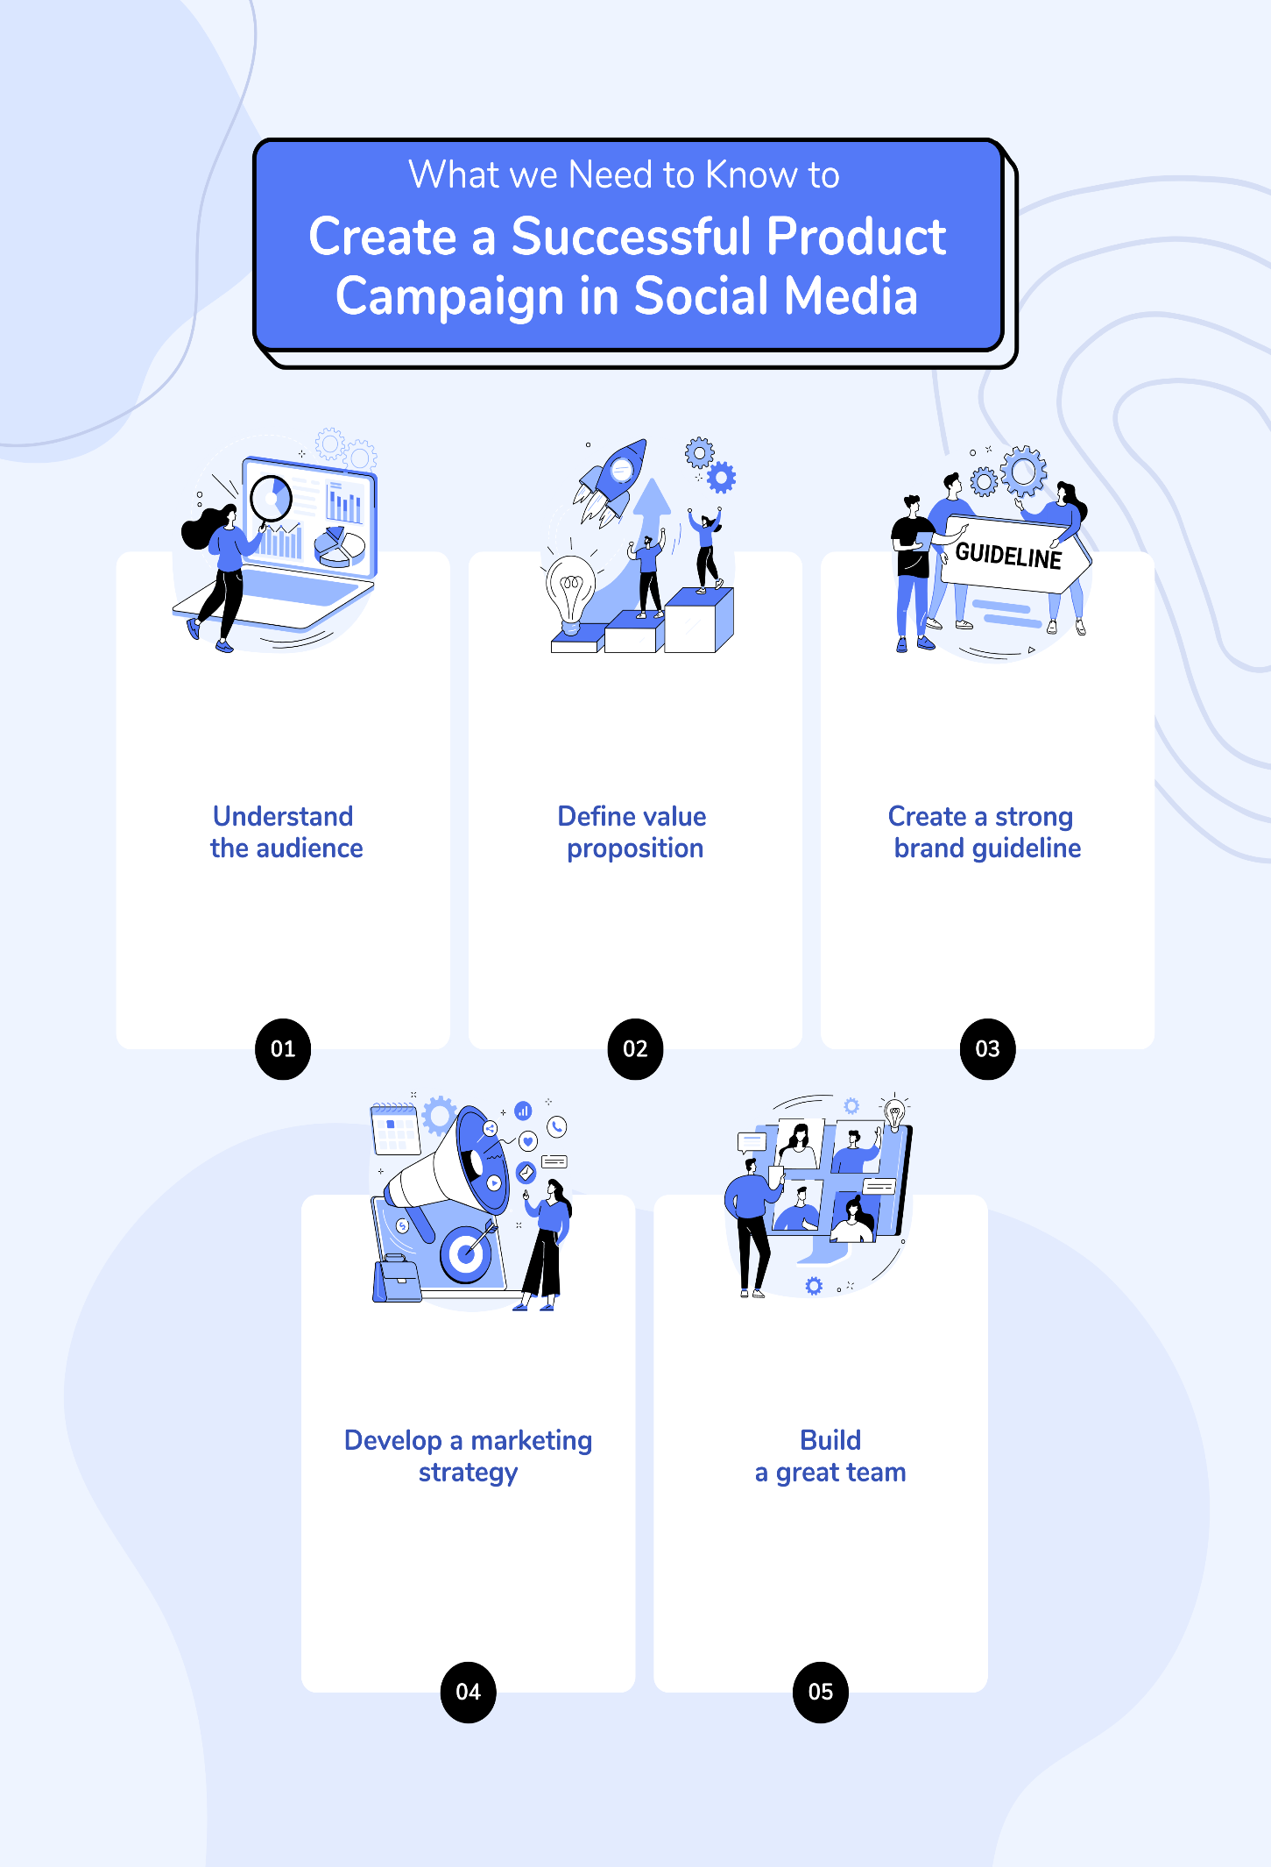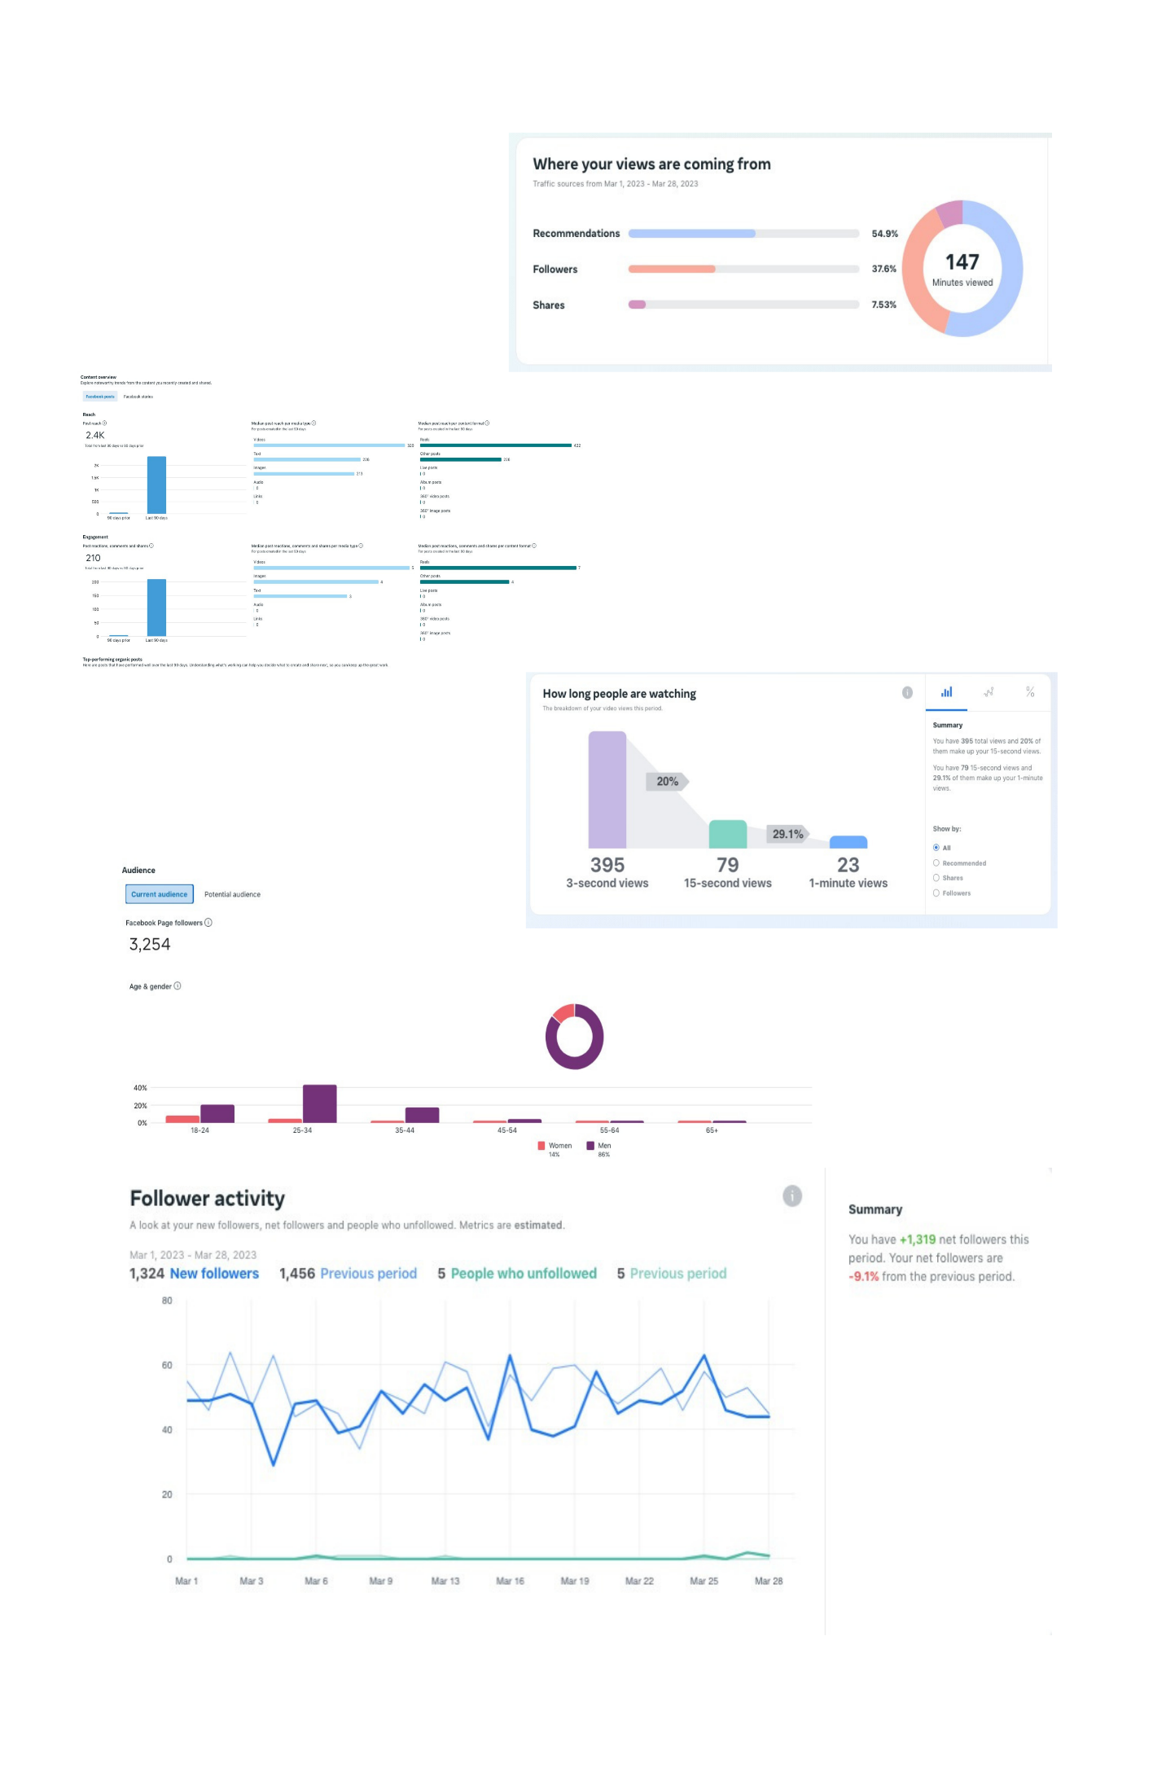
A3 Poster for Social Media Campaign and its attributes data driven result with graph and chart [7]
List of References:

[1] Smart Insight (2023), Essential digital marketing tools [Infographic], Available online at: https://www.smartinsights.com/digital-marketing-platforms/essential-digital-marketing-tools-infographic/ [Last Accessed on: 03/07/2023]
[2] Tableau, (2023), “The Tableau Platform”, Available online
at: https://www.tableau.com/products/our-platform[Last Accessed on: 03/07/2023]

[3] Qlik, (2023), “Qlik: Digital Dashboard Guide”, Available online at:
https://www.qlik.com/us/dashboard-examples/digital-
dashboard#:~:text=What%20is%20a%20Digital%20Dashboard,directly%20within%20the%20dashboard%20itself. [Last Accessed on: 03/07/2023]]

[4] Hutchinson A; (2023, March 27), “Meta’s Testing New Ad Tools for Retailers to Help
Maximise Campaign Performance”. Available online at: https://www.socialmediatoday.com/news/metas-testing-new-ad-tools-for-
retailers-to-help-maximize-campaign-perform/646088/ [Last Accessed on: 03/07/2023]

[5] Hootsuite, (2023), “3 Tools to Use Instead of Facebook Analytics”. Available online at:
https://blog.hootsuite.com/facebook-analytics-insights-beginners-guide/#Facebook_analytics_tools [Last Accessed on 03/07/2023]

[6] Sonnenberg, A., (2022, June 06), “How to Set up Meta Business Suite and Business Manager
for Clients”. Available online at: https://www.socialmediaexaminer.com/how-to-set-up-meta-business-suite-and-business-manager-for-clients/ [Last Accessed on: 03/07/2023]

[7] A3 Poster design: https://www.canva.com/design/DAFnsAN-1MM/nU6mACylLCch-4qmodXhxg/edit [Last Accessed on: 04/07/2023]
[8] Website to illustrate personal branding on wix platform Available online: https://anissyscom.wixsite.com/socialmediamarketing [Last Accessed on: 04/07/2023]
[9] LinkedIn Profile link: Available online at: https://www.linkedin.com/in/md-anisul-islam-10b401282/ [Last Accessed on: 04/07/2023]
[10] TEDx Talk, Available online: https://youtu.be/ekPGf3QeBlE [Last Accessed on: 04/07/2023]

